The Science Academy of South Texas Mercedes, TX

The Science Academy of South Texas
Mercedes, TX
667 students
Hispanic 65%
White 24%
Asian 10%
African American 1%
Students receiving free/ reduced price lunch 40%
Students receiving SPED services 7%
Student-teacher ratio 13:1
Student turnover rate 7%
Overview/Setting
Just seven miles from the U.S.-Mexico border, the Science Academy of South Texas (Sci. Tech.) is one of four comprehensive magnet secondary schools in the South Texas Independent School District (STISD). Sci. Tech. located in Mercedes, draws students from 28 districts in the largely Hispanic Rio Grande Valley.
Approximately 41% of students at Sci. Tech. are on free or reduced price lunch programs, and some must travel up to one hour to attend school each day. Yet the state has designated the school an “Exemplary” Accredited school for 12 of the past 13 years: some 90% of Sci. Tech. students pass or exceed state standards in Reading/Language Arts and Math, and last year 98% of the school’s students went to four-year colleges. Half of those students were the first in their families to attend college.
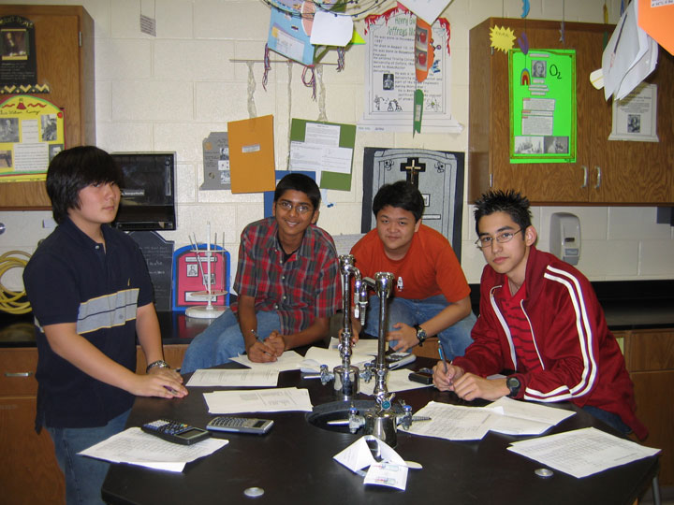
Sci. Tech. currently enrolls 667 students on a first-come-first-serve basis, and boasts a 13:1 student-teacher ratio. Enrollment is open to any student who completes 8th grade, has a strong interest in math and science, and speaks English well enough to succeed in an English-only classroom. All applying students and their parents must meet with principal, Edward Argueta, to make sure they understand the school’s demanding curriculum. Students are accepted only into grades 9 and 10; any later, administrators believe, and students would be unable to catch up to their peers and complete the mandatory coursework.
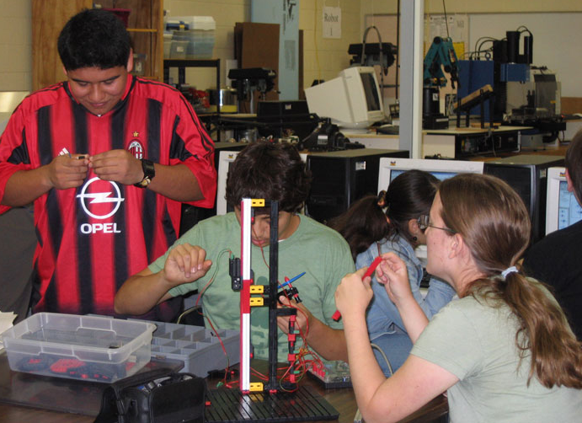
Despite being the “best kept secret” in the area, the school works hard to attract motivated students. Although Sci. Tech. is open to all students, a perception that the school steals their feeder districts’ best students often prevents Sci. Tech. administrators from recruiting in middle schools. Instead, all 8th graders in the 3-county area receive recruitment packages in the mail, and the district advertises in multiple venues—everywhere from its school buses and the local airport to The Discovery Channel. While the school’s math and science focus tends to attract more boys than girls, the school is working to increase its female enrollment.
As the district’s motto, “Think Outside the Book,” suggests, Sci. Tech. strives to prepare students for science and technology related fields with a rigorous, hands-on curriculum. In addition, through a partnership with Rochester Institute of Technology and Project Lead the Way, a national pre-engineering program, students may take pre-engineering and pre-architecture courses and begin earning college credits in their freshman year.
The district receives funding via taxes from its feeding districts (currently at a rate of $0.37/$100), state, and federal sources. Sci. Tech. spends about $3,000 more per student than the state, and the administration actively pursues resources it believes will benefit student learning. As one administrator put it, “Our kids are not going to be second best.” Sci. Tech’s digital design equipment for engineering is but one example of its advanced technology.
Leadership and Relationships

The willingness to do what it takes to succeed echoes from the district level down to the teachers. “We are a school of maximums, not minimums,” says Argueta. Having students pass state tests is not enough, he says: merely passing does not mean students are reaching their potential.
Leadership in the STISD is collaborative and focused at all levels. You must have clear, non-negotiable goals, explains an assistant principal, and everyone must collaborate to accomplish them. The ultimate goal, Argueta says, is “to reach every student and help them make choices for college.” The administration wants students not only admitted to college, but prepared to finish successfully.
Administrators and teachers talk about making a conscious decision to put education and students first. As one administrator says, you must send the message that education is important. Students need to see it and believe it. Leading by example is one technique for doing so. Thus when administration and teachers realized their technology instruction was falling behind, they decided to adopt Project Lead the Way, despite its $500,000 price tag for the training, curriculum, and equipment. Finding the money had to be a team effort, but everyone was willing to work for it.
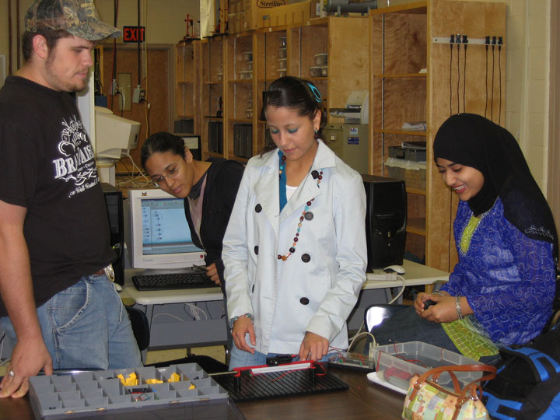
Cultivating relationships with students also sends the message that faculty support them and their education. Relationships depend on access to teachers and administration. Teachers’ doors are open for informal tutoring half an hour before classes start, and students work with the same counselor every year. Sci. Tech. maintains a 200:1 ratio of students to counselors, instead of a more typical ratio of 500:1, so counselors can truly get to know their students and offer individual advice. One counselor noted that “It’s never acceptable to be rude or not accessible to students.” Students said that they like that their teachers, counselors, and administrators know them and have time to talk with them.
Faculty members in turn expect a lot back from their students. Explains an administrator, some schools have a tendency to nurture kids but not push them because they are minorities or come from low income families. Sci. Tech. teachers and administration believe students can achieve regardless of their backgrounds. They temper nurturance with “no excuses.”
Building a First-Rate Faculty

Just as faculty members have high expectations for their students, the students expect a lot from their teachers. If they don’t measure up, students have been known to complain to their counselors that they aren’t being challenged. “I am a professional,” says one teacher. “If I screw up, it is my fault.” Adds a science teacher, “The students ask tough questions. You really need to know your subject.”
“We have an excellent nucleus of teachers. They know how to challenge the students, they know their subject matter, they know about education,” says Argueta. The key, explains an assistant principal, is making sure teachers know they are in a valued profession, that it’s about “nurturing and pushing, for example finding those students who don’t go to tutoring.”
The school’s salaries are in the top 10% of the state. But it’s a challenge for Sci. Tech. to find new teachers with the level of commitment the school demands. Changing a new teacher’s expectations can be hard work, and an administrator describes battling a refusal by some teachers to take responsibility for student education. Not all teachers are renewed, the principal noted, although last year the teacher turnover rate dropped from 11% to 0%.
Because Sci. Tech. is small, teachers know each other well and often meet informally. New teachers are paired with mentors in their subject area and a “campus buddy” to help acclimatize them. There’s a lot of peer pressure to succeed, one teacher explains. “When you watch others reaching their students and the students excelling, you want to do the same.” The administration is very responsive, says an English teacher. They will ask, “What do you need?”
Professional Development

Even among veteran teachers, however, the administration pushes for growth. As long as some students are not passing their courses, there is room to improve instruction. Five to six times a year, administrators take classroom “snapshots,” a technique learned through association with the Dana Center. Sampling numerous, brief teaching examples gives administrators a baseline assessment of a teacher’s strengths and weaknesses. Each snapshot is then turned into a mini-professional development session, during which the administrator reviews his or her notes with the teacher. Teachers also have four in-service days a year, and all technology teachers must be trained every summer at RIT. Of the school’s six technology teachers, four are now considered master teachers.
Occasionally, Argueta says he needs to protect and advocate for Sci. Tech.’s vision and program with teachers, parents, and the community. He uses articles about how students are beginning college unprepared to remind the detractors why the school’s focus is so important. But most are eager to come aboard with Sci. Tech.’s philosophy, and many parents want to give back to the school. The school district began a foundation three years ago to bring parents together and raise money for summer scholarships and stipends for students.
High Expectations and Focused Curriculum

Sci. Tech. faculty members agree that students’ ability to choose their school has a large effect on student motivation. Nonetheless, Argueta takes the time to make sure students understand the school’s academic expectations before they enroll. “Students will give you what you expect from them,” he says. And Sci. Tech expects a lot. The administration considers the Texas standards to be just a starting point; the true goal is to prepare all students to enter and finish college.
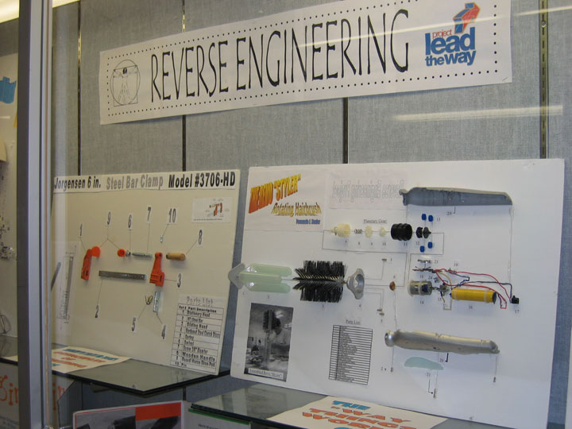
English, math, social studies, and science courses are required every year. Students take two science courses in both their freshman and sophomore years, resulting in four years of high school science in half the time. Many students take math courses during summer school so they can finish Sci. Tech.’s math sequence, which ends with Calculus II. Additionally, all students must take an SAT/ACT course in their junior year, plus courses in computer science, Spanish, art, technical writing, and physical education throughout their four years.
Project Lead the Way’s “required electives” include five pre-engineering courses. Sci. Tech. is the only school in Texas to complete the training and adopt Project Lead the Way’s pre-engineering curriculum, and prides itself in having female students excel in an atypical field. In their senior year, students take Engineering Design and Development (EDD), a senior research project course, in which they must identify a problem, design a solution, and present their results to the school. In the past several years, student projects have received recognition from groups like the Coast Guard for a reversible wind-breaker/life jacket, and students have patented and sold their projects, such as an improved stretcher. Says a technology teacher, “You’ll be amazed at what these kids can do.” EDD is great, adds a senior student, because it gives you a real project to show colleges when you apply. Most Sci. Tech. students graduate with extra high school credits and enter advanced courses as college freshmen.
When asked about integrating the curriculum, teachers say students make their own connections between subjects, relating math and physics to engineering, or discovering why English is necessary in order to write a technical report. Teachers use active learning in classrooms. For example, students practice as a class writing AP English essays, work together on chemistry problems, demonstrate concepts in physics, or build robots in a technology course.
Unrelentingly High Standards

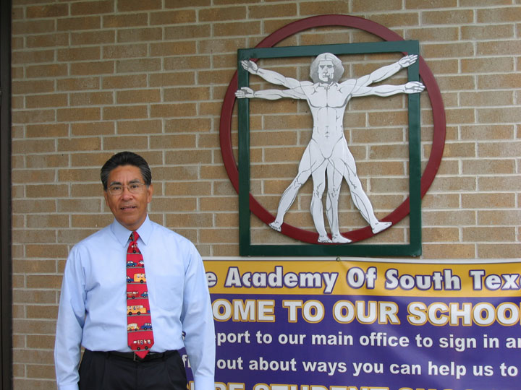
Teachers emphasize that every letter grade has to mean something, and A’s are not handed out easily. “Unlike at some schools, we have no pressure to lower our standards,” says a math teacher. A technology teacher agrees, “Students need the freedom to fail and to think. That’s where they learn.” Although AP and pre-AP courses are weighted, Sci. Tech.’s valedictorians do not typically graduate with 4.0 GPAs. “We believe students are responsible for their learning,” explains an assistant principal, “But we are responsible for teaching them so they can learn.”
Sci. Tech. students take eight courses a year with AB block scheduling. Each day students have an A or B block consisting of four 1 ½ hour periods, seven minutes between classes, and 50 minutes for lunch. Faculty members try to limit homework to core courses and aim for no more than two hours a night. Still, students say it’s easy to fall behind with such an intense workload, but it teaches them time management and how to organize. Many appreciate how helpful these skills will be in college. "It is about responsibility. You just have to get your act together and succeed." Courses are arranged as college prep, pre-AP, and AP courses. Sci Tech. is moving to eliminate college prep courses in the humanities as another way to “raise the bar.” When determining course content, Sci. Tech. goes beyond the Texas standards, and looks at what colleges demand. “We ask colleges what they (students) need. Colleges are our customers.”
Having a small school and small class sizes helps teachers and students, says Argueta, but he is emphatic that the academic focus is what is important. Sci. Tech. has no music program or sports teams, though students organize intramurals and host a battle of the bands. All school clubs must have a faculty sponsor and an academic focus.
Sci. Tech. students accept the challenge with enthusiasm, though they say it can be difficult for them and their parents as they go from being A students in middle school to C students at Sci. Tech. “I didn’t realize how challenging Science Academy was going to be,” says a senior. “But you need high math and English scores to get into a good college. This is the curriculum, the advantage, I want.” Says a freshman student, “We are just barely passing but learning more than we would in our home schools.” Another adds, “It’s a whole different lifestyle. I cannot imagine myself in another high school.” A student compares schools: “At my home district, high school may be fun but not challenging–I am all around smarter than my old friends.”
Student Supports

Guidance Counselors
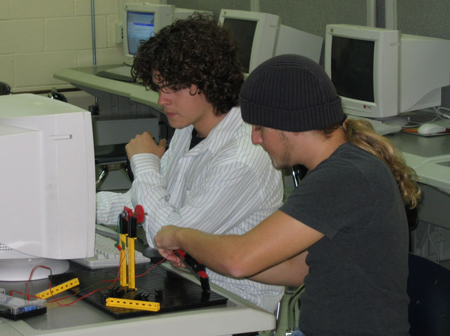
Sci. Tech. employs three full time guidance counselors. Each works with the same students for the students’ entire time at school, enabling counselors to know their students as more than grades on a transcript. During pre-registration, counselors present information on courses and graduation requirements to all underclassmen. They also work one-on-one with all students to plan their schedules based on current classes and grades, and help students keep track of credits.
Counselors begin discussing college with students from their first day at Sci. Tech., and counselors stay involved in every step of the process. In April of their junior year, counselors host a Junior College Night, in which all juniors and their parents are invited to a presentation on applying to college and the financial aid process. Juniors receive a “senior survival kit” that includes a handbook on many topics concerning college and the admissions process. Once those juniors enter their senior year, counselors provide another orientation with more detailed information about college applications, financial aid, and scholarships. Counselors are also available to help students complete applications or fill out the FAFSA and other financial aid forms, review admissions essays, and check final application packages for completeness and accuracy.

Tutors
Administrators expend a concerted effort to make tutoring a regular part of the school day. While classes don’t start until 9:00, for most students the day really begins at 8:30. Teachers are required to be in their classrooms and available to answer students questions and concerns for 30 minutes each morning. Students use the time to get extra help with troubling concepts or to work on their homework with teacher supervision.
Morning tutoring is optional at Sci. Tech., but students may be required to attend afternoon tutoring. Six weeks into each semester, administrators review student progress and identify students who are in danger of failing. Counselors meet with those juniors and seniors, and the principal and assistant principals meet with the freshman and sophomores. If at nine weeks students are still in danger of failing any class, they are required to attend formal, afternoon tutoring sessions. The school provides late buses, and the administration works with students who are prevented by external obligations from staying late. Teachers who volunteer to stay additional hours and tutor are paid for their time.
In addition to coursework tutoring, Sci. Tech. holds mandatory tutoring for the Texas Assessment of Knowledge and Skills (TAKS) in the Spring for students who score below proficient on a diagnostic TAKS test. After- school tutoring for the TAKS focuses on math and science because the language arts portion of the TAKS is given in February, leaving little time for tutoring. Students are assigned to teachers based on their scores and goals, and tutoring is data driven. For the language arts portion, teachers review the student scores on the official TAKS to plan for the following year.

Additional Supports
Communicating with parents is a struggle, says Argueta, because of the large geographic area from which Sci. Tech. draws students. The distance prohibits school visits for some parents. In order to overcome this difficulty, Sci. Tech. uses several techniques to keep parents and students informed about student progress. The school sends progress reports home every three weeks and sends out a newsletter; students and parents can log onto to the K-12 Planet website, which allows them to see test, quiz, and assignment grades. Teachers are encouraged to update their class information on K-12 Planet regularly so students and parents can always access current information. Parents can request a conference at any time, and administrators will require a conference if a student is failing.
Faculty members monitor freshman and sophomore students closely. Aside from tutoring, faculty members will occasionally convene to discuss floundering students, and administrators will meet with students to address issues. “We try to be gentle but firm,” says an administrator, “To understand their difficulty and coax them through it.” For underclassmen, the transition from their old school to Sci. Tech. is often difficult: they lack the necessary organization or management skills, and are daunted by the work load. Argueta admits Sci. Tech. is not for all students. In the Fall of 2005, the entering freshman class comprised 263 students. By March 2006, the freshman class had dropped to 222 students. The loss of students is attributed to “missing band, sports, and friends,” “the rigorous courses,” and “because parents had pushed them to come.”
One technique Sci. Tech. uses to help freshmen succeed is to hold a one-day freshman camp before the school year begins. Faculty and administrators use this time to meet incoming students and their parents, “indoctrinate” students into the Sci. Tech. mindset, and answer questions. Veteran students attend as well to help new students make the transition, and students from various towns can get to know each other.
Sci. Tech. students share their award-winning library, Biblioteca Las Americas (BLA), with STISD’s South Texas High School for Health Professions. The library gives students access to over 40,000 books, 150 periodicals, 4000 videos, and seven newspapers, as well as links to the card catalogs at Rice University and University of Texas at Brownsville, among others, for interlibrary loans. BLA contains a lecture hall, art gallery, numerous computer workstations, conference rooms, and a digital video editing room. Students and faculty can reserve rooms for study groups and check out laptops and digital cameras. Three full-time librarians assist students and faculty with research and course preparation, and the library stays open until 7:00 p.m. for those studying after school.
School Climate

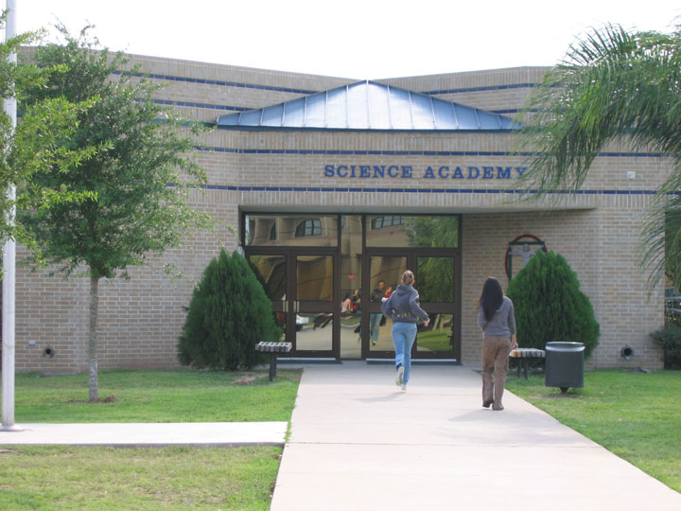
Students attend Sci. Tech. because they are interested in careers in math, science, or engineering, but also because of the school’s safe, welcoming environment and its small size. Discipline is mostly a non-issue, a matter of minor behavioral or academic problems. Sci. Tech. offers students many clubs and activities, and most students participate in at least one. Community service is popular, and Sci. Tech. students can team with other STISD students. At graduation, the school recognizes those who logged exceptional service time.
Perhaps because distance makes it difficult for many students to see their Sci. Tech. friends outside of school, the atmosphere is very tight-knit. “Over the years, this school just grows on you,” says a senior, and a freshman notes that “Everybody’s nice here.” Students describe the school as a family—safe and accepting. One student’s comment is shared by others in various grades: "You can be yourself. No one is judging you.” Students describe the other students they spend 30 minutes or more with en route to Sci. Tech as their “bus family” and often work on homework together during that time.
When students who have special needs and Individual Education Plans (IEPs) apply to Sci. Tech., administrators ascertain if the school can provide the needed IEP services. If administrators and parents agree that a student with special needs would not able to master the content, Sci. Tech. offers a district-wide alternative half-day science program for students with special needs.
The family atmosphere extends beyond student relationships. Students appreciate that they can have personal relationships with their teachers, and that teachers take the time to help and encourage them. An English teacher has his students play hide and seek so they can better appreciate a poem about childhood. “It’s about doing what it takes to reach them,” he says. Sometimes reaching extends beyond Sci. Tech.’s walls. One math teacher meets with her students at a coffee shop on Saturdays to help them with calculus.
Competition for grades and rankings is fierce but friendly. Students recognize they have common goals, and everyone is aiming for college. “The competition makes you work harder,” explains a senior. “But you also work together.”
Sci. Tech. students are pragmatic. They feel Sci. Tech. offers them a taste of what college will be like; both in competition and student diversity, and that knowledge will give them an edge when they graduate.

Science Academy of South Texas

Grade 12 SAT Verbal: Scaled Scores | 2001 | 2002 | 2003 | 2004 | 2005
All students | 539 | 566 | 557 | 565 | 559
% of students tested | 96 | 97 | 96 | 89 | 98
Hispanic students | 518 | 560 | NA | NA | NA
White students | 554 | 608 | NA | NA | NA
State scores | 493 | 491 | 493 | 493 | 493
National scores | 506 | 504 | 507 | 508 | 508
Grade 12 SAT Math: Scaled Scores | 2001 | 2002 | 2003 | 2004 | 2005
All | 563 | 581 | 578 | 575 | 577
% of students tested | 96 | 97 | 96 | 89
Hispanic students | 523 | 548 | NA | NA
State scores | 499 | 500 | 500 | 499
National scores | 514 | 516 | 519 | 518

