Montana
http://www.opi.state.mt.us

School and Teacher Demographics

Per pupil expenditures | $6,726
(CCD, 2000-01)

Number of Districts | 453
(CCD, 2001-02)

Number of Charter Schools | 0
(CCD, 2001-02)

Number of Public Schools
(CCD)

 | 1993-94 | 2001-02
Elementary | 487 | 453
Middle | 236 | 239
High | 173 | 176
Combined | 1 | -
Total | 897 | 868

Number of FTE Teachers
(CCD)

 | 1993-94 | 2001-02
Elementary | 4,817 | 4,761
Middle | 2,083 | 2,169
High | 2,994 | 3,403
Combined | 7
Total | 9,901

Percentage of teachers with a major in the main subject taught, grades 7-12 (SASS)

 | 1994 | 2000
English | 75% | 71%
Math | 77 | 68
Science | 76 | 74
Social Studies | 79 | 67

Sources of Funding
District Average
(CCD, 2000-01)
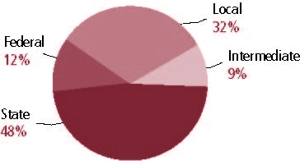

Student Demographics
Public school enrollment
(CCD)

 | 1993-94 | 2001-02
Pre-K | 483 | 497
K-8 | 115,509 | 101,612
9-12 | 46,111 | 49,151
Total (K-12) | 161,620 | 150,763

Race/ethnicity (CCD)

 | 1993-94 | 2001-02
American Indian/Alaskan Natives | 10% | 11%
Asian/Pacific Islander | 1 | 1
Black | * | 1
Hispanic | 1 | 2
White | 88 | 86
Other | - | -

Students with disabilities | 1993-94 | 2001-02
(OSEP) | 10% | 11%

Students with limited | 1993-94 | 2000-01
English proficiency | 5% | 5%
(ED/NCBE)

Migratory students | 1993-94 | 2001-02
(OME) | 1% | 2%

All schools by percent of students eligible to participate in the Free and Reduced-Price Lunch Program† (CCD, 2001-02)
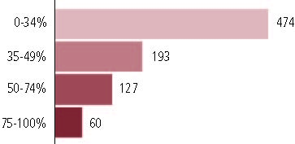

†16 schools did not report.

Statewide Accountability Information

(Collected from states, January 2002 for 2001-02 school year.)

Statewide Goal for Schools on State Assessment
School accreditation process; State assessment system participation.

Expected School Improvement on Assessment
Under development.

Title I Adequate Yearly Progress (AYP) for Schools
Average score on reading and math above 41st percentile for two consecutive years.

Title I 2001-02

(ED Consolidated Report, 2001-02)

 | Schoolwide  Programs | Targeted Assistance | Total
Number of schools | 121 | 515 | 636
Number of schools | 19% | 28% | 100%
Schools meeting AYP Goal | 93 | 500 | 593
Schools meeting AYP Goal | 16% | 84% | 93%
Schools identified for Improvement | 28 | 15 | 43
Schools identified for Improvement | 65% | 35% | 7%

Title I Allocation | $30,980,926
(Includes Basic, Concentration, and LEA grants, Capital Expenditures, Even Start, Migrant Education, and Neglected and Delinquent, ED, 2000-2001)

NAEP State Results
 | Grade 4 | Grade 8

Reading, 2003
Proficient level and above | 35% | 37%
Basic level and above | 69 | 82

Math, 2003
Proficient level and above | 31% | 35%
Basic level and above | 81 | 79

Montana

Student Achievement 2001-02

Assessment:
Iowa Tests of Basic Skills..

State Definition of Proficient:
See Apendix A.

Elementary School
Grade 4
Reading
Students in: | Novice | Nearing | Proficient | Advanced
All schools | 11% | 14% | 57% | 18%
Title I schools
Economically Disadvantaged Students | 18 | 20 | 53 | 9
Students with limited  English proficiency | 45 | 28 | 26 | *
Migratory students | 5 | 35 | 59 | 0
Students with Disabilities | 44 | 25 | 27 | 3

Grade 4
Mathematics
Students in: | Novice | Nearing | Proficient | Advanced
All schools | 14% | 15% | 57% | 14%
Title I schools
Economically Disadvantaged Students | 22 | 19 | 51 | 7
Students with limited  English proficiency | 45 | 25 | 28 | 2
Migratory students | 28 | 17 | 56 | 0
Students with Disabilities | 47 | 22 | 28 | 3

Student Achievement Trend
Reading 4th grade Meets or Exceeds Proficient
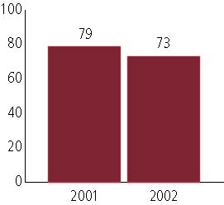

Middle School
Grade 8
Reading
Students in: | Novice | Nearing | Proficient | Advanced
All schools | 14% | 14% | 56% | 15%
Title I schools
Economically Disadvantaged Students | 25 | 20 | 48 | 7
Students with limited  English proficiency | 55 | 25 | 18 | 1
Migratory students | 33 | 17 | 33 | 17
Students with Disabilities | 55 | 22 | 22 | 2

Grade 8
Mathematics
Students in: | Novice | Nearing | Proficient | Advanced
All schools | 17% | 15% | 54% | 14%
Title I schools
Economically Disadvantaged Students | 30 | 20 | 43 | 7
Students with limited  English proficiency | 57 | 20 | 20 | 2
Migratory students | 17 | 17 | 56 | 11
Students with Disabilities | 57 | 24 | 18 | 1

Student Achievement Trend
Mathematics 8th grade Meets or Exceeds Proficient
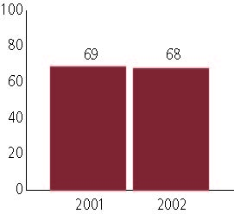

High School
Grade 11
Reading
Students in: | Novice | Nearing | Proficient | Advanced
All schools | 9% | 13% | 57% | 21%
Title I schools
Economically Disadvantaged Students | 21 | 18 | 49 | 12
Students with limited  English proficiency | 39 | 28 | 29 | 3
Migratory students | 20 | 25 | 45 | 10
Students with Disabilities | 47 | 25 | 25 | 2

Grade 11
Mathematics
Students in: | Novice | Nearing | Proficient | Advanced
All schools | 12% | 13% | 58% | 17%
Title I schools
Economically Disadvantaged Students | 23 | 18 | 50 | 8
Students with limited  English proficiency | 43 | 22 | 30 | 5
Migratory students | 23 | 5 | 50 | 20
Students with Disabilities | 55 | 22 | 21 | 1

High School Indicators | 1993-94 | 2000-01
High school dropout rate (CCD, event) | n/a% | 4%
 | 1994-95 | 2000-01
Postsecondary enrollment  (NCES, High school grads enrolled in college) | 54% | 54%

