Iowa
http://www.iowa.gov/educate/

School and Teacher Demographics

Per pupil expenditures | $6,930
(CCD, 2000-01)

Number of Districts | 374
(CCD, 2001-02)

Number of Charter Schools | 0
(CCD, 2001-02)

Number of Public Schools
(CCD)

 | 1993-94 | 2001-02
Elementary | 861 | 811
Middle | 289 | 295
High | 357 | 363
Combined | 21 | 38
Total | 1,528 | 1,507

Number of FTE Teachers
(CCD)

 | 1993-94 | 2001-02
Elementary | 14,649 | 16,436
Middle | 6,521 | 7,349
High | 10,389 | 11,399
Combined | 529 | 773
Total | 32,088 | 35,957

Percentage of teachers with a major in the main subject taught, grades 7-12 (SASS)

 | 1994 | 2000
English | 80% | 70%
Math | 74 | 73
Science | 86 | 89
Social Studies | 81 | 80

Sources of Funding
District Average
(CCD, 2000-01)
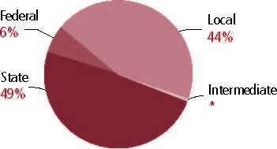

Student Demographics
Public school enrollment
(CCD)

 | 1993-94 | 2001-02
Pre-K | 5,430 | 5,714
K-8 | 333,743 | 321,553
9-12 | 142,601 | 153,856
Total (K-12) | 476,344 | 475,409

Race/ethnicity (CCD)

 | 1993-94 | 2001-02
American Indian/Alaskan Natives | * | 1%
Asian/Pacific Islander | 2% | 2
Black | 3 | 4
Hispanic | 2 | 4
White | 93 | 90
Other | - | -

Students with disabilities | 1993-94 | 2001-02
(OSEP) | 11% | 13%

Students with limited | 1993-94 | 2000-01
English proficiency | 1% | 2%
(ED/NCBE)

Migratory students | 1993-94 | 2001-02
(OME) | * | 2%
All schools by percent of students eligible to participate in the Free and Reduced-Price Lunch Program (CCD, 2001-02)
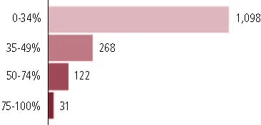

Statewide Accountability Information

(Collected from states, January 2002 for 2001-02 school year.)

Statewide Goal for Schools on State Assessment
Goals established locally.

Expected School Improvement on Assessment
Districts set targets.

Title I Adequate Yearly Progress (AYP) for Schools
Same for all schools.

Title I 2001-02

(ED Consolidated Report, 2001-02)

 | Schoolwide  Programs | Targeted Assistance | Total
Number of schools | 136 | 629 | 765
Number of schools | 18% | 28% | 100%
Schools meeting AYP Goal | 124 | 615 | 739
Schools meeting AYP Goal | 17% | 83% | 97%
Schools identified for Improvement | 12 | 14 | 26
Schools identified for Improvement | 46% | 54% | 3%

Title I Allocation | $59,828,475
(Includes Basic, Concentration, and LEA grants, Capital Expenditures, Even Start, Migrant Education, and Neglected and Delinquent, ED, 2000-2001)

NAEP State Results
 | Grade 4 | Grade 8

Reading, 2003
Proficient level and above | 35% | 36%
Basic level and above | 71 | 80

Math, 2003
Proficient level and above | 35% | 33%
Basic level and above | 83 | 76

Iowa

Student Achievement 2001-02

Assessment:
Iowa Basic Skills Test.

State Definition of Proficient:
See Appendix A.

Elementary School
Grade 4
Reading
Students in: | Partially Proficient | Proficient/ Advanced
All schools | 31% | 69%
Title I schools
Economically Disadvantaged Students | 48 | 52
Students with limited  English proficiency | 62 | 38
Migratory students | 68 | 32
Students with Disabilities | 72 | 29

Grade 4
Mathematics
Students in: | Partially Proficient | Proficient/ Advanced
All schools | 28% | 72%
Title I schools
Economically Disadvantaged Students | 44 | 56
Students with limited  English proficiency | 54 | 46
Migratory students | 60 | 40
Students with Disabilities | 63 | 37

Student Achievement Trend
Reading 4th grade meets or exceeds Proficient
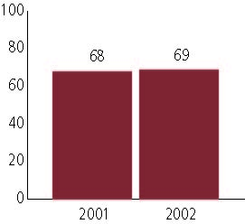

Middle School
Grade 8
Reading
Students in: | Partially Proficient | Proficient/ Advanced
All schools | 31% | 69%
Title I schools
Economically Disadvantaged Students | 51 | 49
Students with limited  English proficiency | 62 | 38
Migratory students | 73 | 27
Students with Disabilities | 75 | 25

Grade 8
Mathematics
Students in: | Partially Proficient | Proficient/ Advanced
All schools | 27% | 73%
Title I schools
Economically Disadvantaged Students | 48 | 52
Students with limited  English proficiency | 59 | 42
Migratory students | 67 | 33
Students with Disabilities | 73 | 27

Student Achievement Trend
Mathematics 8th grade meets or exceeds Proficient
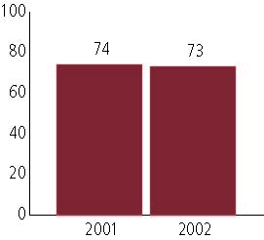

High School
Grade 11
Reading
Students in: | Partially Proficient | Proficient/ Advanced
All schools | 23% | 77%
Title I schools
Economically Disadvantaged Students | 39 | 61
Students with limited  English proficiency | 67 | 33
Migratory students | 67 | 33
Students with Disabilities | 72 | 28

Grade 11
Mathematics
Students in: | Partially Proficient | Proficient/ Advanced
All schools | 19% | 81%
Title I schools
Economically Disadvantaged Students | 34 | 66
Students with limited  English proficiency | 53 | 48
Migratory students | 56 | 45
Students with Disabilities | 61 | 39

High School Indicators | 1993-94 | 2000-01
High school dropout rate (CCD, event) | 3% | 3%
 | 1994-95 | 2000-01
Postsecondary enrollment  (NCES, High school grads enrolled in college) | 64% | 65%

