Illinois
http://www.isbe.state.il.us

School and Teacher Demographics

Per pupil expenditures | $7,643
(CCD, 2000-01)

Number of Districts | 895
(CCD, 2001-02)

Number of Charter Schools | 23
(CCD, 2001-02)

Number of Public Schools
(CCD)

 | 1993-94 | 2001-02
Elementary | 2,616 | 2,634
Middle | 707 | 729
High | 641 | 756
Combined | 27 | 135
Total | 3,991 | 4,254

Number of FTE Teachers
(CCD)

 | 1993-94 | 2001-02
Elementary | 56,172 | 65,509
Middle | 17,322 | 21,600
High | 29,424 | 35,560
Combined | 956 | 2,113
Total | 103,874 | 124,782

Percentage of teachers with a major in the main subject taught, grades 7-12 (SASS)

 | 1994 | 2000
English | 89% | 70%
Math | 82 | 65
Science | 77 | 93
Social Studies | 80 | 90

Sources of Funding
District Average
(CCD, 2000-01)
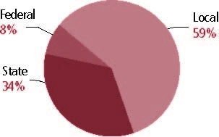

Student Demographics
Public school enrollment
(CCD)

 | 1993-94 | 2001-02
Pre-K | 42,359 | 57,550
K-8 | 1,259,394 | 1,423,829
9-12 | 503,024 | 585,396
Total (K-12) | 1,762,418 | 2,009,225

Race/ethnicity (CCD)

 | 1993-94 | 2001-02
American Indian/Alaskan Natives | * | *
Asian/Pacific Islander | 3% | 3%
Black | 21 | 21
Hispanic | 11 | 16
White | 65 | 59
Other | - | -

Students with disabilities | 1993-94 | 2001-02
(OSEP) | 11% | 12%

Students with limited | 1993-94 | 2000-01
English proficiency | 5% | 7%
(ED/NCBE)

Migratory students | 1993-94 | 2001-02
(OME) | * | *
All schools by percent of students eligible to participate in the Free and Reduced-Price Lunch Program (CCD, 2001-02)
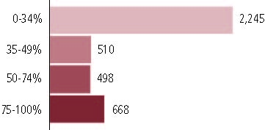

†371 schools did not report.

Statewide Accountability Information

(Collected from states, January 2002 for 2001-02 school year.)

Statewide Goal for Schools on State Assessment
All student scores above the 50th percentile level for a school composite score.

Expected School Improvement on Assessment
Gains to meet 50th percentile in five years; currently working on changing the definition to meet the AYP requirements of NCLB.

Title I Adequate Yearly Progress (AYP) for Schools
Annual gain to 90 percent proficient by 2007.

Title I 2001-02

(ED Consolidated Report, 2001-02)

 | Schoolwide  Programs | Targeted Assistance | Total
Number of schools | 984 | 1,424 | 2,408
Number of schools | 41% | 28% | 100%
Schools meeting AYP Goal | 326 | 1,267 | 1,593
Schools meeting AYP Goal | 20% | 80% | 66%
Schools identified for Improvement | 484 | 22 | 506
Schools identified for Improvement | 96% | 4% | 21%

Title I Allocation | $380,502,220
(Includes Basic, Concentration, and LEA grants, Capital Expenditures, Even Start, Migrant Education, and Neglected and Delinquent, ED, 2000-2001)

NAEP State Results
 | Grade 4 | Grade 8

Reading, 2003
Proficient level and above | 31% | 34%
Basic level and above | 61 | 76

Math, 2003
Proficient level and above | 33% | 29%
Basic level and above | 74 | 66

Illinois

Student Achievement 2001-02

Assessment:
Illinois Standards Achievement Test.

State Definition of Proficient:
Meets Standards.

Elementary School
Grade 3
Reading
Students in: | Academic Warning | Below Standards | Meets Standards | Exceeds Standards
All schools | 7% | 31% | 44% | 19%
Title I schools | 8 | 35 | 42 | 15
Economically Disadvantaged Students | 13 | 47 | 34 | 6
Students with limited  English proficiency | 16 | 47 | 32 | 6
Migratory students | 10 | 29 | 39 | 22
Students with Disabilities | 21 | 47 | 26 | 6

Grade 3
Math
Students in: | Academic Warning | Below Standards | Meets Standards | Exceeds Standards
All schools | 7% | 19% | 44% | 30%
Title I schools | 9 | 22 | 44 | 25
Economically Disadvantaged Students | 15 | 31 | 42 | 12
Students with limited  English proficiency | 12 | 28 | 45 | 15
Migratory students | 7 | 18 | 37 | 39
Students with Disabilities | 19 | 29 | 39 | 13

Student Achievement Trend
Reading 3rd grade meets or exceeds Proficient
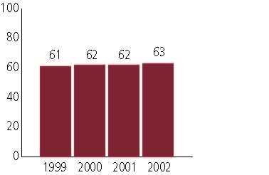

Middle School
Grade 8
Reading
Students in: | Academic Warning | Below Standards | Meets Standards | Exceeds Standards
All schools | 1% | 31% | 58% | 10%
Title I schools | 1 | 33 | 49 | 17
Economically Disadvantaged Students | 2 | 48 | 47 | 3
Students with limited  English proficiency | 4 | 72 | 24 | 1
Migratory students | 0 | 57 | 36 | 7
Students with Disabilities | 6 | 68 | 25 | 1

Grade 8
Math
Students in: | Academic Warning | Below Standards | Meets Standards | Exceeds Standards
All schools | 7% | 40% | 37% | 15%
Title I schools | 5 | 47 | 41 | 7
Economically Disadvantaged Students | 13 | 58 | 25 | 4
Students with limited  English proficiency | 19 | 62 | 15 | 4
Migratory students | 9 | 54 | 32 | 5
Students with Disabilities | 32 | 54 | 12 | 2

Student Achievement Trend
Mathematics 8th grade meets or exceeds Proficient
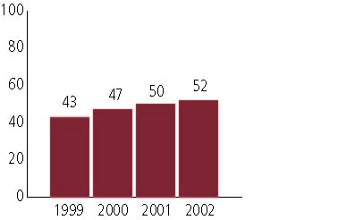

High School
Grade 11
Reading
Students in: | Academic Warning | Below Standards | Meets Standards | Exceeds Standards
All schools | 8% | 34% | 45% | 13%
Title I schools | 10 | 38 | 41 | 11
Economically Disadvantaged Students | 17 | 51 | 30 | 3
Students with limited  English proficiency | 17 | 47 | 31 | 4
Migratory students | 33 | 43 | 21 | 3
Students with Disabilities | 36 | 45 | 16 | 3

Grade 11
Mathematics
Students in: | Academic Warning | Below Standards | Meets Standards | Exceeds Standards
All schools | 10% | 36% | 45% | 8%
Title I schools | 14 | 40 | 39 | 7
Economically Disadvantaged Students | 24 | 53 | 23 | 1
Students with limited  English proficiency | 17 | 47 | 31 | 4
Migratory students | 25 | 46 | 21 | 0
Students with Disabilities | 42 | 43 | 14 | 1

High School Indicators | 1993-94 | 2000-01
High school dropout rate (CCD, event) | 7% | 6%
 | 1994-95 | 2000-01
Postsecondary enrollment  (NCES, High school grads enrolled in college) | 64% | 60%

