GENERAL SERVICES ADMINISTRATION Washington, DC 20405 February 11, 2008
FEDERAL MANAGEMENT REGULATION
Amendment 2008-02
TO: Heads of Federal agencies
SUBJECT: FMR Case 2007-102-5; Delegated Leasing Authority, RealProperty Policies Update
- Purpose. This document includes pages that reflect amendmentsto Part 102-72 of the Federal Management Regulation (FMR).
- Background. The Government Accountability Office and theGeneral Services Administration Office of Inspector General havereported that some Federal agencies using the delegated leasingauthority issued to Federal agencies on September 25, 1996, arenot following properly the instructions specified as a conditionfor use of the leasing delegation. To address the concerns raised by these audits, to facilitate compliance with allapplicable laws and regulations governing the acquisition of realproperty leasehold interests, and to minimize risk to the FederalBuildings Fund, GSA will no longer authorize General Purposeleasing delegations for space acquisitions in excess of 19,999rentable square feet.
- Effective date. This rule was published in the Federal Register at 73 FR 2166 and became effective on January 14, 2008.
- Explanation of changes. Part 102-72 is amended to limit General Purpose leasing delegations for space acquisitions up toa maximum of 19,999 rentable square feet.

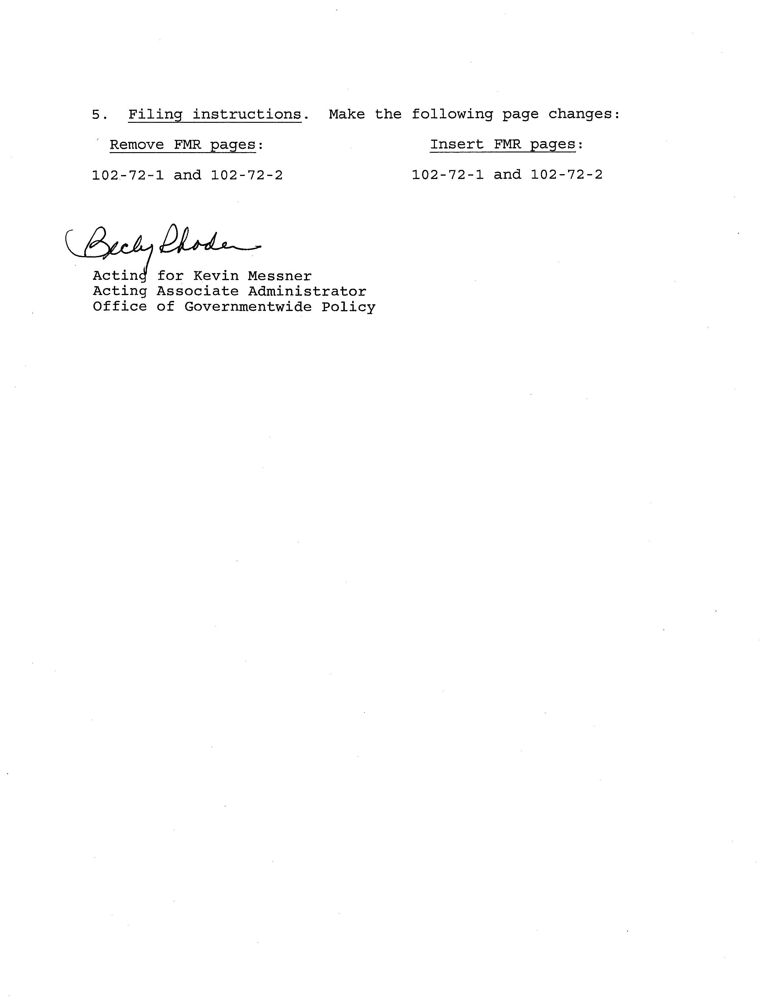
AMENDMENT 2008–02 JANUARY 14, 2008
PART 102-72—DELEGATION OF AUTHORITY §102-72.45
PART 102-72—DELEGATION OF AUTHORITY
Subpart A—General Provisions
§102-72.5—What is the scope of this part?
The real property policies contained in this part apply to Federal agencies, including GSA’s Public Buildings Service (PBS), operating under, or subject to, the authorities of the Administrator of General Services.
§102-72.10—What basic policy governs delegation of authority to Federal agencies?
The Administrator of General Services may delegate and may authorize successive redelegations of the real property authority vested in the Administrator to any Federal agency.
Subpart B—Delegation of Authority
§102-72.15—What criteria must a delegation meet?
Delegations must be in the Government’s best interest, which means that GSA must evaluate such factors as whether a delegation would becost effective for the Government inthe delivery of space.
§102-72.20—Are there limitations on this delegation of authority?
Federal agencies must exercise delegated real property authority and functions according to the parameters described in each delegation of authority document, and Federal agencies may only exercise the authority of the Administrator that is specifically provided within the delegation of authority document.
§102-72.25—What are the different types of delegations of authority?
The basic types of GSA Delegations of Authority are—
(a) Delegation of Leasing Authority;
- (b) Delegation of Real Property Management and Operation Authority;
- (c) Delegation of Individual Repair and Alteration Project Authority;
- (d) Delegation of Lease Management Authority (Contracting Office Representative Authority);
  - (e) Delegation of Administrative Contracting Officer (ACO) Authority;
  - (f) Delegation of Real Property Disposal Authority;
  - (g) Security Delegation of Authority; and
  - (h) Utility Services Delegation of Authority.

§102-72.30—What are the different types of delegations related to real estate leasing?
Delegations related to real estate leasing include the following:
- (a) Categorical space delegations and agency special purpose space delegations (see §102-73.140 of this title).
- (b) The Administrator of General Services has issued a standing delegation of authority (under a program known as “Can’t Beat GSA Leasing”) to the heads of all Federal agencies to accomplish all functions relating to leasing of up to 19,999 rentable square feet of general purpose space for terms of up to 20 years and below prospectus level requirements, regardless of geographic location. This delegation includes some conditions Federal agencies must meet when conducting the procurement themselves, such as training in lease contracting and reporting data to GSA.
- (c) An ACO delegation, in addition to lease management authority, provides Federal agencies with limited contracting officer authority to perform such duties as paying and withholding lessor rent and modifying lease provisions that do not change the lease term length or the amount of space under lease.

§102-72.35—What are the requirements for obtaining an ACO delegation from GSA?
When Federal agencies do not exercise the delegation of authority for general purpose space mentioned in §102-72.30(b) of this part, GSA may consider granting an ACO delegation when Federal agencies—
- (a) Occupy at least 90 percent of the building’s GSA-controlled space, or Federal agencies have the written concurrence of 100 percent of rent-paying occupants covered under the lease; and
- (b) Have the technical capability to perform the leasing function.

§102-72.40—What are facility management delegations?
Facility management delegations give Executive agencies authority to operate and manage buildings day to day, to perform individual repair and alteration projects, and manage real property leases.
§102-72.45—What are the different types of delegations related to facility management?
The principal types of delegations involved in the management of facilities are—
- (a) Real property management and operation authority;
- (b) Individual repair and alteration project authority; and

(c) Lease management authority (contracting officer representative authority).
102-72-1
AMENDMENT 2005–03 NOVEMBER 8, 2005
§102-72.50 FEDERAL MANAGEMENT REGULATION
§102-72.50—What are Executive agencies’ responsibilities under a delegation of real property management and operation authority from GSA?
With this delegation, Executive agencies have the authority to operate and manage buildings day to day. Delegated functions may include building operations, maintenance, recurring repairs, minor alterations, historic preservation, concessions, and energy management of specified buildings subject to the conditions in the delegation document.
§102-72.55—What are the requirements for obtaining a delegation of real property management and operation authority from GSA?
An Executive agency may be delegated real property management and operation authority when it—
- (a) Occupies at least 90 percent of the space in the Government-controlled facility, or has the concurrence of 100 percent of the rent-paying occupants to perform these functions; and
- (b) Demonstrates that it can perform the delegated real property management and operation responsibilities.

§102-72.60—What are Executive agencies’ responsibilities under a delegation of individual repair and alteration project authority from GSA?
With this delegation of authority, Executive agencies have the responsibility to perform individual repair and alterations projects. Executive agencies are delegated repair and alterations authority for reimbursable space alteration projects up to the simplified acquisition threshold, as specified in the GSA Customer Guide to Real Property.
§102-72.65—What are the requirements for obtaining a delegation of individual repair and alteration project authority from GSA?
Executive agencies may be delegated repair and alterations authority for other individual alteration projects when they demonstrate the ability to perform the delegated repair and alterations responsibilities and when such a delegation promotes efficiency and economy.
§102-72.70—What are Executive agencies’ responsibilities under a delegation of lease management authority (contracting officer representative authority) from GSA?
When an Executive agency does not exercise the delegation of authority mentioned in §102-72.30(b) to lease general purpose space itself, it may be delegated, upon request, lease management authority to manage the administration of one or more lease contracts awarded by GSA.
§102-72.75—What are the requirements for obtaining a
delegation of lease management authority (contracting
officer representative authority) from GSA?
An Executive agency may be delegated lease management authority when it—
- (a) Occupies at least 90 percent of the building’s GSA-controlled space or has the written concurrence of 100 percent of rent-paying occupants covered under the lease to perform this function; and
- (b) Demonstrates the ability to perform the delegated lease management responsibilities.

§102-72.80—What are Executive agencies’
responsibilities under a disposal of real property
delegation of authority from GSA?
With this delegation, Executive agencies have the authority to utilize and dispose of excess or surplus real and related personal property and to grant approvals and make determinations, subject to the conditions in the delegation document.
§102-72.85—What are the requirements for obtaining a
disposal of real property delegation of authority from
GSA?
While disposal delegations to Executive agencies are infrequent, GSA may delegate authority to them based on situations involving certain low-value properties and when they can demonstrate that they have the technical expertise to perform the disposition functions. GSA may grant special delegations of authority to Executive agencies for the utilization and disposal of certain real property through the procedures set forth in part 102-75, subpart F of this chapter.
§102-72.90—What are Executive agencies’
responsibilities under a security delegation of authority
from GSA?
Law enforcement and related security functions were transferred to the Department of Homeland Security upon its establishment in 2002. The Homeland Security Act authorizes the Secretary of Homeland Security, in consultation with the Administrator of General Services, to issue regulations necessary for the protection and administration of property owned or occupied by the Federal Government and persons on the property. Notwithstanding the foregoing, GSA retained all powers, functions and authorities necessary for the operation, maintenance, and protection of buildings and grounds owned and occupied by the Federal Government and under the jurisdiction, custody, or control of GSA.
§102-72.95—What are the requirements for obtaining a security delegation of authority from GSA?
An Executive agency may request a security delegation from GSA by submitting a written request with the detailed basis for the requested delegation to the Assistant Regional
102-72-2

