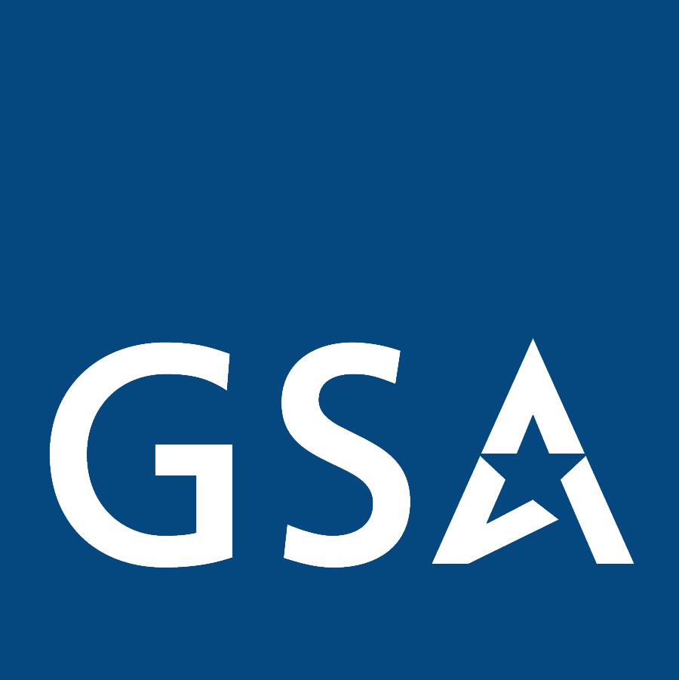 GSA Federal Acquisition Service

NOTICE CONCERNING:

Vendor Information Session
Emergency Bus Evacuation Services

On March 14, 2008, the General Services Administration (GSA) will host a vendor information session to discuss supplemental requirements to Schedule 48’s Ground Passenger Transportation services (Special Item Number (SIN) 411-1) to support the Federal Emergency Management Agency’s (FEMA) emergency bus evacuation requirements. GSA is seeking bus operators who can provide evacuation services in support of national or natural disasters. Interested vendors shall have capabilities to provide nationwide or regional bus evacuation services.

Along with Ground Passenger Transportation services, interested parties must also be prepared to offer transportation consulting services (SIN 411-3) to support both operational planning of their response to a specific evacuation and to assist federal, state, and local emergency planners in developing preparedness plans. With respect to preparedness planning, interested parties would play a supporting role and would not be asked to lead such efforts. Emergency bus evacuation and transportation consulting services are solicited through GSA’s Schedule 48 for Transportation, Delivery & Relocation Solutions (TDRS).

Representatives from FEMA and GSA will be in attendance to discuss the requirements. In the morning session, FEMA representatives will specifically outline their agency’s overall emergency bus evacuation strategy so that potential Schedule 48 contractors can see how services awarded under SINs 411-1 and 411-3 fit into the overall agency’s strategy.

The information session will include a “How To Prepare a Quality TDRS Offer” presentation in the afternoon. Following the formal “How To” presentation, there will be time allotted for questions and one-on-one sessions.

The GSA anticipates refreshing the TDRS Schedule with a supplemental Statement of Work (SOW) to SIN 411-1 that addresses some of the unique components associated with emergency bus evacuations. Please bring a copy of the refreshed solicitation (FBGT GG 050001 B) including the supplemental SOW, with you.

The vendor information session will be held:

When: March 14, 2008 from 8:30 a.m. to 3:30 p.m

Where: 2200 Crystal Drive
Room L1303
Arlington, VA 22202
(Directions are on the following page)

Registration: All interested attendees must register on-line at www.gsa.gov/events.

Questions: Please email onthego@gsa.gov with subject line “FEMA Bus Evacuation Services.”

The Agenda follows:

8:30 to 8:40: Welcome & Opening Remarks

8:40 to 10:00: Overview of FEMA’s Overall Strategy for Bus Evacuation

10:00 to 11:00: Questions & Answers on Overall Strategy

11:00 to 11:45: FEMA Proposed Approach to Motor Coach Evacuation Planning &
Operational Support Contract (MCEP&OS)

11:45 to 12:30: Questions & Answers on MCEP&OS

12:30 to 1:30: Lunch

1:30 to 3:30: How To Prepare a Quality GSA Schedule 48 Offer

Directions
FAS headquarters are in the Crystal City neighborhood of Arlington, VA. The Crystal Plaza 4 building is located at 2200 Crystal Drive. The following directions are provided from the subway (Metro), I-395 S from Washington, DC, and three DC area airports.
Metro:
Take the blue (towards Franconia) or yellow (towards Huntington) line train to the Crystal City Metro Station. Exit Metro to street level, turn left, and walk east on 18th Street to Crystal Drive. Turn right on Crystal Drive and proceed to 2200 Crystal Drive.
From Washington, DC and I-395 S:
Take I-395 S to US-1 South, exit right on the 15th Street ramp. Make a left at the traffic signal at the bottom of the ramp (crosses under Route 1) and proceed to Crystal Drive. Make a right onto Crystal Drive and proceed to 2200 Crystal Drive which is located on the right. Garage and meter parking are available.
From Ronald Reagan Washington National Airport:
Take the ramp to Return to Airport/(US-1)/Crystal City. Continue on Abingdon Drive toward Crystal City (US-1)/Remote Parking (I-66) General Aviation. Bear right at VA-233. Turn right onto the Crystal Drive ramp and turn right at Crystal Drive. Proceed to 2200 Crystal Drive. Garage and meter parking are available.
From Washington Dulles International Airport:
Head east from Aviation Drive. Turn left into the Dulles Airport Access Road entry ramp. Continue on VA-267E and then I-66 E. Take VA-110 S exit 75 to Pentagon/Alexandria. Continue on Jefferson Davis Hwy and turn left at 23rd Street S. Turn left at Crystal Drive and proceed to 2200 Crystal Drive. Garage and meter parking are available.
Note: Both lanes of I-66 are reserved for HOV-2 eastbound/inbound during the morning (6:30 to 9:00 am) and westbound/outbound in the evening (4:00-6:30 pm). However, motorists traveling to and from Dulles International Airport to go to the airport or to pick someone up at the airport are permitted to use I-66 inside the Beltway (I-495) during HOV hours. Motorists traveling to or from Dulles International Airport are not exempt from HOV restrictions on I-66 outside the Beltway (I-495). You are not permitted to use I-66 during HOV hours if you are going to the airport to eat, get coffee, etc.
From Baltimore-Washington International Airport:
Travel southeast to I-195 W toward airport exit. Take the MD-295 S exit 2B to Washington. Merge into US-50 W and continue on New York Ave. NE. Continue on New York Ave. NW and turn left at I-395 S. Take the US-1 exit 8C to Pentagon City/Crystal City/Alexandria. Continue on Jefferson Davis Hwy. Turn left at 23rd Street S. Turn left at Crystal Drive. Proceed to 2200 Crystal Drive. Garage and meter parking are available.

