GSA Public Buildings Service


IOLP:
Inventory of
Owned and Leased
Properties
Version 2.33

User Guide

Table of Contents

Introduction 3
View Property Information 3
Search for Properties 4
Search for Hot Properties 7
Add and Modify Hot Properties 9
Reports 14
Leased Space Report 15
Owned Space Report 17
All Buildings Report 18
Index 21

Introduction

When acquiring government lease space we have no control over space in the occupied leased buildings.

Overview | With the General Services Administration (GSA) Inventory of Owned and Leased Properties (IOLP), employees inside the GSA as well as the public can view expiring lease/occupancy information for over 8,000 Public Buildings Service (PBS) leases and 1,500 government owned buildings.  Visitors to the site can do the following:  - View expiring lease/occupancy information by state or district.  - Search for a range of vacant leased/owned square feet and/or lease expiration dates.  - View vacant properties owned by GSA that are available for immediate occupancy.  IOLP data is updated daily from the central database.

View Property Information

Overview | You can view information about each property owned by the government. Not all properties will have all the information available.  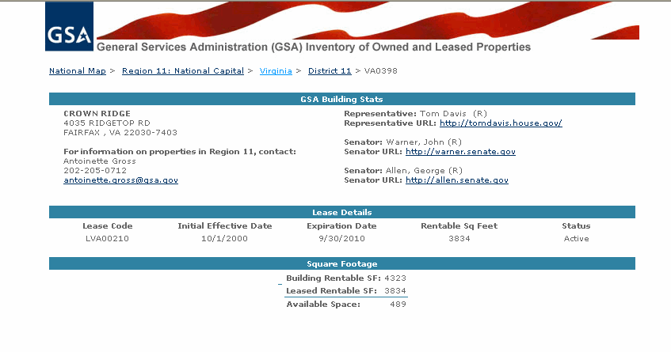  - Property Information Screen  Note: The square footage lists the space available to rent at that property.

Search for Properties

Search for a Property | Visitors to the IOLP site can search for government owned and leased properties by using a variety of criteria.  To search for a property:  - From the home page, do one of the following:  - Click the state on the map (1).  - Select the state from the drop-down menu (2).  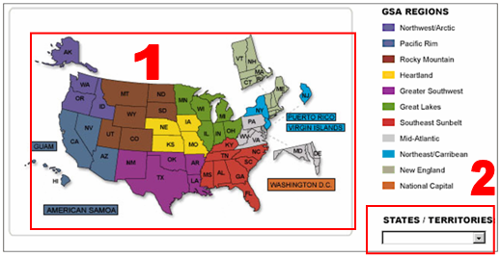  - IOLP Home Page  Result: You are at the state search screen for that state.
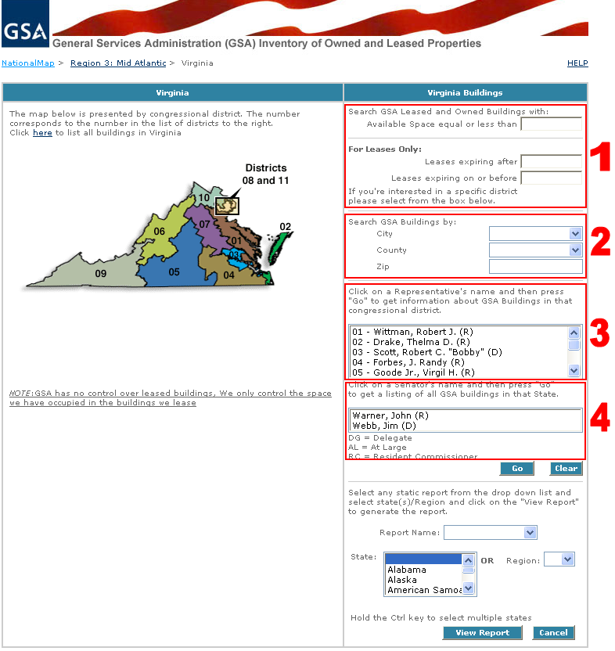
- State Search Screen
A user can search for a property within that state according to four different criteria:
- Square footage or lease expiration date
- City
- Congressional District
- Statewide by Senator.
Note: Users can click Go without using the search criteria which would display all the leased/owned buildings in that State.

Search For a Property in  a State | Note: The numbers in parentheses (#) refer to the different search criteria in the above graphic  Search by square footage available or lease expiration date (1):  - At the top right of the state search screen enter one of the following in the appropriate box:  - Approximate square footage. IOLP will search for all properties with that square footage or less available.  - Date by. The date when the lease will have expired.  - Click Go.  Result: IOLP displays a list of properties that fit the search criteria.  Search by city, county, or ZIP code (2):  - At the state search screen, enter the city, county or ZIP code in the appropriate box. Click Go.  Result: IOLP displays the GSA properties in that city, county, or ZIP code.  Search by Congressional district (3):  - At the state search screen, select a representative from to the list to get information about GSA buildings in that Congressional district.  - Click Go.  Result: IOLP displays a list of GSA properties in that Congressional district.  Search by Senator (4):  - At the state search screen, select a Senator from to the list to get information about GSA buildings in that state.  - Click Go.  Result: IOLP displays a list of GSA properties in that state.  - Click a property to view more information.  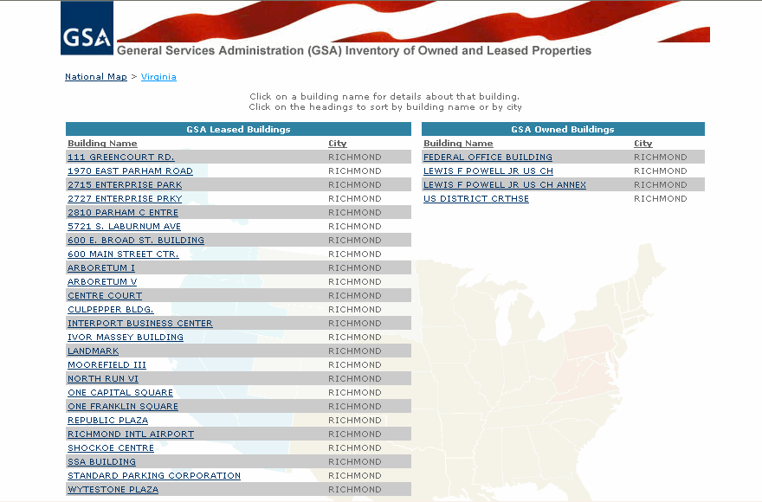  - Search Results List  Note: Click the header of a column to sort the results by that category.

Search for Hot Properties

Definition:  Hot Property | A hot property is a vacant property owned by GSA that is available for immediate occupancy.
Search for  Hot Properties | A user can view the properties owned by GSA that are available immediately for occupancy.  To search for hot properties:  - From the home page, click the Owned Hot Properties link.  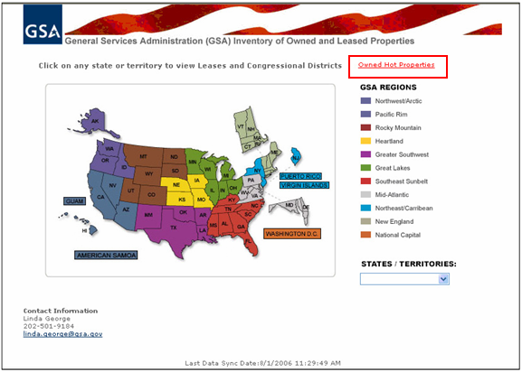  - IOLP Home Page  Result: IOLP displays a list of GSA hot properties.  - Click a property from the list to view the building information.  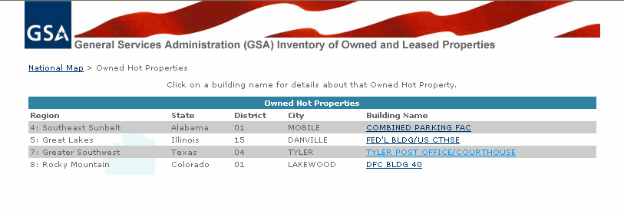  - List of Hot Properties  Result: The hot property building information appears.  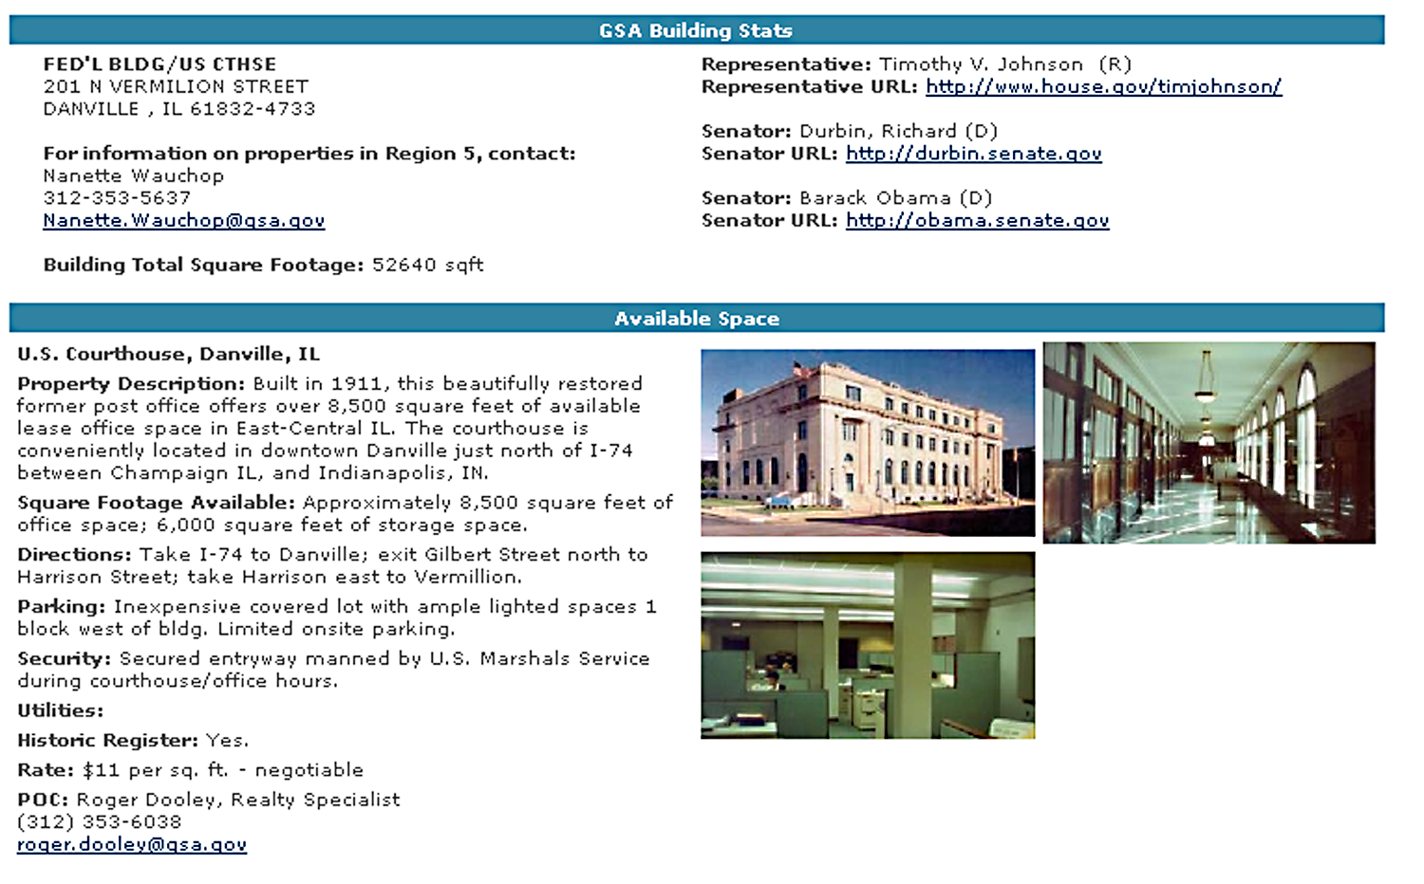  - Hot Property Information  To add or modify Hot Properties, Please contact the IOLP Administrator.

Add and Modify Hot Properties

Add a New Hot Property | Administrators of the IOLP site may add and modify hot properties. Once added, the property will appear in the list of hot properties linked from the home page of IOLP.  To add a hot property:  - From the Congressional Districts page (Administrators initial page), select the Owned Hot Properties Link.  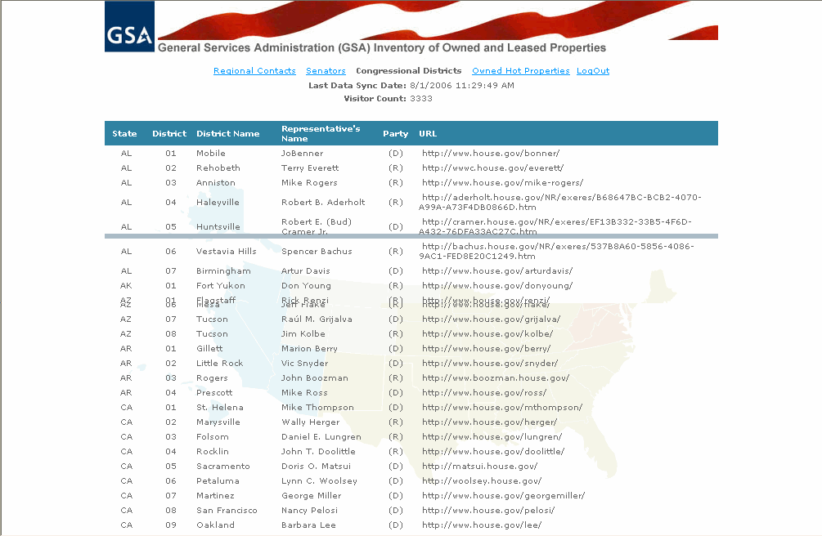  - Congressional District Screen  Result: The hot property listing appears.  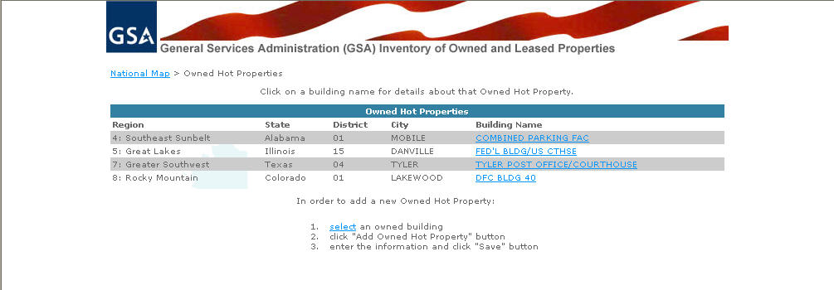  - List of Hot Properties (Administrator’s View)  - From the hot property listing screen, follow the procedures listed at the bottom. Click the select link.  Note: Click the Search for a Property procedure to find an owned building  Result: IOLP displays a list of GSA properties in that state.  - Click a GSA owned property to Add it to the hot properties list  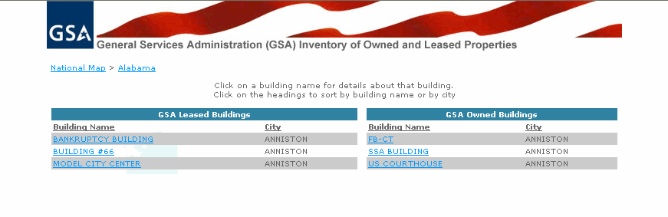  - List of GSA Properties within a selected State  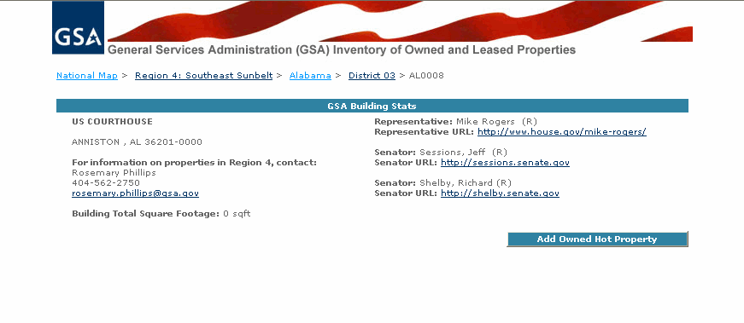  - Property Information Screen  - Click the Add Owned Hot Property button.  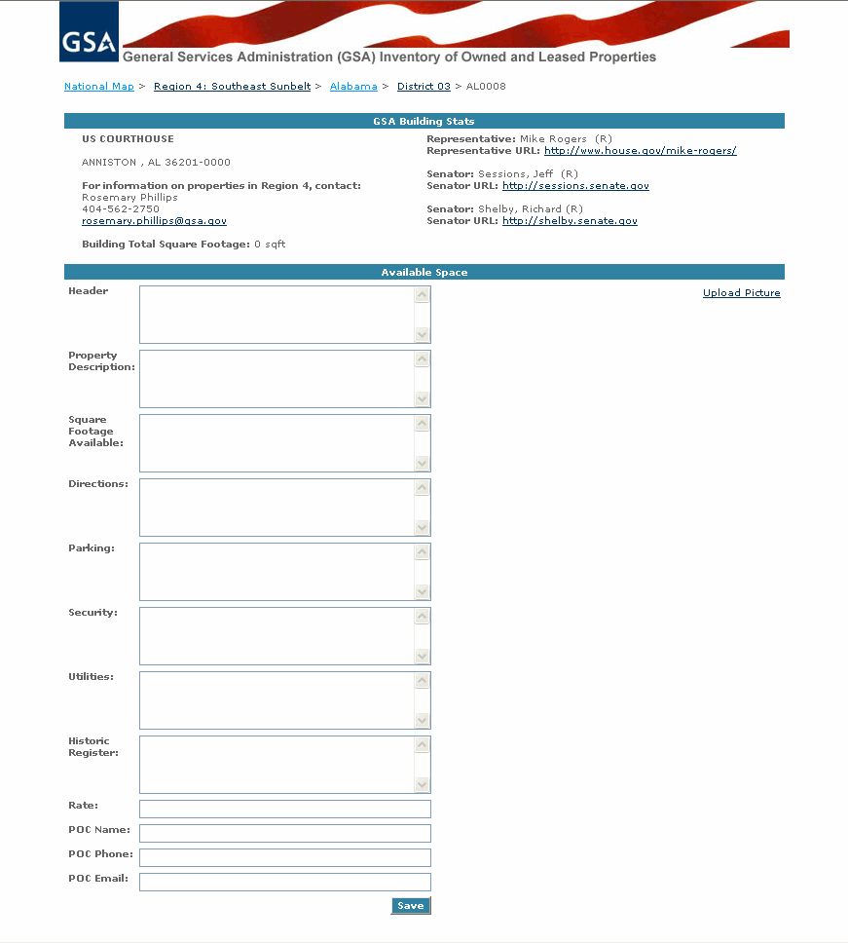  - Hot Property Information Screen  - . Type the appropriate information in the text boxes when the information is as complete as possible, click Save.  Note: POC refers to the person of contact for the building.  Result: The property will appear on the Owned Hot Properties list.

Modify a Hot Property | Once added, a property will appear in the list of hot properties linked from the home page of IOLP.  To modify hot property information:  - From the Congressional Districts page (Administrators initial page), click the Owned Hot Properties Link.  - Congressional District Screen  Result: The hot property list appears.  - List of Hot Properties (Administrator’s View)  - From the hot property list screen, click on the Building Name for the hot property you would like to modify.  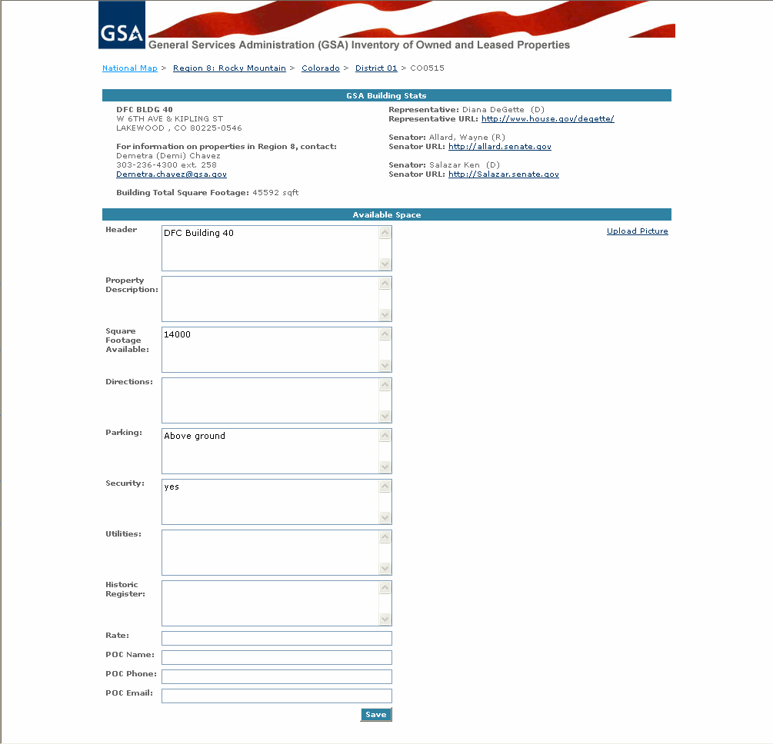  - Hot Properties Information Screen  - When you are an Administrator, the hot property information screen is editable. Edit the information, and then click Save.

Reports

Reports General Information | IOLP provides three static reports:  - Leased Space (displays all active leases)  - Owned Space (displays all active buildings)  - All Buildings (displays all active leases and buildings)  All three reports have the following selection criteria:  - Report Name  - State  Users may create any of the three reports based on the specific selection criteria.  Once the reports are created, they may be exported to Excel for further analysis.
Select a  Report | - From the home page, do one of the following:  - Click the state on the map (1).  - Select the state from the drop-down menu (2).  - IOLP Home Page

Leased Space Report

Create Leased  Space Report | To create Leased Space Report:  - Choose report name. See report general information.  - From the Search screen, click the Report Name drop down button.  Select the Leased Space report.  - Select the desired State/Region.  - Click on the View Report button  The Cancel button can be used if the user wishes to change the selection criteria.  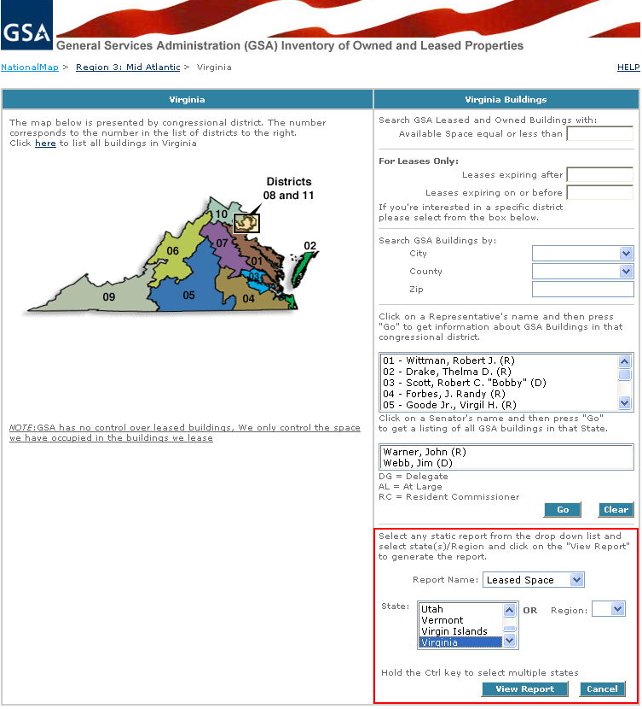  - Report Selection Criteria Screen  - Select the required selection criteria from the drop down list.  Note: To select multiple states hold the Ctrl key. You can not select both State and Region.  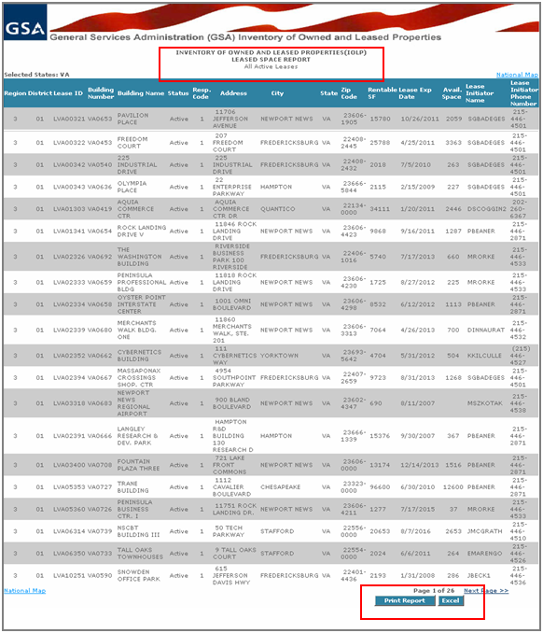  - Leased Space Report Screen  Result: The system will generate Leased Space report screen.  - Click on the Print button to print report  - Click on the Excel button to export report into Excel.  Note: To print the report in the right format set your Page Settings as shown below  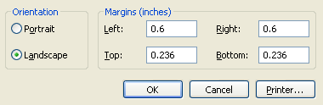

Owned Space Report

Create Owned  Space Report | To create Owned Space Report:  - Choose report name.  See report general information.  - From the Search screen, click the Report Name drop down button.  Select the Owned Space report.  - Select the desired State.  - Click on the View Report button  The Cancel button can be used if the user wishes to change the selection criteria.  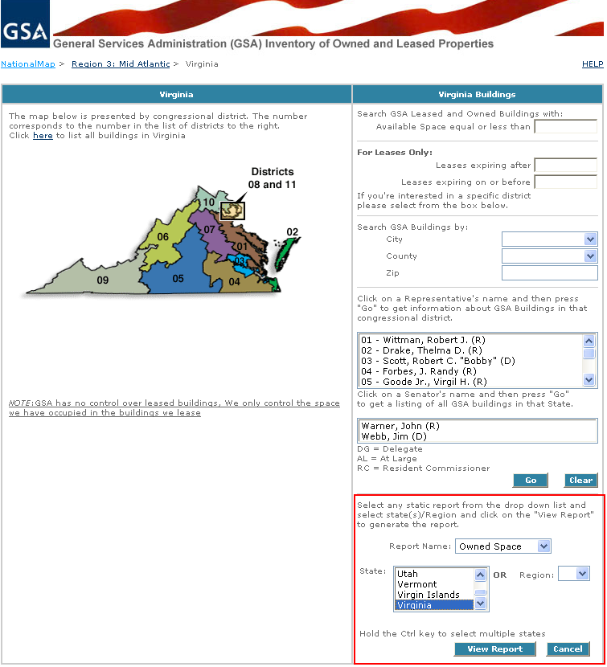  - Report Selection Criteria Screen  - Select the required selection criteria from the drop down list.  Note: To select multiple states hold the Ctrl key. You can not select both State and Region.  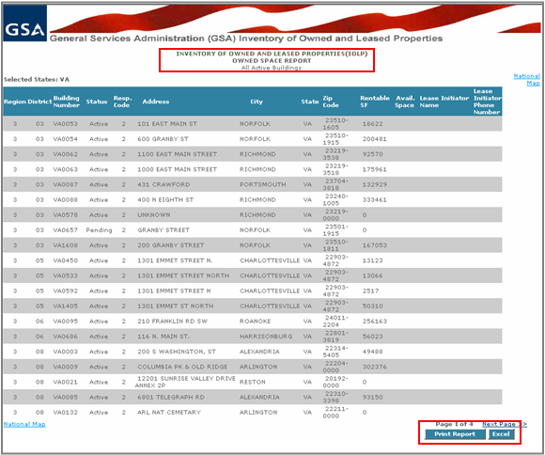  - Owned Space Report Screen  Result: The system will generate Owned Space report screen.  - Click on the Print button to print report  - Click on the Excel button to export report into Excel.  Note: To print the report in the right format set your Page Settings as shown below

All Buildings Report

Create  All Buildings Report | To create All Buildings Report:  - Choose report name. See report general information.  - From the Search screen, click the Report Name drop down button.  Select the All Buildings report.  - Select the desired State.  - Click on the View Report button  The Cancel button can be used if the user wishes to change the selection criteria.  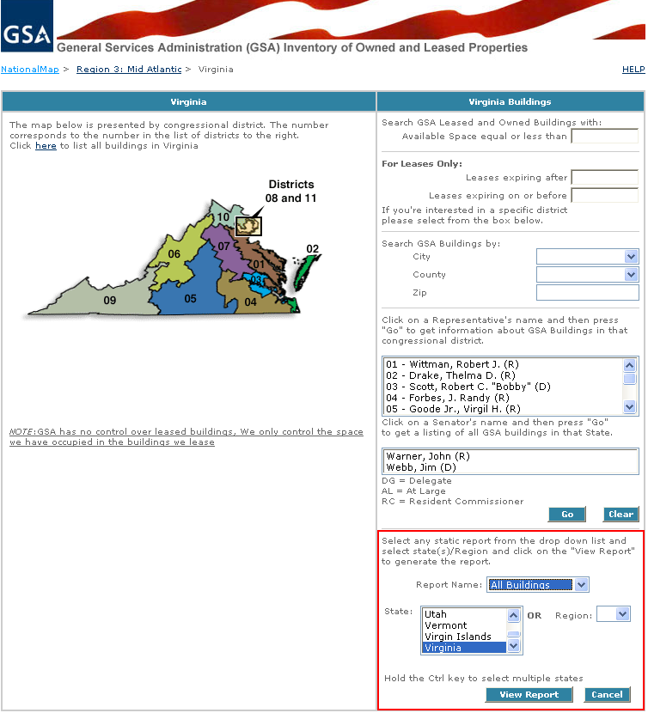  - Report Selection Criteria Screen  - Select the required selection criteria from the drop down list.  Note: To select multiple states hold the Ctrl key. You can not select both State and Region.  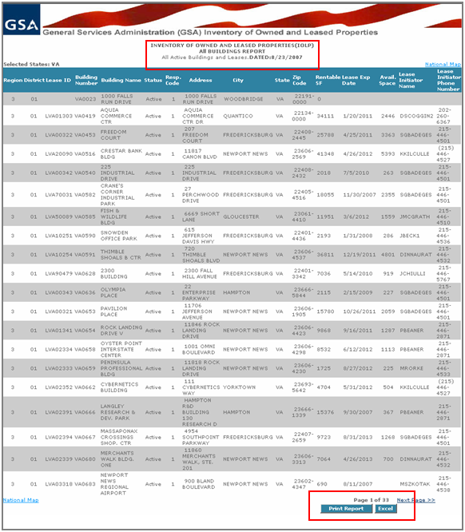  - All Buildings Report Screen  Result: The system will generate All Buildings report screen.  - Click on the Print button to print report  - Click on the Excel button to export report into Excel.  Note: To print the report in the right format set your Page Settings as shown below

Index

C
city 5
congressional district 5
county 5
H
hot property 7
add 9, 15, 17, 19
modify 11
search for 7
I
IOLP
overview 3
updated 3
P
property
search for 4–3
view information 3
R
Report General Information 14
Reports
All Buildings Report 19
Leased Space Report 15
Owned Space Reports 17
S
search 4
senator 5
square footage 3, 5
state map 4, 14
V
vacant property 7
Z
ZIP code 5

For additional explanation of owned and leased space, you should refer to the Official PBS Business Assignment Guide.

