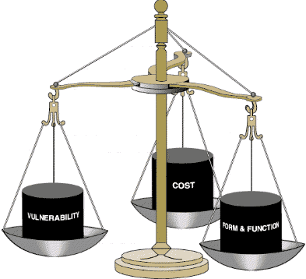
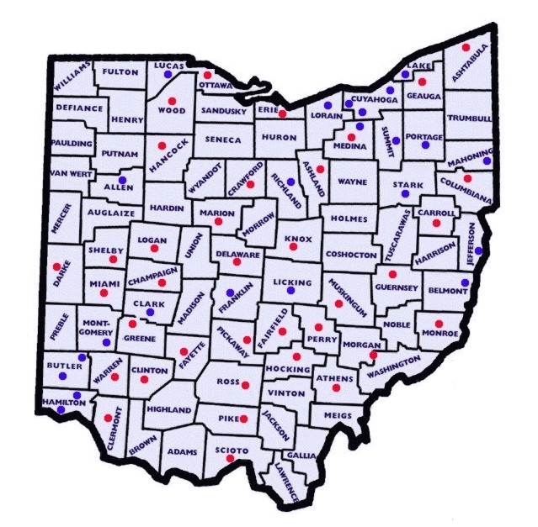

GUIDE TO CONDUCTING CRITICAL ASSET PROTECTION SELF-ASSESSMENTS

1.0 Introduction

Enhancing security is one of the highest priorities for the nation’s public transportation network, including heavy, light and commuter rail operations and bus and paratransit service. Transit operators recognize that they have a proactive role in protecting their passengers, employees, and ability to sustain service. Yet this recognition can be a source of frustration. Today’s threats are diffuse, multifaceted, and dynamic. Security concerns for public transportation systems now include a daunting array of challenges.

2.0 Purpose

This Guide to Conducting Critical Asset Protection Self-Assessments has been prepared to provide transit managers, operations and maintenance personnel, as well as transit police and security managers, with a set of tools to plan and conduct security assessments to address heightened threat levels. These assessments will promote proactive measures:

- To determine the agency’s level of security and emergency preparedness
- To identify counter-measures that can be implemented to improve security performance and emergency response capabilities
- To emphasize a management approach to security that promotes consistency, assures thoroughness, and enhances the integrity of the transit operation.

This Guide has been designed to support security improvements at all transit agencies, whatever their size, mode of service, or operational requirements. Since many smaller bus and paratransit operations do not have dedicated security functions, this Guide provides a process and easy-to-use forms and worksheets that can be applied by non-security personnel. However, when evaluating both security and emergency response capabilities, ODOT strongly encourages these smaller agencies to partner with their local public safety organizations.

3.0 Scope

Security is provided in the transit environment to protect critical assets from intentional harm resulting from well-defined threats. Critical assets must be secure to guarantee the well-being of passengers, employees, contractors, emergency responders, and the general public. As indicated in Figure 1, security needs for critical asset protection are identified using a variety of approaches. These needs must prioritized based on vulnerability and translated into action items for implementation. Executive management retains ultimate accountability for the security of the service provided.

4.0 Objective
Transit agencies of all sizes must reexamine the threats to their systems and determine if adequate resources are being applied to meet the growing threat of terrorism and the agency’s policies towards:

- Mitigation
- Preparedness
- Response
- Recovery

Figure 2 presents the activities performed in the transit environment to deter, detect, and respond to unauthorized and illegal activity, and to mitigate its impacts through effective emergency response. When integrated into a coordinated program directed by a focused assessment of need and vulnerability, these activities protect critical assets from acts of aggression and extreme violence.

Figure 1: Addressing Heightened Threat Levels – Scope of Transit Agency Response

5.0 Requirements

The Critical Asset Protection Self Assessment requires a team-based approach to implement a process that identifies and prioritizes:

- Critical transit assets
- Site-specific threats
- Vulnerabilities resulting from a range of scenarios pairing identified assets and threats
- Critical security systems and procedures
- Critical emergency preparedness capabilities
- Counter-measures to improve both security performance and emergency response

Results of this activity should be documented in a formal Security Assessment Report presented to transit management for immediate action and implementation.

Figure 2: Integrated Program for Critical Asset Protection

6.0 Process

Figure 3 presents the approach required to conduct the Critical Asset Protection Self-Assessment. This Figure highlights interactions with transit management, and also identifies essential activities. The Assessment process has the following steps:

- Management Authorization
- Team Selection and Initial Meeting
- Action Plan
- Asset Inventory
- Critical Asset Identification
- Threat and Vulnerability Resolution Process
- Counter-measure Investigation and Emergency Response Assessment
- Security Assessment Report
- System Security Integration Activities

Each step is discussed below.

6.1 Management Authorization

Transit management, ultimately responsible for the agency’s safe and secure operation, should approve performance of the Security Self-Assessment. That approval should initiate formal planning for the Assessment.

6.2 Team Selection and Initial Meeting

The Assessment Team should include representatives from all of the disciplines and external organizations that play a role in ensuring the security and emergency preparedness of the transit system. Depending on the size, level of service, and resources of the transit agency, the Assessment Team may range in size from 3 to 15 members. Small transit properties are encouraged to include local law enforcement and other public safety personnel as part of the Assessment Team.

To prepare for the Security Assessment, the Team Members should conduct an initial meeting designed to hone the skills required for active investigation of agency vulnerability to acts of aggressions and extreme violence. During this first meeting, Team Members should brainstorm to identify threats to their operation. Upon completion of this activity, Team Members should construct one scenario – based on one of the most serious threats on the list. Team Members should “walk through” this scenario, constructing a chronology of what would likely happen if this event were to occur. The aim of this activity is not to predict the future accurately, but to allow the Assessment Team to explore and experience a range of possible situations -- detaching temporarily from reality and becoming part of the “plot” - thereby experiencing the same fear and anxiety that would be caused in response to the actual event. Scenario-based planning is an essential component of effective security management. Engaging in this activity will support the Assessment Team’s understanding of how the transit agency will manage heightened threat levels and strengthen the skills necessary to conduct the assessment.

Figure 3: Critical Asset Protection Self-Assessment Process

6.3 Action Plan

To promote optimum effectiveness, the Team is encouraged to document its approach in an Action Plan. This Plan should be straightforward, and provide the following information:

- Formal identification of Team Members (who will conduct the analysis)
- Definition of Assessment process (how the Assessment will proceed)
- Available information resources (to promote access to information and personnel)
- Authorization for the development and use of the Assessment Scenarios and Checklists (to document activity)
- Logistical support for the Assessment (to address scope, schedule, Team assignments and cost)
- Confidentiality restrictions (to ensure sensitive treatment of process and findings)
- Implementation of the results (to guarantee a meaningful outcome)

6.4 Asset Inventory

Establishing an inventory of transit agency assets is the first step in performing the Assessment. The identification and grouping of transit agency assets enables the creation of discrete geographical and situational components that can be ranked based on their criticality to transit operations, their attractiveness as targets for terrorism, and their vulnerability to the impacts of a successful terrorist attack.

For purposes of this Assessment, an asset is defined as any facility, equipment, or property owned by the public transportation system. A complete inventory should be prepared, organizing transit assets into categories (e.g., stations, support facilities, vehicles, etc.) and identifying all elements of the operation. The size of the operation will determine the number of asset categories, however, to support effective management of the Assessment, it is recommended that assets be grouped in no more than 20 categories. For example, for a small bus operation, spare part inventories, lubricants, light tools, and cleansers and paints could all be categorized under “Non-revenue Maintenance Facilities.”

6.5 Critical Asset Identification

Assets are “critical” when their loss either endangers human life or impacts the transit agency’s ability to maintain service. This step in the Assessment process enables Team Members to identify:

- What assets the transit agency must protect
- How these assets are valued – both to the transit agency and a potential adversary
- The impact if these assets are lost -- on passengers, employees, public safety organizations, the general public and the transit operation

All assets are not critical, and some assets are only critical under certain conditions. For example, a single bus can be classified as a critical asset – when its destruction results in the loss of life (e.g., bus bombings in Israel). However, loss of that same bus – if empty and parked at a change-over facility– would neither endanger human life nor significantly impact the agency’s operation. In this situation, therefore, the bus would not be classified as a “critical asset.”

To identify critical assets for the entire system, under the full range of operational conditions, a simple process called “asset criticality valuation” must be performed. This process helps transit management prioritize the allocation of limited resources on protecting the most vital elements of its operation for both revenue and non-revenue service, by time of day. Attachment 1 explains this process and provides sample evaluation tables for generic rail and bus asset categories.

6.6 Threat and Vulnerability Resolution Process

After the Assessment Team has identified the specific assets most critical to its mission to protect people and the agency’s ability to provide service, it must initiate a “threat and vulnerability resolution process” to identify and evaluate the vulnerabilities of these assets to specific threats, and to promote reasoned decision-making which balances risk against the cost of protective countermeasures and enhanced emergency preparedness. This process provides the Assessment Team with a useful tool to address the following:

- Identification and characterization of the threats to specific assets. What are the threats to the system? How can these threats be described and quantified in terms that support management decision-making activity?

- Identification and characterization of the vulnerability of specific assets. What vulnerabilities -- or weaknesses in the security posture of the asset -- exist that could be exploited? Can the transit operator make design or operational changes to reduce risk levels by altering the nature of the asset itself? Are there additional procedural, technology or equipment measures that would reduce vulnerability? Should special activities be performed to improve emergency preparedness as a result of the vulnerabilities of the asset?
Local law enforcement and state and federal agencies, as well as other transit agencies provide excellent resources for assistance with threat and vulnerability identification, preparation, and countermeasures.
Attachment 1 also provides guidance on conducting this process for the Critical Asset Protection Self-Assessment. Typically, threats to specific assets are investigated through the use of scenarios illustrating what could happen under current and enhanced levels of protection. To support this activity for the transit industry, Attachment 1 provides both a threat assessment for generic bus and rail operations, and a set of scenarios that comprise the terrorist threat confronting transit. Information is this Attachment, however, will need to be tailored by the Assessment Team for the specific transit operation. The end result of this activity will be preparation of Prioritized Vulnerability Report, which presents the most significant vulnerabilities for each category of critical asset. A sample report is also provided in Attachment 1.

6.7 Counter-measure and Emergency Response Assessment

Once key vulnerabilities have been identified and the Assessment Team has determined that its current protective measures may not be adequate, Team Members must turn their attention to the identification of countermeasures, costs and tradeoffs, and the evaluation of emergency preparedness. Attachment 3 provides information regarding the different countermeasures available to protect critical assets. This Attachment contains:

- A “Baseline Worksheet” to identify specific elements of each of the 5 security program activities identified in Figure 2 that may support security improvements for critical asset protection
- A general list of recommendations, organized by specific threat type to critical asset

In many cases, there is a point beyond which adding countermeasures will raise costs without appreciably enhancing the protection afforded. Attachment 4 provides information to support the evaluation of emergency response capabilities to address heightened threat levels. During this phase of activity, the Assessment Team should remain focused on specific action items and recommendations to be implemented, documenting findings and evaluations, and briefing top transit management throughout the process.

6.8 Security Assessment Report

This Report should be delivered to transit management at the completion of the Critical Asset Protection Self-Assessment. It should provide a record of activities conducted for the Assessment and the rationale for recommended improvements. It should contain the following sections:

Section 1: Critical Asset Protection Strategies: Policy and Philosophy
Section 2: List of Threats to Be Addressed
Section 3: Current Capabilities to Address Threats
Section 4: Current Vulnerabilities To Be Addressed
Section 5: Recommended Physical Security Improvements
Section 6: Recommended Emergency Preparedness Improvements
Section 7: Resources Required to Implement Improvements
Section 8: Proposed Schedule for Implementation

6.9 System Security Integration Activities

Through the Self-Assessment development process, security activities should be integrated into the transit agency’s existing System Security Program. This is particularly important for those activities that will require longer-term implementation and management.

Security Programs and Resources

More information can be obtained about available security resources by visiting the following websites:

http://www.tsi.dot.gov (Transportation Safety Institute)
http://policy.rutgers.edu/nti/ (National Transit Institute)


These guidelines are available for downloading on the FTA Office of Safety and Security Website (www.fta.dot.gov -- click on “safety and security”):

1998 | Transit Security Handbook
1998 | Critical Incident Management Guidelines
1997 | Emergency Preparedness for Transit Terrorism
1997 | Improving Transit Security
1996 | Perspectives on Transit Security:  Strategies for Success
1996 | Transit Security Procedures Guide
1994 | Transit System Security Program Planning Guide

