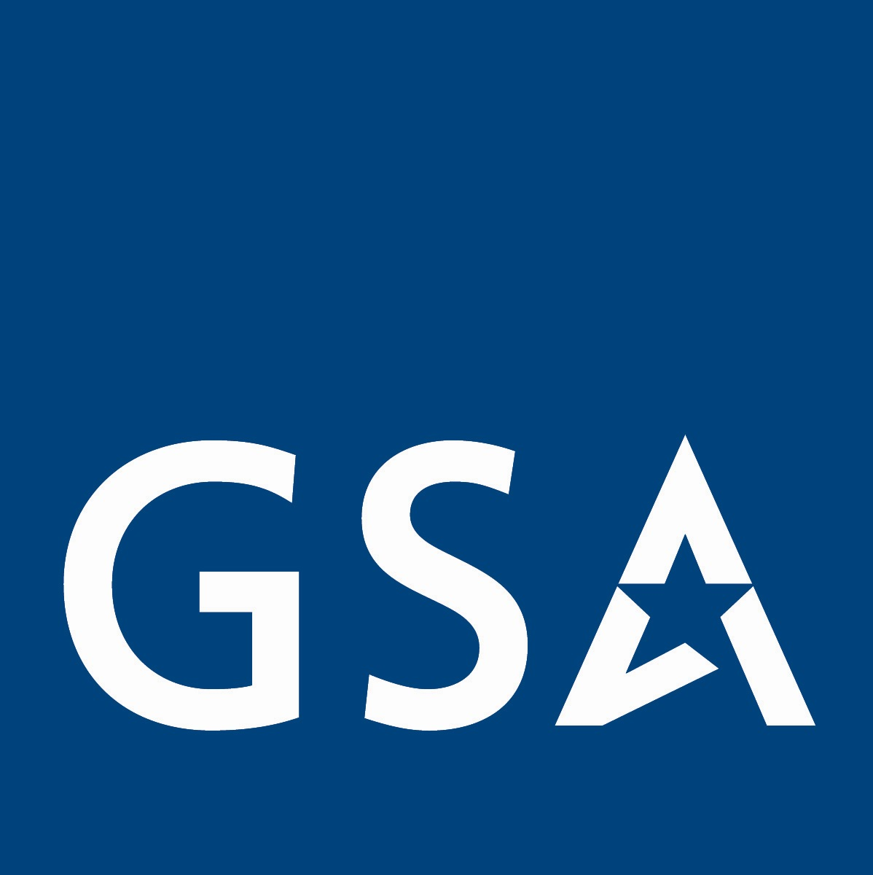
Management Services Center News You Can Use

April 2008 Volume 3, Number 3

In This Issue:  - GSA is too expensive?  - Government Information  - Women-Owned Small Businesses  - MSC Industry Days  - All Schedules will be refreshed soon  - Repair and Alterations added to Log World  - Past Articles for Review  - MSC Points of Contact  Do you need Government Information?  Here is a great place to start!  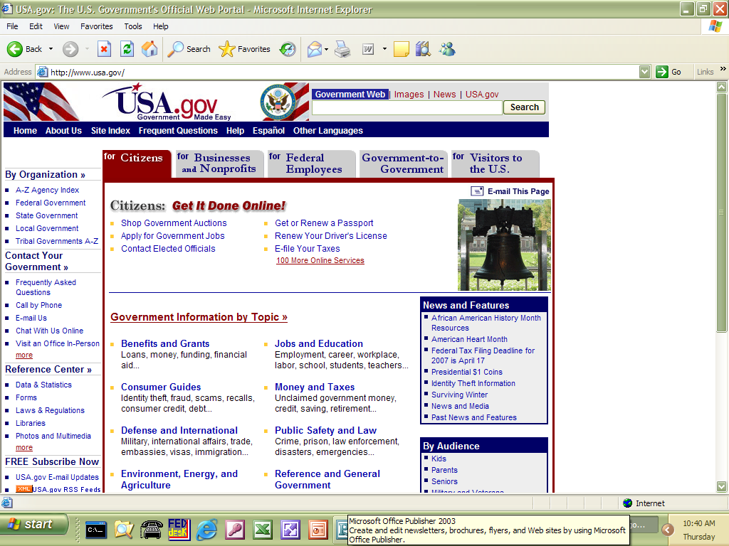  USA.gov is the website for access to government agencies. Some of the categories you will find are:  - Benefits and Grants  - Consumer Guides  - Defense and International  - Environment, Energy and Agriculture  - Family, Home and Community  - Health and Nutrition  - History and Arts  - Jobs and Education  - Money and Taxes  - Public Safety and Law  - Reference and General Government  - Science and Technology  - Voting and Elections  Users are encouraged to use the search engine for everything from taxes, passports, federal benefits and countless other topics from multiple federal, state, local, territorial and tribal government sources. This website used to be FirstGov.gov but is improved with greater search capacity.    Past Articles for Review  Past editions are available at the Management Services Center website: www.gsa.gov/mgmtservices  Here is a list of articles in past editions:  Oct 2006  Professional Engineering Services  MOBIS News – New Name for MOBIS  Vendor Support Center  GSA Expo 2006  Apr 2007  Why an Agency should use GSA Schedules!  Joint Services Environmental Management Conference & Exposition (JSEM)  Disaster Recovery Purchasing by State and Local Governments  GSA Organization Updates  Management Services Center Industry Day (Trip Report)  Next MSC Industry Day  Opportunities at GSA 2007 Expo  Hands-on Program Management Training  Jul 2007  Finding Federal Customers!  MSC Outreach to Federal Agencies  Invitation to the next MSC Industry Day  Prime-Subcontracting Arrangements May Lead to Loss of GSA Schedule Contract  GSA Organizational Update  Contingency Planning and MOBIS  Security Awareness  Reasons Federal Agencies Use GSA Multiple Award Schedules!  Jan 2008  Changes to LogWorld Contract  GSA Organizational Update  MOBIS News  MSC Industry Day  Some Ins and Outs of the Schedule Input Program (SIP)  Marketing Tips and Tricks    What is a Mass Mod?  The Government initiates Mass Mods when uniform changes to large numbers of Federal Supply Service Contracts are required. Examples include clause updates, Schedule changes and the addition of contract requirements. Mass Mods are identical for all recipients.  How does a contractor know a Mass Mod is available?  When a modification becomes available for contractor review, the Contractor point of contact is sent an email with a direct hyperlink to a portion of the FSS Vendor Support Center (VSC) website that contains the modification process. The email also contains a personal identification number (PIN) associated with the contract number and specific modification for security and verification purposes.    Points of Contact  Professional Engineering Services (PES)  Language Services  Tammy Lindsley  (253)931-7627  tam.lindsley@gsa.gov  MOBIS  Helen Jay  (253) 931-7063  helen.jay@gsa.gov  MOBIS  Debbie Gamble  (253) 931-7895  debbie.gamble@gsa.gov  Environmental Services  Carolyn DiCugno  (253) 931-7042  carolyn.dicugno@gsa.gov  LOGWORLD Services  Maureen Duckworth  (253) 931-7514  maureen.duckworth@gsa.gov  Consolidated  Maureen Duckworth  (253) 931-7514  maureen.duckworth@gsa.gov | GSA IS TOO EXPENSIVE?  As a contractor on GSA Schedules, you are challenged with meeting various obstacles and overcoming objections voiced by customer agencies as you try to see your services. At the same time you may find yourself in a situation where you are the first and only person who has talked directly with the client about using GSA schedules. In addition to our own Customer Service Directors we count on you to be our eyes and ears as you work to advocate for the use of schedules.  We hear quite frequently from our industry partners that customers are hesitant to use schedules because they feel GSA is too expensive. It’s important that when you hear that objection you know how to respond. The following are possible misconceptions that agencies may have and some guidance on how to address them:  - The agency does not understand that the .75% Industrial Funding Fee (IFF) is already included in your prices. They think that they need to add this fee to the price you quote. Make it very clear that there are no additional fees added to the advertised or quoted price for agencies who see “direct order/direct bill” use of schedule contracts.  - The agency thinks that GSA has to manage the procurement. They believe that all purchases made using schedules include a fee charged for “Assisted Services”. GSA does offer procurement assistance for a fee, but this level of service is optional and would need to be requested by the ordering activity (and proper procedures for approval would have to be obtained). It’s important to tell representatives of the ordering office that they can manage the procurement themselves and the only “fee” they would pay is the IFF which, of course, is already included in the prices you quote. The misunderstanding seems to be quite prevalent. It’s important that you know how to handle this objection, and that you refer the contact to the Management Services Center for further clarification if necessary. If the customer does, indeed, need “assisted services” you may refer them to the MSC and we will get them in contact with the appropriate office.  - A potential customer may look at published prices in GSA Advantage! or view contract prices on an advertised price list and think they are high. Many state that they can get better rates/prices on their own. Your response could be that the prices they see represent indefinite quantities, and indefinite delivery. GSA Schedule prices are negotiated with the intent of achieving the contractors’ “most favored customer” pricing/discounts under similar conditions. In order to ensure that they receive the best value at the lowest overall cost when using GSA Schedule contracts, agencies are encouraged and empowered to seek price reductions, not only for orders over the maximum order threshold, but also when circumstances warrant (see FAR 8.405-4). In addition, it’s important to point out the other requirements GSA had covered. Purchasing from GSA Schedule contracts offers the following advantages over procuring on the open market:  - GSA had determined prices under Schedule contracts to be fair and reasonable.  - Synopses are not required for Schedule purchases  - Schedule contracts have been awarded in compliance with all applicable laws and regulations.  - Administrative time is reduced.  - Schedule contracts offer a wide selection of state-of-the-art commercial supplies and services.  Did you know that in fiscal year 2007 over $35 billion worth of goods and services were sold to the government using GSA Schedules? $8.0 billion of that was from contracts managed by the MSC! Clearly, the work you do to market schedules is paying off. The Management Services Center looks forward to working with you in the future to continue these great efforts. Not only are we available on the phone or email, but there are many Customer Service Directors located throughout the United States, Japan, Korea, and Europe to assist agencies. If you have a potential client that you think needs to talk with someone at GSA, by all means, give us a call or send an email.  Women-Owned Small Business  The number of small businesses in the U.S. continues to grow faster each year and the number of small businesses owned by women is steadily increasing as well. Many women are rethinking their future in the overall job market. Many are opting to ditch the traditional office landscape and start their own business from home instead. But don’t be fooled, these women-owned businesses are serious competitors and they are making their voices heard all over the country. The want a “piece of the pie” and will not take “no” for an answer.  The Small Business Administration (SBA) heard their concerns and had proposed to increase opportunities for women-owned businesses in the future. Under a proposed rule, published in December 2007, contracting officers in and Federal agency can set aside contracts for Women Owned Small Businesses (WOSB) in agencies where “only small businesses owned or controlled by economically disadvantaged women would be eligible for these contracts. Each agency would have to conduct an appropriate analysis of its own procurement history to determine if there is sufficient evidence of relevant discrimination in that industry by the procuring agency before it can exclusively award a contract to a WOSB.  Small businesses makeup over half of the current contractors on all of the professional service schedule. And of these contractors, a number have reported an increase of sales of $500,000 and above. Sales reported in FY 07 showed a marked increase of 25% in sales by not only small women owned businesses, but disadvantaged women owned businesses and 8(a) women owned businesses. It is predicted that by 2012 this number will triple. Much of their business comes from repeat Federal customers who are very satisfied with the professionalism and expertise these woman owned businesses bring to the table. A successful past performance record is a favorable indicator that a Federal agency will reconsider the woman-owned business when awarding the next task order or request for quote (RFQ). Federal agencies tend to award contracts to familiar and dependable schedule contractors verses a company that is new or unfamiliar. Many women-owned businesses are repeat customers within the Federal arena, and they have enjoyed building a successful reputation in many Federal agencies such as DOE, DHS and DOJ.  To stay ahead of the game, here are 5 tips from some successful GSA schedule women-owned businesses:  - Know your schedule. If you are a MOBIS, Language, Environmental, IT etc. schedule, know what is required from that schedule. Re-read the clauses and provisions and understand the dimensions of your particular schedule. Pay attention to mass modifications and refresh editions. Contact your current contracting officer when there is a change to your contract.  - Spruce up your schedule. If it’s been a while since you looked at your schedule information on eLibrary and GSA Advantage!, then take a look. Remember, this information is your “face” to the Federal community. Keep you company information current! Submit updates through the Schedule Input Program (SIP) system, CCR, and SBA when necessary.  - Marketing strategy. Don’t wait for business opportunities to come to you. Use the phone book and contact the local Federal agencies in your area. Utilize the Federal Business Opportunities (FedBizOpps) competitors are within your geographical area. Propose Teaming Arrangements with like contractors and don’t be afraid to subcontract with large contractors.  - Be seen. Attend government conferences and training events, trade shows and Expos that bring contractors and government agencies together. When attending and event, make it a point to set up times to talk with representatives from Federal agencies. Ask to be put on their mailing list when they are planning for future take orders.  - Advertisements. Take advantage of the written word. Advertise within government publications and military newsletters. Submit articles in publications that cater to the Federal community. Be sure to indicate at the end of your article or advertisement the GSA logo. This will show that you are a current GSA government contractor.  The horizon looks very good for women-owned small businesses. If you are not a current GSA schedule contractor, consider the possibilities of getting on one of the many schedules. Go to www.gsa.gov/schedules and read all about the GSA schedules program.  Article by: Deborah Gamble  Business Management Specialist  MSC Industry Days!  There will be two MSC Industry Days this year. Here are the venues for the meetings:  Chicago, Illinois-June 4, 2008 at the Dirksen Federal Courthouse:  This will be a more abbreviated day; as we will not do breakouts into individual Schedules of contract/GSA contracting officer appointments at this meeting. The afternoon will be reserved for Small Business concerns.  There is only room for 50 attendees. Invitations were originally sent out to local firms but there are still a few openings available. Small businesses will be given priority to this event.  An agenda for the Chicago meeting will be distributed to all of our contractors at the end of April.  Registration for this event is at:  http://apps.fas.gsa.gov/conferences/Regform.cfm?EventID=1609&form.type=vendor&form.addresstype  Seattle, Washington-August 6, 2008 at the Seattle Federal Building  The format will be roughly the same as last year with a few improvements. The first half of the day will include individual contractor meetings with GSA Contracting Officers and then there will be general presentations with question periods. The afternoon will have 2 breakout sessions by Schedule (duplicative meetings so that you can go to 2 different Schedule meetings). This year there will be more rooms reserved for breakout sessions and contractor meetings.  An agenda for the Seattle meeting will be distributed to all of our contractors at the end of April.  Registration for this event is at:  http://apps.fss.gsa.gov/conferences/Regform.cfm?EventID=1614&form.type=vendor&form.addresstype  These meetings are solely for you, our current contractors. What subjects would you like to see addressed at the Industry Day? Your input is CRITICAL to a good meeting. Please email your ideas to Maureen.duckworth@gsa.gov no later then Friday May 2nd, 2008. If you have already sent ideas in the last MSC Industry Day critique, we will be using them for these meetings.  These meetings are free but you will be on your own for coffee, snacks and lunch.  All of our Schedules will be refreshed soon!  GSA is gearing up to standardize the Multiple Award Schedule (MAS) solicitations. A new software system is being used to produce the solicitations. The will all have the same format and will be using a main core of common clauses. The requirements for past performance identification will be uniform as well as the format for each solicitation. As you can imagine, this is a big deal for us at GSA and will have implications for all of you as well.  GSA is planning of refreshing 12 Schedules right away with the others to be done soon after. All of the MSC Schedules are in the first batch to be refreshed. The software that is used to publish the solicitations is undergoing beta-testing and is planned for deployment this month.  What does it mean for you? You will be getting a modification to your contract that will update all your clauses to the new list of clauses. Some Schedules will have new Specials Item Numbers (SINs) while, at a minimum, all Schedules will undergo a variety of small changes. These changes will all be identified in Part I of the new refresh.  It is important that you sign your modification and return it to us quickly. We also look forward to populating new SINs quickly. Each new SIN will not show up on e-Library or e-Buy until a company had been awarded that SIN.  Some of the changes coming up to multiple Schedules  PES Schedule 871 has a new SIN  Construction Management was always a part of the Professional Engineering Services (PES) Schedule 871 but the scope of the services required clarification. After researching the services that would be appropriate under the schedules program, it was decided to create a new Special Item Number (SIN) 871-7 Construction Management (CM) to clarify both the scope of services, as well as make it easier to find contractors who perform these services. Therefore some of the contractors, who previously offered CM under SIN 871-6, will be getting a Mass Modification Letter within the next month to add the new SIN 871-7. Below is brief overview of the intent and scope. For more details go to the PES website and look under the PES Document Library for the Construction Management Implementation Guide (Final) at www.gsa.gov/engineering  The new SIN was created for Construction Management, in order to better define its scope and to make it easier for an agency to find contractors capable of performing CM services. In order not to conflict with the FAR Part 36, this guide establishes what is meant by Construction Management and clarifies the role of the Construction Manager as well as what services are authorized under the schedule.  Construction Management (CM) – There are basically two types of Construction Management (CM) Services. One is the CM as an owner’s agent/consultant. In this role the CM does not take entrepreneurial risk for costs, timeliness, or quality of construction. Contractors deal directly with the owner. The second type is CMs that offer their services during both the design phase and also as the general contractor during the construction phase. The only type of services acceptable under this Schedule are those of a CM as an owners agent/consultant and comply the American Institute of Architects, the Associated General Contractors, and the National Society of Professional Engineers Standard Form of Agreements for Construction Management.  Customer agencies should utilize construction managers as its principal agent to advise on or manage the process over the project regardless of the project delivery method used. The Construction Manager assumes the position of professional adviser or extension of staff to the customer agency. The Construction Manager frequently helps the customer agency identify which delivery method is the best for the project. The construction management approach utilizes a firm (or team of firms) with construction, design and management expertise to temporarily expand the customer agency’s capabilities so that the customer agency can successfully accomplish its program or project. The Construction Manager also provides expert advice in support of the customer agency’s decisions in the implementation of the project.  Acquisition Management Support now on MOBIS Schedule 874  It took nearly a year to work through issues with Congress, but the MOBIS team finally obtained approval to create SIN 874-6 Acquisition Management Support. Because of the potential for abuse, the Management Services Center has created a word document entitled Special Ordering Instructions for MOBIS Acquisition Management Support and it can be found on the MOBIS web site at: www.gsa.gov/mobis Once there, look on the left side of the web page for the MOBIS Library link. The Guide can be found under the Acquisition Management Support Instructions.  NOTE: A Mass Modification is coming soon. For current SIN 874-6 holders, the modification will change your SIN description to the new one. If you want to add other labor categories to support the broader scope you will need to submit a modification to add labor categories. For Companies who do not currently hold SIN 874-6, but would like to add the service to your schedule contract, you will need to submit a modification to add the new SIN. Modification instructions are also on the MOBIS website in the MOBIS Library under the Modification Section.  Below are some key cautions, but be sure to read the complete instructions.  NOTICE REGARDING PROHIBITION OF INHERENTLY GOVERNMENTAL SERVICES UNDER MOBIS SIN 874-6  Some acquisition services are inherently governmental in nature and shall not be performed by contractors. Pursuant to FAR 7.503, the following federal procurement services are considered inherently governmental and thus are prohibited under MOBIS:  - Determining what supplies or services are to be acquired by the Government;  - Participating as a voting member on any source selection boards;  - Approving any contractual documents, to include documents defining requirements, incentive plans, and evaluation criteria;  - Awarding contracts;  - Administering contracts (including ordering changes in contract performance or contract quantities, taking action based on evaluations of contractor performance, and accepting or rejecting contractor products or services;  - Terminating contracts;  - Determining whether contract costs are reasonable, allocable, and allowable; and  - Performing as a voting member on performance evaluation boards  Pursuant to FAR 7.503, the following acquisition support services are generally not considered to be inherently governmental; however, they may approach being in that category due to the nature of the function, in the manner in which the contractor performs, or the manner in which the ordering agency administers contract performance. Thus, ordering activities should ensure that any of the services described below, if required, are structured, performed, and managed so as to not be considered inherently governmental:  - Services that involve or relate to the evaluation of another contractor’s performance;  - Services in support of contract management (such as where the contractor might influence official evaluations of other contractors);  - Services involving the technical evaluation of contract proposals;  - Services providing assistance in the development of statements of work;  - Services that permits or might permit contractors to gain access to confidential business information of other contractors; and  - Services requiring contractors to participate in any situation where it might be assumed that they are agency employees or representatives  Repair and Alterations Will be Added to Log World  Four GSA Schedules have been scheduled for the inclusion of Repair and Alterations as a support service. These three Schedules are:  874 V Logistics Worldwide (LogWorld)  03FAC Facilities Maintenance and Management  71 I Office Furniture  Xxxxx xxxxxxxxxxx  A Repair and Alteration (R&A) Special Item Number (SIN) will be added to each of these Schedules. The LogWorld SIN will be 874-597. Contractors will be able to add this SIN in support of other SINs that they have previously been awarded. New contractors will be eligible to apply for this SIN in support of other requested SINs in their offer. R&A services may only be utilized in support of a larger task within the Schedule scope.  The addition of R&A will allow a greater ability to manage a whole project under one Task Order and will increase the ease of use for our customers. Part III of the LogWorld solicitation (Refresh 5) includes all the clauses applicable to this R&A SIN.  The Public Building Service and Federal Acquisition Service have agreed to these guidelines in order to best support the management of public buildings in relation to R&A:  - Ancillary R&A services may only be ordered in conjunction with, or in support of, products or services ordered under another SIN associated with the given MAS schedule contract.  - Ancillary R&A services may only be ordered from the MAS contractor tasked with providing the underlying product or service under the given MAS schedule contract.  - Performance of R&A services may not be the primary purpose of the task order, but may, instead, be an integral part of the total solution offered.  - Ancillary R&A services performed under a MAS contract will not include Architect-Engineering (A&E) services, major or new construction of buildings, construction of roads, parking lots and other facilities, or complex R&A of entire facilities or significant portions of facilities.  - For federally-owned space managed by PBS,  - Approval of the PBS Building Manager must be received by the ordering activity before any ancillary R&A services may be ordered.  - A copy of the approval must be provided to the MAS contractor before or concurrent with the work order.  - A copy of the approval must be retained by both the ordering activity contracting officer and the MAS contractor performing the ancillary R&A services.  - The ordering activity must include written documentation in its contract file demonstrating the activity's authority to perform the ancillary R&A services to be ordered.  - Where the estimated value of the ancillary R&A work is less than $100,000, the ordering activity shall be presumed to possess authority to perform the work. In such an event, the ordering activity shall include in its contract file a written cost estimate of the R&A work required.  - Where the estimated value of the ancillary R&A work is greater than $100,000, the ordering activity shall provide to the MAS contractor written evidence of a delegation of authority from GSA for the activity to perform the R&A work required. The MAS contractor and the ordering activity shall be required to retain this documentation.  - An ordering activity may not utilize independent authority to perform R&A services with respect to work to be performed in PBS-owned space.  For federally-owned space outside the PBS inventory:  - Approval of the local building manager will be required where the ancillary R&A work is to be performed in a facility not under the custody or control of the ordering activity. A copy of the approval must be provided to the MAS contractor and retained by both the MAS contractor and the ordering activity.  - The ordering activity must include written documentation in its contract file demonstrating the activity's authority to perform the ancillary R&A services to be ordered.  Ancillary R&A SINs may not be used in connection with work to be performed in PBS controlled lease space.  FAS Industrial Operations Analysts (IOAs) will monitor ancillary R&A utilization as part of the scope reviews performed during routine contractor assistance visits.  Look for this coming SIN!  Do you want to read an article on a particular subject? Send your suggestions to staci.oetting@gsa.gov

