PKI for the Public: Business Case & Return on Investment (ROI) Analysis & Methodology

July 2002

TABLE OF CONTENTS

Executive Summary 5
Section 1. Introduction 9
1.1 Purpose 9
1.2 Scope 9
1.3 Document Layout 9
Section 2. Appropriate Role of PKI 10
2.1 Drivers for Trusted Transactions in Government 10
2.2 How PKI Supplies Trust 12
2.3 How PKI Compares with More Familiar PIN/Password Deployments 14
2.3.1 Security Services 14
2.3.2 Vulnerabilities 15
2.3.3 Cost 16
2.3.4 Interoperability 17
2.4 Acquisition Strategies for Federal PKI Solutions 17
2.4.1 In-sourcing 17
2.4.2 Outsourcing 18
2.4.3 Leveraging ACES as a PKI Solution 19
Section 3. Review of Existing Literature 21
3.1 How Commercial Sector is Using PKI 21
3.2 Business Case and Methodology Findings of Others 22
Section 4. PKI ROI Cost Methodologies 24
4.1 Business Case Analysis Process 24
4.2 Determining ROI 24
4.3 Cost Estimating Approach 25
4.3.1 Investment Costs 26
4.3.2 Operating Costs 28
4.3.3 Personnel Costs 30
Section 5. Apply ROI Methodologies to Four Archetypal Scenarios 32
5.1 SCENARIO 1 36
5.1.1 Scenario 1 Description 36
5.1.2 Scenario 1 Findings 36
5.1.3 Scenario 1 Assumptions 36
5.1.4 BASELINE Parameters for Scenario 1 36
5.1.5 Baseline Life Cycle Cost of Scenario 1 37
5.1.6 Build PKI Parameters for Scenario 1 38
5.1.7 Build PKI Life Cycle Cost of Scenario 1 39
5.1.8 ACES Parameters for Scenario 1 40
5.1.9 ACES Life Cycle Cost of Scenario 1 41
5.2 SCENARIO 2 42
5.2.1 Scenario 2 Description 42
5.2.2 Scenario 2 Findings 42
5.2.3 Scenario 2 Assumptions 42
5.2.4 BASELINE Parameters for Scenario 2 42
5.2.5 Baseline Life Cycle Cost of Scenario 2 43
5.2.6 Build PKI Parameters for Scenario 2 44
5.2.7 Build PKI Life Cycle Cost of Scenario 2 45
5.2.8 ACES Parameters for Scenario 2 46
5.2.9 ACES Life Cycle Cost of Scenario 2 47
5.3 SCENARIO 3 48
5.3.1 Scenario 3 Description 48
5.3.2 Scenario 3 Findings 48
5.3.3 Scenario 3 Assumptions 48
5.3.4 BASELINE Parameters for Scenario 3 48
5.3.5 Baseline Life Cycle Cost of Scenario 3 49
5.3.6 Build PKI Parameters for Scenario 3 50
5.3.7 Build PKI Life Cycle Cost of Scenario 3 51
5.3.8 ACES Parameters for Scenario 3 52
5.3.9 ACES Life Cycle Cost of Scenario 3 53
5.4 SCENARIO 4 54
5.4.1 Scenario 4 Description 54
5.4.2 Scenario 4 Findings 54
5.4.3 Scenario 4 Assumptions 54
5.4.4 BASELINE Parameters for Scenario 4 54
5.4.5 Baseline Life Cycle Cost of Scenario 4 55
5.4.6 Build PKI Parameters for Scenario 4 56
5.4.7 Build PKI Life Cycle Cost of Scenario 4 57
5.4.8 ACES Parameters for Scenario 4 58
5.4.9 ACES Life Cycle Cost of Scenario 4 59
5.5 Global Assumptions 60
5.6 Conclusion 61
Section 6. Conclusion 62
Appendix A: Literature Reviewed 63

TABLE OF FIGURES

Figure ES-1. Scenario Summary Table 6
Figure ES-2. ROI Scenarios: Five-Year Live Cycle Costs 7
Figure ES-3. ROI Findings 7
Figure ES-4. Operating Costs: Baseline vs. PKI Alternatives 7
Figure 2-1. Authentication & Encryption Using PKI 13
Figure 2-2. Comparison of PIN and PKI (Using ACES) 16
Figure 2-3. ACES Transaction Costs 20
Figure 4-1. Business Case Analysis 24
Figure 4-2. Cost Element Structure of Investment Cost 27
Figure 4-3. Cost Element Structure of Operating Cost 29
Figure 4-4. ACES Transaction Costs by Year 30
Figure 4-5. Personnel Cost Assumptions for Scenarios 3 & 4 30
Figure 4-6. Cost Element Structure of Personnel Cost 30
Figure 5-1. Scenario Summary Table 32
Figure 5-2. Findings of Scenarios 33
Figure 5-3. ROI Findings 33
Figure 5-4. Operating/Personnel Costs by Security Solution 34

Executive Summary
As a result of the Government Paperwork Elimination Act (GPEA) of 1998, Federal agencies are mandated to move key business-to-government (B2G) and citizen-to-government (C2G) processes online by October 2003. Further, agencies are being pressured to respond to e-Government priorities that focus on reducing the expense and difficulty of doing business with the government and on improving access to government services for citizens. Many of these current processes and services have requirements for signature(s), strong user authentication, and/or non-repudiation. And, while the use of public key technology has been widely recognized as the strongest means of satisfying these requirements, PKI has long been viewed as too difficult and too expensive to implement. Previous literature, which may discuss the cost/benefit or the potential cost savings of PKI, does so at a superficial level insufficient for agency decision makers to arrive at an informed and defensible business decision.

PKI for the Public is intended to serve as a guide for Federal government financial officers, budget analysts, program managers, and application owners who should be considering the acquisition of public key infrastructure (PKI) products and services to facilitate trusted transactions with their external business partners and/or citizen constituency. This guide compares and contrasts two different PKI acquisition strategies; in-sourcing wherein the agency builds, maintains, and manages its own PKI internally, and outsourcing, where the agency contracts out the entire PKI operation to a trusted third party (TTP) and manages only the (public-key-enabled) application internally. The TTP model used is the GSA-sponsored Access Certificates for Electronic Services (ACES) contract which was specifically established to serve government agencies in their interactions with businesses (B2G) and citizens (C2G). Each strategy may be viable and beneficial under the right circumstances and the decision as to which to pursue is ultimately a measured business decision. This guide is intended to help quantify that decision in terms of return on investment (ROI).

This guide not only addresses the migration of paper-based processes to PKI, but existing electronic processes as well. Many agencies have opted to deploy their applications using a personal identification number (PIN) and password based scheme only to find that: 1) Password databases present vulnerabilities to compromise that the organization must expend significant funds and resources to mitigate; and 2) passwords are labor intensive to manage and, subsequently, expensive to maintain. Further, PINs and passwords do not provide confidentiality, data/message integrity and non-repudiation features that may be required to adequately protect privacy and legally bind parties of a transaction. Two of the sample business case scenarios provided in this report demonstrate the application of ROI methodologies in the migration of PIN/password-based systems to PKI.

In addition, this guide:
- Characterizes the appropriate role of PKI for trusted electronic business to government (B2G) and citizen to government (C2G) transactions;
- Reviews existing literature on the business case and ROI for PKI;
- Develops business case and ROI methodologies comparing current systems (baseline) costs with both an in-sourcing (i.e., Build PKI) acquisition strategy and a trusted third party outsourcing strategy using a shared PKI such as ACES;
- Demonstrates the application of the ROI methodology in four sample scenarios archetypal of B2G and C2G PKI use within the Federal government; and
- Presents conclusions and recommendations from the sample scenarios.

A detailed discussion of the cost methodologies used in this analysis provide a step-by-step guide in assessing the current baseline process/system, identifying alternatives (e.g., Build PKI or ACES), calculating costs, and determining ROI. As analysts embarked on creating the cost estimating approach, a standard cost element structure was created and applied across the baseline and each identified alternative. This cost element structure is divided into three main categories of costs: investment costs, operating costs and personnel costs. This “standard” cost element structure was then vetted and refined through the creation of four sample scenarios of differing agency business processes. All assumptions developed and applied in the four sample scenarios are provided, which users of this guide may find helpful in developing their own independent PKI cost projections, budget justifications and ROI calculations.

Under these scenarios PKI is used primarily for digital signature and non-repudiation.
A range of constituent sizes is selected from 25 vendors to 1 million businesses, to evaluate the impact of economies of scale on ROI. Finally, frequency of transactions is also modeled ranging from one to 52 transactions per year, per participant.

Figure ES-1. Scenario Summary Table
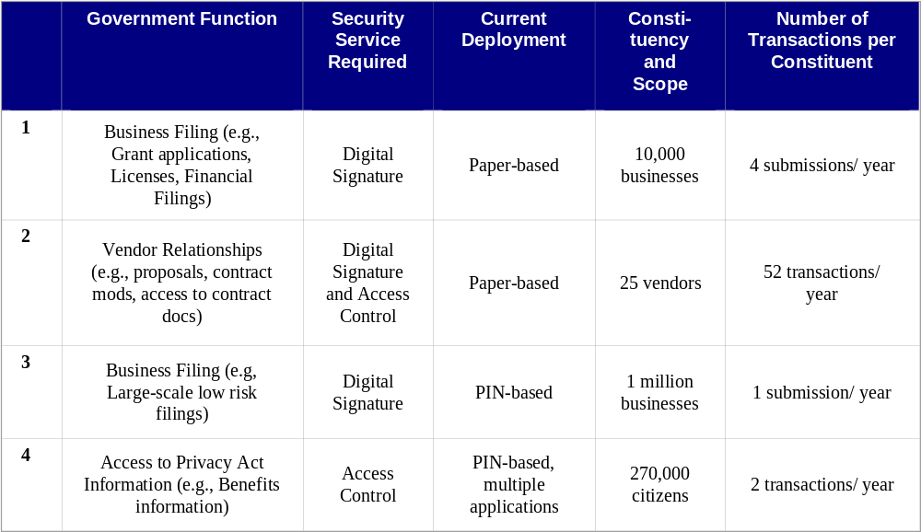

- Scenarios 1, 2 and 3 represent B2G – Transactions between business and the government
- Scenario 4 represents C2G – Transactions between citizens and the government

For each scenario a baseline was created. The baseline documents the cost of the business transaction in a pre-PKI environment. For paper-based transactions this includes the cost to print and store a form as well as the cost to file, process and key a form. For PIN/password-based transactions the baseline includes the cost of administering the system and maintaining PINs or passwords.

A Build PKI approach was also created for each scenario which captures the investment cost associated with buying or developing a PKI-ready application, developing PKI certificate policy and practice statements, purchasing infrastructure hardware and software, and performing all the functions of a certification authority including all registration and identity proofing activities. Build PKI also includes operating cost of the application and certificate authority operation/maintenance, annual reviews and audits, directory license, and training. Finally, personnel cost includes support required from system administrators, PKI system operators, local registration authorities, help desk, the Chief Information Officer, the risk manager, a security officer and an attorney. This guide provides users a better understanding of major cost categories and a rationale for developing cost estimates for Build PKI solutions.

An acquire ACES approach was also created for each scenario. The ACES approach investment cost includes buying or developing a PKI-ready application, issuing certificates, acquiring an agency application certificate, and installing a Certificate Arbitrator Module (CAM). The operating cost is primarily the operating cost of the application plus transaction costs and personnel costs, comprising system administrators and an attorney.

Following are five-year life cycle cost estimates for each of the four sample ROI scenarios.

Figure ES-2. ROI Scenarios: Five-Year Live Cycle Costs
Scenario | Baseline | Build PKI | ACES
Scenario 1 | $32 million | $9.03 million | $4.1 million
Scenario 2 | $1.04 million | $2.4 million | $701 thousand
Scenario 3 | $33.4 million | $35.5 million | $33.5 million
Scenario 4 | $10 million | $15.2 million | $9 million

It is important to note that no volume discounting was assumed so all costs are worst-case scenario unit price. Also, it was assumed that the acquire ACES alternative for all scenarios used transaction-based costing. In a subscription-based costing model, where the agency would pay a recurring certificate subscription fee rather than transaction fees, life cycle costs would be reduced in Scenario 2 and in any business process requiring large numbers of transactions with the same constituents.

The following return on investment table shows the total present value cost of each alternative to savings in operating costs from the baseline. Because the ROI is expressed as savings, in a preferred outcome this number should be negative. If the number is positive, it means that no efficiency/savings is achieved from the baseline environment. The more negative the ROI, the greater the savings and stronger the ROI.

Figure ES-3. ROI Findings
Scenario | Build PKI | ACES
Scenario 1 | -2.74 | -7.14
Scenario 2 | 0.46 | -0.51
Scenario 3 | -0.27 | -0.86
Scenario 4 | 0.04 | -0.71

It may seem counter intuitive that scenarios three and four show a favorable ROI when the Build PKI and ACES approach have a total life cycle cost that is greater than the baseline. Remember however, that ROI is looking at operating cost savings, not investment costs. Another look at scenarios 3 and 4 shows the following.

Figure ES-4. Operating Costs: Baseline vs. PKI Alternatives
Scenario | Baseline Operating/Personnel Cost | Build PKI Operating/Personnel Cost | ACES Operating/Personnel Cost
Scenario 3 | $33.4 million | $23.7 million | $4.7 million
Scenario 4 | $10 million | $10.7 million | $3.6 million

This report demonstrates that PKI under both approaches (Build PKI and ACES) could be a viable investment. In all scenarios however, it is cheaper to operate PKI under ACES rather than Build PKI. Use of the ACES acquisition approach yielded a positive Return on Investment in every scenario but requires a significant investment under scenario 3 for issuance of certificates at a standard ACES price without a volume discount. Further, it was determined that:

- The Build PKI approach also yielded a positive ROI in two of four scenarios and was competitive with the baseline in all scenarios.
- In scenarios 1 and 2, Build PKI requires a greater cash outlay than ACES. However, in scenario 3, Build PKI requires less upfront costs than ACES.
- Build PKI shows a slight discount to ACES in investment cost required for scenario 4.

In general, deploying PKI-enabled applications becomes more cost-effective as additional applications come online, leveraging the value of the initial investment. This is the primary reason for the cost-effectiveness of the ACES program, in which multiple agencies leverage the same PKI physical and policy infrastructure investments government-wide. It also suggests that the overall cost-competitiveness of Build PKI as an option will improve as an agency brings up additional applications, though it may or may not reach the degree of leverage achieved by sharing a government-wide infrastructure.

Introduction

1.1 Purpose
The purpose of this guide is to provide a comprehensive analysis of government and industry business cases and Return on Investment (ROI) case studies associated with public key infrastructure (PKI), and to provide standard frameworks for government agencies to use in projecting ROI of PKI and ACES PKI services.

This guide seeks to answer the following questions:
- Why should I consider PKI?
- Who else is using it and what have they found?
- What are my options, and how can I cost them out?
- Which options work best for four typical Federal functions?
- What conclusions can I draw for my own situation?

1.2 Scope
This guide focuses on the use of PKI for trusted on-line transactions between the federal government and citizens, businesses and other government agencies. Use of PKI by federal employees for authentication and digital signature functionality on internal agency systems is not considered within the scope of this report. The ROI scenarios provided are designed to show the value of issuing PKI certificates outside an agency as a means of providing enhanced security for e-Government transactions.

1.3 Document Layout
PKI for the Public addresses business to government (B2G) and citizen to government (C2G) government-wide applications and comprises six main sections.

Section 1—Introduction: Presents the purpose and scope of the document.
Section 2—Characterizes Appropriate Role of PKI: Illustrates the appropriate role of PKI as a preferred investment to address both business and security needs.
Section 3—Reviews Existing Literature/Studies: Describes the findings of a review of industry and government studies and research on business and ROI cases.
Section 4—Develops PKI ROI Cost Methodologies: Describes the methodologies used to calculate ROI and also includes a discussion of how assumptions are developed and applied.
Section 5—Applies ROI Methodology to Four Archetypal B2G and C2G Scenarios: Describes four different agency business processes spanning a range of different criteria for size, scope, use of PKI security services, and current use of digital technology, and applies the cost methodology to them.
Section 6—Derives Conclusions: Summarizes the findings of this guide.

This guide was designed in this fashion to help agency personnel identify where the use of PKI is advantageous; to build a business case as appropriate, and to understand Return on Investment factors associated with PKI in general and with the use of the ACES contract in particular.

Appropriate Role of PKI
This section will describe the range of circumstances under which PKI appears to provide the best solutions for achieving trusted electronic transactions with government constituents. The section will address the legislative mandates and other drivers that are creating interest in online trusted transactions; how PKI can supply the trust required for those transactions; and how the use of PKI compares to the more familiar PIN or password deployments. Finally, the options available to agencies for acquiring PKI will be described, from in-sourcing to outsourcing to a trusted third party.

Drivers for Trusted Transactions in Government
The uses of the Internet and advanced software technology have transformed traditional paper-based protocols and processes. However, the great benefits gained from many electronic services are contrasted by increased potential for breakdowns in security, privacy and information integrity. The purpose of this section is to show the existing mandates for e-Government and to demonstrate the need for security in the Digital Age.

A chain of e-Government mandates began with the Paperwork Reduction Act of 1995, which sought, among other things, to minimize the government’s paperwork burden and minimize the cost to the public of the government’s need to collect and maintain information. The subsequent Electronic Freedom of Information Act Amendments of 1996 recognized the increasing shift to electronic records. It requires the federal government to make electronic records as available to the public as paper-based records. The Amendments also requires agencies to maintain the same level of privacy and security to the public in the electronic arena as maintained in the paper arena.
Key e-Government Legislation /
Executive Direction in the 1990’s
Paperwork Reduction Act of 1995
Electronic Freedom of Information Act Amendments of 1996
Government Paperwork Elimination Act of 1998 (GPEA)
Executive Memorandum – Electronic Government 12/17/1999
E-SIGN Act of 2000

The Government Paperwork Elimination Act (GPEA) of 1998 specifically recognizes the relationship between electronic signatures and the security and authenticity of transactions. GPEA also mandates that no later than October 2003, Executive agencies must provide for the option to substitute electronic formats when practicable for paper and must provide for the use and acceptance of electronic signatures when practicable. The subsequent Electronic Signatures in Global and National Commerce (E-SIGN) Act of 2000 provides that electronic signatures carry the same legal weight as written signatures.

Prompted by the governmental mandates above and following in the path blazed by the private sector, the public sector began the process of transforming its decades-old paper-based model of business processes in the 1990s. Early e-Government efforts were characterized by a focus on putting public information on web sites. Security issues, in these circumstances, were limited in brochure-ware type applications that provided neither the opportunity for transactions or linked front and back-end systems.

As the year 2001 approached, the number of federal government e-Government initiatives documented by the Chief Information Officer's Council swelled to 1,300. All of these initiatives must more fully realize the benefits and satisfy the expectations that have grown out of private sector innovations.

To fulfill this need, the administration has articulated three guiding principles for government reform. Government should be:

- Citizen-centered, not bureaucracy-centered;
- Results-oriented; and
- Market-based, actively promoting rather than stifling innovation through competition.

President Bush established a task force to identify key initiatives and activities to comprise the Administration's e-Gov strategy. The task force grouped initiatives into four categories:

- Citizen to Government (C2G) – “building easy to find one-stop shops for citizens to create single points of easy entry to access high quality of governmental services”;
- Business to Government (B2G) – “reducing the burden on businesses by using Internet protocols and consolidating the myriad of redundant reporting requirements”;
- Government to Government (G2G) – “make it easier for states to meet reporting requirements, while enabling better performance measurement and results”; and
- Internal Effectiveness and Efficiency (IE&E) – “improve the performance and reduce costs of federal government administration by using best practices in areas such as supply chain management, financial management, and knowledge management.”

Each of these initiatives spans multiple agencies, and so solutions for any one of the initiatives must be designed so as to be interoperable across multiple partners.

This guide focuses specifically on the implications of conducting trusted C2G and B2G transactions: transactions that involve external agency constituents.

As information and services become more accessible, they also become more vulnerable. This increased vulnerability has had a greater impact in the public sector than the private sector because of the types of information collected, stored and disseminated by the federal government.

“Anticipated benefits include reducing the expense and difficulty of doing business with the government, providing citizens improved access to government services, and making government more transparent and accountable. Success in achieving these benefits will require agencies and others involved to ensure that the systems supporting E-government are protected from fraud, inappropriate disclosures, and disruption. Without this protection, confidence in E-government may be diminished, and the related benefits never fully achieved.”

Critical Infrastructure Protection Significant Challenges in Protecting Federal Systems and Developing Analysis and Warning Capabilities, Statement of Joel C. Willemssen, Managing Director, Information Technology Issues, GAO Testimony (GAO-01-1132T), September 2001

Examples of security lapses in e-government systems – ranging from computer networks to online citizen-facing applications – are not difficult to uncover. News of hackers penetrating networks with viruses such as “Code Red” or “NIMDA” have been published in the popular press. In December 2001, a Washington Post article reported the issuance of a court order demanding one cabinet agency to shut down its access to the Internet. The court order was issued based on a study commissioned by a US district judge that found individual trust fund accounts were vulnerable to manipulation by hackers.

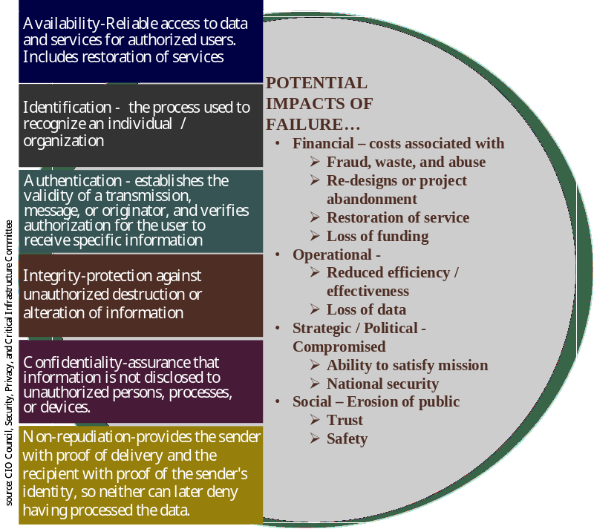
Privacy Act information and its unauthorized disclosure or theft is of primary concern in C2G applications. Similarly, the unauthorized disclosure and/or theft of confidential business information is a key concern in B2G applications. In the examples above, organizations failed to achieve fundamental security goals. These goals have been articulated by the CIO Council’s Security, Privacy, and Critical Infrastructure Committee and are listed in the graphic to the left. Depending on the initiative, failure to meet these security goals could have expensive to catastrophic consequences.
Stakeholders share the costs associated with compromised systems and information across the value chain. Whether calculated in dollars/cents, customer satisfaction, or loss of lives and property, the costs of inadequate security measures are shared by all. Many organizations are looking to public-key technology as a potential security solution to support some components of the transformation to electronic business processes. Properly managed, PKI technology can deliver all the security services articulated above.

How PKI Supplies Trust
The “holy grail” for trusted electronic transactions is the ability for two parties, previously unknown to each other, to conduct a transaction over the Internet that satisfies all of the security criteria outlined in the graphic above.

Public key infrastructure (PKI) offers a method of achieving this level of trusted transactions through two different technologies: digital certificates and the use of public-private key pairs. It allows for certification of who is sending/receiving information (authentication of identity); proof that the document has not been altered in any way during transmission or at a later time (integrity); association between the sender and the document sent (non-repudiation); and privacy of the transaction (confidentiality).

Digital certificates. Deployment of PKI rests upon the issuance of an identifying credential, called a digital certificate, to a specific individual (or other entity) called the subscriber. The digital certificate is a public document that:
- states the identity of the subscriber;
- asserts that a certification authority has properly identified the subscriber’s identity according to a published set of policies; and
- binds that identity in an inalterable manner to the subscriber’s public key.

Key pairs. Any transaction involving PKI uses a key pair uniquely associated with the digital certificate holder. The keys, one private and one public, are highly complex, mathematically related numerical values. The public key is published in the digital certificate. It is available for access by the whole world (or a designated subset). Only the subscriber knows the private key, which may be stored in encrypted form on the subscriber’s hard drive, in client software, or on a hardware token or smart card. During encryption of a message, the sender's software accesses the recipient's public key (typically from his certificate) to encrypt the message, and the receiver uses her private key to decrypt the message. Since only the recipient should have the complementary private key, only the recipient should be able to decrypt the message. Therefore, confidentiality of the message is assured.

For authentication, message integrity, and non-repudiation of a message, the sender's software creates a hash – in effect, a numerical fingerprint – of the message, and then encrypts the hash using the sender's private key. This encrypted hash becomes the digital signature. It is a numerical value derived from the message itself and from the private key. It is attached to the message when it is sent forward. Anyone receiving the message who can get access to the sender's public key can verify the "signature" of the sender and that the message has not been altered. Since each public key is unique to a certain sender, the fact that a given message can be verified with a specific public key means that it must have been signed by the particular sender's private key. Figure 1 below demonstrates how PKI works.

Both uses – encryption and authentication – are typical uses of a PKI. It is important to note that the ACES contract is designed to provide the authentication, message integrity, and non-repudiation services described in the paragraph above. ACES, however, does not provide encryption certificates and so ACES services are typically deployed in conjunction with SSL server encryption to provide confidentiality of messages in transmission.

Figure 2-5. Authentication & Encryption Using PKI

Certification Authorities (CAs). The management of public and private keys is a critical component of a PKI. Again, public keys do not exist on their own but are stored in the digital certificate, the purpose of which is to formally associate the subscriber’s identity with their public key. Digital certificates are issued and digitally signed by a certification authority (CA). It is the CA’s signature that ensures that the contents of the certificate cannot be altered without detection.

Certificate Validation and Revocation. In a PKI, the CA has the sole authority to create, issue, store, and validate digital certificates. The role of the CA in a transaction is to provide assurance that the individual holding the unique certificate is, in fact, who he or she claims to be. This includes:
- The individual was properly authenticated prior to issuance of the certificate (i.e., according to the policies of the PKI) and
- The individual has not subsequently revoked the certificate.
If a subscriber has reason to believe that her certificate has been compromised (perhaps through the theft of her computer or token), she may direct the CA to revoke her certificate. As a result, one function of the CA is managing revoked certificates, either by publishing a certificate revocation list (CRL) or establishing a mechanism to check the validity of a certificate in real time, typically using online certificate status protocol (OCSP). During a trusted electronic transaction, the receiving party’s application software not only examines the certificate to make sure that it appears sound (certificate comes from a recognized and trusted CA, hasn’t expired) but also checks the current status of the certificate with the CA (certificate is not on a revocation list).

Overall Infrastructure. Key elements of any PKI include: (1) policy; (2) system controls; (3) registration/identity proofing; (4) certificate issuance and key management; and (5) certificate validation. PKI starts with the certificate policy. The certificate policy outlines rules for the use of a PKI and certificate services. The policy should also provide for an independent review and audit of systems records and activities to ensure adequacy of system controls, to ensure compliance with the policy, to detect breaches in security, and to recommend any changes in control, policy, and procedures.

The certificate policy is also where the requirements for authentication to receive a certificate can be found. The certificate policy should describe the trust level attached to the certificate and the identifying information each certificate will contain, including the user’s name, public key, and a unique digital signature, which binds the user to the certificate.

How PKI Compares with More Familiar PIN/Password Deployments
Today many IT systems and applications rely on Personal Identification Numbers (PINs) and/or passwords for access control. These approaches are familiar to the general public and relatively easy to deploy, although their costs can be deceptive. This subsection describes some of the reasons why agencies may look to PKI as a replacement for or an enhancement to their PIN or password systems.

PINs and passwords fall into the category of “shared secrets” or single-key solutions. In a shared-secret scenario, the agency application assigns a password (or the customer selects one), and that secret must be shared between the customer and the agency. The customer presents his “secret” to the agency for access, where it is checked against a database to see if it is valid. Accordingly, in a PIN or password approach, the agency becomes responsible for maintaining a central database of these shared secrets, one or more for each customer.

Shared secrets provide only a subset of the security services characterized above; present some additional vulnerabilities associated with central storage of the secret; are more costly to operate than is often understood; and do not offer interoperability among separate security domains.

Security Services

Perhaps the primary reason that agencies today opt for PKI pertains to specific requirements for security services. PINs and passwords, along with biometrics and other shared secret approaches, provide authentication. However they do not offer the confidentiality, message integrity and non-repudiation features like PKI.

Confidentiality is relatively easy to supply by other means such as Secure Socket Layer (SSL), actually a variant of PKI. In fact, the ACES PKI does not include a confidentiality offering. Achieving message integrity and non-repudiation without using PKI is more difficult, for at least two reasons. Imagine that a constituent authenticates himself to an online application and submits a document, perhaps a grant proposal, during that session. He “signs” it using his password. The constituent later decides to deny that he submitted that document.
- The constituent can claim that the document he submitted was subsequently altered by someone in the government.
- The constituent can claim that, because his password is a shared secret, of necessity there are other people who have access to his password, and one of them was spoofing him.

Many legal scholars believe that it will be difficult to prove any electronic transaction in a court of law that was “signed” using a shared secret.

With PKI, when a document is digitally signed, the signature represents a mathematical combination of the signer’s identity (the private key) and the document’s identity (a hash of the document). The document cannot be changed without detection. The signer cannot claim that the document has been altered, nor can he claim that someone accessed a central repository and stole his signing key. At best, he can claim that he was irresponsible or negligent in the management of his private key.

Vulnerabilities

There are specific vulnerabilities associated with any type of shared secret solution. These include the following:
- The very existence of a centralized database of secrets creates an attractive target for external hackers and a key vulnerability to insider threats
- Communication of the password across the internet, if not properly encrypted, can permit “sniffing” of a password
- It is not a good idea for a user to reuse the same password across multiple systems, nor is it a good idea for applications in different security domains to share the same password database. This multiplies the vulnerability of the system, since under these circumstances, a hacker compromising a password in one location would have access to multiple applications.
- In order to avoid guessing and dictionary attacks, good security protocol requires that passwords be unguessable; contain a mix of alpha and numeric characters, and be changed on a regular schedule. This, coupled with the previous point, often has the undesirable effect of forcing users to write passwords down.

In contrast, PKI uses a dual key system in which there is no central database of shared secrets. The subscriber holds a private key that she never shares or releases. She uses that private key to encrypt data in a manner that can only be decrypted by the associated public key stored in her (public) digital certificate, and it is that action that proves that she is the person referenced in the digital certificate.

Accordingly, in a PKI:
- There is no central database of shared secrets, and hence no central database attractive to hackers. To hack the subscribers’ private keys the hacker must gain physical access to each subscriber’s desktop computer or token.
- There is no opportunity to guess a password to an application.
- Multiple applications can use the same public key to validate transactions conducted with the private key, at no additional risk.
- The user can protect his private key with a single password that he can remember.

Cost

The cost of maintaining a PIN/password system is often greatly understated. According to the Gartner Group, a typical organization with 2,500 users spends $850,000 in help desk costs to manage network password resets. This represents a per seat cost of $340 a year, certainly challenging the commonly held notion that passwords are "free." These numbers are compiled from the cost of system administration time spent managing and resetting passwords and time spent by end users as a result of forgetting them.

In another study, Booz Allen Hamilton evaluated the costs of PIN/password in an organization with 54 users. The organization had a password policy that was followed by most of the users. The study found that productivity loss (as a result of password maintenance) estimates were over $8,000 per year, or about $148 in password maintenance cost per individual, per year. This number represents the costs to maintain a password system that mandates relatively few password strength conventions. Costs used in the calculation included the following:
- Hardware maintenance, upgrades, and recurring fees
- Software maintenance and recurring fees
- Government staff responsible for each operating system
- Administrator time spent unlocking accounts
- End-user time spent locked out of their account
- Technical support (help desk)

While PKI is more expensive to deploy initially than passwords, many of these ongoing customer support problems are largely avoided. Password resets are not required under PKI configurations, since no vulnerable information travels over the Internet. And since there is no central database of passwords, insider hacker threat is diminished as well.

Within this paper, analysts were able to calculate a range of per-seat costs for four different PKI scenarios. For the three larger deployments, these costs compared very favorably with password costs, with relative costs savings more apparent as deployments increased in size. For the smaller deployment, passwords are substantially less expensive. PKI would be used here only if the additional security services are considered an essential component of the application.

Interoperability

Password-based security infrastructures are of necessity highly redundant, with each system requiring its own stove-piped standalone password infrastructure. While not all are yet electronic, OMB finds that there are 5,600 federal agency transactions that are subject to the Government Paperwork Elimination Act.

Because multiple agencies can agree to share a certificate policy and accept the same certificates, the use of PKI across a set of applications can enhance Return on Investment and lower cost as the same certificate is reused for several applications. Customer satisfaction also increases as citizens find that the same credential they use to query benefits can now also be used to file financial documents with a different agency. This possibility is explored in one of the ROI scenarios detailed in Section 5.

Agencies may also wish to interoperate with non-federal entities. Specifically, some agencies would like to be able to rely on State-issued or university-issued digital credentials. This can and has been readily achieved. For example, the Social Security Administration reviewed the State of Washington’s certificate policy and found it to be sufficient for SSA’s security requirements for Annual Wage Reporting. In the most recent filing season SSA demonstrated that its ACES-based PKI was also able to correctly process and validate digital certificates from the State of Washington. This allowed SSA to share in the benefit from PKI investments already made by participants in the State of Washington PKI.

Acquisition Strategies for Federal PKI Solutions
As outlined above, agencies may decide to acquire PKI either to gain specific security services like digital signature, to enhance system security, for long-term cost economy, or for greater interoperability with other agency or government systems. Those desiring to do so encounter a spectrum of acquisition options.

Federal agencies can acquire public key infrastructure products and services via one of two basic strategies; they can in-source the operation by building and maintaining its own PKI, or they can outsource the operation through the use of a trusted third party (TTP). Each strategy may be viable and beneficial under the right circumstances and the decision as to which to pursue is ultimately a measured business decision. There are also viable solutions that combine these two strategies, i.e., in-source certain aspects of the operation and outsource others. For the purposes of this paper, we have detailed and compared the two ends of this spectrum, i.e., in-sourcing a PKI completely, and outsourcing in a trusted third party model under the GSA Access Certificates for Electronic Services (ACES) contract.

The GSA ACES PKI was selected for this analysis because it represents the ability for agencies to outsource to the greatest degree. It was also selected because the ACES contract was explicitly designed to provide cost savings for implementation of PKI for federal agencies, and GSA desired to model that cost savings. As will be described in Section 3, no existing business case or ROI study found in the literature adequately addresses the savings available from TTP approaches to PKI like ACES.

In-sourcing

When considering in-sourcing as an acquisition strategy for PKI, an agency will need to develop its own certificate policy and practice statements, purchase its own infrastructure hardware and software, and perform all the functions of a certification authority including all registration and identity proofing activities. Building a PKI also includes operating cost of application and certificate authority operation/maintenance, annual reviews and audits, directory license, and training. Finally, personnel costs includes support required from system administrators, PKI system operators, local registration authorities, help desk, the Chief Information Officer, the risk manager, security officers and attorneys. However, even after taking all of these factors/costs into consideration, in-sourcing may still be a viable strategy when:

- Security is a core mission function or critical to the organization’s business;
- The risk and liability associated with being a certification authority must or can only be borne by the organization; and
- When the organization foresees a high volume of transactions requiring PK functionality and can take advantage of economies of scale.

As an example, the Federal Deposit Insurance Corporation (FDIC) built and maintains its own PKI offering digital signature and security functionality to its bank examiners. As these bank examiners travel the US extensively performing bank audits, FDIC made a business decision not to outsource this core function. As in the case of FDIC, most of the current in-sourced PKI solutions in the Federal government are designed to fulfill the particular agency’s (or program’s) “enterprise” or internal transaction requirements. In other words they were established to serve agency employees and not external communities of interest, businesses, or citizens/constituents.

One example of an in-sourced PKI that was established to support external (B2G) transactions is the Patent and Trademark Office (PTO). The PTO has created a series of public-key-enabled applications that lets inventors, trademark applicants, and lawyers file applications via the Internet and then track the progress of those applications electronically. To date, the PTO has issued more than 2,000 digital certificates to these external users. As a result of converting this previously paper-intensive process to electronic PTO has cost justified spending over $ 4 million so far on their PKI. Likewise, agencies that choose to in-source their PKI will need to develop defensible ROI value proposition.

Outsourcing

The complexity of establishing trust models for authentication, the difficulty in integrating with internal applications, and the intricacy of managing digital certificates make outsourcing PKI attractive to organizations that lack the in-house expertise and the lead time or staff resources to do it themselves. Primary reasons to select outsourcing are to lower the agency’s administrative burden, lower costs, and to take advantage of easier implementation. One form of outsourcing is the use of a trusted third party (TTP). The TTP model used throughout this paper is the GSA-sponsored Access Certificates for Electronic Services (ACES) contract. ACES was created to provide outsourced PKI products and services to Federal agencies under a shared set of policies and to support ready-made interoperability across all participants, thus achieving an economy of scale across all of Government. Under ACES, appropriate certificate policies, a policy infrastructure, and an auditing/compliance infrastructure have already been established to serve government agencies in their interactions with businesses (B2G) and citizens (C2G).

In using ACES, an organization does not invest in the development of its own PKI and relies on one of the ACES vendors as its certification authority service provider. With ACES, organizations join the ACES policy community, purchase only the equipment necessary to connect with the ACES vendor validation services, and invest only the finances necessary to PK- enable its applications.

Outsourcing is usually selected when the organization wants its security functions provided by experts; when:
- The organization does not possess the required technical expertise to manage a PKI program;
- The organization is not able or does not choose to bear the costs of implementing and managing PKI;
- Security is not a core mission function of the organization.
- Outsourcing under ACES is appropriate to consider when, in conjunction with some or all of the above,
- The agency finds that the ACES certificate policy meets its needs for level of trust, and/or
- Immediate interoperability with other federal programs or with alternative commercial and state sources of certificates is desirable or required.

ACES provides a Government-wide PKI that is already in place. ACES offers a method for issuing digital certificates to the public, at no charge to them, for supporting secure electronic transactions with the federal government. ACES also provides auxiliary services that participating agencies may need in order to make use of the infrastructure. The main advantages of ACES are that it reduces costs by aggregating government requirements and it permits citizens and companies to do business with multiple agencies using a single digital identity credential. In addition, GSA performs system certification and accreditation and requires periodic security review and audits to make sure that trusted third parties remain trusted.

Agencies wishing to participate in the ACES Infrastructure must join the ACES policy community by entering into a Relying Party Agreement with GSA. Upon completion of the agreement and receipt of a funding document from the agency, GSA provides the agency a Certificate Arbitrator Module (CAM), which resides within the agency’s infrastructure and acts as an application-level certificate validation router. All ACES PKI products and services are task-based and are competed among the ACES industry partners. The ACES program provides four main categories of products and services:
- Certificate issuance
- Certificate validation
- Supplemental PKI services including necessary PKI consulting/expertise, and
- Hardware/Software including hardware tokens

Under ACES, the agency only bears the cost of the portion of the public key infrastructure it uses, such as certificates and certificate validations, on an as needed/used basis. The agency does not have to build its own PKI, expend the resources to manage it internally, or provide ongoing security/ information system assurance.

The standard approach to pricing services under ACES is transaction-based. Since this pricing approach is highly detailed and there are numerous deployments, this is the approach that has been used in this paper to develop cost models under ACES. However, the ACES contract is designed to provide PKI services to agency application owners using both certificate-based and transactions-based validation payment schemes. Program managers expecting moderate to very high transaction volumes (e.g., daily or more frequent database information requests) should investigate ACES subscription options rather than apply the transaction pricing included here. In general, readers of this paper should understand that they have more options, under both Build PKI and ACES PKI models, than was possible to represent here.

Leveraging ACES as a PKI Solution

Benefits of the GSA ACES contract include:

- Provides Government agencies with the capability to strongly authenticate individuals participating in secure e-commerce transactions;
- Provides real-time validation of security credentials;
- Affords agencies the capability to provide more personalized services to their constituents and business partners;
- Provides a Government-wide PKI trust model which features a single certificate policy, interoperable digital certificates, and strict GSA monitoring of vendor practices and procedures;
- Reduces individual agency costs by combining Government requirements across multiple agencies;
- Provides participating agencies with access to comprehensive digital signature and PKI support services;
- Reduces the time to deployment by eliminating much of the time-consuming upfront set-up required to build a PKI; and
- Provides ready access to PKI consulting expertise.

Any agency authorized to use a Government-wide Acquisition Contract (GWAC) can use the ACES contract. The contract is supported by three industry partners who provide applicant registration and certificate manufacturing, issuance, maintenance, and validation functions, as ACES Certification Authorities (CA’s) on a fee-per-certificate and/or fee-per-transaction basis. While the fee per certificate varies from vendor to vendor, GSA regulates the transaction fee. For purposes of this paper, analysts have used a certificate fee that represents an average of that charged by the three vendors, except in scenarios involving very large-scale issuance (more than 100,000 certificates), where it is assumed that agencies would select the cheapest certificate price. For those scenarios analysts used the lowest published certificate price, though further volume discounts would likely be available. Standard ACES transaction costs are also used in each of the ROI scenarios. The following chart shows the rate structure of transaction costs ranging from $1.25 to $0.42. These costs decrease with increasing government-wide volume of transactions across the government.

Figure 2-6. ACES Transaction Costs
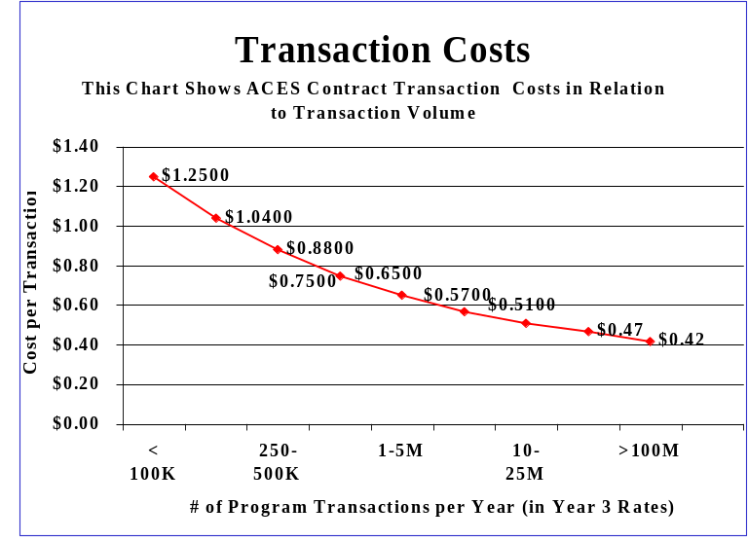

For the purposes of this analysis, a transaction cost of $1.25 was used unless the scenario itself generated sufficient transactions to move to a lower cost band. For example, for the scenario assuming one million transactions, a transaction price of $0.65 is used.

Agencies have also used the ACES contract for supplemental services in preparing for PKI, including
- Feasibility studies
- Digital signing software assessments
- Pilot and production deployments
- Electronic transaction risk assessments
- CAM installation testing and integration, and
- Other services

Review of Existing Literature
The commercial sector has recognized the increased security benefits of PKI, and several industries have implemented it with great success. These examples and existing PKI studies were reviewed for guidance on calculating ROI. All provided helpful information on the utility of PKI in general and within enterprises but fell short of providing useful guidance in the government-specific contexts of B2G and C2G services.

How Commercial Sector is Using PKI
PKI is currently being used in the commercial sector for both business and security reasons. In addition to the security benefits highlighted in the previous section, the following significant business benefits are also widely cited:

Cost Savings – Implementing a single security solution throughout a large organization will yield larger cost savings than choosing several different security solutions. The incremental costs of adding new users or applications will be minimal compared to adding users or applications to a disparate security infrastructure. The costs associated with deploying, maintaining, and operating multiple solutions are more likely to be higher than those associated with just a single infrastructure.

Interoperability (intra-enterprise) – Implementing a single infrastructure ensures interoperability within an enterprise, because each application or device utilizes the components in an identical manner.

Interoperability (inter-enterprise) – Implementing a technical solution that operates under open, international standards will be more likely to gain acceptance among its users rather than using a single, proprietary solution.

Choice of Provider – A security infrastructure offering a consistent approach towards various applications and devices will be secure.

Following are a few of the sectors that are embracing PKI:

Finance Industry – Securely transmitting business transactions over unsecured data lines benefits from the services that PKI can offer. This includes on-line loans and securities exchanges. The Bank of Nova Scotia was one of the first to leverage PKI to provide e-commerce solutions. In addition, in 1999, a group of financial institutions formed Identrus, a company that provides an infrastructure for global E-commerce. Identrus provides a Global Identification (ID) that is supported by the Identrus system’s distributed, bank-hosted PKI structure. Businesses can form a single trusted relationship with Identrus, and the Global ID gives businesses digital credentials that are interoperable across multiple buyers and sellers in a supply chain. For example, the Royal Bank of Scotland has used a digital certificate system based on the Identrus standard to sign off £82 million ($51.3 million) of leasing transactions online in just eight months. Transaction processing time has dropped from two weeks to one day.
Energy Industry – One of the nation's largest e-commerce applications supports the electricity-trading system. The Open Access Same-time Information System, or OASIS, underpins the Federal Energy Regulatory Commission's efforts to deregulate the electric utility industry by promoting competition. Nearly 75 percent of the power traded via OASIS utilizes digital certificate-backed, PKI security services. More than 3,000 certificate-enabled users in over 400 companies, including utility cooperative, power marketing, public utility, and investor-owned utility companies perform daily transactions on OASIS using digital certificates. OASIS has conducted more than $30 billion in e-commerce transactions using commercially provided outsourced products and services.

Healthcare Industry – The Health Insurance Portability Accountability Act (HIPAA) has placed stringent security and privacy requirements upon health care organizations and insurance providers. Securely transmitting patient information, prescriptions and insurance information over the Internet or by other means must be conducted in secure manner. Examples include:

Healthkey – A multi-state project to create a "replicable model" for healthcare PKI. Healthkey publishes an alternate view of healthcare PKI where interoperability is dependent upon adherence to set certificate practices, subordination of enterprise Certificate Authority to common industry provided roots, and the deployment of 'trusted' directories.

CHIME – Developed by the healthcare community offering the Connecticut health industry, the nation's first fully developed public Certificate Authority with a specific healthcare industry focus. Focuses on different industries within the healthcare sector to enable interoperability among providers, insurers, employers, and patients.

Higher Education – The Higher Education PKI (HEPKI) activity groups represent the cooperative efforts of the Corporation for Research & Educational Networking (CREN), EDUCAUSE/Net@EDU and Internet2 in furthering PKI development for the higher education community. Through the establishment of HEPKI, to goal is to make online access more secure for higher education and research institutions by allowing individuals at those institutions to share information in a secure environment.

Business Case and Methodology Findings of Others
Before creating the four ROI scenarios, analysts reviewed the work of others to understand existing theories and approaches to PKI returns. The objective of the review was to determine the following:
- If any usable ROI methodologies already exist that can be applied in a citizen to government (C2G) or business to government (B2G) context.
- If any assumptions or conclusions from industry ROI can be applied to the government.

This effort showed that most studies to date have focused on enterprise PKI for employee use rather than certificates issued to external businesses and citizens. Therefore, the lessons learned were limited in their applicability for business to government (B2G) and citizen to government (C2G) environments. However, studies like the Aberdeen and GIGA studies cited below were useful in understanding the categories of cost drivers for building a PKI. The GSA PKI/Smart Card Project provided two case studies showing the effective use of PKI within an agency. The NIST Managing Your Own PKI and RSA PKI ROI papers show the high level benefits of PKI and provide a list of implementation suggestions, but fall short of actual ROI calculations. These references are included in this guide as additional resources, and a detailed summary is found in Appendix A.

The consensus of these documents was that the intangible benefits that PKI provides outweigh all associated costs, and that therefore, the ROI of PKI is positive. While most of the documents provided a “how to” regarding the formulation of a business case or ROI calculation, most stopped short of truly demonstrating the true Return on Investment of PKI and indicating the primary drivers of ROI.

The completion of the review led to the following conclusions:
- No ROI methodologies were found that could be readily applied in a citizen to government (C2G) or business to government (B2G) context. – The existing literature on PKI ROI is focused on building enterprise PKI systems for internal use rather than on e-commerce/e-Gov application of PKI. Furthermore, none of the studies look at broadly shared PKI systems that may be required in an e-Gov environment.
- Assumptions and conclusions from industry ROI were not readily applicable to the government. Rather than providing conclusive ROI evidence, many of the studies provide a "How To" approach stating how to calculate ROI rather than providing mathematical rigor to demonstrate that PKI has a strong ROI.
Accordingly, analysts and GSA sponsors of this guide determined to move forward with development of a cost methodology specific to PKI-enabled B2G and C2G transactions.

PKI ROI Cost Methodologies
This section of the report will provide guidance in developing PKI cost projections, budget justifications and ROI calculations. It will also describe the assumptions used in Section 5's ROI scenarios. Cost projections and ROI calculations are a key piece in a business case analysis (cost-benefit analysis). The business case analysis process is very useful to an agency as it:

- Provides a better means for planning, budgeting and acquiring capital assets like PKI
- Provides a technical basis and defense for programs
- Establishes a clear baseline against which progress can be measured
- Supports agency compliance with OMB’s requirement for sound capital programming principles

Business Case Analysis Process
Business case analyses often adhere to the process illustrated below.

Figure 4-7. Business Case Analysis
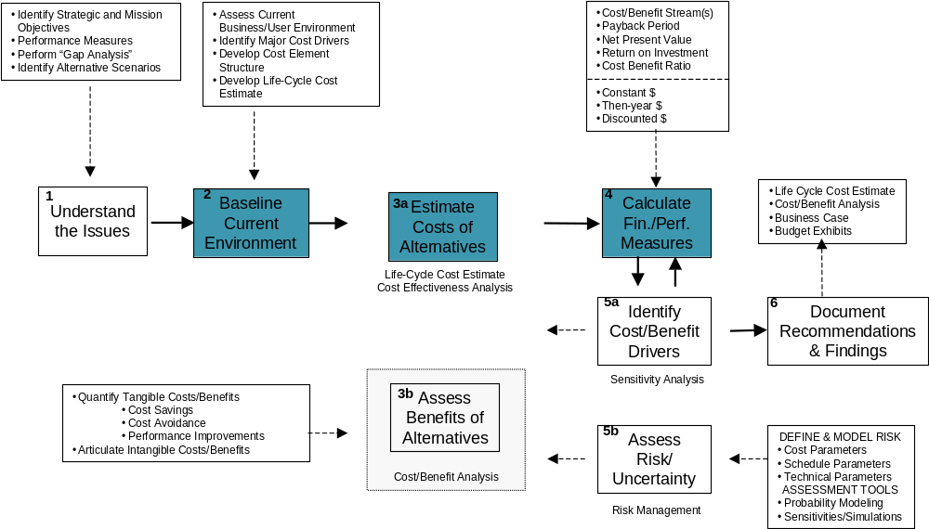

A comprehensive business case analysis focuses on cost, benefits, and risk. This document is specifically designed to provide guidance on baselining the current environment (Element 2 in the chart above), the cost calculation (Step 3a), and ROI projection (Step 4) portions of the business case analysis.

Determining ROI
This section provides a step-by-step guide to performing elements 2, 3a, and 4 from the above process chart to determine ROI.

Step 1: Assess the current business/user environment and establish a baseline
One of the most common mistakes made when developing Return on Investment calculations is undervaluing the baseline. Baseline costs are exceedingly difficult to derive, as most organizations group cost according to budget breakouts and not executable business processes that cross over multiple organizations within an agency. To create a comprehensive baseline, the total cost of ownership of an asset/system/process should be determined. A common mistake is to assume that the cost of a particular program/process is captured in that program's annual budget. This is problematic, as budget dollars do not always represent real costs. For example:
- End of year money and other sources are not always captured in capital planning documents
- Budget may only cover a portion of annual security hardware/software purchases
- Security personnel are often assigned from other duty stations.

The process of baselining establishes a starting point for a review of improvement or outsourcing options. High performing organizations begin baseline exercises by asking the questions – What are we getting for our money? and How do we compare with similar organizations? To the extent that most organizations are able to articulate baseline costs, those costs most often only represent direct costs of hardware/software, operations and administration. Indirect costs are often overlooked, such as downtime experienced as the result of a security incident when a system is off-line as well as the impact to end user operations.

Step 2: Identify alternatives
During the alternatives analysis step, a full range of plausible investment alternatives should be considered. Before calculating the cost of these plausible alternatives, filter the alternatives through key stakeholders as a sanity check in an attempt to winnow the number of alternatives down to a viable set of alternatives. In the case of acquiring PKI this may include building PKI or using the GSA ACES contract in a trusted third party arrangement. These two alternatives are used in this guide for each of the scenarios.

Step 3: Calculate costs
To begin the process of calculating costs, major cost drivers need to be identified. From the cost drivers, a cost element structure should be developed that is both comprehensive and repeatable. Although alternatives may not exercise the exact same cost elements, the list of cost elements should be held constant across all the alternatives so that each is objectively evaluated.

The cost calculations require both vendor quotes on list prices of equipment acquired and estimates of staff and contractor time. Vendor quotes and internal labor rate data can then be used to calculate life cycle cost estimates. Typically, a five-year life cycle is used. Establishing the life cycle is important because it enables the analyst to capture recurring operating and maintenance cost. Sometimes merely comparing alternatives on the basis of investment (acquisition) costs alone skews findings.

Step 4: Determine ROI
There are numerous ways to measure investments. Different metrics are utilized to yield different information. Typically, ROI is derived as part of an OMB capital planning exercise (Exhibit 300). Therefore the ROI metric most frequently used is a savings to investment ratio that represents the present value savings divided by the present value investment.

Present value savings = the present value of the alternative's cost savings (direct savings and cost avoidance) plus any savings that accumulate from systems operations arising from replacement of the status quo

Present value investment = the present value of the initial investment for the proposed alternative (development cost plus implementation cost).

Cost Estimating Approach
For this guide, four different illustrative agency applications were modeled, in an effort to span a range of different agency requirements with respect to size, scope, PKI security services required, and other factors. For each of these archetypal applications, or scenarios, analysts prepared:
- A baseline cost estimate (what the service costs to provide prior to application of PKI)
- A cost estimate based on the agency in-sourcing a PKI (“Build PKI)
- A cost estimate based on the agency selecting the ACES PKI (“ACES PKI”)
Accordingly, the analysis in Section 5 contains twelve separate estimates of cost: three for each of four agency scenarios.

As analysts embarked on creating these agency scenarios, a standard cost element structure was created to be used as the basis for all twelve estimates. This cost element structure is divided into three main sections: investment costs, operating costs and personnel costs.

This grouping or division of cost elements is very important when calculating the ROI, as a distinction is made between investment costs, which are non-recurring and operating/personnel costs, which are recurring.

- Non-recurring investment costs – from a program perspective vice an accounting perspective, represents costs that are incurred one time only. From a program perspective, all development and implementation costs are non-recurring since they are incurred only one time. Note this differs from the accounting definition of "non-recurring," which is synonymous with fixed or non-variable costs, meaning costs that do not change relative to volume or quantity. Non-recurring investment costs are not included in calculations of ROI and should be considered as an independent input into an investment decision.

- Recurring cost: operating and personnel costs – from a program perspective vice an accounting perspective, represents costs that are incurred regularly and repeatedly. From a program perspective, all operations and support costs are recurring since they are incurred repeatedly so long as the system is operated. Note that this differs from the accounting definition of "recurring," which is synonymous with variable costs, meaning costs that change in a linear fashion relative to volume or quantity.

Following is a detailed description of the components of the investment costs, operating costs (non-personnel), and personnel costs.

Investment Costs

The following cost element structure shows the cost factors to use to derive investment costs. These include cost factors for PKI infrastructure and security features. Most of these are one time/non-recurring costs. Infrastructure cost elements include software, required architecture, directories, equipment, and back up equipment. Security costs account for certificate issuance costs, toolkits to Public Key Enable applications, an agency application certificate and CAM where needed and PKI policy and practices development.

Figure 4-8. Cost Element Structure of Investment Cost
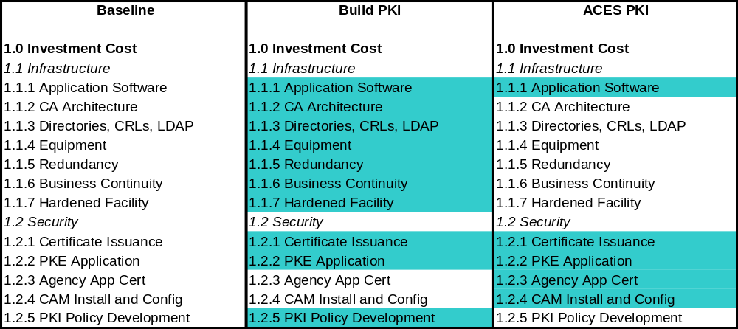

Under the Build PKI approach, a major cost driver is the establishment of the PKI infrastructure. Many steps need to be taken to accomplish this including the establishment of a Certificate Authority (CA) architecture; the creation of Directories, CRLS, and LDAPs; the procurement of equipment with associated redundancy; the accounting for business continuity and a hardened facility. These steps are not taken when acquiring an ACES PKI solution but rather are embedded in the certificate issuance fee assessed to the agency. These cost elements and the assumptions used in their constructions are discussed below:

1.1.2 CA Architecture includes the cost to design, build and stand up a certificate authority to take between 4 man months and 1.5 man-years depending on the size of the system. The labor rate used was a Developer off the GSA IT Schedule at $98 per hour.

1.1.3 Directories/CRL/LDAP were assumed to be $5 per entry. Therefore $5 was multiplied times the number of systems users.

1.1.4 Equipment costs were assumed to be between $8,000 (Intel-based) and $45,000 (HP-UX or Solaris) a box. Smaller solutions like Scenario 2 required 3 boxes while more complex solutions like Scenario 3 required 6 boxes.

1.1.5 Redundancy to assure necessary uptime was assumed to be 50% of PKI Equipment costs.

1.1.6 Business Continuity in the event of disaster included the cost of developing and testing a continuity plan and ranged from 80 hours for Scenario 2 to 3 months for Scenario 3.

1.1.7 Harden Facility costs were determined on a per square footage basis for cipher locks, hardened doors/ceilings/walls. This cost included cabling, dedicated T-1 lines, and security alarms. Hardened facility assumptions were made for all scenarios except Scenario 2.

Security investment costs differ between a Build PKI approach and ACES. Under Build PKI, certificate issuance costs and PKI Policy Development costs must be considered.

1.2.1 Certificate Issuance costs in a Build PKI approach was assumed to be $1 per certificate with a 10% annual re-issuance rate. Certificates were assumed to have a one-year useful life. These costs will scale to the number of system users.

1.2.2 PKE Application costs are the cost to public key enable (PKE) an application. This applies only to PIN-based systems converting to PKI. PKE costs are assumed to be $150,000 per application through the use of a toolkit. The model assumes that for paper-based transactions, the PKE costs are embedded as part of the application software.

1.2.5 PKI Policy and Practices Development costs are a major component of a Build PKI approach and were assumed to include 3 full time equivalents (FTE) (this includes one GS9, one GS12 and one GS15) for between 6 and 9 months depending on the complexity of the system. For purposes of estimate, we assumed Step 5 for each GS level.

Security investment costs for ACES are a function of certificate issuance costs, the acquisition of an agency application certificate, and the installation and configuration of a CAM.

1.2.1 Certificate issuance fees are based on the following ACES price schedule that is an average cost of all 3 ACES vendors -
ACES Year | Year 3 | Year 4 | Year 5 | Year 6 | Year 7 Projected
Cert Issuance | $51.66 | $51.85 | $52.04 | $52.25 | $53.82

However, for applications with 100,000 users or more, a certificate issuance fee was assumed using the lowest ACES vendor rate.

ACES Year | Year 3 | Year 4 | Year 5 | Year 6 | Year 7 Projected
Cert Issuance | $20.00 | $20.60 | $21.22 | $21.85 | $22.51

1.2.3 Agency application certificate typically assumes 2 CAMs per application for redundancy. However simple systems like Scenario 2 only need one CAM.

1.2.4 CAM installation and configuration assumes 1 FTE per CAM for 40 hours. Under the ACES contract, this FTE rate is $125 per hour.

Operating Costs

Like investment costs, the operating costs differ across the three approaches. For paper-based baseline transactions, the cost of printing and storing paper as well as filing, processing and keying in data from forms needs to be accounted. For PIN-based baseline transactions, no (non-personnel) operating costs are assumed. Electronic forms for delivery over the Internet can reduce the great costs of manual data transactions by cutting down on the labor and resources required for data input, processing, and storage. Multiple sources indicate that there is “substantial” cost reduction when processing an electronic form over a paper-based form. Case study-based metrics reveal between 48% and 99.4% cost reduction when organizations transition from manual forms to an electronic transaction environment as described below:
- The Department of Defense identified $1.2 billion in savings by automating 16 most-used forms over a 10-year period. ROI metrics reveal a 1500% return ($60 million investment) for its $4 million investment in form automation in FY92.

These printing and storage 2.3; and filing, processing and keying 2.4 assumptions of $15 per form and $145 per form respectively were used as assumptions in the Baselines of Scenarios 1 and 2. These cost assumptions are detailed in Appendix A.

Figure 4-9. Cost Element Structure of Operating Cost
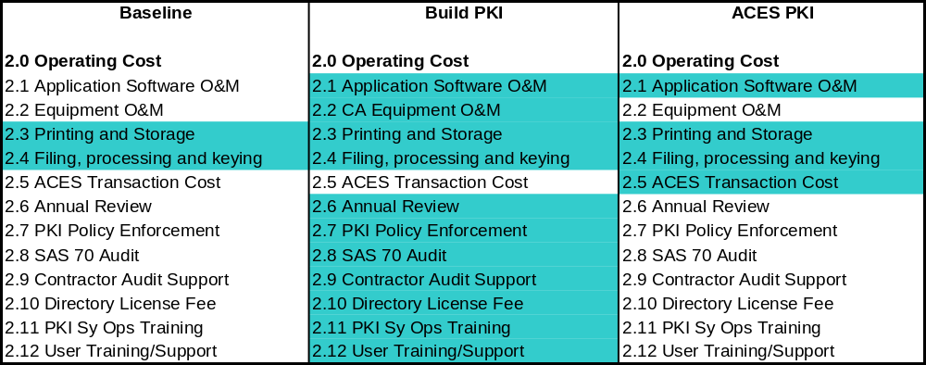

The Build PKI approach operating costs include: Certificate Authority (CA) equipment operations and maintenance, annual system review, PKI policy enforcement, SAS 70 Audit, contractor audit support, directory license fee, PKI system operations training, and end user training and support. It is important to note that these costs recur annually.

2.1 Application software O&M (operations and maintenance) is assumed to be 18% of application acquisition costs.

2.2 CA equipment O&M was assumed to be 10% a year of CA equipment acquisition costs from the investment cost section.

2.6 Annual review of system assumed one GS 15 for between 45 and 120 hours depending on the size of the system.

2.7 Enforcement of PKI policy was assumed to range between $75,000 and $150,000

2.8 SAS 70 audit included 10 FTEs for 60-160 hours. This includes four GS 7, four GS 12, and two GS 15 at between 60 and 160 hours each depending on the size of the system.

2.9 Contractor audit support was assumed to be between ¼ and ¾ of a man-year.

2.10 Directory license fee and operation/maintenance (O&M) cost was assumed to be between $50,000 and $70,000 license fee under scenarios 1,3 and 4 with O&M cost being 15% of annual directory cost. Scenario 2 is very streamlined therefore we assumed $5000 for total directory fee.

2.11 PKI system operation training was assumed to be $1500 per PKI system operator. Since there is a high turn over rate in this position, these costs were assumed to recur every year. Assume .5 FTE for small systems and 3 FTE for large systems (GS 14).

2.12 End user training and support was assumed to include awareness training, documentation and web support. Initial training development ranged between $25,000 and $225,000 depending on scenario with a 10% recurring rate in the out years after initial development.

Finally, if paper-based transactions are not completely eliminated then a marginal cost for printing and storing forms as well as filing, processing and keying data will remain and should be included in the PKI costs.

Under ACES, operating costs recur annually and comprise application software operation and maintenance, ACES transaction costs, and the marginal cost for supporting paper-based transactions if they are not eliminated.

2.5 Application software operations and maintenance is assumed to be 18% of application acquisition costs.

ACES operations costs are also very straightforward and are administered on a "per transaction" cost. The following chart shows the ACES transactions costs:

Figure 4-10. ACES Transaction Costs by Year
ACES Year | Year 3 | Year 4 | Year 5 | Year 6 | Year 7 Projected
<100,000 certificates | $ 1.25 | $ 1.24 | $ 1.25 | $ 1.29 | $ 1.33
250K-<500K | $ 0.88 | $ 0.89 | $ 0.90 | $ 0.91 | $ 0.94
1 mil-<5 mil | $ 0.65 | $ 0.66 | $ 0.66 | $ 0.67 | $ 0.69

Personnel Costs

Personnel cost drivers differ across approaches. For PIN-based baseline transactions, system administrator and help desk (both GS 13) are required to support baseline transactions. To capture the baseline costs of Scenarios 3 and 4, the system administration and help desk costs to maintain a PIN-based system were captured. The following assumptions were made.

Figure 4-11. Personnel Cost Assumptions for Scenarios 3 & 4
Scenario | Total Support Ratio | System Administrators | Help Desk
3 | 1 support staff/16,667 users | 20 FTE | 40 FTE
4 | 1 support staff/15,000users | 8 FTE | 10 FTE

Figure 4-12. Cost Element Structure of Personnel Cost
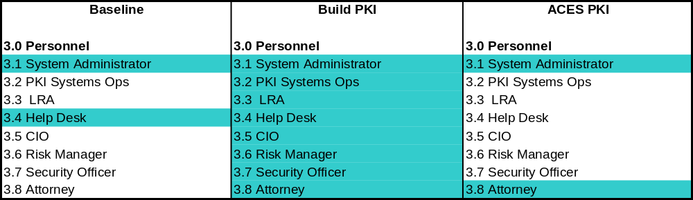

Build PKI personnel costs are based on the following assumptions for: system administrator, PKI system operators, Local Registration Authorities (LRA), help desk, Chief Information Officer (CIO), Risk Manager, Security Officer and Attorney.

3.1 System administrator (GS 13) requirement between 1-3 FTE depending on scenario. These assumptions are the same under ACES as well.

3.2 PKI system operator (GS 14) requirement between 0.5 – 3 FTE.

3.3 LRA (GS 9) assumed 5 minutes to issue each certificate.

3.4 Help desk support (GS 7) level assumes 33% of users call and each call takes 10 minutes.

3.5 CIO (ES 2) support of between 40-120 hours a year depending on scenario.

3.6 Risk manager (GS 15) annual support between 10-15%.

3.7 Security officer (GS 15) annual support between 12-50% depending on scenario.

3.8 Attorney (GS 15) between 35-75% of time first year and then 80-180 hours in later years.

3.9 Program Manager Process Owner (GS 14) .10 FTE per 200,000 users in the recurring years. Add an additional 50% in the first year and yet another 50% if starting as a paper-based transaction. For ACES, the additional 50% in the first year does not apply.

Finally ACES personnel costs include a system administrator and an attorney. The system administrator assumptions are the same for Build PKI and ACES. The attorney support is much less than it is for Build PKI requiring 1-2 attorneys (GS 15) for only 2 weeks.

In Section 5, Apply ROI Methodologies to Four Archetypal Scenarios, these baseline and ROI best practices are applied to demonstrate four ROI scenarios.

Apply ROI Methodologies to Four Archetypal Scenarios
This paper explores Return on Investment results of four scenarios. These scenarios demonstrate the use of PKI for different types of transactions: government and business, and government and citizen. Under these scenarios PKI is used primarily for digital signature and non-repudiation. Scenarios were selected at different phases – two are modeled with paper-based baseline business processes, and two are modeled in a PIN-based environment. Of the PIN-based baseline business processes, the scenarios consider the use of PKI by a system owner on a single application and the view of a Chief Information Officer (CIO) managing a portfolio of applications and streamlining 3 standalone PIN-based systems into a shared PKI.

A range of constituent sizes is selected from 25 vendors to 1 million businesses to discern if economies of scale have an impact on ROI. Finally, frequency of transactions is also modeled ranging from one to 52 transactions per year. These variables show the scalability of PKI.

- Phase of the Transaction in the Digital Lifecycle. Scenarios 1 and 2 represent business processes that currently require ink on paper signatures and are thus paper-based. Scenarios 3 and 4 represent business processes that are currently automated but rely on PIN/password. Most users of this guide will fall into one of these two categories.
- Constituent Size. Users communities of varying sizes are also provided ranging from 25 vendors to 1 million businesses. Constituent size is an important cost driver related to certificate issuance. This broad range enables users of the guide to map their interest more closely to like-size PKI applications.
- Number of Annual Transactions/Submissions. Transaction volume (number of PKI validations) varies from one annual submission per user to 52 weekly transactions. The volume of annual transactions/submissions impacts operating costs especially under ACES where agencies pay on a transaction fee basis.
- Business Requirement. Scenarios 1-3 reflect applications requiring digital signature, and scenario 4 demonstrates the use of PKI for access control.

Figure 5-13. Scenario Summary Table

- Scenarios 1, 2 and 3 represent B2G – Transactions between business and the government
- Scenario 4 represents C2G – Transactions between citizens and the government

Scenario 1: This scenario assumes an agency that receives signed quarterly filings from 10,000 businesses (a total of 40,000 transactions per year). Currently this business process is completely paper-based. Under this scenario, the agency must first acquire an appropriate COTS application and then utilize PKI functionality either through a Build PKI approach or an ACES trusted 3rd party approach. The agency desires to use PKI for digital signature capability.

Scenario 2: This scenario assumes an agency that receives weekly filings from 25 businesses (a total of 1300 transactions per year). Currently this business process is completely paper-based. The agency must first acquire an appropriate COTS application and then utilize PKI functionality either through a Build PKI approach or an ACES trusted 3rd party approach. For the Build PKI model we assumed a limited deployment, meaning with such a small, close-knit user community, the desired investment in PKI would be minimal. The agency is pursuing PKI to satisfy a digital signature requirement.

Scenario 3: This scenario assumes an agency that receives annual filings from 1,000,000 businesses (a total of 1,000,000 transactions per year). An electronic application using user ID/PIN is currently be used but the agency is looking to PKI for enhanced digital signature functionality. The agency will utilize PKI functionality either through a Build PKI approach or an ACES trusted 3rd party approach.

Scenario 4: This scenario assumes an agency that receives annual filings from 270,000 citizens. All the constituents access at least one of three applications. Each application serves 150 users and the agency is looking to PKI for enhanced access control beyond their current PIN solution. Sixty percent of users can access more than one account. The agency is trying to streamline its IT security infrastructure and is looking at PKI as a possible solution.

The following summarizes the five-year life cycle cost estimates for each of the scenarios. Details of these calculations are presented later in this section.

Figure 5-14. Findings of Scenarios
Scenario | Baseline | Build PKI | ACES
Scenario 1 | $32 million | $9.03 million | $4.1 million
Scenario 2 | $1.04 million | $2.4 million | $700 thousand
Scenario 3 | $33.4 million | $35.5 million | $33.5million
Scenario 4 | $10 million | $15.2 million | $9 million

It is important to note that volume discounting was assumed when 100,000 or more certificates were required. The rest are worst-case scenario unit price. Also, it was assumed that PKI under either Build PKI or acquire ACES could be fully stood up and completely utilized in the first year. In all likelihood, this assumption is quite ambitious.

Figure 5-15. ROI Findings
Scenario | Build PKI | ACES
Scenario 1 | -2.74 | -7.14
Scenario 2 | 0.46 | -0.51
Scenario 3 | -0.27 | -0.86
Scenario 4 | 0.04 | -0.71

The above Return on Investment chart shows the total present value cost of each alternative to savings in operating costs from the baseline. Because the ROI is expressed as savings, in an optimal case, this number should be negative. The more negative the ROI, the greater the savings and stronger the ROI. If the number is positive, it means that no efficiency/savings is achieved from the baseline environment. It may seem counterintuitive that Scenarios 3 and 4 could show a favorable ROI when the Build PKI and ACES approach have a total life cycle cost that is greater than the baseline. Remember however, that ROI is looking at operating cost savings, not investment costs. Another look at Scenarios 3 and 4 shows the following.

Figure 5-16. Operating/Personnel Costs by Security Solution
Scenario | Baseline Operating/Personnel Cost | Build PKI Operating/Personnel Cost | ACES Operating/Personnel Cost
Scenario 3 | $33.4 million | $23.7 million | $4.7 million
Scenario 4 | $10 million | $10.7 million | $3.6 million

Analysts concluded that PKI under both approaches (Build PKI and ACES) could be a viable investment. In all scenarios however, it is cheaper to operate PKI under ACES rather than Build PKI. Use of the ACES acquisition approach yielded a positive Return on Investment in every scenario but requires a significant investment under scenario 3 for issuance of certificates at a standard ACES price without a volume discount. Further, it was determined that:

- The Build PKI approach also yielded a positive ROI in two of four scenarios and was competitive with the baseline in all scenarios.

- In scenarios 1 and 2, Build PKI requires a greater cash outlay than ACES. However, in scenario 3, Build PKI requires less upfront costs than ACES.

- Build PKI shows a slight discount to ACES in investment cost required for scenario 4.

Four Proposed Scenarios

The four sample scenarios are designed to show the fundamental differences in how and where dollars are allocated for building a PKI system versus using a trust 3rd party under ACES. To calculate Return on Investment (ROI) for each scenario, the PKI approaches (e.g., either Build PKI or acquire ACES) are compared to a baseline. Each scenario contains 5 main sections:

- ROI Findings: The ROI shows the findings/summary of the analysis by comparing the Return on Investment for the Build PKI and ACES approaches to the baseline.
- Parameters: The parameter section is where all the assumptions for each of the three approaches are held.
- Baseline: The baseline is the pre-PKI state and shows the cost of executing the business process without using PKI.
- Build PKI: The Build PKI approach takes the fundamental assumptions driving the transaction level of the scenario and arrays them against the cost of building and operating an internal PKI for this business application.
- ACES: The ACES approach takes the fundamental assumptions driving the transaction level of the scenario and arrays them against ACES contract cost drivers for PKI.

Following are findings for each scenario with detailed backup. The backup pages are organized as follows for each scenario:

Summary Page:
- ROI results (Sections 5.1.2, 5.2.2, 5.3.2, and 5.4.2)
- Business assumption (Sections 5.1.3, 5.2.3, 5.3.3, and 5.4.3)
- Baseline parameters (Sections 5.1.4, 5.2.4, 5.3.4, and 5.4.4)

Tables:
- Baseline Lifecycle Cost
- Build PKI
  - Parameters
  - Lifecycle Cost
- ACES PKI
  - Parameters
  - Lifecycle Cost

Also included at the end of this section is a set of global assumptions applicable across all scenarios for GS, executive service, and contractor wage rates.

SCENARIO 1

Scenario 1 Description

This scenario assumes an agency that receives signed quarterly filings from 10,000 businesses (a total of 40,000 transactions per year). Currently this business process is completely paper-based. Under this scenario, the agency must first acquire an appropriate COTS application and then utilize PKI functionality either through a Build PKI approach or an ACES trusted 3rd party approach. The agency desires to use PKI for digital signature capability.

Scenario 1 Findings
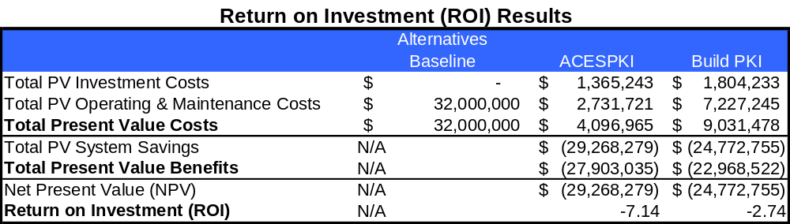

This Return on Investment chart compares total present value cost of each alternative to savings in operating costs from the baseline. Because the ROI is expressed as savings, in an optimal case, this number should be negative. If the number is positive, it means that no efficiency/savings is achieved from the baseline environment. The more negative the ROI, the greater the savings and stronger the ROI.

Scenario 1 Assumptions



These fundamental assumptions feed the total volume levels for the baseline, ACES, and Build PKI approaches.

BASELINE Parameters for Scenario 1



Assumptions on printing and storage as well as filing processing and keying cost found in "Business at the Speed of Thought, Succeeding in the Digital Economy" by Bill Gates. These are conservative estimates of manual processing costs.

Baseline Life Cycle Cost of Scenario 1
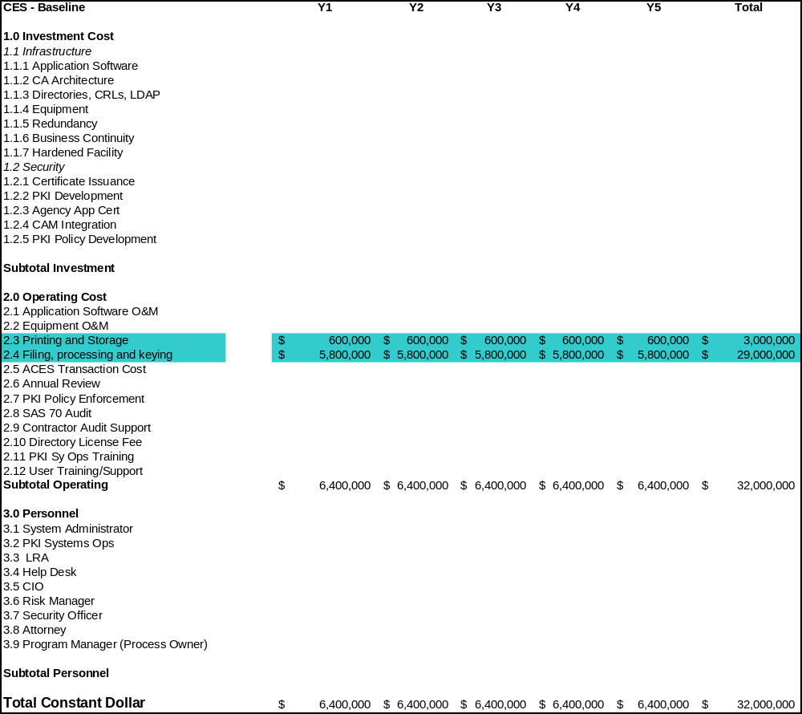

The total life cycle cost for operating a paper-based business process with 40,000 transactions a year is $32 million over 5 years (constant dollar).

Build PKI Parameters for Scenario 1
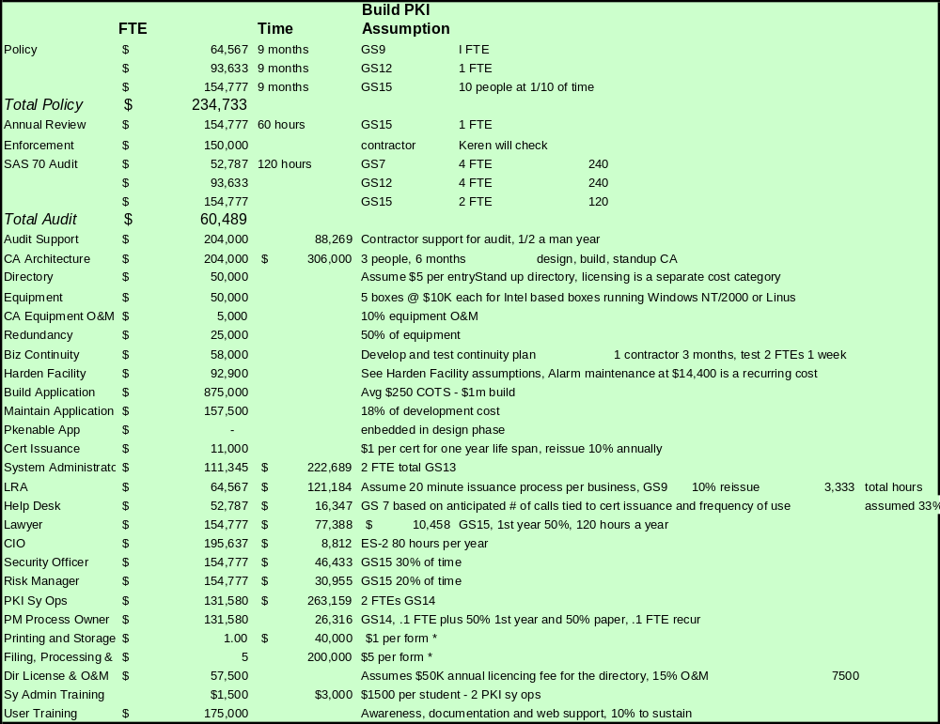

Build PKI Life Cycle Cost of Scenario 1
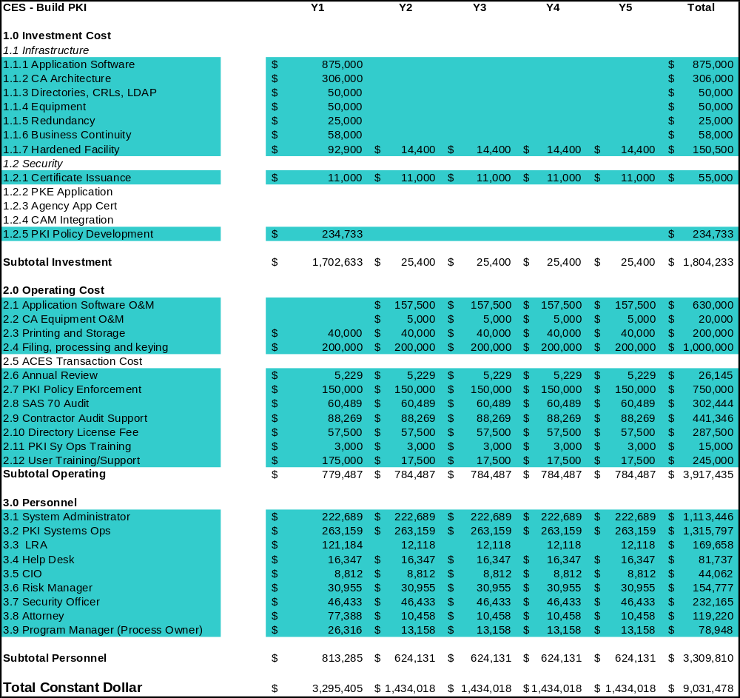

ACES Parameters for Scenario 1
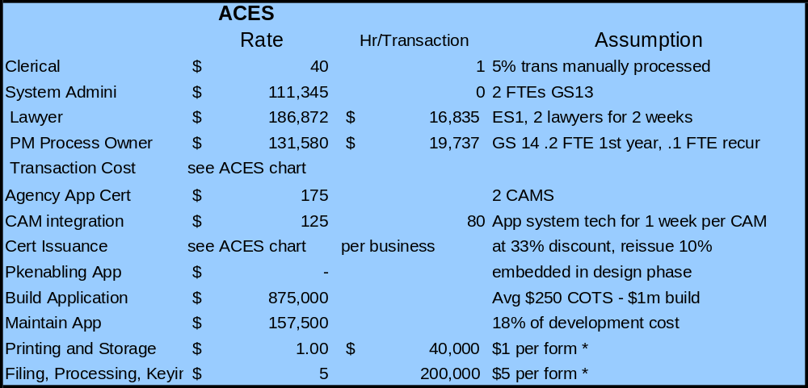

ACES Year | Year 3 | Year 4 | Year 5 | Year 6 | Year 7 Projected
Cert Issuance | $51.66 | $51.85 | $52.04 | $52.25 | $53.82
Transaction Cost | $ 1.25 | $ 1.26 | $ 1.27 | $ 1.29 | $ 1.33

The certificate issuance costs are an average of the three ACES provider rates.

ACES Life Cycle Cost of Scenario 1
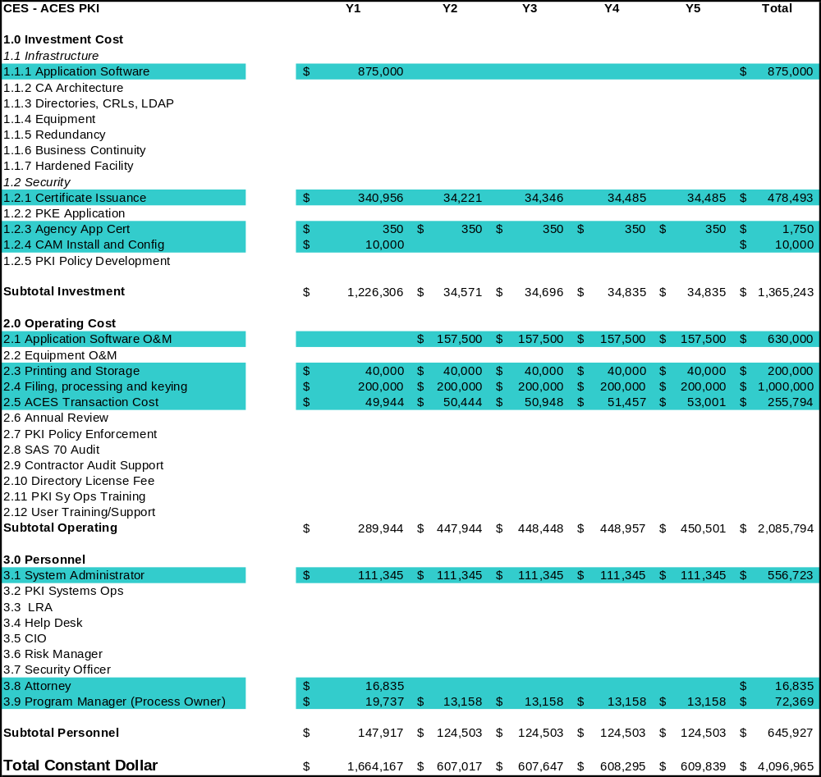

SCENARIO 2

Scenario 2 Description

This scenario assumes an agency that receives weekly filings from 25 businesses (a total of 1300 transactions per year). Currently this business process is completely paper-based. The agency must first acquire an appropriate COTS application and then utilize PKI functionality either through a Build PKI approach or an ACES trusted 3rd party approach. For the Build PKI model we assumed a limited deployment, meaning with such a small, close-knit user community, the desired investment in PKI would be minimal. The agency is pursuing PKI to satisfy a digital signature requirement.

Scenario 2 Findings

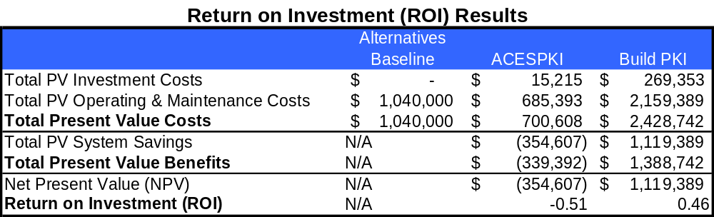

Scenario 2 Assumptions

BASELINE Parameters for Scenario 2

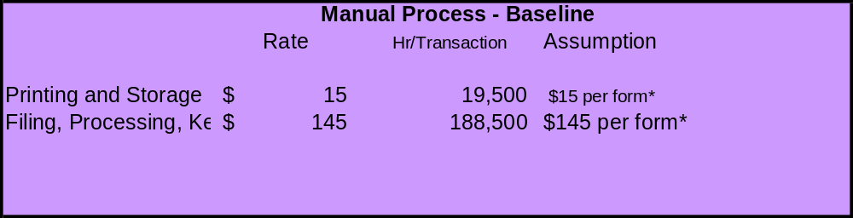

Baseline Life Cycle Cost of Scenario 2

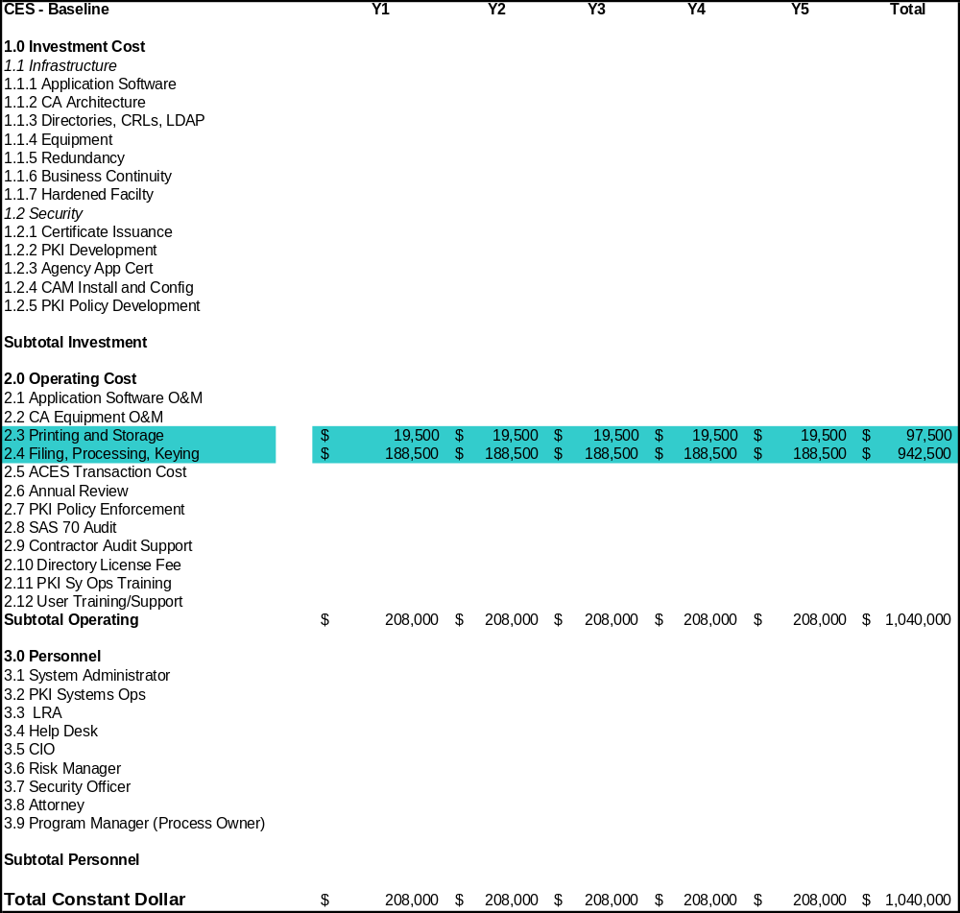

Build PKI Parameters for Scenario 2

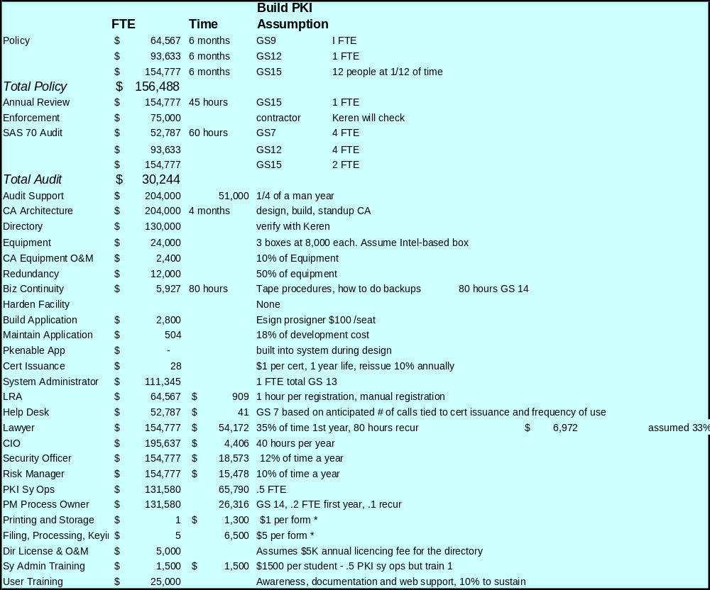

Build PKI Life Cycle Cost of Scenario 2

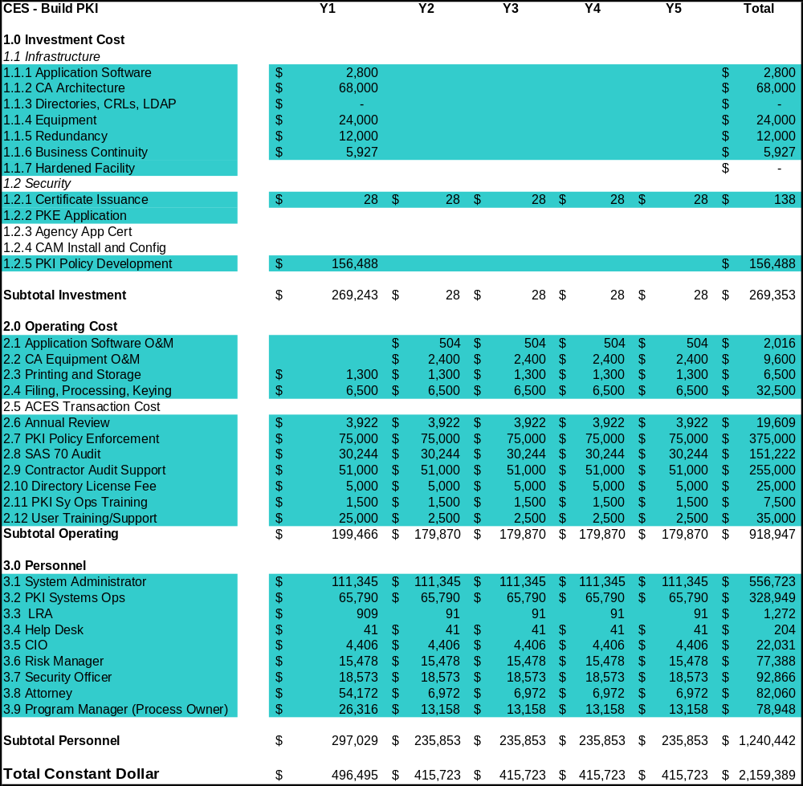

ACES Parameters for Scenario 2
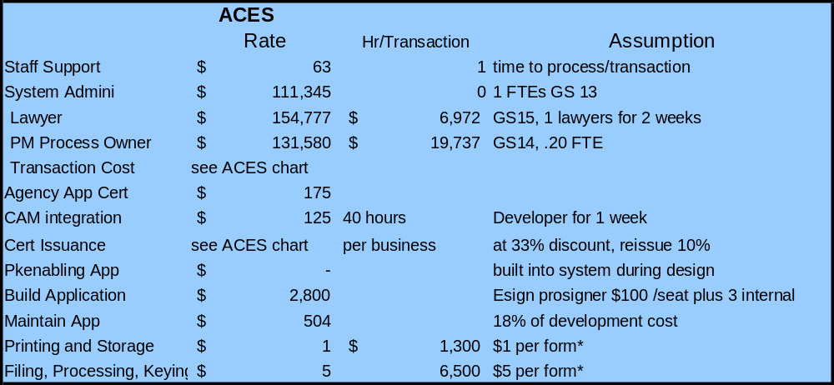

ACES Year | Year 3 | Year 4 | Year 5 | Year 6 |  | Year 7 Projected
Cert Issuance | $51.66 | $51.85 | $52.04 | $52.25 | $53.82
Transaction Cost | $1.25 | $1.26 | $1.27 | $1.29 |  | $1.33

ACES Life Cycle Cost of Scenario 2

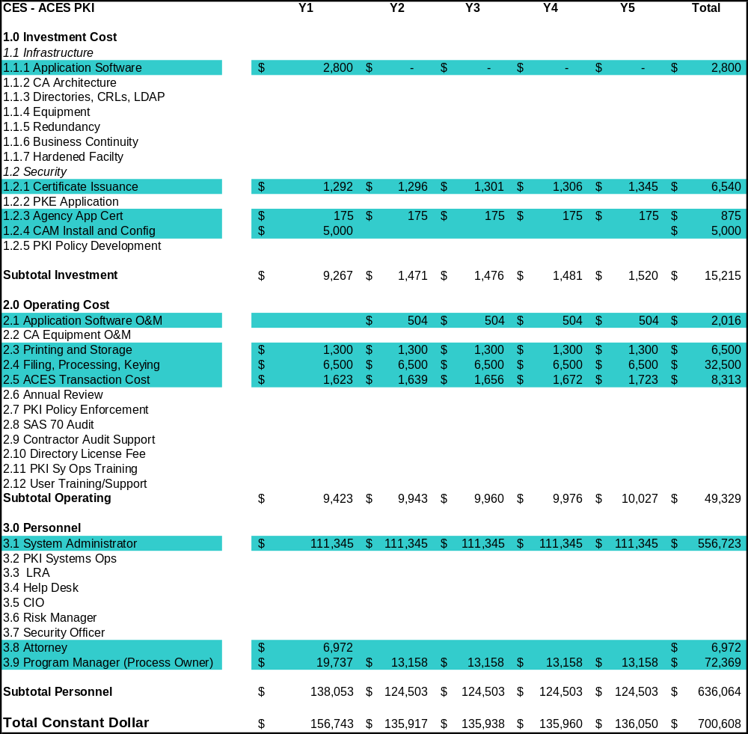

SCENARIO 3

Scenario 3 Description

This scenario assumes an agency that receives annual filings from 1,000,000 businesses (a total of 1,000,000 transactions per year). An electronic application using user ID/PIN is currently employed, but the agency is looking to PKI for enhanced digital signature functionality. The agency will utilize PKI functionality either through a Build PKI approach or an ACES trusted 3rd party approach.

Scenario 3 Findings

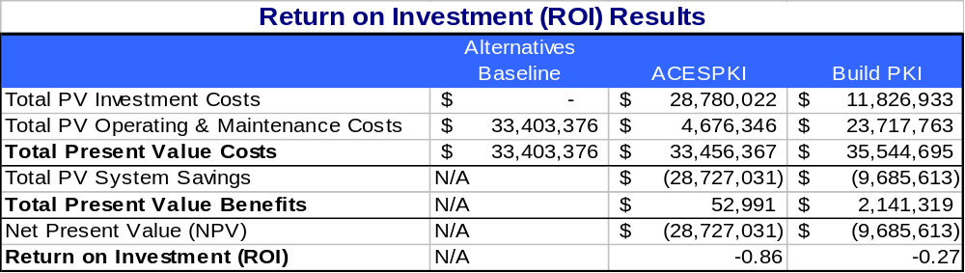


Scenario 3 Assumptions

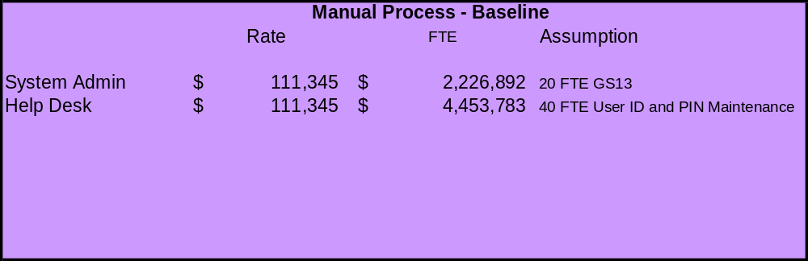
BASELINE Parameters for Scenario 3

Baseline Life Cycle Cost of Scenario 3

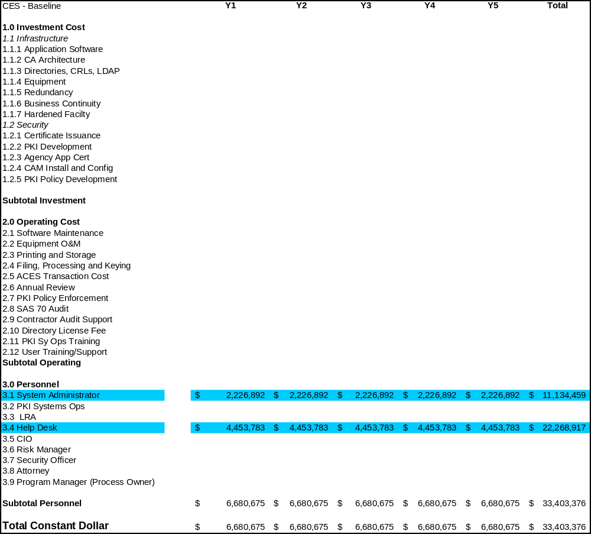

Build PKI Parameters for Scenario 3

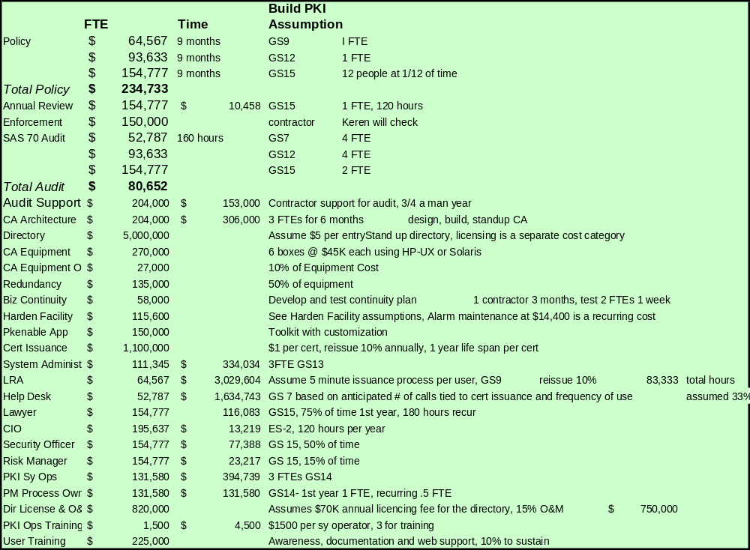

Build PKI Life Cycle Cost of Scenario 3

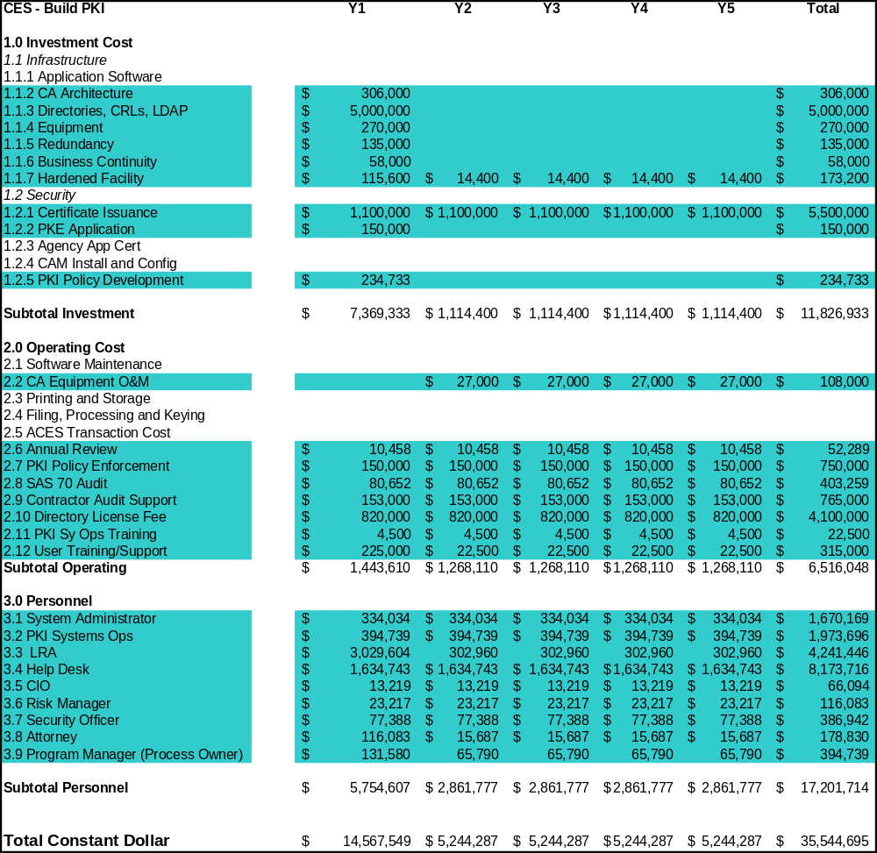

ACES Parameters for Scenario 3
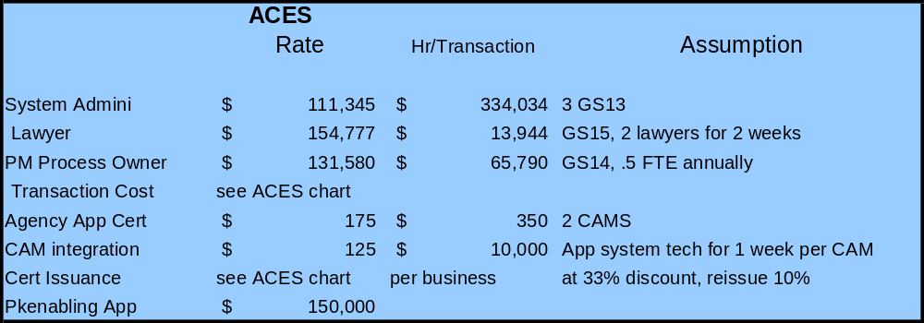

ACES Year | Year 3 | Year 4 | Year 5 | Year 6 | Year 7 Projected
Cert Issuance | $20.00 | $20.60 | $21.22 | $21.85 | $22.51
Transaction Cost | $0.65 | $0.66 | $0.66 | $0.67 | $0.69

ACES Life Cycle Cost of Scenario 3

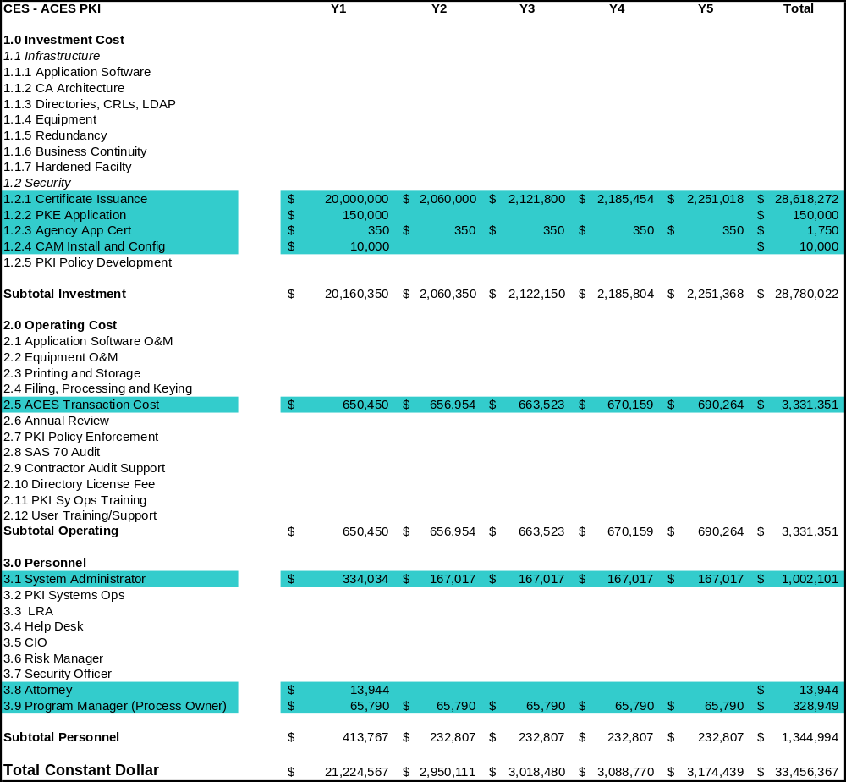

SCENARIO 4

Scenario 4 Description
This scenario assumes an agency that receives annual filings from 270,000 citizens. All the constituents access at least one of three applications. Each application serves 150 users, and the agency is looking to PKI for enhanced access control beyond its current PIN solution. Sixty percent of users can access more than one account. The agency is trying to streamline its IT security infrastructure and is looking at PKI as a possible solution.

Scenario 4 Findings

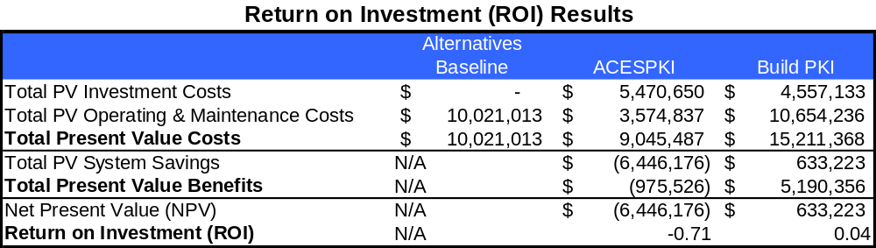

Scenario 4 Assumptions

BASELINE Parameters for Scenario 4
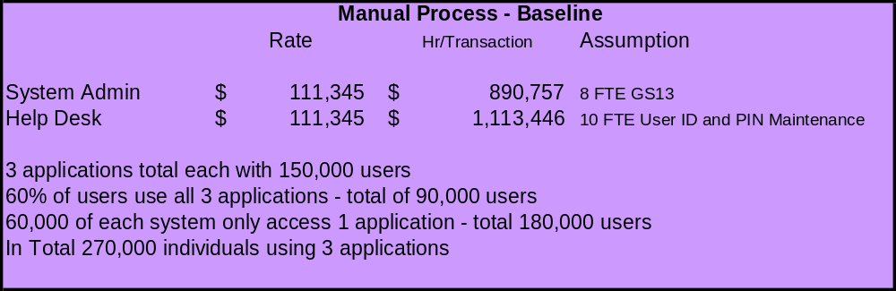

Baseline Life Cycle Cost of Scenario 4

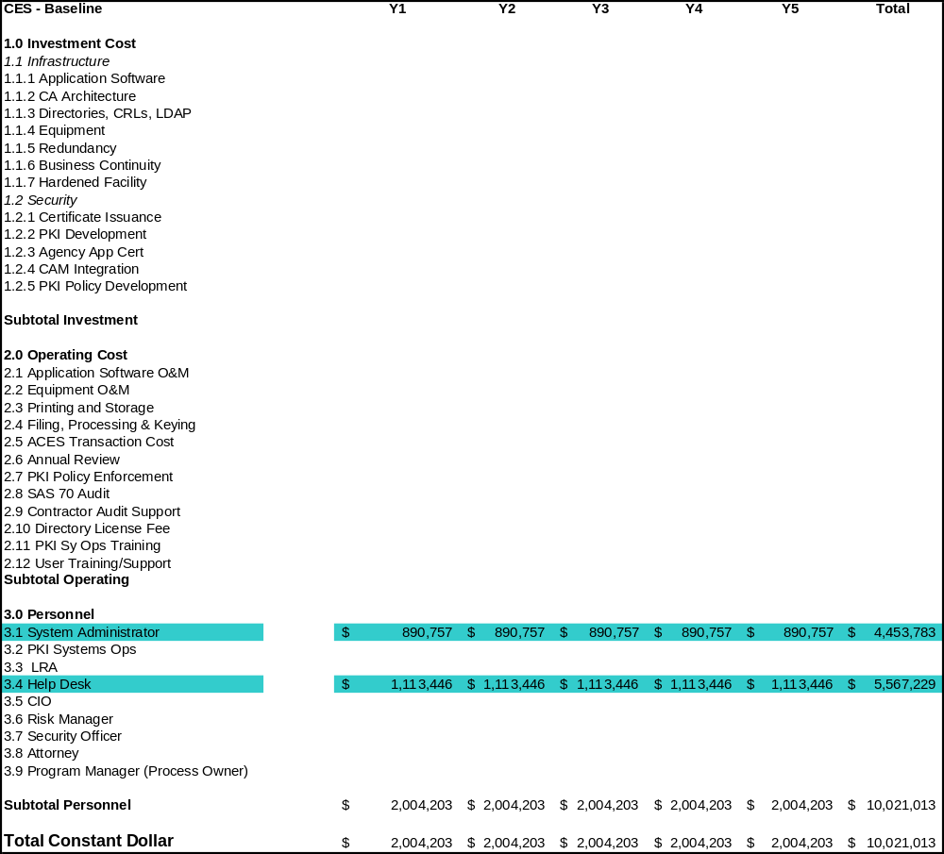

Build PKI Parameters for Scenario 4

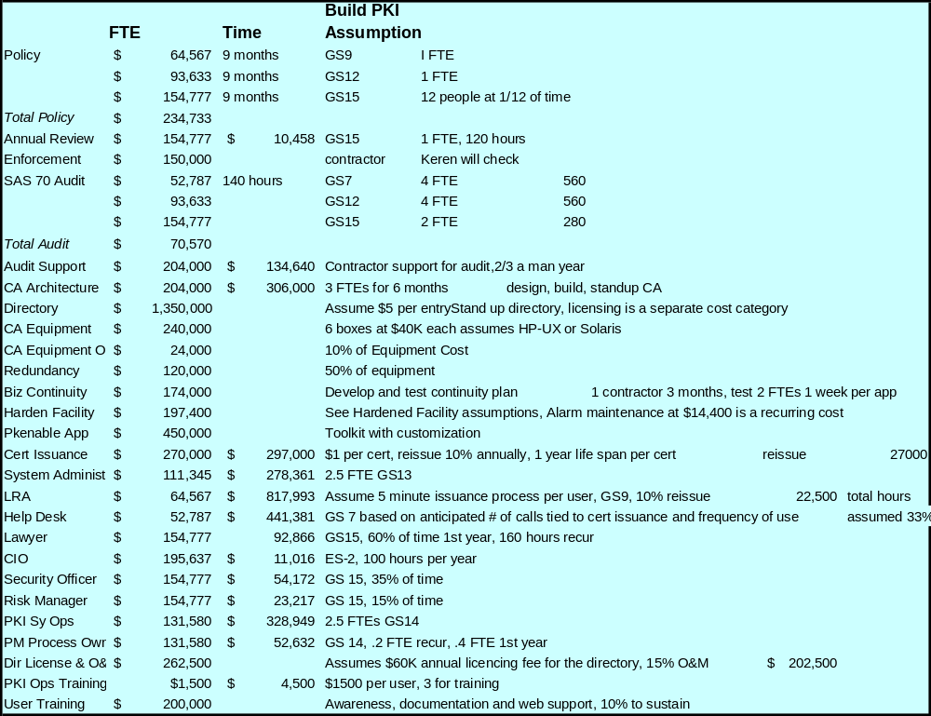

Build PKI Life Cycle Cost of Scenario 4

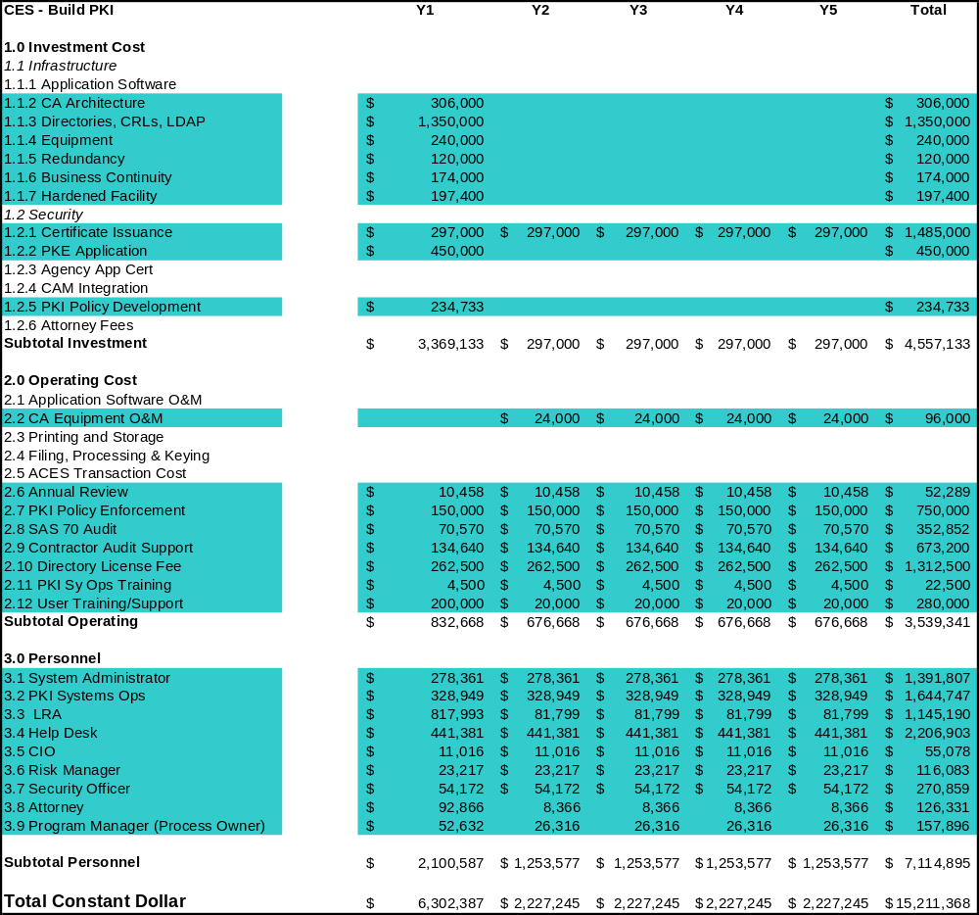

ACES Parameters for Scenario 4

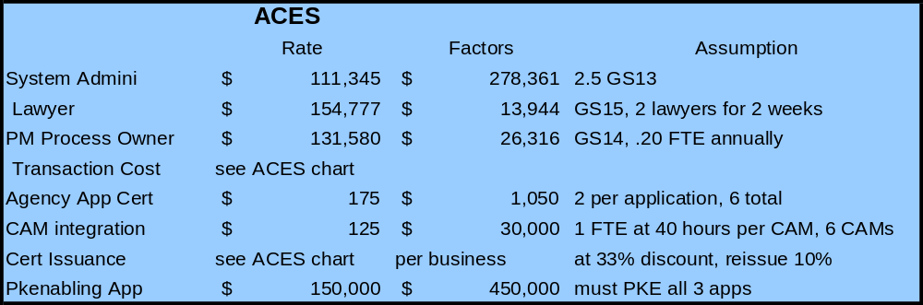

ACES Year | Year 3 | Year 4 | Year 5 | Year 6 | Year 7 Projected
Cert Issuance | $20.00 | $20.60 | $21.22 | $21.85 | $22.51
Transaction Cost | $0.88 | $0.89 | $0.90 | $0.91 | $0.94

ACES Life Cycle Cost of Scenario 4

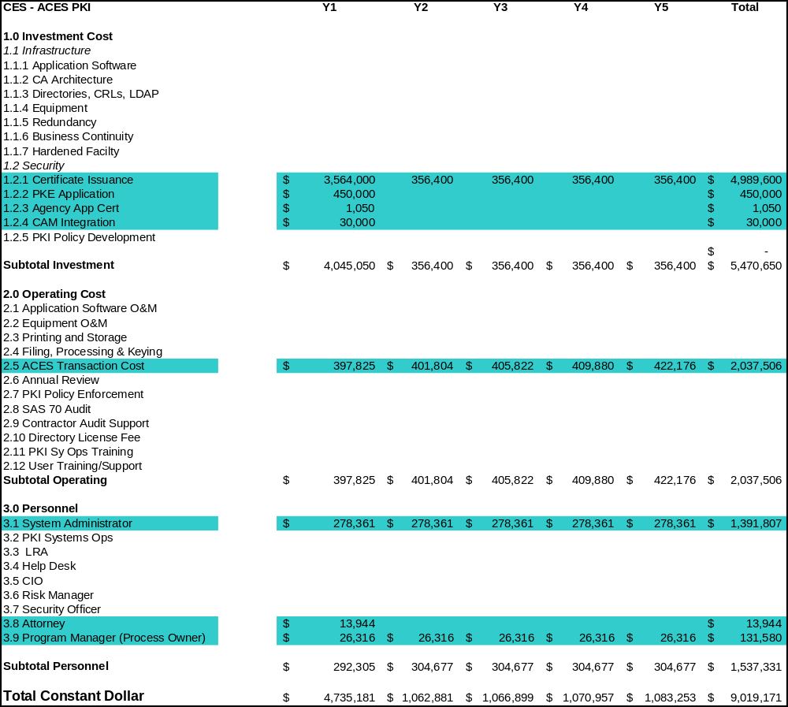

Global Assumptions
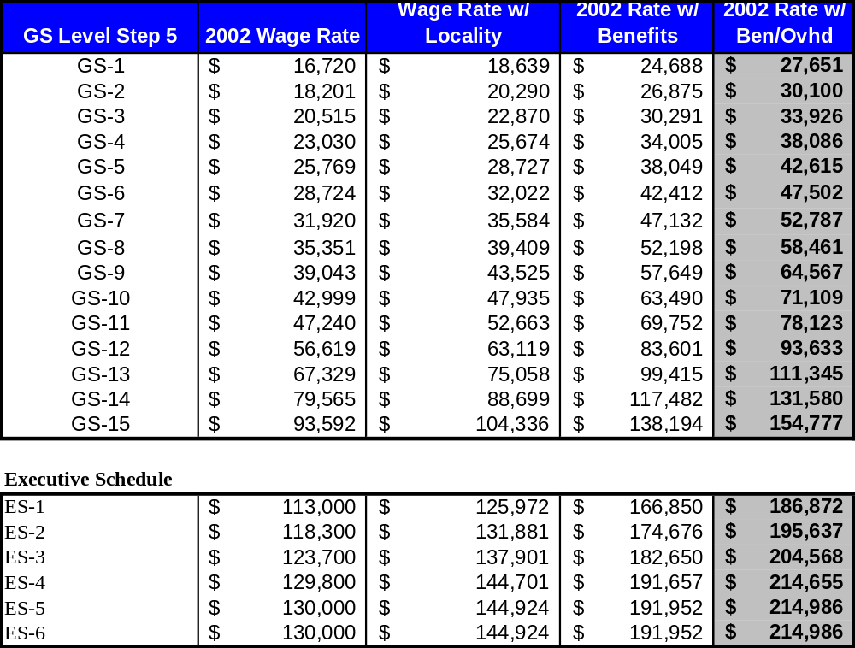
GS Pay Scale

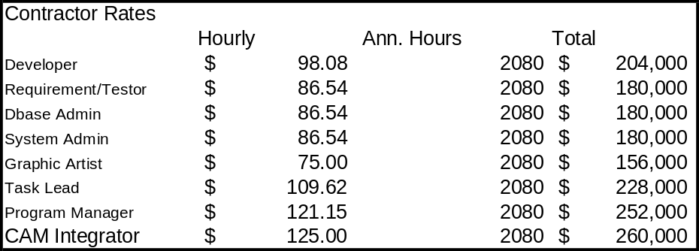Contractor

Conclusion
Analysts concluded that PKI under both approaches could be a viable investment. Use of the ACES acquisition approach yielded a positive Return on Investment in every scenario but requires a significant investment under scenario 3 for issuance of certificates (again, no volume discounts were applied). However, ACES vendors have traditionally worked with clients on pricing to include volume discounting and use of subscription based pricing rather than transaction-based pricing. Subscription based pricing is likely used in instances where high transactions levels are expected like in Scenario 2 (weekly or more frequent submissions per user). The Build PKI approach also yielded a positive ROI in two of four scenarios and was competitive with the baseline in all scenarios. In scenarios 1 and 2, build PKI requires a greater cash outlay than ACES. However, in scenario 3, build PKI requires less upfront costs than ACES. Build PKI shows a slight discount to ACES in investment cost required for scenario 4. In all scenarios however, it is cheaper to operate PKI under ACES rather than Build PKI.

Conclusion
For this study, analysts set out to evaluate existing methodologies for calculating Return on Investment for PKI, and found that they have not been developed for the B2G and C2G environments. Accordingly, a cost methodology was created specifically to determine the ROI of PKI in those environments. To test the methodology, four scenarios were developed that seemed to capture a broadly representative sampling of the types of B2G and C2G services Federal agencies need to deploy in a trusted online environment.

The methodology examined two alternative approaches to PKI: an in-sourced Build PKI model and the government-wide contract available for a ready-made, outsourced PKI, ACES. The findings support the proposition that PKI in general is more cost effective compared to paper-based systems and electronic systems that use PIN/password security. The findings additionally demonstrate that outsourced PKI, like ACES, is especially effective in small to large environments.

In general, deploying PKI-enabled applications becomes more cost-effective as additional applications come online, leveraging the value of the initial investment. This is the primary reason for the cost-effectiveness of the ACES program, in which multiple agencies leverage the same PKI physical and policy infrastructure investments government-wide. It also suggests that the overall cost-competitiveness of Build PKI as an option will improve as an agency brings up additional applications, though it may not reach the degree of leverage achieved by sharing a government-wide infrastructure.

Appendix A: Literature Reviewed
The following documents were reviewed:

- GSA PKI/Smart Card Project: Approach for Business Case Analysis of Using PKI on Smart Cards for Governmentwide Applications, January 2001 – www.egov.gov/smartgov/BAHFinal18Apr01.doc

Findings/Lessons Learned/Benefits: Small agency (FDIC) – PKI was used and determined to be scalable, improve operations, streamline business processes, reduce costs, create economies of scale, offer affordable technology, enhance quality of data check, and expedite service. A comparison of large and small agency showed that both prepare a certificate policy and a certificate practice statement, determine needs for interoperability, consider phasing, use a department-wide approach, define the registration process, employ revocation policy and liability issues, and determine requirements for secure communications.

PKI Functionality: Small agency (FDIC) – encryption of data (confidentiality), digital signature for travel vouchers. Large agency – data integrity.

ROI Methodology: Business case analysis: (1) perform environmental assessment; (2) establish baseline and set targets; (3) identify alternatives; (4) determine costs; (5) determine benefits; (6) determine risks; (7) evaluate economic impact; (8) compare and recommend; (9) monitor the impact. The cost of four information assurance solutions were compared, two with PKI and two without PKI.

ROI Claims: Use of PKI and digital signature for travel voucher almost paid for the entire PK infrastructure with savings of $3.2–4 million per year.

Target Environment/Transaction Parties: FDIC and a large agency.

Life Cycle Cost Factors: $1.4 million for the smartcards and PKI.

Assumptions: FDIC – based on vendor information, $75 per seat for the license and cost of infrastructure, including standing up the PKI, cost of issuing stations, and cost of kiosks. Large agency – outsource, keep certificates to a minimum, and single source.

Applicability to Federal Environment: Because this paper focused on one large and one small agency of the federal government, the analysis should be almost completely applicable to any agency in the federal government, suggesting substantial cost savings through the use of PKI.

- NIST Managing Your ROI – www.csrc.nist.gov/nissc/1999/program/tutorial.htm

Findings/Lessons Learned/Benefits: PKI can effectively address security concerns such as confidentiality of connectivity, application of digital signatures in a paperless environment, single sign-on authentication, and evolving court cases involving hacker damage and corporate liability.

PKI Functionality: confidentiality, identification and authentication, and digital signatures

ROI Methodology: This paper does not provide an ROI calculator. Instead, it describes the steps that an organization should take to ensure that PKI is successful and returns value for investment: solicit management buy-in; evaluate industry PKI impacts; evaluate assets at risk; determine scope of PKI applicability; determine applicable PKI components; evaluate vendor PKI alliances; plan for realistic cost recovery strategy; and define and enforce applicable policies and procedures.

ROI Claims: The paper does not put a dollar value on savings or ROI, but it lists several benefits that it considers to make PKI well worth the investment: less asset exposure during online transactions; reduced costs in elimination of paper; and convenience to the customer of automated processing and business process reengineering.

Target Environment/Transaction Parties: Government and private sector

Life Cycle Cost Factors: certificate authorities, directories, tokens, certificate extensions, key recovery, and standards bodies.

Assumptions: None

Applicability to Federal Environment: The paper provides some helpful planning tips on how to ensure that the implementation of a PKI goes smoothly and returns value on the investment from the beginning of the process. Again, however, it does not calculate a dollar value for the ROI of PKI.

- RSA PKI ROI – www.rsasecurity.com/newsletter/v2n2/pkiroi.html

Findings/Lessons Learned/Benefits: RSA asserts that the value of PKI is so beneficial that it outweighs all associated costs.

PKI Functionality: The article focuses on the value of PKI in general and does not get into specific PKI functionality.

ROI Methodology: The article does not provide an ROI calculator. Instead, it concentrates on the cost and benefit factors that an organization should focus on when doing a business case analysis for PKI. It advises that an organization should use incremental analysis, use a line-item veto (if a particular cost element does not apply to the particular business environment under analysis, simply cross it out), and keep things in perspective (when selecting a vendor, the organization should also consider product functionality, technical architecture, strategic vision, financial strength, reputation, and service and support). In calculating the Return on Investment, the organization should adhere to the following framework: focus on the business process; establish appropriate metrics; establish a baseline for the current state; compare to the desired future state.
ROI Claims: ROI comes from increase in revenues, avoidance or reduction of costs, better ability in compliance, and mitigation of risks (e.g., productivity loss, monetary loss, indirect loss, and legal exposure).
Target Environment: Not specifically stated, but seemed primarily directed at the private sector.
Life Cycle Cost Factors: product/technologies, facilities, people, and process
Assumptions: Timeframe of 3-5 years
Applicability to Federal Environment: This article offers an optimistic view on PKI but does not offer an ROI calculator. Like most of the other papers, articles, and studies currently available on the ROI of PKI, it outlines certain factors to which organizations should assign value in determining the
- GIGA, A Total Economic Impact Analysis of Two PKI Vendors: Entrust and Verisign

Findings/Lessons Learned/Benefits: The choice of PKI provider depends on whether a customer wants to in-source or outsource the PKI.

PKI Functionality: digital certificates, secure e-mail, and desktop file encryption

ROI Methodology: The purpose of the study was to differentiate between the total costs of ownership of two different PKI solutions. GIGA’s Total Economic Impact study purports to “embrace the cost components of [Total Cost of Ownership] and a best-practice approach to minimizing costs, and extends it by explicitly incorporating both benefits and flexibility while tempering them with concepts of risk.”

ROI Claims: The study does not make any specific ROI claims as its focus is on cost comparison.

Target Environment/Transaction Parties: intranet/extranet; retain financial services; publishing; manufacturing; high tech R&D and manufacturing; and a federal government research agency.

Life Cycle Cost Factors: PKI systems; maintenance; services; staffing; and client software

Assumptions: Customer has already made the decision to implement a PKI; the study simply compares costs between two PKI providers.

Applicability to Federal Environment: While the study does not provide a calculator for ROI, it does outline the advantages of managing a PKI in-house (in-sourcing) and leaving the management of the PKI to an external organization (outsourcing). The study also provides several scenarios and associated costs that could be useful in an ROI calculation.

- Aberdeen, Evaluating the Cost of Ownership for Digital Certificate Project – www.aberdeen.com

Findings/Lessons Learned/Benefits: Cost comparison for PKI is difficult because of the widely varying differences in pricing structures among vendors.

PKI Functionality: digital certificates, certificate database repository, and digital certificate issuance and revocation procedures

ROI Methodology: The purpose of the study was to differentiate between the total costs of ownership of three different PKI solutions. It did not describe an ROI methodology or provide an ROI calculator.

ROI Claims: The study does not make any specific ROI claims as its focus is on cost comparison.

Target Environment/Transaction Parties: intranet; intranet/extranet; retain financial services

Life Cycle Cost Factors: PKI systems, maintenance, services, staffing, and client software

Assumptions: Customer has already made the decision to implement a PKI; the study simply compares costs among three PKI providers.

Applicability to Federal Environment: Like the GIGA study, this study does not provide a calculator for ROI. Instead, it compares costs among three PKI vendors in three different scenarios: 5,000 seat digital certificate project for an intranet geared primarily toward employees; 50,000 seat digital certificate project for an intranet/extranet with certificates being issued to employees, suppliers, and customers; and 500,000 seat retain financial services project where the majority of the certificates are issued to customers. The study found substantial cost savings in purchasing the products of a PKI services provider to whom management of the PKI is outsourced. It could be a persuasive demonstration that, at least in the generic scenarios described above, outsourcing is the most cost-effective method of implementing PKI.
Multiple sources indicate that there is substantial cost reduction when processing an electronic form over a paper-based form. Case study-based metrics reveal between 48% and 99.4% cost reduction when organizations transition from paper-based forms to an electronic transaction environment and enormous financial returns experienced on automation investments:

- DoD identified $1.2 billion in savings by automating 16 most-used forms over a 10-year period. ROI metrics reveal a 1500% return ($60 million investment) for its $4 million investment in form automation in FY92.
- The IRS found an average cost reduction of 81% per return when processing taxes electronically instead of manually.
- Texas Instruments experienced an over 90% drop in the average cost to process purchase orders when it transitioned from paper-based transactions ($49 per order) to electronic transactions ($4.70 per purchase order).
- A Gartner study revealed an average 48% reduction in the cost of form processing by using an Integrated E-Form Management System instead of traditional, paper-based forms systems.
- Forrester reported the potential for a 70% savings in the cost of processing corporate taxes in France, where large and medium businesses are required to file online.
- According to recent statistics from Bill Gates’ book Business at the Speed of Thought, digitizing forms and associated processes has a much higher range of return, from 93-96%, as shown in the chart below:
Costs of Paper v. Electronic Forms, Gates’ Measures
 | Paper Forms | Electronic Forms | Cost Reduction using Electronic Forms
Printing and storage | $15/form | $1/form | 93% Cost Reduction
Filling, processing & keying | $145/form * | $5/form ** | 96% Cost Reduction
Cost/completed form | $160.00 | $6.00 | 96% Cost Reduction
Excerpted from "Business at The Speed of Thought, Succeeding in The Digital Economy" by Bill Gates, with modifications.
*Includes: Employee time filling by hand, routing completed form for approval, routing to end user, manual keying into application, cost of lost forms and keying errors.
** Includes: Completing form, submitting form, processing form data into database or back office application.

Other studies were reviewed but found to have limited applicability to defining the ROI of PKI. These documents include:
- Dataconnection – www.dataconnection.com/press/dirroi.htm Document was not applicable
- Hurwitz ROI Calculator Tool – www.hurwitz.com/purchasejustification/roicalcex.htm – This ROI tool is designed for product sales representatives to use during marketing presentations with potential clients.
- Return on Investment Article by Martha Heller – www.cio.com/executive/edit/value.htm. The article focuses on obtaining market share and overall productivity and is not specific to PKI.
Other documents reviewed include IT Papers, CIO Council documents on capital planning and IT security as well as OMB Memos 97-12 and 97-02. All were found to be general and not specific to PKI or ROI determinations.

The President’s Management Agenda, Fiscal Year 2002, Executive Office of the President, Office of Management and Budget, August 25, 2001.
There are now increasingly sophisticated tools allowing hackers to crack passwords. Hackers often utilize password auditing software packages. Tests performed with one such tool measure the strength of password policy, and have shown that 8 digit passwords with only alphabetic characters can be cracked in anywhere from 5 seconds to 14 hours. After increasing the length of passwords and making them more complex (alpha/numeric), passwords with 8-14 digits were cracked within 2 seconds to 50 hours. Finally, passwords with alpha/numeric and special characters took a maximum of 54.5 hours to crack. Agencies address these vulnerabilities by imposing strong passwords and by forcing regular changes to passwords (thereby reducing usefulness of passwords that may have been compromised). A common practice is requiring users to change passwords every 30, 60 or 90 days and not permitting reuse of old ones. Unfortunate consequences of this include increased time spent by system administrators resetting passwords for people who have forgotten them, and participants become more likely to have to write their passwords down.
Gartner Research Group, Bionetrix Webinar http://www.access360.com/webcast1201/replay1201.html
http://www.va.gov/proj/vapki/
Contact information for agencies that have implemented ACES can be found at the ACES website: www.gsa.gov/ACES
Understanding Public Key Infrastructure
www.aberdeen.com
“A Total Economic Impact Analysis of Two PKI Vendors: Entrust and Verisign,” GIGA Information Group, September 1998.
www.egov.gov/smartgov/BAHFinal18Apr01.doc
www.csrc.nist.gov/nissc/1999/program/tutorial.htm
www.rsasecurity.com/newsletter/v2n2/pkiroi.html
CRL is a Certificate Revocation List and LDAP is a Lightweight Directory Access Protocol
“Forms Processing Perspective” Gartner Technology Overview, 5 July 2001, Karen Shegda, Harvey Spencer. 6.
LRA is Local Registration Authority
“Forms Processing Perspective,” Gartner Technology Overview, 5 July 2001, Karen Shegda, Harvey Spencer. 6.
"Streamlining Procurement Through Electronic Commerce" by Federal Electronic Commerce Acquisition Program Management Office.
Ibid.
Ibid.
Casonato, Regina, Andrew Rollason, Brian Lett. “Integrated E-Form Management Strategies.” 29 April 1996. Gartner.
Federal Computer Week, “The E-Tax Man Cometh,” 27 August 2001.

