OWCP Web Portal
Medical Authorization
User Guide
Table Of Contents
Medical Authorization Entry Features 1
Medical Authorization Entry Page 2
Medical Authorizations 3
Surgical Authorizations 5
Physical/Occupational Therapy Authorizations 7
Durable Medical Equipment Authorizations 9
Medical Authorization Entry - Attachments 11
Medical Authorization Entry – Review 13
Medical Authorization Entry - Confirmation 14
Glossary 17

Web Medical Authorization Entry (FECA and DEEOIC Providers only)
To enter medical authorization requests via the DOL OWCP web portal (http://owcp.dol.acs-inc.com) , a provider must have an enrollment status of 'Active' and an OWCP-assigned provider ID. Additionally, the provider user must have medical authorization entry access privileges assigned by his or her administrator.

To access Medical Authorization Entry:
FECA - Provider > Accept > Login > Medical Authorization Entry (hyperlink located in left navigation menu)

OR
DEEOIC - Provider > Accept > Login > Medical Authorization Entry (hyperlink located in left navigation menu)

Medical Authorization Entry Features
- Employs 128-bit encryption and requires User ID and password
- Automatically submits provider information (based on log in) when user submits authorization request
- Allows entry of up to five procedure codes with each request
- Allows the attachment of supporting documentation, such as patient progress reports and attending physician reports
- Provides a real-time response indicating whether a request is approved, denied, or pending

Medical Authorization Entry Page
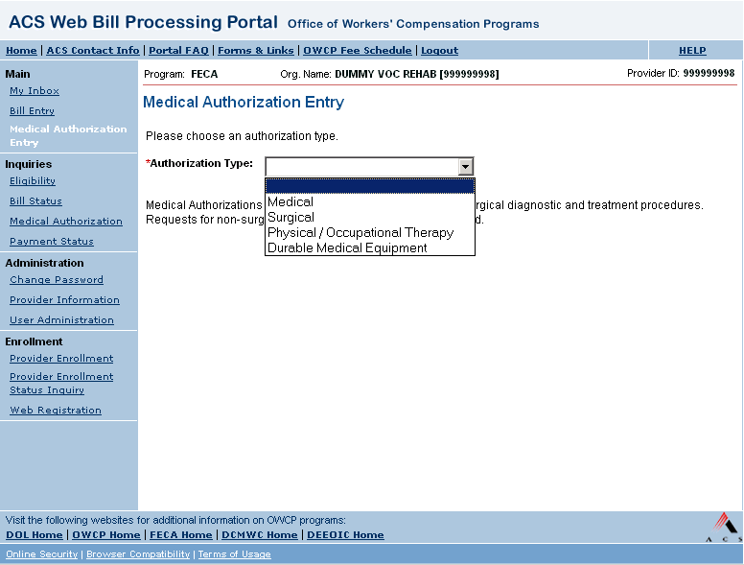
- Select Authorization Type from the drop down list on the Medical Authorization Entry page.
The Web portal offers providers the ability to enter the following types of authorizations:
  - Medical – This category includes radiology, laboratory, and non-surgical diagnostic and treatment procedures. Requests for non-surgical hospital admissions must be faxed.
  - Surgical
  - Physical / Occupational Therapy
  - Durable Medical Equipment
- Based on the Authorization Type selected, the appropriate entry fields become available.

Medical Authorizations
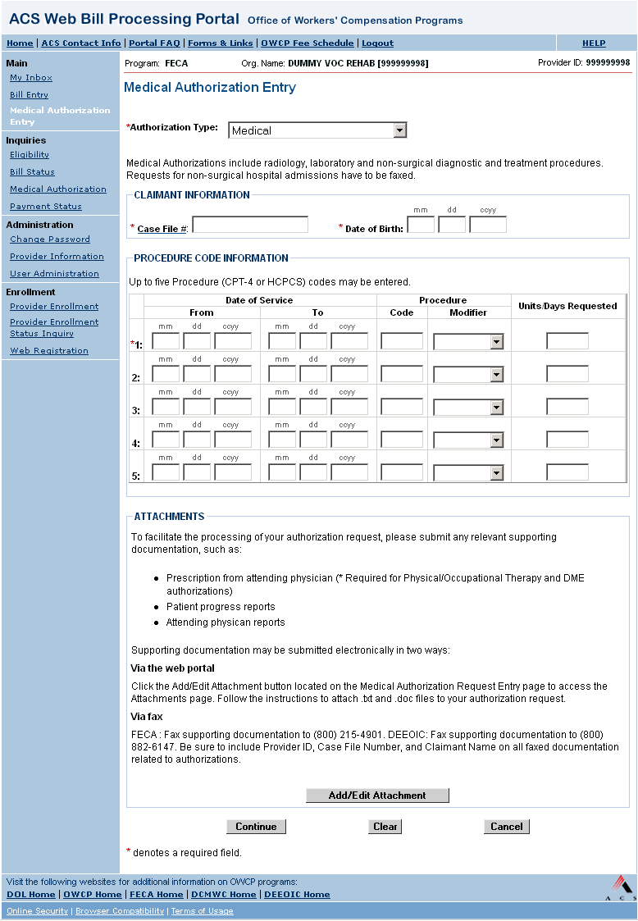
- For General Medical authorizations, enter data in the following fields:
CLAIMANT INFORMATION
  - Case File # (REQUIRED) - 9 digit numeric
  - Date of Birth (REQUIRED) - mm/dd/ccyy format
PROCEDURE CODE INFORMATION
- Date of Service From (REQUIRED) - mm/dd/ccyy format
- Date of Service To (REQUIRED) - mm/dd/ccyy format
- Procedure Code
- Description (REQUIRED) - 5 alphanumeric characters; HCPCS and CPT-4 codes are accepted.
- Modifier (Optional) - drop down list; Choices: Right Side (RT), Left Side (LT), and Bilateral (50)
- Units/Days Requested (REQUIRED)
- To add attachments to the medical authorization request, click the Add/Edit Attachments button.
The Medical Authorization Entry - Attachments page opens.
- To continue to the next step, click the Continue button.
The Medical Authorization Entry - Review page opens.

Surgical Authorizations
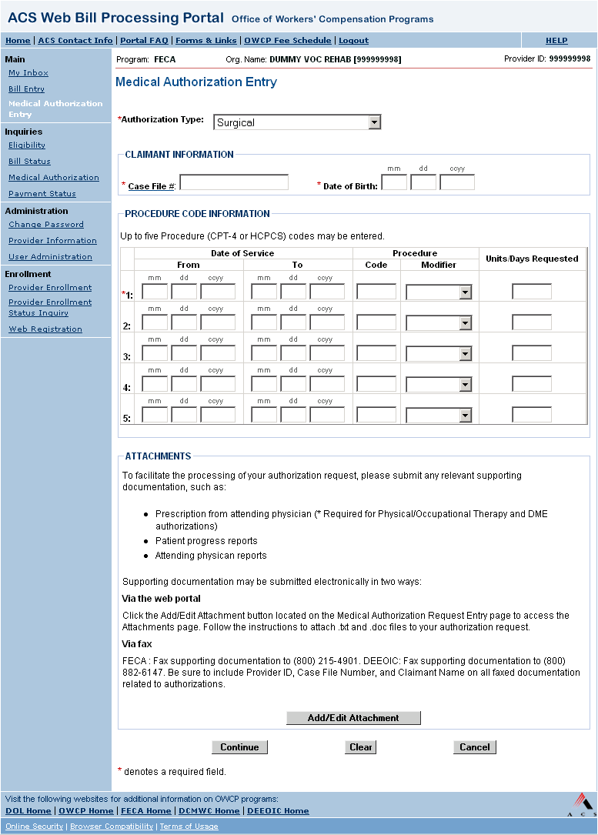
- For Surgical authorizations, enter data in the following fields:
CLAIMANT INFORMATION
  - Case File # (REQUIRED) - 9 digit numeric
  - Date of Birth (REQUIRED) - mm/dd/ccyy format
PROCEDURE CODE INFORMATION
- Date of Service From (REQUIRED) - mm/dd/ccyy format
- Date of Service To (REQUIRED) - mm/dd/ccyy format
- Procedure Code
- Description (REQUIRED) - 5 alphanumeric characters; HCPCS and CPT-4 codes are accepted.
- Modifier (Optional) - drop down list; Choices: Right Side (RT), Left Side (LT), and Bilateral (50)
- Units/Days Requested (REQUIRED)
- To add attachments to the medical authorization request, click the Add/Edit Attachments button.
The Medical Authorization Entry - Attachments page opens.
- To continue to the next step, click the Continue button.
The Medical Authorization Entry - Review page opens.

Physical/Occupational Therapy Authorizations
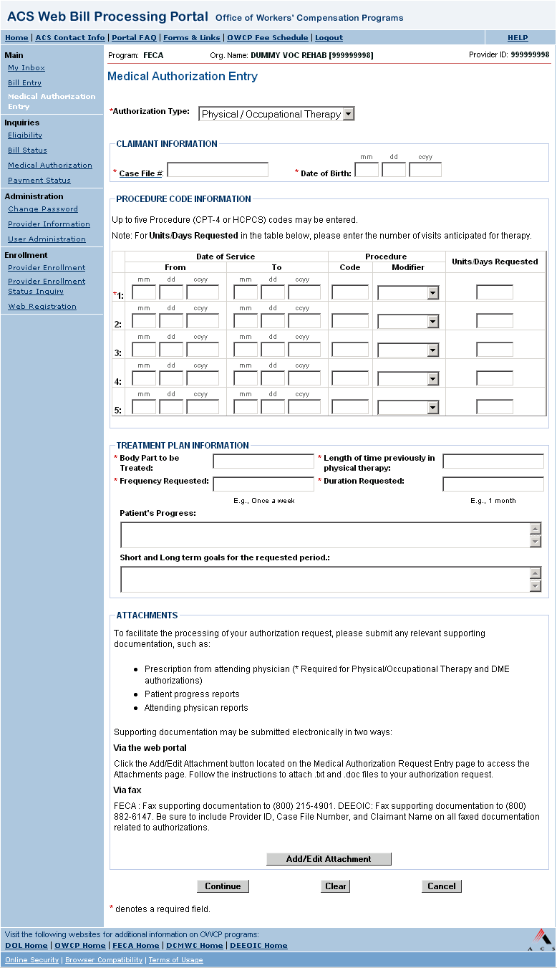
- For Physical or Occupational Therapy authorizations, enter data in the following fields:
CLAIMANT INFORMATION
  - Case File # (REQUIRED) - 9 digit numeric
  - Date of Birth (REQUIRED) - mm/dd/ccyy format
PROCEDURE CODE INFORMATION
- Date of Service From (REQUIRED) - mm/dd/ccyy format
- Date of Service To (REQUIRED) - mm/dd/ccyy format
- Procedure Code
- Description (REQUIRED) - 5 alphanumeric characters; HCPCS and CPT-4 codes are accepted.
- Modifier (Optional) - drop down list; Choices: Right Side (RT), Left Side (LT), and Bilateral (50)
- Units/Days Requested (REQUIRED)
- Enter Treatment Plan information, which consists of the following fields:
  - Body Part to be Treated (REQUIRED)
  - Length of Time Previously in Physical Therapy (REQUIRED) – E.g., ‘3 months’
  - Frequency Requested (REQUIRED) – E.g., ‘Once a week’
  - Duration Requested (REQUIRED) – E.g., ‘1 month’
  - Patient’s Progress (Optional) – Refers to patient’s progress against short and long term goals
  - Short and long term goals for the requested period (Optional)
  - Is there a physician’s prescription? (REQUIRED) – Choices: Yes or No
- To add attachments to the medical authorization request, click the Add/Edit Attachments button.
The Medical Authorization Entry - Attachments page opens.
- To continue to the next step, click the Continue button.
The Medical Authorization Entry - Review page opens.

Durable Medical Equipment Authorizations
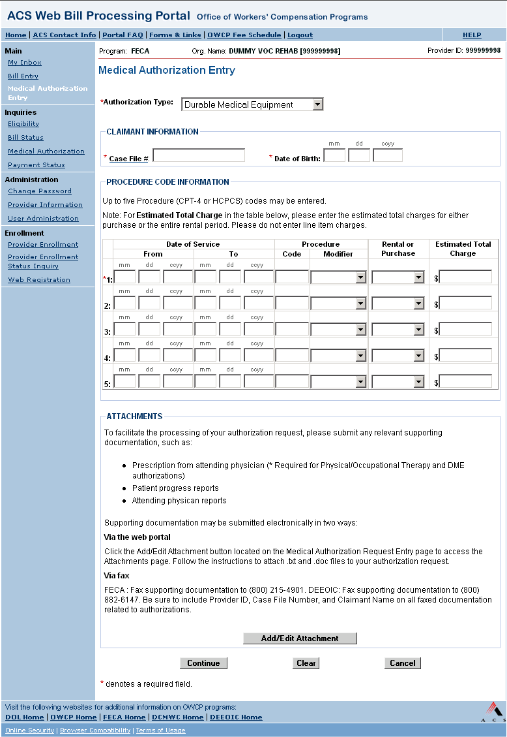
- For Durable Medical Equipment authorizations, enter data in the following fields:
CLAIMANT INFORMATION
  - Case File # (REQUIRED) - 9 digit numeric
  - Date of Birth (REQUIRED) - mm/dd/ccyy format
PROCEDURE CODE INFORMATION
- Date of Service From (REQUIRED) - mm/dd/ccyy format
- Date of Service To (REQUIRED) - mm/dd/ccyy format
- Procedure Code
- Description (REQUIRED) - 5 alphanumeric characters; HCPCS and CPT-4 codes are accepted.
- Modifier (Optional)- drop down list; Choices: Right Side (RT), Left Side (LT), and Bilateral (50)
- Rental or Purchase (REQUIRED)
- Estimated Total Charges (REQUIRED)
- To add attachments to the medical authorization request, click the Add/Edit Attachments button.
The Medical Authorization Entry - Attachments page opens.
- To continue to the next step, click the Continue button.
The Medical Authorization Entry - Review page opens.

Medical Authorization Entry - Attachments
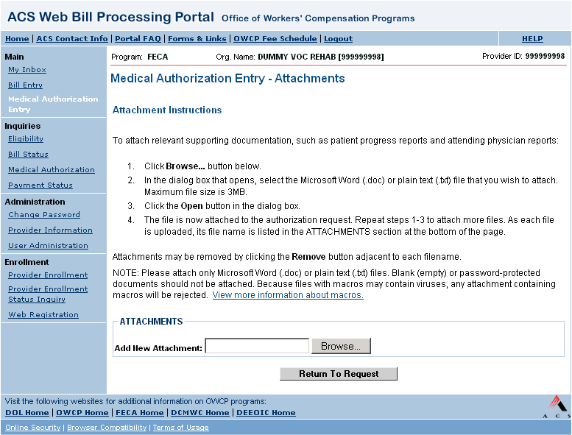
- Click Browse to locate the desired file. Only files of .doc and .txt format may be attached, and files must be smaller than 3MB.
- Select the file and click Open on the Choose File dialog box.
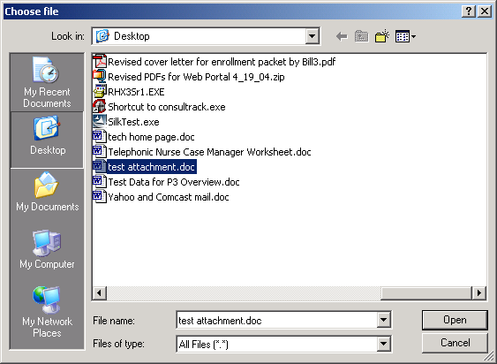
- The file is now attached to the authorization request. Repeat steps 1 and 2 to attach more files. As each file is uploaded, its file name is listed in the ATTACHMENTS section at the bottom of the page. Attachments may be removed by clicking the Remove button adjacent to each filename.
- After attaching all applicable attachments, click the Return To Request button.
- The Medical Authorization Entry page reopens.

Medical Authorization Entry – Review
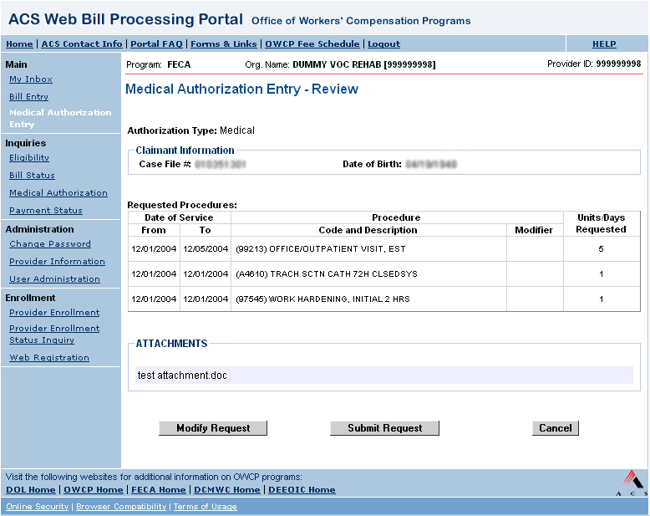
- To make modifications to the request, click the Modify Request button to return to the Medical Authorization Entry page.
- When satisfied with the request, click the Submit Request button to submit the authorization request for processing.
- If the request contains no errors, the Medical Authorization Entry - Confirmation page opens.

Medical Authorization Entry - Confirmation
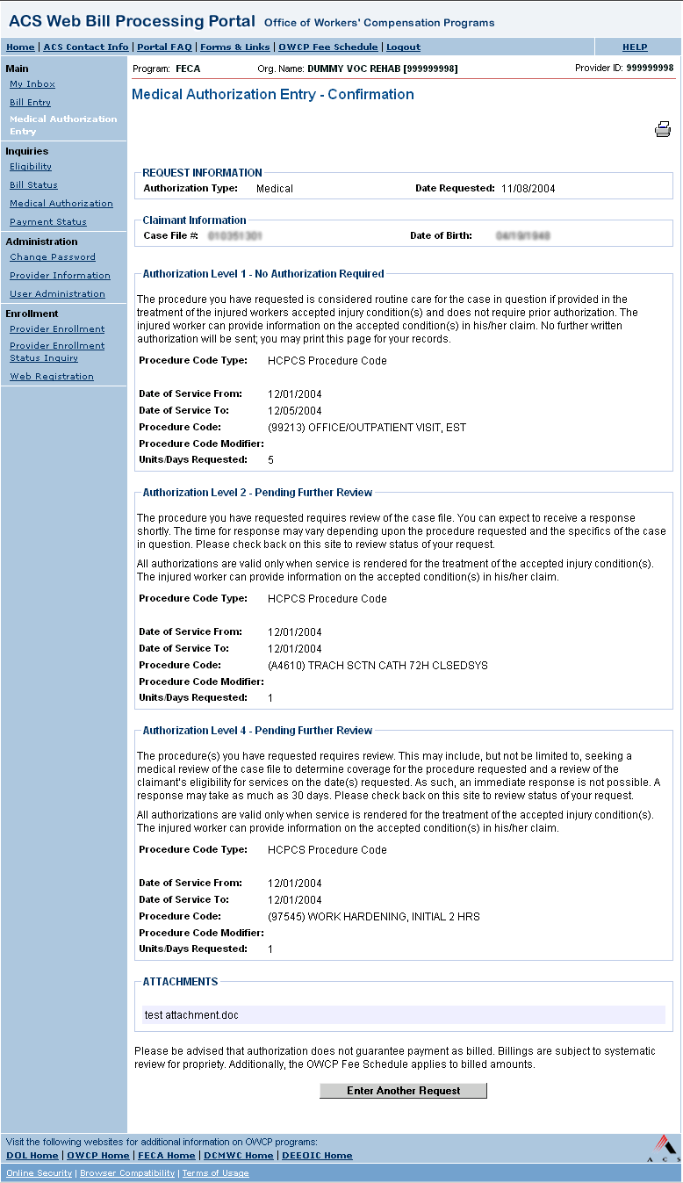
The Medical Authorization Entry - Confirmation page displays after an authorization request is submitted. A unique fifteen digit Confirmation Number displays at the top of the Confirmation page, and all previously entered information from the Medical Authorization Entry page displays back to the user. Additionally, the user is given a status for each procedure code requested.
Each procedure code requested is assigned an authorization level, which indicates whether authorization is required or if medical review is necessary. There are three authorization levels:
- Level 1 - The procedure code requested is considered routine care for the case in question and does not require authorization.
- Level 2 - The procedure code requested requires review of the case file. A response can be expected shortly.
- Level 3 or 4 - The procedure code requested requires review of the case file. A response can take as much as 30 days.

Glossary
#
.doc: File format indicative of a Word document.
.txt: File format indicative of a plain text document.
A
ACS: Affiliated Computer Services, Inc.
B
browser: Software for a PC that allows the user to access information through the Internet or Intranet. Also known as a Web browser.
C
Case file #: A unique 9-character number assigned by the Department of Labor to a claimant to identify associated illnesses or injuries.
E
Encryption: A means of scrambling data for transmission or storage such that the data is unintelligible without unscrambling it with a specific key.
F
FECA: Federal Employees Compensation Act
H
hyperlink: A hyperlink, or hyperlink text, is a pointer within a Web page that leads the user to another location. Link is used as an abbreviated form of this word.
O
OWCP: Office of Workers' Compensation Programs
U
User ID: A unique login ID, which is used to log in to the Web portal.

