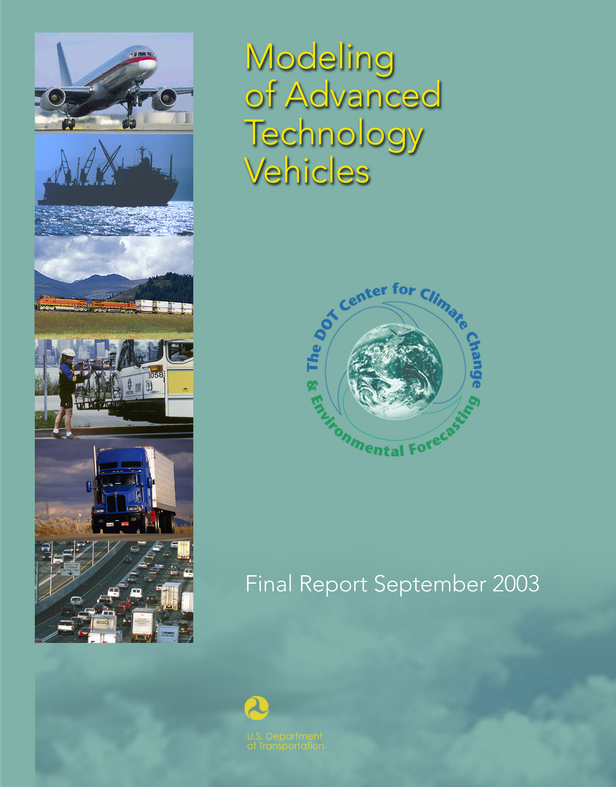

Notice
This document is disseminated under the sponsorship of the Department of Transportation in the interest of information exchange. The United States Government assumes no liability for its contents or use thereof.
Notice
The United States Government does not endorse products or manufacturers. Trade or manufacturers’ names appear herein solely because they are considered essential to the objective of this report.

NSN 7540-01-280-5500 Standard Form 298 (Rev. 2-89)
REPORT DOCUMENTATION PAGE |  |  |  | Form Approved  OMB No. 0704-0188
Public reporting burden for this collection of information is estimated to average 1 hour per response, including the time for reviewing instructions, searching existing data sources, gathering and maintaining the data needed, and completing and reviewing the collection of information. Send comments regarding this burden estimate or any other aspect of this collection of information, including suggestions for reducing this burden, to Washington Headquarters Services, Directorate for Information Operations and Reports, 1215 Jefferson Davis Highway, Suite 1204, Arlington, VA 22202-4302, and to the Office of Management and Budget, Paperwork Reduction Project (0704-0188), Washington, DC 20503.
1. AGENCY USE ONLY (Leave blank) |  | 2. REPORT DATE  September 2003 |  | 3. REPORT TYPE AND DATES COVERED  Final Report  June 2003
4. TITLE AND SUBTITLE  Modeling of Advanced Technology Vehicles |  |  |  |  | 5. FUNDING NUMBERS  RS391/P3071
6. AUTHOR(S)
Kevin Green
7. PERFORMING ORGANIZATION NAME(S) AND ADDRESS(ES)  U.S. Department of Transportation  John A. Volpe National Transportation Systems Center  55 Broadway  Cambridge, MA 02142 |  |  |  |  | 8. PERFORMING ORGANIZATION REPORT NUMBER  DOT-VNTSC-RSPA-03-01
9. SPONSORING/MONITORING AGENCY NAME(S) AND ADDRESS(ES)  U.S. Department of Transportation  Research and Special Programs Administration  400 7th Street, S.W.  Washington, D.C. 20590 |  |  |  |  | 10. SPONSORING/MONITORING  AGENCY REPORT NUMBER
11. SUPPLEMENTARY NOTES

12a. DISTRIBUTION/AVAILABILITY STATEMENT  This document is available to the public through the National Technical Information Service, Springfield, Virginia 22161. |  |  |  |  | 12b. DISTRIBUTION CODE
13. ABSTRACT (Maximum 200 words)
The characterization of some types of “advanced technology vehicles” may help to understand policies that are strongly either explicitly or implicitly technology-dependent. Recent models attempt to characterize such technologies in terms of fuel economy, price, and a range of performance and utility characteristics, examples of which include acceleration, power, and luggage space. However, information to make robust quantitative forecasts appears generally limited. Therefore, a simpler generalized form is proposed, in order to accommodate price and fuel economy functions that evolve with available information. Such an approach would assume that other advanced vehicle characteristics are similar to those of conventional vehicles, or that they can be exogenously translated into equivalent changes in price. A simple model of fuel economy and price increases is used to illustrate this concept, and recent projections regarding the status of and outlook for hybrid electric vehicles and fuel cell vehicles provide ranges of plausible values for the relevant constants. Although information is more limited for other advanced transportation equipment, projections for buses, marine vessels, and aircraft suggest that a common general approach can be applied widely to the transportation sector. In any event, study of methods for characterizing purchaser preferences would be an important complement to this study of vehicle characterization.

14. SUBJECT TERMS  advanced technology vehicles, fuel cell vehicles, hybrid electric vehicles, modeling, simulation |  |  |  |  |  | 15. NUMBER OF PAGES  40
 |  |  |  |  |  | 16. PRICE CODE
17. SECURITY CLASSIFICATION  OF REPORT  Unclassified | 18. SECURITY CLASSIFICATION  OF THIS PAGE  Unclassified |  | 19. SECURITY CLASSIFICATION  OF ABSTRACT  Unclassified |  |  | 20. LIMITATION OF ABSTRACT  Unlimited
Prescribed by ANS Std. 239-18
298-102

Preface

The Administration’s National Energy Policy and the President’s approach to the challenge of global climate change stress, among other things, the importance of technology as a means to increase efficiency and reduce emissions. In the transportation sector, “advanced” or “breakthrough” technologies are cited as showing particular promise. Such technologies might develop and find market success without the Federal Government’s involvement. However, most observers evidence support for some such involvement.

Decision makers face a wide range of options for Federal involvement in such technologies. Examples include subsidies, regulation, and research funding. Even within a given area, there are numerous specific options, such as what types of technologies should receive what types and levels of public subsidies. When weighing options, decision makers may benefit from analyses addressing prices and other effects.

Based on its own analytical work and discussions with analysts in other agencies and the national energy laboratories, the Department’s Center for Climate Change & Environmental Forecasting determined that it would be appropriate to closely review models that have been used for this type of analysis and to then, as appropriate, identify potential improvements. This report is intended as a first step along that path. While written primarily for a technical audience, this report may also be of broader interest, in part, because it makes recommendations regarding the design of models that may be used for analyses of policies related to vehicle technologies.

This report discusses a few different models relevant to advanced technology vehicles (ATVs)—vehicles that use advanced technologies but operate on conventional fuels. These models fall into two basic categories: vehicle design tools and market analysis tools. Among the latter, which are more useful for policy analysis, this report notes that some current models describe ATVs based on numerous characteristics, examples of which include price, fuel economy, acceleration, range, and luggage space. After reviewing available information regarding some prominent advanced technologies, this report concludes that there is a limited basis for predicting a variety of vehicle characteristics. Consequently, this report proposes a less complex approach that attempts to forecast the relative price and fuel economy of ATVs and assumes that other vehicle characteristics either are similar to those of conventional vehicles or lend themselves to simulation as some equivalent monetary value.

This report provides a quantitative illustration of how this approach might be implemented for different ATVs. Whether or not this specific illustration is ultimately helpful to model developers, it is hoped that simpler modeling approaches with open architectures will be given close consideration in the future, as such approaches should allow analysts greater flexibility to match vehicle representation with available information and also help to increase the transparency with which policy options are examined using such tools.

This report does not attempt to address modeling issues associated with the representation of consumer preferences. Work in this area would be an important complement to this report, which focuses on vehicle characterization.

METRIC/ENGLISH CONVERSION FACTORS
ENGLISH TO METRIC |  |  |  |  | METRIC TO ENGLISH
LENGTH (APPROXIMATE) |  |  |  |  | LENGTH (APPROXIMATE)
1 inch (in) | = | 2.5 centimeters (cm) |  | 1 millimeter (mm) |  | = |  |  | 0.04 inch (in)
1 foot (ft) | = | 30 centimeters (cm) |  | 1 centimeter (cm) |  | = |  |  | 0.4 inch (in)
1 yard (yd) | = | 0.9 meter (m) |  | 1 meter (m) |  | = |  |  | 3.3 feet (ft)
1 mile (mi) | = | 1.6 kilometers (km) |  | 1 meter (m) |  | = |  |  | 1.1 yards (yd)
 |  |  |  | 1 kilometer (km) |  | = |  |  | 0.6 mile (mi)
AREA (APPROXIMATE) |  |  |  |  | AREA (APPROXIMATE)
1 square inch (sq in, in²) | = | 6.5 square centimeters (cm²) |  | 1 square centimeter (cm²) |  | = |  |  | 0.16 square inch (sq in, in²)
1 square foot (sq ft, ft²) | = | 0.09 square meter (m²) |  | 1 square meter (m²) |  | = |  |  | 1.2 square yards (sq yd, yd²)
1 square yard (sq yd, yd²) | = | 0.8 square meter (m²) |  | 1 square kilometer (km²) |  | = |  |  | 0.4 square mile (sq mi, mi²)
1 square mile (sq mi, mi²) | = | 2.6 square kilometers (km²) |  | 10,000 square meters (m²) |  | = |  |  | 1 hectare (ha) = 2.5 acres
1 acre = 0.4 hectare (he) | = | 4,000 square meters (m²)
MASS - WEIGHT (APPROXIMATE) |  |  |  |  | MASS - WEIGHT (APPROXIMATE)
1 ounce (oz) | = | 28 grams (gm) |  | 1 gram (gm) |  | = |  | 0.036 ounce (oz)
1 pound (lb) | = | 0.45 kilogram (kg) |  | 1 kilogram (kg) |  | = |  | 2.2 pounds (lb)
1 short ton = 2,000 pounds (lb) | = | 0.9 tonne (t) |  | 1 tonne (t) |  | =  = |  | 1,000 kilograms (kg)  1.1 short tons
VOLUME (APPROXIMATE) |  |  |  |  | VOLUME (APPROXIMATE)
1 teaspoon (tsp) | = |  | 5 milliliters (ml) |  | 1 milliliter (ml) |  | = |  |  | 0.03 fluid ounce (fl oz)
1 tablespoon (tbsp) | = |  | 15 milliliters (ml) |  | 1 liter (l) |  | = |  |  | 2.1 pints (pt)
1 fluid ounce (fl oz) | = |  | 30 milliliters (ml) |  | 1 liter (l) |  | = |  |  | 1.06 quarts (qt)
1 cup (c) | = |  | 0.24 liter (l) |  | 1 liter (l) |  | = |  |  | 0.26 gallon (gal)
1 pint (pt) | = |  | 0.47 liter (l)
1 quart (qt) | = |  | 0.96 liter (l)
1 gallon (gal) | = |  | 3.8 liters (l)
1 cubic foot (cu ft, ft³) | = |  | 0.03 cubic meter (m³) |  | 1 cubic meter (m³) |  | = |  |  | 36 cubic feet (cu ft, ft³)
1 cubic yard (cu yd, yd³) | = |  | 0.76 cubic meter (m³) |  | 1 cubic meter (m³) |  | = |  |  | 1.3 cubic yards (cu yd, yd³)
TEMPERATURE (EXACT) |  |  |  |  | TEMPERATURE (EXACT)
[(x-32)(5/9)] °F | = |  | y °C |  | [(9/5) y + 32] °C |  | = |  | x °F
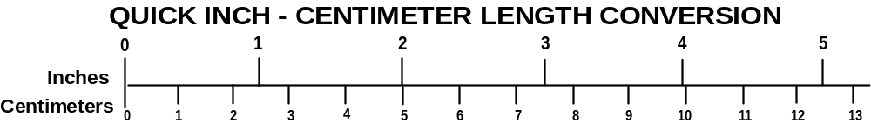
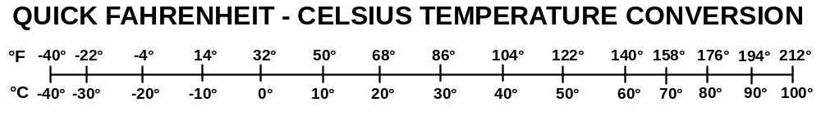
For more exact and or other conversion factors, see NIST Miscellaneous Publication 286, Units of Weights and Measures. Price $2.50 SD Catalog No. C13 10286 Updated 6/17/98
Table of Contents

Section Page
Executive Summary ix

1. Advanced Technology Vehicles (ATVs) 1

2. Goals of Advanced Technology Vehicle Modeling 2

3. Key Characteristics of Advanced Technology Vehicles 2

4. Representation of Advanced Technology Vehicles in Recent Models 3

5. Other Advanced Technology Transportation Equipment 7

6. General Methodological Recommendations 8

7. Sample Representation of Hybrid Electric Vehicles 12

8. Representation of Different Types of Transportation Equipment 13

9. Conclusion 14

Appendix A. Light Vehicles 17

Appendix B. Other Transportation Equipment 27

List of Figures

Figure Page
1. Example of HEV Incremental RPE vs. Time and Penetration Rate 20
2. Sample Assumption for Market Share vs. Incremental RPE 21
3. Sample HEV Market Simulation 22
4. Sample RPE Increase vs. Share of Savings Attributed to Time 23
5. Sample Market Share vs. Share of RPE Savings Attributed to Time 23

List of Tables

Table Page
1. HEV Description in ANL Life-Cycle Cost Model 5
2. Plausible Characteristics of Different Advanced Transportation Equipment 14
3. Key Characteristics of Selected Model Year 2001 Cars 17
4. Plausible Range of Values for Hybrid-Electric Cars & Light Trucks 20
5. MIT Forecasts of FCV Characteristics in 2020 24
6. AEO 2002 Forecasts of FCV Characteristics 24
7. FCV Fuel Economy Forecasts by Joan Ogden 25
8. Plausible Range of Values for Fuel Cell Vehicles 25
9. Plausible Range of Constants for Transit Buses 27
10. Argonne Estimates of Railroad and Locomotive Technology Characteristics 28
11. MARINTEK, et al., Estimates of Marine Technology Characteristics 28
12. Aircraft Technology Assumptions for AEO 2001 29
13. Stratus Consulting Estimates for Two Aircraft Technologies 30

List of Abbreviations

AEO Annual Energy Outlook
AFV Alternative Fuel Vehicle
ANL Argonne National Laboratory
ATV Advanced Technology Vehicle

CAFE Corporate Average Fuel Economy
CALCARS California Conventional and Alternative Fuel Response Simulator
CI Compression Ignition
CO₂ Carbon Dioxide
CVT Continuously Variable Transmission

DOE Department of Energy
DOT Department of Transportation

EIA Energy Information Administration
EPAct Energy Policy Act

FCV Fuel Cell Vehicle

GHG Greenhouse Gas

HEV Hybrid Electric Vehicle

IPCC Intergovernmental Panel on Climate Change

kW kilowatt

MIT Massachusetts Institute of Technology
MPG miles per gallon
MPH miles per hour
MSRP Manufacturer’s Suggested Retail Price

NASA National Aeronautics and Space Administration
NEMS National Energy Modeling System
NRC National Research Council
NREL National Renewable Energy Laboratory
NYCTA New York City Transit Authority

PEM Proton Exchange Membrane
PNGV Partnership for a New Generation of Vehicle
PSAT PNGV System Analysis Toolkit

RPE Retail Price Equivalent

TAFV Transitional Alternative Fuel and Vehicle

UEET Ultra-Efficient Engine Technology Program

VVT Variable Valve Timing

ZEV Zero Emission Vehicle

Executive Summary

The characterization of some types of “advanced technology vehicles” may help affected and otherwise interested parties to understand policies that are strongly either explicitly or implicitly technology-dependent. Recent models attempt to characterize such technologies in terms of fuel economy, price, and a range of performance and utility characteristics, examples of which include acceleration, power, and luggage space. However, information to make robust quantitative forecasts appears generally limited. Therefore, a simpler generalized form is proposed, in order to accommodate price and fuel economy functions that evolve with available information. Such an approach would assume that other advanced vehicle characteristics are similar to those of conventional vehicles, or that they can be exogenously translated into equivalent changes in price. A simple model of fuel economy and price increases is used to illustrate this concept, and recent projections regarding the status of and outlook for hybrid electric vehicles and fuel cell vehicles provide ranges of plausible values for the relevant constants. Although information is more limited for other advanced transportation equipment, projections for buses, marine vessels, and aircraft suggest that a common general approach can be applied widely to the transportation sector. In any event, study of methods for characterizing purchaser preferences would be an important complement to this study of vehicle characterization.

Advanced Technology Vehicles (ATVs)
For decades, observers across a wide range of organizations have been considering the potential to use technological advances to reduce transportation consumption of energy and, in particular, petroleum. Manufacturers of cars and light trucks have already taken advantage of numerous advances, such as aerodynamic design and front-wheel drive, to effectively balance consumer demands for performance with regulatory requirements for fuel economy and occupant protection. Manufacturers of other transportation equipment, such as locomotives, freight trucks, and aircraft, have similarly taken advantage of numerous engineering advances in recent decades.

Many technological advances represent incremental improvements on existing designs. However, some observers, engineers, and policy-makers have tended to stress advances that could be more discontinuous in terms of energy efficiency and/or fundamental design. The nation’s FreedomCAR program, much like the earlier Partnership for a New Generation of Vehicle (PNGV), represents a commitment to developing public/private partnerships to fund high-risk, high-payoff research into advanced automotive technologies. For most of the last decade, significant attention has been focused hybrid electric powertrains (diesel or possibly gasoline) and proton-exchange membrane (PEM) fuel cells.

Before these research partnerships were launched, other important policies—in particular, the Energy Policy Act’s (EPAct’s) alternative fuel mandate for some light vehicle fleets and California’s Zero Emission Vehicle (ZEV) mandate—had already intensified interest in alternative fuel vehicles (AFVs). AFVs may or may not incorporate significant technological advances. For example, while cost-effective electric vehicles would require batteries that currently do not exist, gasoline vehicles require only modest redesign and component changes to run on ethanol. Largely because such vehicles suffered from some combination of reduced utility (particularly range) and fuel availability (due to lack of infrastructure), numerous analytical tools were developed and/or modified to attempt to account for these differences from gasoline and diesel vehicles. As California modified the ZEV mandate to accommodate hybrid electric vehicles (HEVs), many analysts retained this conceptual approach.

Conceptually, it is appropriate to consider that some technologies can replace others, and that technologies can have important differences in price, performance, and other characteristics. For example, this approach might treat continuously variable transmissions (CVTs) as an advanced highway vehicle technology that could replace current transmissions with discrete gear ratios. A primary concern would then be how to differentiate between the two based on relative price, fuel economy, and performance. By simple logical extension, this basic approach could also treat hybrid electric powertrains as another alternative powertrain technology, one with the potential to both replace current transmissions and possibly enable some engine downsizing. Given an a priori assumption that markets will tend to gravitate toward designs that are similar to current vehicles in their utility and performance, this approach would certainly seem more logical than one that assumes hybrid vehicles would, like AFVs, differ in a truly fundamental way (i.e., in terms of fuel availability) from current vehicles. On the other hand, insofar as some fuel cell vehicles (FCVs) would not be compatible with current fuels, after accounting for what may be a complete change in powertrain design and components, it may be more appropriate to treat such FCVs as a type of AFV.

Delineation of some types of ATVs may help affected and otherwise interested parties to understand policies that are strongly either explicitly or implicitly technology-dependent. Rather than attempting to precisely define the term “advanced technology vehicle,” this analysis will consider vehicles with powertrains that are considerably different from those of conventional vehicles. In particular, this analysis will focus on HEVs and FCVs, both the focus of considerable current attention.

Goals of Advanced Technology Vehicle Modeling
Models that attempt to represent the characteristics of ATVs can serve a few basic purposes relevant to public policy. First, they can help to predict future energy and environmental trends, taking into account the potential future role of ATVs, and they can help to make related economic projections. Second, they can help to evaluate policies that could influence the development and adoption of ATVs.

For both purposes, the primary modeling task is to predict market behavior given some set of defined characteristics of both ATVs and those policies that might influence the market. In general, other important results, particularly energy and environmental implications, relate directly to market performance, given a few additional ATV characteristics.

Therefore, any model useful for policy analysis must implicitly or explicitly attempt to account for market forces and the influence of relevant policies, and the manner in which each relate to the characteristics of ATVs.

Vehicle designers, of course, require models with different capabilities, including the ability to evaluate tradeoffs between a wider range of detailed vehicle performance characteristics based on a more detailed engineering description of specific candidates for production. The design of commercially available civilian vehicles is not, however, a public sector role. Some vehicle characteristics dependent on engineering design are a matter of public interest. However, that interest relates to the performance characteristics (e.g., emission rates, occupant protection, fuel economy) themselves—not the underlying engineering characteristics, per se.

Key Characteristics of Advanced Technology Vehicles
The forces that govern vehicle markets are complex. Demographic, economic, technological, and even fashion trends are among those that interact to determine how many vehicles of which types will be manufactured and purchased. Apparently, even most manufacturers can hope for market comprehension that is, at best, far from perfect.

Since this analysis focuses on vehicles that use energy-related advanced technologies (as opposed to myriad other “advanced” devices such as voice recognition, wireless networking, and head-up displays), it is appropriate to first consider market forces that are either energy-related or general enough to treat with a reasonable degree of confidence. It is also appropriate to focus on policies that relate directly to either those market forces or the ATVs under consideration—HEVs and FCVs.

Clearly, any representation of market forces will have to somehow account for ways in which prices and fuel economy might influence ATV sales volumes. For alternatively fueled FCVs, that representation must also consider the role of fuel compatibility (and, as a factor external to FCVs, themselves, fuel availability). Therefore, the most important ATV characteristics include purchase price, fuel economy, and fuel compatibility.

A wide range of other ATV characteristics could have significant influence on the market for these vehicles. Examples include performance (e.g., acceleration), utility (e.g., passenger, luggage, load, and towing capacities), reliability, maintenance costs, as well as accessories, comfort, ride, and handling. All of these are subject to such significant uncertainty that attempts to account for each might introduce complexity that would be both unnecessary and misleading. To the extent that there is a compelling basis to project quantitative differences between ATVs and current vehicles across these characteristics, it might then be more practical to deal with these ATV characteristics through some exogenously-determined net adjustment expressed as a monetized present value. Otherwise, though, an a priori assumption of net equivalence would probably be more appropriate.

In addition to accounting for ATV characteristics most likely to influence market adoption, models must account for the relationship between ATVs and those policies that might most strongly influence sales volumes. For HEVs and FCVs, this likely includes Federal Corporate Average Fuel Economy (CAFE) standards, potential income tax credits, and California’s ZEV mandate. Recent legislation would provide an income tax credits for the purchase of HEVs based on a complex crediting schedule. Similarly, the ZEV mandate uses a relatively complex schedule to determine the “creditability” of some ATVs. While such provisions could necessitate detailed representation of a variety of ATV characteristics, this does not mean that reliable information regarding such characteristics will be readily available. Therefore, as an alternative to trying to anticipate and explicitly account—in a modeling context—for various legally relevant ATV engineering characteristics, it might be more practical either to incorporate another exogenously-determined adjustment to vehicle price.

Representation of Advanced Technology Vehicles in Recent Models
Considering a number of recent analyses and models used for purposes identical or similar to those mentioned above, three basic approaches appear prominent. The first makes a priori assumptions about ATV sales without explicitly accounting for ATV prices. The second makes specific assumptions about different vehicle systems and subsystems as a basis for estimating ATV performance and/or prices. Finally, the third makes assumptions across a wider range of ATV characteristics (e.g., range, luggage space) without making specific underlying engineering assumptions. Because a key purpose of this analysis is to identify ways of characterizing ATVs to facilitate market analysis, the latter two approaches are of greatest interest.

Within the second of these categories, a few recent modeling tools serve to illustrate the potential range in complexity and functionality. Two laboratories owned by the Department of Energy (DOE) have developed models that perform somewhat detailed simulations (in MathWorks’ MATLAB® and SIMULINK®) of the operation of vehicles with specified design characteristics. The National Renewable Energy Laboratory (NREL) has developed an HEV simulation model called ADVISOR, which is currently available to the public. Under the direction of Ford, DaimlerChrysler, and General Motors, Argonne National Laboratory (ANL) has developed a conceptually similar model called the PNGV System Analysis Toolkit (PSAT). PSAT is not publicly available.

ADVISOR’s approach to simulating HEV performance entails three basic steps:

- First, the user specifies a range of vehicle characteristics, such as vehicle type (e.g., small car), drivetrain configuration (e.g., parallel) fuel conversion (e.g., internal combustion engine), energy storage (e.g., lead acid), and motor type (e.g., AC). The user can also specify characteristics of many specific components—for example, the power and weight of a diesel engine—or allow the model to automatically determine such characteristics based on anticipated performance levels.

- Second, the user specifies a driving cycle (e.g., speed, elevation, and accessory loads as functions of time, solar loading).

- Third, based on these inputs, ADVISOR simulates the specified vehicle’s performance over the specified driving cycle. This includes not only aggregate measures, in particular overall miles per gallon, but also more detailed measures of engineering performance (e.g., speed, acceleration, battery discharge) as a function of time.

Notwithstanding its specific methodologies and assumptions, ADVISOR clearly uses an explicit engineering-based approach to predicting fuel economy. Indeed, the levels of detail with which ADVISOR represents vehicle characteristics, driving conditions, and vehicle performance, as well as the computational demands, are all high enough that the model may be more relevant to vehicle design than, for example, market analysis. Although PSAT is not publicly available, it appears to involve the same basic steps as ADVISOR, and to also be intended primarily for powertrain designers. Neither ADVISOR nor PSAT performs financial calculations.

ANL has also developed a simpler spreadsheet-based (in Microsoft® Excel®) model that estimates the cost of HEVs based on a range of assumptions regarding powertrain configuration, the size and cost of various components, and the fuel economy of series and parallel hybrid midsize cars. ANL’s model uses these inputs to estimate the purchase cost and operating costs of both conventional and hybrid vehicles, as well some specific HEV engineering characteristics (e.g., weight, motor power, battery capacity).

Table 1, below, summarizes the way in which this ANL model characterizes HEVs in terms of basic input assumptions, intermediate calculations, and final projections of cost and performance.
Table 1. HEV Description in ANL Life-Cycle Cost Model
Major Inputs | Intermediate Calculations | Cost and Performance
Configuration | Relative Fuel Economy | Component-Level HEV Cost
0-60 MPH Time | Relative On-Road Fuel Economy | Electricity Cost
Materials | Maintenance Cost | Fuel Cost
Fueling (Gasoline or Diesel) | Grade Climbing Performance | Non-Fuel Cost
Motor/Generator Type | Motor Constant Power Rating | Battery Cost
Battery Type | Power Rating | Scrappage Value
Battery Specific Power | Fuel Economy | Total Life-Cycle Cost
Battery Specific Energy
Battery Cost
Battery Shelf Life
Battery Cycle Life
Grid Connection

Although this model has some component-level characterization of HEVs and appears to draw on some results of ADVISOR-based simulations, it is much simpler than ADVISOR and, presumably, PSAT. Unlike either of those dynamic simulation tools, ANL’s spreadsheet model estimates HEV purchase price and operational costs. Estimates are specific to four different market-wide annual sales levels: 0-25,000 units, 50,000-100,000 units, 150,000-200,000 units, and 250,000 or more units. Although the model does not use these price and cost calculations to make market-related projections for HEVs, price and cost estimates would clearly be relevant toward such projections.

As mentioned earlier, a third approach to HEV characterization focuses more on performance and utility characteristics that may influence market behavior than on design and engineering characteristics that underlie performance and utility. Of course, this approach addresses the latter characteristics in the course of developing exogenous assumptions regarding the former.

Leiby and Rubin have developed a model called the Transitional Alternative Fuel and Vehicle (TAFV) model, the purpose of which is to provide a means of simulating market transitions between current and alternative vehicles and fuels. The model was designed with a particular emphasis on explicitly considering the role of availability of alternative fuels as well as different makes and models of AFVs. In particular, fuel price and availability are endogenous results of the model’s attempt to solve for fuel-related capital investments consistent with market function as informed by AFV price, fuel economy, and diversity.

Current efforts are focused on, among other things, adding a capability to simulate market demand for HEVs. Based recent work by Greene regarding planned methods to represent choices by vehicle buyers, it appears that TAFV will do so by representing the following characteristics of HEVs:

- Purchase Price—in dollars
- Fuel Economy—exogenous and fixed over the vehicle’s life
- Maintenance Cost—represented by an annual dollar expenditure
- Battery Replacement—useful life (years) and cost
- Fuel Tank Size—gallons
- Fuel Compatibility—types of fuel with which the HEV can be fueled
- Grid Connection—including assumptions regarding recharging algorithm
- Acceleration Performance—time (seconds) to accelerate from 0 to 60 MPH
- Luggage Space—relative to conventional gasoline vehicle
- Make and Model Availability—as fraction of conventional gasoline makes and models

Based on fuel economy, tank size, and fuel compatibility, TAFV also estimates vehicle range. The model then employs a nested multinomial logit model to predict market demand based on these vehicle characteristics and several additional assumptions, including discount rates, fuel availability and price, and the value of time.

Like Leiby and Rubin, Kavelec uses a multinomial logit model, the California Conventional and Alternative Fuel Response Simulator (CALCARS), to simulate market demand in California for AFVs. CALCARS represents 14 categories of light vehicles and characterizes each in terms of purchase price, fuel economy, 0 to 30 MPH acceleration time, top speed, range, and tailpipe emissions. CALCARS does not attempt to represent HEVs or FCVs.

The Energy Information Administration’s (EIA’s) National Energy Modeling System (NEMS), which also simulates, among other things, market adoption of HEVs and FCVs, does so using a logit model and approach to HEV characterization very similar to methods embodied in TAFV.

Fundamentally, both TAFV and NEMS treat HEVs and FCVs much like AFVs. That is, they begin by assuming that HEVs and FCVs would be so different from gasoline and diesel vehicles with conventional mechanical drivetrains that analytical methodologies designed for AFVs such as natural gas vehicles would be more appropriate than methodologies designed for “conventional” engine and transmission technologies, such as variable valve timing (VVT) and CVTs. This approach may be appropriate for FCVs that run on alternative fuels such as methanol or hydrogen, as such FCVs could be considered a type of AFV.

However, insofar as manufacturers of gasoline and diesel HEVs and FCVs might strive to make these vehicles as much like conventional gasoline and diesel vehicles as possible, it could be simpler for models treat such HEVs and FCVs more like conventional vehicles. For example, in NEMS, more than fifty different technological options “compete” in a market simulation that is both less complex in its representation of consumer preferences and more explicit in its attempt to account for the influence of fuel economy regulations. Here, the following characteristics of each technology are represented:

- Price—absolute price penalty (in dollars) as a function of time
- Range—percentage change relative to conventional gasoline vehicles
- Fuel Economy—percentage change relative to conventional gasoline vehicles
- Weight—percentage change relative to conventional gasoline vehicles
- Power—percentage change relative to conventional gasoline vehicles

Analysis using any of the methods described above will be subject to the significant uncertainties that accompany projections of even basic ATV characteristics. For example, myriad HEV configurations are plausible, each with different relationships between vehicle price, fuel economy, capability, and performance. Such uncertainty could tend to diminish the likelihood of successful prediction across a range of detailed ATV characteristics. Although the success and/or effects of any given type of ATV could ultimately prove to be highly dependent on one or more specific characteristics, predicting both those characteristics and their market relevance could prove highly uncertain.

Other Advanced Technology Transportation Equipment
Most of the models mentioned above in Section 4 focus only on light highway vehicles. TAFV currently addresses only automobiles. However, “advanced” technologies could influence the fuel consumption and greenhouse gas (GHG) emissions of virtually all types of transportation equipment, including such diverse examples as buses, commercial jet aircraft, freight trucks, helicopters, locomotives, passenger ferries, and oceangoing bulk tankers. In addition, it is plausible that technological learning and economies of scale could cross boundaries between modes and even between the transportation sector and other sectors. For example, advances in fuel cells for stationary applications might influence the rate at which the cost of fuel cells for transportation vehicles changes over time. However, the representation of both the engineering characteristics of and market for every type of transportation (and nontransportation) equipment at a level of detail sustained by models such as ADVISOR and TAFV would clearly be intractable.

Of these models, only NEMS considers transportation equipment other than light highway vehicles. Currently, NEMS divides the transportation sector into eight groups. Among these, NEMS maintains some level of explicit representation of equipment characteristics for three groups: automobiles and light trucks, freight trucks, and aircraft. In representing both freight truck and aircraft technology options, NEMS uses a method qualitatively similar to that used to represent “incremental” technologies for cars and light trucks. For freight trucks, NEMS projects the timing and scale of the market adoption of relevant energy technologies based on their assumed fuel economy improvement and capital cost, as well as the extent to which they supersede other truck technologies. Similarly, NEMS simulates the market adoption of relevant aircraft technologies based on assumptions regarding cost and fuel economy. NEMS has no explicit representation of technologies for buses, locomotives, or marine vessels.

Although detailed engineering and market models for diverse transportation equipment may be intractable, the qualitatively common approaches used by NEMS suggest that models used to make projections regarding advanced (and more incremental) technologies for the transportation sector likely must, at a minimum, characterize technologies in terms of their influence on capital costs and fuel economy improvements.

General Methodological Recommendations
Considering that relevant models can use a range of approaches to characterize ATVs and perform policy-relevant simulations of market behavior, and that any approach entails uncertainty, it is appropriate to make five fundamental a priori assumptions:

- Relative to current vehicles, ATVs will have price and energy characteristics that differ from those of conventional vehicles. Meaningful quantitative analysis of ATV-related policies will require explicit representation of these differences.

- Some other performance and/or utility characteristics of ATVs may also differ from those of current vehicles. However, analysis of policies related to conventionally-fueled ATVs may not require explicit representation of these differences unless they are the direct basis for such policies.

- Information regarding the price and energy characteristics of future ATVs is likely to be limited and uncertain. Information regarding other characteristics of future ATVs is likely to be even more limited and uncertain.

- Insofar as they require fuels not widely available, AFVs are likely to entail further modeling requirements. However, those requirements may not apply if the primary interest is related to ATVs that can use conventional fuels.

- Most analysts are more likely to be capable of utilizing relatively simple models with fewer inputs than relatively complex models with more inputs. On the other hand, providing some model functions will increase complexity and information requirements.

Having begun with these basic assumptions, models should be able to represent ATVs—both light vehicles and other transportation equipment—according to their differences in price and fuel efficiency relative to conventional vehicles. In addition, assuming that quantitative information regarding other characteristics of future ATVs is limited, there is little or no disadvantage at this time to limiting explicit characterization to these two measure. Of course, it may still be advantageous to use an architecture that can represent other characteristics as more information becomes available in the future, particularly given accompanying information regarding the market relevance of those characteristics.

Considering hybrid-electric cars and light trucks as an example, reasonable price estimation could likely entail some assumptions regarding the dependence of costs on time and production volumes. In mathematical terms, then, models should likely assume that the average incremental
retail price equivalent (RPE) of HEVs (ΔRPE_{HEV}) is a function of both the year (y) and market share (SHARE_{HEV}):
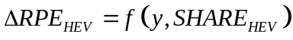
It would likely be important to include both time and penetration rate as variables influencing RPE. Inclusion of time would allow for some representation of processes that influence RPE and are function primarily of time. In particular, any “learning curves” associated with basic ATV-enabling technologies (e.g., batteries, fuel cell stacks) might depend largely on time, as might ATV market introduction assumptions. On the other hand, inclusion of penetration rate would be essential to representing economies of scale in component and ATV manufacturing. In any event, is a general form—not a specific function.

Models that simulate market behavior on an annual basis are likely to assume that ATV penetration rates in any given year depend on the typical RPE penalties observed by purchasers in that year:

Because vehicle supply and demand must ultimately be in balance, models using the general forms indicated in and would need to seek solutions in which RPE and penetration rate are in balance. For some functional forms, such solutions might be achieved algebraically. More generally, though, it would likely be necessary to iteratively seek solutions within some accepted tolerance level. Either approach would probably be feasible using relatively simple code or even spreadsheet macros.

Alternatively, it may be appropriate to treat the incremental RPE as dependent on the penetration rate during the preceding year:
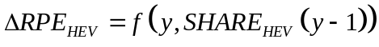
Models using a “lagged” general form such as would avoid the need to solve some simultaneous equations and might, therefore, be easier to for many analysts to use and manipulate. Simple simulations implementing both approaches in a spreadsheet environment are shown in Appendix A. However, representation of markets with multiple ATV types would require simultaneous solutions to the penetration rates of those different types. Nonetheless, whether solving simultaneous equations or using lagged functions, models used to predict ATV penetration rates will need to (1) make assumptions regarding the dependence of penetration rate on RPE (2) provide penetration rates to algorithms used to predict ATV RPEs.

This approach could be used to represent the aggregate influence of factors such as production-related economies of scale and the rate of advances in basic technologies. Faced with complexity-related limitations and uncertainties regarding advanced technologies, market- and policy-oriented models can likely be designed to accept a range of functional forms for or , rather than committing to a specific form. Users of a model that follows this approach may need to develop an exogenous rationale for any RPE assumptions. However, an open form should be amenable to advances in the understanding of ATV RPE.

At least two basic approaches could be used to characterize ATV energy performance. Considering HEVs as an example, one approach would be to treat “hybridization” as a matter of degree that has some functional relationship to RPE. This approach would also entail a simultaneous relationship between RPE and energy performance, where, considering as starting point, RPE would have the following form:
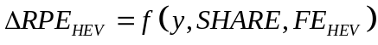
Here, FE represents fuel economy, and would have the following general form:
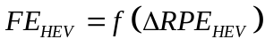
This approach would provide for some representation of the engineering tradeoffs considered in detail by ADVISOR and with cost by the ANL spreadsheet model discussed on page 5, and would require the identification of simultaneous solutions to and .

Alternatively, it may be appropriate to define a few discrete types of a given ATV (e.g., 42 Volt HEVs, mild parallel FEVs, aggressive parallel HEVs, and serial HEVs), and represent each with RPE and fuel economy assumptions that are mutually independent.

Under either general approach, models can likely represent relative ATV energy performance either as a constant or as a simple change relative to conventional vehicles, taking into account any relative differences in the ratios between real-world and laboratory performance. For hybrid electric cars and light trucks, then, such models would represent energy performance either as a constant (FE_{HEV}, e.g., 50 MPG) or as a relative change in fuel economy (ΔFE_{HEV}, e.g., +100 %) or fuel consumption. Models would clearly need to accommodate energy performance measures relevant to different types of transportation equipment, though.

The models discussed above in Section 4 involve various other ATV characteristics, such as power, range, and luggage capacity. ATVs might differ not only in terms of these characteristics of conventional vehicles, but could possibly also have some characteristics not observed in conventional vehicles. For example, HEVs and FCVs might conceivably be designed to provide electrical power in remote locations or to serve as backup generators. However, predicting both differences in these characteristics and the market influence of such differences appears likely to prove complex and uncertain. Also, manufacturers may be less likely to provide forecasts of many different ATV characteristics (much less relationships between those characteristics) than of overall RPE and possibly fuel economy. It may be more feasible, therefore, to analyze such factors outside of market models such as NEMS, and express any differences as adjustments to RPE. Such analysis would entail projection of differences in characteristics, valuation of those differences, and, for differences that take place over time (such as HEV battery replacement), discounting. These adjustments could either be integrated into the RPE function (as the hedonic equivalent of RPE) or treated as an explicitly separate adjustment. In any event, this approach would avoid commitment to any particular set of ATV characteristics and/or market determinants.

For ATVs that require alternative fuel, fuel compatibility would represent an important exception to this simplifying approach to ATV characteristics other than RPE and fuel economy. Given the importance of fuel availability, it would likely be more appropriate to represent such vehicles as AFVs, explicitly accounting for fuel compatibility in a modeling approach that also accounts for fuel availability as influenced by, for example, capital investment for refueling infrastructure development. However, for ATVs that can use conventional fuels, this would not likely be necessary.

In summary, then, the least complicated and most flexible approach to representing ATVs appears to entail representation of the relative increase in fuel efficiency and the relative change in RPE, as adjusted to account for the value of differences in other utility and performance characteristics. Developing open modeling architectures—either through revision or initial design—would help analysts to revise and implement representations of ATVs based on evolving information.

Sample Representation of Hybrid Electric Vehicles
Given recent policy proposals, HEVs provide an especially relevant example through which to illustrate the modeling approach described in Section 6. There is currently significant uncertainty regarding the outlook for HEVs. Many different HEV configurations and degrees of hybridization are plausible. Coupled with uncertainties regarding the future RPE and performance of underlying technologies, these design uncertainties lead to significant uncertainty regarding the future characteristics, including the RPE and fuel economy, of HEVs.
Notwithstanding this uncertainty, a scenario that warrants consideration is one in which HEVs, on the average, involve fuel economy and RPE increases that are significant, but not dramatic. For example, a “mild” hybrid midsize sedan in 2003 might achieve a fuel economy of 33 MPG (perhaps 28 MPG in actual service) at an incremental RPE of approximately $3,000. As discussed in Section 6, a model can simply treat HEV fuel economy as either an absolute level (e.g., FE_{HEV} =33 MPG) or a relative increase (e.g., ΔFE_{HEV} =20%).

However, reasonable RPE estimation for HEVs (and, presumably, other emerging or developing technologies) is likely to be more complex. At a minimum, any model intended to simulate dynamic markets for such vehicles must somehow differentiate between short- and long-term incremental RPEs as compared to conventional vehicles. This implies the introduction of at least two constants to the general forms presented in equations and . If ΔRPE_{MAX} and ΔRPE_{MIN} are used to represent short- and potential long-term incremental RPEs, respectively, takes the following form:
The user of a model employing as a generalized RPE function would need to determine whether a and b are absolute (e.g., $3,000 and $1,000) or relative (e.g., 15 percent and 5 percent) values. Of course, open forms such as and would accommodate an incremental RPE function with both absolute and relative components. In addition, the analyst would need to define a specific functional form representing the transition between short- and long-term RPEs, as well as constants used to apply that form.

For example, recent versions of NEMS have assumed a simple step function based solely on production volume. Considering the light market vehicle, as a whole, such a discontinuous RPE function appears highly unlikely. A model with an open architecture would facilitate testing and application of more intuitive RPE functions, such as the example presented in Appendix A.

As revealed by this example, sensitivity to changes in coefficients could be important, depending on the functional forms applied. This suggests that, for any methodologies used to simulate ATV characteristics and corresponding market characteristics, the development of accompanying algorithms for Monte Carlo analysis might help to understand the likelihood of different outcomes. In general, given sufficient computational resources, such algorithms could likely be developed for virtually any model with open source code.

Representation of Different Types of Transportation Equipment
One advantage of an uncomplicated approach to representing advanced transportation technology is that the same basic methods could likely be applied to a wide range of transportation equipment. The methodology described in Section 6 differentiates between “advanced technology” and “conventional” transportation equipment based on fuel efficiency and RPE. As discussed in Section 5, these characteristics are central to the way NEMS represents not just advanced cars and light trucks, but also heavy trucks and aircraft.

Of course, any model attempting to address ATVs must begin with some representation of the RPE and efficiency of “conventional” transportation equipment. Although RPE can be commonly represented as an equivalent capital cost, appropriate measures of efficiency may vary between equipment types. For most equipment, one of the following three measures of efficiency will likely be appropriate:

- Distance achieved per unit of energy consumed: This is the measure currently applied to cars and light trucks, for which distance/energy is expressed in MPG.
- Seat-distance achieved per unit of energy consumed: This is a logical measure of the efficiency of equipment used primarily for passenger transportation, and can be expressed in seat-miles per gallon (SMPG).
- Mass-distance achieved per unit of energy consumed: This is a logical measure of the efficiency of equipment used primarily for freight transportation, and can be expressed in ton-miles per gallon (TMPG).

Information regarding the likely characteristics of most advanced technology transportation equipment is even more limited than for advanced technology cars and light trucks. Based on recent literature, Table 2 presents plausible ranges for constants that would apply for a variety of advanced technology transportation equipment under the approach described in Section 6, assuming that near-term (ΔRPE_{MAX}) and long-term RPEs (ΔRPE_{MIN}) are estimated using :

Table 2. Plausible Characteristics of Different Advanced Transportation Equipment
Group | Advanced  Technology | ΔFE  (vs. 1990) | Constants for RPE Function
Group | Advanced  Technology | ΔFE  (vs. 1990) | ΔRPE_{MAX} | ΔRPE_{MIN}
Cars & Light Trucks | HEV | 0.2~1.0 | 0.15~1 | 0.02~0.25
Cars & Light Trucks | Gasoline FCV | 0.0~0.8 | 2~5 | 0.3~0.6
Cars & Light Trucks | Methanol FCV | 0.2~0.8 | 1.5~4.5 | 0.2~0.6
Cars & Light Trucks | Hydrogen FCV | 0.3~1.2 | 1.5~3.5 | 0.2~0.7
Buses | HEV | 0.5~1.0 | ~2 | 0.2~0.3
Buses | Methanol FCV | ~1 | 3~4 | ~1
Buses | Hydrogen FCV | ~1 | 3~4 | ~0.5
Railroads & Locomotives | Idle Reduction | ~0.1 | ? | ?
Railroads & Locomotives | Energy Recovery | ? | ? | ?
Railroads & Locomotives | Wheel/Rail Friction | ~0.2 | ? | ?
Railroads & Locomotives | Aerodynamics | ~0.05 | ? | ?
Railroads & Locomotives | Homogeneous Charge | 0 | ? | ?
Railroads & Locomotives | Fuel Cells | 0 | ? | ?
Railroads & Locomotives | Gas Turbines | 0 | ? | ?
Marine Vessels | Hull Shape | 0.05~0.25 | ? | ?
Marine Vessels | Propeller Choice | 0.05~0.11 | ? | ?
Marine Vessels | Powerplants | 0.02~0.14 | ? | ?
Aircraft | Winglets | 0.01~0.04 | 0.01~0.08 | 0.01~0.08
Aircraft | Ribbed Coatings | 0.01~0.02 | .001~.007 | .001~.007

Conclusion
In order to understand the outlook for and implications of advanced technologies and policies relevant to them, analysts must somehow characterize these technologies. For light vehicles, in particular automobiles, a few recent models developed by the national energy laboratories attempt to characterize such technologies in terms of relative RPE and fuel economy, as well as various performance-related characteristics, such as power, fuel tank size, and luggage space. However, it appears that there is limited information to support projections across a range of vehicle characteristics. For advanced technologies that are not yet in wide use, this may be understandable. For other highway and off-highway vehicles, information regarding advanced technologies appears to be even more limited.

As an alternative approach, this report suggests focusing on projections of relative fuel economy and RPE, assuming that either that all other vehicle characteristics are either approximately similar to conventional vehicles or, equivalently, that important differences in such characteristics can be exogenously assigned some monetary value. Models that follow this approach could use an open architecture to accommodate a range of relatively uncomplicated forms to represent fuel economy and RPE. The latter is virtually certain to be a function of both time (e.g., due to basic technological advances) and volume (due, in particular, to economies of scale). For any model, ranging from simple to complex, the development of algorithms for Monte Carlo analysis would help to understand the likelihood of different outcomes.

Even within the framework of a relatively uncomplicated approach such as is suggested here, additional analysis would probably help to develop a better-supported model of future advanced technology RPEs. This could entail deeper consideration of the relationships between the characterization of technologies and the characterization of industry economics.

Appendix A. Light Vehicles

A1. Hybrid Electric Vehicles

Ideally, a model of HEV characteristics would utilize expected relationships between the RPE and performance of HEVs for each vehicle category. However, even without making distinctions between vehicle categories, there is considerable uncertainty regarding these relationships.

Two manufacturers, Toyota and Honda, are currently selling HEVs. The Toyota Prius and the hybrid version of the Honda Civic are largely similar to the Corolla and Civic, respectively. However, the Honda Insight is less similar to other Honda vehicles, because it seats up to two persons yet has a relatively low power-to-weight ratio (unlike two-seat performance cars). Key characteristics of the Toyota Corolla and Prius and the Honda Civic are presented below (Table 3):
Table 3. Key Characteristics of Selected Model Year 2001 Cars
 | Toyota |  | Honda Civic
Characteristic | Corolla | Prius | LX | EX | Hybrid
Price (MSRP) | $15,170 | $20,665 | $15,920 | $17,770 | $20,010
Curb Weight (kg) | 1,167 | 1,256 | 1,142 | 1,182 | 1,213
Maximum Seating | 5 | 5 | 5 | 5 | 5
Passenger Volume (m³) | 2.56 | 2.51 | 2.59 | 2.49 | 2.59
Cargo Volume (m³) | 0.39 | 0.33 | 0.37 | 0.37 | 0.29
Maximum Power (kW) | 97 | 73 | 86 | 95 | 69
Fuel Economy (MPG) | 33 | 48 | 34 | 34 | 48

Relative to their conventional counterparts, the Prius and Civic Hybrid each achieve a fuel economy increase of about 40-45 percent. However, both hybrid vehicles are considerably less powerful, particularly considering their somewhat higher weights.

The Prius and Honda Civic are currently priced roughly about 20-40 percent higher than comparable conventional vehicles. However, insofar as many observers have indicated that (1) Toyota and Honda are losing unknown amounts of money on these vehicles and (2) price penalties would be smaller at higher volumes, it is unclear whether these advertised prices have any real predictive value. For example, in formal comments submitted in 2002 regarding fuel economy standards, Honda indicated that:

“Unfortunately, the incremental cost of hybrid systems is not insignificant. Initially, hybrids also have high development costs spread over relatively low sales. Manufacturers are understandably reluctant to discuss the cost of their hybrid systems, so it is difficult to determine a realistic cost. Still, it is clear that hybrids currently cost at least several thousand dollars more than the equivalent conventional gasoline vehicle, with the cost increasing proportionally for larger vehicles. In the future, these costs should come down as the market expands and the technologies evolve, but in the near term cost is an issue.”

This characterization of HEV costs is consistent with references in National Research Council’s (NRC’s) recent report on fuel economy standards, which projects significant and uncertain incremental costs for hybrid drivetrains:

“The varying complexity of the different hybrid types is reflected in large variations in the incremental cost. The cost premium of today’s limited production vehicles is estimated at $3,000 to $5,000 for mild hybrids when they reach production volumes over 100,000 units per year. For fully parallel systems…the cost premium can escalate to $7,500 or more.”

In preparing its Annual Energy Outlook 2003 (AEO 2003), EIA assumed that hybrid-electric light vehicles sold in 2025 would cost 6-14 percent ($1,700-$4,700) more than conventional vehicles (depending on class and fueling) and achieve fuel economy increases of 45 percent. In the nearer term, EIA assumed somewhat greater relative fuel economy improvements (31-35 percent), but much more significant ($7,600-$12,400, or 17-43 percent) cost penalties.

A recent report by the Massachusetts Institute of Technology (MIT) estimated that gasoline hybrid-electric midsize sedans in 2020 might be priced 17 percent ($3,100) higher than conventional midsize sedans and might achieve fuel economy improvements of 64 percent., This report bases its estimates of fuel economy changes on simulations involving projections of underlying engineering characteristics, including the maximum power of the combustion engine and electric system.

Considering uncertainties regarding HEV design, it appears plausible that HEVs might achieve fuel economy increases of roughly 20-100 percent through 2020. The future incremental RPE of HEVs currently appears subject to even greater uncertainty. At low near-term production volumes, incremental RPEs of 15-100 percent appear plausible. In the longer term and at higher volumes, those RPE penalties might plausibly fall to 2-25 percent. Notwithstanding EIA’s recent projections of a 50 percent reduction in the incremental RPE of HEVs between 2002 and 2003, it appears plausible that RPE reductions could take place more gradually and further into the future.

One potential approach to representing such RPE estimates would assume that, as a percentage of the RPE of a conventional vehicle, the average incremental RPE of an HEV will decline smoothly over time (due, for example, to improvements in basic technologies such as chemical batteries), and that the decline in any given year will be proportional to the HEV penetration rate in the preceding year (because, for example, economies of scale limit the extent to which basic technology advances translate into actual RPE reductions). These assumptions can be expressed mathematically as follows:

(A.1)
where

ΔRPE is expressed as a percentage of the RPE of conventional vehicles sold in year y,
ΔRPE_{MAX} defines a near-term RPE penalty,
SAV_{TIME} defines the RPE penalty reduction achieved over time,
y_{m} is the year when half that reduction is achieved,
k_{TIME} is a constant that determines the shape of the time dependence,
SAV_{MKT} defines the RPE penalty reduction achieved with market share increases,
SHARE_{m} is the market share when half that reduction is achieved, and
k_{MKT} is a constant that determines the shape of the market dependence.

This form approaches a minimum RPE increase of ΔRPE_{MIN} = ΔRPE_{MAX} - SAV_{TIME} - SAV_{MKT} over time and as the market penetration nears 100 percent. Figure 1 shows the incremental RPE calculated when applying the following constants to (A.1): ΔRPE = 25%, SAV_{TIME} = SAV_{MKT} = 10%, y_{m} = 2005, k_{TIME} = 1, SHARE_{m} = 10%, and k_{MKT} = 5. Under this approach and set of assumptions, the average incremental RPE of an HEV can fall from a current value of 25 percent to a long-term value 5 percent, but only to the extent allowed by the penetration rate, and only as fast as allowed by the gradual time-dependent factor in (A.1).
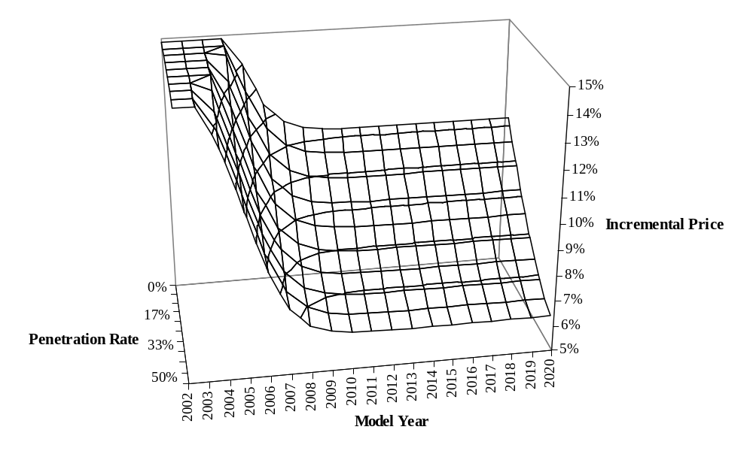
Figure 1. Example of HEV Incremental RPE vs. Time and Penetration Rate
Equation (A.1) makes no explicit assumptions regarding HEV maintenance or other lifecycle costs, or regarding HEV performance and utility characteristics such as power and load capacity. This is consistent with an implicit assumption that, relative to those of conventional vehicles, these HEV characteristics would have an approximate net present value of zero. To the extent that differences in such characteristics can be both projected and valued with a reasonable degree of confidence, they could be represented as simple modifications to (A.1), such as changes in constants or the inclusion of an additional term.

Both complex models such as NEMS and simpler spreadsheet models should be readily adaptable to this representation of HEVs. Based on recent literature, the following ranges for ΔFE, ΔRPE_{MAX} (the near-term price penalty), and ΔRPE_{MIN} (the potential long-term price penalty) appear plausible at this time (Table 4):
Table 4. Plausible Range of Values for Hybrid-Electric Cars & Light Trucks
Constant | Plausible Range
ΔFE (vs. 1990) | 0.2~1
ΔRPE_{MAX} | 0.15~1
ΔRPE_{MIN} | 0.02~0.25

Although limited information is currently available, basic engineering principles suggest that values are likely to vary between different types of cars and light trucks. In particular, at normal levels of performance and utility, achievable fuel economy gains are likely to be smaller for some vehicles than for others. For example, as a limit on fuel economy increases, engineering constraints are likely to be more significant for pickup trucks used to carry or tow significant loads than for passenger cars.

The sample RPE equation presented above for HEVs and the ranges shown above in Table 4 for the corresponding constant terms address the focus of this analysis—the characterization of ATVs. However, as discussed in section 6, this consideration of ATV characterization is intended to facilitate market analysis, which would also require the characterization of market behavior. Although this analysis does not extend to the latter, a sample simulation serves to illustrate the interaction between ATV and market characterization. This simulation couples the RPE function presented in (A.1) with the following assumption regarding the dependence of market share on relative RPE:
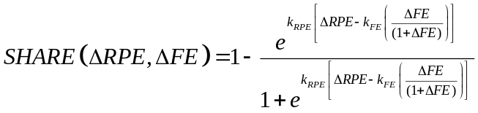 (A.2)
Here, the midpoint market share is offset from ΔRPE = 0 by a term related to the value of the change in fuel economy, ΔFE. This valuation is determined by the constant k_{FE}. A second constant, k_{PRICE}, determines the smoothness of the transition from low to high market share. This market assumption, based on the general form shown in , is illustrated below for k_{PRICE} = 35, k_{FE} = 1429, and ΔFE = 25% (Figure 2):
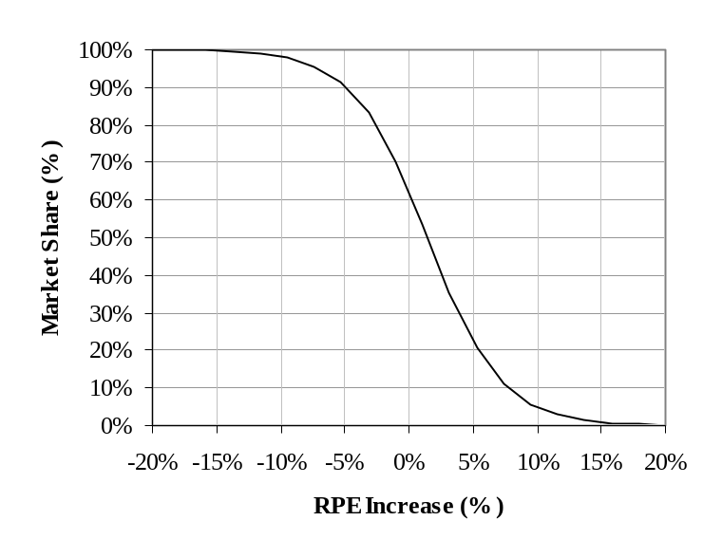
Figure 2. Sample Assumption for Market Share vs. Incremental RPE

As suggested in section 6, (A.1) and (A.2) can be used together to produce a market simulation through simultaneous solution to this system of equations. Within a specified error tolerance, this can easily be accomplished through linear programming, even using macros within a spreadsheet environment. Figure 3 shows results obtained through the second approach.
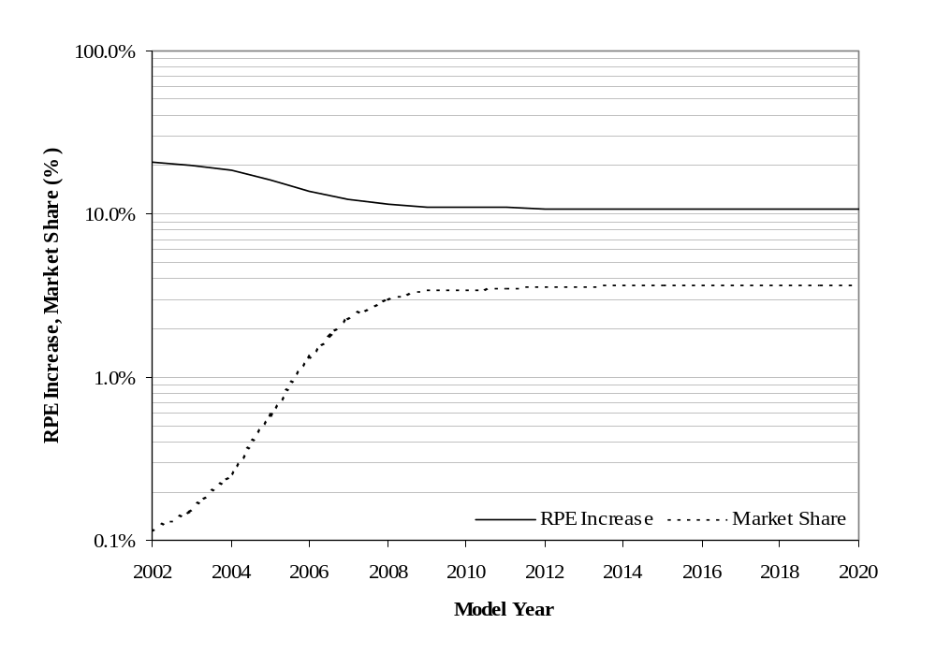
Figure 3. Sample HEV Market Simulation
Development of an actual model might be preceded by the examination of a much wider range of functional forms and the calibration of selected forms using a more robust set of forward-looking estimates of HEV characteristics and possibly historical data (as relevant) regarding rates of cost reduction for other automotive technologies.

In calibrating an actual model, sensitivity to coefficient values would warrant close attention, and might best be understood through Monte Carlo analysis. For example, given the forms shown above in (A.1) and (A.2) and the assumption that the RPE penalty could fall from 25 percent to as little as 5 percent in the long term, the predicted RPE and market penetration would be highly sensitive to the share of this price reduction attributed to time. As shown in Figure 4 and Figure 5, if most (in this case, 75 percent) of the potential RPE reduction is attributable to time, the simulation stabilizes at an RPE penalty of about 14 percent and a market share of slightly more than 1 percent. However, if little (in this case, 25 percent) of the potential RPE reduction is attributable to time, the simulation stabilizes at an RPE penalty of about 7.5 percent and a market share of nearly 11 percent. Therefore, in using such a model, it would be important to understand the relatively likelihood of different values of the RPE penalty reduction coefficients, as well as those of other coefficients. Given acceptable probability distributions for model coefficients, it would be possible to perform Monte Carlo analysis in order to characterize the range and uncertainty of potential outcomes.
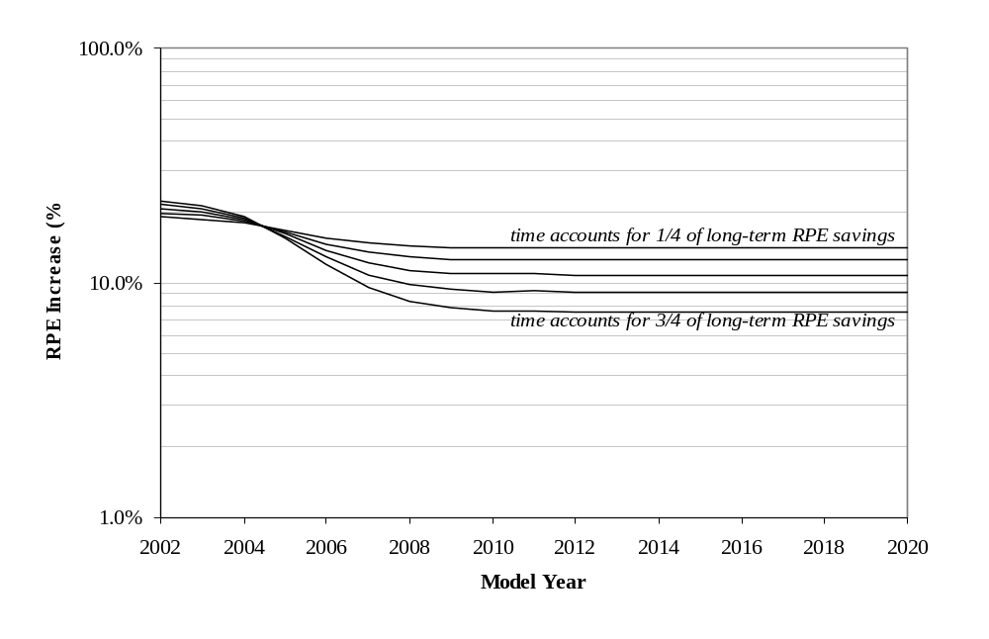
Figure 4. Sample RPE Increase vs. Share of Savings Attributed to Time

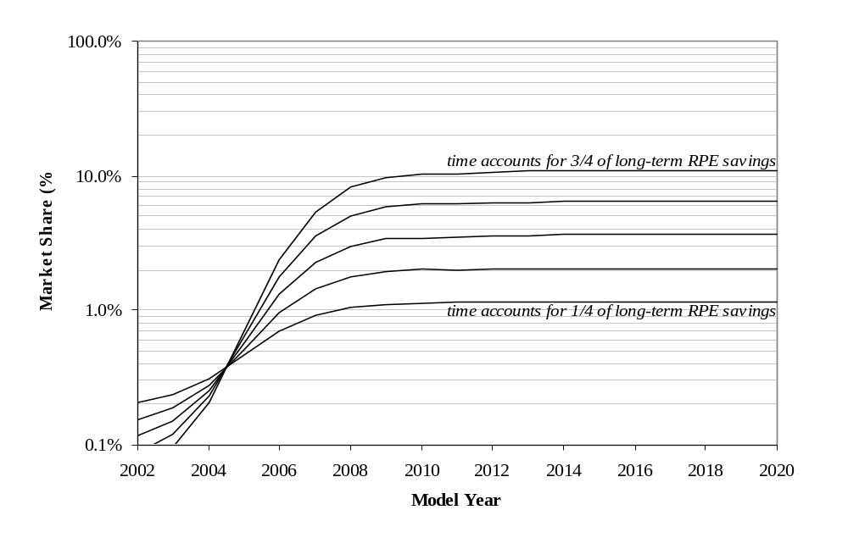
Figure 5. Sample Market Share vs. Share of RPE Savings Attributed to Time
Fuel Cell Vehicles

As for HEVs, there is currently considerable uncertainty regarding the likely future characteristic—in particular the RPE and fuel economy—of FCVs. Among various fuel cell technologies, PEM fuel cells appear to show the greatest promise for light vehicles. Although PEM fuel cells require pure hydrogen, on-board reformers can be used to extract hydrogen from hydrocarbon fuels such as methanol and gasoline.

The above-mentioned MIT report considered FCVs designed to operate on gasoline, methanol, and hydrogen, and predicted that, by 2020, each could have the following characteristics compared to conventional gasoline vehicles that have benefited from significant incremental improvements (Table 5):
Table 5. MIT Forecasts of FCV Characteristics in 2020
Fuel | Incremental Increase
Fuel | Fuel Economy | RPE
Gasoline | -2% | 30%
Methanol | 32% | 29%
Hydrogen | 116% | 23%

For methanol and hydrogen, fuel economy is expressed on an energy-equivalent basis. This report predicted that although FCVs with gasoline reformers in 2020 would achieve more than a 50 percent fuel economy gain relative to conventional gasoline cars sold in 1996, a slightly greater fuel economy increase could be achieved through incremental improvements to conventional vehicles over the same period.

EIA’s AEO 2002 predicted smaller increases in the fuel economy of conventional vehicles. However, although AEO 2002 correspondingly predicted greater sustained fuel economy increases for gasoline and methanol FCVs, it predicted smaller gains for hydrogen FCVs. AEO 2002 also predicted greater RPE penalties for FCVs through 2020 (Table 6).
Table 6. AEO 2002 Forecasts of FCV Characteristics
Fuel | Incremental Increase
Fuel | Fuel Economy | RPE
Gasoline | 38-72% (2005)  14-57% (2020) | 227-510% (2005)  26-61% (2020)
Methanol | 48-83% (2005)  22-67% (2020) | 197-444% (2005)  23-54% (2020)
Hydrogen | 62-101% (2005)  34-83% (2020) | 159-341% (2005)  37-72% (2020)

In 1999, Joan Ogden of Princeton University provided fuel economy estimates for FCVs based on assumed engineering characteristics. These estimates suggest the following fuel economy increases relative to a conventional vehicle that achieves 27.5 MPG (Table 7):
Table 7. FCV Fuel Economy Forecasts by Joan Ogden
Fuel | Fuel Economy Increase
Gasoline | 158%
Methanol | 151%
Hydrogen | 285%

Ogden did not provide RPE estimates for hydrogen FCVs, but did indicate that “methanol fuel cell automobiles are projected to cost about $500-600 more than comparable hydrogen fuel cell vehicles” and that “gasoline FCVs are projected to cost $800-1200 more than hydrogen fuel cell vehicles.”

In terms of the form suggested earlier in (A.1), the estimates from these sources suggest constants in the ranges suggested below (Table 8):
Table 8. Plausible Range of Values for Fuel Cell Vehicles
Constant | FCV Fuel
Constant | Gasoline | Methanol | Hydrogen
ΔFE (vs. 1990) | 0~0.8 | 0.2~0.8 | 0.3~1.2
ΔRPE_{MAX} | 2~5 | 1.5~4.5 | 1.5~3.5
ΔRPE_{MIN} | 0.3~0.6 | 0.2~0.6 | 0.2~0.7

Appendix B. Other Transportation Equipment

B.1 Buses

As for light-duty vehicles, hybrid-electric and fuel cell powertrains are under development for transit buses. In 1999, the New York City Transit Authority (NYCTA) purchased several hybrid electric buses at a unit price of about $575,000—roughly twice the cost of a conventional diesel bus, with expectations that the price would drop to approximately $350,000 at high production volumes. Test results in 1999 cited by Lockheed Martin indicated that hybrid electric buses achieved a 70 percent increase in fuel economy relative to a conventional diesel bus (5.8 vs. 3.4 MPG). NYCTA reportedly paid a unit price of $380,000 for a much larger order of hybrid buses in 2000. More recently, ISE Research has cited a base price of $329,000 for a 30-foot hybrid electric bus.

For fuel cell buses, fuel economy increases of about 100 percent have been reported. Current hydrogen fuel cell bus prices of four to five times that of conventional diesel buses have been cited. However, based on assumptions regarding reductions in the price of fuel cell stacks, some analysts have estimated that the incremental cost of a hydrogen fuel cell bus could fall to fifty percent (or 100 percent for a methanol fuel cell bus).,

Following the same general analytical approach suggested above for light-duty vehicles, the above sources suggest constants in the following ranges (Table 9):
Table 9. Plausible Range of Constants for Transit Buses
Constant | Hybrid Bus  (Diesel) | Fuel Cell Bus
Constant | Hybrid Bus  (Diesel) | Methanol | Hydrogen
ΔFE (vs. 1990) | 0.5~1.0 | ~1 | ~1
ΔRPE_{MAX} | ~2 | 3~4 | 3~4
ΔRPE_{MIN} | 0.2~0.3 | ~1 | ~0.5

B.2 Locomotives

A few reports released since 1990 address fuel efficiency of freight locomotives. In 1991, a DOT-sponsored study by Abacus Technology Corporation reviewed several energy-related design options, including engine and auxiliary system modifications, wheel flange lubricators, and reductions in railcar drag through overall redesign (e.g., to reduce weight and aerodynamic drag) or changes in components (e.g., air foils, bearing seals, lightweight materials). Abacus reviewed the efficiency potential and level of adoption of these technologies, but not their relative cost.

More recently, ANL has completed a Railroad and Locomotive Technology Roadmap for the U.S. Department of Energy. This report evaluates more than a dozen potential technological and operational changes, and reviews the potential energy savings associated with following technologies (Table 10):
Table 10. Argonne Estimates of Railroad and Locomotive Technology Characteristics
Technological Improvement | Incremental Increase
Technological Improvement | Fuel Economy | Cost
Idle Reduction | 10% | N/A
Energy Recovery | N/A | N/A
Wheel/Rail Friction | 24% | N/A
Aerodynamics | 5% | N/A
Homogeneous Charge CI | 0% | N/A
Fuel Cells | 0% | N/A
Gas Turbines | 0% | N/A

B.3 Marine Vessels

Although marine transportation is, where feasible given geographic and temporal constraints, the most energy-efficient mode available, some technological advances could further maritime energy efficiency. A recent report prepared for the International Maritime Organization reviewed a wide range of technological, operational, and market-based approaches to reducing GHG emissions from ships. Among the technological options for new ships, this report estimates fuel savings in three areas, but offers more limited estimates of corresponding cost increases, summarized in Table 11.
Table 11. MARINTEK, et al., Estimates of Marine Technology Characteristics
Technological Improvement | Incremental Increase
Technological Improvement | Fuel Economy | Cost
Optimized Hull Shape | 5-25% | N/A
Choice of Propeller | 5-11% | N/A
Powerplant Efficiency | 2-14% | 0-20%

While these estimates may provide a sufficient basis for characterizing the energy performance of potential vessel technologies, the basis for cost estimation appears even less solid for vessels than for light vehicles and buses.

B.4 Aircraft

A 1990 report by Greene reviews ten efficiency-related technological options for commercial aircraft. Among these, this report provides cost information for propfan engines, which it estimates would add $5 million to the cost of a $30-40 million aircraft with “present generation” (i.e., bypass ratio of 6-7) high bandpass engines, increasing fuel economy by 30 percent.

Using NEMS, the EIA’s AEO 2001 based its projections of aircraft fuel use on, among other things, the penetration rate of six aviation technologies. For each, AEO 2001 made an assumption regarding the relative fuel economy increase as well as the “trigger year” (i.e., the year the technology is introduced) and “trigger price” (i.e., the minimum jet fuel price at which the technology is assumed to be commercially viable). These assumptions are summarized in Table 12.
Table 12. Aircraft Technology Assumptions for AEO 2001
Technology | Fuel Economy  Increase | Trigger  Year | Trigger  Fuel Price  ($/gallon)
Ultra-high Bypass | 0.10 | 1995 | 0.56
Propfan | 0.23 | 2000 | 1.36
Thermodynamics | 0.20 | 2010 | 1.22
Hybrid Laminar Flow | 0.15 | 2020 | 1.53
Advanced Aerodynamics | 0.18 | 2000 | 1.70
Weight Reducing Materials | 0.15 | 2000 | 0.00

These assumptions regarding “trigger price” are not transparent with respect to any underlying estimates of incremental capital costs or other (e.g., maintenance) costs, and are therefore of limited use as a basis for characterizing these technologies as discussed above in Section 6.

A 1999 report prepared by the Intergovernmental Panel on Climate Change (IPCC) at the request of the International Civil Aviation Organization includes an extensive review of several different technologies and that could influence aircraft fuel consumption and GHG emissions. The report suggests that unducted propulsors with very high (i.e., above 15) bandpass ratios could increase propulsive efficiency by about 25 percent, but present numerous technical challenges. In addition, the report provides cost information for neither such propulsors nor any of the other aircraft technologies it reviews.

In 2000, the National Aeronautics and Space Administration (NASA) reported progress in several research areas under its Ultra-Efficient Engine Technology Program (UEET). NASA’s corresponding vision and mission are to “develop and hand off revolutionary turbine engine propulsion technologies that will enable future generation vehicles over a wide range of flight speeds.” Specifically, NASA indicates that the UEET will “address long term aviation growth potential without impact on climate by providing technology for dramatic increases in efficiency to enable reductions in CO₂ based on overall fuel savings goal of up to 15 percent.” NASA has projected overall UEET technology benefits of 9-18 percent for different types of aircraft, and has indicated that it plans to evaluate factors such as cost and noise in the future.

Based on the above, it appears there is currently limited basis for quantitative analysis of markets for advanced aircraft technologies. Even for propfans, for which the greatest amount of information is available, that information is still only partially useful toward the analytical approach discussed in Section 6. Fuel economy increases of 20-30 percent appear supportable. However, although Greene’s work suggests cost increases of 10-20 percent as of the late 1980s, the pace and extent to which such cost increases might decline over time and/or with volume is not clear. NASA’s fuel economy goals under the UEET are considerably more modest, but are even less clear in their relationship to cost.

A recent draft report prepared for the Environmental Protection Agency by Stratus Consulting examines not only engine replacement, but also aerodynamic technologies including blended winglets and ribbed plastic coatings. Data provided in this report suggests the following range of fuel economy and price increases for these two technologies (Table 13):
Table 13. Stratus Consulting Estimates for Two Aircraft Technologies
Technology | Incremental Increase
Technology | Fuel Economy | Price
Vertical Winglets | 1-4% | 1-8%
Ribbed Coatings | 1-2% | 0.1-0.7%

Stratus indicates that these aerodynamic improvements are available today, and that ribbed coatings can be applied to existing aircraft.


NREL (2001). About ADVISOR. NREL, Golden, CO (available on the Internet at http://www.ctts.nrel.gov/analysis/advisor.html).
ANL (2001). Hybrid Electric Vehicle Modeling: PNGV Systems Analysis Toolkit. ANL, Argonne, IL (available on the Internet at http://www.transportation.anl.gov/ttrdc/hybrids/ct3-PSAT.html).
Vyas, Anant (2001). HEVCOST V1.xls. ANL, Argonne, IL.
Leiby, Paul and Rubin, Jonathan (1997). Technical Documentation of the Transitional Alternative Fuels and Vehicles (TAFV) Model. Oak Ridge National Laboratory, Oak Ridge, TN.
Greene, David (2001). TAFV Alternative Fuels and Vehicles Choice Model Documentation. Oak Ridge National Laboratory, Oak Ridge, TN.
Kavalec, Chris (1996). CALCARS: The California Conventional and Alternative Fuel Response Simulator. California Energy Commission, Sacramento, CA.
CALCARS represents tailpipe emissions as an indexed value relative to the 1993 model year. Although the basis for the index is not specified, it likely represents a weighted total of criteria pollutant emission rates.
EIA (2003). The Transportation Sector Model of the National Energy Modeling System (available on the Internet at http://tonto.eia.doe.gov/FTPROOT/modeldoc/modeldocpubs.htm).
Although NEMS treats high-voltage HEVs much like AFVs, it does address low-voltage (42 volt) regenerative braking using the same methods as for the large number of more conventional technologies.
For freight trucks, NEMS currently accommodates up to 40 technologies, including improved transmissions and multiples levels of aerodynamic drag reduction, tire rolling resistance reduction, diesel and gasoline engine improvements, and weight reduction.
For aircraft, NEMS considers ultra high-bypass (UHB) turbofan engines, propfan engines, improved thermodynamic efficiency (i.e., higher core temperature and/or pressure), hybrid laminar flow control (LFC), advanced aerodynamics (e.g., “smart” wings), and weight reducing materials.
For example, evaluating a policy that differentiates between ATVs and conventional vehicles based on specific engineering characteristics rather than more general performance could require explicit accounting for applicable engineering characteristics.
Here, “retail price equivalent” refers to the price that would be charged given, for example, normal markups and profit margins and normal recovery of both fixed (including R&D) and variable costs.
It is conceivable that a generalized cost function might also accommodate some exogenous attempt to consider synergies with other modes or sectors (e.g., transferable fuel cell advances driven by stationary power applications).
In any given year y functions within forms and would yield a set of two equations with two unknowns (ΔRPE_{HEV} and SHARE_{HEV}). For some functional forms, an algebraic solution to this set of equations may be available. For example, the solution to x = y +1 and y = 2x +3 is x = -4 and y = -5. However, many functional forms will not yield algebraic solutions.
An alternative approach would have some representation of both purchaser preferences and production sector economics, and would iteratively seek ATV prices and penetration rates at which supply and demand are balanced.
To the extent that fuel economy would change over time if cost were held constant (e.g., due to technological advances that only affect performance), it might be important to include time as an independent variable in .
In fact, NEMS effectively monetizes assumed changes in performance and utility characteristics by converting such changes, along with changes in price, to changes in net utility. Sensitivity runs indicate that NEMS-based sales forecasts for HEVs are highly dependent on assumptions related to these vehicle characteristics. For example, NEMS projects that if HEVs provide an average of only half the luggage space of conventional vehicles, HEV sales would be about 50 percent lower than if HEVs provide normal luggage space. However, the relevant coefficients are based primarily on stated preference surveys, and it is not clear to what extent such surveys provide a reliable basis for forecasting the actual behavior of future vehicle buyers. Also, the basis for some assumed vehicle characteristics is less than clear. For example, NEMS assumes that maintenance and battery replacement costs for both gasoline and diesel HEVs will be 5 percent higher than for conventional gasoline vehicles.
Although the examples presented here all address ATVs with positive incremental costs—that is, costs that exceed those of conventional vehicles—the generalized function forms considered here would accommodate any cost reductions if anticipated for some ATVs.
Values are from http://www.toyota.com (as of May 30, 2003) and are for a 2001 Corolla CE with a 4-speed automatic transmission, air conditioning, and cassette sound system. The MSRP includes a $485 fee for delivery, handling, and processing.
Values are from http://www.toyota.com (as of May 30, 2003) and are for a 2001 Prius with air conditioning and cassette sound system. The MSRP includes a $485 fee for delivery, handling, and processing.
Values are from http://www.honda.com (as of May 30, 2003) and are for 2003 Civic LX with a 5-speed manual transmission and front side airbags. The MSRP includes a $440 destination charge.
Values are from http://www.honda.com (as of May 30, 2003) and are for 2003 Civic EX with a 5-speed manual transmission and front side airbags. The MSRP includes a $440 destination charge.
Values are from http://www.honda.com (as of May 30, 2003) and are for 2003 Civic Hybrid with a 5-speed manual transmission. The MSRP includes a $460 destination charge.
Such comparisons are complicated by the fact that specific features (e.g., climate control, antilock brakes, sound systems) of the Prius and Honda Civic do not precisely match those of any particular conventional vehicle.
American Honda Motor Co. (2002). Honda Response to NHTSA Request for Comments on CAFE 67 FR 5767.
NRC (2001). Effectiveness and Impact of Corporate Average Fuel Economy (CAFE) Standards.
EIA’s assumptions regarding incremental price reflect a high rate of decline during 2000-2003 and a discontinuous shift to a low rate of decline thereafter.
Weiss, et al. (2000). On the Road in 2020: A life-cycle analysis of new automobile technologies, Massachusetts Institute of Technology, Cambridge, MA, pp. 3-24, 3-29.
This is based, in part, on MIT’s projection that the fuel economy of conventional midsize sedans can be increased by 56 percent (about 15 MPG) by 2020 without increasing vehicle price by more than 5 percent.
These simulations were performed in Microsoft® Excel®.
For the sample model considered here, which was developed in Microsoft®Excel®, Monte Carlo analysis could be performed by developing purpose-specific macros or possibly by using commercially available add-in Monte Carlo analysis tools for Excel. However, other development environments might be more efficient for this type of analysis, even if spreadsheet software is used for information input, output, and presentation.
Ogden, Joan (1999). “Developing a Fueling Infrastructure for Fuel Cell Vehicles.” Princeton University, Princeton, N.J. (presented at conference on the Spirit of Innovation in Transportation, U.S. DOT, Volpe National Transportation Systems Center, 1999).
Lowell, Dana (1996). personal communication. NYCTA, New York, NY.
Lockheed Martin (1999). HybriDriveTM Propulsion Systems. Lockheed Martin, Johnson City, NY. (Lockheed Martin recently sold LM Control Systems, which had held rights to this propulsion system, to BAE Systems.)
Webb, Thomas (2000). personal communication. BAE Systems Controls, Inc., Somerville, MA.
ISE Research (2000). ThunderVolt™ Turbine Hybrid-Electric Transit Bus Receives Award. ISE Research, San Diego, CA.
U.S. DOE (1996). Climate Challenge Program Report. U.S. DOE, Washington, D.C.
Gibson, Helen (November 21, 2000). “Running On Thin Air.” Time Europe, (available on the Internet at http://www.time.com/time/europe/specials/ff/walkup/hydrogen.html).
Hörmandinger, Günter and Nigel J. D. Lucas, Nigel (2001). An Evaluation of the Economics of Fuel Cells in Urban Buses. Imperial College, London, UK, (excerpts available on the Internet at http://www.e-sources.com/fuelcell/econpap.html).
In other words, some analysts have estimated that the price of hydrogen and methanol fuel cell buses might fall to 150 percent and 200 percent, respectively, of the price of a conventional bus.
Abacus (1991). Rail vs. Truck Fuel Efficiency. Abacus Technology Corporation, Chevy Chase, MD.
ANL. (2002). Railroad and Locomotive Technology Roadmap, ANL/ESD/02-6, Argonne, IL.
“…it would not be unreasonable to expect idle-reduction technologies to be able to reduce fuel consumption by at least 10 percent in the long term.”
“…tremendous if a suitable [energy] storage technology can be developed.”
“Past studies have indicated that energy savings could be as high as 24 percent…”
MARINTEK, et al. (2000). Study of Greenhouse Gas Emissions from Ships. Norwegian Marine Technology R Research Institute – MARINTEK, Trondheim, Norway.
Greene, David (1990). Energy Efficiency Improvement Potential of Commercial Aircraft to 2010. Oak Ridge National Laboratory, Oak Ridge, TN.
These cost estimates appear to have been in 1990 dollars.
EIA (2000). AEO 2001. U.S. DOE, EIA, DOE/EIA-0383(2001), Washington, D.C.
IPCC (1999). Aviation and the Global Atmosphere. IPCC. Cambridge University Press, Cambridge, UK.
NASA (2000). Ultra-Efficient Engine Technology Program (UEET)—Overview, (available on the Internet at http://www.ueet.nasa.gov).
NASA (2000). Ultra-Efficient Engine Technology Program (UEET)—Preliminary Technology Benefits, (available on the Internet at http://www.ueet.nasa.gov).
Henderson, Jim and Ries, Heidi (2001). Controlling Carbon Dioxide Emissions from the Aviation Sector: Draft Final Report. Stratus Consulting, Boulder, CO.

