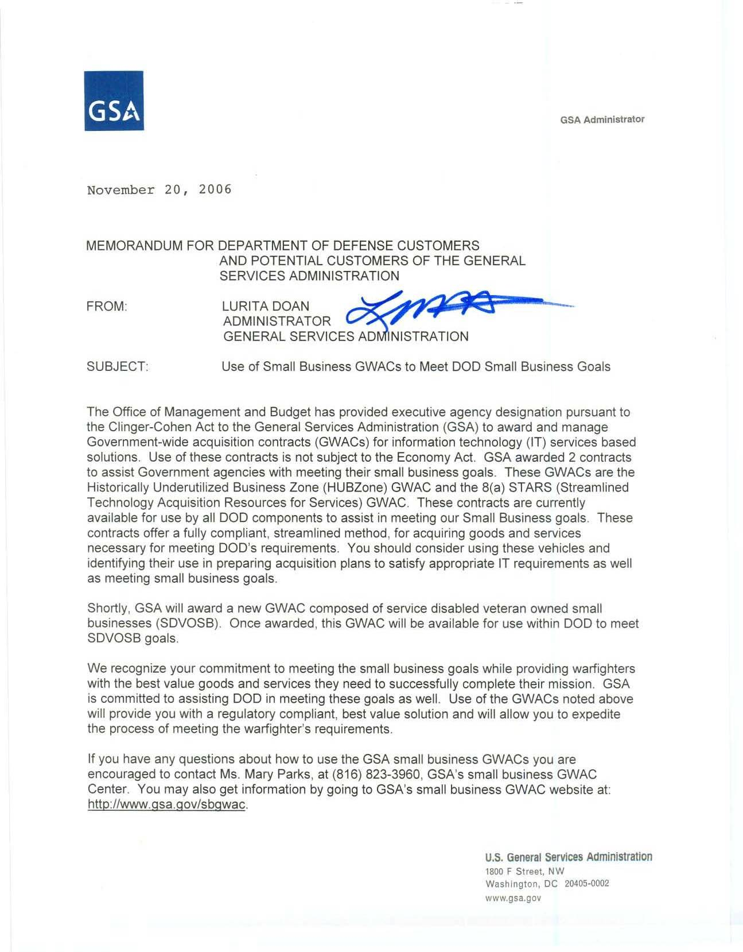
GSA Administrator

November 20, 2006

MEMORANDUM FOR DEPARTMENT OF DEFENSE CUSTOMERS
AND POTENTIAL CUSTOMERS OF THE GENERAL SERVICES ADMINISTRATION

FROM: LURITA DOAN
ADMINISTRATOR
GENERAL SERVICES ADMINISTRATION

SUBJECT: Use of Small Business GWACs to Meet DOD Small Business Goals

The Office of Management and Budget has provided executive agency designation pursuant to
the Clinger-Cohen Act to the General Services Administration (GSA) to award and manage
Government-wide acquisition contracts (GWACs) for information technology (IT) services based
solutions. Use of these contracts is not subject to the Economy Act. GSA awarded 2 contracts
to assist Government agencies with meeting their small business goals. These GWACs are the
Historically Underutilized Business Zone (HUBZ0ne) GWAC and the 8(a) STARS (Streamlined
Technology Acquisition Resources for Services) GWAC, These contracts are currently
available for use by all DOD components to assist in meeting our Small Business goals. These
contracts offer a fully compliant, streamlined method, for acquiring goods and services
necessary for meeting DOD's requirements. You should consider using these vehicles and
identifying their use in preparing acquisition plans to satisfy appropriate IT requirements as well
as meeting small business goals

Shortly. GSA will award a new GWAC composed of service disabled veteran owned small
businesses (SDVOSB) Once awarded, this GWAC will be available for use within DOD to meet
SDVOSB goals.

We recognize your commitment to meeting the small business goals while providing war fighters
with the best value goods and services they need to successfully complete their mission. GSA
is committed to assisting DOD in meeting these goals as well. Use of the GWACs noted above
will provide you with a regulatory compliant, best value solution and will allow you to expedite
the process of meeting the warfighters requirements

If you have any questions about how to use the GSA small business GWACs you are
encouraged to contact Ms. Mary Parks, at (816) 823-3960, GSA's small business GWAC
Center. You may also get information by going to GSA's small business GWAC website at:
http:llwww.gsa.gov/sbqwac

