Frequency Analysis

Table: | SP_GSA_AGENCY

Filter: | None

Question: | Name of Cabinet within which your agency resides or Other if your agency does not fall within a Cabinet.

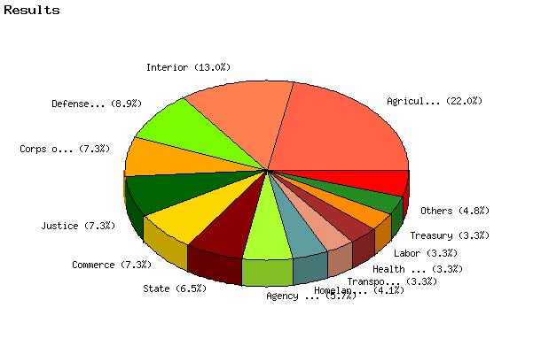

   | Count | % Sample  Answered | % Sample  Asked | % Sample  Total
  Agriculture | 27 | 22.0% | 22.0% | 22.0%
  Commerce | 9 | 7.3% | 7.3% | 7.3%
  Defense (Except Corps of Engineers) | 11 | 8.9% | 8.9% | 8.9%
  Corps of Engineers | 9 | 7.3% | 7.3% | 7.3%
  Education | 0 | 0.0% | 0.0% | 0.0%
  Energy | 2 | 1.6% | 1.6% | 1.6%
  Health & Human Services | 4 | 3.3% | 3.3% | 3.3%
  Homeland Security | 5 | 4.1% | 4.1% | 4.1%
  Housing & Urban Development | 2 | 1.6% | 1.6% | 1.6%
  Interior | 16 | 13.0% | 13.0% | 13.0%
  Justice | 9 | 7.3% | 7.3% | 7.3%
  Labor | 4 | 3.3% | 3.3% | 3.3%
  State | 8 | 6.5% | 6.5% | 6.5%
  Transportation | 4 | 3.3% | 3.3% | 3.3%
  Treasury | 4 | 3.3% | 3.3% | 3.3%
  Veterans Affairs | 1 | 0.8% | 0.8% | 0.8%
  Agency not within Cabinet | 7 | 5.7% | 5.7% | 5.7%
  Government Corporations | 1 | 0.8% | 0.8% | 0.8%
  Not Answered | 0 | N/A | 0.0% | 0.0%
  Not Asked | 0 | N/A | N/A | 0.0%
  Total | 123 | 100% | 100% | 100%
  Statistics
  Minimum Value | 1.00
  Maximum Value | 18.00
  Average | 7.25
  Sum | 892
  Standard Deviation | 5.35
  Median | 8
  Mode | 1

Question: | Please select the appropriate Defense Agency.

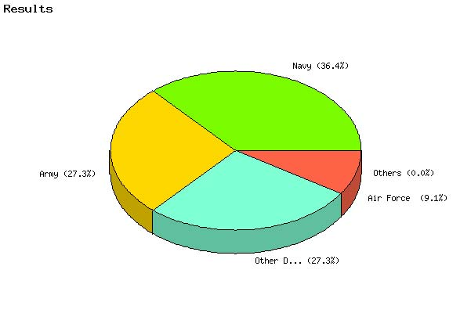

   | Count | % Sample  Answered | % Sample  Asked | % Sample  Total
  Air Force | 1 | 9.1% | 9.1% | 0.8%
  Army | 3 | 27.3% | 27.3% | 2.4%
  Navy | 4 | 36.4% | 36.4% | 3.3%
  Marine Corps | 0 | 0.0% | 0.0% | 0.0%
  Other DoD organization (Please specify) | 3 | 27.3% | 27.3% | 2.4%
  Not Answered | 0 | N/A | 0.0% | 0.0%
  Not Asked | 112 | N/A | N/A | 91.1%
  Total | 123 | 100% | 100% | 100%
  Statistics
  Minimum Value | 1.00
  Maximum Value | 5.00
  Average | 3.09
  Sum | 34
  Standard Deviation | 1.38
  Median | 3
  Mode | 3

Question: | Has your agency developed specific relocation guidance to supplement the Federal Travel Regulation (FTR)?

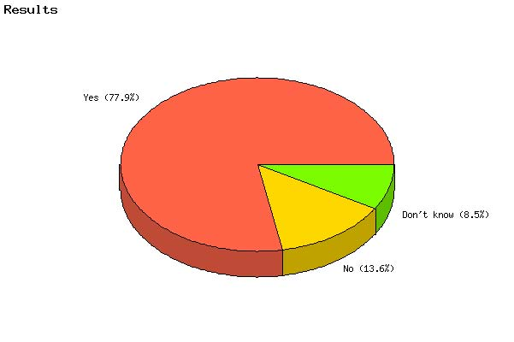

   | Count | % Sample  Answered | % Sample  Asked | % Sample  Total
  Yes | 92 | 78.0% | 74.8% | 74.8%
  No | 16 | 13.6% | 13.0% | 13.0%
  Don't know | 10 | 8.5% | 8.1% | 8.1%
  Not Answered | 5 | N/A | 4.1% | 4.1%
  Not Asked | 0 | N/A | N/A | 0.0%
  Total | 123 | 100% | 100% | 100%
  Statistics
  Minimum Value | 1.00
  Maximum Value | 3.00
  Average | 1.31
  Sum | 154
  Standard Deviation | 0.62
  Median | 1
  Mode | 1

Question: | How frequently is your agency's internal relocation policy reviewed and updated?

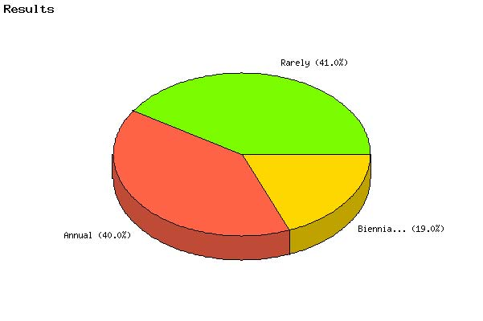

   | Count | % Sample  Answered | % Sample  Asked | % Sample  Total
  Annual | 40 | 40.0% | 32.5% | 32.5%
  Biennial (every two years) | 19 | 19.0% | 15.4% | 15.4%
  Rarely | 41 | 41.0% | 33.3% | 33.3%
  Not Answered | 23 | N/A | 18.7% | 18.7%
  Not Asked | 0 | N/A | N/A | 0.0%
  Total | 123 | 100% | 100% | 100%
  Statistics
  Minimum Value | 1.00
  Maximum Value | 3.00
  Average | 2.01
  Sum | 201
  Standard Deviation | 0.90
  Median | 2
  Mode | 3

Question: | Does your agency use the GSA Relocation Policy Guide? (The guide can be found at: http://www.gsa.gov/Portal/gsa/ep/contentView.do?P=MTT&contentId=14886&contentType=GSA_BASIC)

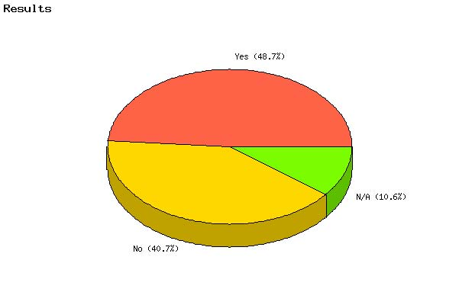

   | Count | % Sample  Answered | % Sample  Asked | % Sample  Total
  Yes | 55 | 48.7% | 44.7% | 44.7%
  No | 46 | 40.7% | 37.4% | 37.4%
  N/A | 12 | 10.6% | 9.8% | 9.8%
  Not Answered | 10 | N/A | 8.1% | 8.1%
  Not Asked | 0 | N/A | N/A | 0.0%
  Total | 123 | 100% | 100% | 100%
  Statistics
  Minimum Value | 1.00
  Maximum Value | 3.00
  Average | 1.62
  Sum | 183
  Standard Deviation | 0.67
  Median | 2
  Mode | 1

Question: | Actual number of relocations authorized for Fiscal Year 2004.

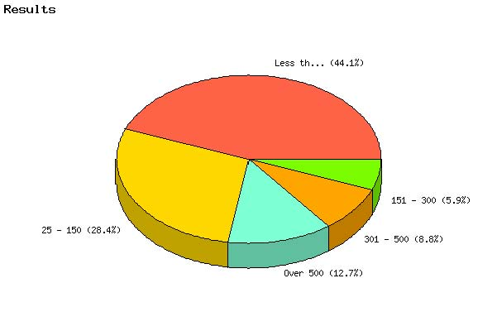

   | Count | % Sample  Answered | % Sample  Asked | % Sample  Total
  Less than 25 | 45 | 44.1% | 36.6% | 36.6%
  25 - 150 | 29 | 28.4% | 23.6% | 23.6%
  151 - 300 | 6 | 5.9% | 4.9% | 4.9%
  301 - 500 | 9 | 8.8% | 7.3% | 7.3%
  Over 500 | 13 | 12.7% | 10.6% | 10.6%
  Not Answered | 21 | N/A | 17.1% | 17.1%
  Not Asked | 0 | N/A | N/A | 0.0%
  Total | 123 | 100% | 100% | 100%
  Statistics
  Minimum Value | 1.00
  Maximum Value | 5.00
  Average | 2.18
  Sum | 222
  Standard Deviation | 1.41
  Median | 2
  Mode | 1

Question: | For a given fiscal year, please estimate the percentage of relocating employees who handle their relocation on their own with reimbursement for actual expenses.

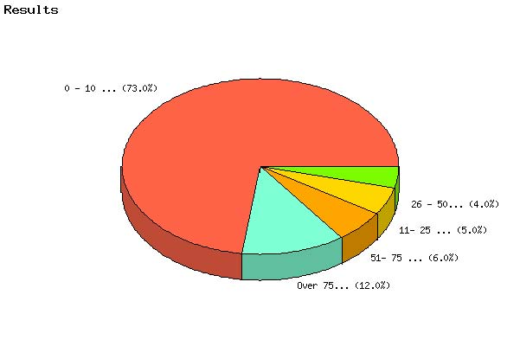

   | Count | % Sample  Answered | % Sample  Asked | % Sample  Total
  0 - 10 percent | 73 | 73.0% | 59.3% | 59.3%
  11- 25 percent | 5 | 5.0% | 4.1% | 4.1%
  26 - 50 percent | 4 | 4.0% | 3.3% | 3.3%
  51- 75 percent | 6 | 6.0% | 4.9% | 4.9%
  Over 75 percent | 12 | 12.0% | 9.8% | 9.8%
  Not Answered | 23 | N/A | 18.7% | 18.7%
  Not Asked | 0 | N/A | N/A | 0.0%
  Total | 123 | 100% | 100% | 100%
  Statistics
  Minimum Value | 1.00
  Maximum Value | 5.00
  Average | 1.79
  Sum | 179
  Standard Deviation | 1.44
  Median | 1
  Mode | 1

Question: | For a given fiscal year, please estimate the percentage of relocating employees who receive a lump-sum payment as full reimbursement for their relocation.

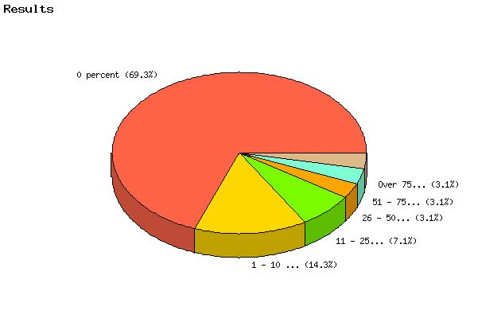

   | Count | % Sample  Answered | % Sample  Asked | % Sample  Total
  0 percent | 68 | 69.4% | 55.3% | 55.3%
  1 - 10 percent | 14 | 14.3% | 11.4% | 11.4%
  11 - 25 percent | 7 | 7.1% | 5.7% | 5.7%
  26 - 50 percent | 3 | 3.1% | 2.4% | 2.4%
  51 - 75 percent | 3 | 3.1% | 2.4% | 2.4%
  Over 75 percent | 3 | 3.1% | 2.4% | 2.4%
  Not Answered | 25 | N/A | 20.3% | 20.3%
  Not Asked | 0 | N/A | N/A | 0.0%
  Total | 123 | 100% | 100% | 100%
  Statistics
  Minimum Value | 1.00
  Maximum Value | 6.00
  Average | 1.65
  Sum | 162
  Standard Deviation | 1.24
  Median | 1
  Mode | 1

Question: | On the average, for your agency, which best describes the lead time given to your employees for relocation?

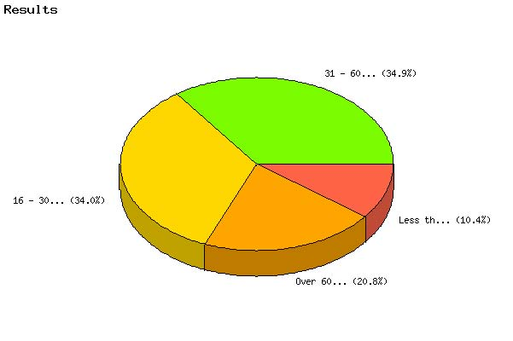

   | Count | % Sample  Answered | % Sample  Asked | % Sample  Total
  Less than 15 days | 11 | 10.4% | 8.9% | 8.9%
  16 - 30 days | 36 | 34.0% | 29.3% | 29.3%
  31 - 60 days | 37 | 34.9% | 30.1% | 30.1%
  Over 60 days | 22 | 20.8% | 17.9% | 17.9%
  Not Answered | 17 | N/A | 13.8% | 13.8%
  Not Asked | 0 | N/A | N/A | 0.0%
  Total | 123 | 100% | 100% | 100%
  Statistics
  Minimum Value | 1.00
  Maximum Value | 4.00
  Average | 2.66
  Sum | 282
  Standard Deviation | 0.92
  Median | 3
  Mode | 3

Question: | Is your agency's relocation program managed centrally or decentrally, i.e., handled one agency location or dispursed through two or more locations? Please describe.
Topic: | Function

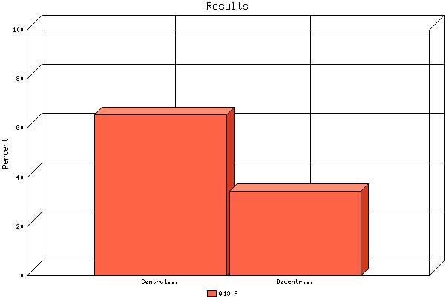

   | Count | % Sample  Answered | % Sample  Asked | % Sample  Total
  Centralized | 61 | 65.6% | 49.6% | 49.6%
  Decentralized | 32 | 34.4% | 26.0% | 26.0%
  Not Answered | 30 | N/A | 24.4% | 24.4%
  Not Asked | 0 | N/A | N/A | 0.0%
  Total | 123 | 100% | 100% | 100%
  Statistics
  Minimum Value | 1.00
  Maximum Value | 2.00
  Average | 1.34
  Sum | 125
  Standard Deviation | 0.48
  Median | 1
  Mode | 1

Question: | Is your agency's relocation program managed centrally or decentrally, i.e., handled one agency location or dispursed through two or more locations? Please describe.
Topic: | Administrative

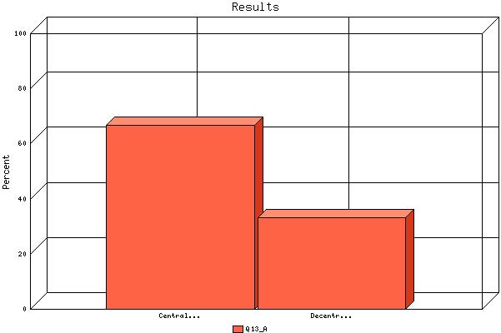

   | Count | % Sample  Answered | % Sample  Asked | % Sample  Total
  Centralized | 68 | 66.7% | 55.3% | 55.3%
  Decentralized | 34 | 33.3% | 27.6% | 27.6%
  Not Answered | 21 | N/A | 17.1% | 17.1%
  Not Asked | 0 | N/A | N/A | 0.0%
  Total | 123 | 100% | 100% | 100%
  Statistics
  Minimum Value | 1.00
  Maximum Value | 2.00
  Average | 1.33
  Sum | 136
  Standard Deviation | 0.47
  Median | 1
  Mode | 1

Question: | Is your agency's relocation program managed centrally or decentrally, i.e., handled one agency location or dispursed through two or more locations? Please describe.
Topic: | Finance

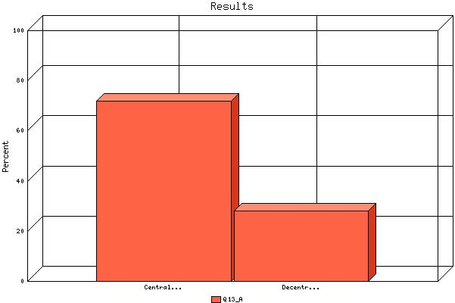

   | Count | % Sample  Answered | % Sample  Asked | % Sample  Total
  Centralized | 74 | 71.8% | 60.2% | 60.2%
  Decentralized | 29 | 28.2% | 23.6% | 23.6%
  Not Answered | 20 | N/A | 16.3% | 16.3%
  Not Asked | 0 | N/A | N/A | 0.0%
  Total | 123 | 100% | 100% | 100%
  Statistics
  Minimum Value | 1.00
  Maximum Value | 2.00
  Average | 1.28
  Sum | 132
  Standard Deviation | 0.45
  Median | 1
  Mode | 1

Question: | Is your agency's relocation program managed centrally or decentrally, i.e., handled one agency location or dispursed through two or more locations? Please describe.
Topic: | Human resources

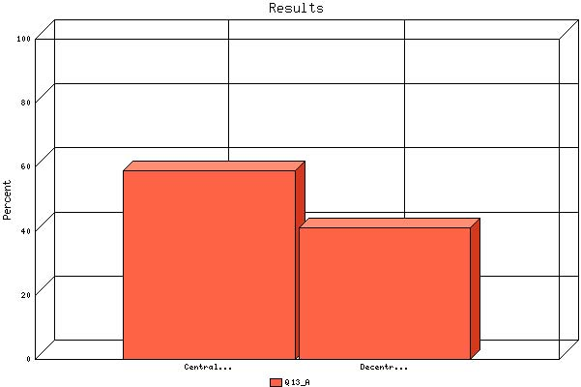

   | Count | % Sample  Answered | % Sample  Asked | % Sample  Total
  Centralized | 60 | 58.8% | 48.8% | 48.8%
  Decentralized | 42 | 41.2% | 34.1% | 34.1%
  Not Answered | 21 | N/A | 17.1% | 17.1%
  Not Asked | 0 | N/A | N/A | 0.0%
  Total | 123 | 100% | 100% | 100%
  Statistics
  Minimum Value | 1.00
  Maximum Value | 2.00
  Average | 1.41
  Sum | 144
  Standard Deviation | 0.49
  Median | 1
  Mode | 1

Question: | Is your agency's relocation program managed centrally or decentrally, i.e., handled one agency location or dispursed through two or more locations? Please describe.
Topic: | Shipment & storage of household goods

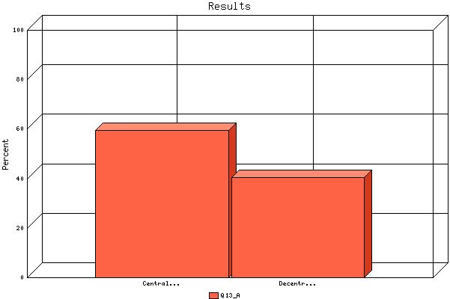

   | Count | % Sample  Answered | % Sample  Asked | % Sample  Total
  Centralized | 62 | 59.6% | 50.4% | 50.4%
  Decentralized | 42 | 40.4% | 34.1% | 34.1%
  Not Answered | 19 | N/A | 15.4% | 15.4%
  Not Asked | 0 | N/A | N/A | 0.0%
  Total | 123 | 100% | 100% | 100%
  Statistics
  Minimum Value | 1.00
  Maximum Value | 2.00
  Average | 1.40
  Sum | 146
  Standard Deviation | 0.49
  Median | 1
  Mode | 1

Question: | Is your agency's relocation program managed centrally or decentrally, i.e., handled one agency location or dispursed through two or more locations? Please describe.
Topic: | Voucher payments

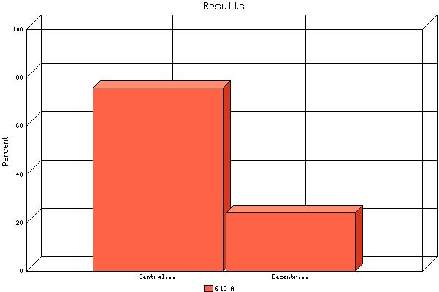

   | Count | % Sample  Answered | % Sample  Asked | % Sample  Total
  Centralized | 78 | 75.7% | 63.4% | 63.4%
  Decentralized | 25 | 24.3% | 20.3% | 20.3%
  Not Answered | 20 | N/A | 16.3% | 16.3%
  Not Asked | 0 | N/A | N/A | 0.0%
  Total | 123 | 100% | 100% | 100%
  Statistics
  Minimum Value | 1.00
  Maximum Value | 2.00
  Average | 1.24
  Sum | 128
  Standard Deviation | 0.43
  Median | 1
  Mode | 1

Question: | Is your agency's relocation program managed centrally or decentrally, i.e., handled one agency location or dispursed through two or more locations? Please describe.
Topic: | Relocation policy

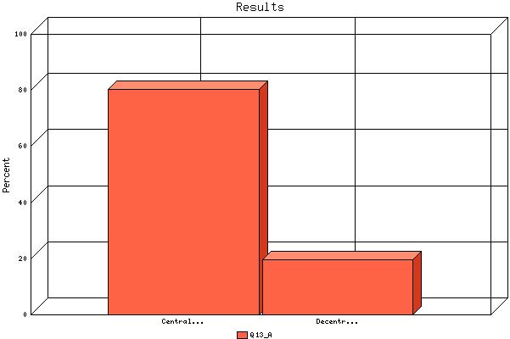

   | Count | % Sample  Answered | % Sample  Asked | % Sample  Total
  Centralized | 82 | 80.4% | 66.7% | 66.7%
  Decentralized | 20 | 19.6% | 16.3% | 16.3%
  Not Answered | 21 | N/A | 17.1% | 17.1%
  Not Asked | 0 | N/A | N/A | 0.0%
  Total | 123 | 100% | 100% | 100%
  Statistics
  Minimum Value | 1.00
  Maximum Value | 2.00
  Average | 1.20
  Sum | 122
  Standard Deviation | 0.40
  Median | 1
  Mode | 1

Question: | Is your agency's relocation program managed centrally or decentrally, i.e., handled one agency location or dispursed through two or more locations? Please describe.
Topic: | Third-party relocation contracts

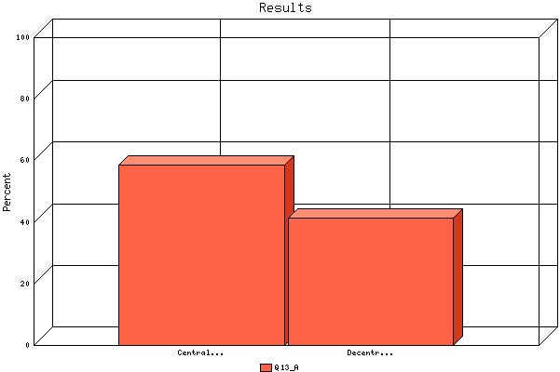

   | Count | % Sample  Answered | % Sample  Asked | % Sample  Total
  Centralized | 55 | 58.5% | 44.7% | 44.7%
  Decentralized | 39 | 41.5% | 31.7% | 31.7%
  Not Answered | 29 | N/A | 23.6% | 23.6%
  Not Asked | 0 | N/A | N/A | 0.0%
  Total | 123 | 100% | 100% | 100%
  Statistics
  Minimum Value | 1.00
  Maximum Value | 2.00
  Average | 1.41
  Sum | 133
  Standard Deviation | 0.50
  Median | 1
  Mode | 1

Question: | Is your agency's relocation program managed centrally or decentrally, i.e., handled one agency location or dispursed through two or more locations? Please describe.
Topic: | Counseling

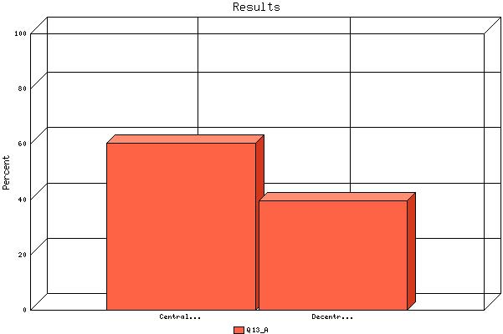

   | Count | % Sample  Answered | % Sample  Asked | % Sample  Total
  Centralized | 61 | 60.4% | 49.6% | 49.6%
  Decentralized | 40 | 39.6% | 32.5% | 32.5%
  Not Answered | 22 | N/A | 17.9% | 17.9%
  Not Asked | 0 | N/A | N/A | 0.0%
  Total | 123 | 100% | 100% | 100%
  Statistics
  Minimum Value | 1.00
  Maximum Value | 2.00
  Average | 1.40
  Sum | 141
  Standard Deviation | 0.49
  Median | 1
  Mode | 1

Question: | Is your agency satisfied with the organization of its relocation functions?

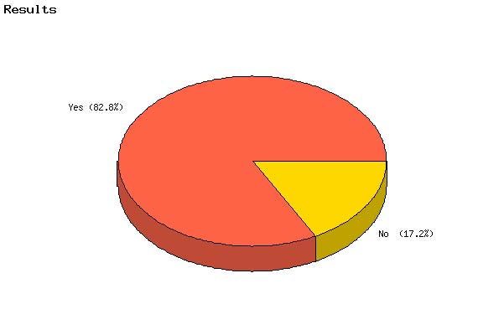

   | Count | % Sample  Answered | % Sample  Asked | % Sample  Total
  Yes | 82 | 82.8% | 66.7% | 66.7%
  No | 17 | 17.2% | 13.8% | 13.8%
  Not Answered | 24 | N/A | 19.5% | 19.5%
  Not Asked | 0 | N/A | N/A | 0.0%
  Total | 123 | 100% | 100% | 100%
  Statistics
  Minimum Value | 1.00
  Maximum Value | 2.00
  Average | 1.17
  Sum | 116
  Standard Deviation | 0.38
  Median | 1
  Mode | 1

Question: | Has your agency encountered any problems administering the 1-year Government service agreement?

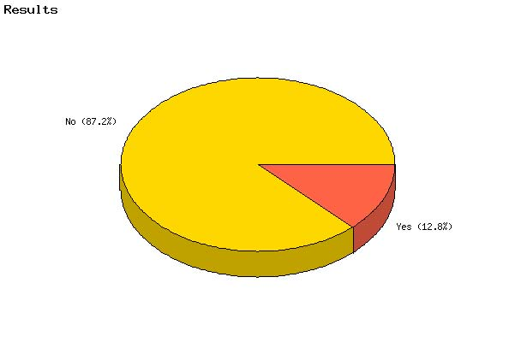

   | Count | % Sample  Answered | % Sample  Asked | % Sample  Total
  Yes | 12 | 12.8% | 9.8% | 9.8%
  No | 82 | 87.2% | 66.7% | 66.7%
  Not Answered | 29 | N/A | 23.6% | 23.6%
  Not Asked | 0 | N/A | N/A | 0.0%
  Total | 123 | 100% | 100% | 100%
  Statistics
  Minimum Value | 1.00
  Maximum Value | 2.00
  Average | 1.87
  Sum | 176
  Standard Deviation | 0.34
  Median | 2
  Mode | 2

Question: | Which , if any, aspects of the relocation process in your agency is automated?
Topic: | Service agreement

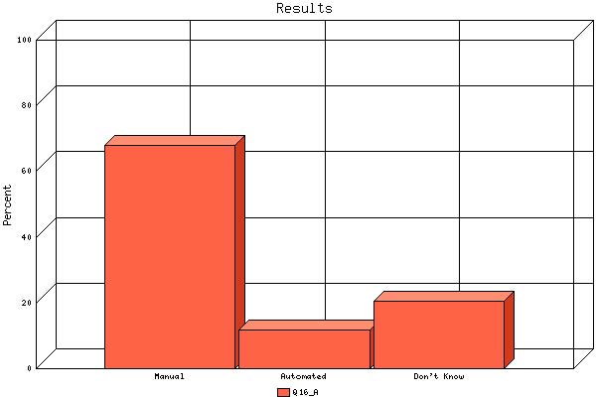

   | Count | % Sample  Answered | % Sample  Asked | % Sample  Total
  Manual | 70 | 68.0% | 56.9% | 56.9%
  Automated | 12 | 11.7% | 9.8% | 9.8%
  Don't Know | 21 | 20.4% | 17.1% | 17.1%
  Not Answered | 20 | N/A | 16.3% | 16.3%
  Not Asked | 0 | N/A | N/A | 0.0%
  Total | 123 | 100% | 100% | 100%
  Statistics
  Minimum Value | 1.00
  Maximum Value | 3.00
  Average | 1.52
  Sum | 157
  Standard Deviation | 0.81
  Median | 1
  Mode | 1

Question: | Which , if any, aspects of the relocation process in your agency is automated?
Topic: | Travel authorization

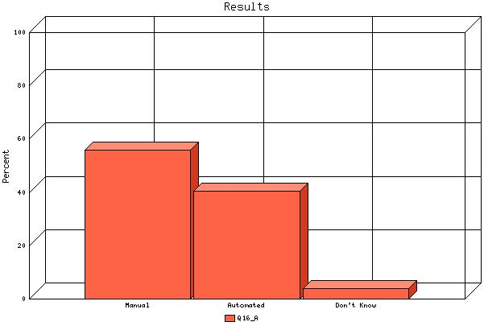

   | Count | % Sample  Answered | % Sample  Asked | % Sample  Total
  Manual | 58 | 55.8% | 47.2% | 47.2%
  Automated | 42 | 40.4% | 34.1% | 34.1%
  Don't Know | 4 | 3.8% | 3.3% | 3.3%
  Not Answered | 19 | N/A | 15.4% | 15.4%
  Not Asked | 0 | N/A | N/A | 0.0%
  Total | 123 | 100% | 100% | 100%
  Statistics
  Minimum Value | 1.00
  Maximum Value | 3.00
  Average | 1.48
  Sum | 154
  Standard Deviation | 0.57
  Median | 1
  Mode | 1

Question: | Which , if any, aspects of the relocation process in your agency is automated?
Topic: | Voucher preparation

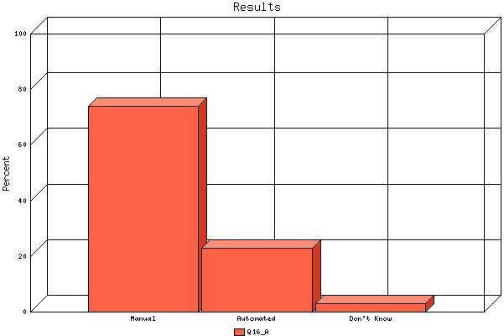

   | Count | % Sample  Answered | % Sample  Asked | % Sample  Total
  Manual | 77 | 74.0% | 62.6% | 62.6%
  Automated | 24 | 23.1% | 19.5% | 19.5%
  Don't Know | 3 | 2.9% | 2.4% | 2.4%
  Not Answered | 19 | N/A | 15.4% | 15.4%
  Not Asked | 0 | N/A | N/A | 0.0%
  Total | 123 | 100% | 100% | 100%
  Statistics
  Minimum Value | 1.00
  Maximum Value | 3.00
  Average | 1.29
  Sum | 134
  Standard Deviation | 0.52
  Median | 1
  Mode | 1

Question: | Which , if any, aspects of the relocation process in your agency is automated?
Topic: | Relocation Income Tax Allowance/Q941

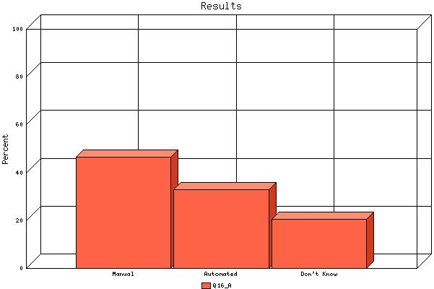

   | Count | % Sample  Answered | % Sample  Asked | % Sample  Total
  Manual | 48 | 46.6% | 39.0% | 39.0%
  Automated | 34 | 33.0% | 27.6% | 27.6%
  Don't Know | 21 | 20.4% | 17.1% | 17.1%
  Not Answered | 20 | N/A | 16.3% | 16.3%
  Not Asked | 0 | N/A | N/A | 0.0%
  Total | 123 | 100% | 100% | 100%
  Statistics
  Minimum Value | 1.00
  Maximum Value | 3.00
  Average | 1.74
  Sum | 179
  Standard Deviation | 0.78
  Median | 2
  Mode | 1

Question: | Which , if any, aspects of the relocation process in your agency is automated?
Topic: | Integration with payroll/finance

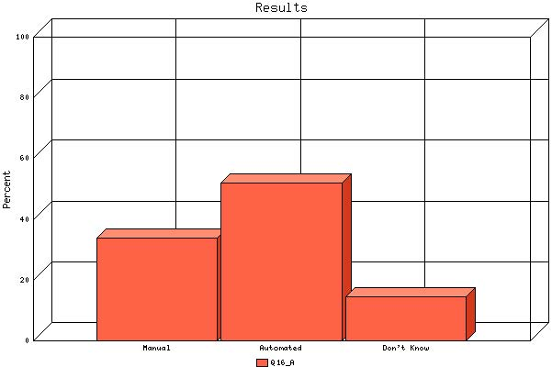

   | Count | % Sample  Answered | % Sample  Asked | % Sample  Total
  Manual | 35 | 33.7% | 28.5% | 28.5%
  Automated | 54 | 51.9% | 43.9% | 43.9%
  Don't Know | 15 | 14.4% | 12.2% | 12.2%
  Not Answered | 19 | N/A | 15.4% | 15.4%
  Not Asked | 0 | N/A | N/A | 0.0%
  Total | 123 | 100% | 100% | 100%
  Statistics
  Minimum Value | 1.00
  Maximum Value | 3.00
  Average | 1.81
  Sum | 188
  Standard Deviation | 0.67
  Median | 2
  Mode | 2

Question: | Which , if any, aspects of the relocation process in your agency is automated?
Topic: | Integration with Vendor Information

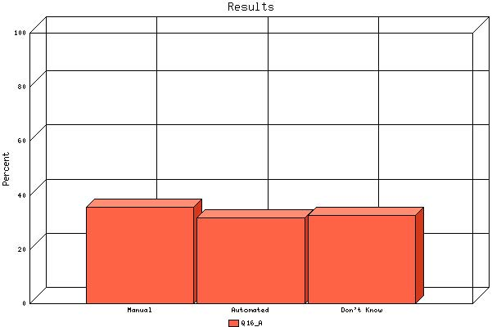

   | Count | % Sample  Answered | % Sample  Asked | % Sample  Total
  Manual | 37 | 35.6% | 30.1% | 30.1%
  Automated | 33 | 31.7% | 26.8% | 26.8%
  Don't Know | 34 | 32.7% | 27.6% | 27.6%
  Not Answered | 19 | N/A | 15.4% | 15.4%
  Not Asked | 0 | N/A | N/A | 0.0%
  Total | 123 | 100% | 100% | 100%
  Statistics
  Minimum Value | 1.00
  Maximum Value | 3.00
  Average | 1.97
  Sum | 205
  Standard Deviation | 0.83
  Median | 2
  Mode | 1

Question: | Which , if any, aspects of the relocation process in your agency is automated?
Topic: | Household Goods?

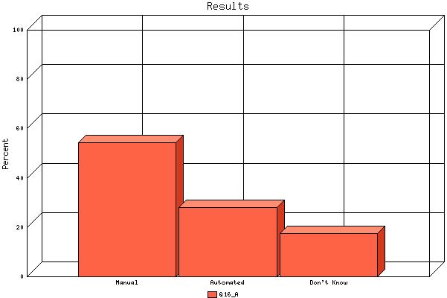

   | Count | % Sample  Answered | % Sample  Asked | % Sample  Total
  Manual | 56 | 54.4% | 45.5% | 45.5%
  Automated | 29 | 28.2% | 23.6% | 23.6%
  Don't Know | 18 | 17.5% | 14.6% | 14.6%
  Not Answered | 20 | N/A | 16.3% | 16.3%
  Not Asked | 0 | N/A | N/A | 0.0%
  Total | 123 | 100% | 100% | 100%
  Statistics
  Minimum Value | 1.00
  Maximum Value | 3.00
  Average | 1.63
  Sum | 168
  Standard Deviation | 0.77
  Median | 1
  Mode | 1

Question: | Which , if any, aspects of the relocation process in your agency is automated?
Topic: | Home Sale?

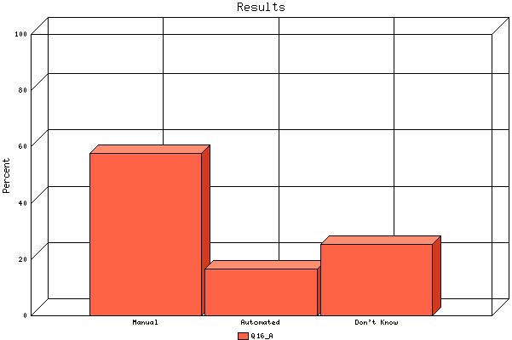

   | Count | % Sample  Answered | % Sample  Asked | % Sample  Total
  Manual | 59 | 57.8% | 48.0% | 48.0%
  Automated | 17 | 16.7% | 13.8% | 13.8%
  Don't Know | 26 | 25.5% | 21.1% | 21.1%
  Not Answered | 21 | N/A | 17.1% | 17.1%
  Not Asked | 0 | N/A | N/A | 0.0%
  Total | 123 | 100% | 100% | 100%
  Statistics
  Minimum Value | 1.00
  Maximum Value | 3.00
  Average | 1.68
  Sum | 171
  Standard Deviation | 0.86
  Median | 1
  Mode | 1

Question: | Which , if any, aspects of the relocation process in your agency is automated?
Topic: | Relocation information package

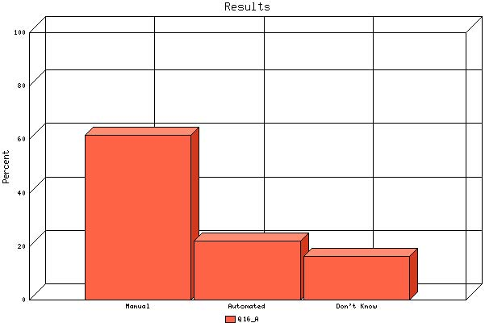

   | Count | % Sample  Answered | % Sample  Asked | % Sample  Total
  Manual | 64 | 61.5% | 52.0% | 52.0%
  Automated | 23 | 22.1% | 18.7% | 18.7%
  Don't Know | 17 | 16.3% | 13.8% | 13.8%
  Not Answered | 19 | N/A | 15.4% | 15.4%
  Not Asked | 0 | N/A | N/A | 0.0%
  Total | 123 | 100% | 100% | 100%
  Statistics
  Minimum Value | 1.00
  Maximum Value | 3.00
  Average | 1.55
  Sum | 161
  Standard Deviation | 0.76
  Median | 1
  Mode | 1

Question: | Which , if any, aspects of the relocation process in your agency is automated?
Topic: | Access policy

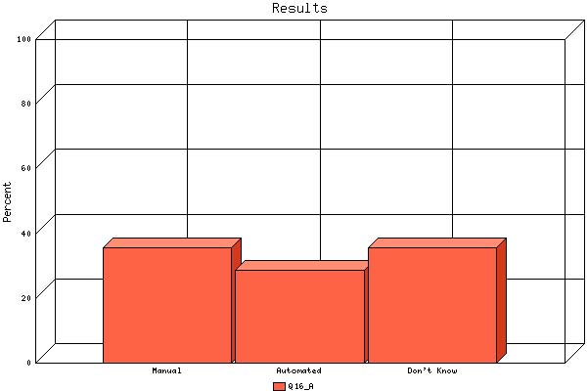

   | Count | % Sample  Answered | % Sample  Asked | % Sample  Total
  Manual | 37 | 35.6% | 30.1% | 30.1%
  Automated | 30 | 28.8% | 24.4% | 24.4%
  Don't Know | 37 | 35.6% | 30.1% | 30.1%
  Not Answered | 19 | N/A | 15.4% | 15.4%
  Not Asked | 0 | N/A | N/A | 0.0%
  Total | 123 | 100% | 100% | 100%
  Statistics
  Minimum Value | 1.00
  Maximum Value | 3.00
  Average | 2.00
  Sum | 208
  Standard Deviation | 0.85
  Median | 2
  Mode | Multi-Modal

Question: | Does your agency agree with the current "keep-whole" philosophy of reimbursement for employee expenses associated with relocation?

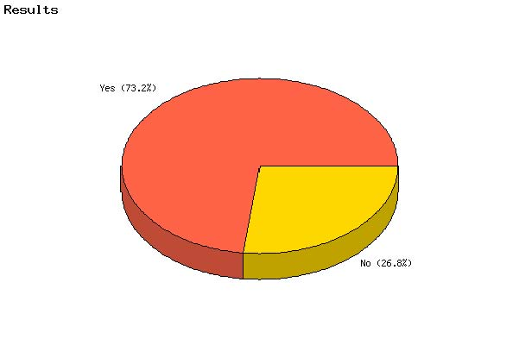

   | Count | % Sample  Answered | % Sample  Asked | % Sample  Total
  Yes | 60 | 73.2% | 48.8% | 48.8%
  No | 22 | 26.8% | 17.9% | 17.9%
  Not Answered | 41 | N/A | 33.3% | 33.3%
  Not Asked | 0 | N/A | N/A | 0.0%
  Total | 123 | 100% | 100% | 100%
  Statistics
  Minimum Value | 1.00
  Maximum Value | 2.00
  Average | 1.27
  Sum | 104
  Standard Deviation | 0.45
  Median | 1
  Mode | 1

Question: | Most of the FTR entitlements provide a "one size fits all" or "across-the-board" benefit. Instead, should the Government consider developing "tiered" policies that reflect the needs of specific employee groups (e.g., by grade level)?

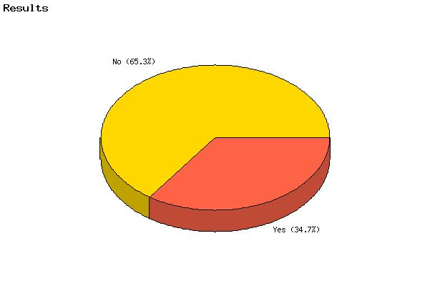

   | Count | % Sample  Answered | % Sample  Asked | % Sample  Total
  Yes | 35 | 34.7% | 28.5% | 28.5%
  No | 66 | 65.3% | 53.7% | 53.7%
  Not Answered | 22 | N/A | 17.9% | 17.9%
  Not Asked | 0 | N/A | N/A | 0.0%
  Total | 123 | 100% | 100% | 100%
  Statistics
  Minimum Value | 1.00
  Maximum Value | 2.00
  Average | 1.65
  Sum | 167
  Standard Deviation | 0.48
  Median | 2
  Mode | 2

Question: | Does your agency contract out any relocation services work?

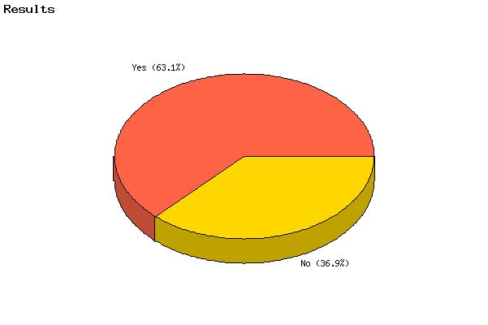

   | Count | % Sample  Answered | % Sample  Asked | % Sample  Total
  Yes | 65 | 63.1% | 52.8% | 52.8%
  No | 38 | 36.9% | 30.9% | 30.9%
  Not Answered | 20 | N/A | 16.3% | 16.3%
  Not Asked | 0 | N/A | N/A | 0.0%
  Total | 123 | 100% | 100% | 100%
  Statistics
  Minimum Value | 1.00
  Maximum Value | 2.00
  Average | 1.37
  Sum | 141
  Standard Deviation | 0.48
  Median | 1
  Mode | 1

Question: | How many vendors does your agency utilize?

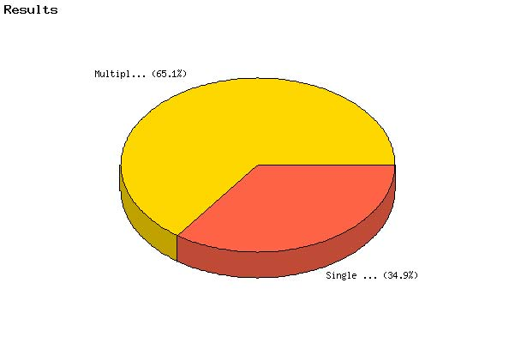

   | Count | % Sample  Answered | % Sample  Asked | % Sample  Total
  Single Vendor | 30 | 34.9% | 24.4% | 24.4%
  Multiple Vendors (Indicate Number) | 56 | 65.1% | 45.5% | 45.5%
  Not Answered | 37 | N/A | 30.1% | 30.1%
  Not Asked | 0 | N/A | N/A | 0.0%
  Total | 123 | 100% | 100% | 100%
  Statistics
  Minimum Value | 1.00
  Maximum Value | 2.00
  Average | 1.65
  Sum | 142
  Standard Deviation | 0.48
  Median | 2
  Mode | 2

Question: | In obtaining your relocation services do you use; (check all that apply)

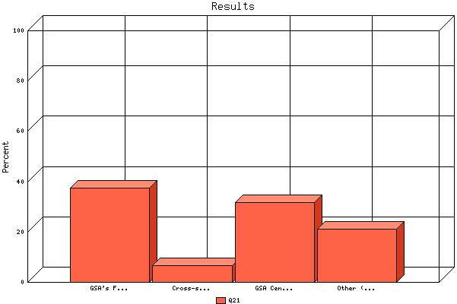

 | Count | % Sample  Answered
GSA's Federal Supply Service Relocation Schedules | 46 | 37.4%
Cross-service agreements | 8 | 6.5%
GSA Centralized Household Goods Traffic Management Program (CHAMPS) | 39 | 31.7%
Other (Please specify) | 26 | 21.1%

Question: | How would you best describe your agency's approach to developing the annual relocation budget?

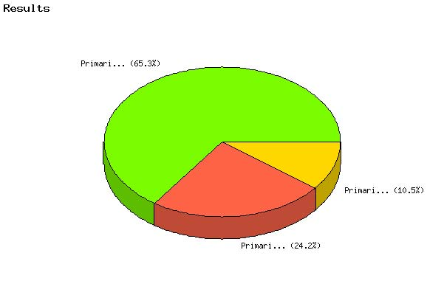

   | Count | % Sample  Answered | % Sample  Asked | % Sample  Total
  Primarily based on previous years' funding levels | 23 | 24.2% | 18.7% | 18.7%
  Primarily based on the impact of future agency mission changes | 10 | 10.5% | 8.1% | 8.1%
  Primarily based on a combination of a and b. | 62 | 65.3% | 50.4% | 50.4%
  Not Answered | 28 | N/A | 22.8% | 22.8%
  Not Asked | 0 | N/A | N/A | 0.0%
  Total | 123 | 100% | 100% | 100%
  Statistics
  Minimum Value | 1.00
  Maximum Value | 3.00
  Average | 2.41
  Sum | 229
  Standard Deviation | 0.86
  Median | 3
  Mode | 3

Question: | As you execute your budget during the year, do you sometimes need to transfer available funds from other object classes or activities to cover any shortfall or overage in the relocation components of your agency's budget? Choose one of the following that best describes how often yearly adjustments of greater than 5% of the relocation allocation are made between budget allocations for relocations and budget allocations for other purposes.

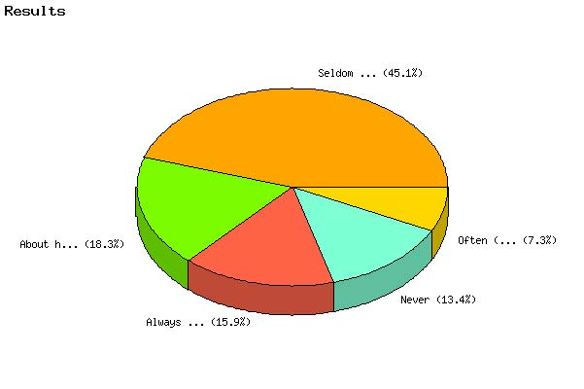

   | Count | % Sample  Answered | % Sample  Asked | % Sample  Total
  Always (Every year) | 13 | 15.9% | 10.6% | 10.6%
  Often (three out of every four years) | 6 | 7.3% | 4.9% | 4.9%
  About half the time | 15 | 18.3% | 12.2% | 12.2%
  Seldom (One out of every four years) | 37 | 45.1% | 30.1% | 30.1%
  Never | 11 | 13.4% | 8.9% | 8.9%
  Not Answered | 41 | N/A | 33.3% | 33.3%
  Not Asked | 0 | N/A | N/A | 0.0%
  Total | 123 | 100% | 100% | 100%
  Statistics
  Minimum Value | 1.00
  Maximum Value | 5.00
  Average | 3.33
  Sum | 273
  Standard Deviation | 1.27
  Median | 4
  Mode | 4

Question: | Please complete the statement that most closely describes your agency's reporting capabilities. Reporting on the full relocation program is:

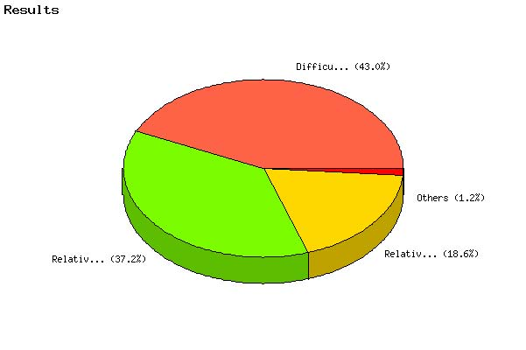

   | Count | % Sample  Answered | % Sample  Asked | % Sample  Total
  Difficult to provide, as information is in separate systems and/or in paper files (oftentimes requiring a manual effort to collect) and there is little or automated integration with the agency's financial systems. | 37 | 43.0% | 30.1% | 30.1%
  Relatively easy from a high level but there is limited access to more detailed contractor information and limited automated integration with the agency's financial systems or with contractor systems. | 16 | 18.6% | 13.0% | 13.0%
  Relatively easy with more detailed relocation information centrally available in a database, with some integration with the agency's financial systems. | 32 | 37.2% | 26.0% | 26.0%
  Robust with easy automated access to all relocation data and full automated integration of the relocation system with the agency's financial systems and with contractor systems. | 1 | 1.2% | 0.8% | 0.8%
  Not Answered | 37 | N/A | 30.1% | 30.1%
  Not Asked | 0 | N/A | N/A | 0.0%
  Total | 123 | 100% | 100% | 100%
  Statistics
  Minimum Value | 1.00
  Maximum Value | 4.00
  Average | 1.97
  Sum | 169
  Standard Deviation | 0.93
  Median | 2
  Mode | 1

Question: | Select the statement that best describes your ability to quickly respond with accurate and complete information to agency management requests from levels higher than those directly responsible for the travel and relocation programs and to those stakeholders outside the agency.

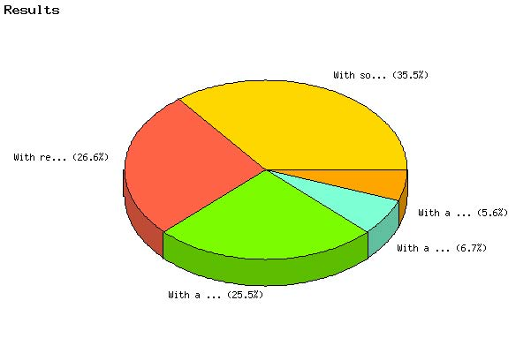

   | Count | % Sample  Answered | % Sample  Asked | % Sample  Total
  With relative ease, within timeframes required. | 24 | 26.7% | 19.5% | 19.5%
  With some difficulty, but within timeframes required. | 32 | 35.6% | 26.0% | 26.0%
  With a great deal of effort, but within timeframes required. | 23 | 25.6% | 18.7% | 18.7%
  With a great deal of effort, with an incomplete response. | 5 | 5.6% | 4.1% | 4.1%
  With a great deal of effort, with significant gaps and unable to meet timeframes. | 6 | 6.7% | 4.9% | 4.9%
  Not Answered | 33 | N/A | 26.8% | 26.8%
  Not Asked | 0 | N/A | N/A | 0.0%
  Total | 123 | 100% | 100% | 100%
  Statistics
  Minimum Value | 1.00
  Maximum Value | 5.00
  Average | 2.30
  Sum | 207
  Standard Deviation | 1.13
  Median | 2
  Mode | 2

Question: | What do you see as the most significant issues facing your agency should a recommendation come from the Governmentwide Relocation Advisory Board (the Board) to improve your information management capabilities?

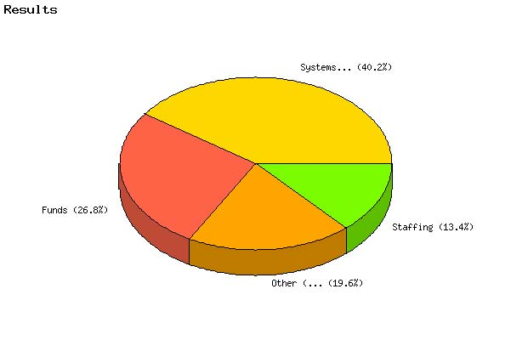

   | Count | % Sample  Answered | % Sample  Asked | % Sample  Total
  Funds | 26 | 26.8% | 21.1% | 21.1%
  Systems development | 39 | 40.2% | 31.7% | 31.7%
  Staffing | 13 | 13.4% | 10.6% | 10.6%
  Other (Please specify) | 19 | 19.6% | 15.4% | 15.4%
  Not Answered | 26 | N/A | 21.1% | 21.1%
  Not Asked | 0 | N/A | N/A | 0.0%
  Total | 123 | 100% | 100% | 100%
  Statistics
  Minimum Value | 1.00
  Maximum Value | 4.00
  Average | 2.26
  Sum | 219
  Standard Deviation | 1.06
  Median | 2
  Mode | 2

Question: | How many employees' (FTE's) perform relocation work (i.e., permanent change of station moves) in your agency? Approximately how many of these employees work full-time and part-time on this program?
Topic: | Full Time

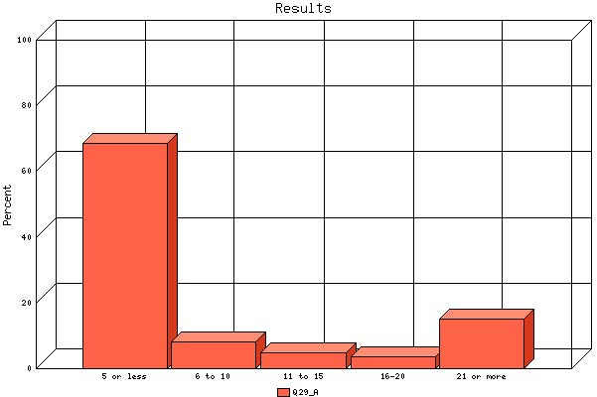

   | Count | % Sample  Answered | % Sample  Asked | % Sample  Total
  5 or less | 59 | 68.6% | 48.0% | 48.0%
  6 to 10 | 7 | 8.1% | 5.7% | 5.7%
  11 to 15 | 4 | 4.7% | 3.3% | 3.3%
  16-20 | 3 | 3.5% | 2.4% | 2.4%
  21 or more | 13 | 15.1% | 10.6% | 10.6%
  Not Answered | 37 | N/A | 30.1% | 30.1%
  Not Asked | 0 | N/A | N/A | 0.0%
  Total | 123 | 100% | 100% | 100%
  Statistics
  Minimum Value | 1.00
  Maximum Value | 5.00
  Average | 1.88
  Sum | 162
  Standard Deviation | 1.50
  Median | 1
  Mode | 1

Question: | How many employees' (FTE's) perform relocation work (i.e., permanent change of station moves) in your agency? Approximately how many of these employees work full-time and part-time on this program?
Topic: | Part Time

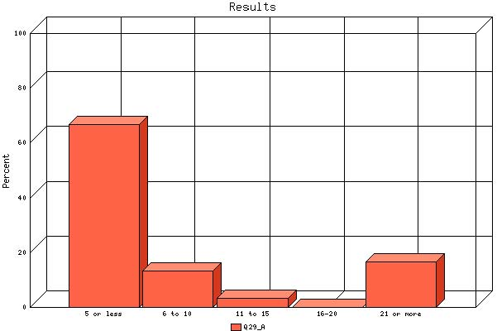

   | Count | % Sample  Answered | % Sample  Asked | % Sample  Total
  5 or less | 20 | 66.7% | 16.3% | 16.3%
  6 to 10 | 4 | 13.3% | 3.3% | 3.3%
  11 to 15 | 1 | 3.3% | 0.8% | 0.8%
  16-20 | 0 | 0.0% | 0.0% | 0.0%
  21 or more | 5 | 16.7% | 4.1% | 4.1%
  Not Answered | 93 | N/A | 75.6% | 75.6%
  Not Asked | 0 | N/A | N/A | 0.0%
  Total | 123 | 100% | 100% | 100%
  Statistics
  Minimum Value | 1.00
  Maximum Value | 5.00
  Average | 1.87
  Sum | 56
  Standard Deviation | 1.50
  Median | 1
  Mode | 1

Question: | What is the most common General Schedule (GS) grade level (or equivalent) of the employees administering your agency's relocation program?

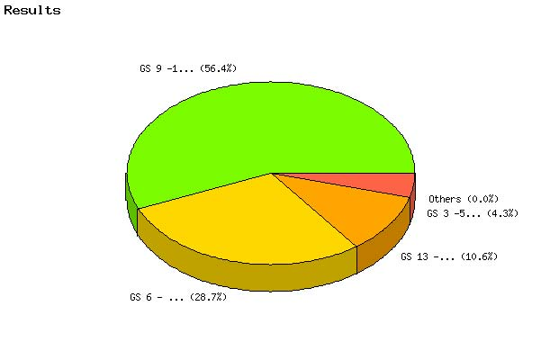

   | Count | % Sample  Answered | % Sample  Asked | % Sample  Total
  GS 3 -5 (or equivalent) | 4 | 4.3% | 3.3% | 3.3%
  GS 6 - 8 (or equivalent) | 27 | 28.7% | 22.0% | 22.0%
  GS 9 -12 (or equivalent) | 53 | 56.4% | 43.1% | 43.1%
  GS 13 - 15 (or equivalent) | 10 | 10.6% | 8.1% | 8.1%
  Senior Executive Service (SES)( or equivalent) | 0 | 0.0% | 0.0% | 0.0%
  Not Answered | 29 | N/A | 23.6% | 23.6%
  Not Asked | 0 | N/A | N/A | 0.0%
  Total | 123 | 100% | 100% | 100%
  Statistics
  Minimum Value | 1.00
  Maximum Value | 4.00
  Average | 2.73
  Sum | 257
  Standard Deviation | 0.71
  Median | 3
  Mode | 3

Question: | Does your agency document service agreements in the employees' Official Personnel Folders (OPFs)?

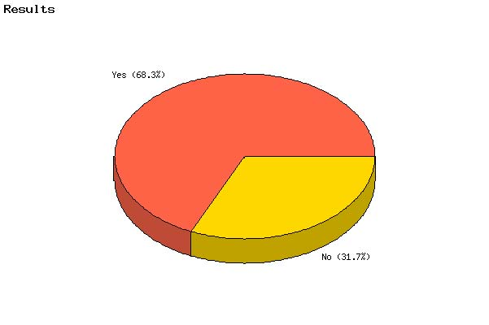

   | Count | % Sample  Answered | % Sample  Asked | % Sample  Total
  Yes | 84 | 68.3% | 68.3% | 68.3%
  No | 39 | 31.7% | 31.7% | 31.7%
  Not Answered | 0 | N/A | 0.0% | 0.0%
  Not Asked | 0 | N/A | N/A | 0.0%
  Total | 123 | 100% | 100% | 100%
  Statistics
  Minimum Value | 1.00
  Maximum Value | 2.00
  Average | 1.32
  Sum | 162
  Standard Deviation | 0.47
  Median | 1
  Mode | 1

Question: | Would your agency be in favor of using a remark (optional or required) on the Standard Form 50 (SF-50) in the future that would make it possible to track and report service agreements for employees with paid relocations?

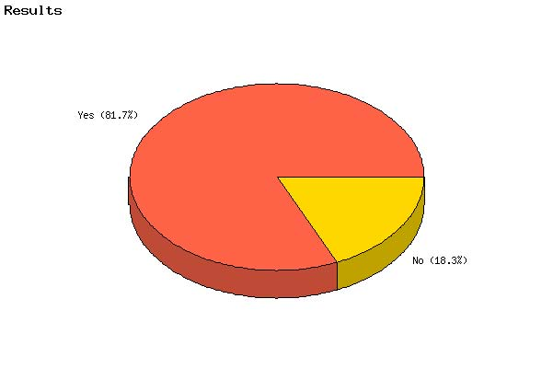

   | Count | % Sample  Answered | % Sample  Asked | % Sample  Total
  Yes | 85 | 81.7% | 69.1% | 69.1%
  No | 19 | 18.3% | 15.4% | 15.4%
  Not Answered | 19 | N/A | 15.4% | 15.4%
  Not Asked | 0 | N/A | N/A | 0.0%
  Total | 123 | 100% | 100% | 100%
  Statistics
  Minimum Value | 1.00
  Maximum Value | 2.00
  Average | 1.18
  Sum | 123
  Standard Deviation | 0.39
  Median | 1
  Mode | 1

Question: | Has your agency developed training, tutorials, or practical advice for employees who relocate?

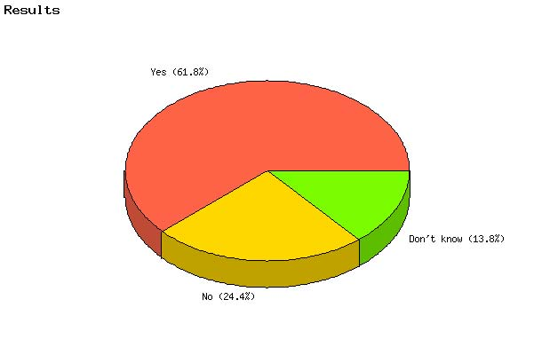

   | Count | % Sample  Answered | % Sample  Asked | % Sample  Total
  Yes | 76 | 61.8% | 61.8% | 61.8%
  No | 30 | 24.4% | 24.4% | 24.4%
  Don't know | 17 | 13.8% | 13.8% | 13.8%
  Not Answered | 0 | N/A | 0.0% | 0.0%
  Not Asked | 0 | N/A | N/A | 0.0%
  Total | 123 | 100% | 100% | 100%
  Statistics
  Minimum Value | 1.00
  Maximum Value | 3.00
  Average | 1.52
  Sum | 187
  Standard Deviation | 0.73
  Median | 1
  Mode | 1

Question: | Select all format(s) your agency uses to advise employees of their relocation benefits.

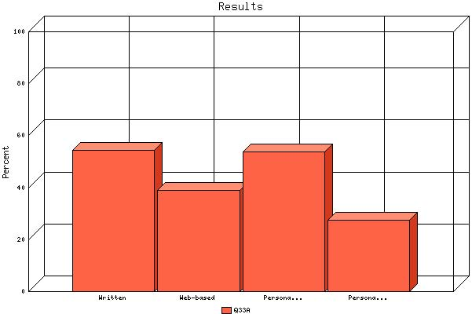

 | Count | % Sample  Answered
Written | 67 | 54.5%
Web-based | 48 | 39.0%
Personal counseling provided by agency | 66 | 53.7%
Personal counseling provided by third party | 34 | 27.6%

Question: | Select all information these formats cover.

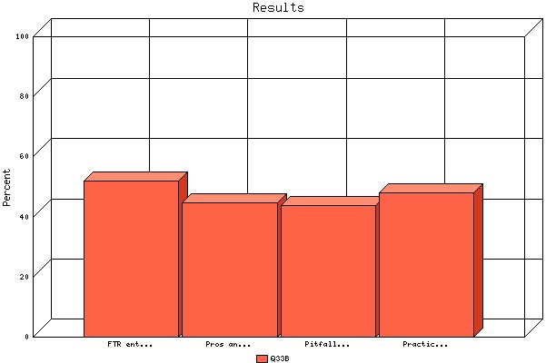

 | Count | % Sample  Answered
FTR entitlement | 64 | 52.0%
Pros and cons of various choices employees can make regarding their relocation | 55 | 44.7%
Pitfalls to avoid | 54 | 43.9%
Practical advice covering aspects of relocation, such as marketing assistance, preparing a home for sale, property management, buyer and rental home finding assistance, mortgage counseling, closing services, etc. | 59 | 48.0%

Question: | From whom do the Federal employees (relocation specialists) administering the relocation program in your agency get their training.

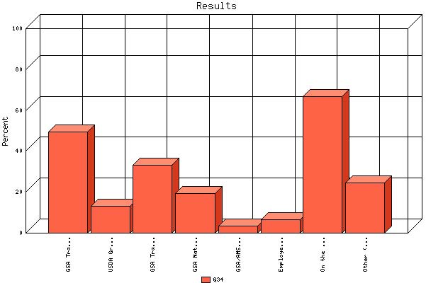

 | Count | % Sample  Answered
GSA Travel Training | 61 | 49.6%
USDA Graduate School | 16 | 13.0%
GSA Travel & Transportation Workshops | 41 | 33.3%
GSA National Travel Forum | 24 | 19.5%
GSA/AMSA Annual Forum | 4 | 3.3%
Employee Relocation Council Certificate | 8 | 6.5%
On the job Training | 82 | 66.7%
Other (Please specify) | 30 | 24.4%

Question: | How often are these programs offered?
Topic: | GSA Travel Training

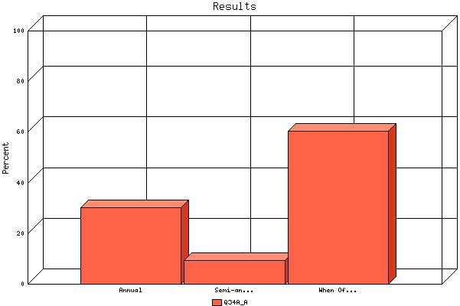

   | Count | % Sample  Answered | % Sample  Asked | % Sample  Total
  Annual | 16 | 30.2% | 13.0% | 13.0%
  Semi-annual | 5 | 9.4% | 4.1% | 4.1%
  When Offered | 32 | 60.4% | 26.0% | 26.0%
  Not Answered | 70 | N/A | 56.9% | 56.9%
  Not Asked | 0 | N/A | N/A | 0.0%
  Total | 123 | 100% | 100% | 100%
  Statistics
  Minimum Value | 1.00
  Maximum Value | 3.00
  Average | 2.30
  Sum | 122
  Standard Deviation | 0.91
  Median | 3
  Mode | 3

Question: | How often are these programs offered?
Topic: | USDA Graduate School

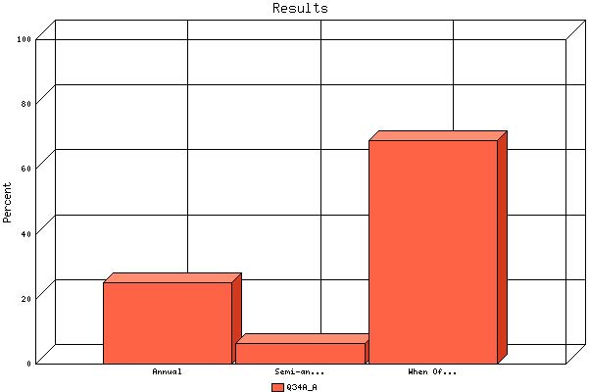

   | Count | % Sample  Answered | % Sample  Asked | % Sample  Total
  Annual | 4 | 25.0% | 3.3% | 3.3%
  Semi-annual | 1 | 6.2% | 0.8% | 0.8%
  When Offered | 11 | 68.8% | 8.9% | 8.9%
  Not Answered | 107 | N/A | 87.0% | 87.0%
  Not Asked | 0 | N/A | N/A | 0.0%
  Total | 123 | 100% | 100% | 100%
  Statistics
  Minimum Value | 1.00
  Maximum Value | 3.00
  Average | 2.44
  Sum | 39
  Standard Deviation | 0.89
  Median | 3
  Mode | 3

Question: | How often are these programs offered?
Topic: | GSA Travel & Transportation Workshops

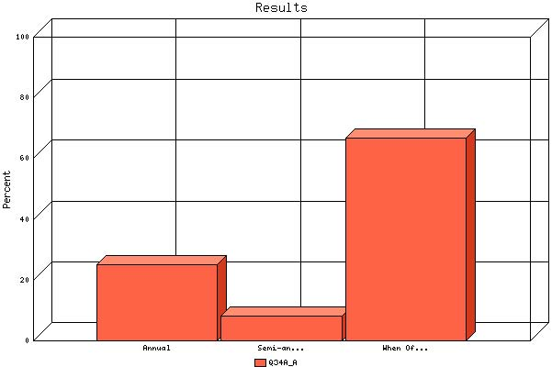

   | Count | % Sample  Answered | % Sample  Asked | % Sample  Total
  Annual | 9 | 25.0% | 7.3% | 7.3%
  Semi-annual | 3 | 8.3% | 2.4% | 2.4%
  When Offered | 24 | 66.7% | 19.5% | 19.5%
  Not Answered | 87 | N/A | 70.7% | 70.7%
  Not Asked | 0 | N/A | N/A | 0.0%
  Total | 123 | 100% | 100% | 100%
  Statistics
  Minimum Value | 1.00
  Maximum Value | 3.00
  Average | 2.42
  Sum | 87
  Standard Deviation | 0.87
  Median | 3
  Mode | 3

Question: | How often are these programs offered?
Topic: | GSA National Travel Forum

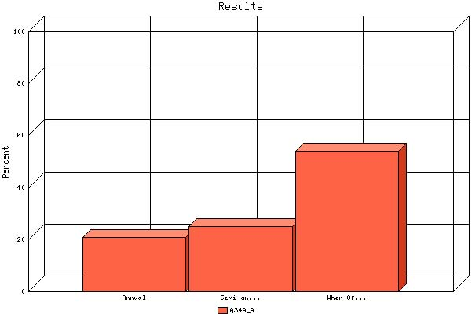

   | Count | % Sample  Answered | % Sample  Asked | % Sample  Total
  Annual | 5 | 20.8% | 4.1% | 4.1%
  Semi-annual | 6 | 25.0% | 4.9% | 4.9%
  When Offered | 13 | 54.2% | 10.6% | 10.6%
  Not Answered | 99 | N/A | 80.5% | 80.5%
  Not Asked | 0 | N/A | N/A | 0.0%
  Total | 123 | 100% | 100% | 100%
  Statistics
  Minimum Value | 1.00
  Maximum Value | 3.00
  Average | 2.33
  Sum | 56
  Standard Deviation | 0.82
  Median | 3
  Mode | 3

Question: | How often are these programs offered?
Topic: | GSA/AMSA Annual Forum

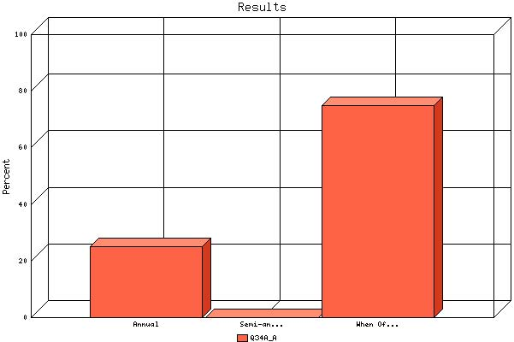

   | Count | % Sample  Answered | % Sample  Asked | % Sample  Total
  Annual | 1 | 25.0% | 0.8% | 0.8%
  Semi-annual | 0 | 0.0% | 0.0% | 0.0%
  When Offered | 3 | 75.0% | 2.4% | 2.4%
  Not Answered | 119 | N/A | 96.7% | 96.7%
  Not Asked | 0 | N/A | N/A | 0.0%
  Total | 123 | 100% | 100% | 100%
  Statistics
  Minimum Value | 1.00
  Maximum Value | 3.00
  Average | 2.50
  Sum | 10
  Standard Deviation | 1.00
  Median | 3
  Mode | 3

Question: | How often are these programs offered?
Topic: | Employee Relocation Council Certificate

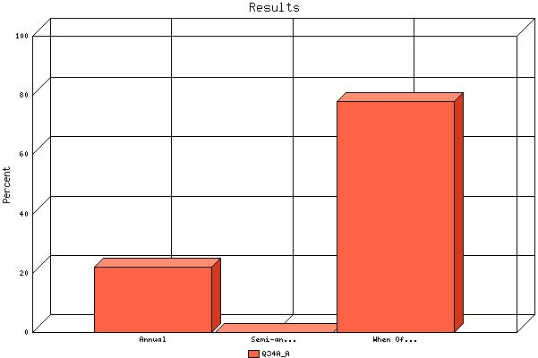

   | Count | % Sample  Answered | % Sample  Asked | % Sample  Total
  Annual | 2 | 22.2% | 1.6% | 1.6%
  Semi-annual | 0 | 0.0% | 0.0% | 0.0%
  When Offered | 7 | 77.8% | 5.7% | 5.7%
  Not Answered | 114 | N/A | 92.7% | 92.7%
  Not Asked | 0 | N/A | N/A | 0.0%
  Total | 123 | 100% | 100% | 100%
  Statistics
  Minimum Value | 1.00
  Maximum Value | 3.00
  Average | 2.56
  Sum | 23
  Standard Deviation | 0.88
  Median | 3
  Mode | 3

Question: | How often are these programs offered?
Topic: | On the job Training

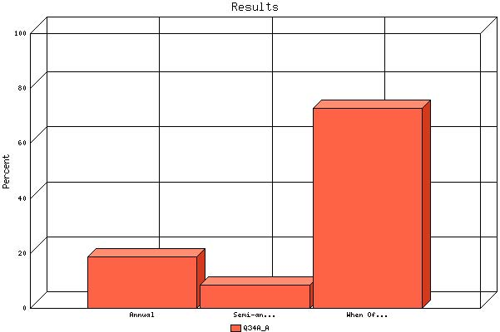

   | Count | % Sample  Answered | % Sample  Asked | % Sample  Total
  Annual | 13 | 18.6% | 10.6% | 10.6%
  Semi-annual | 6 | 8.6% | 4.9% | 4.9%
  When Offered | 51 | 72.9% | 41.5% | 41.5%
  Not Answered | 53 | N/A | 43.1% | 43.1%
  Not Asked | 0 | N/A | N/A | 0.0%
  Total | 123 | 100% | 100% | 100%
  Statistics
  Minimum Value | 1.00
  Maximum Value | 3.00
  Average | 2.54
  Sum | 178
  Standard Deviation | 0.79
  Median | 3
  Mode | 3

Question: | How often are these programs offered?
Topic: | %Q34Specified_8%

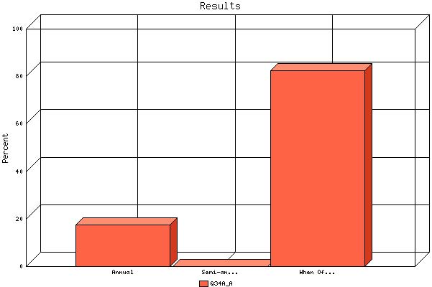

   | Count | % Sample  Answered | % Sample  Asked | % Sample  Total
  Annual | 3 | 17.6% | 2.4% | 2.4%
  Semi-annual | 0 | 0.0% | 0.0% | 0.0%
  When Offered | 14 | 82.4% | 11.4% | 11.4%
  Not Answered | 106 | N/A | 86.2% | 86.2%
  Not Asked | 0 | N/A | N/A | 0.0%
  Total | 123 | 100% | 100% | 100%
  Statistics
  Minimum Value | 1.00
  Maximum Value | 3.00
  Average | 2.65
  Sum | 45
  Standard Deviation | 0.79
  Median | 3
  Mode | 3

Question: | Does your agency send employees to attend the following Government and relocation industry meetings?

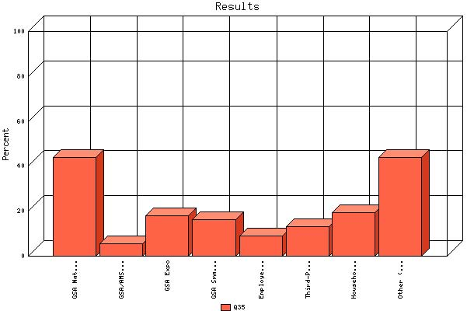

 | Count | % Sample  Answered
GSA National Travel Forum | 54 | 43.9%
GSA/AMSA Annual Forum | 7 | 5.7%
GSA Expo | 22 | 17.9%
GSA SmartPay | 20 | 16.3%
Employee Relocation Council, National and Regional | 11 | 8.9%
Third-Party Relocation Industry Meetings | 16 | 13.0%
Household Goods Carriers Conferences | 24 | 19.5%
Other (Please specify) | 54 | 43.9%

Question: | Did you find the meetings useful?
Topic: | GSA National Travel Forum

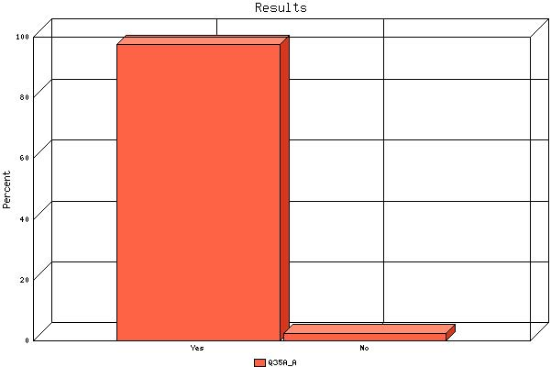

   | Count | % Sample  Answered | % Sample  Asked | % Sample  Total
  Yes | 41 | 97.6% | 33.3% | 33.3%
  No | 1 | 2.4% | 0.8% | 0.8%
  Not Answered | 81 | N/A | 65.9% | 65.9%
  Not Asked | 0 | N/A | N/A | 0.0%
  Total | 123 | 100% | 100% | 100%
  Statistics
  Minimum Value | 1.00
  Maximum Value | 2.00
  Average | 1.02
  Sum | 43
  Standard Deviation | 0.15
  Median | 1
  Mode | 1

Question: | Did you find the meetings useful?
Topic: | GSA/AMSA Annual Forum

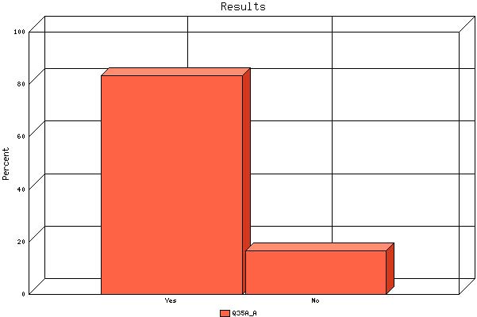

   | Count | % Sample  Answered | % Sample  Asked | % Sample  Total
  Yes | 5 | 83.3% | 4.1% | 4.1%
  No | 1 | 16.7% | 0.8% | 0.8%
  Not Answered | 117 | N/A | 95.1% | 95.1%
  Not Asked | 0 | N/A | N/A | 0.0%
  Total | 123 | 100% | 100% | 100%
  Statistics
  Minimum Value | 1.00
  Maximum Value | 2.00
  Average | 1.17
  Sum | 7
  Standard Deviation | 0.41
  Median | 1
  Mode | 1

Question: | Did you find the meetings useful?
Topic: | GSA Expo

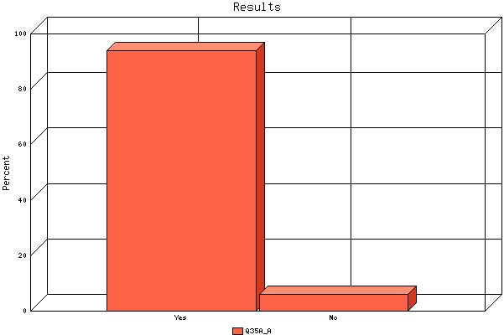

   | Count | % Sample  Answered | % Sample  Asked | % Sample  Total
  Yes | 15 | 83.3% | 12.2% | 12.2%
  No | 3 | 16.7% | 2.4% | 2.4%
  Not Answered | 105 | N/A | 85.4% | 85.4%
  Not Asked | 0 | N/A | N/A | 0.0%
  Total | 123 | 100% | 100% | 100%
  Statistics
  Minimum Value | 1.00
  Maximum Value | 2.00
  Average | 1.17
  Sum | 21
  Standard Deviation | 0.38
  Median | 1
  Mode | 1

Question: | Did you find the meetings useful?
Topic: | GSA SmartPay

   | Count | % Sample  Answered | % Sample  Asked | % Sample  Total
  Yes | 16 | 94.1% | 13.0% | 13.0%
  No | 1 | 5.9% | 0.8% | 0.8%
  Not Answered | 106 | N/A | 86.2% | 86.2%
  Not Asked | 0 | N/A | N/A | 0.0%
  Total | 123 | 100% | 100% | 100%
  Statistics
  Minimum Value | 1.00
  Maximum Value | 2.00
  Average | 1.06
  Sum | 18
  Standard Deviation | 0.24
  Median | 1
  Mode | 1

Question: | Did you find the meetings useful?
Topic: | Employee Relocation Council, National and Regional

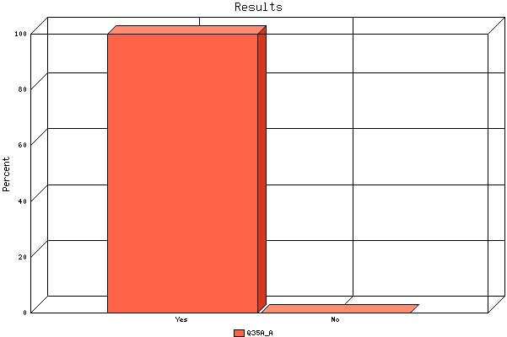

   | Count | % Sample  Answered | % Sample  Asked | % Sample  Total
  Yes | 10 | 100.0% | 8.1% | 8.1%
  No | 0 | 0.0% | 0.0% | 0.0%
  Not Answered | 113 | N/A | 91.9% | 91.9%
  Not Asked | 0 | N/A | N/A | 0.0%
  Total | 123 | 100% | 100% | 100%
  Statistics
  Minimum Value | 1.00
  Maximum Value | 1.00
  Average | 1.00
  Sum | 10
  Standard Deviation | 0.00
  Median | 1
  Mode | 1

Question: | Did you find the meetings useful?
Topic: | Third-Party Relocation Industry Meetings

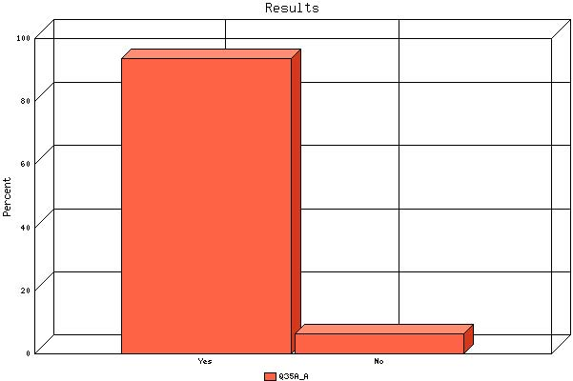

   | Count | % Sample  Answered | % Sample  Asked | % Sample  Total
  Yes | 15 | 93.8% | 12.2% | 12.2%
  No | 1 | 6.2% | 0.8% | 0.8%
  Not Answered | 107 | N/A | 87.0% | 87.0%
  Not Asked | 0 | N/A | N/A | 0.0%
  Total | 123 | 100% | 100% | 100%
  Statistics
  Minimum Value | 1.00
  Maximum Value | 2.00
  Average | 1.06
  Sum | 17
  Standard Deviation | 0.25
  Median | 1
  Mode | 1

Question: | Did you find the meetings useful?
Topic: | Household Goods Carriers Conferences

   | Count | % Sample  Answered | % Sample  Asked | % Sample  Total
  Yes | 21 | 100.0% | 17.1% | 17.1%
  No | 0 | 0.0% | 0.0% | 0.0%
  Not Answered | 102 | N/A | 82.9% | 82.9%
  Not Asked | 0 | N/A | N/A | 0.0%
  Total | 123 | 100% | 100% | 100%
  Statistics
  Minimum Value | 1.00
  Maximum Value | 1.00
  Average | 1.00
  Sum | 21
  Standard Deviation | 0.00
  Median | 1
  Mode | 1

Question: | Did you find the meetings useful?
Topic: | %Q35Specified_8%

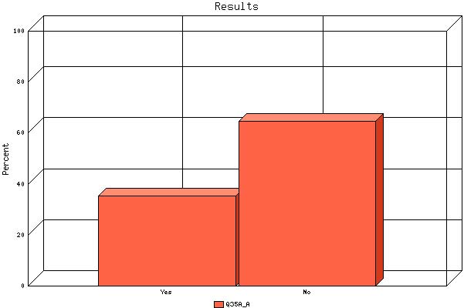

   | Count | % Sample  Answered | % Sample  Asked | % Sample  Total
  Yes | 12 | 35.3% | 9.8% | 9.8%
  No | 22 | 64.7% | 17.9% | 17.9%
  Not Answered | 89 | N/A | 72.4% | 72.4%
  Not Asked | 0 | N/A | N/A | 0.0%
  Total | 123 | 100% | 100% | 100%
  Statistics
  Minimum Value | 1.00
  Maximum Value | 2.00
  Average | 1.65
  Sum | 56
  Standard Deviation | 0.49
  Median | 2
  Mode | 2

Question: | Have any of your agency's employees received the "Certified Relocation Professional" certification awarded by the Employee Relocation Council?

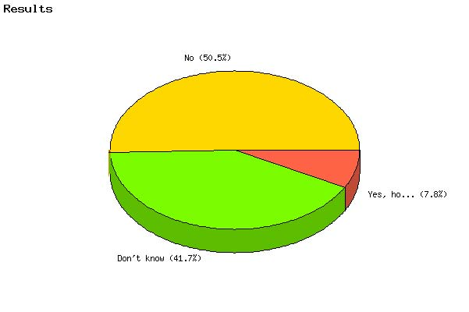

   | Count | % Sample  Answered | % Sample  Asked | % Sample  Total
  Yes, how many | 9 | 7.8% | 7.3% | 7.3%
  No | 58 | 50.4% | 47.2% | 47.2%
  Don't know | 48 | 41.7% | 39.0% | 39.0%
  Not Answered | 8 | N/A | 6.5% | 6.5%
  Not Asked | 0 | N/A | N/A | 0.0%
  Total | 123 | 100% | 100% | 100%
  Statistics
  Minimum Value | 1.00
  Maximum Value | 3.00
  Average | 2.34
  Sum | 269
  Standard Deviation | 0.62
  Median | 2
  Mode | 2

Question: | What safeguards have your agency taken to ensure protection of personal data for relocating employees, especially when sensitive information is turned over to contractors and third-party vendors? Select all that apply:

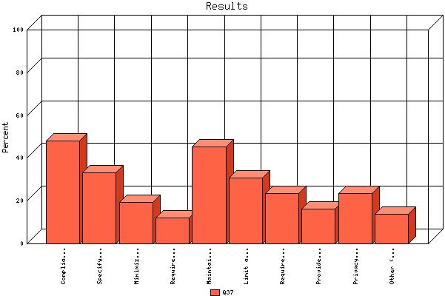

 | Count | % Sample  Answered
Compliance with Privacy Act (5 U.S.C. 552a) and OPM regulations (5 CFR 297, 293) | 59 | 48.0%
Specify in Government contract, if applicable, that personal information is subject to the Privacy Act | 41 | 33.3%
Minimize the amount of Government information the contractor is permitted to maintain in its computer system (if it is permitted to maintain any information at all), and ensure that the information is used only for the approved purposes | 24 | 19.5%
Require background checks of all contractor and subcontractor individuals who will obtain and process personal information of relocating Government employees | 15 | 12.2%
Maintain relocation records in secure filing cabinets | 56 | 45.5%
Limit access to relocation work areas where sensitive information is stored | 38 | 30.9%
Require password-protected relocation electronic documents | 29 | 23.6%
Provide training to appropriate personnel on the provisions of the | 20 | 16.3%
Privacy Act and procedures for safeguarding | 29 | 23.6%
Other (Please specify) | 17 | 13.8%

Question: | Do your agency's relocation specialists have proper, updated security clearances?

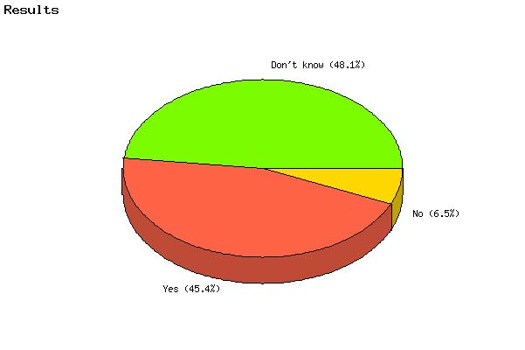

   | Count | % Sample  Answered | % Sample  Asked | % Sample  Total
  Yes | 49 | 45.4% | 39.8% | 39.8%
  No | 7 | 6.5% | 5.7% | 5.7%
  Don't know | 52 | 48.1% | 42.3% | 42.3%
  Not Answered | 15 | N/A | 12.2% | 12.2%
  Not Asked | 0 | N/A | N/A | 0.0%
  Total | 123 | 100% | 100% | 100%
  Statistics
  Minimum Value | 1.00
  Maximum Value | 3.00
  Average | 2.03
  Sum | 219
  Standard Deviation | 0.97
  Median | 2
  Mode | 3

Question: | Does your agency require background investigations (drug tests and check of criminal records) for contract employees?

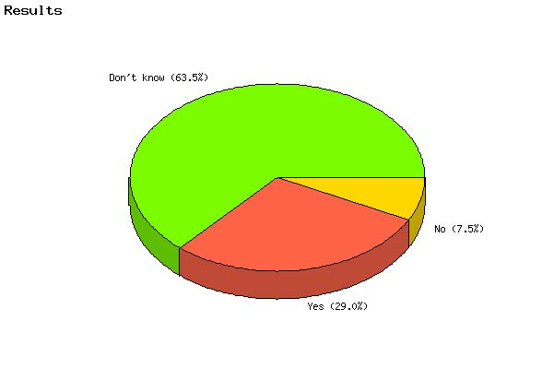

   | Count | % Sample  Answered | % Sample  Asked | % Sample  Total
  Yes | 31 | 29.0% | 25.2% | 25.2%
  No | 8 | 7.5% | 6.5% | 6.5%
  Don't know | 68 | 63.6% | 55.3% | 55.3%
  Not Answered | 16 | N/A | 13.0% | 13.0%
  Not Asked | 0 | N/A | N/A | 0.0%
  Total | 123 | 100% | 100% | 100%
  Statistics
  Minimum Value | 1.00
  Maximum Value | 3.00
  Average | 2.35
  Sum | 251
  Standard Deviation | 0.90
  Median | 3
  Mode | 3

Question: | Does your agency have a formal procedure for reviewing and updating these background investigations?

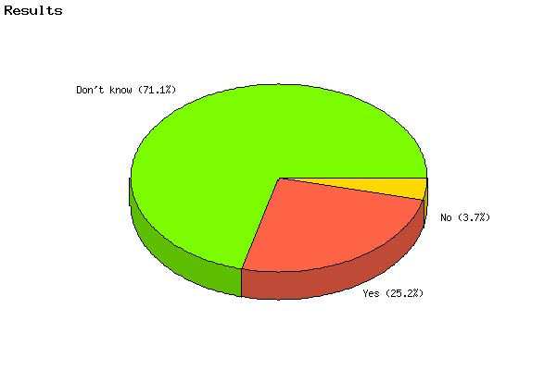

   | Count | % Sample  Answered | % Sample  Asked | % Sample  Total
  Yes | 27 | 25.2% | 22.0% | 22.0%
  No | 4 | 3.7% | 3.3% | 3.3%
  Don't know | 76 | 71.0% | 61.8% | 61.8%
  Not Answered | 16 | N/A | 13.0% | 13.0%
  Not Asked | 0 | N/A | N/A | 0.0%
  Total | 123 | 100% | 100% | 100%
  Statistics
  Minimum Value | 1.00
  Maximum Value | 3.00
  Average | 2.46
  Sum | 263
  Standard Deviation | 0.87
  Median | 3
  Mode | 3

Question: | Does your agency have any special emergency policies for its Continuity of Operations Plan (COOP) in response to emergency requirements to relocate employees following terrorist attacks, natural disasters, and other serious conditions?

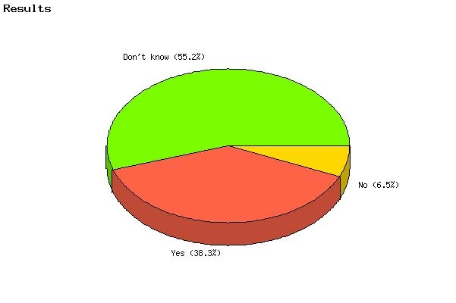

   | Count | % Sample  Answered | % Sample  Asked | % Sample  Total
  Yes | 41 | 38.3% | 33.3% | 33.3%
  No | 7 | 6.5% | 5.7% | 5.7%
  Don't know | 59 | 55.1% | 48.0% | 48.0%
  Not Answered | 16 | N/A | 13.0% | 13.0%
  Not Asked | 0 | N/A | N/A | 0.0%
  Total | 123 | 100% | 100% | 100%
  Statistics
  Minimum Value | 1.00
  Maximum Value | 3.00
  Average | 2.17
  Sum | 232
  Standard Deviation | 0.96
  Median | 3
  Mode | 3

Question: | Should HHG (temporary storage en route) be limited?

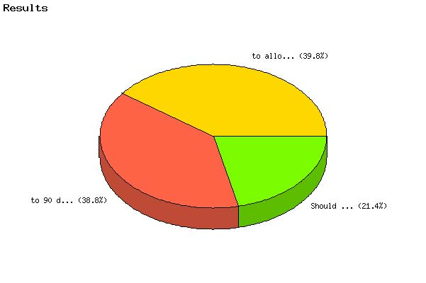

   | Count | % Sample  Answered | % Sample  Asked | % Sample  Total
  to 90 days plus 90 days or is there a need for authority? | 40 | 38.8% | 32.5% | 32.5%
  to allow for exceptional situations in which additional storage time is required? | 41 | 39.8% | 33.3% | 33.3%
  Should the currently allowed storage time be reduced. | 22 | 21.4% | 17.9% | 17.9%
  Not Answered | 20 | N/A | 16.3% | 16.3%
  Not Asked | 0 | N/A | N/A | 0.0%
  Total | 123 | 100% | 100% | 100%
  Statistics
  Minimum Value | 1.00
  Maximum Value | 3.00
  Average | 1.83
  Sum | 188
  Standard Deviation | 0.76
  Median | 2
  Mode | 2

Question: | Is the commuted rate method of shipping HHG a desirable method?

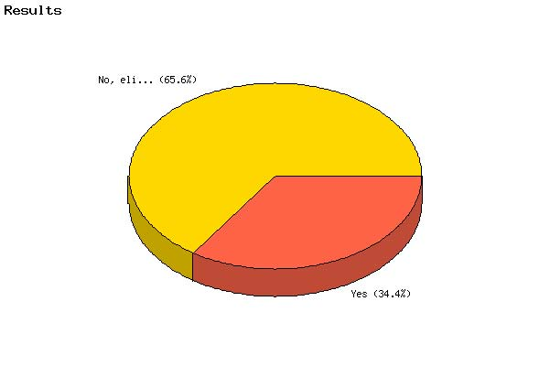

   | Count | % Sample  Answered | % Sample  Asked | % Sample  Total
  Yes | 33 | 34.4% | 26.8% | 26.8%
  No, eliminate | 63 | 65.6% | 51.2% | 51.2%
  Not Answered | 27 | N/A | 22.0% | 22.0%
  Not Asked | 0 | N/A | N/A | 0.0%
  Total | 123 | 100% | 100% | 100%
  Statistics
  Minimum Value | 1.00
  Maximum Value | 2.00
  Average | 1.66
  Sum | 159
  Standard Deviation | 0.48
  Median | 2
  Mode | 2

Question: | Incident to a permanent change of station, up to how many POVs is a reasonable amount to be stored at Government expense?

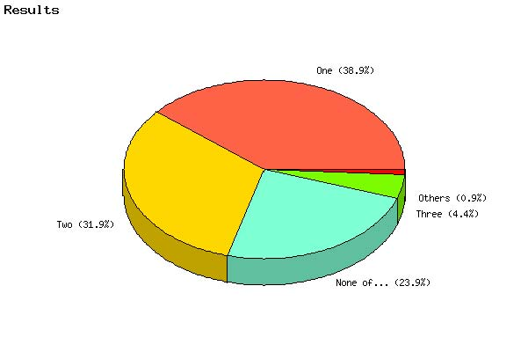

   | Count | % Sample  Answered | % Sample  Asked | % Sample  Total
  One | 44 | 38.9% | 35.8% | 35.8%
  Two | 36 | 31.9% | 29.3% | 29.3%
  Three | 5 | 4.4% | 4.1% | 4.1%
  Four | 1 | 0.9% | 0.8% | 0.8%
  None of the above | 27 | 23.9% | 22.0% | 22.0%
  Not Answered | 10 | N/A | 8.1% | 8.1%
  Not Asked | 0 | N/A | N/A | 0.0%
  Total | 123 | 100% | 100% | 100%
  Statistics
  Minimum Value | 1.00
  Maximum Value | 5.00
  Average | 2.39
  Sum | 270
  Standard Deviation | 1.58
  Median | 2
  Mode | 1

Question: | Under what criteria should the Government store a POV?

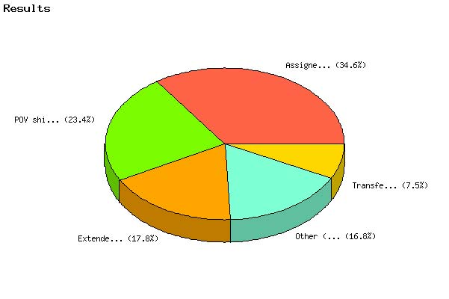

   | Count | % Sample  Answered | % Sample  Asked | % Sample  Total
  Assigned to an isolated duty station . | 37 | 34.6% | 30.1% | 30.1%
  Transfer within the continental U.S. with en-route temporary duty | 8 | 7.5% | 6.5% | 6.5%
  POV shipment prohibited by assignment. | 25 | 23.4% | 20.3% | 20.3%
  Extended temporary duty assignment within or outside the continental U.S. | 19 | 17.8% | 15.4% | 15.4%
  Other (Please specify) | 18 | 16.8% | 14.6% | 14.6%
  Not Answered | 16 | N/A | 13.0% | 13.0%
  Not Asked | 0 | N/A | N/A | 0.0%
  Total | 123 | 100% | 100% | 100%
  Statistics
  Minimum Value | 1.00
  Maximum Value | 5.00
  Average | 2.75
  Sum | 294
  Standard Deviation | 1.51
  Median | 3
  Mode | 1

Question: | Should mobile home shipment within CONUS and to/from Alaska in lieu of HHG shipment be continued?

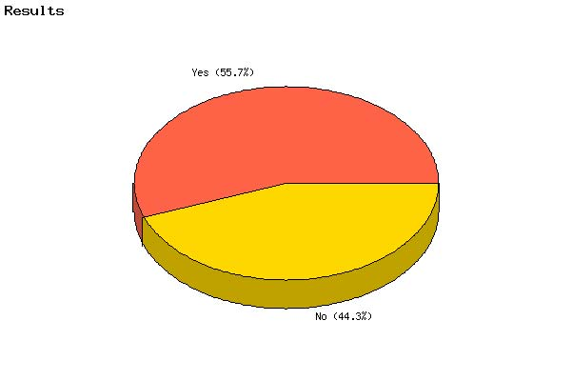

   | Count | % Sample  Answered | % Sample  Asked | % Sample  Total
  Yes | 59 | 55.7% | 48.0% | 48.0%
  No | 47 | 44.3% | 38.2% | 38.2%
  Not Answered | 17 | N/A | 13.8% | 13.8%
  Not Asked | 0 | N/A | N/A | 0.0%
  Total | 123 | 100% | 100% | 100%
  Statistics
  Minimum Value | 1.00
  Maximum Value | 2.00
  Average | 1.44
  Sum | 153
  Standard Deviation | 0.50
  Median | 1
  Mode | 1

Question: | What should the Government reimburse an employee for a mobile home used by an employee as a permanent residence? Limited to the cost of shipping 18,000 lbs of HHG plus 90 days of temporary storage. (Current regulations)

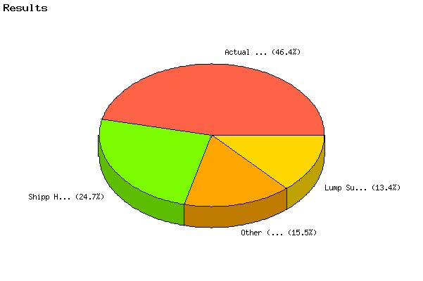

   | Count | % Sample  Answered | % Sample  Asked | % Sample  Total
  Actual Cost (prepping and shipping the mobile home) | 45 | 46.4% | 36.6% | 36.6%
  Lump Sum payment of $25,000 | 13 | 13.4% | 10.6% | 10.6%
  Shipp HHG and the Mobile home to the new locations | 24 | 24.7% | 19.5% | 19.5%
  Other (Please specify) | 15 | 15.5% | 12.2% | 12.2%
  Not Answered | 26 | N/A | 21.1% | 21.1%
  Not Asked | 0 | N/A | N/A | 0.0%
  Total | 123 | 100% | 100% | 100%
  Statistics
  Minimum Value | 1.00
  Maximum Value | 4.00
  Average | 2.09
  Sum | 203
  Standard Deviation | 1.16
  Median | 2
  Mode | 1

Question: | Should HHG be allowed to be shipped AND a mobile home moved?

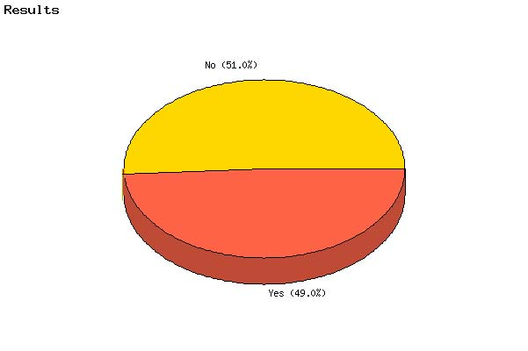

   | Count | % Sample  Answered | % Sample  Asked | % Sample  Total
  Yes | 51 | 49.0% | 41.5% | 41.5%
  No | 53 | 51.0% | 43.1% | 43.1%
  Not Answered | 19 | N/A | 15.4% | 15.4%
  Not Asked | 0 | N/A | N/A | 0.0%
  Total | 123 | 100% | 100% | 100%
  Statistics
  Minimum Value | 1.00
  Maximum Value | 2.00
  Average | 1.51
  Sum | 157
  Standard Deviation | 0.50
  Median | 2
  Mode | 2

