Slide 1 | 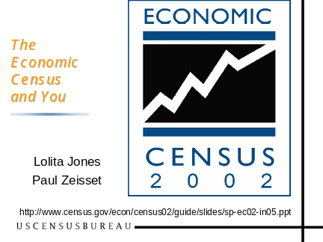 | →Hand out slide handouts, exercises, and brochure  My name is ____, and I and my colleague ____ are here today to talk to you about the 2002 Economic Census and related data from the Census Bureau.  We would like to thank _____ for sponsoring this conference and handling the local logistics.
Slide 2 |  | There are several parts to this presentation. For most of the time, we will focus on the Economic Census .  We’ll start with a brief overview and look at what the Economic Census is about, and how it fits with our other economic surveys.  Next, my colleague ______ will talk about industry classification—particularly in terms of the North American Industry Classification System or NAICS  Third, I’ll talk about products from the 2002 Economic Census and when they are coming out.  Fourth, _______ will review the various web tools that will help you use the data, and where you can get more information.  Finally, we’ll broaden the scope to deal with other data sets collected annually that include information for local areas.
Slide 3 | 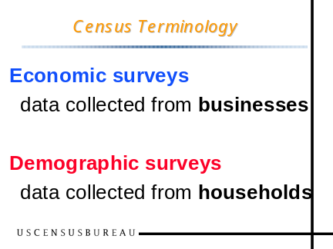 | First it would be useful to make sure that our jargon is clear: When we at the Census Bureau refer to economic surveys or an economic census we are referring to data that we collect from businesses. We use the term demographic to refer to data collected from households.  Of course, there are lots of important data about the American economy that can be gleaned from the income, occupation, and labor force information published in Census 2000 and from other household surveys. But what we are talking about today are data about businesses.
Slide 4 |  | There are many statistics for and about business issued by the federal government. Many of these come from the U.S. Census Bureau. This presentation will focus on one of the richest of the business data sets, the 2002 Economic Census.
Slide 5 |  | The Census Bureau publishes a number of the Principal Economic Indicators, like  ■ Monthly retail sales,  ■ Manufacturers shipments, inventories and orders  ■ International Trade in Goods and Services...  ■ and the brand new Quarterly Services Survey
Slide 6 | 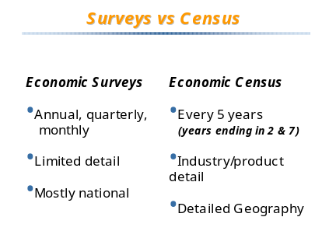 | But the surveys that make the best news for their frequency and timeliness are not necessarily the same ones that provide all of the details needed for many practical business decisions.  While we have a number of surveys that provide annual, quarterly and monthly data, they mostly have limited industry detail, and they mostly tell us only what is going on in the nation as a whole.
Slide 7 |  | Fortunately, once every 5 years, we have a much larger survey we call the Economic Census. The census provides us with much greater detail about specific industries and about the products they produce or sell.
Slide 8 | 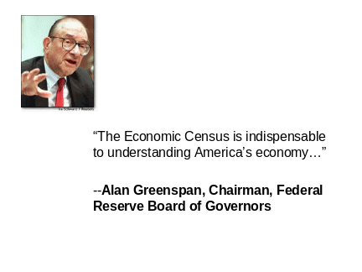 | All of these statistics are very important to policy makers and business people.  Alan Greenspan has said that “The Economic Census is indispensable to understanding America’s economy”
Slide 9 |  | The Economic Census serves a number of important needs in the public sector.  ■ Government agencies use the census as the foundation--or benchmark--for other statistics and surveys, from the Gross Domestic Product to monthly retail sales.  ■ Policy-making agencies in government use census data to:  ■ Measure and track changes in local economies, and  ■ Analyze the impact of policies and economic programs  ■ Local agencies frequently use economic census data to focus efforts to attract new business and retain existing firms, and to assist entrepreneurs in business development.
Slide 10 |  | These data are not just for government use.  The president of the U.S. Chamber of Commerce has remarked that "Sound and timely economic data are the fuel that powers business decision making..."
Slide 11 |  | Businesses are especially important as data users because it is they who provide the data in the first place.  First, firms can look at their own industry. A firm can compare its own statistics with figures for the industry, computing market share and evaluating its own growth and product mix relative to the competition.
Slide 12 |  | Second, firms use census data in business-to-business marketing. Manufacturers and distributors that sell their products to or through other businesses use the economic census to study those markets, and then apply what they have found in  Locating plants, warehouses, and stores; and  Laying out sales territories;  Making sales forecasts.  ■ Of course, businesses engaged in marketing to household consumers (B-to-C instead of B-to-B), make many of these same types of decisions using data about people--from the 2000 Census of Population and Housing.
Slide 13 |  | Third, firms use census data to evaluate investment opportunities. This can be especially important to small businesses if they want someone else to invest in their business, as when they apply for a loan. Even if the the owner of a small shop knows his or her markets and the competition enough to run day-to-day operations, that owner may sometime need to convince someone else--like a bank's loan officer or a venture capitalist--just how good the business opportunity is. Census figures on the market may help out.
Slide 14 |  | What does the Economic Census include?  The Economic Census covers most, but not quite all, domestic economic activity. The Census Bureau conducts a separate Census of Governments and the U.S. Department of Agriculture conducts a separate Census of Agriculture at the same time as the Economic Census. Taken together, these censuses cover about 98 percent of economic activity.  The Economic Census, per se, covers only the nonfarm, private economy, about 85% of the pie.  (The parts not covered include forestry and fisheries, scheduled commercial airlines, railroads, schools and colleges, political and religious organizations, and private households)
Slide 15 |  | Parts of the Economic Census date back to 1810, when the first questions about manufacturing were part of the Population Census. The Economic Census didn’t really take its current form until 1954. Note that coverage of most of Transportation, Communications, and Utilities and Finance, Insurance, and Real Estate began only in 1992. So time series for some parts of the economy may be relatively short.
Slide 16 |  | How do we collect the data?  We collect most of the data in the Economic Census by mail. At the end of 2002 we sent forms to 5 million businesses. These included all of the large and mid-size employers and a sample of the smallest employers.  Many companies took advantage of the opportunity to report electronically, although most just filled out the paper forms.  We waited until the end of 2002 to send out forms so companies could report all of their activity for the calendar year. …  Data collection activities continued through most of 2003.  And then we started to publish data in early 2004.  We used more than 650 variations on the census form, so that each business could respond in terms meaningful to its own industry.
Slide 17 | 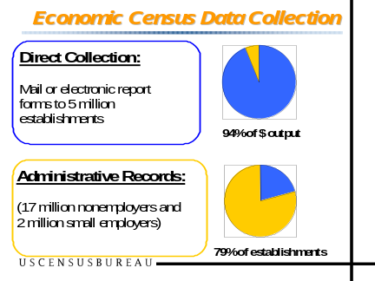 | Most businesses in the U.S. are actually very small –- millions are self employed or have only a few employees yet they account for only a few percent of economic activity. Rather than send out 19 million more forms, we substituted information from the administrative records of other federal agencies.  But while those 5 million establishments to which we send forms account for the overwhelming majority of economic activity, there are another 19 million firms that are so small that their aggregate impact is only a few percent of output. These businesses are primarily self-employed persons, and we will talk more extensively about nonemployers later.  Rather than send out 19 million more forms, we substituted information from the administrative records of other federal agencies, and thus substantially reduced the reporting burden on American business.
Slide 18 |  | In this segment, we talk about how economic census data are organized.
Slide 19 | 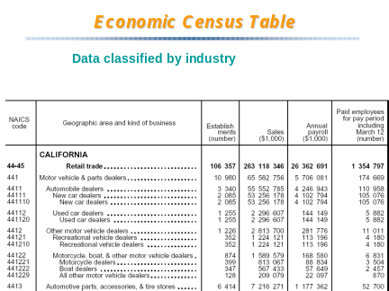 | This is a typical table from the economic census, featuring data on the  Number of business establishments  Sales  Payroll  Number of employees  In this table, those key data items are distributed by geography (in this case, California)  …and by industry or kind-of-business, as illustrated by various types of motor vehicle and parts dealers shown in the sample table.
Slide 20 |  | The Government’s official system for classifying industries from the 1930's through most of the 1990’s was the Standard Industrial Classification (or SIC) system.  But the SIC system reflected an economy dominated by manufacturing, not the service economy into which we have evolved.
Slide 21 |  | America needed a better classification system, and now it has one. Out with SIC, enter NAICS in 1997.
Slide 22 |  | The new North American Industry Classification System replaced the old Standard Industrial Classification (or SIC) system as of 1997. NAICS (which rhymes with “snakes") was defined as a joint project of the U.S., Canada and Mexico.
Slide 23 |  | NAICS introduced a new numbering system.  The new NAICS codes have 6 digits that replaced the 4-digit SIC system.  Here is an actual example of the NAICS hierarchy.  Within the Information Sector, 51, there is  a 3-digit subsector for Broadcasting other than the Internet,  a 4-digit industry group for Radio and Television Broadcasting, and  a 5-digit industry for Radio Broadcasting.  Only the U.S. further defines a 6-digit industry for Radio Stations  Many users had hoped that going from a 4-digit SIC to a 6-digit NAICS code would mean orders of magnitude more detail. In fact, the number of classifications has gone up only about 15 percent.  The greatest significance is that the NAICS identifies important new industries and important new groupings.
Slide 24 |  | At the same time, the way that industries are grouped into major economic sectors also changed.  The SIC had 10 divisions, NAICS has 20 sectors.
Slide 25 |  | This slide shows how new sectors were broken out from the familiar divisions of the SIC.  For example: Utilities, and Transportation and Warehousing, were broken out from a single SIC division.  More dramatic were the new differentiations within service industries–6 new sectors.  Yet……..
Slide 26 |  | …..that straightforward chart was really an oversimplification.  In fact, major chunks of service industries went into the new Accommodation and Food Services sector and the Real Estate and Rental and Leasing sector.  And the new Information sector shown at the bottom of the screen really got its largest component–communications–from the old transportation, communications, and utilities division of the SIC.
Slide 27 | 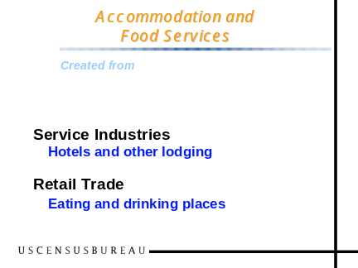 | Let’s look at an example:  The new accommodation and food services sector was created by marrying the hotel and lodging industries, from the SIC services sector, with eating and drinking places from retail trade.  Retail trade is, of course, a very familiar concept. In 1992, Eating and drinking places made up about 10 percent of retail sales and fully one third of retail employment. In NAICS, that large chunk was removed from retail trade.
Slide 28 | 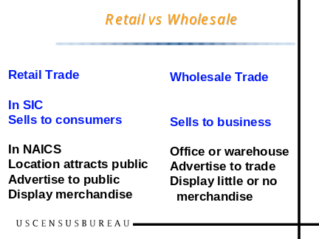 | But there is more …  The distinction between retail and wholesale trade used to be in terms of who the customer was. Under SIC, retailers were those who sold to consumers, and wholesalers sold to businesses and institutions. Then along came a variety of computer stores and office supply stores and building material stores that sold to both businesses and individuals.  In NAICS, a retailer is characterized more by the way it does business–with a storefront, advertising to the public, and display of merchandise–than who its customer is.  The net effect of these changes is to subtract some activity from wholesale trade and add it to retail trade.
Slide 29 | 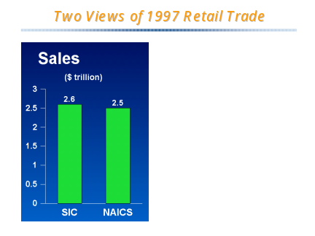 | Looking at 1997 retail sales as classified by SIC and NAICS, they don’t look all that much different.  The inflow of wholesalers into retail trade appears to have offset much of the loss of restaurants to the new accommodations and foodservices sector.  At least that is the way it looks in terms of sales.
Slide 30 | 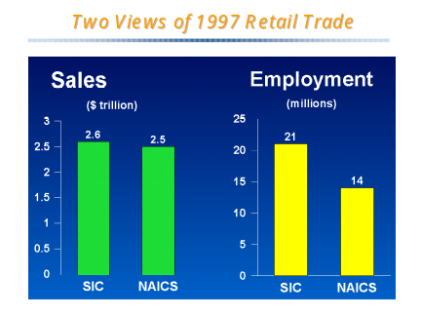 | But the picture is much different in employment.  Restaurants tend to have lots of employees relative to their sales.  The formerly wholesale establishments that came in to retail have much fewer.  In terms of employment, retail trade under SIC and NAICS look quite different – and if one didn’t understand the change in composition, one might incorrectly infer that productivity in the Retail sector had improved dramatically.
Slide 31 | 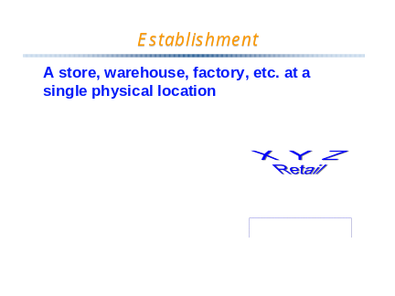 | Before we go further, lets make sure we understand just what it is that is being classified by industry.  A business establishment is a store, warehouse or factory operating at a specific physical location.
Slide 32 | 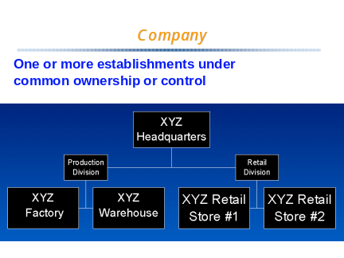 | That is not the same thing as a company or firm.  A company consists of one or more establishments under common ownership or control. We require each company to give us separate data for each of their establishments, because frequently the different establishments do different things, and typically the different establishments are located in different geographic areas.  So it is each establishment that gets a NAICS code, not the company as a whole.  And it is the number of establishments, not the number of companies, that is featured in most census statistics.
Slide 33 |  | There are many resources to help you figure out relationships between current data published by NAICS and historical data still out there by SIC.  The definitive resource is the NAICS Manual, available in print and at our web site.  Notice at the bottom that there are separate 1997 and 2002 editions of the NAICS manual. I will return to that in a moment.  The manual includes definitions for each industry, an alphabetic index, and, in the 1997 edition, detailed tables illustrating the correspondence between NAICS and SIC, and vice versa.
Slide 34 |  | Here you can see the correspondence between publishing industries within NAICS and SIC.  Newspaper publishing (NAICS 51111) is, one-for-one, the same as SIC 2711, and the table includes an E code to tell you that this is simply an Existing industry.  Periodical and book publishers have a code R to tell you these industries have been Revised from their SIC counterparts  Database and Directory publishers (NAICS 51114) have a code N for a New industry, without a real counterpart in SIC.  The correspondence tables are very useful, but when an industry is split or made up of parts of other industries, they don’t tell you how important each component is. This table tells you that one component of the new Book Publishers NAICS code is technical manuals and books, which used to be part of SIC 2741. This table doesn’t tell you how important technical manuals are relative to other parts of the book publishing industry—coming from SIC 2731.  So……..

Slide 35 |  | ….Fortunately, the 1997 Economic Census published a Bridge between NAICS and SIC.  The “Bridge” report gives national statistics defining for us just how much of each SIC category went to each NAICS–and vice versa–thereby defining comparability issues much more thoroughly than the correspondence tables in the NAICS manual or any other source.  The answer to our question about Book Publishers is that the 1997 Economic Census didn’t even find any establishments primarily engaged in publishing technical manuals to the exclusion of all else, so movement of that category had no practical effect.  The symbols here are a take-off on the bridge metaphor. Those categories completely comparable between SIC and NAICS are shown with a full bridge with superstructure. Those not comparable are shown by a drawbridge wide open. Those almost comparable, like book publishers, are shown with a drawbridge nearly closed. We used that symbol if SIC-based data could get us within 3% of the NAICS sales or revenue.
Slide 36 | 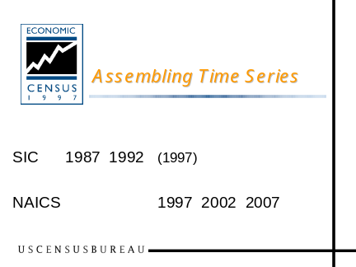 | Data prior to 1997 were published based on SIC. All data for 2002 and future years will be based on NAICS. Only for 1997 do we have some overlap between the two systems. Most 1997 data were published by NAICS, but selected national and state data were also published by SIC to facilitate the transition.  NAICS gives us a better foundation for analysis of trends in the future. But in many respects there is a disconnect. Some series simply will not be able to bridge the gap between the two systems.  [Speaker’s note: Several of the Indicators series have gone back to 1992 and approximated NAICS data - like Monthly Retail Sales]
Slide 37 | 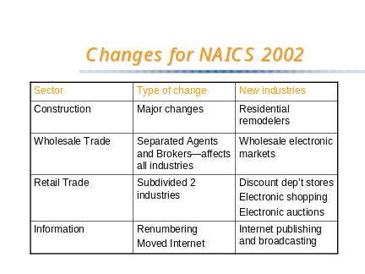 | The old SIC system was updated every 10 to 15 years. That proved to be too infrequent. NAICS will be reviewed every 5 years.  There are already changes implemented for 2002.  Industries have been largely redefined within Construction and Wholesale Trade. Still, none of the boundaries between sectors were affected, so we have nothing like the upheaval users dealt with for 1997.  Changes in retail trade and information are comparatively minor, with little or no impact on historical comparability
Slide 38 |  | The place where you can find answers to your questions is the NAICS website. You can access this page from the Census Bureau Homepage (www.census.gov)  In the upper left corner of the page is the link to the NAICS to SIC and SIC to NAICS tables we illustrated earlier. Just below that is a NAICS search box where you can type in a word and get a list of all of the related industries.  Let’s imagine that we have typed “software” in and clicked NAICS Search……
Slide 39 | 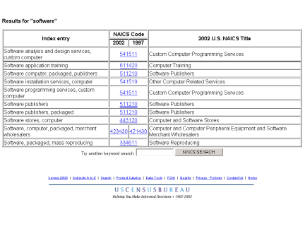 | Here is a list of related industries, including Software Publishers, NAICS 511210, that the search returns. Let’s click on that code 511210.
Slide 40 | 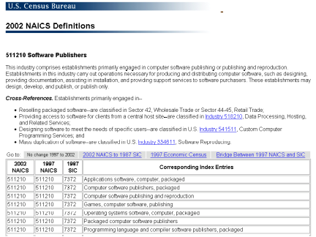 | This brings us to the formal paragraph-style definition of software publishers, coupled with cross-references to related industries and a list of all of the index entries that could have brought us to this industry—sort of an operational definition.  This page also lets us link directly to correspondence tables (NAICS02 to SIC), to the 1997 bridge tables, and to a sampler of economic census data for this industry from the 1997 Economic Census.
Slide 41 |  | Backing up to the list of entries we saw a moment ago, note that there are actually two code columns, one for 2002 and one for 1997. The code for software wholesaling changed so you see two separate codes in the next to the last entry. You can click on the two codes to see how the definition changed.
Slide 42 |  | The NAICS web page is frequently updated. Concordances for 2002, and between NAICS and some international classification systems, have been added. There is even information about changes planned for 2007.  For those of you concerned with the statistics of other agencies, there are annotations of when some of the data series of the Bureau of Economic Analysis and the Bureau of Labor Statistics will complete their conversion to NAICS.
Slide 43 |  | In what industry would you find gambling cruises?  Select “NAICS” in the Business section of www.census.gov  Enter keyword “gambling” in NAICS search box  Gambling cruises are NAICS 713210
Slide 44 |  | That brings us back to the Economic Census, and in particular, how Economic Census data get into your hands through a set of data products. For that, I give you to my colleague, ____.
Slide 45 |  | Since nearly all Economic Census products get to you via the Census Bureau web site, and most references are there too, let’s find the charts we need as web pages.  The Census home page gives us a link straight to the Economic Census.  <<click on Economic Census>>
Slide 46 |  | The primary Economic Census page features both 2002 and 1997 economic census data, because, we want you to have easy access to 1997 data while we are still in the process of releasing 2002 data.  The first link in the main column is to the schedule. Let’s start there  <<click on “schedule”>>
Slide 47 |  | This page is part of the Guide to the Economic Census.  It shows reports being issued across more than a 2-year period, from the first quarter of 2004 to the 3rd quarter of 2006.  Some of the blocks include a book symbol to indicate that those reports will be published in print. There are very few series to be in print.  We won’t talk about the advance report, because those data have now been superseded.  The Industry Series gave us our first look at really detailed numbers.
Slide 48 |  | In past censuses we have issued industry series reports only for goods-producing sectors: mining, construction, and manufacturing.  What is new for 2002 are industry reports for all of the other industries, in what we will refer to as service-producing sectors.  1) Here, the data are limited to the national level only.  Both types of industry reports include data about products of the industries as well as the industries themselves. I will illustrate product data later.  All 651 of these reports have now been released.
Slide 49 |  | The main type of reports being published right now are the Geographic Area Series reports  <<click on “Geo Area Series”>>
Slide 50 |  | Area series reports are issued state by state, and to determine what is available, all you have to do is click on your state.  <<click on _Indiana_ on the map>>
Slide 51 | 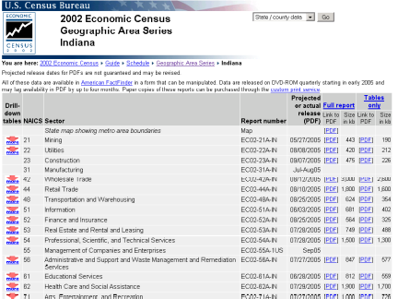 | Of the 18 sectors, _Indiana_ data have been published for 16 of them. The last ones are scheduled for release by the end of September.
Slide 52 | 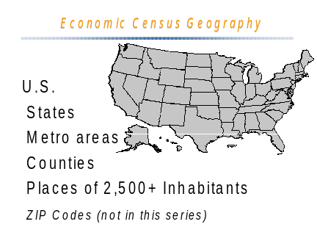 | The Economic Census publishes data  for the nation as a whole, for states,  for metropolitan areas,  for counties,  or cities and other places that have 2500 or more inhabitants,  and for ZIP Codes.  All but ZIP Codes are included in the Geographic Area Series.  [cite only in the states listed:] In New England, New York and Wisconsin, we also publish data for towns with 10,000 or more inhabitants, and include them in the tables of data for places. In Indiana, Minnesota, New Jersey and Pennsylvania, that applies to townships of 10,000 or more.
Slide 53 | 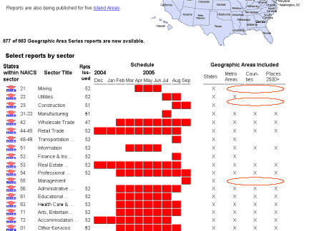 | Back on the page for all states, lower down, is a graphic summary of when the various sectors will be published—all of which are to be complete by the end of September.  If you want to see which states have been published for a particular sector, you can click on one of the down (“more”) arrows on the left.  But let’s focus on the righthand part of the chart shows, which shows that not all sectors publish data for all geographic areas.  Three sectors have only state level data: mining, construction, and management of companies.  Three more show data only for states and metropolitan areas, but not for counties and places: Utilities, Transportation and Warehousing, and Finance and Insurance.
Slide 54 | 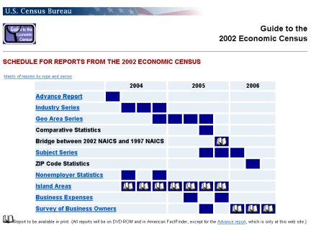 | After the completion of the Geographic Area Series, we will publish the Comparative Statistics and Bridge reports.
Slide 55 |  | In Comparative Statistics, we compare data from the current census with data from the previous census. In order to provide comparable data, we have to employ the classification system of the previous census. For 1997, that meant showing 1997 data by the SIC system as used in 1992, and Comparative Statistics was the main report for 1997 that tied back to the old SIC system.  The Comparative Statistics report for 2002 will not tie back to 1987 SIC, but rather will be based on the 1997 NAICS.  The 1997 report gave comparable, SIC-based data for the U.S. and for states. There were no comparable SIC-based data for metro areas, counties, or cities for 1997.  For 2002, Comparative Statistics isn’t quite so important, given that all sectors are comparable, 1997 to 2002, at the sector total level, and most sectors are completely comparable for individual industries as well. Thus, you can easily make your own comparisons between 1997 reports and 2002 reports without the Comparative Statistics Report.
Slide 56 | 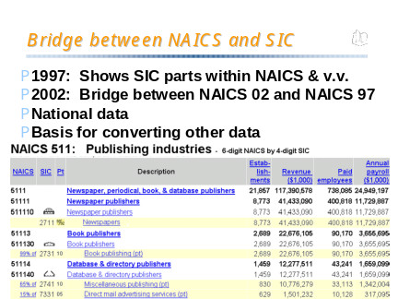 | We have already talked about the Bridge Between NAICS and SIC in the NAICS discussion, published only at the national level for 1997.  There will be a 2002 counterpart, but it will bridge between the 2002 version of NAICS and the 1997 version, only in those limited areas where they are different.
Slide 57 |  | Subject reports generally explore specialized topics at the national level.  For 14 service-producing sectors, there are three subject reports:  Product Lines  Establishment and Firm Size, and  Miscellaneous Subjects  Let me say a little more about the Product Lines reports….
Slide 58 |  | We have already published an advance look at product line data in the Industry Series reports.  a) Convenience stores are a separate industry, NAICS 44512.  b) Convenience stores sold $20.9 billion dollars in goods during 2002, of which $9.4 billion were groceries. The next to the last column shows that that $9.4 billion is 45% of total sales of convenience stores.  c) Other major categories include 10.2% for meals for immediate consumption  …another 10.2% for packaged liquor, wine and beer  …and a whopping 24.8% for cigarettes and other tobacco products  d) These product data are already published at the national level in Industry reports, but the Product Lines reports will revise the figures and bring them all together.  While the Product Lines PDFs will include only national data, databases that we will be discussing later on American FactFinder and DVD-ROM will include  State data for many sectors  Metropolitan area data for three sectors: wholesale trade, retail trade, and accommodations and food services.  Product Lines reports are coming this fall and winter.
Slide 59 |  | ZIP Code statistics are published separately from the other geographic area reports, as we mentioned earlier, and include establishment counts by industry by size.  These data are the only indicators of the geographic distribution of business within large cities, since the economic census includes no data for census tracts or the other small areas published in the population census.  These data appear as databases only, on CD-ROM and on the Internet, not as PDF reports, and they are among the last products of the 2002 census (2nd quarter of 2006).
Slide 60 |  | However, ZIP Code statistics are not published for every sector. From the Economic Census ZIP data are published for  * Manufacturing  * Retail trade,  and for various service industries.  Later we will talk about another data set that provides ZIP Code data for other sectors.
Slide 61 |  | Nonemployer Statistics are next on the list.  As shown on the chart, the 2002 data all became available last year.  But what are these nonemployers?……
Slide 62 | 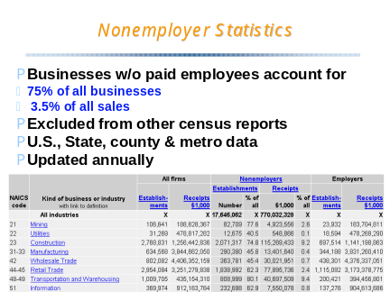 | By definition, nonemployers are businesses with no paid employees.  Most nonemployers are what we think of as self-employed persons.  In terms of sales or receipts, they account for only about 3.5% of total sales by employers and nonemployers combined.  But if you are counting numbers of companies, around 75% are nonemployers.  Nonemployer data have now been published for states, counties and metro areas, well ahead of other economic census data.  This is a unique display in presenting data for “all firms”, nonemployers and employers together. In most cases you have to add together data published separately for nonemployers, from the Nonemployer Statistics report, and employers, from any of the other economic census reports  Since the data come from tax returns rather than questionnaires, we get fresh data each year.
Slide 63 | 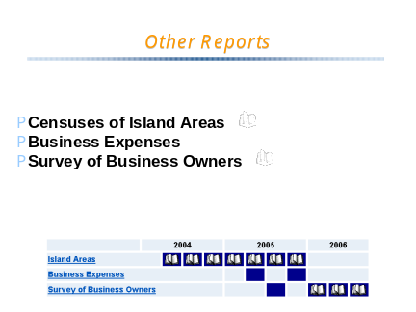 | The Censuses of Island Areas provide data for Puerto Rico, the U.S. Virgin Islands, Guam, the Northern Mariana Islands, and, new for 2002, American Samoa.  The Business Expenses Survey produces a report covering most industries, but only at the national level, and a preliminary report has just been released.
Slide 64 |  | Although the data are only at the national level, there are some pretty compelling figures here. Business Expenses shows some key types of operating expenses, like printing services and advertising services. If you are in the printing or advertising business, here is information on your potential customer base.  For example, this shows that Furniture and home furnishings stores (NAICS 442) have a much higher rate of spending on advertising services than building material and supply stores (NAICS 444).  Admittedly, the industry classification is fairly broad, but this can be good marketing information for businesses that provide services to other businesses.
Slide 65 |  | The most widely used of this group of reports is the Survey of Business Owners, with most data due to be published in 2006.
Slide 66 |  | This is the new title for what was previously known as the Survey of Minority-Owned Business Enterprises and the Survey of Women-Owned Business Enterprises.  These reports show the total number of businesses owned by Blacks, Hispanics, American Indians, and Asians and Pacific Islanders, along with overall totals for all businesses and for businesses owned by women. Separate reports are issued for each of the categories shown on the slide.
Slide 67 |  | Here is sample of the preliminary data just released for the U.S. and states.  Survey of Business Owners reports include two sets of data columns.  The four columns on the right are for firms with paid employees, the same ones covered in most Economic Census reports.  But the columns in the middle, and the ones most frequently cited, are for all firms, including nonemployers as well as employers. This is in recognition of the fact that the largest numbers of minority- and women-owned businesses are really self-employed individuals.  On this table you can clearly see that firms with paid employees comprise  5.5 out of 23 million businesses (24%) <<point to these figures>>,  but 21.9 out of 22.6 trillion dollars in receipts (about 96.6%) <<point to these figures>>  Note one other thing. The Survey of Business Owners includes a line at the top for the Universe of All Firms (labeled here just with “United States”)<<point>>. None of the other Economic Census reports add up totals across all sectors, but this one does.
Slide 68 |  | Survey of Business Owners reports for 2002 are scheduled for release next year, except for the preliminary national numbers we were just looking at.
Slide 69 |  | In addition to the new name there are other important things new with the Survey of Business Owners for 2002.  Comparability of 1997 and 2002 data is affected by the fact that  Respondents were allowed to identify themselves with one or more race group, and they are counted in the tallies of each race group they identify, likely raising some counts.  1997 data were classified by SIC, 2002 will be by NAICS  Of special interest even to those not concerned with minorities are the new characteristics on the form, to be published at the U.S. and state levels in a report entitled Characteristics of Business Owners:  Owner characteristics like age, education, veterans status, hours worked, and disability, and  Business characteristics, like home-based or family-owned businesses, franchising, age of the business, and sources of financing
Slide 70 |  | When will ZIP Code Statistics from the 2002 Economic Census be published?  Select “Economic Census” from the Business section of www.census.gov  Select “Schedule” under “2002 Economic Census Reports”  ZIP statistics are scheduled to be released 2d quarter of 2006.
Slide 71 |  | We’ve pointed out some of the features of the Economic Census that are new for 2002.  So what else is new?…..
Slide 72 |  | We have a detailed page addressing what’s new for 2002 in the “Guide to the Economic Census”.  The Guide is accessible from the sidebar on the Economic Census page and has a lot of other overview information, as you can see.
Slide 73 |  | a) Actually, the most important point is what isn't new. Most of the statistics will look just like their 1997 counterparts, and that should be a relief for those who agonized through the transition from SIC to NAICS last time.  b) We spoke of the changes to NAICS classification within 4 sectors.  c) We also talked about the industry series reports and the Survey of Business Owners.  d) We haven’t yet talked about the change to the definitions of many Metropolitan Areas, and the addition of a new class of areas, called Micropolitan Areas….
Slide 74 |  | Let’s first look at metropolitan areas as defined for the 1997 Economic Census, shown here in light green for _Indiana_, and in the next slide in dark green.
Slide 75 |  | As a result of Census 2000 and the new criteria implemented by the Office of Management and Budget in 2003, a new metropolitan area was created for Michigan city-LaPorte, and most of the existing metro areas each gained a county or two.  Another significant change the map was that 26 of Indiana’s remaining nonmetropolitan counties were defined as micropolitan statistical areas (shown in light green).  Micro areas are defined with the same kind of criteria as metro areas, but they have a smaller core population, as little as 10,000, in contrast to the 50,000 cutoff for the core of metropolitan areas.  Micropolitan areas will be included everywhere we publish data for metropolitan areas, and that means that there will be data for more areas in certain sectors that previously had data only down to the metropolitan area level: utilities, transportation and warehousing, and finance and insurance.
Slide 76 |  | So where would you find these maps?  In the Guide to the Economic Census,…
Slide 77 |  | You can select Geography from the menu at the left…
Slide 78 | 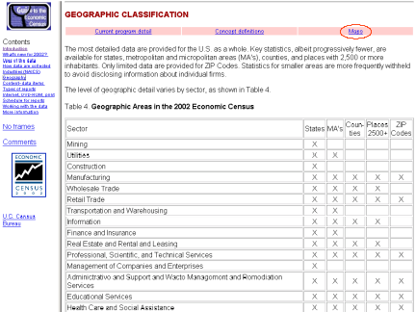 | … and from there you can go to “Maps”.
Slide 79 | 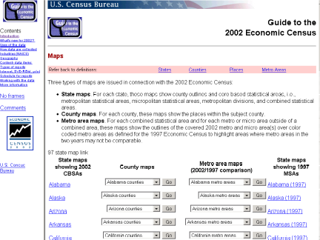 | And there you will find maps for each state, county and metro area, providing much more detail than we have ever before offered in connection with the Economic Census.
Slide 80 | 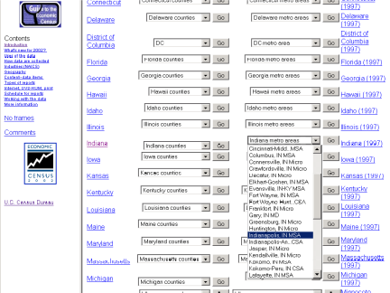 | Under _Indiana_ we can pull down a list of metropolitan areas, select _Indianapolis MSA_ and click “Go”.  <<click Go next to _Indiana_ metro areas>>
Slide 81 |  | This rather complicated map shows  the 2002 boundaries of the Indianapolis-Anderson-Columbus combined statistical area, with a heavy green border, and the  The 2002 boundaries between Indianapolis MSA, the Anderson MSA, and the Columbus MSA, and the new Crawfordsville, New Castle, and North Vernon micropolitan statistical areas in a narrow green border.  Some of the largest metro areas, like Chicago-Naperville-Joliet, have metropolitan divisions, like the Gary metro division we could have seen on the earlier slide.  The extent of the 1997 Indianapolis metropolitan statistical area is shown in a orange background color.  You can see by comparing the orange shaded area to the area outlined in green that Indianapolis MSA grew by 2 counties, but lost Madison county, which became the separate Anderson MSA. The combined statistical area adds in not only Anderson but also Columbus MSA as well as the three micro areas.  It is a complicated map, but it explains a complicated reality.
Slide 82 |  | Now _____ will take us through the various ways we can access and use the data.
Slide 83 |  | By now you are well aware that there are only a few printed reports issued from the 2002 Economic Census.  But, most data series are still available in page-formatted form, in PDF files on the Internet.  The Census Bureau is rethinking the way it creates Portable Document Format (PDF) files for the 2007 Economic Census, to be published in 2009 and thereafter.
Slide 84 |  | The PDFs published for the 2002 Economic Census use the same style features that have been employed in PDFs and earlier printed reports for decades. For 2007, we plan to convert to commercially produced photocomposition software, so we have the opportunity to rethink the features and conventions used in the PDFs, and possibly streamline our operations.  Here is an illustration from a current PDF, focusing just on the tabular presentation, ignoring titles and headnotes for the moment.
Slide 85 |  | Here is an alternate presentation…
Slide 86 |  | And yet another.
Slide 87 |  | We have parsed out the specific characteristics of these examples, such as the use of row and column dividing lines, and constructed a form that allows users to indicate which format works best for them, and why.
Slide 88 | 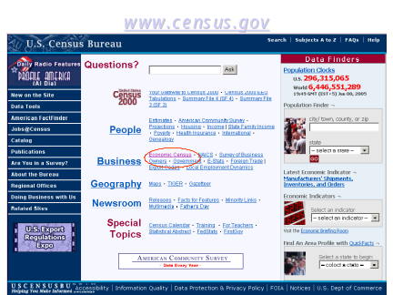 | This discussion of PDF issues is, as you would expect, available on the Economic Census website.  <<click on Economic Census>>
Slide 89 | 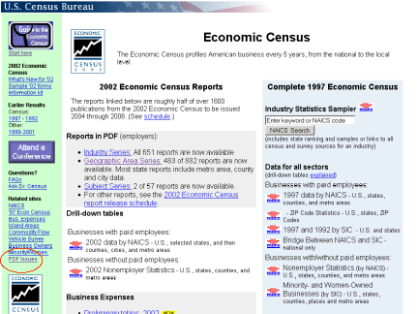 | In the far-left light-green column, the last entry is “PDF issues”.  <<click PDF Issues>>
Slide 90 | 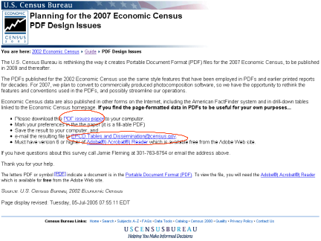 | If you have the Adobe Acrobat reader 6.0 or better, you can open the “PDF issues” paper, mark your preferences, save the result to your computer, then attach the file to an e-mail that will open when you click on the second link highlighted.  If you care about how PDFs are designed, but don’t think you will remember to fill it out on-line, you can pick up one of the handful of paper copies we brought with us.
Slide 91 |  | Now _____ will take us through the various ways we can access and use the data.
Slide 92 |  | From the Economic Census web page you can access not only the PDF versions of the reports, but you can directly access drill-down html tables. Let’s take a look at this first, and then we’ll talk about the data available on DVD-ROM and as databases on American FactFinder, and in other forms on the Internet.
Slide 93 |  | First, let’s look at the easiest way to get to the data.  On the census home page, let’s click again on “Economic Census” right next to the big “Business” heading, to get to the Economic Census page...
Slide 94 |  | In the main (white) column, under “Drill-down tables”, we select 2002 data by NAICS and click on the down-arrow…
Slide 95 |  | In one click we have national data.  Let’s look at _Indiana_…  <<click on the little down arrow next to Select a state>>
Slide 96 | 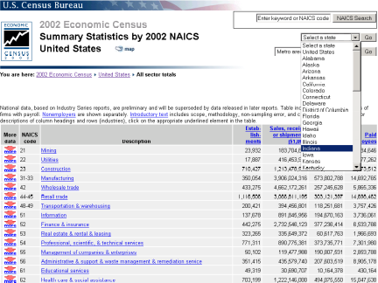 | …picking _Indiana_ on the “select a state” list, and clicking GO.
Slide 97 | 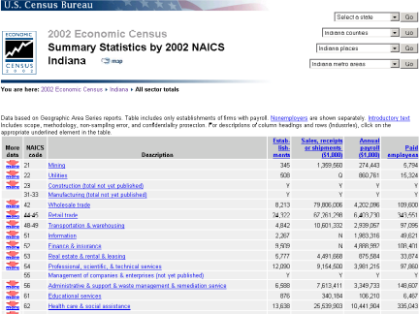 | The first thing that is evident is that not all numbers have been filled in in this table – you can see some “Y”’s.  As you may recall, geographic area reports are released by industry sector, and “Y” means the data for that sector have not Yet been published, or at least not published on AFF and in these tables (which lag 2-4 weeks behind corresponding data in pdf).  From here let’s look at data for Tolland county.
Slide 98 | 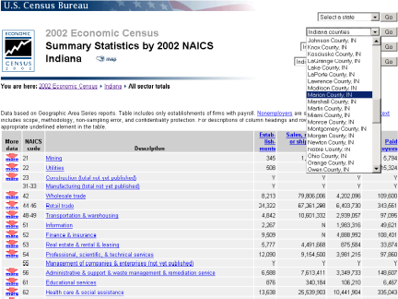 | Let’s look at _Marion_ County.  Click on the down arrow in the counties box, select a county and then click on “GO”.
Slide 99 | 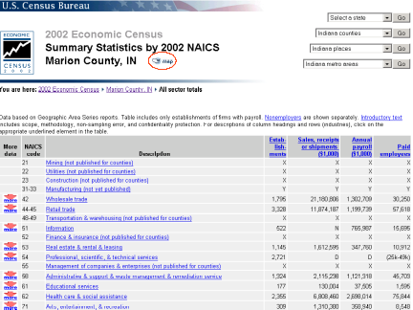 | You then have _Ingham_ county. <<point the cursor at the county name under the table title upper left>>>  If you want a sense of comprise the geographic areas, next to the geographic area name is a link to a map, which opens a new window  <<click on Map icon>>…….
Slide 100 | 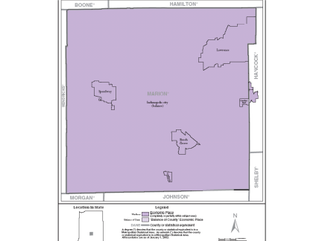 | This map shows the boundaries of _Ingham County_ and all of the towns and townships that are recognized in the Economic Census—-- << run the cursor over a couple of cities>>— that is, incorporated places of 2,500 inhabitants or more. If we were looking at any county other than Marion, there would be a light purple showing what we call “Balance of County”, the remainder after all identified places are taken out. As it is, we treat Indianapolis as a consolidated city, so that we label the part after Speedway, Lawrence, Beach Grove, Southport and part of Cumberland are taken out as “Indianapolis City (balance)”.  Census Designated Places from the population census are not included in the economic census, so that is why you don’t see _____ identified on the map.  The light purple then shows what we call “Balance of County”, the remainder after all identified places are taken out, but including the unidentified places.
Slide 101 |  | For more industry detail we can drill down into any sector. For example, let's take a closer look at Retail Trade…  We click on down arrow next to 44-45 Retail Trade, and…..
Slide 102 | 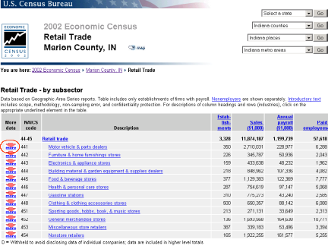 | …We see the 12 subsectors within Retail Trade.  Let's drill down further to individual industries: Let's look at Motor vehicle dealers.  We click on down arrow next to 441….
Slide 103 | 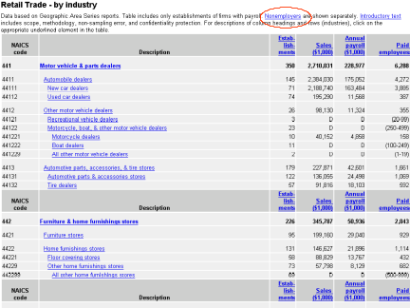 | …And here we have: New car dealers <<cursor over the titles>>, Used car dealers, Motor cycle dealers, and so forth.  Note that there are __74___ used car dealers with over $__195 million____ in sales.  An important qualification is shown at the top <<Point Cursor at headnotes>>: As we mentioned earlier, this is in a series where the “Table includes only establishments of firms with payroll. Nonemployers are shown separately.” If we click on Nonemployers, it takes us to <<Click on Nonemployers link>>…..
Slide 104 | 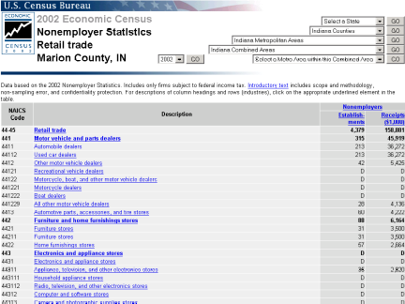 | Nonemployer Statistics<<point cursor at Table header>> provide a parallel table with statistics <<run cursor over NAICS codes>> and functionality <<run cursor over drop down boxes in upper right corner>> that match up to the data for employers.  There are __213__ nonemployer used car dealers (_nearly 3 times the number of employers), with over $__36 million__ in sales, so that nonemployers adds nearly a fifth to employer sales. … this is well above the 2.5% average for all retailers.  Nonemployers and employers are additive, even though the data come from two different sources.  We can return to the employer page by hitting the Back button…
Slide 105 | 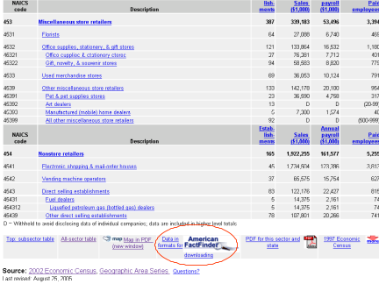 | At the bottom of the page is a link to the map we saw before, to a PDF report, and to a corresponding display for 1997. But the most important of these is the link to the American FactFinder.  Let's say we want to actually work out these figures. The link specifies that FactFinder will gives us data in a format for downloading. The American FactFinder system, unlike these simple static pages, is a sophisticated database system with data selection and specific download options.  Let’s click on “Data in formats for downloading”…
Slide 106 | 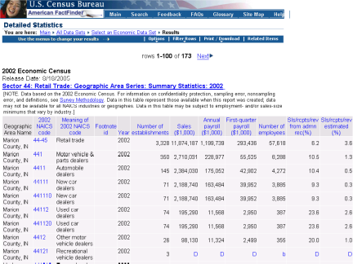 | Here are the same data in a different format: This “downloadable” option takes us inside American FactFinder. Besides the ability to download <<hover cursor over Print/Download on the blue bar>> American FactFinder offers us options to change things to suit ourselves. For example, if we place the cursor over “Filter Rows”…
Slide 107 | 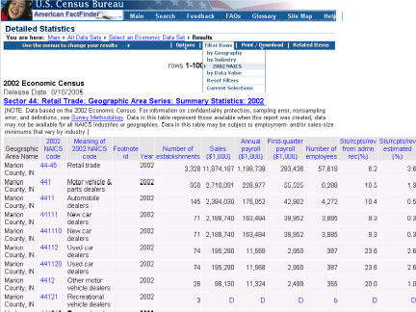 | …it offers us the opportunity to change the geography, focus on a particular industry, show only large data values, etc.  But this brought us in to American FactFinder through the back door.
Slide 108 | 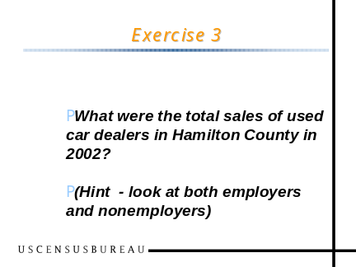 | What were total sales of used car dealers in Orange County, CA, in 2002? (Hint - look at both employers and nonemployers) [Goal: Use drill-down tables; practice adding employers and nonemployers to calculate ALL establishments in an industry for a geographic area]  Employers:  Select “Economic Census” from the Business section of www.census.gov  Under “Drill-down tables” click the red down arrow next to “2002 data by NAICS”  In “Select a state” box in upper right, select “Indiana”, click on “Go”  In “Indiana counties” box, select “Oakland County”, and click “Go”  Click the red down arrow next to NAICS 44-45 Retail trade  Click the red down arrow next to NAICS 441 Motor vehicle & parts dealers  Note used car sales (by employers, NAICS 44112) of $47,065 (000) in 15 establishments  Nonemployers:  Cursor up until you see the “Nonemployers” link in the headnote of the table – it takes you directly to the same sector and geographic area in the nonemployer tables  Note used car sales (by nonemployers, NAICS 44112) of $12,380 (000) in 49 establishments  Total: $59,445(000) in 64 establishments
Slide 109 | 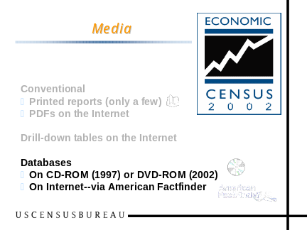 | Let’s broaden the discussion to include both of the products that allow you to manipulate the data: DVD-ROM and American FactFinder.
Slide 110 | 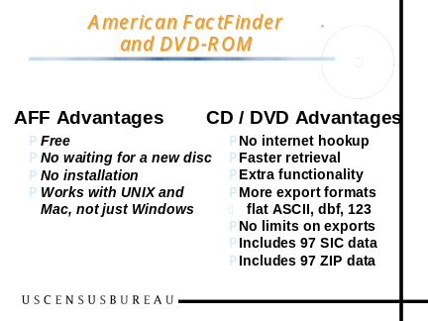 | Users who want Economic Census data in a form they can manipulate have two main choices: They can get the data on-line with the American FactFinder system, or they can buy the 1997 data on CD-ROMs or 2002 data on DVD-ROM.  With data free on the Internet, why would you want the data on CD or DVD? After all, with  American Factfinder:  FactFinder is free (The most popular DVD-ROM subscription costs $300 for 2002.)  There is no delay waiting for the next quarterly disc to come out, and no delay waiting for the shipment to arrive once you place your order.  No installation  Works with UNIX and Mac, not just Windows  But the 1997 CD-ROMs and the 2002 DVD-ROMs still have a number of advantages:  No internet hookup is needed (handy if you are using a laptop)  They have faster retrieval, particularly important if you are working with large quantities of data.  There’s some extra functionality, such as more types of preformatted reports, and a more flexible search system.  There are more export formats, including ‘flat’ ASCII, dbf, 123  There is no limitation on the size of the export (FactFinder limits most reports to 15,000 lines)  Finally, FactFinder did not include some of the databases issued for 1997. For 2002, that difference will disappear.
Slide 111 |  | A moment ago, we got into American FactFinder through a back door, through a link provided in a drill-down table.  But let’s explore that resource going through the front door, through the link right on the Census home page. In the middle of the left-hand, dark blue column, is a link to American FactFinder.  Let’s go there……..<<click on AFF link>>
Slide 112 | 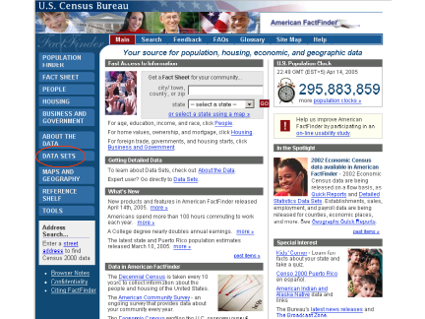 | Some of you may have already explored the American FactFinder.  This is a single entry point for all subject matter, including the decennial census.and American Community Survey.  The most efficient way to get to the data is to head straight for the “Data Sets” button  <<click on Data Sets>>
Slide 113 | 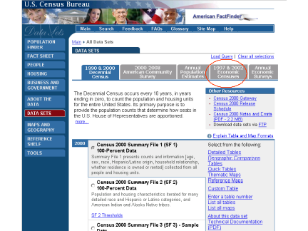 | The Economic Census is under the 4th tab.  If we click on 1997 & 2002 Economic Censuses…
Slide 114 | 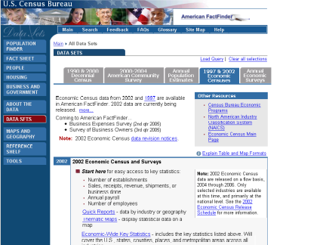 | …We see the full range of options for 2002.  Under “Start here” <<hover the cursor>> you see Quick Reports and Economic-Wide Key Statistics.  And if we cursor down a bit....
Slide 115 | 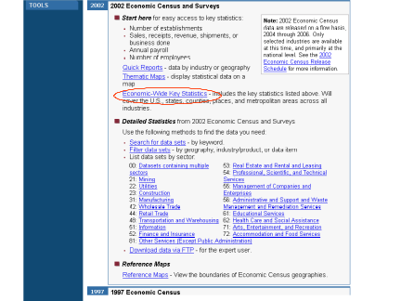 | You see a third option of going right to Detailed Statistics queries.  Let’s say that we want to compare sales of fast food eating places across all cities in _Indiana_.  Fast food is an industry in Sector 72: Accommodation and Food Services. We could click “Accommodation and Food Services” down under Detailed Statistics, but since the Economy-Wide Key Statistics file has all of the data that are available for counties and cities, we can skip a step and go directly to that file.
Slide 116 | 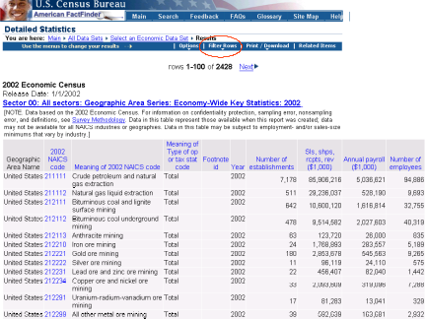 | Data are immediately displayed, but we still haven’t selected an area we are interested in.  Since we want to look only at data about cities in _Indiana_, we want to filter the rows…  <<put your cursor over “Filter Rows”>>
Slide 117 | 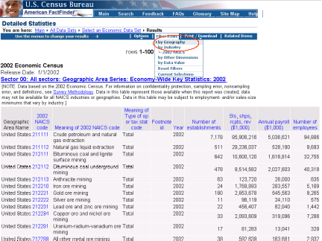 | And select “by Geography”…
Slide 118 |  | Our first task is to select a “geographic type” so we pull down that menu.  <<click in the field that says “Nation”>>
Slide 119 |  | Select a geographic type of “Economic Place”, since that is the terminology American FactFinder uses for those places recognized in the Economic Census  And then click on Economic Place…
Slide 120 |  | Select the state you want cities in, then click “Add”.  <<click Add>>
Slide 121 |  | Select “All Economic Places” and click “Add”.  <<click Add>>
Slide 122 | 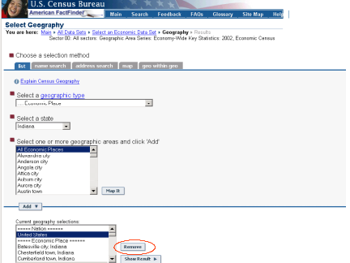 | That moved the county list into the current selections box. At this point we probably want to get rid of the default United States record (which appears in every file in which the national total is available).  So we highlight the record we want to get rid of, then click “Remove”.
Slide 123 | 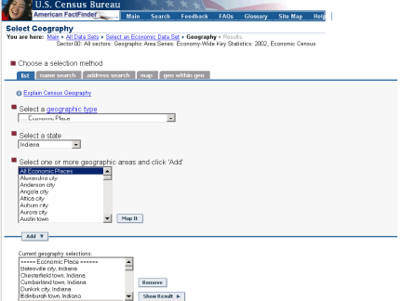 | Before proceeding, we can add in the state total for comparison.  <<click on down arrow in geographic type box>>
Slide 124 | 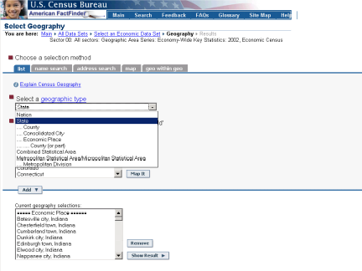 | We select State as a geographic type  <<click on “State”>>
Slide 125 | 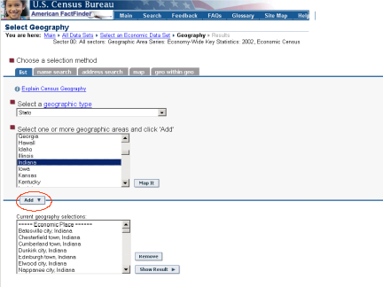 | We select the state we want, and then click Add.  <<click “Add”>>
Slide 126 | 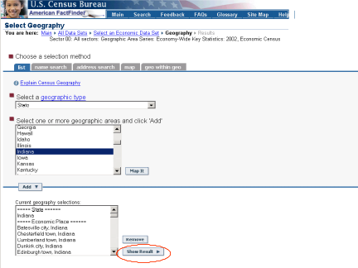 | The last step is to “Show Result”.  <<click “Show Result”>>
Slide 127 | 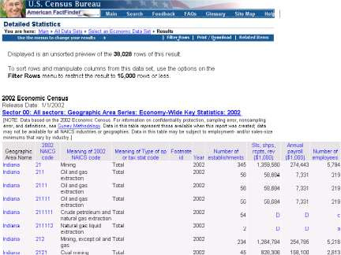 | And the result is a list of all industries for the state and all cities, although we don’t see the cities yet.  Now, to just look at “fast food places”, we are going to “Filter Rows” in the menu bar at the top.  <<hover over “Filter Rows”>>
Slide 128 | 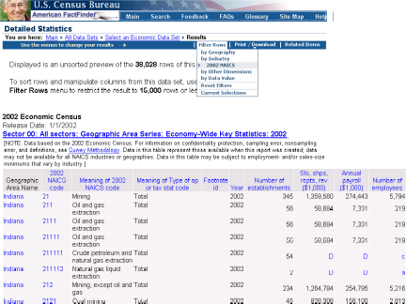 | We will filter rows by Industry: 2002 NAICS  <<click on 2002 NAICS>>
Slide 129 |  | We can either select a sector and drill down from there, or use the industry search at the top. We can enter the term “fast food”, check that we want to “Use synonyms”, and click “Search”.  <<click Search>>
Slide 130 |  | Limited-service restaurants is only industry option we are given. At this point we must highlight the option we are given, and click Add.  <<click Add>>
Slide 131 |  | Then click “Show Result”  <<click Show Result>>
Slide 132 |  | That gives us our list, one row per city. The options menu at the top allows us to select columns, to get rid of the ones that are just repetitive, or even create new columns of calculations like sales per employee.  In this case, I will demonstrate sorting the output into rank order.  <<click Sort Rows>>
Slide 133 |  | We pull down a menu of variables to sort by and select Sales—which in this file is represented as “Sls, shps, rcpts, rev”. We also click the radio button to make the sequence descending. Finally we click the “Update” button.  <<click Update>>
Slide 134 |  | Now we have cities in rank order of sales. At this point we can download the data from the Print/Download button on the menu bar.  <<click Download>>
Slide 135 |  | We will accept the defaults to create a comma-delimited file and click “OK”.  <<click OK>>
Slide 136 |  | At this point the dialogue will vary depending on what browser we are using. My setup will allow me do open a .csv file directly in Excel.  <<click OK>>
Slide 137 |  | And here we are with the same data in Excel, not as pretty, but ready for us to reformat or manipulate to our hearts content.  There are admittedly a lot of steps to go through, but they are justified by the kind of power you get as a result.
Slide 138 | 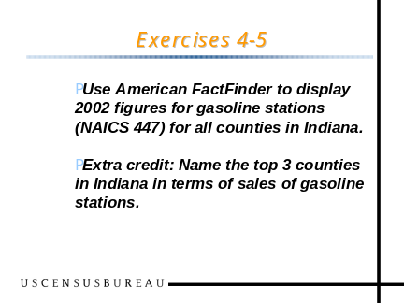 | Use American FactFinder to display 2002 figures for gasoline stations (NAICS 447) for all counties in Indiana. [Goal: Use American FactFinder to assemble a customized table from economic census data]  Select “American FactFinder” from the left sidebar on www.census.gov OR at the bottom of the Economic Census main page.  Select “Data Sets” from the left sidebar.  Select “1997 & 2002 Economic Censuses” from the tabs across the top.  In the 2002 section, select “Economic-Wide Key Statistics”  Economic-Wide Key Statistics”  To select all counties in the state…  i. In the “Filter Rows” drop-down menu at the top, select “by geography”.  ii. Select geographic type “County”.  iii. Select your state from the drop-down.  iv. Select “All Counties” and then click “Add”  v. In the “Current geography selections” box, select “United States” and then “Remove”  vi. Click “Show Result”.  To show data for gasoline stations  i. In the “Filter Rows” drop-down menu select “2002 NAICS”  ii. Enter “gasoline” in the search box and click “Search” (This is an occasion where clicking “Use synonyms” gives us more than we want.)  iii. Highlight “447: Gasoline stations” in the “Select an industry” box, and click “Add”  iv. Click “Show result”  Extra credit: Name the top 3 counties in Indiana in terms of sales of gasoline stations. [Goal: Use additional customizing features of American FactFinder]  From the Results page in exercise 4, Select “sort rows” from the “Options” drop-down on the top menu bar,  Select “Sls, shps, rcpts, rev ($1,000)” from the “Sort by” drop-down, and then click the “Descending” button, and click “Update”  Top 3 counties: Lake, Marion, and Porter
Slide 139 | 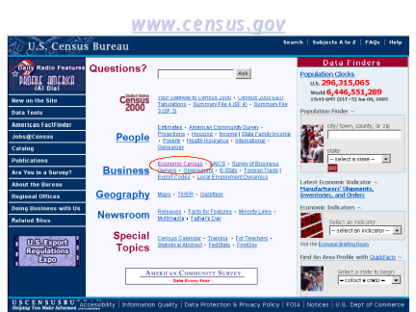 | Back at the main web site  Let’s click on “Economic Census” again.
Slide 140 | 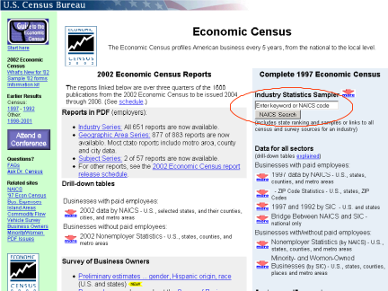 | There is another important tool on the Economic Census page I want to draw your attention to: On the right side of the page is the “Industry Statistics Sampler” search box. It’s on the 1997 side of the page, but in a couple of months the data will be complete enough for us to redo it with 2002 data also. For now, let’s use the 1997 version to see how the tool works.  We are looking for the state with the most casino revenues.  We can type in a key word or NAICS code. Let’s enter “casino” and click NAICS Search.
Slide 141 |  | This brings up a list of index entries and the industries associated with each.  We are not interested in casino construction, but there are still 2 industries left—casino hotels and casinos other than casino hotels. Casino hotels are part of the Accommodation and Food Services sector, but casinos alone are part of Arts Entertainment and Recreation, and that is the industry we want to look at now  <<click on 713210>>
Slide 142 | 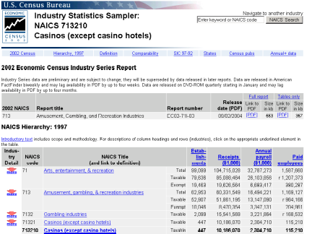 | This display starts with a link to the 2002 Industry Series report.<<Cursor over the 2002 Title>>  Most of the rest of the page is still devoted to 1997 data, but that will change in a couple of months when we have the final area totals for all industries.  The 1997 numbers include the applicable NAICS hierarchy.
Slide 143 | 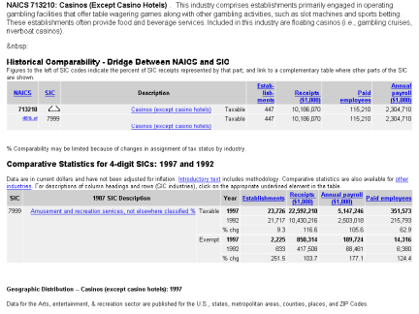 | Other features, lower down on the page, include a narrative definition of the industry, the applicable part of the Bridge between NAICS and SIC—which shows that, under SIC, casinos were just part of “Amusement and recreation services, not elsewhere classified”  Lower down on the page are data on the Geographic Distribution…

Slide 144 | 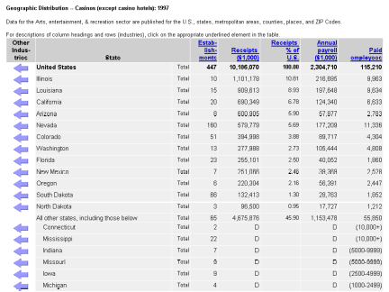 | Here, the states are presented in rank order based on the total receipts.  You may be surprised that Nevada is not Number 1. Actually, the biggest casinos in Nevada are part of casino hotels, and those figures are included in the separate Casino Hotels industry, not here.  If we were looking for the state with the largest casino receipts, excluding casino hotels, we might then respond that the winner is Illinois, since its has the highest receipts shown.  But notice that there are a number of states at the bottom of the page with receipts shown as “D” or withheld to avoid disclosure. The line just above the D’s says that all states not listed in the top section have receipts totaling $4.6 billion—in other words, nearly half of nationwide receipts are not shown at the state level.  We can see why data have been suppressed for Connecticut, because the Economic Census never shows characteristics of one or two establishments. While Mississippi has 22 establishments, it may well be that a small number of companies dominate receipts, so that we must suppress those data to keep users from making estimates too close to the figures of actual companies. Even though receipts have been suppressed, the number of employees is shown as a range—10,000 or more for Connecticut and Mississippi. That’s more employees than in any of the states listed above. So it could very well be that Connecticut or Mississippi or perhaps Indiana and Missouri may outrank Illinois.  Disclosure can be quite inconvenient for data users studying industries where business may be highly concentrated in a small number of companies.  This table illustrates the important use of subtraction in understanding the data where some figures have been suppressed. By subtracting unsuppressed figures from a higher level total, we get an idea of the overall magnitude of the suppressed figures.
Slide 145 | 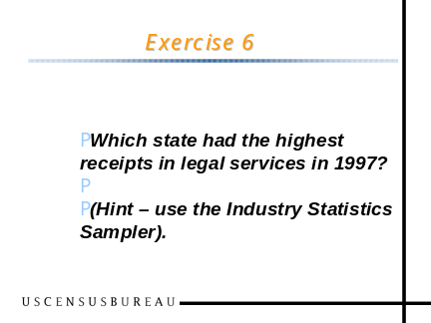 | Which state had the highest receipts from legal services in 1997? [Goal: See the variety of data presented in the Industry Statistics Sampler, learn the impact of data withheld to avoid disclosure]  Select “Economic Census” in the Business section of www.census.gov OR go directly to www.census.gov/econ/census02  Enter “legal” in Industry Statistics Sampler  Click on NAICS “5411” (Legal Services)  Click on the link for “States” in the blue navigation bar near the top; go to “Geographic Distribution—Legal services:1997” table – this is already ranked by receipts size. California has the highest receipts.  Note – further down in this table you see a list of states for which Receipts was suppressed – the total of which is 3.57% of the U.S. total receipts. Thus, none of the suppressed states could outrank California (with 14.60% of total receipts.)
Slide 146 | 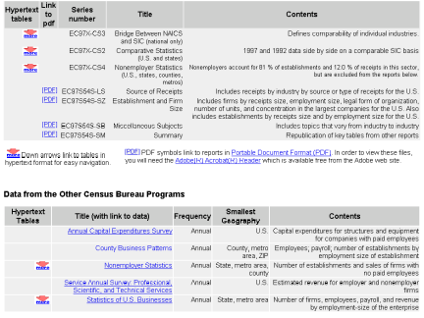 | Toward the bottom of the same page are links to other data from 1997, in both PDF reports and “drill-down” hypertext tables.  Also shown are links to other Census Bureau programs with data for this industry, sources for more recent data and, in some cases, characteristics beyond the scope of the Economic Census for most industries, like capital expenditures.  If you are looking for data more frequent than the 5-year economic census for a specific industry, this is the most efficient way to find it—by looking up the industry and coming down to this table, then going to the original documents.
Slide 147 | 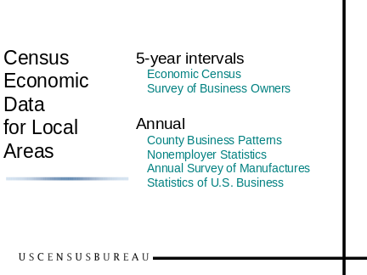 | We have already discussed the two sources of business statistics that we collect once every 5 years:  The Economic Census  The Survey of Business Owners  Among the annual data sets, we have discussed Nonemployer Statistics  Now let’s address the other three.
Slide 148 | 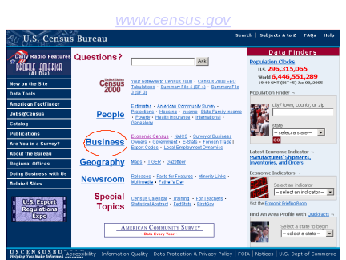 | …From the Census home page you can click on the main heading Business.
Slide 149 | 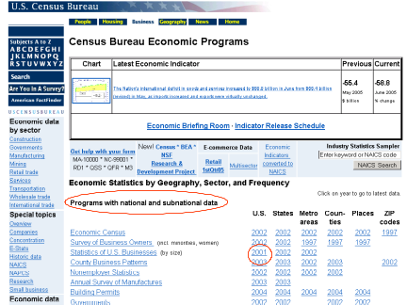 | The table of “Programs with national and subnational data” lists 8 programs, and, on the right, links directly to data -- where available -- for states, metro areas, counties, cities, and ZIP codes.  One of those programs with unique content is the Statistics of U.S. Business.  Let’s click on 2001 in the U.S. column, in the row for Statistics of U.S. Business…
Slide 150 | 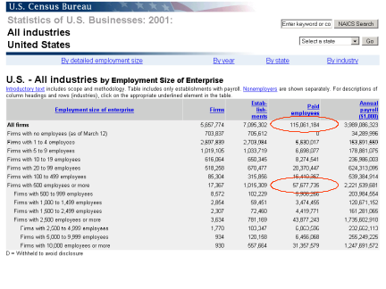 | This is the most comprehensive source of information about small business. Firms are classified by the number of employees in the entire enterprise. Data include total employment and payroll. You can see, for example, that about half of the 114 million employees in all firms are in 17,000 firms with 500 or more employees (almost 57 million). There are millions of firms with under 10 employees, but there aggregate impact is much smaller.  These data are also shown, in somewhat less detail, by year, by state, and by industry. See the selection menu across the top of the table. Metro area data can also be obtained in a downloadable spreadsheet.
Slide 151 | 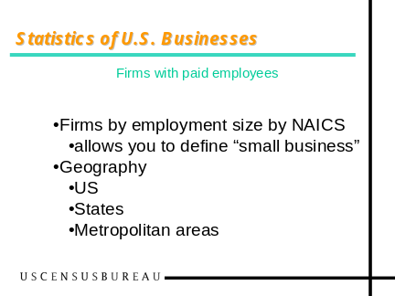 | To summarize, Statistics of U.S. Business allow you define small business in terms of employment size of the company. Data are available for the U.S., for states and for metropolitan areas.
Slide 152 |  | Another source of data for metropolitan areas is County Businesses Patterns, even though we wouldn't have guessed from the title.  We can go straight to the data if we click on the year in the appropriate data cell.  <<click on 2002 in the metro column in the row for County Business Patterns>>
Slide 153
Slide 154 | 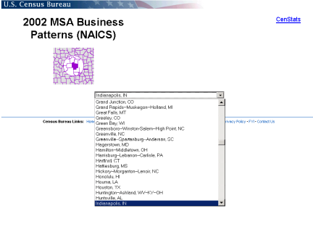 | And pick out _Indianapolis_ metropolitan area.  We click on Submit, which is hiding under the drop-down on the slide……
Slide 155 |  | And, we have data for the _Indianapolis_ metro area—we will talk about its definition in a moment.  The MSA Business Patterns are formatted a little differently from the economic census pages, but much of the same functionality is still there.  You can click on one of the "Detail" buttons on the left to go to finer industry breakdowns, much like the down arrow on the census pages.  You can click on the Compare button to see establishments by employment size.  What is most significantly different is that there are no sales or receipts figures.  County Business Patterns has data on employment, payroll, and the number of establishments, like the census, but only the census has sales or receipts. Let me explain this a bit….
Slide 156 |  | County Business Patterns comes up with annual employment and payroll figures based on records from the payroll tax system, supplemented by our Company Organization Survey, but it gets its detailed industry classification of each establishment from the Economic Census. That means that industry classifications are updated only once every 5 years, starting with the year after the Economic Census. Thus, the new 2002 NAICS codes discussed in the earlier presentation, the ones used for the 2002 Economic Census, won’t show up in County Business Patterns until the publication of 2003 data. The same thing applies to metro area definitions, which are still those used after 1997.  [That is why you saw __ as the title of the metro area, and not the more complicated current title.]  2003 data, incidentally, are due out in just a few weeks.
Slide 157 |  | Annual Survey of Manufactures, on the other hand, is a big survey. It produces statistics for detailed industries at the national level, and for broader (4-digit) industry categories for states.  (Note that state data have already been issued for 2003 in ASM, even though the 2002 census geographic area series reports have just been released. The 2002 reports have more industry detail, down to 6-digits, and more geographic detail—including metro areas, counties and places.)
Slide 158 |  | The Business page also provides you links to the other business data we produce, including those that are available only at the national level, through the “Economic data by sector” list in the left column.  All in all, the business page is the best place to start for business data other than the economic census.
Slide 159 | 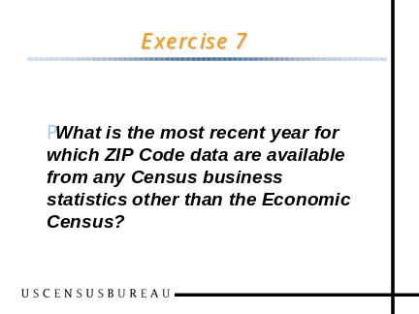 | What is the most recent year for which ZIP Code data are available from any OTHER Census Business statistics? [Goal: Be aware that there are more sources of business statistics than the Economic Census, and that they can be found through the “Business page”]  Select “Business” on www.census.gov  In the “Programs with National and Subnational Data” section, you can see that 2002 ZIP statistics are already available from the County Business Patterns program.
Slide 160 | 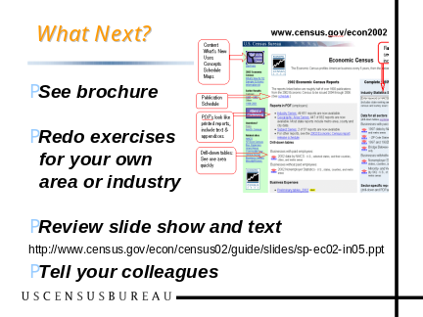 | →Hand out evaluation forms  →Hand out exercise answer sheets  So, now that we have exposed you to all of these new tools, how do you fix them in your mind?  First, we have designed a photocopied brochure that helps remind you of the features of the various web pages we looked through today. Once you get back to your office, review that first.  Then repeat the exercises we did this morning, but this time substituting the areas or industries that interest you. If you get bogged down, you can refer to the answer sheet and follow it step by step.  You also have access to our complete presentation today. The url on the screen has both the slides and the text that goes with them. You could even wow your colleagues by practicing and delivering this whole workshop on your own.  We do hope you will take the opportunity to pass on information you learned today to your colleagues.
Slide 161 |  | And when you have questions, you can contact us by phone or e-mail.  Please complete your evaluation form before you go. We would appreciate your comments to help us prepare for remaining workshops in this series.  Thanks you for your attention and interest.

