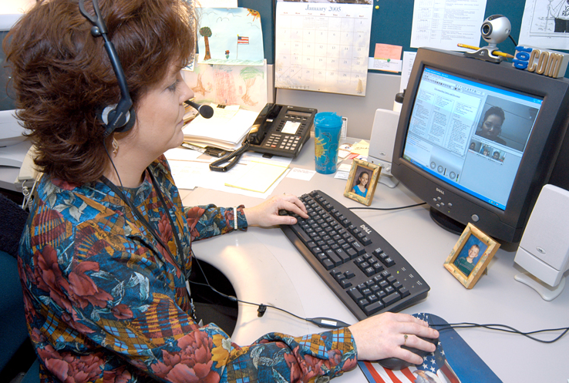
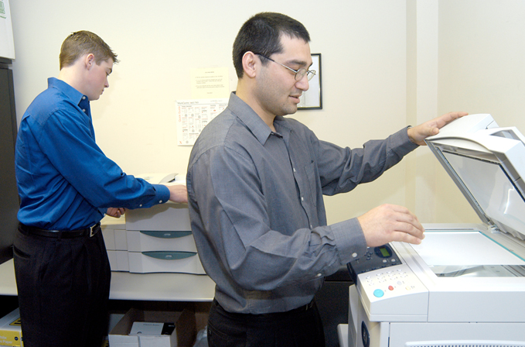
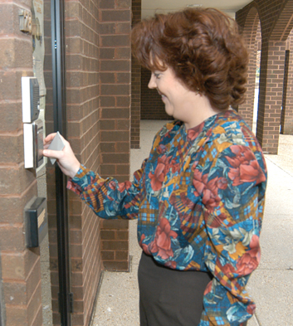
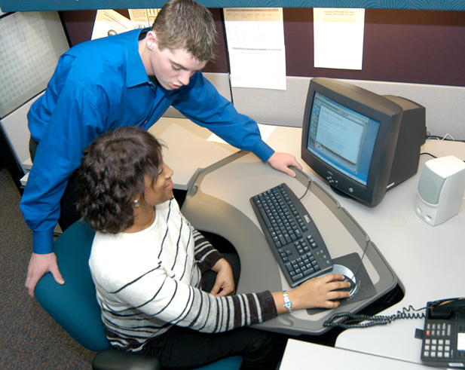

Telework Centers Can be a Convenient Option for You

A telework center is a multi-agency office facility, which is more geographically convenient to where employees live rather than where they may typically work.

Why Telework?  Save gas  Save time  Less traffic  Less stress  Healthier lifestyle  Improve job performance  Improve work/life balance  More family time  Employee retention | Why Use a Telework Center?  Convenient to home/community  Same accountability as other worksites  Professional environment  On-site technical support  High-speed Internet access  Fewer distractions  Well-equipped  Secure

Typical Telework Center Features
- Current computer technologies  - Secure server with back-up systems  - High speed internet connectivity  - E-mail and file transfer capabilities  - Standard office software  - Laser and color printers  - Digital phone systems with voicemail | - Fax, scanner, and copy equipment  - On-site technical support  - Lockable personal storage  - Kitchenette  - Conference rooms  (most with video/web conferencing)  - 24-hour secured client access  - Accessible to persons with disabilities

GSA Telework Centers Located in the
Greater Washington DC Metropolitan Area

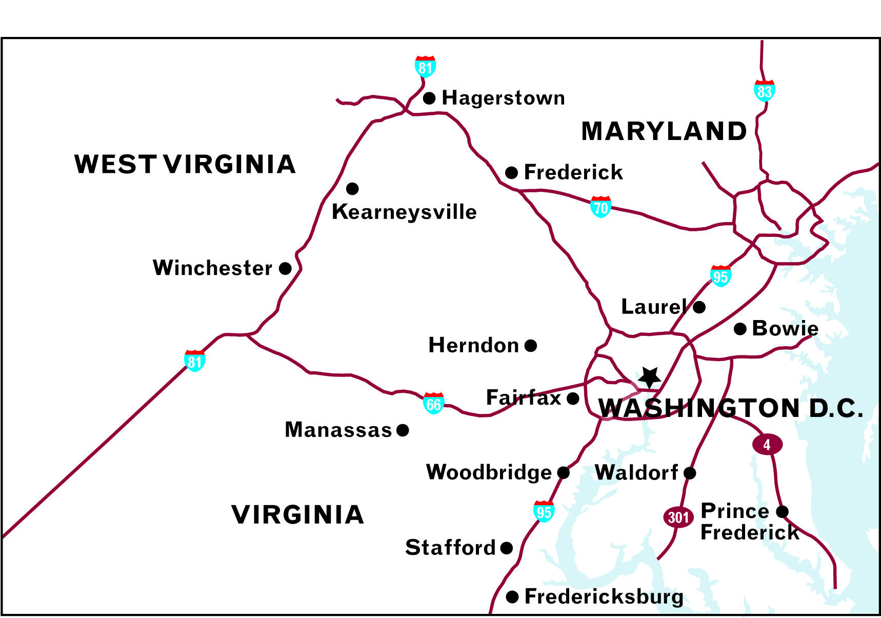 | Maryland  - Bowie  - Frederick  - Hagerstown  - Prince Frederick  - Waldorf  - Laurel  West Virginia  - Kearneysville | Virginia  - Fairfax  - Herndon  - Manassas  - Fredericksburg  - Stafford  - Woodbridge  - Winchester

Visit www.gsa.gov/teleworkcenters for more information.

4 Easy Steps to Register and Start Using a Telework Center
- Contact your agency Telework Coordinator (www.gsa.gov/teleworkcontacts) for any agency-specific guidelines or procedures.
- Select the Telework Center that is right for you (www.gsa.gov/teleworkcenters).
- Contact the Telework Center Director to determine availability and to obtain specific information about the center you select.
- Register through the Telework On-Line Billing System (TOLBS).

Coordinator’s Name
Telephone Number
Email Address

Website URL
Revised September 2007

