New User Registration/Reset Password Instructions

Access the CHRIS home page from GSA.GOV using the following URL: www.gsa.gov/CHRIS.

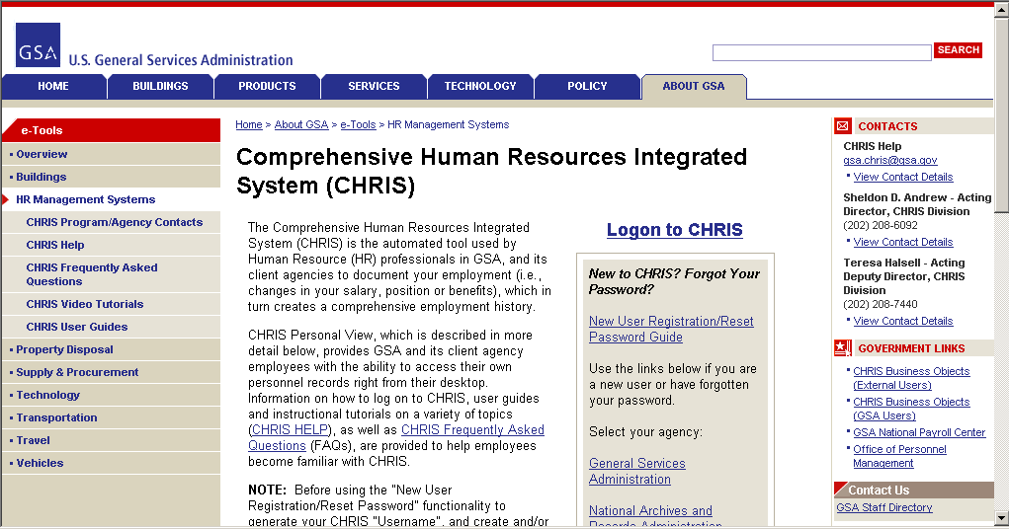

Select your agency from the list.

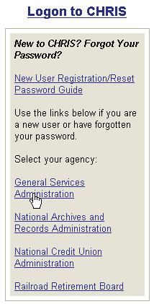

Read “carefully” the Warning, Privacy Act, Security and Rules of Behavior requirements. When you click the “Accept” button you are acknowledging that you understand and will comply with each requirement, as written.

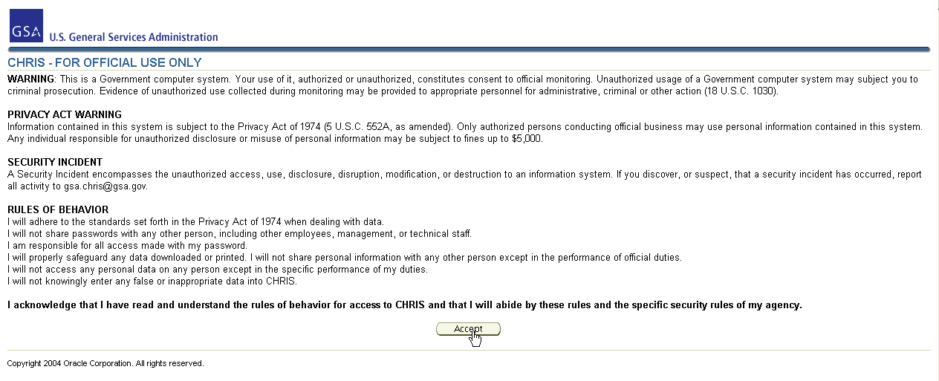

The CHRIS New User Registration/Reset Password window opens.

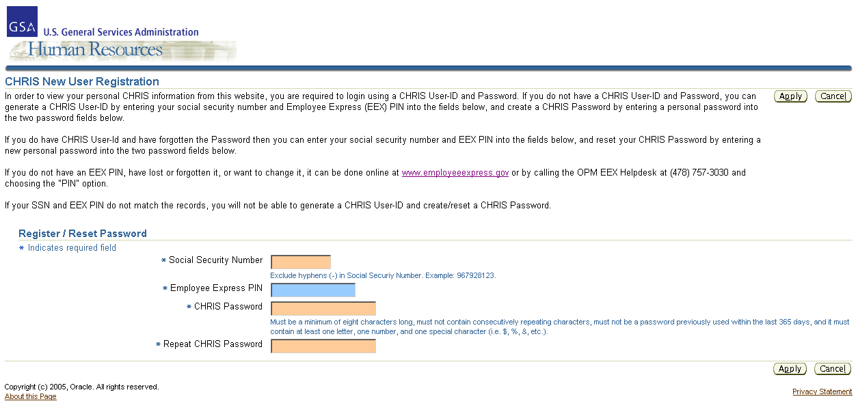

Enter your SSN (without dashes), your EEX PIN, and a CHRIS Password of your choosing. Click the “Apply” button.

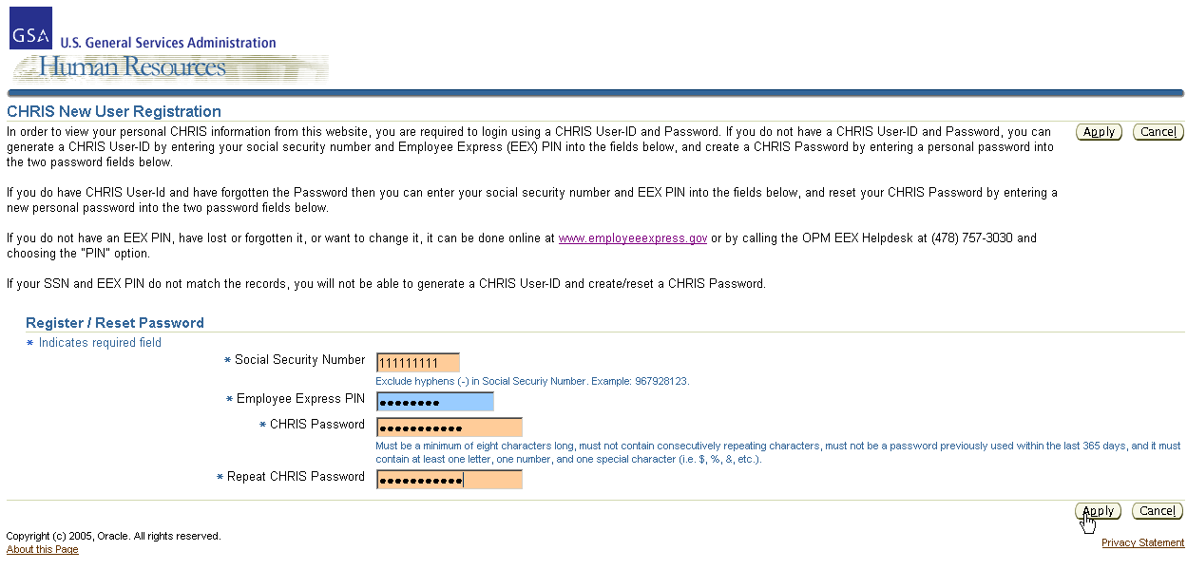

The CHRIS logon window opens, auto-populated with your CHRIS Username.

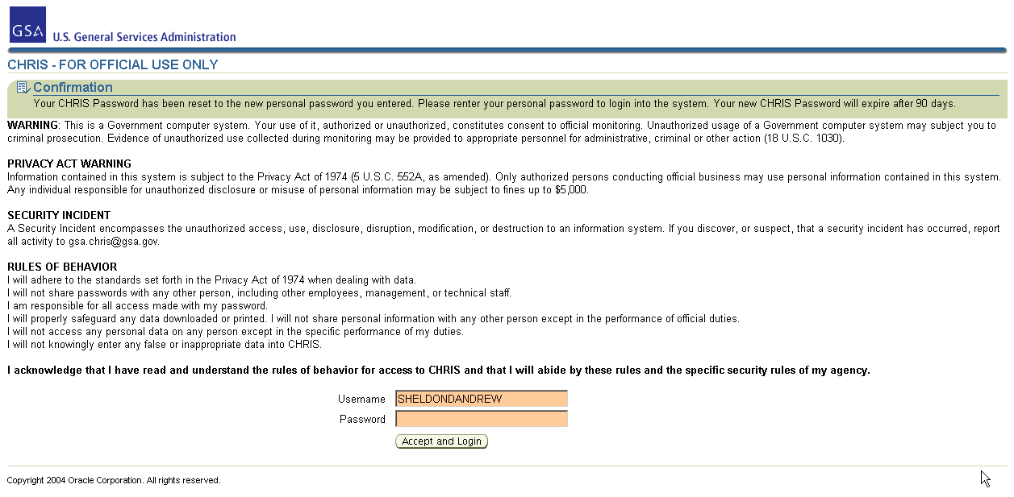

Enter your personal CHRIS Password, created in the preceding steps, into the Password field. When you click the “Accept and Logon” button you are acknowledging that you understand and will comply with each requirement, as written.

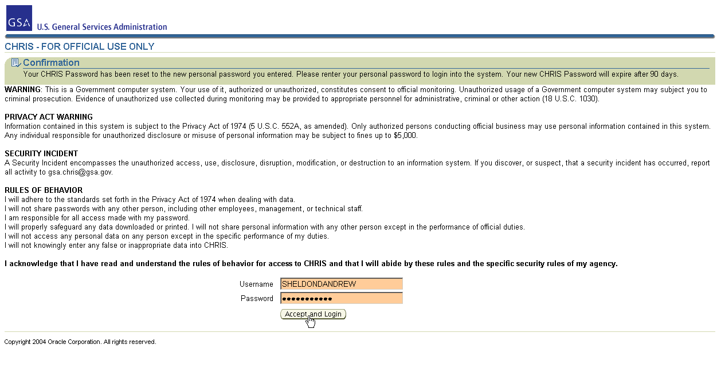

The Navigator window opens. Click on your Personal Self-Service responsibility.

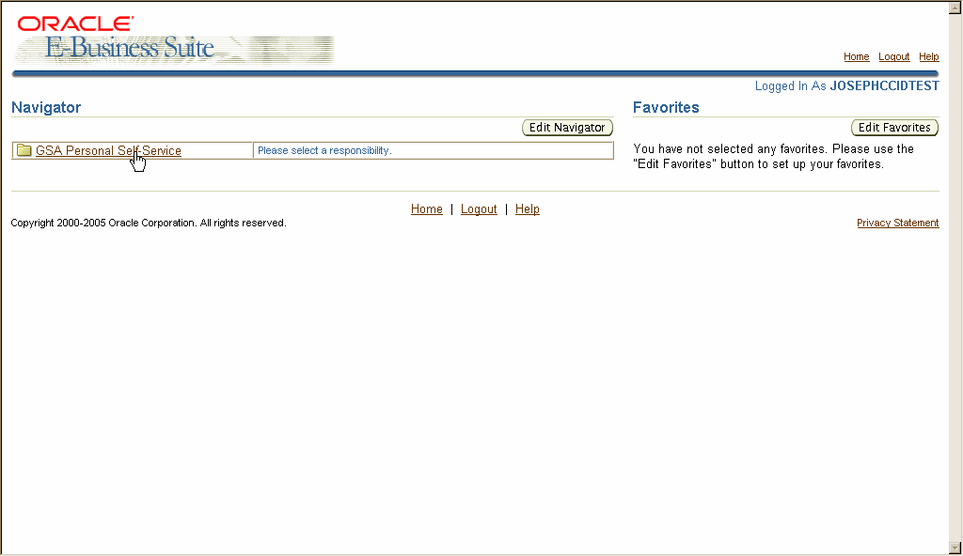

Click on Personal View to access your personnel data.

