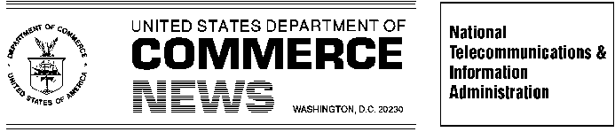
For Immediate Release Contact: Clyde Ensslin or Ranjit de Silva

July 12, 2005 202-482-7002

COMMERCE DEPARTMENT TO HOST JULY 20 PUBLIC MEETING
ON WIRELESS SECURITY THREATS AND SOLUTIONS

Commerce Officials Gallagher, Kneuer and Caprio Will Moderate Panel Discussions

The U.S. Commerce Department’s National Telecommunications and Information Administration (NTIA) will host a forum on July 20, 2005 to address security issues related to new mobile communications technologies including wireless Internet access, “smart” cell phones, and mesh networks.

“In today’s new high-speed, always-on world, wireless technologies play an ever larger role in the performance of the U.S. economy, job growth and our economic and national security,” said Michael D. Gallagher, Assistant Secretary of Commerce for Communications and Information. “This forum will not only help us understand the threats we face from computer viruses, spam, and data theft, but also shed light on a range of defenses against those threats.”

Panelists from the private sector and government will address vulnerabilities as well as a variety of solutions. Assistant Secretary of Commerce Michael D. Gallagher, Deputy Assistant Secretary John M.R. Kneuer, and Deputy Assistant Secretary and Chief Privacy Officer Daniel Caprio will serve as panel moderators. John Pescatore, Vice President of Internet Security for Gartner Research, will deliver an opening keynote address.

The meeting will have two panel discussions. The first panel will address security challenges in the new mobile world, including viruses and spam, interception of conversations or private information, and harmful signal interference. The second panel will discuss solutions, including industry-developed hardware and software solutions, the current state of security-related research and development, and educational and self-regulatory initiatives underway to protect wireless technologies from external threats. Exhibits of cutting-edge wireless security tools and solutions will be on display in the main lobby.

More information and a complete list of presenters is available on the NTIA Web site at
www. ntia.doc.gov. The July 20 meeting is open to the public and will be held from 9 am to 1:00 pm in the main auditorium of the U.S. Department of Commerce, 1401 Constitution Ave. N.W., Washington, D.C.
# # #

