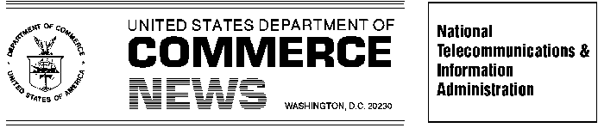
For Immediate Release Contact: Clyde Ensslin or Ranjit de Silva

February 8, 2005 202-482-7002

NTIA AND FCC LAUNCH ON-LINE REGISTRATION FOR HIGH-SPEED WIRELESS LINKS SHARING SPECTRUM IN THE 70-80-90 GHz BANDS

Response to President’s Call for More Efficient Use of Nation’s Airwaves

As part of the President’s initiative to streamline U.S. spectrum policy, fiber-speed wireless communications links in several spectrum bands may now be coordinated and approved for non-federal use in a matter of minutes. These extremely large “millimeter wave” bands were once used exclusively by the federal government and radio astronomers. Commercial users can now establish high-speed, point-to-point data links through a Web-based registration process first activated on Tuesday, February 8.

Federal users will use the same process to apply for and obtain frequency assignments in the 71-76 GHz, 81-86 GHz, 92-94 GHz, and 94.1-95 GHz bands. In terms of bandwidth, the bands span nearly thirteen GHz, which is at least five times larger than the aggregate amount of spectrum used by AM and FM radio, television broadcasters and cellular telephone carriers combined.

“President Bush called for a spectrum policy for the 21st Century. Today we take a concrete step to institutionalize innovation excellence in spectrum policy,” Assistant Secretary of Commerce Michael D. Gallagher said. “On-line registration of spectrum links is another way we are enabling non-federal users to get faster, easier access to spectrum, just as we have improved access for ultrawideband, advanced wireless services and unlicensed WiFi,” he said.

“The significance of today’s launch of a prototypic automated coordination mechanism for licensed systems cannot be overstated,” Gallagher said. “The technical experts at the Department of Defense and the Federal Communications Commission (FCC) deserve the credit for this breakthrough.”

Before now, applications in these bands could take months to be processed while the potential interference to government systems was assessed. Under the new system, non-federal users and third party database operators can determine whether a proposed high-speed point-to-point link could be operated without causing interference to government operations, and register the link immediately.

The public may access the automated system at the following url: http://FreqCoord.ntia.doc.gov. Applicants must have a Federal Communications Commission Registration Number (FRN) and license in order to file using the new Universal Licensing System (ULS). Applicants can obtain an FRN using the FCC Wireless Telecommunications Bureau web site at http://wireless.fcc.gov. and selecting CORES/Call Sign Registration from the right-hand menu under the heading of Licensing.
# # #

