

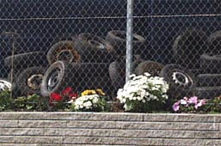

QUICKTAKE

Unlock Europe‘s Environmental Market!

Interested in Europe’s growing environmental markets? Take advantage of Quicktake, a new service now offered by the U.S. Commercial Service. Give us 10 business days, and nearly 30 environmental market specialists across Europe will quickly evaluate your product’s market potential.

Quicktake provides broad-ranging feedback on the following topics:

- Current Demand
- Future Demand
- Competition
- Need for Partner
- Local Tastes
- Technical Requirements

The data collected is based on telephone calls to contacts, off-the-shelf market research, and the specialists' market experience. In addition, Quicktake includes complete contact information for European environmental specialists, who can provide additional information or services on request.

Quicktake is available to export-ready U.S. companies with a high-quality product or service. The ideal Quicktake candidate is not yet doing business in Europe (or on limited bases), but has a serious interest in exploring the market.

Note:
Due to limited resources, Quicktakes can be performed only once every two weeks. Potential Quicktake clients will be screened in advance.

Fee: $750
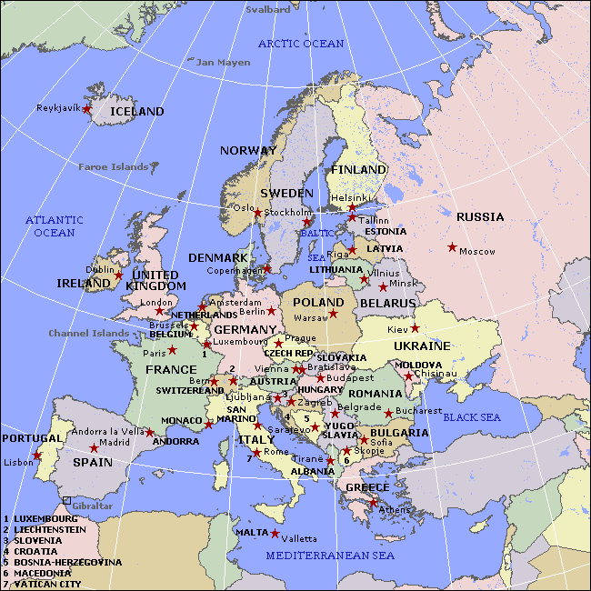

For more details please contact:
Ms. Veronika Novakova, Commercial Specialist
U.S. Commercial Service, American Embassy
Trziste 18, 118 01 Praha 1
Czech Republic
Tel: +420 257 531 162, ext. 2437
Fax: +420 257 531 165
Email : Veronika.novakova@mail.doc.gov

