

Stabilized Liquid Membrane Device (SLMD) for Passive,
Integrative Sampling of Bioavailable Metals in Water

The SLMD (patent no. 6,296,760) is a passive, integrative sampler that provides an alternative or complementary approach to conventional water sampling for trace metals. A water-insoluble organic complexing mixture diffuses in a controlled manner to the exterior surface of the sampler membrane (Figure 1), which provides for continuous sequestration of labile (bioavailable) forms of trace metals including cadmium (Cd), cobalt (Co), copper (Cu), nickel (Ni), lead (Pb), and zinc (Zn) for up to several weeks. In-situ deployment of SLMDs in both “bare” and “sheathed” configurations (Figure 2) provides for a passive, time-integrated analogue of unfiltered and filtered samples. The SLMD can also be utilized for in-laboratory preconcentration and speciation of labile trace metals from grab water samples.

Features:
- In-situ passive integrative sampling approach provides for the determination of the time-integrated dose of labile (bioavailable) metal species for periods of days to weeks.

- Preconcentration factors of up to several thousand for trace metals; selectivity factor ~100x relative to major cations (Ca, Mg. Na, K) – facilitates determinations at ultra-trace levels. Typical method quantitation limit (ICP-MS determination): 10 ng/L (0.01 ppb).

- Simple recovery (extraction w/ 20% HNO3) for analysis by ICPES, ICP-MS, or AA.

- Conveniently deployed with or without outer membranes or housings; sampler size is readily adaptable to specific applications.

- Applicable for either in-situ or in-laboratory (on grab samples) preconcentrative sampling for the determination of labile (bioavailable) metal species.

Fig. 1. Conceptualized diagram of metal ion sequestration by SLMD. 1 and 1’ are outer surfaces of polymeric membrane. 2 and 2’ are inner surfaces of membrane. 3 is the hydrophobic reagent mixture sealed inside the membrane. 4 and 4’ are the aqueous sampling media. R = alkyl group with 8 to 12 carbons, Ca⁺² = calcium ion, M⁺² = metal ion.
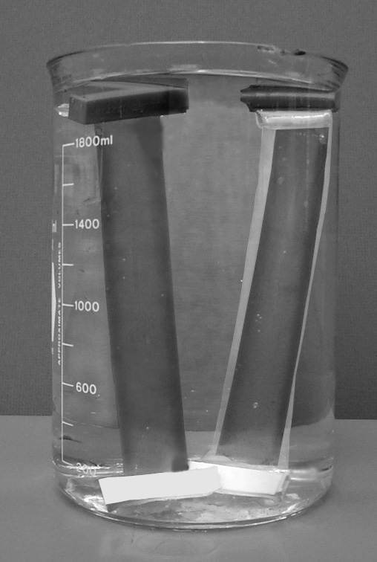

Fig. 2. Bare (left) and sheathed (right) SLMD samplers in 2-L water-filled beaker. Sheathed configuration is encased in 1000 MW cut-off cellulose dialysis tubing. Because the sampling rate is a function of SLMD surface area, the size of the SLMD can readily be adapted for specific applications. Individual SLMDs are typically deployed in 2.5-cm i.d., tubular PVC housings.
The SLMD is capable of quantitative removal of labile metal ions from natural waters. As illustrated in the figure below, nearly 100% of labile metal ions (20 to 200 ppb) were sampled by the SLMD from a 2-L water volume after 24 hr. This forms the basis for characterizing the lability of metal species in natural waters.
Fig. 3. Concentration of metal ions as a function of time in stirred water containing SLMD. (2-L water volume, pH 7.6, zinc = 200 ppb, all others = 20 ppb at time zero).
Continuous diffusion of the SLMD reagent to the outer surface of the membrane provides fresh complexing agent and linear uptake of metals for periods of days to weeks. The results of 9-day field sampling (grab vs. SLMD) for Cu and Ni are depicted in the figure below. SLMDs retrieved after 3, 5, and 9 days exhibited highly linear uptake of Cu and Ni despite considerable variation among grab samples collected over the same time interval.

Fig. 4. Concentration of Cu and Ni in filtered grab water samples plotted with mass recovered from SLMDs deployed for 3, 5, and 9 days in a stream affected by mining.

For fast-flowing waters, high sampling rates for bare SLMDs can result in large pre-concentration factors [metal]_{SLMD}/ [metal]_{water} . This is illustrated in Figure 4 where absolute SLMD concentration factors of up to 35,000 were measured for Pb after 4-day SLMD field exposures at five sites on a river impacted by metals mining. Furthermore, the Pb sampled by the SLMD correlated extremely well with the filtered water concentrations across sites.

Fig. 5. Concentration of Pb in filtered water plotted with mass of Pb recovered from SLMDs deployed for 4 days at 5 sites on a river impacted by mining.
Sampling of metal ions by the SLMD is limited primarily to labile species, which tend to be the most bioavailable. Laboratory-derived sampling rates for selected metals in a synthetic freshwater spiked with a mixture of metals at 20 ng/mL with or without either 0.1 mM citrate or EDTA are listed below. As indicated, SLMD sampling rates were not remarkably different in the presence of excess citrate ion, which forms relatively weak complexes. However, there was minimal uptake when excess EDTA was present, which forms very strong complexes with these metal ions.
SLMD sampling rate (L-equiv/day)
Treatment Cu Ni Zn Cd Pb
no ligand 3.9 4.3 3.6 2.0 3.3
0.1 mM citrate 3.3 1.7 2.7 2.4 2.0
0.1 mM EDTA 0.2 0.0 0.0 0.0 0.0

References:
Brumbaugh, W.G.; Petty, J.D.; Huckins, J.N.; Manahan, S.E. 2002. Stabilized liquid membrane device (SLMD) for the passive, integrative sampling of labile metals in water. Water, Air, & Soil Pollut. 133:109-119.

For more information contact:
Dr. William Brumbaugh or Dr. Jim Petty, USGS, Columbia Environmental Research Center, 4200 New Haven Rd, Columbia, MO 65201. 573-875-5399

