PHOTOS
LEED-Certified Building
Howard M. Metzenbaum U.S. Courthouse
201 Superior Ave., Cleveland, Ohio
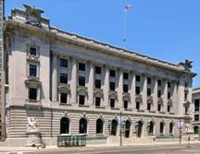 | 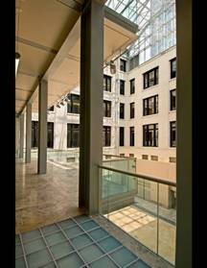 | 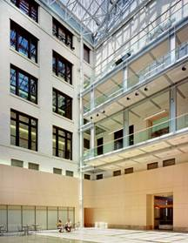
Status: Government-owned
Square-feet: 235,600
Date completed: June 2005
Cost: $44,600,000

Sustainable Site | - Brown field redevelopment through the abatement of hazardous materials previously located throughout the building  - Urban redevelopment is achieved in an area with a development density of 421,815-square-feet/acre  - 12 bicycle stalls and 4 showers are provided within 200 yards of the project for 190 occupants  - Alternative transportation is available in 6 bus lines within 1/4 mile of the project site  - 100% of parking spaces have been placed underground
Water Efficiency | - No planting has been added and no permanent irrigation system  - Over 32.4% reduction in water use
Energy & Atmosphere | - 15% energy reduction
Materials & Resources | - Maintained 95.49% of existing shell; 58.90% of interior elements  - Diverted 54.11% of construction waste  - 6.69% of total building materials by value contain recycled materials  - 24.4% local and regional materials manufactured regionally
Indoor Environmental Quality | - Carbon dioxide sensors monitor to outside ambient levels and increased ventilation if exceeding thresholds  - Low emitting adhesive, sealants and carpets were used
LEED-Certified Building
Shared Port-of-Entry
Sweet Grass, Montana / Coutts, Alberta, Canada

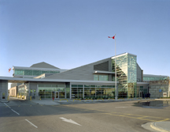 | 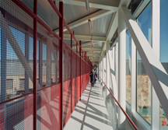 | 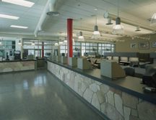
Status: Government-owned
Square-feet: 100,000
Date completed: September 2004
Cost: $26,500,000

Sustainable Site | - Brownfield redevelopment  - 100% of roof meets emissivity requirements and complies with Energy Star to reduce heat island effect  - Access to public transportation from both sides of the border  - Bicycle storage and shower/ changing rooms available for alternative transportation  - Alternative fueling stations provided for 3% of population  - Preferred parking for carpools and vanpools to serve 10% of occupants
Water Efficiency | - 21.8% reduction in water use through use of low-flow and water-efficient fixtures and appliances  - Landscaping uses native and adaptive vegetation and does not require not require permanent irrigation system  - No potable water use for irrigation
Energy & Atmosphere | - Green power purchased to meet 100% of the building’s electrical needs for more than two years
Materials & Resources | - Diverted 98% of construction waste, including soil  - 47% local and regional materials manufactured regionally  - 55% harvested ore extracted locally  - Occupant recycling
Indoor Environmental Quality | - Low emitting paints, carpet and composite woods were used  - Indoor pollutant source control  - Designed for thermal comfort compliance with ASHRAE 55–1992 for relative humidity and temperature  - 96% of all occupants have direct line of sight to views for all space occupied for critical visual tasks

LEED-Certified “Silver” Building
Department of Transportation Office Building
555 Zang St., Lakewood, Colorado

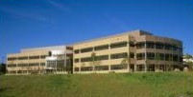 | 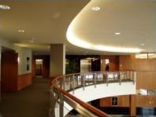
Status: Government-leased
Square-feet: 129,000
Date completed: June 2004
Cost: $17,600,000

Sustainable Site | - Local open space requirement was exceeded by over 25%  - High reflective roofing was used to reduce the heat island effect  - Public transportation access  - Electronic vehicle charging stations  - 22 carpool/vanpool spaces provided  - Bike racks, showers and changing rooms are provided
Water Efficiency | - More than 50% reduction in water consumption for irrigation
Energy & Atmosphere | - Heating, Ventilation, and Air Conditioning (HVAC) systems are free of HCFCs and halons  - Renewable energy purchases will offset 50% of the building’s electricity  for 2 years
Materials & Resources | - Over 76% of the construction waste was diverted from landfill  - 23% of the building materials contain recycled content  - 72% of building materials were locally manufactured  - 41% of building materials were locally harvested
Indoor Environmental Quality | - Low-emitting materials, adhesives and sealants were used  - Carpeting is certified as a low-emitting material  - Temperature and humidity monitoring  - 91% of the regularly occupied spaces receive natural light

LEED-Certified “Silver” Building
OSHA Salt Lake Technical Center
781 S 300 W. Salt Lake City, Utah

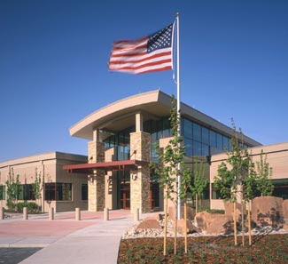 | 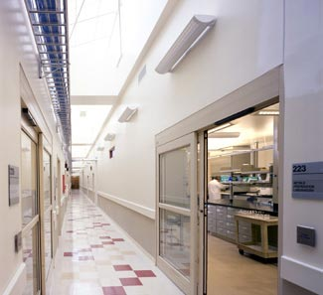
Status: Government-leased
Square-feet: 129,000
Date completed: February 2004
Cost: $14,000,000

Sustainable Site | - High albedo roofing materials to reduce heat island effect  - Alternative fueling stations provide for 3.33% of the occupants  - Bicycle storage, showers and changing rooms for 7.7% of occupants  - Close proximity to public transportation
Water Efficiency | - 52% reduction in use of potable water through non-irrigated landscaping  of native mixtures  - High-efficiency irrigation system provided for limited areas  - Use of low-flow and water-efficient fixtures and appliances
Energy & Atmosphere | - 47.1% energy reduction  - HCFC and halon free Heating Ventilation and Air Conditioning (HVAC) Plan for sub-metering water and energy usage  - Use of Variable Frequency Drives ( VFD) for optimization of energy use
Materials & Resources | - 50% of construction waste management diverted from landfill  - 29.1% locally-sourced materials  - Occupant recycling
Indoor Environmental Quality | - CO2 sensors monitor to outside ambient levels and increased  ventilation if exceeding thresholds  - Low-emitting adhesives, paints and carpets used
LEED-Certified “Gold” Building
Byron G. Rogers U.S. Courthouse
1823 Stout St., Denver, Colorado

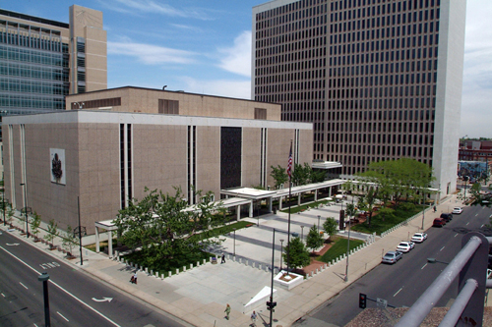 | 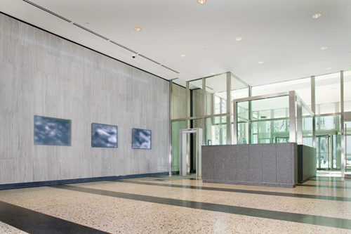 | 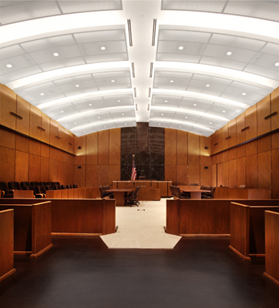
Status: Government-owned
Square-feet: 247,000
Date completed: 2008 (expected)
Cost: $52,300,000

Sustainable Site | - 53% open areas are vegetated  - 27% open areas are vegetated with planting native or adapted vegetation.  - 50% of the parking is underground  - 75% roofing materials in use are Energy Star labeled, with a minimum initial reflectance of 0.65, a minimum three year-aged reflectance of 0.5 and a minimum emissivity of 0.9  - A management plan for establishing/maintaining site and building exterior to reduce/manage impact of existing building on local environments and for establishing/maintaining a low impact site and building exterior chemical/fertilizer/pest management/snow removal program  - Located within an area with a density of at least 60,000 square feet of building floor space per acre (2-story downtown development).  - The building is within a ¼ mile of two established bus routes and is within ½ mile of a public rail station
Water Efficiency | - The building’s existing building water use is equal to or less than a calculated baseline use of 90% if the total building fixture count were outfitted with plumbing fixtures that meet the Energy Policy Act of 1992 fixture performance requirements
Energy & Atmosphere | - Comprehensive plans developed for operation of all building systems; documentation of repairs and upgrades; and retro-commissioning  - Energy performance achieved 87 Energy Star rating  - 100% green power  - CFC-free HVAC equipment

Byron G. Rogers U.S. Courthouse (continued)
Materials & Resources | - Procurement/management policies implemented to maintain reduced waste stream through purchasing strategies and collection station equipment and agreements, and occupant awareness notices  - Organizational policy specifying that all future purchases of mercury-containing light bulbs will be made in such a way that the annual average mercury content of the light bulbs is less than 90 picograms/lumen hour.  - Recycled-content material used  - Certified wood policy specifies inclusion of certified wood specification provisions for any construction materials used in the building or on the site.  - Occupant recycling
Indoor Environmental Quality | - Existing building outside-air ventilation introduction and distribution system allow the maximum capacity of outside air introduction into the building or 10 CFM/person and complies with EPA IAQ guidelines OR SMACNA IAQ guidelines for HVAC system maintenance to insure the proper operations and maintenance of HVAC components as they relate to IAQ and maintain the operation of all exhaust systems in existence in the building including bathroom, shower, kitchen, and parking exhaust system.  - Asbestos removal or encapsulation documentation provided  - CO2 sensors monitor to outside ambient levels and increased ventilation if exceeding thresholds  - Construction IAQ Management plan was in compliance with SMACNA guidelines, during construction, MERV 8 filters were installed at grilles  - Green housekeeping policy – entry way maintenance  - Green housekeeping policy – deck partitions for chemical mixing areas  - Green housekeeping policy – isolation of large volume copiers and printers  - Green housekeeping policy – low environmental impact cleaning fluid and housekeeping policy  - Green housekeeping policy - use of disposable paper products utilizing 100% recycled content and a minimum of 30% post-consumer recycled content and manufactured without the additional use of elemental chlorine or chlorine compounds  - Green housekeeping policy – low environmental impact pest management policy  - Thermal comfort monitoring system installed for relative humidity and temperature  - Documentation showing the ventilation system is in compliance with ASHRAE 62-99 for each space type specified  - No-smoking policy

LEED-Certified “Gold” Building

Wayne L. Morse Courthouse
211 E. 7th Ave., Eugene, Oregon

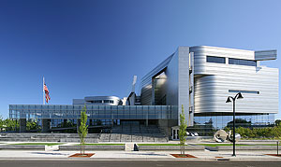 | 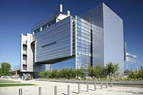 | 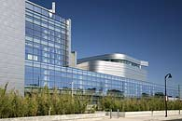
Status: Government-owned
Square-feet: 308,000
Date completed: December 2006
Cost: $52,300,000
Sustainable Site | - 71,537-square-feet of the site area (approx. 60% of the non-building area) has been planted with native or adaptive species  - Storm water runoff rate reduced by 31% and runoff quantity reduced by 26% from pre-development conditions  - Erosion and sedimentation control plan equal to or more stringent than the referenced EPA standard  - Open space provided adjacent to the building that is equal to the building footprint  - Located within an area with a density of at least 60,000 square feet of building floor space per acre (2-story downtown development)  - The building is within a 1/4 mile of two established bus routes and is within ½ mile of a public rail station.  - 50% of the on-site parking stalls are located underground  - Bicycle storage and shower/ changing rooms available for alternative transportation for occupants
Water Efficiency | - Water-efficient landscaping and irrigation systems reduce potable water consumption by 59% from a calculated baseline case  - 43.2% potable water use reduced from a calculated baseline design through the installation of waterless urinals, low flow restroom lavatories, low-flow urinals, and low-flow kitchen sinks

Wayne L. Morse Courthouse (continued)
Energy & Atmosphere | - Comprehensive plans developed for operation of all building systems; documentation of repairs and upgrades; and retro-commissioning  - Optimized energy performance - the project performs 38.39% better than ASHRAE 90.1-1999 requirements using the LEED ECB method  - Energy efficiency measures incorporated into the building design include high efficiency lighting with day lighting controls, under floor air distribution with radiant heating, high efficiency chillers with one heat recovery chiller, and high efficiency condensing boilers  - The project's resulting combined LCGWP and LCODP is 52.3.  - The project has purchased Renewable Energy Certificates (RECs), equal to 50% of the project's energy consumption, that meets the Green-E definition for renewable energy for a minimum two years
Materials & Resources | - 90% of on-site generated construction waste diverted from land fill  - 20% of the total building materials content, by value, have been manufactured using recycled materials  - 31% of the total building materials (by cost) have been manufactured within 500 miles of the project site  - 16% of the total building materials value (52.18% of the locally manufactured materials) have been manufactured using raw materials that were harvested, extracted, or recovered within 500 miles of the project site
Indoor Environmental Quality | - CO2 sensors monitor to outside ambient levels and increased ventilation if exceeding thresholds  - Low-emitting adhesives, sealants, paints, and carpets were used  - HVAC design complies with the recommended design approaches in ASHRAE 2001 Fundamentals Chapter 32, Space Air Diffusion  - Two-week flush-out period conducted prior to occupancy; construction IAQ  - Thermal comfort monitoring system installed for relative humidity and temperature

