Region 17: Philadelphia-Camden-Vineland, PA, NJ, DE, MD CSA

Geographic Boundaries, Political Jurisdictions, and Infrastructure

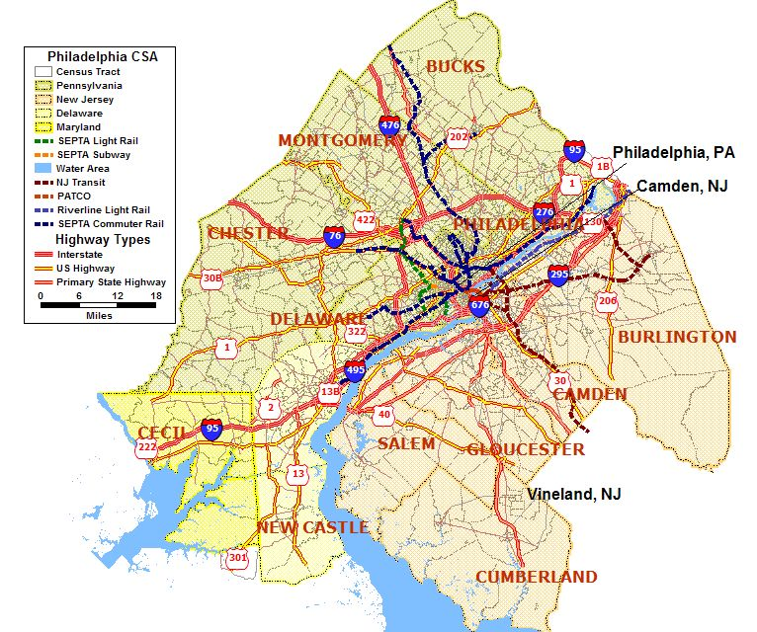
Chesapeake Bay

Delaware Bay

Delaware River

Schuylkill River
Map 17.1 Philadelphia-Camden-Vineland, PA-NJ-DE-MD CSA Major Highways, Fixed Guideway System, and Waterways

The Philadelphia-Camden-Vineland, PA-NJ-DE-MD CSA includes the 12 counties of Philadelphia, Montgomery, Delaware, Chester, Bucks, New Castle, Cecil, Burlington, Camden, Cumberland, Gloucester and Salem and covers approximately 5,201 square miles in four states. The total CSA population is 5,833,585. The 2000 U.S. Census data shows the population for the four states is 26,775,490 as follows: Pennsylvania - 12,281,054, New Jersey – 8,414,350, Delaware – 783,600, and Maryland – 5,296,486.

A number of major interstate, U.S., and state highways serve the Philadelphia CSA. The major east-west highways include Interstates 76, 276, 676 and highways 30, 422, and 40. The major north-south highways include Interstates 95, 195, 295, 495 and highways 1, 2, 13, 202, 206, 222, 301,and 322. Nearly all of the major interstates converge around the Philadelphia, PA and Camden, NJ central cities.

Southeastern Pennsylvania Transportation Authority (SEPTA), Port Authority Transit Corporation (PATCO), and New Jersey Transit Authority (NJTransit) are the three transit system operators providing fixed guideway service to the Philadelphia CSA. Pennsylvania and portions of New Jersey and Delaware are served by commuter rail operated by SEPTA. SEPTA also operates light rail and subway/elevated rail lines in the city of Philadelphia. PATCO operates a subway/elevated rail line through the cities of Philadelphia and Camden and east to several southern New Jersey suburbs. NJTA operates two commuter rail lines through the Camden and Burlington counties and a light rail line north along the Delaware River.

The Chesapeake Bay, Delaware Bay, Delaware River, and Schuylkill River are the four main bodies of water located in the Philadelphia CSA. The Delaware River, which starts in the Catskill Mountains of southeast New York and flows 280 miles southward along the New York–Pennsylvania border and the Pennsylvania–New Jersey border to northern Delaware, where it enters Delaware Bay. The Schuylkill River, a smaller river approximately 130 miles long flows from the Appalachian Mountains, which are northwest of Philadelphia, through the city and empties into the Delaware River. Cecil County, Maryland is bordered on one side by the Chesapeake Bay and Cumberland County, New Jersey is bordered by the Delaware Bay. Though not shown on the map, the Atlantic Ocean is approximately 90 miles east of the city of Philadelphia and less than 30 miles east of Vineland, NJ.

The climate in this region is temperate, given its proximity to the Atlantic Ocean. Summers are hot and often muggy. Winters are cold with variable snowfall.

Agencies Operating in the Philadelphia-Camden-Vineland, PA-NJ-DE-MD CSA

Agency | Jurisdictions Served | Population Served | Operating Budget | Staff Size
Pennsylvania Department of Transportation | Region VI- Bucks, Chester, Delaware, Montgomery, Philadelphia Counties | 3,849,647 | (a) | (a)
New Jersey Department of Transportation | Burlington, Camden, Cumberland, Gloucester, Salem Counties | 1,251,284 | (a) | (a)
Delaware Department of Transportation | New Castle County | 500,265 | (a) | (a)
Maryland Department of Transportation | Cecil County | 85,951 | (a) | (a)
Delaware Valley Regional Planning Commission | Bucks, Chester, Delaware, Montgomery, Philadelphia, Burlington, Camden, Gloucester Counties | 5,387,407 | 19,005,618 | 41
South Jersey Planning Organization | Salem County and Cumberland Counties | 64,285 | (a) | 140
Wilmington Area Planning Council | New Castle and Cecil Counties | 586,216 | (a) | (a)
Southeastern Pennsylvania Transportation Authority (SEPTA) | Pennsylvania: Bucks, Chester, Delaware, Montgomery, Philadelphia Counties, and portions of New Castle County, DE and Burlington County, NJ | 3,883,000 | 1,428,993 | 9,000
New Jersey Transit Corporation (NJTransit) | Philadelphia, Burlington, Camden, Gloucester and Salem | 2,768,834 | (a) | (a)
Delaware Transit Corporation (DART) | New Castle County | 817,491 | (a) | (a)
Port Authority Transit Corporation | City of Philadelphia and Camden County | 743,886 | (a) | (a)
- Information not available

Table 17.1 Philadelphia-Camden-Vineland, PA-NJ-DE-MD CSA Transportation Agencies

Transit Service Area: Fixed Guideway and Bus Service Area

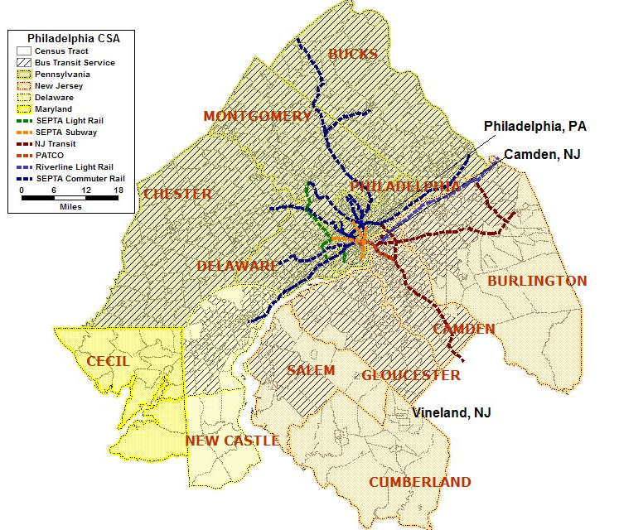
Map 17.2 Philadelphia-Camden-Vineland, PA-NJ-DE-MD CSA Transit Service Area

Southeastern Pennsylvania Transportation Authority (SEPTA), Port Authority Transit Corporation (PATCO), Delaware Transit Authority (DART), and New Jersey Transit Authority (NJTA) are the four transit system operators providing bus and fixed guideway service to the Philadelphia CSA.

- Southeastern Pennsylvania Transportation Authority (SEPTA) - SEPTA is the regional operator serving over 3.8 million people in the five counties of Pennsylvania and portions of New Jersey and Delaware. SEPTA operates bus, subway and elevated rail, commuter rail, and trolley service. SEPTA has the fifth largest transit system in the United States, with 280 active stations, over 450 miles of track, 2,295 revenue vehicles, and 196 routes. Average weekday ridership across the system is about 1,000,000 passengers.

- New Jersey Transit Corporation (NJ Transit) – NJ Transit is New Jersey’s statewide public transportation corporation providing bus, commuter rail and light rail services throughout New Jersey and three neighboring states. NJ Transit is the nation's third largest provider of bus, commuter rail and light rail transit, 240 bus routes, three light rail lines and 11 commuter rail lines. It has 162 commuter rail stations, 55 light rail stations and more than 17,000 bus stops linking major points in New Jersey, New York and Philadelphia. With a fleet of over 3,000 buses, 967 commuter rail vehicles, 144 locomotives and 72 light rail vehicles, NJT provides nearly 240 million passenger trips each year.

- Delaware Transit Corporation (DART) – DART, operated by the Delaware Transit Corporation, is a division of the Delaware Department of Transportation. It operates statewide multi-modal public and specialized transportation services. Service is operated with a fleet of 209 vehicles over 41 bus routes throughout, New Castle, Kent and Sussex Counties in Delaware. The annual ridership figure reported to the 2004 National Transit Database was 8,441,267.

- Port Authority Transit Corporation (PATCO) – The PATCO Speedline operates between the cities of Philadelphia and Camden and several southern New Jersey suburbs. The one line operates with a fleet of 121 rail cars over 31.5 miles stopping at 13 stations. The annual ridership reported in 2004 was 9,150,048.

Number and Proportion of Minority, Below Poverty, and Limited English Proficient Populations in Relation to the Transit Service Area

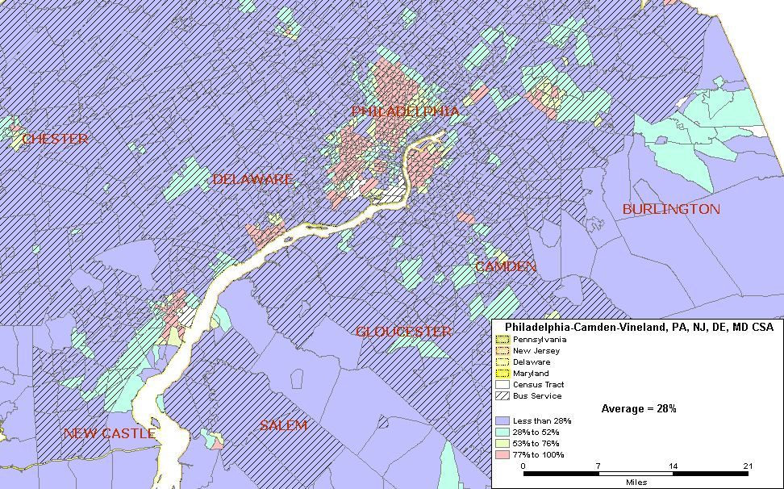
Philadelphia, PA
Camden,NJ
Map 17.3 Philadelphia, PA and Camden, NJ Minority Population
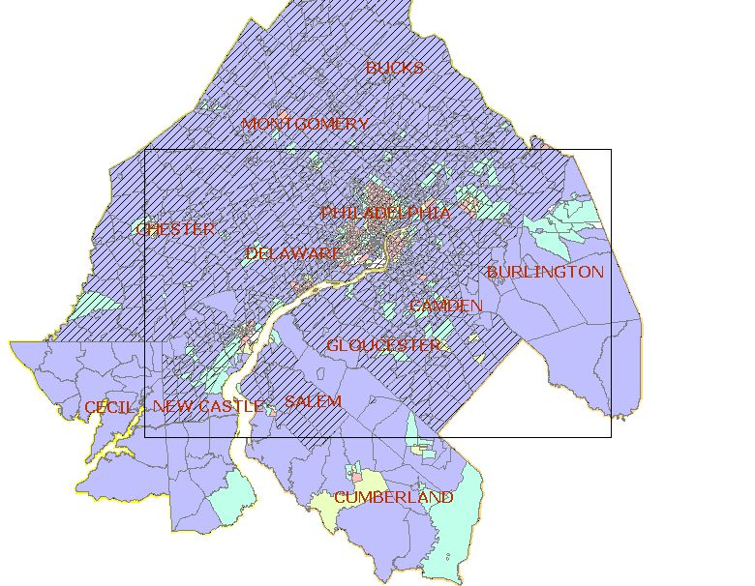
Vineland, NJ
Area of Detail

Philadelphia
Camden

Vineland

Total Number of Census Tracts in CSA 1,504
Total Population of CSA 5,883,585
Total Minority Population residing in CSA 1,610,875
Regional Average of Minority Population in the CSA 28%
Number (%) of Census Tracts with above average minority population 477 (32%)
Total Minority Population in the above average census tracts 1,217,290

Based on U.S. 2000 Census Data, the minority population on average is 28 percent of the total population in the Philadelphia-Camden-Vineland, PA-NJ-DE-MD CSA. Of the 1,504 census tracts in the CSA, 477 (32 percent) have a minority population above the regional average. As shown in the above map, census tracts located in the cities of Philadelphia and Camden contain the highest concentrations of minority population above the regional average. These areas have a combined total population of approximately 2,026,482, of which is approximately 36 percent of the total CSA population. Of the 1,517,550 total population living in Philadelphia County, 834,283 (55 percent) are minorities. Philadelphia County has 222 census tracts with above average percentages of minority populations and Camden has 45.

Approximately 437 census tracts with above average percentages of minority population are served by transit systems located in the CSA. The other 40 census tracts, located in parts of Burlington, Cumberland, and New Castle counties, have a minority population of 58,081 (41 percent of the 141,732 total population) and are not located within the CSA transit service areas. Six of these above average census tracts, with a total minority population of 12,744, are located in the city of Vineland, NJ.

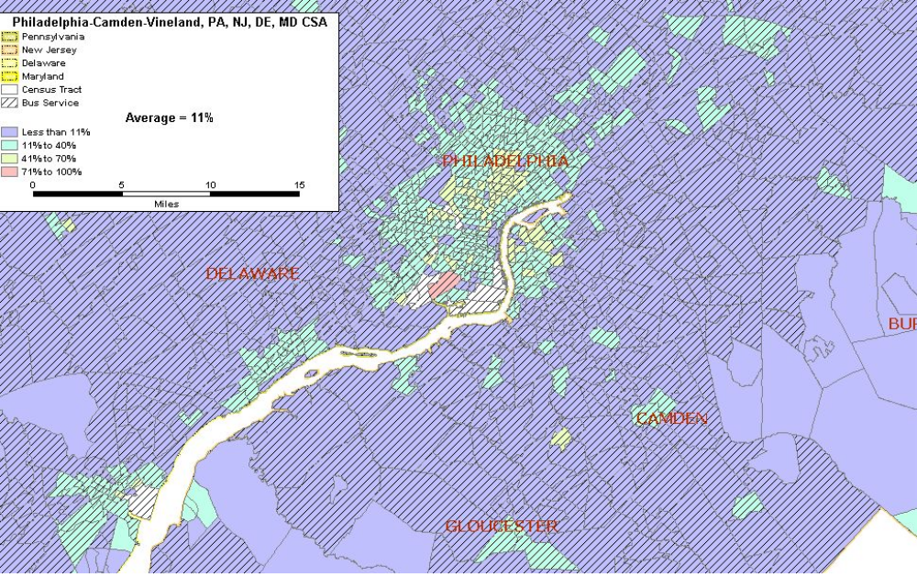Map 17.4 Philadelphia, PA and Camden, NJ Below Poverty Population
Philadelphia, PA
Camden, NJ

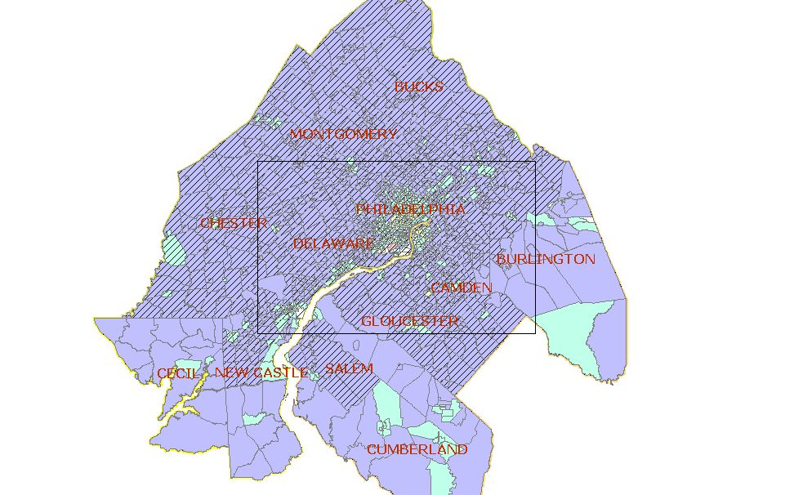
Vineland, NJ
Area of Detail
Philadelphia
Camden

Total Number of Census Tracts in CSA 1,504
Total Population of CSA 5,883,585
Total Below Poverty Population residing in CSA 619,316
Regional Average of Below Poverty Population in the CSA 11%
Number (%) of Census Tracts with above average Below Poverty pop. 441 (29%)
Total Below Poverty Population in the above average census tracts 432,074

The 2000 U.S. Census Data shows an average 11 percent of the total population is below poverty level in the Philadelphia-Camden-Vineland, PA-NJ-DE CSA. Of the 1,504 census tracts, 29 percent (441 census tracts) have an above average percentage of below poverty population. Approximately 300 of the 441 above average percentage census tracts are located in Philadelphia County. The city of Camden has 27 census tracts with above average percentages of below poverty persons. Out of the city’s 80,000 total population, approximately 28,000 (35 percent) of the total Camden population are below poverty level.

A total of 411 (93 percent) of the above average census tracts are located in the CSA transit service area. The other 30 above average census tracts, which have a combined total of 22,000 below poverty level persons, are located outside the transit service area. Five of these census tracts are located in the city of Vineland, NJ, which has a below poverty level population of over 6,500 (approximately 13 percent) of the 56,271 total population.

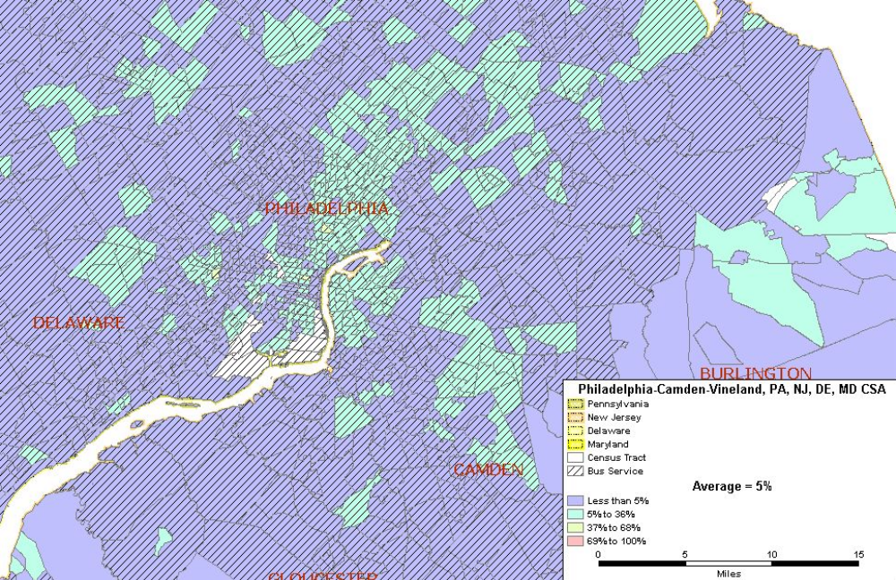
Philadelphia, PA
Camden, NJ
Map 17.5 Philadelphia, PA and Camden, NJ Limited English Proficient
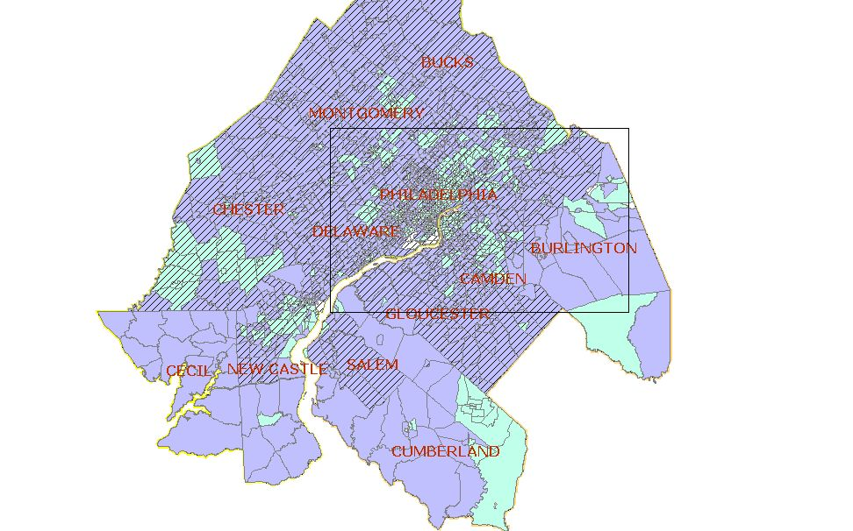
Area of Detail
Philadelphia
Camden
Vineland

Total Number of Census Tracts in CSA 1,504
Total Population of CSA 5,883,585
Total Population 5 years and older of CSA 5,455,406
Total LEP Population* residing in CSA 269,492
Regional Average of LEP Population* in the CSA 5%
Number (%) of Census Tracts with above average LEP population* 381 (25%)
Total LEP Population* in the above average census tracts 176,327
___________________
* LEP includes those 5 years of age and older

The limited English proficient (LEP) population in the Philadelphia-Camden-Vineland, PA-NJ-DE-MD CSA is approximately five percent. A total of 269,492 LEP persons live in the Philadelphia CSA. There are 381 census tracts (25 percent) located in the CSA with an above average percentage of LEP persons. Approximately 176,327 of the CSA’s LEP persons live in the 381 above average census tracts.

Over 200 census tracts (approximately 52 percent) with an above average percentage of LEP population are located in Philadelphia County. In Camden, there are 30 census tracts with an above average population of LEP. These tracts have a total of 16,400 LEP persons, which is approximately 21 percent of the total population. Over 90 percent (351 census tracts) of the census tracts with an above average LEP population are located within a transit service area. Approximately 30 census tracts located in the New Castle, DE, Burlington and Cumberland, NJ Counties with an LEP population above the regional average were located outside the transit service areas. Ten of these tracts are located in Vineland, NJ. Vineland has an above average percentage of LEP population of 15 percent, which are approximately 7,000 LEP persons.

Number and Proportion of Zero Car Households: Greater than the Regional Average

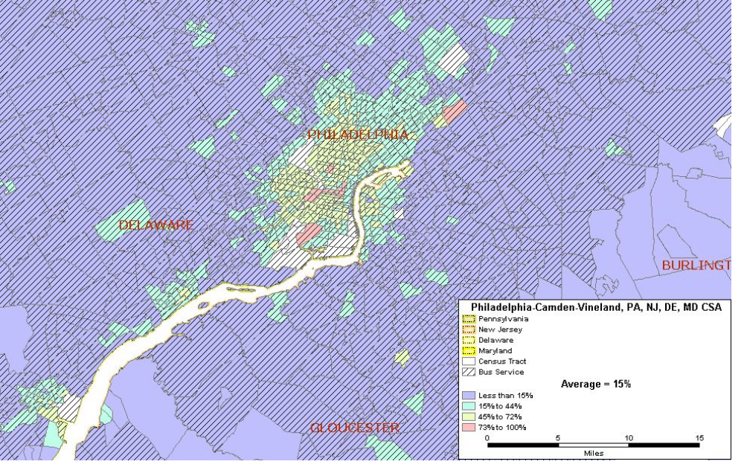Map 17.6 Philadelphia, PA and Camden, NJ Zero Car Households
Philadelphia, PA
Camden, NJ
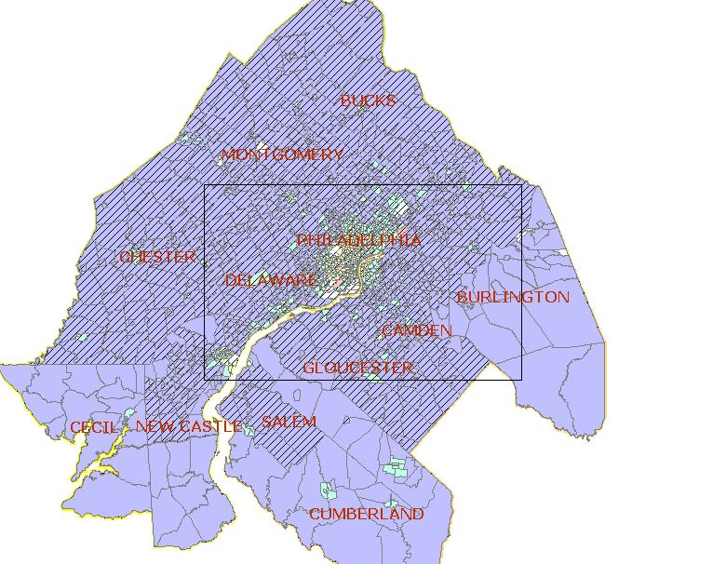
Vineland, NJ
Area of Detail
Philadelphia
Camden

Total Number of Census Tracts in CSA 1,504
Total Households in CSA 2,183,547
Total Zero Car Households in CSA 336,339
Regional Average of Zero Car Households in the CSA 15%
Number (%) of Census Tracts with above average Zero Car HHs 479 (32%)
Total Number of Zero Car Households in the above average census tracts 254,895

The average for households without vehicles is 15 percent of the total households located in the Philadelphia-Camden-Vineland, PA-NJ-DE-MD CSA. A total of 336,339 households in the CSA are households without vehicles. There are 479 census tracts (32 percent) with an above average percentage of zero car households. Approximately 254,895 of the CSA’s zero car households are located in the 479 (32 percent) above average census tracts. A total of 324 census tracts (68 percent) with an above average percentage of zero car households are located in Philadelphia County. Of the over 590,000 households located in Philadelphia County, 210,866 households (36 percent) are households without vehicles. The city of Camden has 24 census tracts with an above average percentage of households without vehicles. Of the 24,177 households located in Camden, approximately 9,000 (37 percent) are households without vehicles.

Over 97 percent of the census tracts with above average zero car households are located within the transit service area. Approximately 15 above average census tracts are located outside transit service areas in Cecil County, Maryland, Cumberland, Burlington, and Gloucester County, NJ, and New Castle, DE. Six of these census tracts are located in Vineland, NJ, which has a zero car household population of over 2,000 (10 percent) out of a total of 19,000 households.

Number and Proportion of Minority Population with overlay of Below Poverty Population

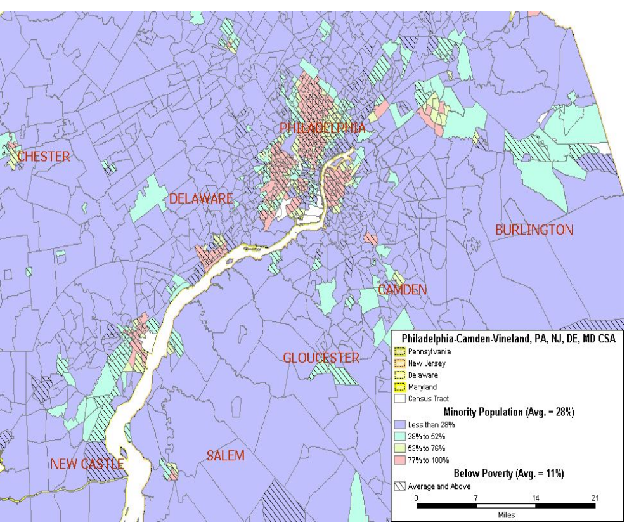Map 17.7A Philadelphia, PA-Camden, NJ Minority Population with an overlay of the Below Poverty Population
Philadelphia, PA
Camden, NJ
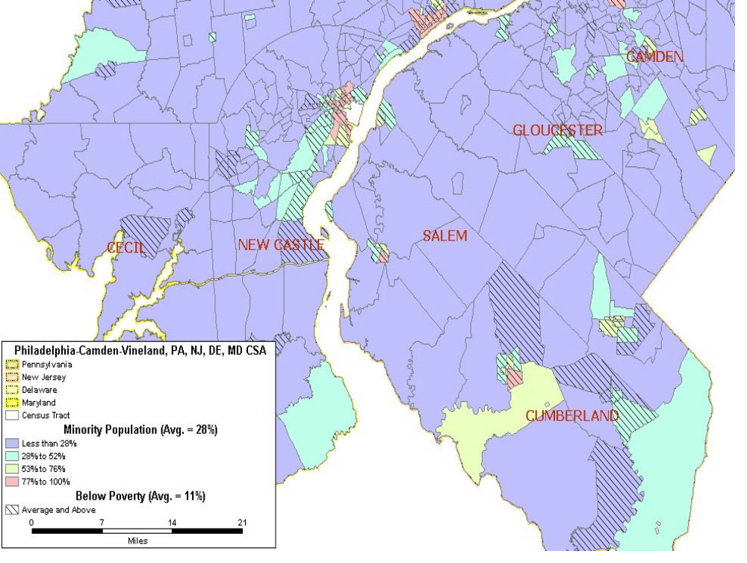Map 17.7B Vineland, NJ Minority Population with an overlay of the Below Poverty Population
Vineland, NJ

The maps above show the distribution of minority census tracts with an overlay of census tracts with above average below poverty populations. There are 369 census tracts (25 percent) in the Philadelphia CSA with an above average percentage of minority and below poverty populations. These census tracts have a total of 1,027,007 minority and 383,914 below poverty level persons. The areas of overlap occur mostly in Philadelphia County. There are 220 census tracts in Philadelphia County where the percentage of minority and below poverty statistics is above average.

Number and Proportion of Minority Population with overlay of Below Poverty Population and Zero Car Households

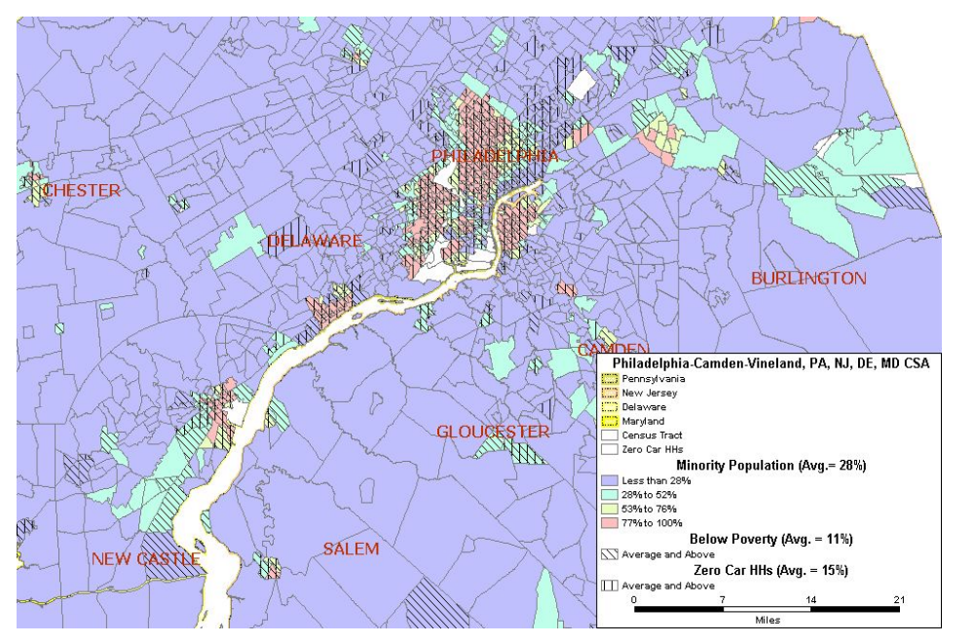Map 17.8 Philadelphia-Camden-Vineland, PA-NJ-DE-MD CSA Proportion of Minority Population with overlays of Below Poverty Population and Zero Car Households
Philadelphia, PA
Camden, NJ
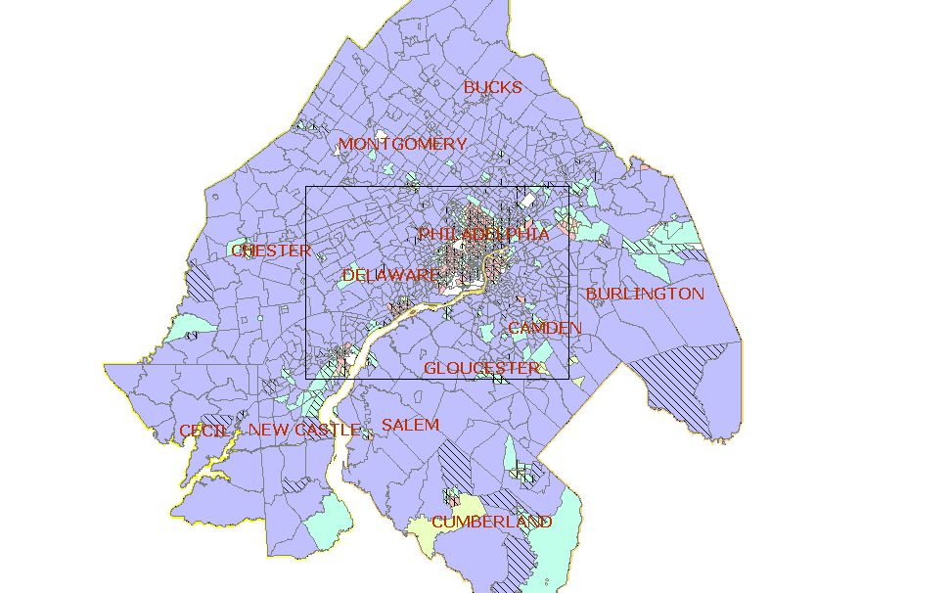
Vineland, NJ
Area of Detail
Philadelphia
Camden

The above maps show the minority population with overlays of the census tracts with higher than average below poverty populations and the census tracts with higher than average zero car households. There are 319 census tracts (21 percent) in the Philadelphia CSA that have above average percentages for all three statistics. A total of 211 of the above average combine statistic census tracts (66 percent) are located in Philadelphia County. The number of census tracts with above average minority, below poverty, and zero car household populations for the cities of Camden and Vineland are 21 and 4 respectively.

Correlation among Minority, Below Poverty, LEP Populations, and Zero Car Households

 | Minority | Below Poverty | LEP | Zero Car HH
Minority | 1.00
Below Poverty | 0.79 | 1.00
LEP | 0.44 | 0.61 | 1.00
Zero Car HH | 0.70 | 0.82 | 0.44 | 1.00

Table 17.2 Philadelphia-Camden-Vineland, PA-NJ-DE-MD CSA Correlation Coefficients

There is a strong positive correlation between zero car households and the below poverty population (0.82) of the Philadelphia CSA. Strong correlations are also observed between the minority population and the below poverty population and zero car households at 0.79 and 0.70 respectively. A moderate correlation coefficient of 0.61 exists between the LEP and Below Poverty populations. The limited English proficient population has no correlation to the minority and below poverty populations located in this CSA.

Natural Disasters

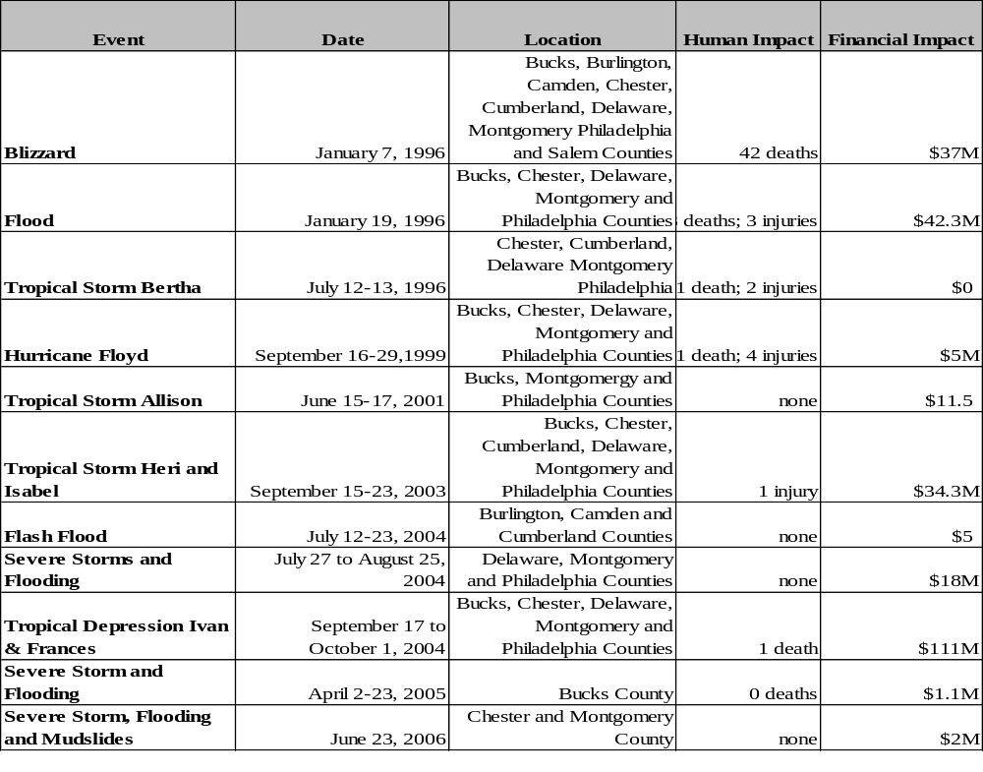The following table outlines the natural disasters that occurred in the Philadelphia-Camden-Vineland, PA-NJ-DE-MD CSA between 1986-2006.
Table 17.3: 20-Year History of Natural Disasters in the Philadelphia-Camden-Vineland, PA-NJ-DE-MD CSA (Source: FEMA and NOAA National Climatic Data Center)
Table 13.3: 20 Year History of Nautural Disasters in the Philadelphia-Camden-Wilmington, PA, NJ, DE CMSA (Source: Federal Emergency Management Agency (FEMA) and the National Environmental Satellite, Data, and Information Service (NESDIS))
Potential natural disasters most likely to impact this region as in the past would be attributable to the brutal winters in the form of ice storms and heavy snows and remnants of various tropical storms passing through the area. These storms may cause heavy flooding, which can result in high counts of human casualties and significant property damage. On a scale ranging from Moderate to High, to Very High Risk, the United States Geological Survey rates the states that comprise this region (PA, NJ, DE, MD) as having Moderate Risks of earthquakes.

Man-made Disasters

A review of information available through state and federal sources did not indicate that there have been man-made disasters in the last 20 years.
The focal point of the Philadelphia-Camden-Vineland, PA-NJ-DE-MD CSA is the City of Philadelphia. Once the capital of the United States, it is now still a major hub for corporate businesses, government and transportation. Philadelphia's economy is heavily based upon manufacturing, refining, food, and financial services. The city is home to many major Fortune 500 companies, including cable television and internet provider Comcast, insurance companies CIGNA and Lincoln Financial Group, energy company Sunoco, food services company Aramark, Crown Holdings Incorporated, Rohm and Haas Company, the pharmaceutical company GlaxoSmithKline, Boeing helicopters division, and automotive parts retailer Pep Boys. The federal government plays a large role in Philadelphia as well. It is home to the United States Mint and one of the 10 Federal Reserve Banks. As discussed above the region is also home to many critical inter-and intra-city transportation infrastructure systems.
High profile sites in the region include the Philadelphia Airport, serving both national and international flights; historical sites such as Independence National Historical Park, Independence Hall, the Liberty Bell, the homes and resting places for historical figures such as Betsy Ross, Benjamin Franklin, etc.; universities; the Philadelphia Stock Exchange; and pharmaceutical and energy companies. As such, there is potential for certain man-made disasters whether by accident or by intention. These include petroleum and chemical leaks or spills and industrial sabotage to manufacturing plants, and infrastructure. The 2005 data from the U.S. Department of Transportation on Hazardous Material Safety shows the states included in this region (PA, NJ, MD, DE) accounted for 10 percent of the hazardous materials incidents and three percent of related deaths for the year.

