Table of Contents

Introduction 4

Module I – Overview 5
Summary 5
Training Session Goal 5
SHARE Network Background 6
North Dakota (SHARE Network) 7
North Dakota Successes 7
Brevard County, FL (Access Points) 8
Brevard County, FL Successes 8
Module I Activity 9
Module I Review 10

Module II – SHARE Network Resource Directory 11
Summary 11
Workforce Development Partners 11
Access and Features 12
Sample SHARE Network Home Page 13
Search by County 14
Basic Search 15
Advanced Search 16
Definitions 17
Search Results 18
Sort Options 18
Search Exercise 19
SHARE Network Member Agreement 20
Your State’s Membership Requirements 20
Add A New Resource – Application 21
Application Details 23
My Virtual Office 24
Initiating A Referral 26
Completing A Referral 27
Contacting Venture CD 29
Resource Directory Staff 29
Setting Goals 30
Website Statistics 30
Website Links for Other States’ SHARE Network Resource Directories 32
Module II Review 33
Module III – SHARE Network Access Points 34

Mission Statement 34
Access Points Definition 34
Community Access 35
What Access Points Need and Do 35
Key Partners and Roles 36
Introduction Review 36
Partnering with Integrity 37
SHARE Network Access Points: Who Does What? 38
Measuring Success 39
SMART Goals 39
Building Relationships 40
Access Points Basics Review 41

Module IV – Outreach 42

Summary 42
Defining Outreach 42
Step 1: Purpose of Outreach 43
Step 2: Defining the Product 44
Step 3: Target Audience 45
Step 4: Outreach Messages 46
Step 5: Outreach Tools 48
Outreach Project Plan 49
Finding Outreach & Marketing Material Templates 49
How to Engage a Network of Providers as Seed Members 50
Module IV Review 51

Training Summary 52

Recap 52
Goals and Agreement 52

Appendix 53

Please Note: Some of these documents are samples of what has been used by other states. You may need to adjust language to fit your needs.

Comparison of SHARE Network Resource Directory & Access Points 54
Organization Chart for a Typical Access Point 55
Partnering With Integrity 56
MOU - Memorandum of Understanding (Samples) 70
Basic Training for Access Points 73
Access Points: The Customer Experience 74
Customer Outcome Tracking Tool 75
Customer Satisfaction 76
Job Placement Form 77
Service Types 78
SHARE Network Marketing Materials 84
Common “Network of Providers” 85
Project Plan (Blank) 86
Project Plan to Launch the Resource Directory 87
Project Plan to Open Access Points 89
Project Plan for Outreach 91
Outreach Matrix (Blank) 92
Outreach Matrix (Sample) 93
Introduction

Match the quote on the left with the source of the quote on the right.

Quote |  | Source
Recall the face of the poorest and the weakest man whom you may have seen and ask yourself if the step you contemplate is going to be of any use to him. |  | Mother Teresa
There are eight levels of justice each greater than the next. The greatest level, above which there is no other, is to strengthen the name of another… by giving him a present or loan, or making a partnership with him, or finding him a job in order to strengthen his hand until he needs no longer [beg from] people. |  | Herman Melville
May my desire be for dealings fair and straight, and may my heart only delight in doing good to others, to the best of my abilities all the days of my life! |  | Shri Jugal Kishor Mukhtyarji (Indian teacher)
Make us worthy, Lord, to serve our fellow men throughout the world who live and die in poverty and hunger. |  | Dr. Martin Luther King, Jr.
Anything we can do to help foster  the intellect and spirit and emotional growth of our fellow human beings, that is our job. |  | Albert Einstein
If you want to be perfect, go, sell your possessions and give to the poor, and you will have treasure in heaven. |  | Rabbi Moshe Ben Maimon (Also known as Maimonides or Rambam)
Everybody can be great because anybody can serve. You don’t need a college degree to serve. You only need a heart full of grace… a soul generated by love. |  | Ohenton Kariwahtekwen - Iroquois thanksgiving address
Today we have gathered and we see that the cycles of life continue. We have been given the duty to live in balance and harmony with each other and all living things. So now, we bring our minds together as one as we give greetings and thanks to each other as people. |  | Fred Rogers (Mr. Rogers)
Only a life lived for others is a life worthwhile. |  | Mahatma Gandhi
We cannot live for ourselves alone. Our lives are connected by a thousand invisible threads, and along these sympathetic fibers, our actions run as causes and return to us as results. |  | Jesus of Nazareth
Module I: Overview

Sharing How Access to Resources Empowers

Summary

This module provides an introduction to the SHARE Network. The session goals and objectives will be outlined and the SHARE Network’s background and current successes will be reviewed.

Training Session Goal

The objectives of this training session are as follows:

- Each team member will gain a solid understanding of the two elements of the SHARE Network: the Resource Directory, and Access Points;

- Working together, the team will develop a plan to adapt SHARE Network to your State, and understand the steps required to implement it successfully;

- Each team member will be able to navigate your state’s SHARE Network Resource Directory website, and be committed to its’ use;

- Each team member will know how to identify, recruit, train and equip successful and sustainable Access Points; and

- Each team member will gain a basic understanding of marketing principles as they apply to this program; and will be able to apply them to implement your SHARE Network.

SHARE Network Background

The roots of the SHARE Network began when President George W. Bush created the White House Office of Faith-Based and Community Initiatives in January 2001. The Office was tasked with leading a “determined attack” on need by strengthening and expanding the role of faith-based and community organizations in addressing the nation’s social problems and promoting effective public/private partnerships. The Office was thereby mandated to identify and eliminate improper Federal barriers to the full participation of faith-based and community-service programs in the provision of social services.

To achieve this goal, the President has also created parallel centers in eleven federal departments that operate human services programs:

- Labor
- Education
- Health and Human Services
- Justice
- Housing and Urban Development
- Homeland Security
- U.S. Agency for International Development
- Veteran’s Affairs
- Small Business Administration
- Agriculture
- Commerce

Within the U.S. Department of Labor, the Center for Faith-Based and Community initiatives focuses on empowering faith-based and community organizations that help their neighbors enter, succeed and thrive in the workforce.

In 2002, the U.S. Department of Labor (USDOL) sent out a national grant announcement for States and intermediary organizations with three key objectives:

- To increase the number of faith-based and community-based organizations (FBCOs) serving as committed and active partners in the One-Stop Delivery System;

- To expand the access of faith- and community-based organizations’ clients and customers to the services offered by the nation’s One-Stop Career Centers; and

- To identify, document, showcase and replicate successful instances of faith- and community-based involvement in our system building.

North Dakota (SHARE Network)

After a competitive process, North Dakota won a grant from the U.S. Department of Labor. In its grant application, Job Service North Dakota committed to conduct a statewide outreach effort to increase the participation of FBCOs in the delivery of One-Stop services by Workforce Investment Act (WIA) partners.

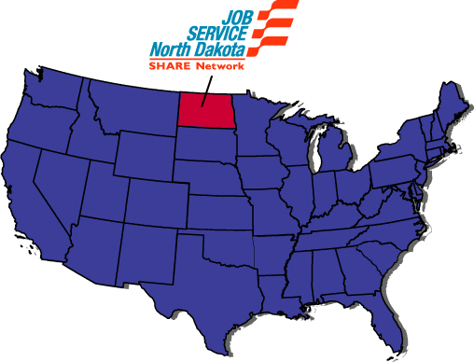

North Dakota Successes

- Added over 85 services
- Partnerships with over 560 providers
- Increased awareness of One-Stop system over 100%
- Gained support of Workforce Investment Board
- Fully integrated into on-going service delivery system
- Won two National awards
Brevard County, FL (Access Points)

In addition to the State grants, in 2002 DOL offered Grants to large non-profit organizations who could work with a network of smaller non-profit organizations. United Way of Brevard County, on Florida’s east central coast, was one of 9 Intermediaries awarded. The charge: Build the capacity of FBCOs to connect effectively with the One-Stop Delivery System.

United Way partnered with the Brevard Workforce Development Board to create 20 “Mini-Job Links” in economically challenged neighborhoods. Two were located in CBOs, and 18 in FBOs.

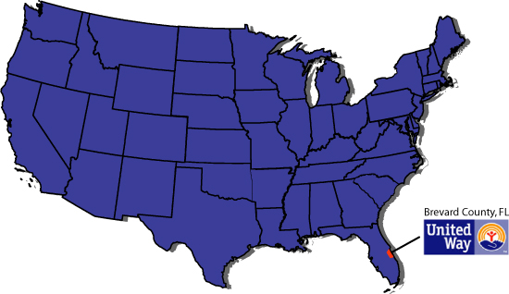

Brevard County, FL Successes

- 95% increase in FBCO participation in One-Stop system
- 43 new direct or indirect Access Points
- 2,903 customers served in one year
- Brevard WDB moved from 14th to 1st in FL
- BWDB won $50K Kirkpatrick Innovation Award
- Gained national recognition

Module 1 – Activity
- Define “faith-based organization:”

- Define “community-based organization:”

- Name an example of a faith-based organization in your community:

- Name an example of a community-based organization in your community:

Module I Review

List two successful projects out of the Department of Labor 2002 Demonstration Grants and three examples of successes that you can see applying to your state.

Project Name: |  | Project Name:
Successes |  | Successes
1. |  | 1.
2. |  | 2.
3. |  | 3.

* Information on how to use the SHARE Network Resource Directory online, and its benefits to you and your customers, will be covered in the next module.

Module II: SHARE Network Website

Summary

The Resource Directory is designed not only to meet the needs of your customers, partners and One-Stop frontline staff, but also to serve as a resource to you – to help you do your job more comprehensively and efficiently.

At the end of this module, you will be able to:

- Describe the SHARE Network Resource Directory to both partners and customers;

- Describe how the SHARE Network Resource Directory will benefit customers; and

- Navigate the SHARE Network Website.

Workforce Development Partners

SHARE Network is a unique partnership working together to help jobseekers transition to self-sufficiency.

Workforce development partners include:

- One-Stop Career Centers

- Workforce development partners

- Faith-based organizations

- Community organizations

- Businesses; and

- Government agencies
Access and Features

For the general user the site can be used to:

- Search for services by state, city, county, or zip code

- Search by service name or service type

- Get service provider information such as address, hours of operation, services offered, telephone number and point of contact.

- Access a map to the service provider

In addition to the features available to the general user, members can use the site to:

- Refer clients and keep a record of clients referred

- Advertise and easily update their agency’s information online

SAMPLE SHARE Network Home Page

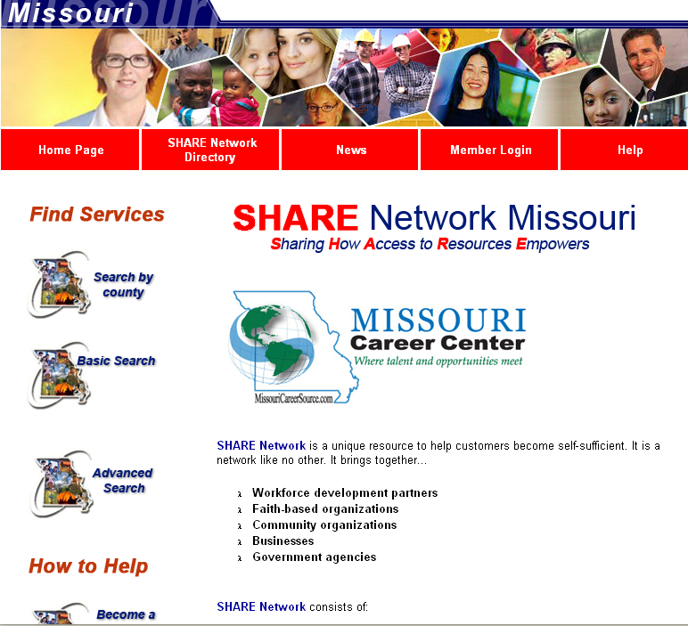

On the left hand side of the page are the links to the major components of the site, which will be used by most users. They include:

- Search by county: This link will take the user to a county map of your state where they can select their county and find the resource available.
- Basic and Advanced Search: These links will take the user to the entire directory of the state and allow them to search the directory based on various criteria.
- Become a SHARE Network member: This link leads providers through the process to join the resource directory.

Below your state’s title may be links to other pages or sites. This is an optional feature.
- Home Page: Link that will bring you back to this page.
- SHARE Network Directory: Links you to the actual directory for your state.
- Login: Allows members to login and have access to additional features.
Search by County

By selecting a county, a listing of services in that county will be listed.

Below the map you will see an additional toolbar with links to the following:

- Search Directory: Will show all service providers and give search options.
- Join SHARE Network: Allows organizations to join the network and become members.
- Service Descriptions: Provides a general description of all the services listed.
- Make Referral: Allows individuals to make a referral of a client to a provider.

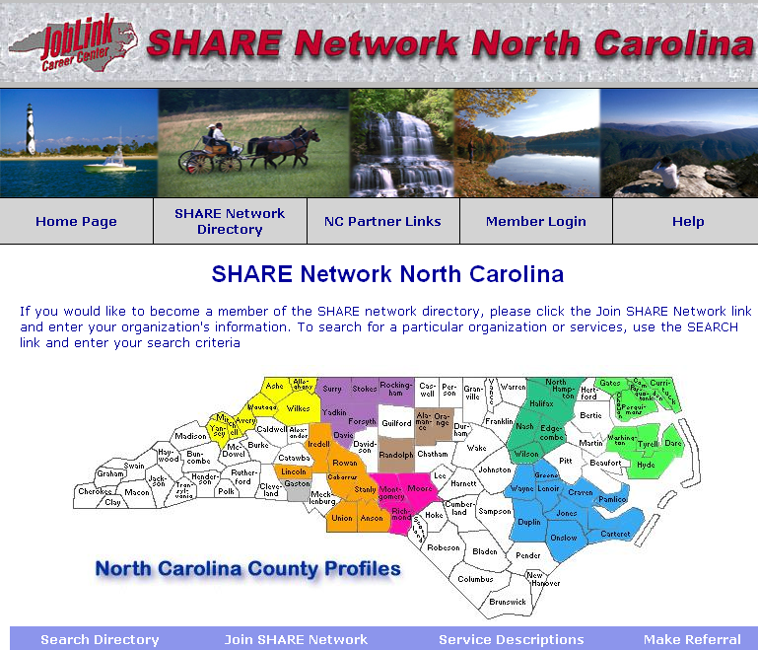

Basic Search

The Basic Search asks the user two questions:

- Where are you located? The user can then select the State, City or County.
- What service(s) do you need? The user can then enter information in the textbox or select from drop-down menu that lists all service categories.

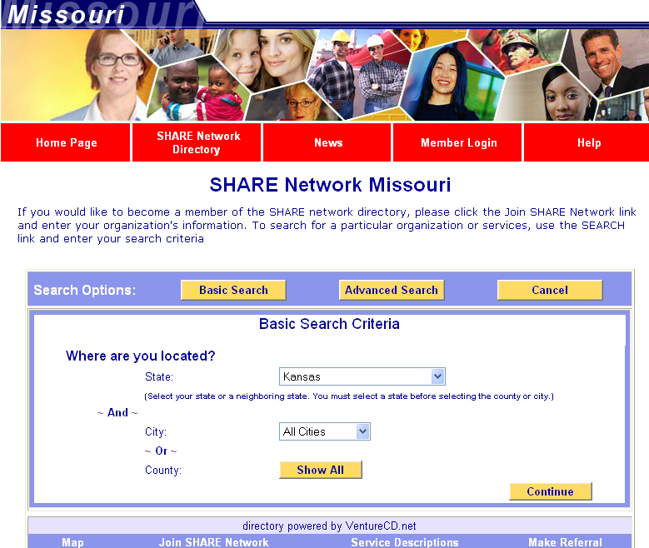
Advanced Search

In the Advanced Search, the user can select many different criteria simultaneously on the Advanced Search page. However, the user is not required to use all of these search criteria before beginning the search; the user can select only the relevant criteria.

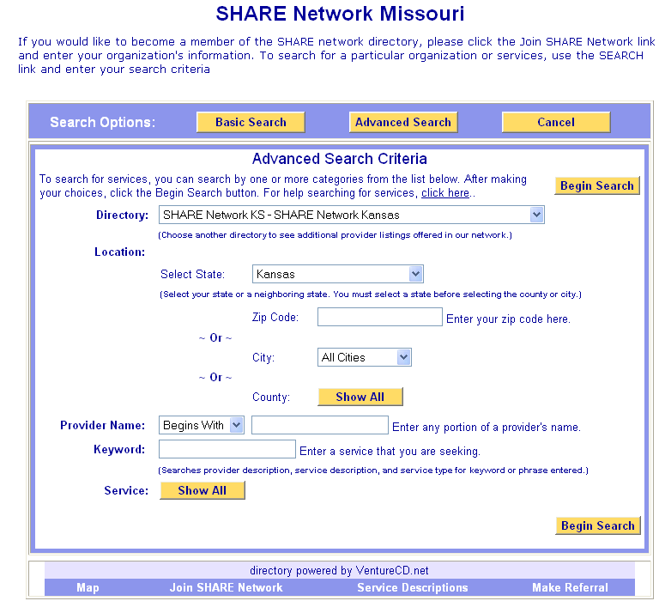
Definitions:

Directory: This will allow you to go to other state’s directories and utilize a pull down menu. This would probably not be used on a regular basis by most users.

State: This provides a pull-down menu of all states. This would be used primarily by users who are located near the border of multiple states. Your state may include services that are actually located in neighboring states.

Zip Code: This option allows the user to provide the zip code. This is useful if the user knows where a service is located but cannot remember the name. This is not always a good way to find services in the area, since some zip code areas are very small or a user may be close to other zip code areas.

City: This provides a pull-down menu of all of your state’s cities. You may select only one at a time. Note: it is very important to consistently and correctly spell the names of cities, as every version will be listed.

County: If you select the yellow “Show All” button, you will see a listing of your state’s counties. You may select more than one county at a time.

Provider Name: There are two boxes to use here. The first gives you two options: “Begins with” or “Contains.” Choose whichever is appropriate. Then, in the second box, put the part of the provider name that you know.

Keyword: Searches provider description, service description, and service type for keyword or phrase entered.

Service Types: This is the list of all the services listed in the state’s Resource Directory. Multiple services can be chosen for a single search. A list of service types is located in the back of your Team Member Manual.

After you have selected your search criteria, select the yellow “Search” button for the search to be performed. Remember that you can always select the button beside any provider to get their detailed contact information.

At the top of this section in the text you will see “for help searching for service, click here.” This will provide assistance in understanding this feature.

Search Results
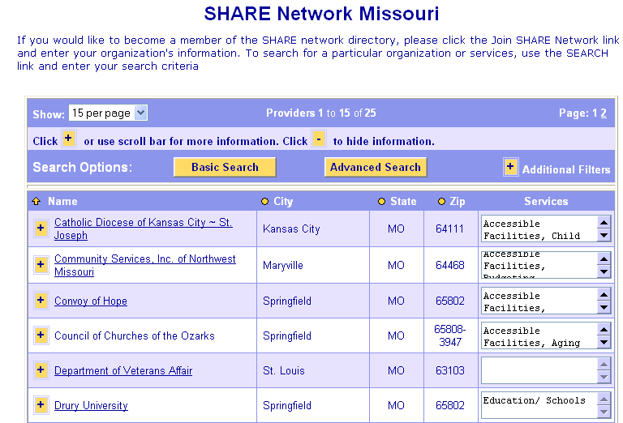

The icon indicates that something is hidden. Clicking this icon will expand the information visible on the page. Selecting the icon will then collapse the expanded information on the page.

When you select next to the Organization Name, a box will expand to provide the following detailed information:

- Address
- Phone
- Fax
- E-mail
- Contact Person
- Hours of Operations
- Description

Sort Options
You can also select the icon above any of the columns (Name, City, State, or Zipcode); the Resource Directory will be sorted by the criteria of that column.

By selecting the or icon, the sort will change from ascending to descending or visa versa.
If the user uses the sign beside “Additional Filters,” the user has the opportunity to sort by A-Z, AB, CD, etc. By selecting any of these items, the listing will be sorted accordingly. Therefore, by selecting the “CD” option, only those providers with names starting with the letters C or D will show. To get the entire listing for the county back, simple select the “A-Z” option.

Search Exercise

List the method or methods you would use to find the information you desire.

Information You Have | Search Method to Use
You have the address of a service provider that you like, but you can’t remember the name of the provider.

You know your client needs Adult Day Care, Job Search Assistance, Child Care. Your client can only use public transportation.

You read about a service provider that is doing remarkable work; however, you can only remember that their name had “St. Mary’s” in it. You don’t remember where they are located either.

Name two situations where you have partial information and need to find an appropriate service provider.

Information You Have | Search Method to Use
SHARE Network Member Agreement (Generic)
- Our description is up-to-date and accurate. The contact listed on the website is willing and able to speak with other non-profits and FBCOs and referred customers.
- Our inclusion in the network indicates that we are willing to accept more clientele and customers. If at any point we do not want referrals, we will change our profile to list “No services available at this time” and not list the services which we normally offer. This will ensure that other organizations will not make referrals to us until we are ready to receive more customers.
- We will update or confirm our contact/description information on a quarterly basis at minimum.
- We will use SHARE Network interactive online system for referrals and will promote each other's programs and services to better serve our customers.
- We understand that if we offer a service which is regulated by the state (such as childcare), we must list our qualification/certification as issued by the state and we will be removed from SHARE Network if the state has taken away our certification.
- We understand that our organization will be removed from the system if multiple SHARE Network members indicate that our service description is deceptive and/or seriously inaccurate or there is significant evidence that our organization poses a threat to well-being of customers.

Your State’s Resource Directory Membership Requirements:

Add a New Resource - Application

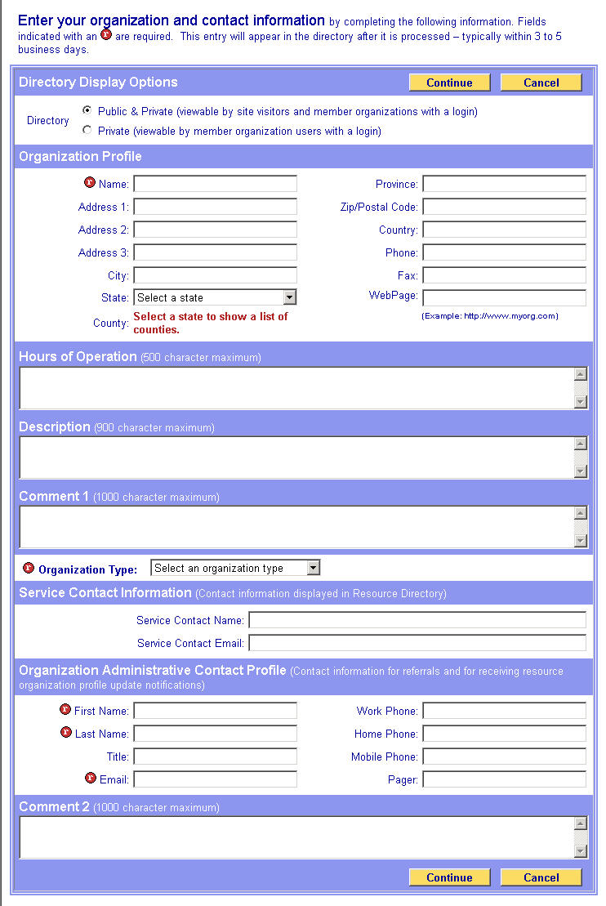
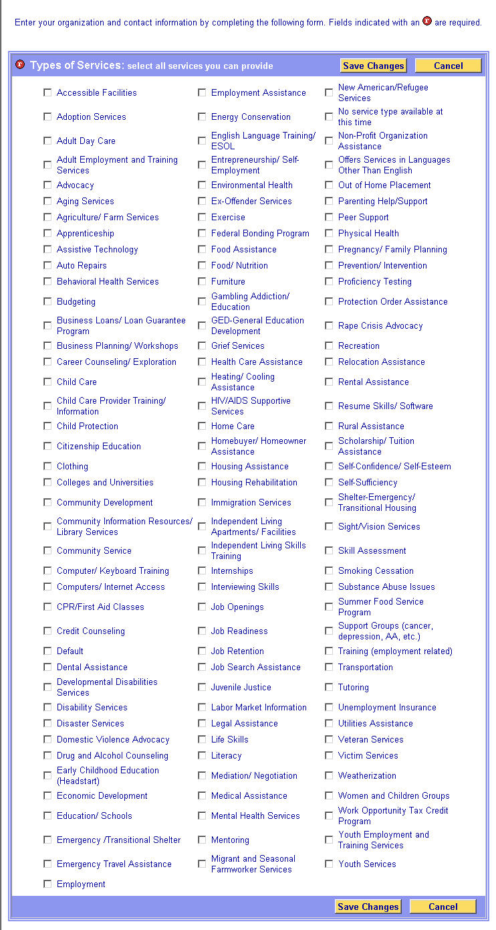
Application Details

Directory Display Options
- The Public & Private (viewable by site visitors and member organizations with a login)
- The Private Directory (viewable by member organizations with a login)

Organizational Profile. The Name is required, and the city, state, zip and county entries can be configured as required.

Hours of Operation.

Description. This can be any description that you would like to be visible to users.

Comment One. This field may be defined by your state or it is for the organizations’ use, such as eligibility, languages, etc. The name of this can be changed in the Resource Directory Configuration Options page.

Organization Type. This is a required field and they must choose one of the following options:

- College
- Community Based Organization
- Community College
- Faith Based Organization
- Government Service Provider
- Individual
- One-Stop Career Center
- SHARE Network Access Point
- University

The choices of organization types displayed in this section are configurable in the Organization Types page selected from the Resource Directory main page.

Service Contact Information. This section includes fields to enter the contact name and email address, and is the contact information displayed in the Resource Directory.

Organization Administrative Contact Profile. Contact information for referrals and for receiving Resource Directory organization profile update notifications.

Types of Services Offered - choose all services you can provide. The applicant will simply select any or all that apply. It is important for them to remember that when a user does a search by services only those organizations that have that service selected will be included in that search. All of the service types will be listed.

Once the application is complete, the applicant will select either of the yellow “Submit” buttons located at the top and bottom of the application. The application will then be sent to the state for processing.
My Virtual Office

When you become a member of the Resource Directory, you will be given a login and password that provides you with additional features. After you log in you will be taken to a screen called “My Virtual Office.” This screen will provide information on any referrals that you have received. In addition, you will have an additional tool bar to the left of your screen giving you fast accessibility to these additional features.

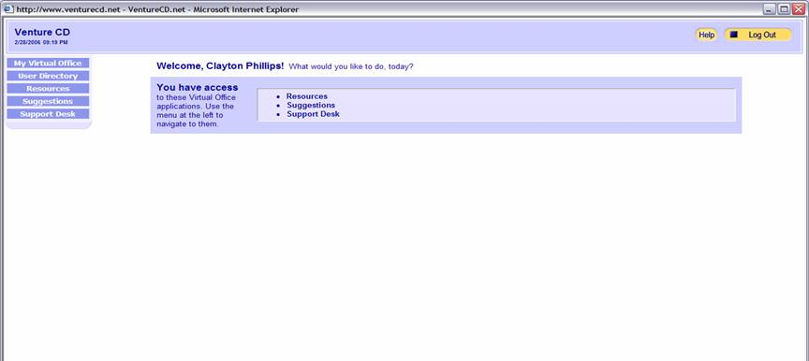

- My Virtual Office: This will return you to the opening page of “My Virtual Office.”

- User Directory:

Update Your Profile – Note: This is not the profile that appears in the Resource Directory. This is your profile viewable only to administrators of the Resource Directory.

Change Your Password

- Resources:

Resource Directory: This takes you to the SHARE Network Resource Directory. Referrals made from the Resource Directory are not tracked unless the option is selected in the Configuration options.

Update Your Profile: This is the profile that appears in the Resource Directory. This allows you to add or change services available by your organization. This will take you to the application that we reviewed previously. However, your information will be filled in and you are able to make any changes that you need.

Refer Client: This takes you directly to the screen to refer clients. It is the same screen that we reviewed earlier. Referrals are tracked here no matter what the configuration option chosen.

- Suggestions: There are two subcategories, allowing you to make suggestions regarding the website and view past suggestions made.

- Support Desk: This will walk you through a series of questions to get help with website issues.

Initiating a Referral – There are two ways to initiate a referral.

1. The first way is by selecting the “Referral” button next to the provider’s information after selecting the icon next to a service provider’s name.

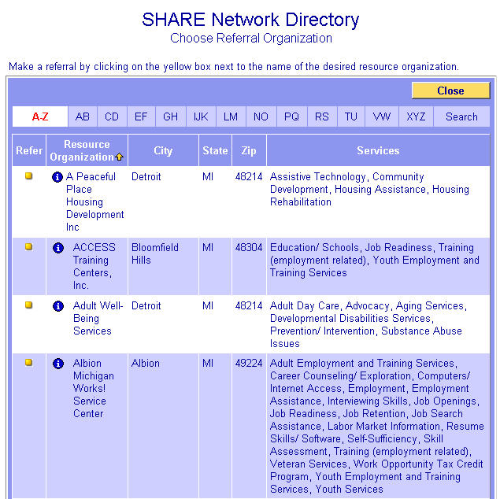

2. The second way to initiate a Referral is by selecting the “Make Referral” button at the bottom of the screen.

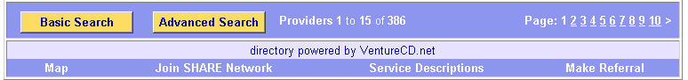

Completing a Referral

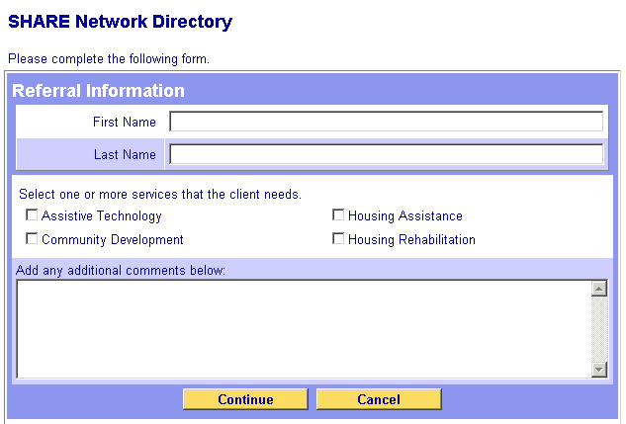

Then,

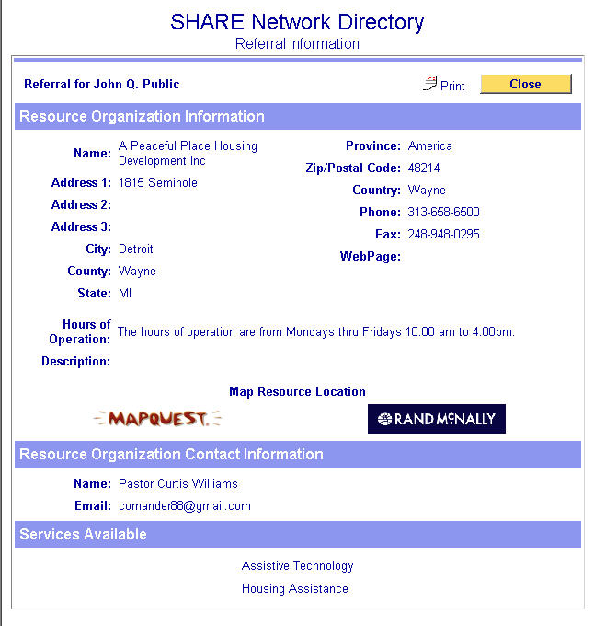

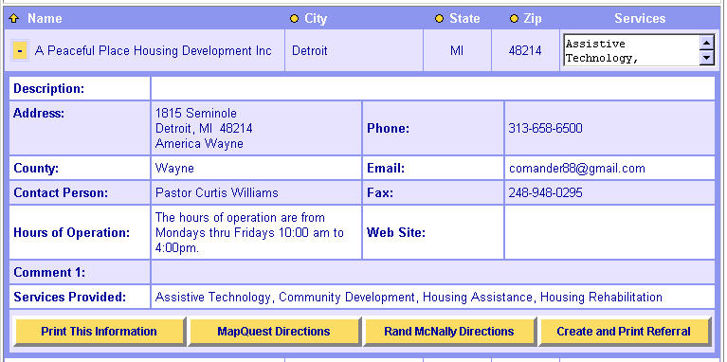

Contacting VentureCD
Training@VentureCD.net
Support@VentureCD.net

Resource Directory Staff:

Organization Administrator
- Adds users and grants rights to all applications
- Manages all applications
- Sets configuration options

Resource Directory Manager(s)
- Approves and rejects providers who add themselves to the site
- Grants user permissions and passwords to the Resource Directory
- Manages Resource Directory application

Site Builder Manager (Optional)
- Grants user permissions to the Site Builder
- Manages Site Builder application
Setting Goals

Official Launch Date
# of Seed Members by Launch Date
# of Members by 6 Months after Launch Date
# of Members by 12 Months after Launch Date
# of Site Hits by 6 Months after Launch Date
# of Site Hits by 12 Months after Launch Date
# of Referrals by 6 Months after Launch Date

Website Statistics

To ensure that the project is staying on schedule and provide opportunities to celebrate successes, it is critical that statistics are reviewed on a monthly basis. The items listed below are indicators of your success. The screen shots that follow this list reflect where the information is captured within the system. Your state’s project plan will outline who is responsible for compiling website statistics on behalf of your team.

- Members: Number of members listed in the directory
- Total Hits: Total number of times the website is accessed
- Visitors: Total number of times the website is accessed and is viewed for 10 seconds or more
- Unique Hits: Total number of different people accessing the site.
- Persistence: Average number of times in the period that a person accesses the site
- Total Pages Viewed
- Average Pages Viewed
- Referrals Made
- Referrals made by SHARE Network Access Points
- Service Provider Information Viewed
- Service Types: Number of different service types being offered
- Total Services: Total number of services being offered

Resource Directory Statistics:

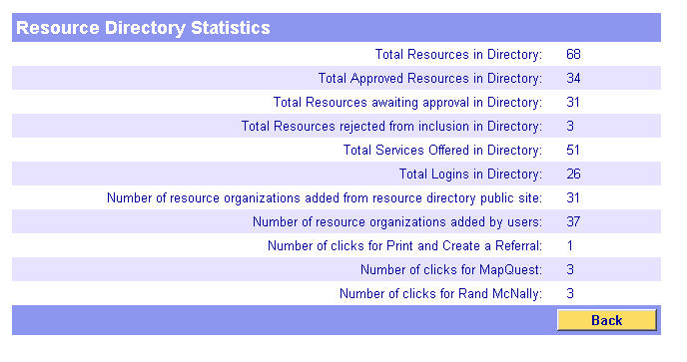

Web Site Statistics

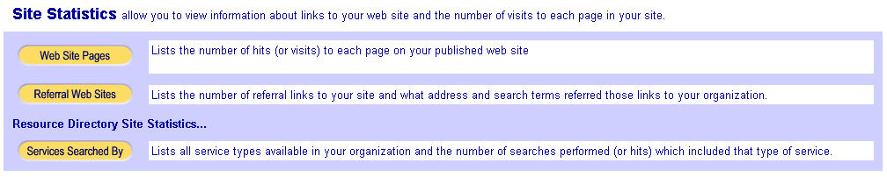
Website Links for SHARE Network Resource Directories

Kansas – www.SHARENetworkKS.com
Indiana – www.SHARENetwork.IN.gov / www.IN.gov/ofbci/share/
Michigan – www.Michigan.gov/SHARENetwork
Missouri – www.SHARENetworkMO.org
New Mexico – www.SHARENetworkNM.org
North Carolina – www.NCSHARENetwork.com
Ohio – www.OhioWorkforce411.gov/SHARENetwork.stm
Tennessee – www.TNSHARENetwork.com
Delaware – Coming Soon!

Module II Review

- What are the main search features of the SHARE Network Web site?

- Name some samples of services that can be found on the SHARE Network Web site.

- Name some of the benefits the SHARE Network Web site will provide to job seekers and providers.

- Name some of the benefits the SHARE Network Web site will provide to state employees and One-Stop staff members.

Module III: SHARE Network Access Points

WIA Mission

To increase the employment, retention and earning of our participants, thereby improving the quality of the workforce, reducing welfare dependency, and enhancing the productivity of the Nation. Condensed from WIA 1998 SEC. 106 PURPOSE.

Mission Statement

Take a few minutes to write out your personal or organizational mission statement relating to your role as a workforce development professional.

What is an Access Point?

A faith-based or community organization where people can go in their own neighborhoods or communities to look for jobs, assisted by trained individuals who connect them to the One-Stop system via computer and direct referrals.
Community Access

Define Community

Define Access

What Access Points Do

- Provide core services for self-directed job search

- Refer customers to the One-Stop and supportive services as needed

- Publicize job search services in their communities

- Report results to the One-Stop

- Assure non-religious use, equal treatment, and religious liberty

- Offer in-kind services

What Do They Need? The Access Points Essentials

- Computer workstation – ideally surplus computers from your Team
- Internet access – preferably high-speed but not necessary if n/a
- Point of Contact person trained by the One-Stop
- Relationship with One-Stop staff
- Regular communications to and from you and the One-Stop

Key Partners and Roles

Local Workforce Investment Authority:

One-Stop Management:

FBCO Hosting the Access Point:

Introduction Review

What is a SHARE Network Access Point?

What distinguishes SHARE Network Access Points from satellites and affiliate sites?

How do SHARE Network Access Points support your Mission Statement?

What are three “in-kind” services sometimes needed by jobseekers that might be provided by FBCOs who become SHARE Network Access Points?
Partnering with Integrity

Equal Opportunity
When choosing SHARE Network Access Points, you must use selection criteria which are neutral toward religion.

Protecting the Religious Liberty of FBOs
A faith-based organization that houses a SHARE Network Access Point may:
- Continue to carry out their religious activities
- Keep religious signs or symbols in their facility
- Select their own board members, including clergy, and otherwise govern themselves on a religious basis
- Offer voluntary religious activities to Access Point customers

Religion-Related Rules for Access Points in FBCOs
- No inherently religious activities (e.g. religious worship, instruction, or proselytizing) may be paid for or supported with USDOL financial assistance
- Inherently religious activities must be held at a separate time or in a separate space from SHARE Network Access Point hours of operation
- Inherently religious activities must be purely voluntary for SHARE Network Access Point customers

Protecting Religious Liberty of Customers
Prospective or active SHARE Network Access Point customers:
- Must not be treated differently because of their religion or religious beliefs (or lack thereof)
- Must be permitted to freely express their views and exercise their right to religious freedom
- Must be provided reasonable accommodation for their religious beliefs
- Must be informed that participation in inherently religious activities is voluntary and will not affect the quality of the services they receive

Access Point Training Resources
- “Partnering With Integrity” PowerPoint presentation in your Appendix
- USDOL Equal Treatment regulations and resources: www.dol.gov/cfbci/legalguidance.htm
- Call the USDOL Center for Faith-Based and Community Initiatives at 202-693-6450

Review
What are the simplest “separation” criteria for protecting customers’ religious liberty?

SHARE Network Access Points: Who Does What?

Local/Regional Workforce Investment Leadership is primarily responsible for:
- Choosing the _________________________ you want to impact.
- Selecting the ______ to host your new SHARE Network Access Points.
- Formalizing the partnership - if there are specified financial values, such as providing ISP or stipends, a contract is necessary. Otherwise, it’s OK to use a Memorandum of Understanding.
- Ensuring all federal and state requirements are met, including those related to ______ Treatment and Religious ________.

One-Stop Leadership is responsible for:

- Training SNAPs to serve jobseekers with ______ services, referrals using the Resource Directory, and quality customer service.

- Ensuring a strong working ___________ between One-Stop frontline staff and Access Point operators.

- Keeping Access Points _________ about job fairs, employer openings, changes in the job matching system, etc.

- Collecting and reporting Access Point __________.

FBCO Leadership is responsible for:
- Providing air conditioned office space in the targeted community, with reasonable insurance coverage, reliable electricity, and Internet access.
- Appointing a Point of Contact (POC) to attend training and assist jobseekers.
- Ensuring public access at specified hours and publicizing services.
- Complying with Religious Liberty and non-discrimination rules.
- Ensuring daily use of the Customer Sign-In sheet to collect customer counts, adding them up and reporting them monthly and quarterly.
Measuring Success

There are many ways to measure the success of your SHARE Network Access Points. Three measures are essential for assessing whether a particular site is meeting your goals for increasing access to jobseeker services:

- Number of customers receiving services (cumulative visits);
- Number of customers who are first-time visitors to this Access Point (unduplicated customers); and
- Number of first-time visitors who have never been to a One-Stop Center

These three numbers can be collected simply by tallying columns on Customer Sign-In sheets over a given period of time.

Here are some additional ways you might measure the success of your Access Points (just be careful not to load them down with too much reporting):

- Customers registering on your job-matching site
- Customers completing a Master Application
- Customers referred to an employer listing
- Customers reporting satisfaction
- Customers showing improvement in their job search skills
- Volume and type of in-kind services provided to jobseekers
- Referrals to the One-Stop for additional services
- Referrals to other service providers for additional services

SMART Goals are:

S_______________________

M_______________________

A_______________________

R_______________________

T_______________________
The Most Important Factor for Success: Building Relationships

Relationships are the _________________________ of the grassroots communities where Access Points have made the biggest differences.

Tips for Successful FBCO Relationships

WHO? Use the appropriate title; ask if uncertain.

WHERE? Know their coverage area and target population; respect their expertise.

WHEN? Know their schedules. Avoid interfering with a community organization’s program schedule. Consider Thursdays for meetings with congregational faith-based organizations.

WHY? WIIFM – Remember to help them to understand, “What’s In It For Me?”

WHAT? Keep your message simple and straightforward. Avoid jargon.

Access Points Basics Review

What does a SHARE Network Access Point need to serve jobseekers?

Name three key partners required for successful SHARE Network Access Points, and their primary roles and responsibilities?

What is the single most important thing to remember when building effective FBCO partnerships?

Module IV: Outreach

Summary

This module provides information on how to conduct outreach for the SHARE Network to customers and members. This module will help you become familiar with the SHARE Network’s target audience and provide the key message and outreach tools to help you reach out to that market.

At the end of this module, you will be able to conduct effective outreach for the SHARE Network to its customers and partners.

Outreach Definition

Public Outreach is:

Step 1: Purpose of Outreach

With outreach, you utilize various opportunities to communicate with (and educate) your customers about your product or service and how it will benefit them. In examining how we can conduct effective public outreach for SHARE Network, there are some lessons we can learn from how the business sector markets products. In both cases, the goal is to communicate the benefits of the product or service for the customer.

Potential Reasons Traditionally Used for Marketing | Examples
Implement a new product or service

Suggest new ways to use a product or service

Describe your product or service to new customers

Announce a change or improvement

Create an awareness of your product or service

Help establish a corporation or organization identity

Increase usage

Inform customers about up-coming events

Which of the reasons above apply to outreach for SHARE Network?
Step 2: Defining the Product

What is the product we are conducting outreach for?

Product Description

To effectively communicate SHARE Network to your customers, it is important that you be able to describe the SHARE Network. One important thing to remember about outreach is _________________________________.

The more specific you are in describing your product, in this case SHARE Network, the more successful you will be in encouraging new customers to try it.

In the marketing field, product descriptions are sometimes called an “elevator speech,” which means you should be able to describe SHARE Network to someone in the amount of time it takes you to get from the ground floor to the top floor in an elevator.

Your SHARE Network Elevator Speech:
Step 3: Target Audience

Now that you understand what you are educating people about, it is time to concentrate on who you are educating.

In order to understand target audiences, it is important to ask three basic questions:

- Who are your customers?

- Why are they your target customer or audience?

- Why is it important for your message to reach these customers?
Who are we trying to reach? There are many different groups that you are going to try to reach. List them all.

Step 4: Outreach Messages

Once you know what your product is and who your customers are, you need to identify what messages each of your customers will be interested in hearing. What message will encourage them to use the SHARE Network?

In order to understand what message will most directly reach your specific customer groups, you must ask yourself one question from the customer perspective… “What’s in it for me?” All customers ask themselves this question in an effort to figure out what works best for them. It is very important to think like your customer.

Two questions that will help you think like your customer are:

- Will your customer reap benefits from SHARE Network?

- What can your customers save, gain or accomplish from using the SHARE Network?

Using the customer group breakdown identified in the “Target Audiences” group activity, brainstorm the benefits of SHARE Network for one of the customer groups.

Target Audience:
WIIFM (What’s In It For Me):
Using the same Target Audience, and the benefits you just identified for it, determine the major components of the Outreach Message for that particular Target Audience. Be sure to include a “Call to Action” statement asking them to take whatever action you want them to take.

Target Audience:
Outreach Message:

Step 5: Outreach Tools

Now that we know “who,” “what,” and “what message,” we can concentrate on the best tool for conveying that message to the appropriate customer.

Outreach tools provide your customers the best access to the information that you have to share. In most cases, this will be you delivering the outreach message personally as you identify customers that will benefit from SHARE Network. Some traditional promotional tools are:

- Specifically targeted ads (TV, Radio, Newspapers, Etc.)

- Brochures or pamphlets

- Small items which remind people about what SHARE Network is and its web address

Several specifically targeted brochures and promotional items are already developed for your use. They just need to be modified to include your State’s SHARE Network information. A listing of these promotional items can be found in the Appendix, titled “Outreach Materials.”

Knowing your customers will help you determine the best tool for reaching them. For example, why do you think it is a good idea to use bookmarks as an outreach tool to remind pastors about SHARE Network?

Using the same Target Audience as in the previous exercises, brainstorm the outreach tool(s) that would be most effective in promoting the SHARE Network.
Target Audience:
Outreach Tools:
Outreach Project Plan

See the Appendix for a sample project plan for Outreach.

Finding Outreach and Marketing Material Templates

Marketing materials have been developed and are ready for states’ use with minor modifications, including adding state specific information (state logo, state website address, etc.). New outreach materials are added frequently.

During the implementation of SHARE Network in your state, these materials are available to you at: www.client.3foldcomm.com/SHAREstates.htm. You can download these files and modify as you need.

All of the PDF files were created using “Illustrator” software and are available in that format if desired. If the “Illustrator” version of the file you want is not on the website, please contact 3Fold Communications at 916.442.1394.

The materials at www.client.3foldcomm.com/SHAREstates.htm include the following topic areas:

- Overview Materials (Frequently Asked Questions, etc.)
- Training Materials (manual, slides, PowerPoint presentations)
- Marketing and Outreach Materials (posters, flyers, bookmarks, brochures, table tents)
- Media Outreach (PSA scripts, announcements)
- Access Points Toolkit (training materials and forms)
- State-specific Materials (sample materials formatted for individual states)

How to Engage a Network of Providers as Seed Members

One of the best ways to quickly populate your Resource Directory with seed members is to win the support of a large organization that has multiple service locations in your state. In the Appendix, a list of possible providers is included under the heading “Network of Providers.” It may require more time to gain the support of these large networks, but it is well worth the time.

Review “How to Engage a Network of Providers as Seed Members” in the Appendix. There are 4 basic steps recommended.
Step 1: Email to be sent 1-2 days prior to telephone call (Introduction, fact sheet, brochure, etc.)
Step 2: Telephone call to set appointment (Introduction, suggest specific time(s) for meeting, etc.)
Step 3: Email to be sent following telephone call (Thank you, confirm appointment, “teaser” to benefits)
Step 4: Person-to-Person meeting (Introduction, review fact sheet and brochure sent with first email, review components of SHARE Network, review how to join, Q&A, ask for commitment, etc.)

Module IV Review
Answer the following questions:

- Define marketing (outreach):

- What is the product we are promoting?

- Who will benefit from the product we are promoting?

- What are the 5 steps to a successful Outreach Plan for SHARE Network?

1.
2.
3.
4.
5.
Training Summary

Recap

After completing this training, you should now:

- Be able to establish an Access Point using a detailed project plan;

- Be able to navigate the SHARE Network and be committed to its use;

- Have a solid understanding of the elements of the SHARE Network and how to apply them within your on-going work environment; and

- Have a basic understanding of marketing principles as they apply to the outreach for the SHARE Network and be able to apply them to potential customers and partners.

Goals and Agreement

Overall goals:

1.

2.

My Commitment:

1.

2.

Appendix

Many documents in this Appendix were developed in the United Way of Brevard through the 2002-2004 USDOL Intermediary grant and one document was developed by Job Service North Dakota Project SHARE through the 2002-2004 USDOL State.. They are reprinted with the permission of the United Way of Brevard and Job Service North Dakota as examples.

The documents are presented for training purposes only and local officials must ensure that their selection of sub-recipients for financial assistance meets all applicable requirements (see 29 CFR 97.36 and 97.37) and must comply with all applicable federal and state laws. In particular, it is recommended that you utilize language from the “Equal Treatment” regulations and not the United Way of Brevard samples with regard to rules for faith-based organizations because they regulations were created after the UWB project was completed.

Comparison of SHARE Network

Resource Directory and Access Points

Resource  Directory |  | Access  Points
High Tech |  | High Touch
Web-Based |  | Community-Based
All Services |  | Job Services
Self Help |  | Assisted Help

Organizational Chart for a Typical Access Point

Senior religious leader (e.g. Minister or Rabbi) or CEO: Approves the plans, signs the papers, gives seal of approval and “presence” when needed.
Associate religious leader (e.g. Minister or Rabbi) or Associate Director: Secures technology, builds relationships with WIB and One-Staff principals, designates Point of Contact (POC).

POC: Receives training in how to help job-seekers, operates Access Point, helps job-seekers, builds referral network, coordinates volunteers, tracks results.
Volunteers: May do any or all of the following – be trained for POC relief, baby-sit for job-seekers, drive customers to interviews, mentor newly-employed people.
Administrator: Secures Internet service, tech support and supplies; manages financial support systems; sends out performance reports; promotes services.

Partnering with Integrity

The following is a summary of the PowerPoint slide available at http://www.dol.gov/cfbci/Partnering_with_Integrity_7-27-05.ppt.

Slide 1 | “Partnering With Integrity”  What Faith-Based Organizations, Community Groups, and Workforce System Leaders Must Know About U.S. Department of Labor Equal Treatment and Religion-Related Regulations  U.S. Department of Labor
Slide 2 | What are the goals of the Faith-Based and Community Initiative?  To expand opportunities for faith-based and community organizations (FBCOs) to meet the social needs of Americans  To ensure the equal treatment of FBCOs in the administration and distribution of Federal financial assistance  To protect the religious liberty of FBCOs that partner with the Federal government and of participants in Federally supported social service programs
Slide 3 | Changes to USDOL regulations and sub-regulatory policies  Goals of reforms undertaken by U.S. Department of Labor (USDOL):  Removing barriers to FBCO participation in USDOL social service programs  Protecting the religious liberty of:  (1) FBCOs that receive Federal financial assistance  (2) Participants in programs operated by these FBCOs  Regulatory changes were published in the Federal Register on July 12, 2004
Slide 4 | Where can I find the relevant changes?  New equal treatment regulations (29 CFR Part 2, Subpart D)  Workforce Investment Act (WIA) nondiscrimination and programmatic regulations (29 CFR 37.6(f); 20 CFR 667.266 and 667.275)  Job Corps regulations (20 CFR 670.555)  Job Corps Policy and Requirements Handbook (PRH)—Sections 6.8 (Civil and Legal Rights), 2.2, 3.17, 5.4 and 6.9
Slide 5 | The USDOL equal treatment regulations  Apply to all providers that implement USDOL supported social service programs, including:  For-profit and non-profit organizations, including FBCOs  State and local governments  One-Stop system  Job Corps Center operators & contractors  Govern the administration and distribution of USDOL support
Slide 6 | The USDOL equal treatment regulations  Apply equally to:  USDOL support  State funds commingled with Federal funds  Funds the State is required to contribute under a matching or grant agreement  Embody core principles of the FBCI at USDOL
Slide 7 | Core Principles of the Faith-Based and Community Initiative at USDOL  I. Equal Opportunity for All Organizations  II. Respect for the Faith of Faith-Based Organizations (FBOs)  III. Respect for the Religious Liberty of Beneficiaries  IV. Appropriate Use of Federal Support
Slide 8 | I. Equal Opportunity for All Organizations  In the administration of USDOL social service programs:  No organization may be discriminated for or against on the basis of religious character or affiliation  No eligible organization may be denied the opportunity to compete for or receive USDOL and other Federal financial assistance based upon the organization’s religious character or affiliation
Slide 9 | Equal Opportunity for All Organizations  Federal, State, or other mechanisms through which Federal support is provided to organizations (for example, a mechanism giving out vouchers for job training) must, by law, be neutral with respect to religion  Example: The entity selecting organizations to be placed on a list of eligible training providers under WIA must neither favor nor disfavor an organization based on religion.
Slide 10 | Respect the Faith of Faith-Based Organizations  Faith-based organizations that receive USDOL support may:  Continue to carry out their religious activities  Keep religious signs or symbols in their facilities  Continue to select their board members (including members of the clergy) and otherwise govern themselves on a religious basis  Offer voluntary religious activities to program participants—keep in mind that no “direct” Federal support can be used for religious activities and these activities must be separate in time or location from Federally supported activities and voluntary for program participants
Slide 11 | III. Respect for the Religious Liberty of Beneficiaries  Prospective or active program participants:  Must not be treated differently because of their religion or religious beliefs (or lack thereof)  Must be permitted to freely express their views and exercise their right to religious freedom  Must be provided with reasonable accommodation for their religious beliefs in programs; ‘reasonableness’ is determined on a case-by-case-basis, with regard to the particular circumstances involved  Must be informed that participation in inherently religious activities is voluntary, and that their choice whether or not to participate will not affect the quality of the service they receive
Slide 12 | IV. Appropriate Use of Federal Support  What is USDOL “support”?  Defined in 29 CFR 2.31(g) as “Federal financial assistance, as well as procurement funding, provided to a non-Federal organization to support the organization’s administration of or participation in a USDOL social service program.”  Includes grants, contracts, cooperative agreements, and other arrangements  Includes monetary and non-monetary assistance (e.g., in-kind contributions, frequent use of Federally-supported property, etc.)
Slide 13 | IV. Appropriate Use of Federal Support  Determined by the type of Federal support and how the support relates to “inherently religious activities”  What are examples of “inherently religious activities”?  Religious worship  Religious instruction  Religious proselytizing
Slide 14 | IV. Appropriate Use of Federal Support  To know how religion can be involved in services provided with Federal support, the first question is whether the Federal support is “indirect”
Slide 15 | IV. Appropriate Use of Federal Support  Federal support is considered “indirect” when:  Beneficiaries are given genuine, independent choices about where to direct the aid, including having at least one option to which the beneficiary has no religious objection  Beneficiaries freely choose where to direct the aid
Slide 16 | IV. Appropriate Use of Federal Support  So long as the tests for “indirect” support listed on the previous slide are satisfied, the following mechanisms can be considered “indirect” support:  Individual Training Accounts (ITAs)  Personal Reemployment Accounts (PRAs)
Slide 17 | IV. Appropriate Use of Federal Support  Federal support is considered “direct” unless it satisfies the tests for “indirect” support (see slide 15)  Some examples of “direct” Federal support include:  Grants  Sub-awards  Contracts  Cooperative agreements  USDOL formula grant funds
Slide 18 | IV. Appropriate Use of Federal Support  There are different rules that apply to how FBCOs may use “direct” and “indirect” support  What rules apply when Federal support is “direct”?  What rules apply when Federal support is “indirect”?
Slide 19 | IV. Appropriate Use of Federal Support  When FBCOs receive “direct” support, the following rules apply:  (1) “Direct” support must not be used for inherently religious activities  (2) Organizations may still engage in inherently religious activities, but these activities must be kept separate in time or location from Federally-supported services  (3) All inherently religious activities must be voluntary for program participants and beneficiaries
Slide 20 | IV. Appropriate Use of Federal Support  When FBCOs receive “indirect” support, the following rules apply:  (1) Inherently religious activities can be made an integrated part of the regular training program. Participation by the customer in these religious activities is considered voluntary because it is the customer who has freely chosen to participate in the training program  (2) As a result, customers can be required to participate fully in the training program, including any inherently religious activities
Slide 21 | IV. Appropriate Use of Federal Support  State and local areas develop standards and procedures by which organizations may qualify as Eligible Training Providers (ETPs). FBCOs that apply and that meet all requirements are placed on the ETP list.  Eligible Training Providers that receive “indirect” USDOL support through an Individual Training Account (ITA), Personal Reemployment Account (PRA), or similar mechanism may:  (1) Make inherently religious activities an integrated part of their regular training program  (2) Require customers to participate fully in their program, including any inherently religious activities
Slide 22 | IV. Appropriate Use of Federal Support  Assuming the tests for “indirect” support are satisfied, One-Stop customers may use Individual Training Accounts (ITAs), Personal Reemployment Accounts (PRAs), or similar mechanisms to purchase training that (1) contains inherently religious activities and/or (2) leads to employment in a religious vocation.
Slide 23 | IV. Appropriate Use of Federal Support  To become an Eligible Training Provider, an organization must submit an application to the Local Workforce Investment Board, following local procedures and deadlines  The applicable local procedures generally require a description of each training program and, for established programs, information on past performance and cost  To promote genuine choice, program descriptions should briefly identify any religious elements
Slide 24 | IV. Appropriate Use of Federal Support  Among the provisions of Section 188 of WIA that apply to all recipients (including FBCOs) is a prohibition on employment decisions based on religion for positions that administer, or are connected with, programs and activities that receive WIA financial assistance  Section 188 does not apply to employment decisions made (1) before an organization first received financial assistance under WIA, or (2) for programs and activities that do not receive WIA financial assistance
Slide 25 | IV. Appropriate Use of Federal Support  The rules that apply to Federal contractors are different from those that apply to recipients of Federal financial assistance  Federal contractors are entities that enter into agreements with the Federal Government for the purchase, sale, or use of real or personal property or non-personal services (they are not grantees)
Slide 26 | IV. Appropriate Use of Federal Support  Nondiscrimination requirements that apply to Federal contractors are in Executive Order (EO) 11246. Additional nondiscrimination requirements that apply to Job Corps contractors can be found in 29 CFR Part 37  The President amended EO 11246 in December 2002 to permit covered Federal contractors (not grantees) to make employment decisions based on religion  USDOL published new rules in the Federal Register implementing this change on September 30, 2003
Slide 27 | Religion-Related Requirements for  Job Corps  Job Corps Centers must take steps to protect the religious liberty of students  Job Corps Centers must not favor an organization for, or exclude an organization from, community outreach, student recruitment and mentoring, community service, and post-Job Corps employment activities on the basis of religious character or affiliation  Job Corps Centers must not discriminate for or against students on the basis of religion or religious belief  FBCOs that partner with Job Corps must be permitted to remain independent  FBCOs partnering with Job Corps must not refuse to serve students on account of religion
Slide 28 | Religion-Related Requirements for  Job Corps  The Job Corps Policy and Requirements Handbook (PRH) outlines steps Job Corps Centers must take to protect the religious liberty of Job Corps students:  Job Corps Centers must not discriminate for or against students on the basis of religion or religious belief  Job Corps Centers must inform students about their religious rights  Job Corps Centers must permit voluntary religious activities, including religious services, to occur at Job Corps Centers (services do not have to be “nondenominational” as under the prior regulation)  (Continued on next slide…)
Slide 29 | Religion-Related Requirements for  Job Corps  Job Corps requirements continued…  Job Corps Centers may continue to transport students to local religious facilities  Job Corps Centers must accommodate student religious practices subject to reasonable time, place, and manner restrictions  Special rule: Where there is such government control over the program environment that student religious exercise would otherwise be significantly burdened, Job Corps Centers may use “direct” Federal support to facilitate student-requested religious activities
Slide 30 | Frequently Asked Questions  for FBCOs and the WIA System
Slide 31 | Q: How does an organization separate its religious activities from its Federally-supported social service program?  A: Organizations that receive “direct” support must:  (1) Separate “inherently religious activities” in time or location from government-funded services  Carefully account for their use of all government support, and ensure that Federal support is not used for inherently religious activities  Ensure that all “inherently religious activities” are voluntary for program participants
Slide 32 | Q: Can people who receive Federally-supported services from a provider also participate in that organization’s religious activities?  A: Yes, provided that a few rules are followed:  (1) Providers that receive “direct” Federal support must not require program participants to take part in any religious activities  (2) Employees or volunteers should reassure the participants that they can receive Federally-supported services even if they do not participate in these activities
Slide 33 | Q: Can employees or volunteers of a faith-based provider receiving “direct” Federal support invite program participants to join in religious services or events?  A: Yes, provided that:  (1) Announcements of or invitations to religious services or events are handled in a similar fashion to announcements or invitations for non-religious events  (2) The religious activities are separate in time or location from the Federally-supported activities  (3) The employees or volunteers make clear that participation is completely voluntary and won’t affect the services the participant receives
Slide 34 | Q: If a program participant at an FBCO asks about the faith of an employee or volunteer, can the employee or volunteer discuss his/her faith with the participant?  A: If a participant asks a program employee/volunteer about his/her personal faith while he/she is providing a Federally-supported service, the employee/volunteer may give a short answer.  If the program participant wishes to have a longer conversation on matters of faith, the employee/volunteer should set up a time outside the context of the Federally-supported program to speak with the participant.
Slide 35 | Q: Can an FBCO use “direct” Federal support to purchase religious materials?  A: No. Faith-based and community organizations may not use Federal support to purchase religious materials, such as the Bible, Torah, Koran, Talmud, or other religious or scriptural materials.  Federal support also cannot be used to purchase materials intended for inherently religious activities.
Slide 36 | Q: Can a faith-based organization use “direct” Federal support to pay the salary of a member of its staff?  A: Yes, provided that this staff person is delivering the Federally-supported service and is not engaged in inherently religious activities, such as religious worship, instruction, and proselytizing, while working to provide the Federally-supported service.  The staff member may be a rabbi, priest, imam, or preacher, for example, so long as he or she does not engage in these activities while being paid with public dollars.
Slide 37 | Q: If an FBCO receives “direct” or “indirect” Federal support, can it choose not to provide services to some people because of their religion?  A: No. If a faith-based or community group receives Federal financial assistance, whether “direct” or “indirect,” it may not discriminate, based on religion or religious belief, against a person who is eligible for the service.
Slide 38 | Q: Are Individual Training Accounts (ITA) and Personal Reemployment Accounts (PRA) examples of “indirect” support?  A: ITAs and PRAs, like vouchers, can be considered “indirect” support so long as the tests for “indirect” support are satisfied (also see slide 15).
Slide 39 | Q: If a faith-based group previously allowed to hire on a religious basis becomes a recipient of WIA financial assistance, will the organization have legal problems related to its previous hiring decisions?  A: No. The law does not apply retroactively. The WIA nondiscrimination provisions will apply only to the activities in which a faith-based organization engages after it becomes a recipient under WIA, and only to jobs that administer or are connected with the programs and activities that receive the Federal financial assistance.
Slide 40 | Legal Guidance for FBCOs and the WIA System  White House Office of Faith-Based and Community Initiatives  www.whitehouse.gov/government/fbci/guidance/index.html  USDOL Center for Faith-Based and Community Initiatives  www.dol.gov/cfbci/legalguidance.htm  USDOL Civil Rights Center  www.dol.gov/oasam/programs/crc/crcwelcome.htm  Job Corps PRH Website  jobcorps.doleta.gov/docs/prh.pdf

[Note: Please check with your legal department to determine the possible need for additional clauses, conditions and forms required in your state.]
[WIB-Share Network Access Point MOU SAMPLE ]
Memorandum of Understanding
For SHARE Network

This agreement describes the mutual understanding between [Local Workforce entity], [address], hereinafter referred to as “The Board” and [faith-based or community organization], [address], hereinafter referred to as "The Access Point", for the purpose of helping unemployed and underemployed people receive job-search services under the [State] SHARE Network.

This agreement shall begin on [DATE] and end on [DATE], is renewable annually, and may be modified or terminated at any time by written agreement by both parties.

The Board agrees to provide the Access Point with:
- computer
- software
- resource library materials and will replenish resource materials as needed
- Up to 12 hours of training to help jobseekers
- Personal connections to Career Center management, staff and key partners.

The Access Point agrees to:
- Host a publicly accessible SHARE Network Access Point consisting of a computer with internet access and a Workforce system trained operator.
- Helping jobseekers at least 8 hours per week;
- Publicizing your jobseeker services to your community;
- Sending an operator to at least 12 hours of initial training;
- Participating in optional training opportunities offered by The Board.
- Submitting [what reports, forms, how often, where] to document activities.
- Ensure that their organization/Access Point is listed on the SHARE Network On-line Directory. The Access Point must also ensure that information listed is maintained and up-to-date.
- Adhere to the SHARE Network Access Point criteria contained in attachment 1.

The Access Point assures that it will take reasonable precautions to ensure hardware, software, and/or other resources remain secure and in good repair; and understands that The Board is not responsible for repair or replacement of Access Point resources.

The Access Point agrees to abide by federal, state and local laws, particularly those ensuring non-religious use, religious liberty, equal protection and non-discrimination.

Signature for The Board |  | Signature for The Access Point
[Name of legal Board signer]  Date: |  | [Name of legal Access Point signer]  Date:
Criteria To Be A Missouri SHARE Network Access Point

- Be a faith-based or community-based organization located in the state of Missouri that provides one or more approved human service functions.

- Provide at least 100 square feet of heated/air conditioned office space, with adequate insurance coverage, reliable electricity, and available high-speed ISP.

- Ensure non-religious use and non-discrimination.

- Provide adequate and trained personnel to provide Career Center Access Point labor-exchange/referral assistance a minimum of 12 hours per week.

- Provide security measures as necessary to safeguard the Career Center Access Point resources and take reasonable precautions to ensure hardware, furnishings and/or other resources remain in good repair.

- Conduct community outreach to inform the public of the availability of Access Point/Career Center services.

- Submit, in a timely manner, required data and evidences such as sign-in sheets, customer satisfaction forms and other documentation to substantiate activities.

- Be neighborhood based and located in an area that is most likely to be accessible by individuals who are striving to enter the workforce.

- Agree to work cooperatively with the local Workforce Investment Board and the local Missouri Career Center to assist individuals with access to Career Center services.

[WIB may choose additional criteria.]

[Note: Please check with your legal department to determine the possible need for additional clauses, conditions and forms required in your state.]
[STATE-WIB MOU SAMPLE ]
Memorandum of Understanding
For SHARE Network

This agreement describes the mutual understanding between [State Entity], [address], hereinafter called The State, and [Local Workforce entity], [address], hereinafter referred to as “The Board,” for the purpose of engaging faith-based and community organizations to become SHARE Network Access Points, helping unemployed and underemployed people with job-search services in cooperation with local [One-Stops].

The State agrees to provide the Board with [surplus materials] and a sample MOU for distribution to at least two (2) faith-based and community organizations selected by The Board as SHARE Network Access Points. The Board agrees to execute its own MOU with the Access Points, distribute the State/WIB -provided items, and copy the Board-Access Point MOUs to the State.

The term of this agreement shall begin on [XX] and end on [XX]. The State is not obligated to cover costs related to this understanding incurred before or after the stated term.
The Board assures that it has the means necessary to receive and redistribute the State-provided items in good repair. The Board shall distribute to at least two (2) Board selected SHARE Access Points in accordance with the criteria contained in attachment 1. The Board understands that the State is not responsible for costs associated with the repair or replacement of these items, nor for the training or performance of the SHARE Network Access Points.

The contract may be modified at any time by written agreement by both parties. Either party may terminate the agreement at any time by 30 days written notice delivered by US mail, return receipt requested, to the other party.

AUTHORIZED REPRESENTATIVE OF CONTRACTOR: |  | WIB name
SIGNED BY:  _______________________________ |  | SIGNED BY:  ________________________________
Printed Name, Title  _________________________ ____ _ |  | Printed Name, Title  _________________________ ____ _
DATE: _______________________________ |  | DATE: _______________________________

Basic Training for Access Points
The best source of training for your Access Point’s operator (Point of Contact or POC) is your local One-Stop, Job Link, or a Career Center. Most One-Stops have a community trainer who works with schools, libraries and other places people might look for jobs.

In the award-winning United Way of Brevard Access Point project cited in the USDOL publication, Bridging the Gap, each POC attended 9 hours of classroom training by the local One-Stop trainer, and then shadowed a “Career Coach” at the full service One-Stop for a half-day. This not only gave the POCs great experience, it also gave them an important relationship with One-Stop staff.

Here is a list of the training units completed by the Brevard POCs:

- Brevard Job Link Orientation - (same as One-Stop customers get, an overview of the services offered by the One-Stop system)*

- One-Stop Tour

- How to Use the Job Links Website*

- One-Stop Partners: Youth Services, Community College*

- Interactive Case Study

- 211, Brevard’s Referral Resource Directory (phone and online)*

- Counseling and Coaching Techniques*

- America’s Job Bank

- www.CareerOneStop.org and www.OneStopCoach.org

- What’s a WIB (And Why Should I Care)?

- Barriers and Breakthroughs (meeting challenges in customer service)*

- Mentoring and More (cosponsored by the Governor’s Office of Faith-Based and Community Initiatives and the Brevard County Mentoring Advocacy Council)

- Community-Based Care Vendor Fair, an overview of local services available to prevent, intervene and treat child abuse/neglect and related family crises

*critical to effective Access Point operations

ACCESS POINTS: The Customer Experience

Here’s what an FBCO Access Point (Mini-Joblink) looks like to the customer:

- Customer is welcomed, completes sign-in sheet.

- POC helps customer complete a master application; discusses previous work experience and preferences. POC lets customer know that s/he will honor the privacy of information they share.

- POC reviews application for completeness, accuracy and neatness.

- POC registers customer on One-Stop website and begins job search via Internet resources.

- If a potential opening is cloaked (employer wants only One-Stop-qualified applicants), POC contacts One-Stop to ensure customer eligibility and obtains job referral information.

- POC assists customer in creating a resume.

- During these processes, POC ascertains the customer’s potential need for support services such as childcare, transportation, veterans’ services, financial assistance/food stamps, interviewing techniques, etc. and gives a personal referral to One-Stop to establish eligibility. POC also utilizes the SHARE Network Resource Directory online to refer to other providers as needed.

- POC establishes a follow-up system to contact customers at regular intervals for encouragement and to track job placements. Job placement reports are provided promptly to the One-Stop for inclusion in WIB performance data.

- Besides job referrals, customers can receive information about career-related education, available scholarships, hot jobs, trends, and community service opportunities.

- A typical customer file contains:
  - Brevard Job Link master application
  - Customer needs sheet
  - Service sheet
  - Resumes
  - Cover letters

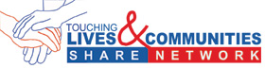
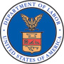

Customer Sign-In Sheet

NAME OF THIS ACCESS POINT: ___________________________________________________ DATE: _____________

By signing in below, you are helping this SHARE Network Access Point receive credit for helping you look for a job, and helping the State to learn what jobseekers need and want. Please be aware that:

- A copy of this sheet is sent to _____________ to prove that this Access Point served you. Therefore the information you enter below, may be shared with ____[list agencies}____ and the US Department of Labor.
- SHARE Network Access Points are committed to helping you look for a job regardless of your race, gender, ethnicity, or religious belief.
- Your participation in any activity offered, including this sign-in sheet, is entirely voluntary and will not affect the quality of the job search services you receive from this SHARE Network Access Point.

By signing below, I agree that I have read and understand the preceding statements, and that I want to receive job search services at this SHARE Network Access Point.
NAME (please print) | SIGNATURE | Your Home Zip Code | First  visit  here | Return  visit  here | Ever been to a One-Stop?  Yes l No

Customer Satisfaction

Please color the appropriate blocks to answer these questions

YES NO
1. Did we treat you with respect?
2. Did we listen to you?
3. Did you feel encouraged?
4. Do you feel more hopeful?
5. Did we help you see your strengths?
6. Did you make progress toward your career goals?
7. What was the one thing you learned in today’s visit that you will use in your career plans?

Additional Comments

Date

Point of Contact

JOB PLACEMENT FORM

Name of Access Point

Phone number

Point of Contact

Customer name

Customer SS#

Date of hire

Employer/company name

Location

Job Title

Starting wage

Be sure to fax this completed form to (XXX) XXX-XXXX to receive credit for this job placement with your One-Stop partners!

Resource Directory Service Descriptions
Service | Description
Accessible Facilities | Facilities which meet or exceed the minimum requirements of the Title III of the America with Disabilities Act for accessibility and usability of facilities covered by that title. (Handicap)
Adoption Services | Receive assistance in adoption.
Adult Day Care | Secure, licensed, care for adults with physical, intellectual and/or aging-related disabilities.
Adult Employment and Training Services | Training programs that teach job skills and provide job placement services for adults who are at least 18 years of age.
Advocacy | Services that include actively supporting individuals or groups of people through acting as a third party that expresses their concerns, needs and positions to agencies that impact their lives.
Aging Services | Education and assistance with aging needs such as help with yard work, shopping, and home health. (Elderly)
Agriculture/ Farm Services | Services to provide training for agricultural production or harvesting.
Apprenticeship | Organizations that provide apprenticeship opportunities.
Assistive Technology | Access technology customized for people with disabilities. (handicap)
Auto Repairs | Assistance with repairing and maintaining automotive transportation needed for self-sufficiency.
Behavioral Health Services | Any services designed to treat a behavioral disorder, psychological injury or chemical dependency.
Budgeting | Assistance with money-management and creating budgets.
Business Loans/ Loan Guarantee Program | Information/assistance with special programs offering small business loans or home mortgages.
Business Planning/ Workshops | Workshops and classes for entrepreneurs and individuals interested in starting businesses.
Career Counseling/ Exploration | Skills assessment and information about employment opportunities.
Child Care | Secure, licensed supervision and care for the children of working parents. (Babysitting)
Child Care Provider Training/ Information | Training to attain or improve job-specific skills for working in a licensed child care facility.
Child Protection | Agencies involved in the prevention, intervention, and treatment of child abuse and neglect.
Citizenship Education | Information on attaining citizenship, documentation and assistance for new citizens.
Clothing | Access to free or reduced-price attire, including clothing suitable for the workplace. (clothes)
Colleges and Universities | Higher education institutions that can provide a range of advanced training, degrees and certificates.
Community Development | Organizations that work to revitalize neighborhoods, expand affordable housing and economic development.
Community Information Resources/ Library Services | Provide public with access to books and information.
Community Service | Opportunities to become involved and assist multiple organizations.
Computer/ Keyboard Training | Basic computer classes including typing.
Computers/ Internet Access | Agencies which provide free access to computers and internet access.
CPR/First Aid Classes | Classes leading to certification as a CPR instructor and/or become certified in first aid.
Credit Counseling | Professional counseling provided by organizations that help consumers find ways to repay their debt and/or manage their money- through careful budgeting.
Default
Dental Assistance | Access to free or reduced-price dental care for those meeting eligibility.
Developmental Disabilities Services | Services for individuals effected by retardation or impairment of general intellectual functioning. (Mentally Handicap)
Disability Services | Agencies providing services of assistance to people with disabilities. (Handicap)
Disaster Services | Information and assistance to victims of a disaster such as rescue, housing, food and long-term recovery.
Domestic Violence Advocacy | Groups who support victims of domestic violence, including supporting them having needs met by the legal system and relevant programs. (spouse, spousal abuse)
Drug and Alcohol Counseling | Therapeutic services for individuals addicted or abusing drugs and/or alcohol.
Early Childhood Education (Headstart) | Programs to provide pre-school education to eligible children from low-income families.
Economic Development | Agencies involved in improving a region's overall economic well-being.
Education/ Schools | Schools and other organizations that provide classes designed to improve knowledge and skills level.
Emergency /Transitional Shelter | Short-stay accommodations, and/or longer residential program for individuals in emergency situations or individuals seeking to transition to self-sufficiency.
Emergency Travel Assistance | Agencies that provide assistance to individuals needing help traveling away from emergency situations.
Employment | Websites or places which list job opportunities. (openings)
Employment Assistance | Support for job seekers in finding job opportunities.
Energy Conservation | Tips on how to manage and conserve energy.
English Language Training/ ESOL | English for Speakers of Other Languages (ESOL) and/or English for the workplace.
Entrepreneurship/ Self-Employment | Help for business owners and aspiring business owners.
Environmental Health | Agencies that help with prevention, identification and resolution of health problems related to the physical environment.
Ex-Offender Services | Services for men or women returning home from jail or prison.
Exercise | Services to help individuals improve health through physical activity.
Federal Bonding Program | Provides insurance for theft to employers that have hired ex-offenders.
Food Assistance | Access to emergency food for those meeting eligibility requirements. (pantry)
Food/ Nutrition | Provides information and education regarding nutritional needs.
Furniture | Free or low-cost home furnishings for those in need.
Gambling Addiction/ Education | Therapeutic services for individuals fighting gambling addiction.
GED-General Education Development | Tutoring for individuals seeking a GED certificate/ High School Equivalency test.
Grief Services | Assistance and counseling on surviving the loss of a loved one, recent and longer-term.
Health Care Assistance | Free or low-cost services and information for those in need.
Heating/ Cooling Assistance | Assistance when life or health is threatened by lack of suitable heating/cooling systems.
HIV/AIDS Supportive Services | Services for those with HIV/AIDS, their families and friends.
Home Care | Various health care and supportive services provided in the home setting by professionals, paraprofessionals, family members, companions and/or volunteers.
Homebuyer/ Homeowner Assistance | Assistance for eligible first-time homebuyers and those with existing mortgage problems.
Housing Assistance | Information on public, subsidized and other housing programs for those in need.
Housing Rehabilitation | Groups specializing in the rehabilitation of deteriorated homes for low-income individuals or people with disabilities.
Immigration Services | Resources the specific needs of immigrants.
Independent Living Apartments/ Facilities | Housing/rentals for individuals with special needs and/or those transitioning out of institutional facilities. (Handicap)
Independent Living Skills Training | Training for people with disabilities to attain/maintain self-sufficient living. (Handicap)
Internships | Opportunities for students to learn valuable skills by working as temporary employee.
Interviewing Skills | Training people in usable skills helpful in interviews.
Job Openings | Websites or places which list job opportunities.
Job Readiness | Programs that teach skills that prepare an individual to be successful in the workforce. (Work)
Job Retention | Training in skills needed to keep a job.
Job Search Assistance | Help looking for a job.
Juvenile Justice | Programs coordinated with the court system for juveniles involved in the criminal justice system.
Labor Market Information | Provides information regarding the labor market.
Legal Assistance | Assistance with legal matters for individuals unable to pay full legal fees for those meeting eligibility requirements.
Life Skills | Programs that teach skills that help an individual manage their life successfully, including personal and professional relationships, time and money management.
Literacy | Tutoring for individuals with basic reading skills.
Mediation/ Negotiation | Provides free or reduced fee mediation/negotiation for individuals or organizations involved in legal matters and/or other disputes who meet eligibility requirements.
Medical Assistance | Provides medical assistance for eligible persons.
Mental Health Services | Provides services to help people address mental health issues.
Mentoring | Provides mentors for youth or adults.
Migrant and Seasonal Farmworker Services | Services specifically targeted towards migrant and seasonal farm workers.
New American/Refugee Services | Services for immigrants.
No service type available at this time
Non-Profit Organization Assistance | Provides assistance to non-profit organizations.
Offers Services in Languages Other Than English | Organizations who offer services in languages other than English, as specified in their description.
Out of Home Placement | Emergency shelter and foster care for abused/neglected children, youth and vulnerable adults.
Parenting Help/Support | Training, education, and provide peer support for parents. (children)
Peer Support | Groups organized around supporting each other with specific issues.
Physical Health | Information and services related to improving one's physical health.
Pregnancy/ Family Planning | Provides information about family planning, support to pregnant women or women seeking to get pregnant.
Prevention/ Intervention | Information and services to prevent the start or worsening of any type of abuse (drug, alcohol, domestic, etc).
Proficiency Testing | Testing to determine one's level in particular language skills or skills in specific occupation.
Protection Order Assistance | Assistance getting legal protection from someone who is threatening personal harm.
Rape Crisis Advocacy | Information and supportive services for rape victims and their families.
Recreation | Provide community recreational activities for individuals and/or children and families.
Relocation Assistance | Provides support for those needing assistance with moving and relocating.
Rental Assistance | Provides relief for those needing emergency support with rent.
Resume Skills/ Software | Provide personal and/or online tools to help with resume development.
Rural Assistance | Assisting rural communities and people.
Scholarship/ Tuition Assistance | Assistance in obtaining scholarships and tuition support for community colleges, technical schools, colleges and/ or university attendance.
Self-Confidence/ Self-Esteem | Support with self-confidence and self-esteem.
Self-Sufficiency | Support in helping individuals become self-sufficient.
Shelter-Emergency/ Transitional Housing | Housing for individuals who are in emergency situations or transitioning to self-sufficiency.
Sight/Vision Services | Services to support people seeking help for the eyes/ vision. (Blind, Handicap)
Skill Assessment | Service that provides skills assessments to help individuals to determine strengths and abilities and create appropriate career path.
Smoking Cessation | Information and services on how to stop smoking cigarettes.
Substance Abuse Issues | Information and services for individuals needing substance abuse treatment, recovery support, as well as support for those with friend/family members who have substance abuse issues.
Summer Food Service Program | Program to help provide food to children from low-income families during summer months.
Support Groups (cancer, depression, AA, etc.) | Support and self-help groups that address specific issues.
Training (employment related) | Job training for individuals seeking to improve or upgrade their skills or obtain a certificate.
Transportation | Information and services for individuals in need of transportation who meet eligibility requirements.
Tutoring | Services which provide tutoring in reading, math and other subjects to children or adults.
Unemployment Insurance | Places to file claims and obtain unemployment insurance following job loss for specified period of time.
Utilities Assistance | Support for utilities for low-income families and residents.
Veteran Services | A range of services to meet the needs of veterans.
Victim Services | A range of services for victims of crime, including domestic violence.
Weatherization | Weatherization services are cost-effective energy efficiency measures for existing residential and multifamily housing with low-income residents. (Heat, Air-conditioning)
Women and Children Groups | Organizations that support women and children.
Work Opportunity Tax Credit Program | Organizations that provide information/support to businesses about how to obtain Work Opportunity Tax Credit that comes from employing people with specified disadvantages (disability, former welfare recipients, etc). (Handicap)
Youth Employment and Training Services | Any program that helps youth develop skills and/or search for employment.
Youth Services | Any services or programs that support youth's social and educational development.

SHARE Network Marketing Materials
Marketing materials have been developed and are ready for states’ use with minor modifications, including adding state specific information (state logo, state website address, etc.). New outreach materials are added frequently.

During the implementation of SHARE Network in your state, these documents are available to you at www.client.3foldcomm.com/SHAREstates.htm and are updated continuously.

All of the PDF files were created using “Illustrator” software and are available in that format if desired. If the “Illustrator” version of the file you want is not on the website, please contact 3Fold Communications at 916.442.1394.

The materials at www.client.3foldcomm.com/SHAREstates.htm include the following topic areas:

- Overview Materials (Frequently Asked Questions, etc.)
- Training Materials (manual, slides, PowerPoint presentations)
- Marketing and Outreach Materials (posters, flyers, bookmarks, brochures, table tents)
- Media Outreach (PSA scripts, announcements)
- Access Points Toolkit (training materials and forms)
- State-specific Materials (sample materials formatted for individual states)

Common “Network of Providers”

The following is a list of large service providers that are found in many states. A comprehensive list of providers will be provided to each state by the USDOL.

AmeriCorp

Campus Ministries

Catholic Charities

Council of Churches

Goodwill

Habitat for Humanity

HUD

Jewish Family Services/Jewish Vocational Services

Jobs for Life

Lutheran Social Services

Salvation Army

Senior Corp

United Way

Urban League

Volunteers of America

YMCA

In addition to the Service Providers listed above look for the following:

- State-wide associations for large religious denominations
- All state government agencies that provide services such as Health and Human Services, Commerce, Department of Corrections, etc.

Project Plan (Blank)

Task | Lead | Due Date | Finished Date

State
Project Plan to Launch the Resource Directory by , 2007

Task | Lead | Due Date | Status
SET OBJECTIVES/REPORTING PROCESS/EVALUATION
Establish Team
- Gain support of local areas
- Identify team
- Identify team lead
- Assign responsibilities

Develop Goals
- Determine official launch date
- Develop performance measurements
  - # of seed members
  - # of members by 6 mo
  - # of members by 12 mo
  - # of site hits by 6 mo
  - # of site hits by 12 mo
  - # of referrals by 6 mo
  - # of referrals by 12 mo

- Reporting schedule

WEBSITE ADMINISTRATION
Administration
- Determine state’s
  - Organization Administrator
  - Resource Directory Manager(s)
  - Site Builder Manager
- Schedule training (Sandra)
  - Organization Administrator
  - Resource Directory Manager(s)
  - Site Builder Manager
- Prepare database
- Establish URL

WEBSITE LOOK & FEEL
Website Look
- Header & Text – draft
- Header & Text – team feedback
- Header & Text – final
- Links
- Options

POPULATE THE DATABASE
Seed Members
- Identify possible seed members
  - Large FBCO
  - Government agencies
  - Local influential
- Determine who will contact
- Contact seed members
- Send mktg materials
- Follow up & gain commitment
- Seed members entered

All Members
- Identify possible members
  - Databases
  - Lists
- Gather information
- Send mktg materials

MEMBER PROCESS
Procedures
- Review member agreement
- Revise member agreement
- Develop procedures for new member approval
- Develop maintenance schedules

State
Project Plan to Open Access Points by , 2007

Task | Lead | Due Date | Status
Select FBCO’s TO BE ACCESS POINTS
Identify target communities and the FBCOs who can best serve them
- Meet with directors
- ID target markets
- ID 2 SNAPs

COMPLETE MOUs WITH ALL PARTNERS
Formalize SNAP roles, responsibilities
- ID what State wants in MOU
- Draft State – WIB MOU
- Draft State – SNAP MOU
- Get all MOUs signed

TRAINING FOR THE ACCESS POINTS
Ensure SNAP operators know how to serve jobseeker customers
- Review SNAP Trainer Toolkit
- Train the trainers
- Set logistics; notify SNAPs
- Conduct training

KICKOFF CELEBRATION for ACCESS POINTS’ OPENING
Host event(s) to celebrate the grand opening of your SNAPs
- Decide: hold statewide?
- If So, plan logistics (state)
- If Not, plan logistics (local)

TRACK AND LEVERAGE RESULTS
How do we know we’re being successful?
- List of SNAPs
- Number trained at each
- ID month 1 baseline
- Give TA and set SMART goals
- Collect RD data on SNAPs

State
Project Plan for Outreach for SHARE Network

Task | Lead | Due Date | Status
GENERAL
Special Events/Conference?
- Develop list of events
- Obtain approval
- Develop speech
- Develop collateral materials

PR
- Determine PR schedule
- Determine papers, periodicals, newsletter, churches, state’s home page, governor’s page, etc.
- Customize press release(s)
- Send press release(s)

RESOURCE DIRECTORY
Seed Member
- Customize talking points
- Customize e-mail
- Customize one sheet

Quick Guide
- Customize
- Determine distribution methods
- Distribute

ACCESS POINTS
Identifying Access Points
- Customize talking points
- Customize e-mail
- Customize one sheet

Outreach Matrix (Blank)

Category of Audience:
Targeted Audience | What’s In It For Me? | Targeted Message | Printed Materials | Promotional Item

Category of Audience:
Targeted Audience | What’s In It For Me? | Targeted Message | Printed Materials | Promotional Item

Job Service North Dakota

Project SHARE Outreach Matrix

(SAMPLE)
FBO
Targeted Audience | What’s In It For Me? | Targeted Message | Printed Materials | Promotional Item
FBO  - Leader  - Leader statewide denominational  - Leader multi-denominational | More time to concentrate on spiritual needs of members | SHARE Network will take care of the physical needs of your members, so you have more time for their spiritual needs | - 4-color Burning Bush packet  - FBO role in One-Stop flyer | - 4-color bookmark
FBO  - Members  - Congregation | Resource where I can get help on my own | SHARE Network provides access to community resources that can meet your needs, and help you help yourself | - 2-color One-Stop self-sufficiency brochure | - 4-color Burning Bush poster (personalized with coordinator contact information)
FBO  - Elder/Deacon Board | Need to meet spiritual and physical needs of the congregation | SHARE Network provides a means to care for physical needs, so leader can concentrate on spiritual needs | - 4-color Burning Bush packet | - 4-color bookmark

CBO
Targeted Audience | What’s In It For Me? | Targeted Message | Printed Materials | Promotional Item
CBO  - Leader | Provides greater services without increasing the budget | SHARE Network provides a means to share resources to provide more services to meet your customers needs | - 4-color CBO packet  - 2-color mission/ vision brochure | - 2-color strip calendar
CBO  - Supervisory staff  - Front-line staff | Need to meet clients’ need when they walk in the door | SHARE Network provides access to community resources and is easy to use | - 4-color CBO packet  - Front-line-referral card | - 2-color strip calendar
CBO  - Clients/ Customers | Need help getting, keeping or landing a better job | SHARE Network helps you help yourself through improved employment | - One-Stop brochure  - Referral card

Mandatory Partners and Workforce Board
Targeted Audience | What’s In It For Me? | Targeted Message | Printed Materials | Promotional Item
Mandatory Partners  - Leadership | Need to coordinate services for clients on tight budget | SHARE Network can meet the needs of your clients affordably | - One-Stop brochure  - Mandatory Partners Role in One-Stop flyer  - 4-color CBO poster | - 2-color strip calendar
Mandatory Partners  - Supervisory staff | Need to coordinate and provide consistent service | SHARE Network provides a means for your staff to meet clients’ needs with a consistent approach | - One-Stop brochure  - Mandatory Partners Role in One-Stop flyer  - 4-color CBO poster | - 2-color strip calendar
Mandatory Partners  - Front-line staff | Need to meet client demands | SHARE Network provides access to more community services and is easy to use | - Mandatory Partners Role in One-Stop flyer  - Referral card | - 2-color strip calendar
Workforce Board  - Director | Need to meet WIA mandates | SHARE Network is a virtual One-Stop that meets the mandates of WIA and the needs of the state’s citizens | - 4-color Burning Bush packet  - 4-color CBO packet  - Mandatory Partners Role in One-Stop flyer | - 2-color strip calendar
Workforce Board  - Members | Need to work together to meet WIA mandates on limited resources | SHARE Network is a virtual One-Stop that meets the mandates of WIA and the needs of the state’s citizens affordably | - 4-color Burning Bush packet  - 4-color CBO packet  - Mandatory Partners Role in One-Stop flyer | - 2-color strip calendar

One-Stop and Stakeholders
Targeted Audience | What’s In It For Me? | Targeted Message | Printed Materials | Promotional Item
One-Stop  - Leadership | Need to do more with less | SHARE Network will save your staff time and improve consistency in services to clients | - 4-color Burning Bush packet  - 4-color CBO packet  - One-Stop brochure | - FBO poster  - CBO poster  - 2-color strip calendar
One-Stop  - Staff | Need to provide comprehensive and consistent services efficiently | SHARE Network is easy to use and has a comprehensive list of services that will meet your clients’ needs | - Referral card | - 2-color strip calendar
One-Stop  - Clients/ Customers | Need to get, keep or land a better job | SHARE Network helps you help yourself to better employment | - One-Stop brochure
Stakeholders  - State’s Senior Management Team | Need to ensure customers needs are met without additional work burden on staff | SHARE Network is easy to use and has a comprehensive list of services that will meet your clients’ needs | - All printed materials | - Personalized goal FBO poster
Stakeholders  - U.S. Department of Labort | Need to ensure grant dollars are used effectively with opportunity for replication | SHARE Network is meeting goals/ objectives and is a replicable system | - U.S. DOL quarterly reports | - Provide samples of all year-end reports
Stakeholders  - Elected Officials | Need to meet the needs of the state’s citizens affordably | SHARE Network is affordable solution to listing comprehensive services available in the community  Good economic development tool | - 4-color CBO packet | - 4-color CBO poster (if appropriate)
Stakeholders  - Other state agencies | Assess mission of the agency

