Effective June 30, 2008, users will use their eAuthentication ID and Password to log in to the eOPF system.

BEFORE LOGGING IN TO THE eOPF SYSTEM YOU WILL NEED THE FOLLOWING INFORMATION FOR STEP 6.

Users must complete a one time registration form using your own personal information.

Your PO ID (Personnel Office Identifier) is based on your agency:

ARS = 4860
ERS, CSREES and NASS = 5250

The Org Code (Organizational Code) can be found:

- A recent SF-50 – block #22
- On the HR Applications website - http://www.afm.ars.usda.gov/hrd/applications/e-opf.htm

You will notice several new screens in the eOPF system. Instructions for each screen are as follows:

NOTE: Please use the following link https://eopf.nbc.gov/landing/ to access the eOPF system until further notice.

STEP 1.

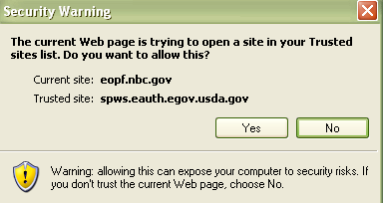
You may receive this warning “Security Warning” . Click “YES”.

STEP 2.

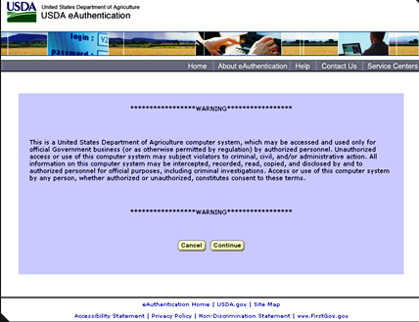
Click on Continue

STEP 3.

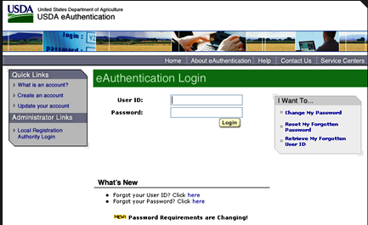
Enter your eAuth User ID
Enter your eAuth Password
NOTE: You may be required to change you e-Authentication password.

STEP 4.

Click on “US Department of Agriculture”

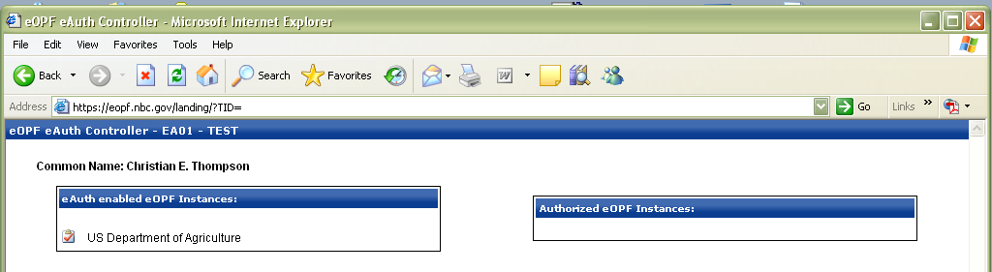

STEP 5.

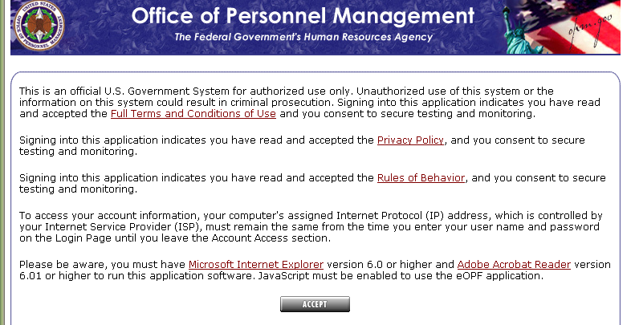
Click on the “ACCEPT”

STEP 6.

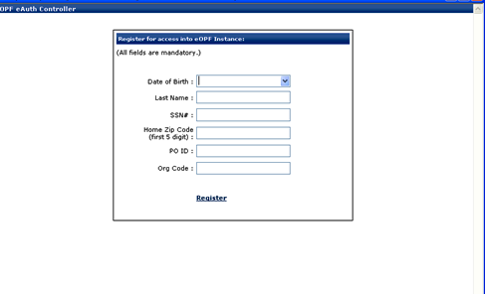
Click on Register
Enter your 18 digit Orgcode, no spaces or dashes
Enter your four digit PO ID:
4860 for ARS
5250 for CSREES, ERS
and NASS
Enter your date of birth – mm/dd/yyyy
(Don’t use the calendar)
Enter your last name (All UPPERCASE)
Enter your Social Security #
Enter your home Zip Code (5 digits only)
only)

STEP 7.

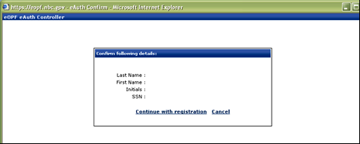
Click on “Continue with registration”
You should now be logged in to the eOPF system!

If you experience any problems with the registration process, please e-mail HRFeedback@ars.usda.gov.

