4
++-

GSA/FSS
Vendor Support Center
Schedules Input Program (SIP)
Version 7.x Documentation

January 17, 2007

VSC-SIP-VER 2.0

Table of Contents

1 GENERAL INFORMATION 1-1
1.1 Introduction 1-1
1.2 GSA Advantage! Overview 1-1
1.3 Schedules Input Program (SIP) 1-1
1.4 Vendor Support Center (VSC) 1-1
1.5 GSA Contract Award 1-1
1.6 GSA Advantage! Catalog Upload Process 1-1
2 GETTING STARTED 2-1
2.1 SIP Registration 2-1
3 SIP DATA ENTRY 3-1
3.1 Contractor Information Screen 3-1
3.2 Primary Contract Information Screen 3-2
3.3 Product Information Screen 3-9
3.3.1 Quantity Volume Discount Breaks 3-10
3.3.2 Dollar Volume Discount Breaks 3-11
3.4 Accessories Information Screen 3-12
3.5 Options Information Screen 3-13
4 ADDING PRODUCT PHOTOS 4-15
4.1 Adding Photos Using Product Information Screen 4-15
4.2 Adding Photos in the Photo Screen 4-16
5 IMPORTING PRODUCTS 5-17
5.1 Import Program Overview 5-17
5.2 Building Import Files 5-17
5.3 Shortcut for Building Import Files 5-17
5.4 Adding Photos Using Spreadsheets 5-18
5.5 Importing Files into SIP 5-18
6 ENTERING SERVICE CATALOG INFORMATION 6-1
6.1 Creating Text Files 6-1
6.2 Attaching Text Files to SIP 6-1
7 Uploading Catalog Information 7-1
7.1 SIP Upload File Types 7-1
7.2 Firewall Settings 7-1
7.3 SIP Upload Instructions 7-1
7.4 Uploading/Using VSC Website 7-2
7.5 Website Upload Conditions 7-2
8 DOWNLOADING AND PROCESSING RESPONSE FILES 8-2
8.1 Downloading and Processing Files 8-3
8.2 Connectivity Errors 8-3
9 BACKING UP AND RESTORING SIP DATA 9-5
9.1 Backing up SIP Data 9-5
9.2 Restoring SIP Data 9-5
10 UPGRADING SIP VERSION 10-6
10.1 Upgrading SIP Version 6.x with Firewall 10-6
10.2 Upgrading From SIP Version 5.2 10-6
11 VENDOR SUPPORT CENTER CONTACT INFORMATION 11-6

GENERAL INFORMATION

Introduction
The Schedules Input Program (SIP) Version 7.x Users Guide defines the process, procedures and tools used to maintain and support the SIP software by the General Services Administration/Federal Supply Services (GSA/FSS) Vendor Support Center (VSC).

GSA Advantage! Overview
GSA Advantage! is a web-based system used by vendors to provide their products and/or services to government buyers. GSA Advantage allows vendors to sell to the government without obtaining agency specific contracts.

Schedules Input Program (SIP)
SIP is a proprietary software program provided by GSA to assist contract holders with uploading their electronic catalog.

Vendor Support Center (VSC)
The VSC supports GSA contract holders that use SIP to upload their data. The VSC also supports password related issues concerning e-Buy and 72(a).

GSA Contract Award
Any contractor interested in providing products and/or services to the government may benefit from obtaining a GSA contract. Most government buyers use GSA Advantage! to search and shop for products and/or services. Companies that wish to acquire a GSA contract must contact a GSA Procurement Contracting Officer (PCO) to obtain the necessary documentation. GSA e-Offers is another tool used to obtain a GSA contract.

GSA Advantage! Catalog Upload Process
After a contract is awarded, the contract must be registered with the VSC. Following registration, a unique password will be assigned to the contract. This password will be used for electronic catalog submission via SIP. Catalog information is then entered into SIP and uploaded. The PCO will receive the file and check for consistency between the electronic file and the written contract. After verification and approval in CORS (Contract Officer Review System) the file is posted in GSA Advantage..

Acronyms and Abbreviations
The acronyms and abbreviations used in this document are listed and defined in the table below.

Acronym | Definition
ATSM/EPA | Acute Traumatic Stress Management/Environmental Protection Agency
CPG | Comprehensive Procurement Guidelines
EDI | Electronic Data Interchange
FOB | Free On Board
FSS | Federal Supply Service
FTP | File Transfer Protocol
GBL | Government Bills of Lading
GSA | General Services Administration
MB | Megabyte
NSN | National Stock Number
PCO | Procurement Contracting Officer
QYY/VOL | Quantity Volume
SIN | Special Items Numbers
SIP | Schedules Input Program
VER | Version
VSC | Vendor Support Center

GETTING STARTED

SIP Registration
You must register your contract before you can upload your catalog. To register, visit the VSC website at (http://vsc.gsa.gov).

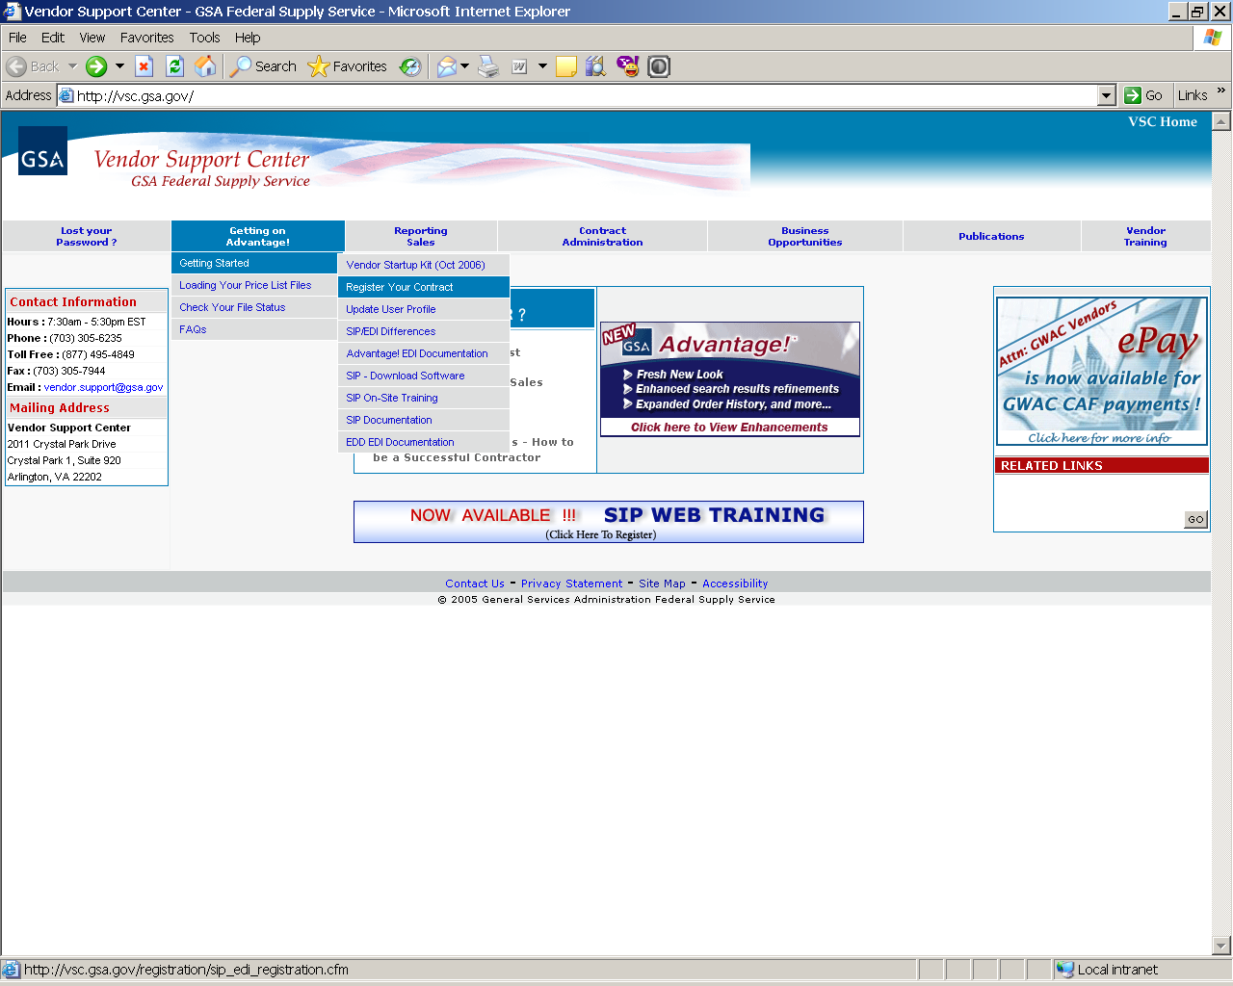
CLICK HERE TO REGISTER

Select “Getting on Advantage” → “Getting Started” → “Register Your Contract”. On the next screen, select the SIP | EDI link. This will bring up a contract number entry screen. Select the appropriate contract type and enter the contract number.
The SIP registration form is shown below. All required information is indicated by
an asterisk (*):

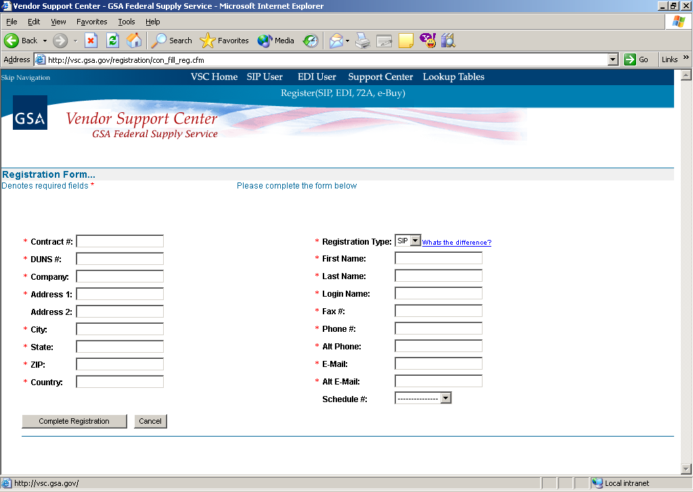

After registration is complete, a confirmation will be sent to the email address provided. The confirmation will include a unique password used for SIP uploads and access to GSA e-Buy!.

SIP Download and Installation

SIP can be downloaded from the VSC website (http://vsc.gsa.gov).

System requirements: Windows 95/98/2000/NT/XP Operating System, Pentium II processor, 32 MB of RAM, internet capabilities and 12 MB of hard disk space.

* Note – Depending on the amount of product data, more disk space may be required.
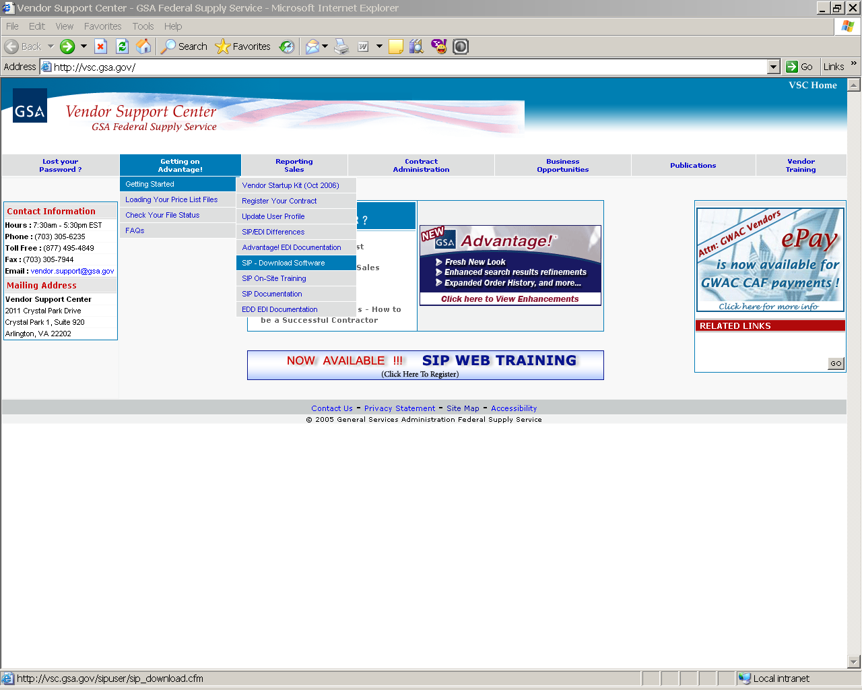
CLICK HERE TO DOWNLOAD SIP

The SIP program is available in two formats (.exe and .zip). The download files are approximately 11.5 MB is size. Vendors with a slower internet connection may want to download the .zip format.

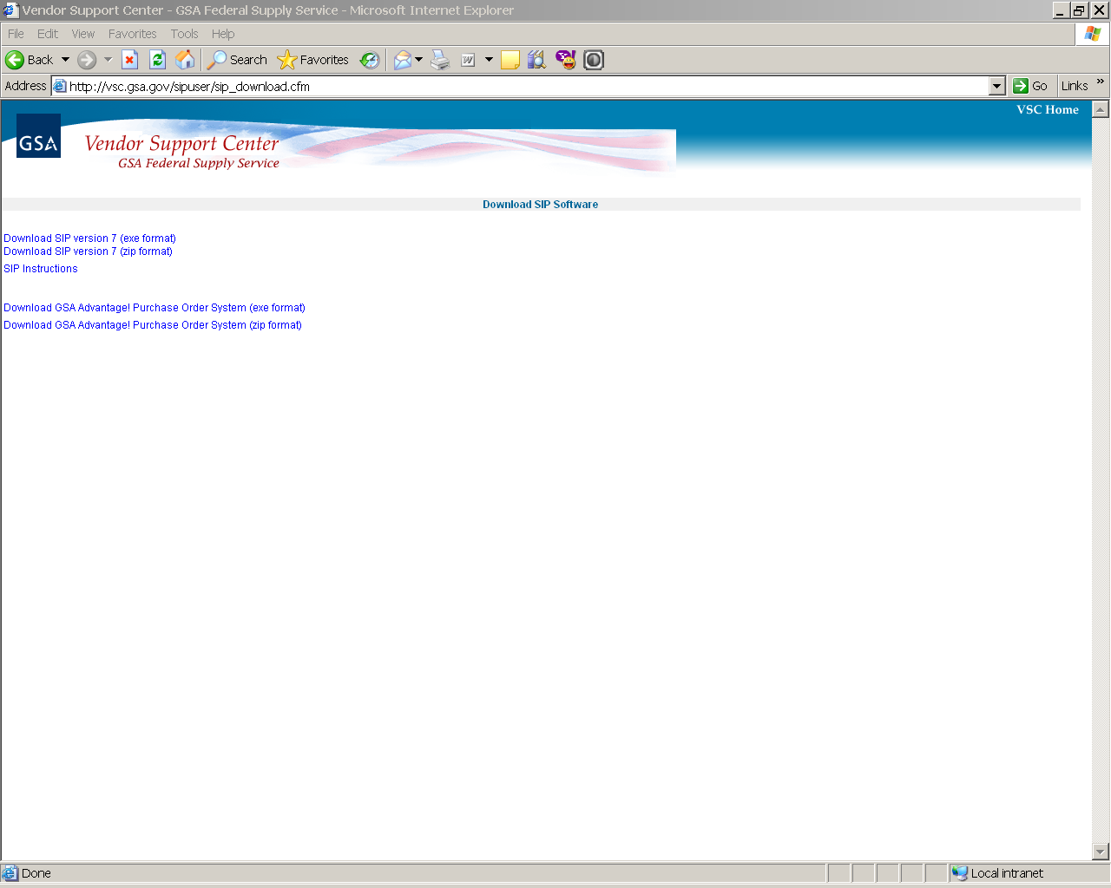
CLICK HERE TO DOWNLOAD SIP (.exe or .zip format)

Step 1: Download and install the .exe or .zip format.

Step 2: Select”Next” on each of the dialog boxes to accept the default settings.

Step 3: Select “Finish” to complete the installation.

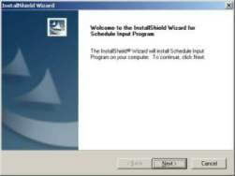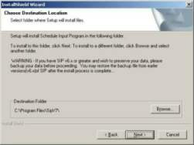

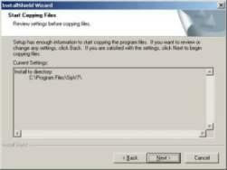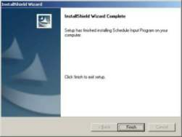

SIP DATA ENTRY
With a new installation of SIP, a dialog box will appear prompting you to “Convert” or “Continue”. If you are a new user select “Continue”. If upgrading from version 5.2C, select “Convert” (Refer to the SIP Upgrades and Conversions section).
.

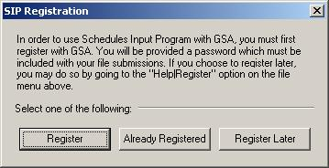

If you have already registered, select “Already Registered”. If you have not registered, select “Register”. After registering, you can import your registration information into SIP. Begin with section 3.2 “Primary Contract Information”. If you selected “Already Registered” begin with section 3.1 “Contractor Information”.

Contractor Information Screen
Step 1: Select “File” → “Open” → “Contractor” or select the “Contractor” icon shown below.

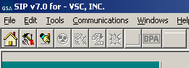
CLICK HERE TO ENTER CONTRACTOR INFORMATION

Step 2: Select “Add”.
Step 3: Enter contractor information and click “Save” at the top of the program.

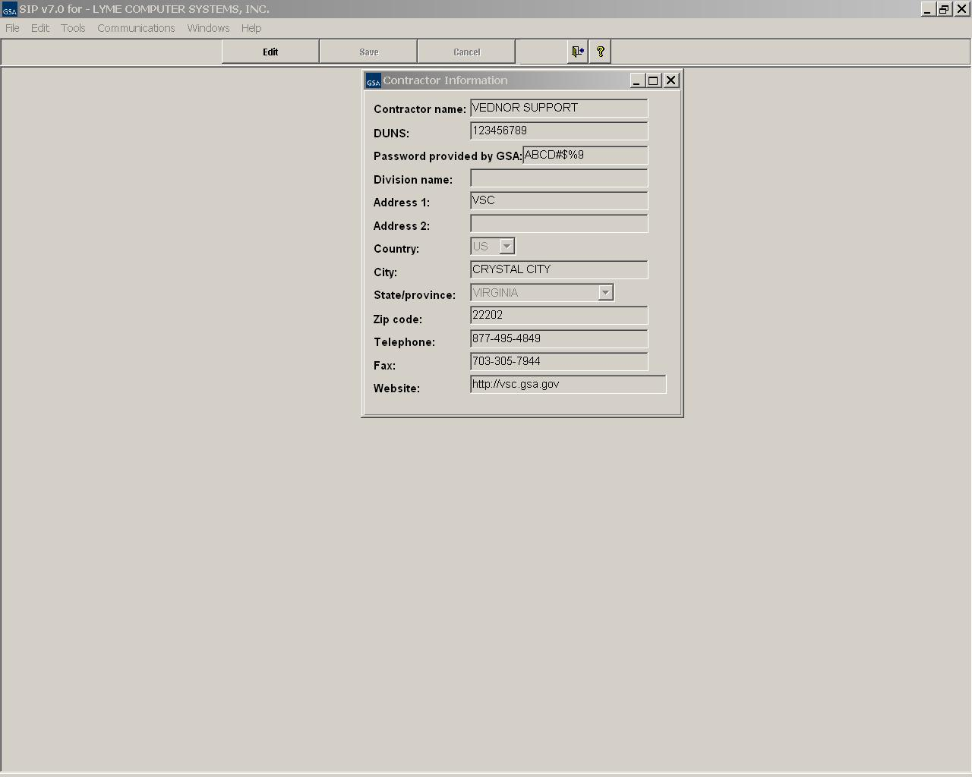

Please see the Index for field descriptions

Step 4: Close the Contractor Information Screen.

Primary Contract Information Screen
Step 1: Select → “File” →”Open” → “Contracts” or select the “Contracts” icon shown below.

CLICK HERE TO ENTER PRIMARY CONTRACT INFORMATION
Step 2: Select “Add”.
Step 3: Enter all required and applicable contract information.
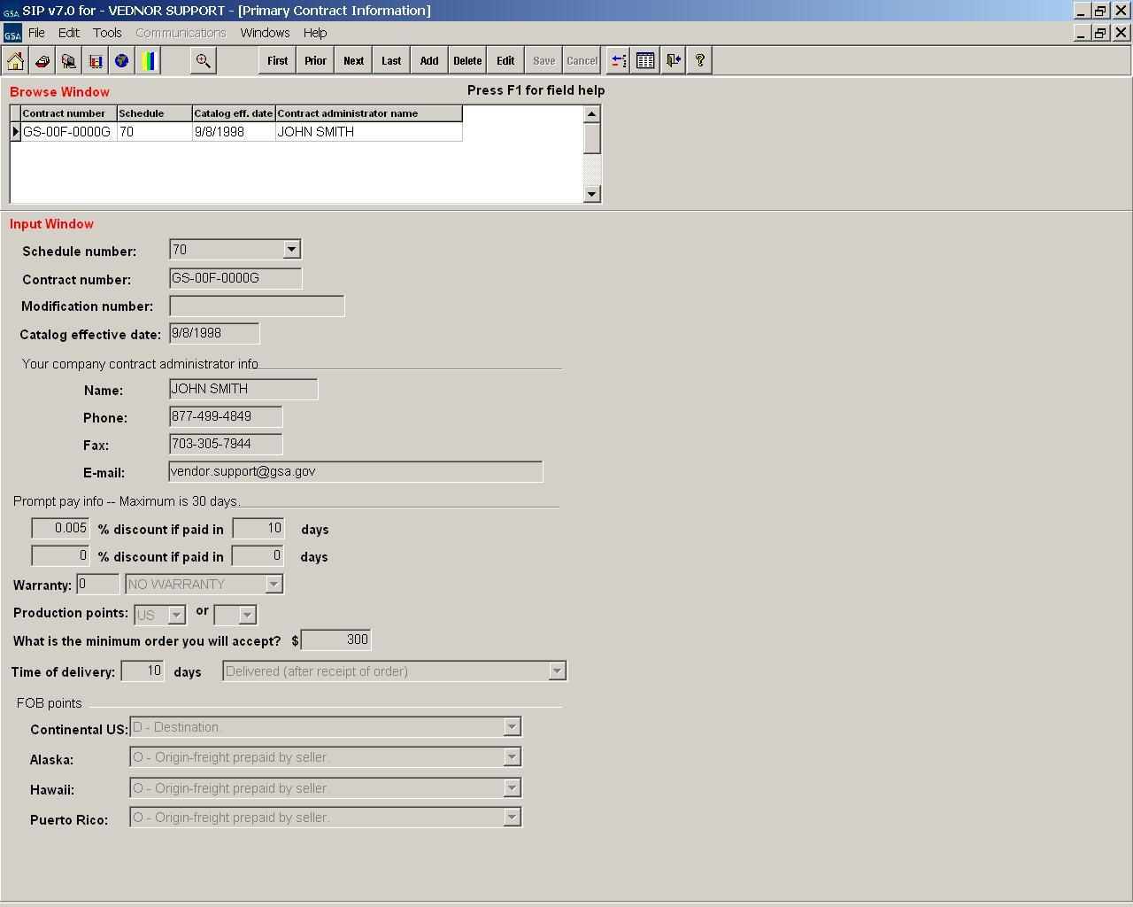

Please see the index for field descriptions
Step 4: Select “Save” when finished.

Step 5: The SIN/Maximum Order screen will appear. Enter Special Item Numbers (SIN's) and Maximum Order Limit(s).
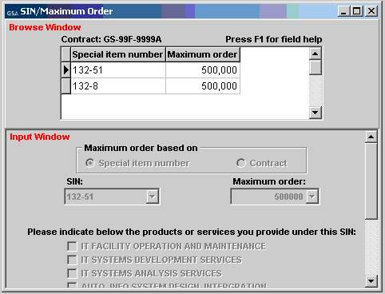

Some SIN may require “Sub SIN’s” or sub-categories. Not all SIN have sub SIN’s. At least one of these sub SIN’s must be selected (checked) in order for the selected SIN to be saved.

NOTE: For each sub SIN selected, it must be attached to at least 1 product. For a list of SIN’s that require sub SIN’s please see the index.

Step 5: Select “Save” and close the SIN/Maximum Order screen.
Step 6: The Order/Payment Address screen will appear. If the address for receiving orders and/or payments is the same as the address entered in the “Contractor Screen”, select the “Use Corporate Address” button to auto fill the information. If not, enter the address information and select “Save”.

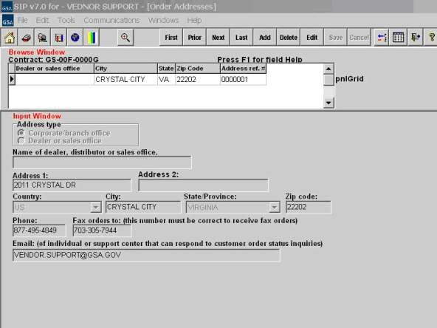
Step 7: Close Order/Payment Address screen.

ZONES
If your pricing varies depending on what part of the country the buyer is located, use this screen.
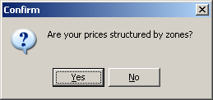

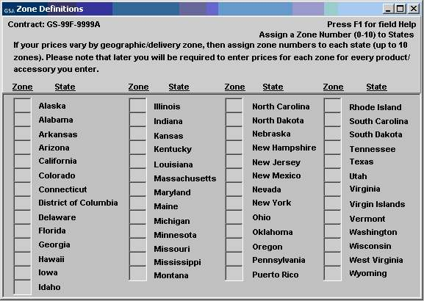

COLORS/FABRICS
If your items have color or fabric options, enter the information here.
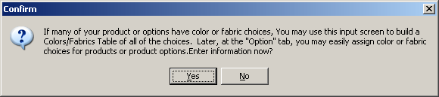

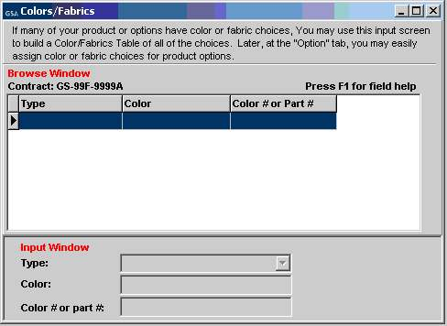

SPECIAL CHARGES
If your items have additional charges enter that information here.
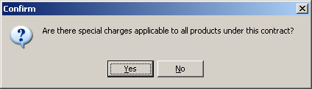

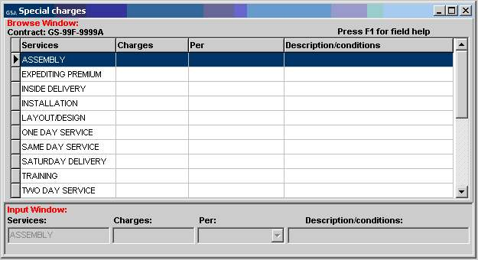
Step 9: Close the Special Charges screen.

Product Information Screen
(Do not enter services in this screen. See section 6.1 on how to enter a text file.)
Step 1: Select “File” → “Open” →”Products” or select the “Products” icon shown below.
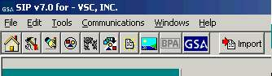
CLICK HERE TO ENTER PRODUCT INFORMATION
Step 2: Select “Add”.
Step 3: Enter product information and select “Save”

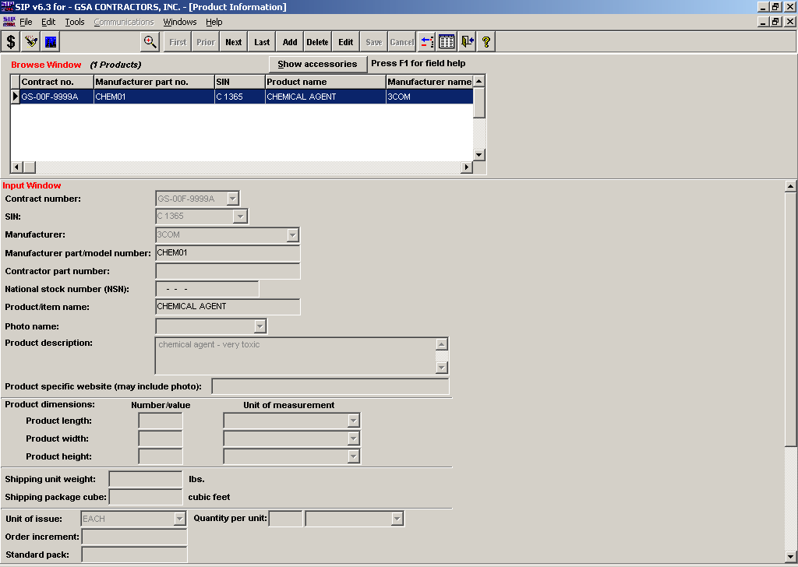

Please see the index for field descriptions

Step 4: The Price Information screen will appear. Enter your pricing information and select “Save” when finished.

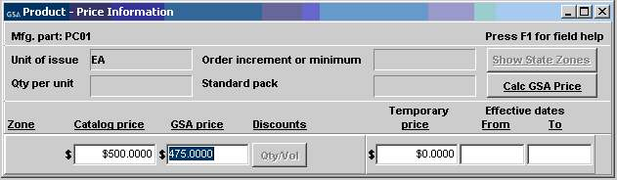
Please see the index for field descriptions

If you have quantity discounts/dollar volume discounts, select the “Qty/Vole” button shown below and select “Edit”.

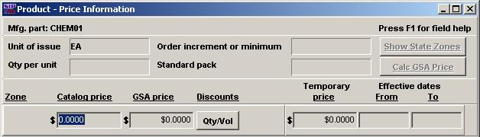
CLICK HERE TO ENTER QUANTITY/DOLLAR VOLUME DISCOUNTS

Quantity Volume Discount Breaks
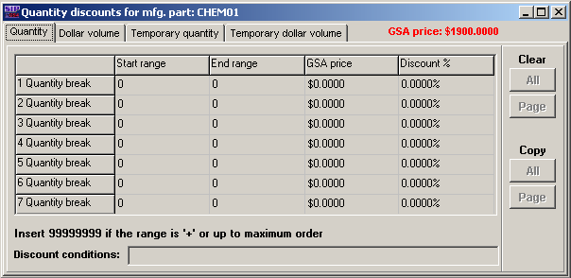

Dollar Volume Discount Breaks
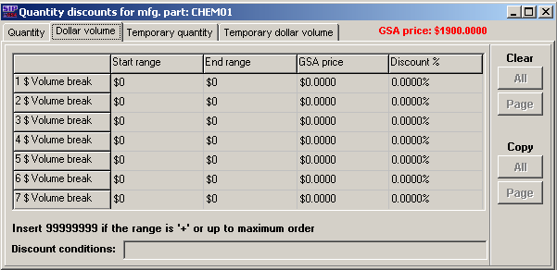

Save and close this screen. You will be redirected back to the “Price” screen.

Step 5: Close the Price Information screen.
Step 6: The Environmental/Special Features screen will appear as shown below. Complete this screen various product features apply.

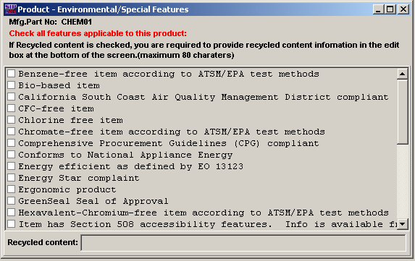
.
The Recycled Content field is only required when the Recycled Content box checked.

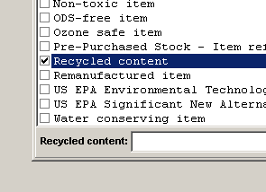

Step 7: Repeat steps 2 - 7 to add additional items.
Step 8: Close Product Information screen.

Accessories Information Screen
Step 1: Select “File” → “Open” → “Accessories” or select the Accessories icon.

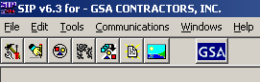
Step 2: Select “Add”.
Step 3: Enter Accessory information and select “Save”.
CLICK HERE TO ENTER ACCESSORY INFORMATION

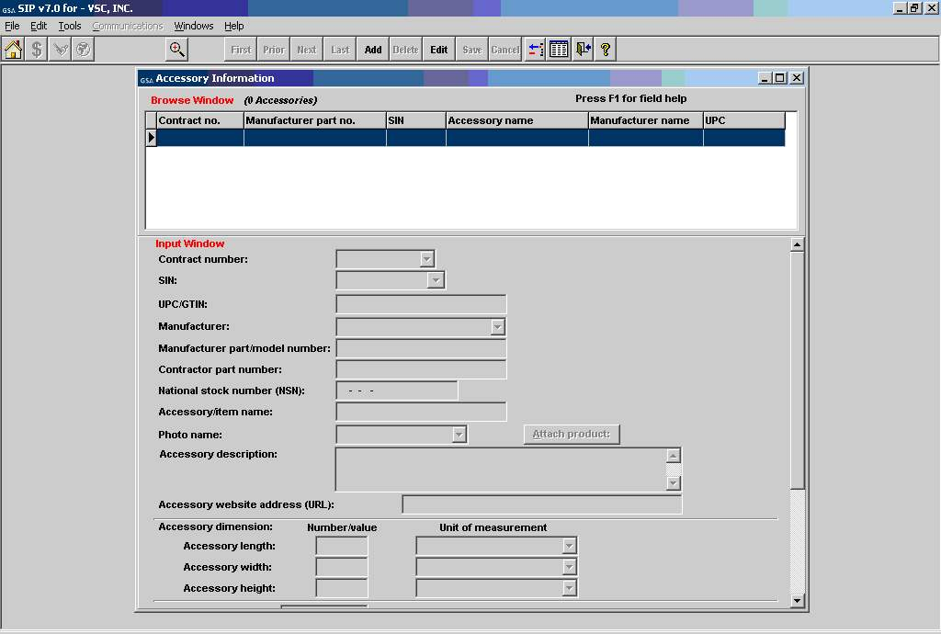

The Accessory screen is identical to the Product screen, with the exception of the “Attach Product” button

Step 4: The Accessory Price Information screen will appear. Enter price information and select “Save” when finished.

Step 5: Repeat steps 2 - 7 to add additional accessories.
Step 6: Close Accessory Information screen.

Options Information Screen
Step 1: Select “File” → “Open” → “Options” or select the Options icon.
CLICK HERE TO ENTER OPTION INFORMATION
Step 2: Select “Add”.
Step 3: Enter option information and select “Save”.

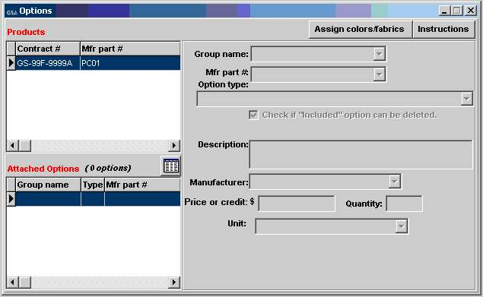

Step 4: Close Options Information Screen.

4

ADDING PRODUCT PHOTOS
Photos can be added using the Product Information Screen or the Photo Screen.

Adding Photos Using Product Information Screen
Step 1: Photo requirements:
- jpg format or gif format
- no larger than 70 kb
- file name can be no longer that 30 characters
- file name should not contain special characters (i.e. space, symbols, etc.)
Step 2: Place the images into the C:\Program Files\SIPV7\photo folder.
Step 3: You can attach the photo in the Product Information screen by selecting a product, selecting “Edit” on the top tool bar, and then select the photo name drop down menu, and choosing appropriate photo file.

NOTE: Image of photo will appear in Product Information Screen once selected. Some images may seem distorted in the Product Information Screen. This does not indicate how the file will view on Advantage!. Images will show correctly on Advantage!.

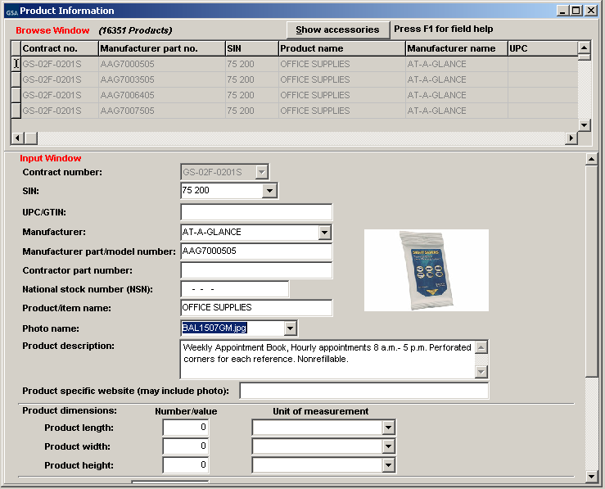
CLICK HERE TO SELECT PHOTO FILE NAME

NOTE: Follow steps 1, 2, and 3 from above to add photos in the Accessory Screen.

Adding Photos in the Photo Screen
Step 1: Follow steps 1 and 2 from above.

Step 2: Select File → Open → Photos. When Photo Screen appears, select “Continue”.

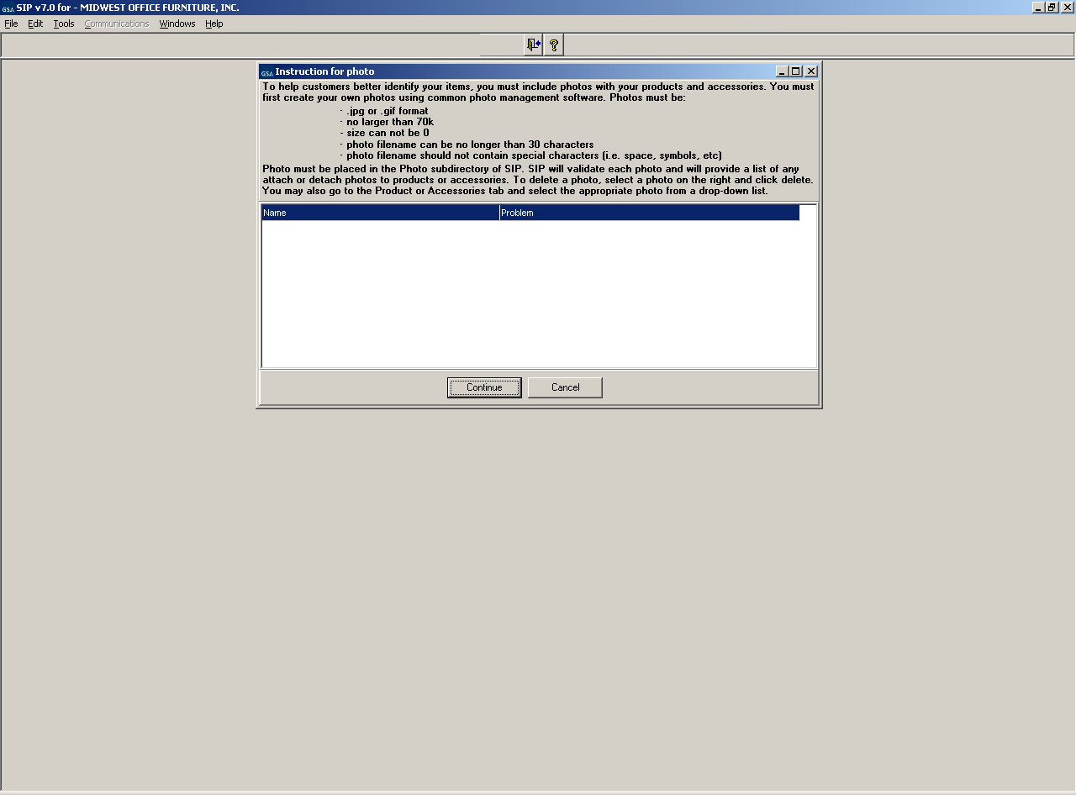

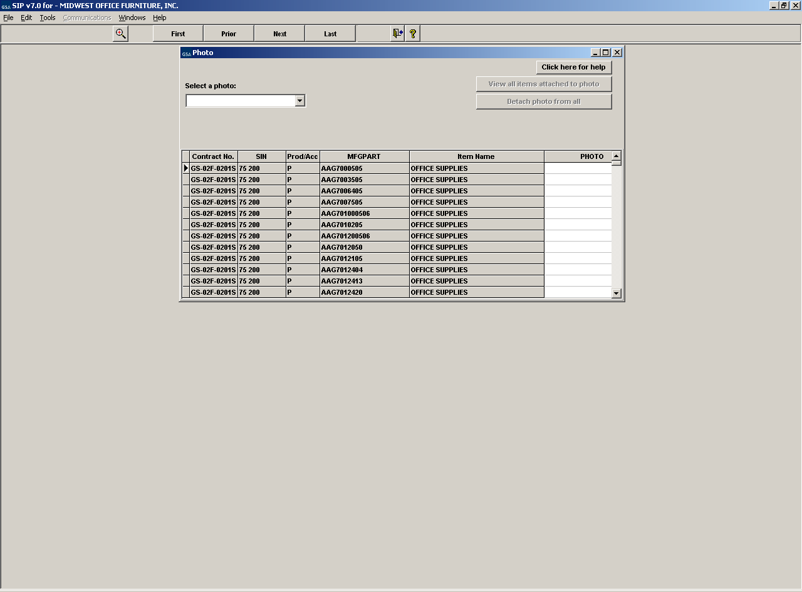
CLICK HERE TO SELECT PHOTO FILE NAME
DOUBLE CLICK HERE TO ATTACH/DETACH PHOTO FILE NAME

Step 3: Select the appropriate photo from the photo drop down menu.

Step 4: Double click in the last column of the table to attach/detach a photo.
Note: You can add a single photo to multiple products.

IMPORTING PRODUCTS

Import Program Overview
The import program is used to enter a large number of products into the SIP program at once. It is suggested that vendors with 100 or more products, use the import program to enter their product data into SIP.

Building Import Files
The import program accepts three file types, ASCII text (.txt), Excel spreadsheets (.xls), and Database files (.dbf). Import Templates are located in the C:\Program Files\SIPV7\import\template folder. Also refer to the SIP Import Excel document located at the VSC website for detailed information on the Excel Import Templates. For further assistance in regards to ASCII text and dbf files, contact the VSC.

Shortcut for Building Import Files
The most efficient way to build your import templates is to manually fill out the first 4 screens in the SIP software (Contractor, Contracts, SIN Max Order, Order Payment). Once those sections are complete, follow the steps below:

Step 1: Select File → Open, → Products or select the “Product” icon shown below. You cannot access the Product screen until the Contractor, Contracts, SIN Max Order and Order Payment screens are complete.

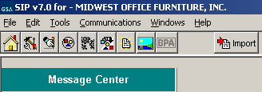
CLICK HERE TO ENTER PRODUCT INFORMATION

Step 2: Follow steps 2 – 7 of the Product Information section and manually enter 10 products.

Step 3: Close the Product Information screen and select “File” → “Export”.

Step 4: Select the export file type.

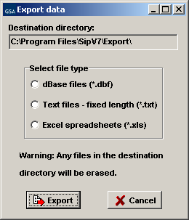

These files will be exported to the C:\Program Files\SIPV7\export folder. The first 10 products you entered in SIP will be in the correct import format. Add the rest of your products to the IPROD and IPRICE files, following the format from the 10 files you manually entered (additional spreadsheets may be required if you have accessories, options, volume discounts, zones or colors/fabrics). Once these files have been completed they MUST be copied or saved to the C:\Program Files\SIPV7\Import folder for importing.

Adding Photos Using Spreadsheets
Step 1: Follow steps 1 and 2 from the photo section
Step 2: Enter photo file name with the extension ( example: photoname.jpg) next to its corresponding part number under column AJ in the IPROD.xls spreadsheet.

Importing Files into SIP
To open the SIP Import program, open SIP and select the “Import” icon. You can also access this program by double-clicking the Import32.exe file located in the C:\Program Files\SIPV7\import folder.

Step 1: Select Import → Move data into import or select the “Move data into import” icon shown below.

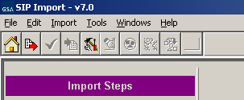
CLICK HERE TO MOVE DATA INTO IMPORT

Step 2: Import Data screen will appear. Select your file type and select Import.

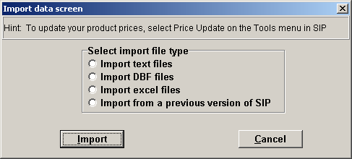
Step 3: Once this process is complete you may receive errors with the file(s) if data was not entered correctly. If this occurs, correct the error(s) indicated in the error report and begin import process from Step 1.

(*NOTE: If you need assistance with this process, contact the Vendor Support Center.)
Step 4: If there are no errors or when the errors are corrected, select “Import” → “Import Data into SIP” or select the “Import Data into SIP” icon shown in step 1.

Step 5: You will then be asked if you would like to append or replace the information currently in SIP. If you are replacing the data in SIP with the information in IPRICE and IPROD, you will need the following data in the import folder (IPROD, IPRICE, ICORPET, ICONTR, IMOLS, and IREMITOR files). If you’re appending your data do not include ICORPET.

Step 6: Close the SIP import function and open SIP by selecting Step 8 on the import menu.

Note: If you have the ICORPET sheet in the import folder, it will always replace the data even if you select append.

ENTERING SERVICE CATALOG INFORMATION

Creating Text Files
Vendors offering services to the Government use the text file feature to explain their services, labor categories and pricing. This option may also be used to explain custom products with approval from the Contracting Officer.

Step 1: Create a document explaining the services your company offers along with your prices. The formats that are acceptable are Microsoft Word (.doc), Adobe Acrobat (.PDF), Excel Spreadsheet (.xls) and Web Page (.htm/.html). NOTE: File names must not include spaces or special characters and must not exceed 70 characters. This document may include but not limited to the following:

- Company’s Information (name, address, phone and fax numbers, web address, and point of contact information)
- Contract Information (contract number, schedule number and description, SIN numbers and description)
- Table of Contents
- Terms and Conditions
- Labor Categories
- Labor Categories Description
- Price List

NOTE: Check with your Contracting Officer for text file page format.

Attaching Text Files to SIP
Step 2: Save or copy your text file into the C:\Program Files\Sipv7 \text file folder.

Step 3: Open SIP, select “File” → “Open” → “Text Files” or select the text file icon.

Step 4: Choose “Select File” on the bottom left of the screen

Step 5: Select the drop down arrow and select your file.

NOTE: Any file in the text file folder will appear in the drop down list. There is also an option to enter a URL linking to your company website that explains your services. You cannot attach a text file and enter a URL.

Step 6: Select “Save” at the top of the program.

Step 7: Close Text File screen.

Uploading Catalog Information

SIP Upload File Types
SIP allows you to upload your product or service information and prices in six (6) file types. SIP catalog file types are:

- A60 Original File: Contains original information to be placed on Advantage!

- C60 Change file: Changes made to existing file on GSA Advantage!

- R60 Replacement file: Replacing entire catalog on Advantage!

- W60 Text file: Text File document

- P60 Photo File: Contains all photos you have attached in SIP

- T60 Temporary Price File: Any temporary prices start and stop dates.

Firewall Settings
When uploading using SIP and you are on a network, please make sure you have full administrative rights. FTP (port 22) should be open both inbound and outbound to our web address http://vsc.gsa.gov.

SIP Upload Instructions
After all the products, service and price information are entered into SIP, and you are connected to the internet:

- Select “Communications” → “Create Catalog File”. This will generate an A60 or C60 file depending if (1) this is the first time uploading with the current SIP program (A60) (2) you’ve made changes to the existing file in SIP (C60). To create an R60 (Replacement) file, select “Communications” → “Create a Replacement File” to replace the catalog on GSA Advantage! with the new catalog in SIP. If you have a text file attached, SIP will generate a W60 file.

- When the program has notified you that the files were created successfully, Select → “Communications” → “Send Catalog File(s)” → “Send”. At the top of the dialog box, you will see “Select File Type”. Make sure “New Catalog” is selected. Select the button labeled “Click Here to Start Upload” (upload times will vary depending on the size of the files).

Uploading/Using VSC Website
If you are behind a firewall or having connectivity issues with SIP, you can upload using our Vendor Response Retrieval and Catalog Upload System website http://vsc.gsa.gov/sipuser/get_files.cfm. You can attach SIP files and successfully upload information to GSA Advantage!. Before uploading file(s) using the website, create the catalog files using the SIP program (see step 1 in SIP Upload Instructions.)

Website Upload Conditions
The Vendor Response Retrieval and Catalog Upload System website is only used if you can not upload using SIP because of firewall issues, or connectivity issues.

Website Upload Instructions
- Log into the Vendor Response Retrieval and Catalog Upload System website http://vsc.gsa.gov/sipuser/get_files.cfm using your GSA contract number and user name. Select the “Upload” radio button and select “Proceed”.

- Click on the browse button(s). From the “Choose File” box and browse to C:\Program Files\Sipv7\Upload folder.

- Attach file(s) from this location. When attaching a photo file (P60) use the browse button for photo. You can only upload A60, C60, R60, W60, P60 OR T60 extensions

- After all files are attached to the website, click on button labeled “Upload Files”.

The website will notify you of a successful upload. After uploading catalog files, please log out of website.

DOWNLOADING AND PROCESSING RESPONSE FILES
After files are uploaded successfully through SIP, a message will appear each time SIP is accessed. This message will read, "SIP is waiting on a response file..." until the electronic response file(s) are downloaded and processed. Electronic response files are available via SIP the day after you receive a fax or e-mail response from your GSA contracting officer.
Download file types: .A60= Original file, .C60= Change file, .R60= Replacement file, .W60= Text file

Downloading and Processing Files
Step 1: Open SIP. A message will appear "SIP is waiting on a response file..."
Step 2: Select "I want to download".
Step 3: Select “Check for Response Files”. Must be connected to the internet to download response file(s). If you experience connectivity problems or if file is not available for download, send e-mail to vendor.support@gsa.gov or call the Vendor Support Center at 877-495-4849.
Step 4: Once download is complete, click OK and close the dialog box
Step 5: Dialog box will appear stating, "Response files are ready to be processed." Select “Process Now.” After processing is complete, you can review the file.
Step 6: Close the screen to return to the main menu

Connectivity Errors
If you’ve uploaded using the Vendor Response Retrieval and Catalog Upload System, follow the steps below.

Step 1: Go online to the Vendor Response Retrieval and Catalog Upload System (http://vsc.gsa.gov/sipuser/get_files.cfm).

Step 2: Enter your contract number and username, select “Download”, and click “Login”.

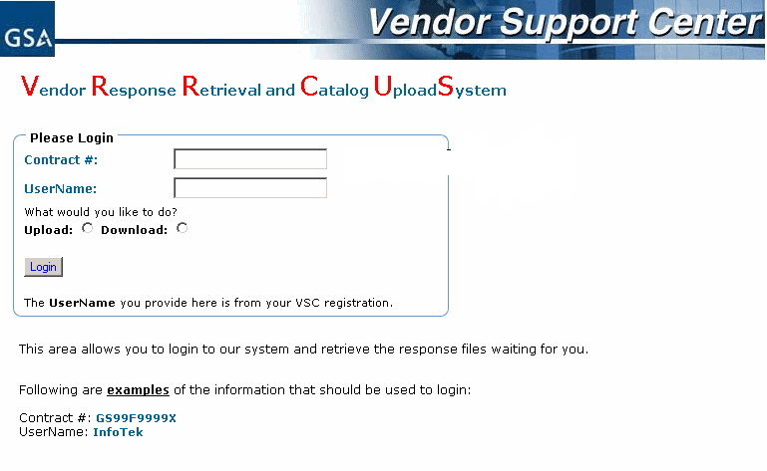
Step 3: Follow the instructions in the screen shot below.
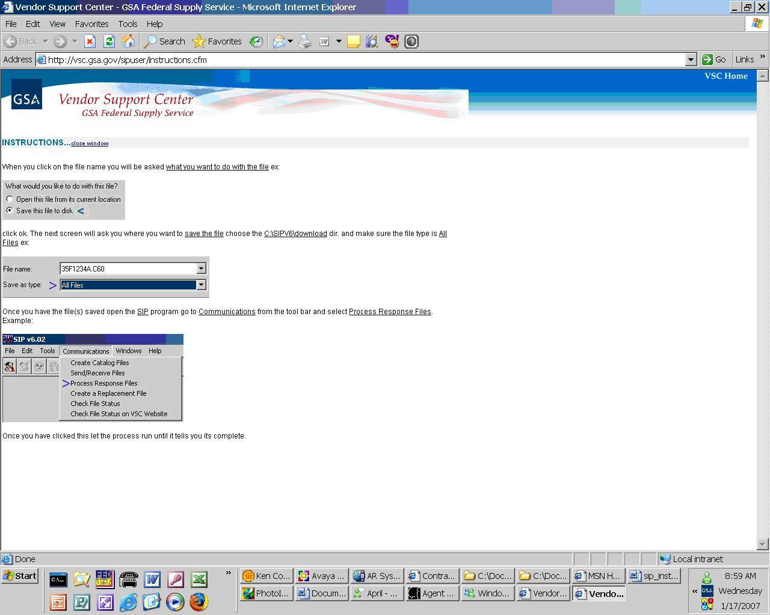

BACKING UP AND RESTORING SIP DATA

Backing up SIP Data
To backup data, select “Tools” → “Backup”.

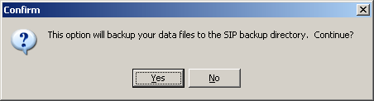

Select “Yes”

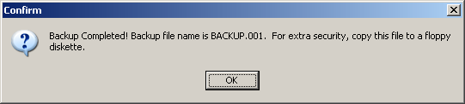

Select “OK” to complete process.

The process created a file called backup.001. This file is located in the C:\Program Files\SIPV7\backup folder. Keep a copy of this file in another location (CD, floppy, network drive, etc.). If you lose your SIP data and do not have a backup file, you must re-enter the entire catalog in SIP. We do not keep copies of this file.

Restoring SIP Data
Copy the backup.001 file into the C:\Program Files\SIPV7\backup folder. Open SIP and select “Tools” → “Restore”.

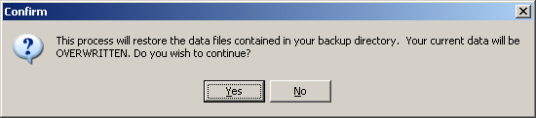

Select “Yes” to restore SIP data.

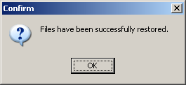

Select “OK”

UPGRADING SIP VERSION
SIP version 6.x automatically searches for upgrades when the SIP program is closed and will upgrade to version 7. For versions earlier than 6.x or for those with firewalls preventing automatic upgrades please read below:

Upgrading SIP Version 6.x with Firewall
If SIP version 6.x does not upgrade automatically to version 7, follow section 6.1 “Back up SIP Data”. Download latest version of SIP from the Vendor Support Center website (http://vsc.gsa.gov), and then follow section 6.2 “Restoring SIP Data”. After you backup your data, save the backup.001 file on a different drive to prevent any data loss.

Upgrading From SIP Version 5.2
Contact the VSC

VENDOR SUPPORT CENTER CONTACT INFORMATION
For any problems regarding SIP or SIP documentation, send an email to vendor.support@vsc.gsa.gov or call the Vendor Support Center at (703) 305-6235 or toll free at (877) 495-4849.

INDEX
Contractor Screen
FIELD NAME | REQUIRED (Y/N) | DESCRIPTION
Contractor Name | Y | Company/Business Name
DUNS | Y | Dun and Bradstreet Number
Password Provided by GSA | Y | Password provided at the time of SIP registration.
Division Name | N | Not required
Address 1 | Y | Company/Business Street Address
Address 2 | N | Additional address info. (ex. Suite 900)
Country | Y | Country
City | Y | City
State | Y | State
Zip Code | Y | Zip Code
Telephone | Y | Business Phone Number
Fax | Y | Business Fax Number
Website | N | Business website/URL

Contracts Screen
FIELD NAME | REQUIRED (Y/N) | DESCRIPTION
Schedule Number | Y | GSA Schedule Category Number
Contract Number | Y | Assigned GSA Contract Number
Modification Number | N | Required only when there is a modification to original contract. Modification Number will be given by assigned Procurement Contracting Officer (PCO).
Catalog Effective Date | Y | Date GSA contract was awarded
Name | Y | Company Contract Administrator’s name
Phone | Y | Company Contract Administrator’s phone number
Fax | Y | Company Contract Administrator’s fax number
E-Mail | Y | Company Contract Administrator’s e-mail address
Prompt Pay Info | N | Additional discount if payment is made within a certain number of days
Warranty | Y | Warranty information; if no warranty applies select “No Warrenty” from drop down menu
Production Points | Y | Country(ies) where products are manufactured. If you provide services use “US”
Minimum Order | Y | Minimum order amount
Time of Delivery | Y | Time of Delivery of products:  Shipped – Products will be shipped in indicated number of days after the receipt of order  Delivered – Products will be delivered in the indicated amount of days after the receipt of order  Contracts providing services must select “from date of award to date of completion”
FOB Points | Y | Freight information  D – Destination  O – Origin – Freight prepaid by seller  G – Origin – Freight paid by buyer from GBL  W – Worldwide (Continental US = destination, Outside Continental US = origin)  N – No delivery to this destination

Products Screen
FIELD NAME | REQUIRED (Y/N) | DESCRIPTION
Contract Number | Y | Assigned GSA Contract Number
SIN | Y | Special Item Number
UPC/GTIN | N
Manufacturer | Y | Manufacturer of Product
Manufacturer part/model number | Y | Manufacturer part/model number of product
Contractor part number | N | Contractors that use their own part number scheme rather than the manufacturers part number
National Stock Number (NSN) | N | National Stock Number
Product/Item Name | Y | Name of Product or Item
Photo Name | N | Filename of photo associated with product - Note:The Photo Name field can only be entered when all appropriate photos files have been placed in the C:\Program files\SIPV6\Photo folder and follow all photo criteria. Please refer to the “Addding Product Photos” section.
Product Description | Y | Detailed description of products. (1000 character limit)
Product Specific Website | N | URL for webpage with product information or company website
Product Length | N | Length of product packaging – NOTE: This field is required when FOB point value is O, G, or W.
Product Width | N | Width of product packaging – NOTE: This field is required when FOB point value is O, G, or W.
Product Height | N | Height of product packaging – NOTE: This field is required when FOB point value is O, G, or W.
Unit of Measurement | N | Unit of measurement used for product length, width, and height - NOTE: This field is required when Product Length, Width, and Height are entered.
Shipping Unit Weight | N | Shipping weight of packaged product - NOTE: This field is required when FOB point value is O, G, or W.
Shipping Package Cube | N | Shipping Package Cube (cubic feet) - NOTE: This field is required when FOB point value is O, G, or W.
Unit of Issue | Y | Unit in which the product is issued/sold
Quantity Per Unit | N | This field is activated when the Unit of Issue requires additional information.
Order Increment | N | Order increment information
Time of Delivery | Y | Number of days in which product will be delivered.
Warranty | Y | Warranty information.
Production Points | Y | Country in which product is manufactured.

Price Screen
FIELD NAME | REQUIRED (Y/N) | DESCRIPTION
Unit of Issue | Y | Cannot be edited in pricing screen. Must be edited in product information screen.
Quantity per unit | N | Cannot be edited in pricing screen. Must be edited in product information screen.
Order Increment or minimum | N | Cannot be edited in pricing screen. Must be edited in product information screen.
Standard Pack | N | Cannot be edited in pricing screen. Must be edited in product information screen.
Catalog Price | Y | Catalog/Commercial Price
GSA Price | Y | GSA Price
Temp Price | N | Temporary discount price – must be lower than GSA price
Effective Date From | N | Temporary discount start date – required if temp price is entered
Effective Date To | N | Temporary discount end date – required if temp price is entered

QTY/Vole Screen
FIELD NAME | REQUIRED (Y/N) | DESCRIPTION
Start Range | Y | Start range (quantity or dollar volume amount) of current break. Start range MUST be 1 greater than previous end range. First start range must be greater than 1. The number 1 is already assumed to be the original GSA price.
End Range | Y | End range (quantity or dollar volume amount) of current break. The final end range value MUST be entered as 999999999 to indicate infinite value OR up to maximum order.
GSA Discount price | Y if → | GSA discount price OR discount percentage is to be entered. Both fields cannot be used.
Discount % | Y if → | GSA discount price OR discount percentage is to be entered. Both fields cannot be used.
Discount Conditions | N | Conditions to discounts that may apply to the product.

Accessories Screen
FIELD NAME | REQUIRED (Y/N) | DESCRIPTION
Contract Number | Y | Assigned GSA Contract Number
SIN | Y | Special Item Number
Manufacturer | Y | Manufacturer of Accessory
Manufacturer part/model number | Y | Manufacturer part/model number of accessory
Contractor part number | N | Contractors that use their own part number scheme rather than the manufacturers part number
National Stock Number (NSN) | N | National Stock Number
Accessory/Item Name | Y | Name of Accessory or Item
Photo Name | N | Filename of photo associated with product - Note:The Photo Name field can only be entered when all appropriate photos files have been placed in the C:\Program files\SIPV6\Photo folder and follow all photo criteria. Please refer to the “Addding Product Photos” section.
Attach Product | Y | Attach a product to the accessory. All accessories must be attached to at least one product.
Accessory Description | Y | Detailed description of accessory. (1000 character limit)
Accessory Specific Website | N | URL for webpage with accessory info or company website
Accessory Length | N | Length of accessory packaging – NOTE: This field is required when FOB point value is O, G, or W.
Accessory Width | N | Width of accessory packaging – NOTE: This field is required when FOB point value is O, G, or W.
Accessory Height | N | Height of accessory packaging – NOTE: This field is required when FOB point value is O, G, or W.
Unit of Measurement | N | Unit of measurement used for accessory length, width, and height - NOTE: This field is required when Accessory Length, Width, and Height are entered.
Shipping Unit Weight | N | Shipping weight of packaged accessory - NOTE: This field is required when FOB point value is O, G, or W.
Shipping Package Cube | N | Shipping Package Cube (cubic feet) - NOTE: This field is required when FOB point value is O, G, or W.
Unit of Issue | Y | Unit in which the accessory is issued/sold
Quantity Per Unit | N | Required when Unit of Issue is BOX, CASE, PACK, etc. Used to provide quantity within the BOX, CASE, PACK, etc.
Order Increment | N | Order increment information
Time of Delivery | Y | Number of days in which accessory will be delivered.
Warranty | Y | Warranty information
Production Points | Y | Country in which accessory is manufactured

Options Screen
FIELD NAME | REQUIRED (Y/N) | DESCRIPTION
Group Name | Y | Accessory group name
Manufacturer Part # | Y | Manufacturer’s accessory part number
Option Type | Y | How option will relate to base product. Values are I=included, S=substituted, A=added, and O=none can be selected for group. NOTE: Option type “S” can only be used if first option in group has an option type”I”.
Description | Y | Accessory description
Manufacturer | Y | Manufacturer of accessory
Price or Credit | Y | Price or credit of accessory
Quantity | Y | Number of accessory(s)
Unit | Y | Unit of measurement of accessory

