 | ~ Human Resources Operations~ Newsletter
Thursday, August 31, 2006 Volume 2
In This Issue  - New OST Employees  - Helpful Tips  - The Benefits Corner  - Automated Leave Request  - New HR Customer  Survey Box  The HRO Team  Associate Director  Deborah Mason – X66202  Employee Relations  John Sutherland – X69444  Program Assistant  Charisse Abarca – X30554  HR Program Manager  Nancy Raum – X63887  HRO Service Team  Sally Ruble (Supervisor) – X69418  Eric Boyd – X69083  Mark Pinkney – X69449  HRO Processing Team  Vanessa Usual (Supervisor) – X60391  Marquee’ Holmes – X63893  Tamieka Cox - X69387  Terrance Sims – X68944  Main Number – X64075  HRO Benefits Team  Casey Schaffer (Supervisor) – X69412  Zee Grant - X66390  Delores Griffin – X64140  “HRO Values”  - Superior Customer Service  - A Commitment to Excellence  - Personal and Organizational Accountability  Additional Contacts  Departmental Office of Human Resources  Nancy Gauthier – X69453  (SES Appointees)  Joan Simpson – X63891  (Political Appointees) | What We Do – Human Resources Operations (HRO)    - HRO Service Team  HR Consultants in the areas of Recruitment and Staffing; Pay and Leave; Classification; Position Management; Employee Relations  - HRO Processing Team  Federal Personnel and Payroll System (FPPS); Pay and Leave Issues; Processing Personnel Actions;  Official Personnel File Maintenance; Entrance on Duty Orientation; Leave Donor Program;  eLMS Administrator  - HRO Employee Benefits Team  Retirement Counseling; Thrift Savings Plan (TSP); Health Benefits; Flexible Spending Account (FSA);  Military and Civilian Deposits; Life Insurance; Long Term Care Insurance; Workers’ Compensation;  VERA/VSIP Management  Join us as we welcome the newest  members of OST…  EMPLOYEE ORGANIZATION  Janae D. Barker Office of the Assistant Secretary for Governmental Affairs  Kristen M. Bracmort Office of the Assistant Secretary for Administration  Robert E. Ellington Office of the Chief Information Officer  Sherri L. Ellis Office of the Chief Information Officer  Travis S. Joyner Office of the Secretary – Executive Secretariat  Amanda Kilanowski Office of the Assistant Secretary for Transportation Policy  Cora McVey Office of the Assistant Secretary for Administration  Vincent Mercadante Office of Intell. Security and Emergency Response  Daniel J. Nash Office of the Assistant Secretary for Administration  Jeffrey D. Pound Office of the Chief Information Officer  Edward C. Ramos Office of the Assistant Secretary for Budget and Programs  Denise Rodriguez-Lopez Small & Disadvantage Bus. Utilization  Laurel Y. Williams Office of the Assistant Secretary for Administration    *Helpful Tips*  It’s that time of year again…Have you started writing up your accomplishments?  Here is an acronym that may be helpful.  C = Challenge –What was the situation or problem you had to confront?  A = Action – What did you do to help?  R = Result – What was the outcome of your results?  Use this as you start to think about your accomplishments and how to express them clearly.  The Benefits Corner  Do you know who your beneficiaries are?  Once you've designated someone as your beneficiary, that person remains your beneficiary – no matter what family or personal life changes you experience – UNLESS you cancel or change your designation in writing. Take a moment to consider the following:    - Are you sure that, if you die, any money payable would be paid to the  person you want?  - Take time to review your beneficiaries. It only takes a few moments to  protect your survivors.  - If you are not satisfied with your current designation of beneficiary, you  should complete all new forms.    - FEGLI, SF-2823, http://opm.gov/forms/pdf_fill/sf2823.pdf  - FERS, SF-3102, http://opm.gov/forms/pdf_fill/sf3102.pdf  or CSRS, SF-2808, http://opm.gov/forms/pdf_fill/SF2808.pdf  - Unpaid Compensation, SF1152, www.opm.gov/forms/pdf_fill/SF1152.pdf  - Thrift Savings Plan, TSP-3, http://tsp.gov/forms/tsp-3.pdf  For more information, please visit the DOT benefits website at benefits.dot.gov or call a member of the employee benefits team.  Coming soon to a computer near you…  “Automated Leave Request”  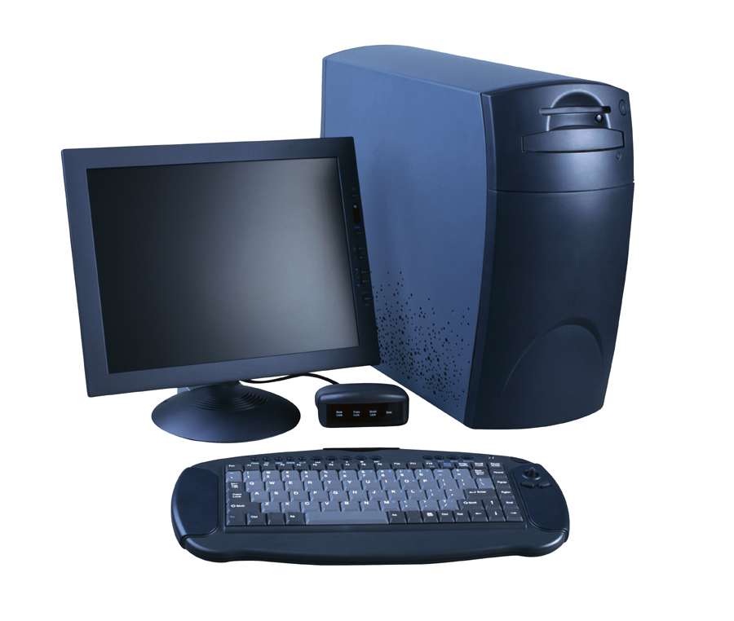  The automated leave request features will include…  *Advantages for Employees*  - Simple online entry of leave requests  - Immediate email notification of leave approval  - Handy online Employee Leave Calendar showing leave requests and approval status.    *Advantages for Approving Officials*  - Immediate email notification of leave requests  - Easy online approval of leave requests  - Useful online Group Leave Calendar showing requested leave and approval status for all employees in the timekeeping group.  *Advantages for Timekeepers*    - Convenient “Enter approved Leave” button to automatically fill the timecard with leave information from approved leave requests.  - Helpful Leave Discrepancy Report to identify discrepancies between leave request and the leave recorded on an employee’s timecard.  - Valuable online history of leave requests.  Customer Survey Drop Box    We want to hear from you! Next time you are in our suite, room 2225, please take a moment to complete our customer survey. Your feedback is greatly appreciated.

