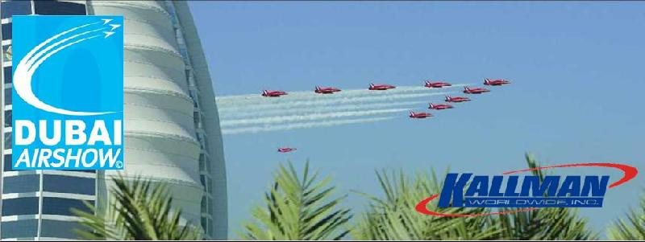

Jebel Ali, Dubai, UAE | 15 -19 Novemember 2009

  Quick Links
  Show Info
  Calendar of Events
  Creative Services
  About Us
  2007 Highlights
  Over 850 exhibitors
  45,421 trade visitors
  140 aircraft
  $155.5 billion in orders
  Visit Us at NBAA
  Booth # 21636
  
  The Middle East is a market that no one in the aviation industry can afford to ignore. With that in mind, the Dubai Air Show, taking place November 15 -19, 2009, is an event that is a must for U.S. companies looking to do business in the region. Consider this:
  Six of the world's top 20 growth markets for the aviation sector are located in the Middle East
  Middle East airlines will need to purchase at least 1100 airplanes worth US$160 billion by 2027
  Etihad, the Abu Dhabi based carrier, will increase its fleet by some 100 aircraft worth over $40 billion
  Fly Dubai has purchased 54 Boeing aircraft to begin operation at the beginning of 2009
  The governments are pouring over $25 billion into airport expansion projects, and capacity in the region is expected to reach over 300m passengers by 2025
  Moving to a brand new location at the Dubai World Central, Jebel Ali, the 2009 Dubai Air Show will raise the benchmark for world-class aerospace facilities. Covering over 425,000 square meters, the facility is double the size of Airport Expo Dubai, with more than 42,000 square meters of exhibition space, 130 chalets and a car park that will hold 7000 vehicles. The Dubai Air Show is a trade only business-to-business exhibition, allow exhibitors to focus entirely on their customers and key contact over the 5 day event.
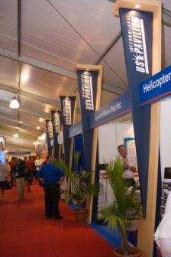U.S. International Pavilion

Kallman Worldwide is proud to be organizing the U.S. International Pavilion at the Dubai Air Show 2009. For over 45 years Kallman Worldwide has organized award winning pavilions at hundreds of international shows and we are pleased to be able to add this credible fixture to our portfolio. We are looking forward to bringing our expertise and quality service to U.S. Exhibitors at the 2009 Dubai Air Show.

For additional details on exhibiting options and pricing please contact:

Gerri Cozic
Aerospace & Defense Program Manager
gerric@kallman.com

or Justin Griffing
Sales & Marketing Associate
justing@kallman.com

Helping U.S. Companies "Exhibit With Confidence" Around the World

