
- NEWS -

Technology Contracts on GSA eBuy!

GSA eBuy has several different types of Technology Contracts: IT Schedule 70, Governmentwide Acquisition Contracts (GWACs) and Network Services and Telecommunications contracts. Network Services & Telecommunications contracts are NEW on GSA eBuy.

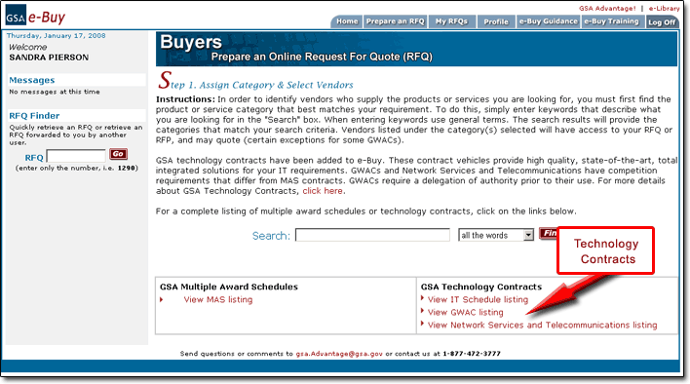

Network Services and Telecommunications

Network Services and Telecommunications contracts cover the whole spectrum of IT solutions, from network services and information assurance to telecommunications and purchase of hardware and software.

NOTE: Only warranted Contracting Officers for a Federal Agency; an authorized user under GSA Order ADM 4800.2E as revised; or an authorized user approved by GSA under FAR 51.102 may place orders. Each contract has a pre-qualified pool of contractors which must be given fair consideration in accordance with FAR 16.505(9)(b). You may not compete MAS contracts and GWACs with these contracts.

Click on “View Network Services and Telecommunications listing” to see Satellite Services II (SATCOM II). Currently SATCOM II is the only Network Services & Telecommunications contract available online, however, more will soon be loaded.

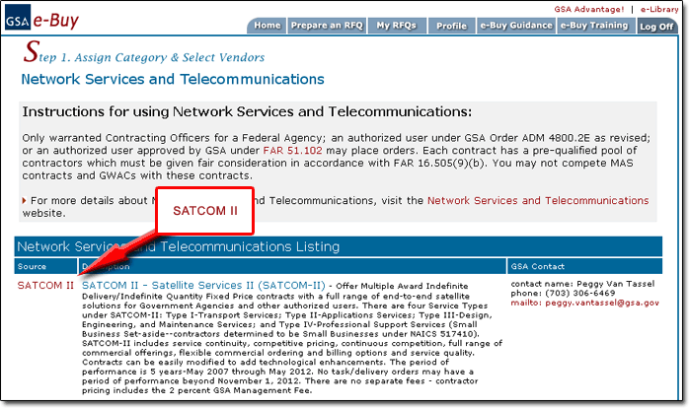

What is SATCOM II?

SATCOM II (Satellite Services-II) offers multiple award IDIQ Fixed Price contracts that provide an expanded range of end-to-end satellite solutions for government agencies. They are not GSA Schedules, GWACs, or Multi-agency Contracts (MACs). The benefits of SATCOM II are competitive pricing, continuous competition, a full range of commercial offerings, flexible commercial ordering and billing options, and high service quality.

Contracts can be easily modified to add technological enhancements. The period of performance is 5 years—May 2007 through May 2012. No task/delivery orders may have a period of performance beyond November 1, 2012. There are no separate fees--contractor pricing includes the 2 percent GSA Management Fee.

From the page above, click on SATCOM-II to view the available service categories.
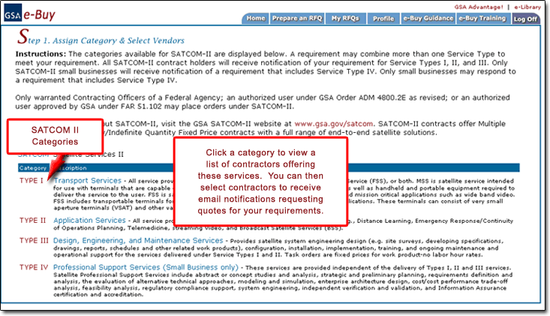

Buyers, a requirement may combine more than one category to meet your requirement. All SATCOM II contract holders will receive notification of your requirement for categories: Type I, II, and III. Only SATCOM II small businesses will receive notification of a requirement having to do with Type IV. Only small businesses may respond to a requirement that includes type IV.

For more information about SATCOM II, contact Peggy Van Tassel at 703-306-6469 or send an email to peggy.vantassel@gsa.gov.

