UNITED STATES DEPARTMENT OF AGRICULTURE
AGRICULTURAL RESEARCH SERVICE

Southern Regional Research Center
New Orleans, LA

INDEX

Section Function Page No.

Background.......................................................................... 6

1. Scope of Work ..................................................................... 7

1.1 Responsibility ………………………………………………… 7

1.1.2 Replacement parts ............................................................... 8

1.1.3 Uniforms………………………………………………………... 8

1.1.4 Compliance. ……………………………………………………. 8

1.2 General Information…............................................................... 9

2 Work Management ................................................................ 11

2.1 Routine Work ......................................................................... 11

2.1.1 Preventive Maintenance ........................................................ 12

2.1.2 Additional Work ...................................................................... 12

2.2 Work Priorities ......................................................................... 12

2.2.1 Priority 1 Work ....................................................................... 12

2.2.2 Priority 2 Work ...................................................................... 12

2.2.3 Priority 3 Work ...................................................................... 12

2.2.4 Alterations and Changes ....................................................... 13

2.3 Transition of Contract .......................................................... 13

2.4 General Management Duties............ .................................... 13
Section Function Page No.

2.5 Quality Control Work ......................................................... 15

3. Administrative Services ……………………………………… 16

3.1 Stockroom Operations .................................................. 16

3.1.1 Stockroom Work ............................................................... 16

3.1.2 Available Government Property, Materials and Services.... 17

3.2 Duplication and Publication Services ................................. 18

3.2.1 Duplication and Publication Work ...................................... 18

3.3 Security Operations……....................................................... 19

3.3.1 Security Related Work ........................................................ 19

3.4 Public Relations .................................................................. 21

3.4.1 Public Inquiry Work ........................................................... 21

3.4.2 Technical Meetings, Tours, Seminars and Conferences.... 22

3.4.3 Foreign Visitors .................................................................. 23

3.4.4 Industrial Development/Speaker File Support .................... 24

3.5 Mail and Messenger Support Work ................................. 25

3.5.1 Mail Services ...................................................................... 25

3.5.2 Messenger Services ........................................................... 25

3.6 Inventory, Property, and Disposal …………………………. 26

4 Safety ................................................................................. 28

4.1 Smoke/ Fire Service Maintenance and Detection............... 28

5 Information Technology (IT) Support ................................. 31

Section Function Page No.

5.1 IT Services......... ................................................................ 31

5.1.1 IT Equipment Requirements .............................................. 31

5.1.2 Software Requirements ...................................................... 31

5.1.2.1 Software Support Work ..................................................... 32

5.1.3 LAN Requirements ............................................................ 32

5.1.3.1 LAN Support Work ............................................................ 32

5.1.4 IT Support Services ............................................................ 33

5.1.5 Electronic Support............................................................... 34

5.1.6 Satellite dish and equipment ……………………………….. 34

6 Utilities Services ................................................................. 35

6.1 Electrical Services .............................................................. 35

6.1.1 Elevator Services and Maintenance ………………………… 36

6.1.2 Metal Fabrication ……………………………………………… 37

6.2 Plumbing and Pipefitting Services ...................................... 37

6.2.1 Deionization Water System …………………………………. 38

6.2.2 Fire Hydrants …………………………………………………. 38

6.3 Heating, Ventilation, Air Conditioning (HVAC) and
Refrigeration .......... ........................................................... 38

6.3.1 HVAC Work ........................................................................ 39

6.3.2 Logs and Records ……………………………………………. 41

6.3.3 Fume Hood 41

6.4 Energy Management Systems ......... ................................... 42
Section Function Page No.

6.4.1 Energy Management Systems Work .................................. 42

7 Facilities Services ................................................................. 44

7.1 Maintenance and Repair Services ........................................ 44

7.1.1 Trash Removal ………………………………………………… 44

7.2 Housekeeping Services........................................................ 45

7.2.1 Housekeeping Work ........................................................... 45

7.3 Grounds Maintenance ........................................................... 47

7.3.1 Ground Maintenance Work ................................................... 48

7.4 Automotive and Farm Vehicle Services ................................ 49

7.4.1 Vehicle Repair ........................................................ 49

7.5 Carpentry Services ................................................................ 50

7.6 Painting Services .................................................................. 50

7.6.1 Painting Work ...................................................................... 50

8 Greenhouse and Plot Services .......................................... 52

8.1 Greenhouse Requirements ................................................ 52

8.1.2 Sterilization Work .............................................................. 52

8.1.3 Potting and Seeding Work ................................................ 53

8.1.4 Watering and Treatment Work ................................... 53

8.1.5 Tagging and Harvesting Work .......................................... 53

8.1.6 Assembly/Disassembly Work ........................................... 53

8.1.7 Plot Requirements ............................................................. 54

LIST OF APPENDICES

Appendix No. Item
1 Glossary

2 List of Required Reports

3 Map/Location of Government Facilities Listings

4 Historical Pricing Data

5 Subcontracted
Government Work

6 Facilities Inventory

7 List of Equipment for PM

8 Government Furnished Property/Equipment

9 Automotive Equipment List

9 (A) Monthly Vehicle Checklist

9 (B) Annual Vehicle Checklist

10 Energy Conservation Policy

11 Visitor Policy

Background

The United States Department of Agriculture (USDA), Agriculture Research Service (ARS), Southern Regional Research Center (SRRC), herein after referred to as the Center is comprised of two research installations. The Southern Regional Research Center is located at 1100 Robert E. Lee Blvd., New Orleans, Louisiana, and the Sugar Cane Research Center (SRU) located approximately 60 miles from SRRC in Houma, Louisiana,

The Centers are agricultural research centers authorized by Congress in 1938 “...to conduct research into and to develop new scientific chemical and technical uses and new and extended markets and outlets for farm commodities and products and by-products thereof.”

The complex at Robert E. Lee Blvd. consists of 24 buildings and a complete utilities system, sophisticated environmental controls, and a variety of specialized laboratories and rooms, all located on approximately 33 acres. The complex presently contains approximately 400,000 square feet of floor space. Basic utilities are purchased from public utility companies.

The Sugarcane Research Unit (SRU) at Houma consists of two sites approximately six miles apart and has 40 buildings, 21 of which are greenhouses.

Government scientists with the aid of research technicians and assistants conduct research at SRRC. The support of this research requires a large number of laboratories, many of which are furnished with extremely complex and expensive test equipment requiring closely controlled environments to function properly. Historically the responsiveness and skill by Contractor employees to repair and restore operation and control of the facilities is critical for the protection of the integrity of the research programs being conducted at the Center.

1 SCOPE OF WORK

The Contractor shall provide all labor, supervision, tools, equipment, spare parts, materials, and work uniforms, except those furnished by the Government, for the operation and maintenance, facilities operations, management and administrative support services to SRRC and IT support for SRU. The performance work statement (PWS) specifies the services required to provide the full range of operational and maintenance support to the Center twenty-four hours a day seven days a week. (24/7).

  - Responsibility

The PWS is divided into various categories for convenience only and all requirements have equal weight and significance throughout. The contract is to be read as a whole document.

Facilities operations and maintenance functions shall include the areas of work management, preventive maintenance, building maintenance, shop services, alteration and repair, ground maintenance, heating, ventilation, air conditioning, refrigeration, electrical, housekeeping, information technology and administrative services.

The Contractor shall perform all work described in this performance work statement in accordance with all applicable USA and Louisiana State laws, regulations, codes, technical manual specifications, manufacturer’s guidelines, and USDA and ARS directives unless otherwise specified or directed. The Contractor shall perform all related services necessary to carry out the provisions of this contract, including quality control, financial control, maintenance of accurate, updated, and complete records, and files and libraries of documents including Appendix 6. The Contractor shall prepare and submit required reports, compile historical data, perform administrative work, and submit any necessary information as requested or specified. The Contractor may be requested to generate and provide a specific report or a portion of a report with a turn around time of as little as four hours.

The Contractor will provide assistance to other contractors on site whether they are working for them directly or for the Government. This type of assistance normally would be in the locating of various utility lines, valves, piping, switches, relocating equipment or components, moving equipment or components, shutting down or turning on of various equipment, utilities, valves, and switches. Depending on the complexity, on average this would take about one hour total per any one task. Such functions are in direct support of the research mission of the Center. In the event the Contractor is unable to fulfill any required time requirements, the Contractor will notify the Government in writing within 24 hours as to the reason why.

Title to all durable parts and construction material purchased by the Contractor in performance of this contract shall be vested in the USDA, SRRC located at 1100 Robert E. Lee Blvd., New Orleans, LA, occurring at the point of delivery to the Contractor.

1.1.2 Replacement Parts

The Contractor will be responsible for the first $1,000 of repair and replacement parts for all types of routine work per work order. Note: Unless negligence occurs on the part of the contractor, the Government will replace all “Government provided” equipment as needed.

1.1.3 Uniforms and Safety Equipment

The Contractor shall furnish uniforms and personal safety equipment for its employees in performance of this contract. Safety equipment includes shoes or boots, eyewear, respirators, and gloves. The Contractor shall, prior to contract performance, submit to the Administrative Contracting Officer (ACO) documentation that shows the type and color of proposed uniforms. The uniforms shall be approved by the ACO and the Contractor shall ensure that all employees are in proper attire within 30 days of contract start date. The follow are suggestions to types of uniforms:

Maintenance:
Shirt, long or short sleeve button down type with no less than one breast pocket, may be solid in color or fine pin stripe; trousers shall be solid in color to enhance the shirt.

Janitorial:
Male janitors may be attired same as maintenance employees, female janitors may utilize a smock.

Administrative and Management: (Includes IT)
Shirt, long or short sleeve, Polo, skirt or dress. May be solid in color or fine pin stripe. Skirts and trousers color will enhance shirt. Vest or Blazers shall be solid in color with the ARS insignia in contrasting color.

All uniforms shall have a permanent name patch / embroidery with the employee’s first name on the right breast and company logo on the left breast. Uniforms shall be consistent throughout the staff. Uniforms will be clean, presentable and in good repair upon start of shift.

    - Compliance

(A) The contractor shall be solely liable for acts of errors and omission in regard to compliance with Federal, state, and local environmental statues, regulations and applicable guidelines which lead to fines, penalties, or prices associated with enforcement actions, removal actions, corrective actions, or remedial actions.

(B) The contractor shall assume full liability for the release of any hazardous substance to air, soil, or water resulting from its own or its subcontractor’s actions. The contractor shall be responsible for the prices associated with the cleanup of any such release. In the event the contractor is removed from the duties at the facility, the contractor shall also be responsible for latent defect caused while performing work while on property.

(C) The Government retains the right to initiate and complete cleanup actions for which the contractor shall reimburse the Government for prices associated with cleanup and disposal.

1.2 General Information

The on-site Government personnel observe the listed dates as holidays:

New Year’ Day January 1
Martin Luther King, Jr.’s Birthday 3rd Monday of January
President’s Day 3rd Monday of February
Memorial Day Last Monday of May
Independence Day July 4th
Labor Day 1st Monday of September
Columbus Day 2nd Monday of October
Veterans’ Day 2nd Monday of November
Thanksgiving Day 4th Thursday of November
Christmas Day 25th of December
Mardi Gras Tuesday prior to Lent/Ash
Wednesday
Any other day designated by
Federal statute, executive order,
or Presidential proclamation. As required

When any holiday falls on a Saturday, the preceding Friday is observed. When any holiday falls on a Sunday, the following Monday is observed. Observance of such days by Government personnel shall not by itself be cause for an additional period of performance, or entitlement of compensation except as set forth within the contract.

The Government reserves the right to close the facilities due to weather conditions, safety, health, or medical emergencies as necessary. Contractor personnel may be required to remain on duty to maintain the facility in the event of such adverse weather conditions or emergencies. Services are
required 24 hours per day, 365 (or 366) days per year, on an uninterrupted basis, including all National and religious holidays.

Note: Unless otherwise noted, regular hours of work at SRRC are from 7:30am to 4:00pm.

Two weeks advance written notice is required for any planned absence of key personnel from the project exceeding ten consecutive workdays. An absence exceeding a two-week period requires the appointment of a suitable fulltime replacement with the concurrence of the Government.

2. WORK MANAGEMENT

The Contractor will provide a paperless automated work management system for the submission, approval, and tracking of all work requests and preventive maintenance. System will track quality control, estimates, material, labor, equipment, scheduling and priorities. Completed work orders shall be visible electronically via the LAN with all required data. Access to the Contractor’s work management system will be available to the Government at anytime during normal duty hours through the Centers’ LAN system. The current file format utilized is generated by MP2.

2.1 Routine Work

Routine Work is defined as recurring services that are scheduled frequently or repetitively throughout the term of the contract and should be accomplished without further input from the Government. No work that substantially alters, modifies, or otherwise changes buildings, structures, or equipment is considered routine work. Routine work/recurring services require planning, scheduling, and frequent quality control monitoring by the Contractor. Work that is considered routine but requires the Government to procure material shall be treated as routine work. The price for routine work shall include all labor, overtime, supplies, materials, equipment and subcontracts deemed necessary to perform the requirements of the PWS, including alterations, renovations, repair and maintenance. This includes work required due to updated technology and changes in research needs. Examples of routine work include maintenance of facilities research support equipment (e.g. facilities electrical, plumbing, building automation, communications, HVAC/R equipment and systems maintenance, grounds and grounds equipment maintenance, vehicles maintenance, PM work , and administrative support, etc.)

2.1.1 Preventive Maintenance

The Contractor shall perform preventive maintenance (PM) of buildings and structures, plants, tools, and equipment. The contractor shall develop and maintain a PM plan and schedule that will include a listing of items and components to be maintained along with inspection, maintenance and shutdown schedules. The schedules will remain constant except for additions, deletions and updates. Contractor will notify the Government within ten days of any changes to the PM schedule or listing. Government approval is required for additions and deletions. All updates shall be accomplished within 30 days of that approval. Historical data indicating average quantities of PM is shown in Attachment 1, Appendix 7.

The PM plan shall be developed in accordance with the following order of precedence:

(1) Manufacturers’ recommendations and standards

(2) National and State of Louisiana codes

(3) Industry standards

(4) Good Laboratory Practices

The Contractor shall maintain PM records that include scheduled and completed dates, work performed, noted observations, craftsman and time expended. This information shall be available to the Government via the Center’s LAN. The records shall include scheduled and accomplished dates, equipment ID, equipment description and craftsman notes. The Contractor shall submit weekly a report of planned PM’s for the following week. A deficiency report shall be submitted weekly of PM’s not completed as scheduled, along with the reason why and a schedule of when they will be completed.

2.1.2 Additional Work

Additional work is defined as work that is not part of the routine operations and maintenance support for the Center, but is within the scope of the contract. Proposals shall be completed within ten workdays of work request submission by the requestor. The proposal shall include a verification of the completion date with the customer, a start date, and a breakdown of price that includes type of labor and hours, material and subcontract price. Additional work shall not interfere with routine work.

2.2 Work Priorities

Work will be prioritized using the following guidelines. The ACO may change work order priority at anytime.

2.2.1 Priority 1

Priority 1 work requires immediate action essential for the protection of critical equipment, facilities, environmental conditions, health, safety or security. Immediate corrective action shall be taken and will be pursued on a continuous basis until permanent repairs are completed or otherwise directed by the ACO.

2.2.2 Priority 2

Priority 2 work shall be accomplished by the first available craftsman. Personnel shall not be diverted from scheduled work. Work shall start within one workday, and be completed within five working days, unless otherwise directed by the ACO.

2.2.3 Priority 3

Priority 3 work shall be accomplished in the most economical and efficient manner on a "first come, first served” basis. At a minimum, work on 50 percent of these requests shall be completed within one working day of receipt. The remainder shall be completed within five working days, unless otherwise directed or authorized by the ACO.

2.2.4 Alterations and Changes.

The customer may make minor alterations and changes to approved additional work requests as long as it does not change the scope of the original work request. Additional requirements will require another work request to be submitted. The ACO has final determination whether the change is within the original scope.

2.3 Transition of Contract Performance

The Contractor shall assist the Government in the transition of contract performance within 30 days of the start of the contract.

Examples of transition work include:

- inventory of storeroom
- site and facilities inspections
- records passed on from previous contractor
- Government furnished property inventory
- security inventory

2.4 General Work Management Duties

The Contractor shall:

(A) maintain a point of contact on-site for receipt of work requests.

(B) review work request for completeness, understanding and clarity. Vague and incomplete work requests shall be returned to the customer for clarification.

(C) provide "marked up" drawings quarterly to the Quality Assurance Specialist (QAS) of any mechanical, electrical or structural changes or alteration done by the contractor of it sub-contractors.

(D) develop and submit weekly to the ACO and QAS a schedule to include routine and additional work by assigned priority and identify those that have an impact on the Center or customers such as utilities, closing of areas, equipment, or safety.

(E) notify ACO, QAS, and affected personnel within 24 hours of any planned interruption of utilities, services or closures.

(F) submit a Backlog Report weekly to ACO and QAS on all work not completed.

(G) submit a schedule of planned work daily to the ACO and QAS by 9:00 am. Schedule shall contain work order number, craftsman assigned, location and a brief description of the work.

(H) ensure that work to be redone is not assigned and treated as “new” work.

(I) inform initiator when their work order is completed, have customer sign off and indicate if they are satisfied or dissatisfied.

(J) raise and lower flags as when required, maintain a flag inventory to ensure that at least one new replacement flag is available at all times and that National Ensigns that are worn or tattered are disposed of in accordance with USC; Title 36; Section 10 or given to a local scouting or military affiliation for proper disposal.

(K) prior to May 15th of each year inventory the Center’s hurricane supplies, conduct a review of the Center’s hurricane plan, propose changes if necessary, and conduct an inspection of SRRC to ensure it is ready for the hurricane season. As needed, plot active storms identified by NOAA and coordinate meetings with the ACO, QAS, General Engineer and Administrative Officer (AO) of any storms that enter the Gulf of Mexico.

(L) submit malfunction report on major equipment or systems failure verbally to the ACO and QAS within 30 minutes and in writing within 24 hours after repairs are completed; classification of reports shall be maintained in a consistent orderly manner for ease of monitoring,

(M) immediately notify the Center in a broadcast manner of any unplanned closures or loss of utilities/facilities, after obtaining government approval.

(N) maintain a warranty log and file to include description of equipment, its location, warranty clauses, date installed and expiration date for all equipment installed by facility contractor or subcontractor. Conduct warranty inspections and investigations to verify any issue under warranty. Brief the ACO or designated representative on warranty coverage for equipment. Notify the ACO or designated representative to obtain warranty servicing assistance if necessary.

2.5 Quality Control Work

The Contractor shall develop, maintain and provide a Quality Control (QC) plan and program that:

- ensures the requirements of the contract are provided as specified and provides a record of performance that can be inspected by the Government.

- Includes a quality control inspection system covering all required contract services, a method of identifying deficiencies in the quality of services performed, and corrective actions taken to prevent performance from becoming unsatisfactory. An adapted commercial system such as ISO 9000 series is an example if all work are addressed.

(C) maintains a record of all QC inspections, results and any corrective actions taken.

(D) utilizes the work management system for the entry of all QC inspection reports.

(E) includes a quarterly random, five question minimum survey of twenty-five percent of customers

(F) includes an eight question minimum customer satisfaction questionnaire. Ten percent of all work orders will be sampled with results available to the Government on the LAN. The Government may request a higher sampling rate if it perceives a problem.

- ADMINISTRATIVE SERVICES

The Contractor performs administrative services to support requirements for researchers and maintain accountability and price control. Storeroom items are commonly used in substantial quantities and savings from volume orders exceed storage prices.

3.1 Storeroom Operations

The Contractor shall operate and maintain the SRRC storeroom eight hours daily continuously from 7:30 am - 3:30 pm. The storeroom issues administrative and scientific parts, supplies and materials. The Contractor will track and notify customers within one hour of receipt of any items addressed to them.

3.1.1 Storeroom Work .

The Contractor shall:

- unpack and store materials, supplies, and equipment upon proper receipt of items. Distribute shipping documentation (including acceptance verification and date) to customer and update storeroom records within 3 days of receipt.

- refrigerate perishable items immediately; notify recipient telephonically and by email within one hour of receipt.

- order, receive and store dry ice in the five storage containers located at the Center and ensure dry ice is distributed and balanced evenly in all containers.

- operate, maintain and keep current a computerized inventory system that labels and assigns stock numbers to items, this includes a continuous process of validating issue and ordering quantities for material and supplies.

- evaluate inventory composition (Items and quantities) and make recommendations to the ACO for changes based upon usage, demand, obsolescence, or ordering quantities. ACO will advise Storeroom Committee.

- receive and maintain all standard and government issued forms required by the Center.

- establish item re-order points (use current unit of issue and ordering quantities) and submit order requests weekly to the acquisition office.

- publish catalog of storeroom items electronically and have a printed catalog available for use in storeroom.

- ensure loss prevention measures are used to avoid loss and damage.

- pack, crate, and weigh outgoing shipments (Material or equipment). Coordinate shipment arrangements with SRRC customer (Customer provides any necessary RMA – Return Material Authorization).

- conduct a full inventory of storeroom annually and a random inventory of 20 percent of items 6 months later.

(L) assist customers within five minutes of arrival in storeroom.

(M) operate and maintain an in house electronic order system for the storeroom where customers may use a shopping cart method to order supplies for pickup.

(N) operate, maintain and keep current the Chemical Tracking System (CTS). Perform inventory annually.

(O) receive /ship and unload/load items at courtyard gate for security reasons; this may be required on the average three time a day.

(P) coordinate receipt, storage, return, and inventory of gas cylinders from customers and external vendors, gas cylinder turnover averages eight per week.

3.1.2 Available Government Property, Materials and Services

The initial source of supply shall be Government owned parts, supplies and materials on hand. The Contractor is responsible for any government property in their possession or that they are responsible for maintaining security over. The contractor shall be responsible for full replacement price of any government property that is damaged or stolen due to their neglect while under their control. The Government incurs all expenses for repair or replacement of government property due to normal wear and tear.

3.2 Duplication and Publication Services

The Contractor shall maintain and operate the centralized copying and duplicating center, the convenience copiers and general use areas. This includes providing copier paper, toner and ink cartridges, binding material, forms, equipment training, formatting, and supporting data entry. The Contractor shall ensure its personnel are familiar with the use, care and operation of equipment.

3.2.1 Duplication and Publication Work

The Contractor shall:

- provide duplication services at the centralized duplication center.

- provide maintenance at the eight general user convenience copier locations.

- check operation, clean, add paper toner or ink to copiers as required, prior to 8:30 am, and maintain a daily log of each copier serviced.

- respond to calls for assistance at convenience copiers within 15 minutes, maintain log of all calls, record problem and solution.

- provide and maintain paper, toner, motor, belts, and paper cutter blades sufficient to support Center operations in an uninterrupted manner. Approximately 240 cases of various type paper are used per year.

- provide duplicating, coping and binding support. The normal workload is 35 jobs per month averaging 100 pages per job.

- maintain production standards of 30 minutes for documents 1-10 pages in length, 2 hours for 11-50 pages, 3 hours for 50-125 pages, 5 hours for 125-250 pages and 24 hours for documents over 250 pages.

- complete all work within the time frame designated by the customer. Work marked “Urgent” requires ACO approval.

- maintain a log of duplicating, coping and binding jobs indicating customer, Group (MU), date submitted, type of job, number of copies requested and completion date.

- transmit and receive facsimile messages and assist in transmission if necessary. Notify facsimile recipients of messages or leave voice mail notice immediately.

- provide typing, formatting, and data entry support (Average weekly production is 52,900 lines) which includes composition and production of the Center’s weekly newsletter, written reports, memos, statistical layout forms, and manuscripts.

- ensure documents adhere to the Government Printing Office Style Manual and USDA Correspondence Manual(s).

- maintain record of word processing activities on the LAN.

3.3 Security Operations

The Contractor shall perform the following services that include assisting Center visitors, key issuance, key control, key entry cards, security control, and physical security (Walking patrols, maintaining surveillance system-CCTV, card access, card issuance, fire alarms, intrusions alarms, vehicle registration, making of government I.D. badges, etc), and receipt of deliveries and packages. Perform regular audits of all security systems and generate usage reports annually.

3.3.1 Security Related Work .

The Contractor shall:

- perform these services on a wide range of security parameters to include shed storage, restricted fields, greenhouses, agricultural structures, laboratories, and multistory buildings.

- ensure all Contractor personnel prominently display a building access badge at all times between the waist and neck when on Center premises.

- ensure all personnel are familiar with all areas of the Center for security and emergency requirements.

- ensure all personnel are familiar with the location of fire and evacuation alarms and procedures to properly activate them.

- monitor all entry and exit building doors 24 hours per-day, 7 days per-week (24/7) at the times provided by the ACO.

- ensure designated roadway gates on Wisner Avenue, courtyard and compound open and close at the times provided by the ACO. All gates except for compound are currently automated on timer devices.

- permit access to the courtyard and boiler room, upon proper authorization, and monitor entrance and exit of personnel.

- maintain information and visitor assistance desk in the lobby of the Center’s main building from 7:30 am to 5:30 pm, Monday through Friday, except Federal holidays.

- program and maintain all intrusion detection and access control systems. Establish and maintain a preventive maintenance program to ensure that building access control card readers (including battery back-up), exterior and automatic door operation, automatic gates (Vehicle and pedestrian), interior and exterior lighting systems, interior and exterior CCTV systems and alarm systems continue to operate at the proper efficiency without interruption. Monitor each intrusion alarm system, fire and environmental zone system 24/7.

- maintain the Center’s Electronic Card Entry System, provide entry to authorized personnel during non-duty hours, and in the event of a system failure provide staff for security and manual operations.

- organize and implement a system to issue temporary passes
and vehicle permits to contractors / sub-contractors. Ensure that badges and permits are issued in accordance with Homeland Security and facility regulations and guidelines. Badges and passes may consist of temporary daily and multi-day.

- maintain the CCTV system, and maintain recording system to enable review of 90 calendar days of data for investigative review.

- maintain the intrusion and fire alarm system, 24 hours a day, 7 days a week.

- establish and implement control and accountability for all Center keys and key cards, report all lost keys and key cards immediately to the AO for authority to duplicate, and maintain a history log.

- conduct no less than one roving patrol (tour) around the entire facility every four hours during non-duty hours to approximately 45 check point locations; personnel shall verify security of all buildings doors and windows; check for good energy conservation practices, check for proper operation of vital equipment, various other systems and lighting operation; check for alarms, hazards, spills, floods and record any abnormal conditions. Notify appropriate personnel and take corrective action. Contractor shall submit list of proposed check points 5 days after contract award for government approval. (There shall be no changes to round locations without ACO approval)

- perform exterior light survey weekly to identify problems, report and correct any problems. Provide report upon request.

- maintain guard round check point report database file for 90 days accessible to the government via the LAN.

- submit security incident report within one work day of incident and report results of the investigation in writing within five working days to the ACO and QAS

- assist Center management in facility security by submitting a list of all personnel violating prescribed security rules; e.g., improper or no parking decal, improper or not wearing of the Center access badge, lost or forgotten keys to the AO and ACO weekly.

- respond to all system alarms. Provide personnel for initial response to trouble, faults and emergencies 24/7. Response time for emergencies during normal working hours shall be immediately; during other times qualified personnel will be onsite within two hours to commence repairs unless the situation is deemed critical then response shall be immediate. Meet and assist emergency personnel.

3.4 Public Relations

The Contractor shall provide public relations support to the Center. This work vary from simple telephonic or electronic contacts to complex international technical seminars. The Contractor shall provide prompt, accurate, complete and courteous service. This work includes conference room scheduling, providing supporting files and documents, and licenses.

3.4.1 Public Inquiry Work .

The Contractor shall:

(A) maintain handbooks, guides and reference materials and provide responses to routine inquiries and requests.

(B) document the nature of all information requests to include the name of the requester, affiliation, type of response, and other relative data.

(C) respond to oral requests within one hour.

- respond to written requests within one working day.

(E) refer non-routine inquiries to the proper ARS activity for reply as required.

3.4.2 Technical Meetings, Tours, Seminars and Conference Work

Technical Meetings

The Contractor shall:

(A) plan, coordinate, arrange and schedule technical meetings
which average 16 per year with approximately 200 participants.

(B) set up room at designated facility including audio-visual equipment. Verify registration materials and set-up place cards prior to meeting.

(C) ensure provided materials, including programs, badges,
place cards, slides, charts and visual aids conform
to the USDA Visual Management Manual AD-791.

(D) prepare technical meeting program plan.

(E) provide group leaders with list of names and titles of SRRC participants.

(F) notify ACO of printed materials required for procurement.

(G) escort visiting attendees to the meeting location upon arrival.

Tours

The Contractor shall;

- plan, coordinate, arrange, schedule and conduct tours of the Center that average 58 per year with approximately 1,300 participants in total.

- prepare a 20-30 minute presentation for tours covering the SRRC research organization, objectives and accomplishments.

- demonstrate commercialized developments originated at SRRC as directed.

- arrange with research leaders at least one week in advance for
tour guides on escorted tours.

(E) notify the AO and DO office in advance of tour groups over 25 people; schedule times and arrange technicians for tours.

Seminars and Conferences

The Contractor shall;

- plan, coordinate, arrange and conduct seminars or poster presentations held at the Center; which average 50 per year with approximately 3,000 participants in total.

- obtain approval from Director to participate in or provide support for seminars conducted at but not sponsored by SRRC.

- verify schedules to avoid conflicts.

- coordinate and assist in planning for unscheduled or unanticipated conferences.

- conduct a count of participants at all events by type and submit
a report to the ACO and QAS for the preceding year by January 15.

3.4.3 Foreign Visitor Related Work

The Contractor shall:

- coordinate and plan foreign personnel visits that average 52 visitors annually to the Center.

- make necessary contacts in writing or by telephone with scheduled foreign visitors at the request of the Government sponsor.

- verify with visitor’s sponsor that the FBI has been informed of planned visitors from communist countries or other countries designated for monitoring by an appropriate government agency.

- coordinate the obtaining of interpreters as requested, make arrangements for hotel reservations and transportation, coordinate and arrange itineraries, plan week-end activities and arrange lunches.

- compile and maintain correspondence for foreign nationals and provide copies of all background information and correspondence pertaining to foreign nationals to the USDA/ARS Human Resources Division located in Beltsville, MD in accordance with Directive 121.2 dated May 8, 1984.

- maintain a foreign visitor log upon entry to the Center.

3.4.4 Industrial Development and Speaker File Support

Industrial Development

The Contractor shall plan, schedule and arrange support as directed for major scientific meetings held either at SRRC or various locations within the United States Historically SRRC has sponsored or co-sponsored an average six sessions per year.

Provide estimates for meeting prices as directed to determine registration fees, collect pre-registration and registration fees, account for funds, make payments for facilities as required, visit proposed conference sites not sponsored by SRRC as directed, and coordinate conference dates, locations and facilities upon approval by the Director of SRRC.

The Contractor shall:

- make all logistical arrangements to support the conferences including accommodations and travel arrangements for visitors.

- prepare invitations to participants, prepare biographical sketches and maintain contact with program chairpersons and speakers.

- contact participants who serve as chairman by telephone and/or written correspondence to confirm acceptance of invitation.

- edit abstracts, verify information, prepare printed material, review galley proofs and release materials for final printing as directed.

- edit, compile, and format summaries, preprint booklets, and submit manuscripts for publication.

- update mailing lists and mail programs.

- prepare and mail thank you letters to conference participants.

Speaker File Support

The Contractor shall maintain a list of SRRC personnel who volunteer for
speaker assignments outside the Center, determine requirement matches
and provide contact information to the requesting activity.

3.5 Mail and Messenger Support Work

The Contractor shall provide mail service Monday through Friday, excluding Federal holidays. Average time required for trip to post office is 45 minutes. Internal mail runs average about 1 to 1-1/2 hours each. All mail shall be handled in accordance with U.S. Postal Regulations.

3.5.1 Mail Service

The Contractor shall:

(A) pick up and deliver mail daily at the USPS located at 501 Jefferson Davis Parkway, 70179 prior to 3:30 each work day.

(B) pick up, sort and deliver internal mail to all offices in the administrative wing twice a day by approximately 10:00 am and 2:00 pm daily.

(C) stamp or meter all out going mail prior to dispatch.

  - wrap outgoing parcels and address “pouch mail”.

  - perform a semi-annual survey of mail sent and received.

3.5.2 Messenger Service

The Contractor shall:

(A) provide messenger services daily from 8:00 am to 4:00pm
which average about 2 hours daily and 200 runs per year.

(B) as directed, pick up and deliver supplies and equipment (examples include documents, articles, paint, chemicals, GSA store items, film, and tickets).

    - maintain current routing and distribution indicators.

- maintain activity log of trips.

- perform semi-annually a survey of messenger runs for number of hours utilized and miles traveled.

3.6 Inventory, Property, and Disposal

The Contractor shall:

(A) perform duties related to the identification, reporting, and control of personal property. Ensure that all Government properties are accounted for, properly transferred, or disposed in accordance with the Federal Government standards and procedures. Maintain documentation files on nonexpendable personal property. Document the Personal Property Management System (PROP), inventory reconciliation, employee exit clearance inventories, and suspense report reconciliation. Document the acquisition, reallocation, and disposal of excess personal property. Reconcile, review, and inventory adjustment forms every 30 days. Identify and determine discrepancies. Receive and screen purchase orders (AD-838). Prepare and review inventory adjustment forms, including Report of Unserviceable, Lost, or Damaged Property (AD-112), and Report of Transfer or Other Disposition or Construction of Property (AD-107). Maintain various inventory lists and assist in performing periodic inventories as required.

(B)Conduct the required periodic physical inventories with the Accountable Property Officers (APO). There are approximately ten APO’s with an average size of 100 items in inventory. Inventories are conducted on average every 18 months. Initiate the inventory and walk through the services organization / laboratory with the APO or designee while the physical inventory is being conducted. Work with the APO to reconcile inventory and follow up as necessary. Work with APO and Property Management Officer in matters relating to acquisition and disposal of excess and surplus property and the reporting of lost, damaged or destroyed property. Visit laboratories, offices, and work sites to assist in determining the most economical means to meet the requirements and to inspect and survey excess property. Contact General Service Administration (GSA), APO’s and other supply sources periodically to determine availability of excess and surplus property for identified facility needs. Advise requesters of excess property or surplus availability. Screen excess property documents received to determine the appropriate action to take on the disposition of excess / surplus property. Coordinate the removal or transfer of excess property using necessary means. Notify certified technicians to remove refrigerant from unserviceable refrigeration equipment prior to disposition. Provide requesters appropriate forms in matters regarding acquisition, disposition, and transfer of nonexpendable personal property. Coordinate removal of property and recycling efforts . Contact designated GSA or other representative to dispose of scrap material and make determination as to whether items have scrap value, should be disposed of in dumpsters, or made available for recycling.

(C)Gather and compile data from property transactions processed during the month to contribute to the Area Property monthly Activity Report. Ensure that information is accurate and updated in the automated system.

(D)Utilize the current Property Management Information System (PMIS) / Personal Property (PROP) database system to manage facility and shop inventories, suspense report purchases, National Financial Center (NFC) bar code assignments, motor vehicle and equipment acquisitions, disposal, excess, and transfers. Ensure that new accountable acquisitions are bar coded and entered into database.

4. SAFETY

The Contractor shall conduct all work in a safe manner and adhere to all required regulations, submit incident reports of all Center incidents, within one work day, and results of the investigative report in writing within five working days, to the Government Safety Manager (GSM) and any other government personnel as required. The Contractor shall operate and maintain the Chemical Tracking System (CTS).

The Contractor shall provide comprehensive assistance to the GSM with clerical and technical support in the administration of SRRC’s safety program. Assistance may be required in various areas; some examples are:

Asbestos Program

Accident Program

- Administration of Controlled Substances

- Chemical Storage Activities

- Safety Training Activities.

Noise Monitoring / Hearing Conservation Program

Safety Library Work

Safety Equipment Support

Safety Advisory and Assistance

Hazardous Communications

4.1. Smoke / Fire Service Maintenance and Detection

The Contractor shall:

- Maintain and monitor the fire alarm smoke detection and sprinkler systems 24/7. Maintain, inspect, test, and certify in accordance with pertinent codes and guidelines. Inspection and servicing shall be conducted by qualified personnel certified by, federal, state or local authority, or by personnel / organization listed by a national testing laboratory for the servicing of fire alarm systems. Perform visual examinations of fire panels, annunciators, smoke and duct detectors, pull stations, bells, strobes / horns, and magnetic door holders. Replace zone labels if missing or out-of-date, as required, on panels and annunciators. Clean and wipe any accumulated dust, insects or varmints inside panels and annunciators. Thoroughly clean any accumulated corrosion. Replace corroded battery disconnect terminal wiring as necessary. Inspect and test batteries with and without load for proper output. Thoroughly clean all smoke detectors and duct detector chambers, screens, and terminal bases annually with NFPA-approved compressed air smoke detector cleaner. Inspect and test all fire alarm supervisor circuits, control panels, and annunciators for normal operation including ground fault detection circuit and magnetic door release. Replace all burned out bulbs as required. Inspect and test all manual pull stations. Replace all missing glass or plastic rods for pull down switches. Inspect and test all alarm bells and strobe / horns. Inspect and test all smoke, duct, and heat detectors. Adjust smoke detectors sensitivity as required for proper functionality. Provide inspection, testing and maintenance for chemical extinguishing systems by trained personnel. Testing of all system components in these rooms shall not cause discharging of agent. Contractor shall assume full liability for any accidental discharge of chemical caused during system testing.

- Perform inspection, testing, and maintenance for the facilities’ automatic fire alarm sprinkler systems (wet and dry) and fire and jockey pumps. Assume the responsibility for any water damage to Government laboratory equipment, research, and property due to contractor negligence. Conduct work semi-annually and annually as required by Federal, local, and state regulations and guidelines and NFPA. Ensure that the system is operating properly at all times.

- Perform inspection, testing, and maintenance of the facilities’ chemical fire
extinguishers. Ensure that extinguishers are present and possess adequate charge. Comply with all pertinent codes and guidelines. Replace extinguishers as necessary to comply with pertinent codes.

(D) Submit 2 weeks after award a written monthly schedule indicating which alarm systems, chemical fire extinguishers, and fire and jockey pumps will be inspected, tested, and maintained through each month. Indicate dates on which each system will be inspected, tested, and maintained.

(E) Submit a report to the ACO as occurrence of any found deficiency, safety hazard, or code violation in the existing fire protection system, equipment, and devices. Report to the ACO of any sprinkler heads subject to manufacturer recall.

(F) Accurately document each inspection, testing, and maintenance performed on any fire alarm detection, sprinkler system, chemical suppression system, and fire pump. Sign and deliver documentation to the ACO within 3 days of task completion.

(G) Respond to all system alarms. Provide personnel for initial response to trouble, faults and emergencies 24/7. Response time for emergencies during normal working hours shall be immediately; during other times qualified personnel will be onsite within two hours to commence repairs unless the situation is deemed critical then response shall be immediate. Meet and assist emergency personnel.

5. INFORMATION TECHNOLOGY SUPPORT

The Contractor shall operate and maintain information technology resources twenty-four (24) hours per day, seven (7) days per week and shall be manned daily between the hours of 7:30am to 4:00pm. The Contractor shall comply with all requirements of the Privacy Act of 1974 and the current Computer Security Act, and applicable vendor and manufacturer warranties.

5.1. IT Services

The Contractor shall provide maintenance, repair, and training services for all IBM and IBM-PC compatible microcomputers and peripheral equipment located on-site at SRRC and SRU; approximately 550 computers. Microsoft Windows 98, 2000 and XP are the predominant workstation operating systems, with some Mac OS, Linux, Free BSD, Sun, and Silicon Graphics operating systems installed. A list is provided in Appendix 8.

5.1.1 IT Equipment Requirements

The Contractor shall:

(A) troubleshoot and correct equipment malfunctions;

(B) install printers, monitors, circuit boards and chips;

(C) relocate IT equipment as needed;

(D) provide technical support and representation in acquisition, evaluation and testing of equipment;

(E) maintain equipment status, maintenance and repair records;

(F) serve as Center representative in coordinating equipment in need of
repair;

(G) maintain facility Information display system and keep current with data provided by the Government;

5.1.2 Software Requirements.

The Contractor shall train SRRC personnel on both commercially packaged and Government custom developed software. The price for training on custom software will be at Government expense. The predominant commercial software packages used are GroupWise, Microsoft Office Suites, WordPerfect Office Suites, Adobe Acrobat Reader, Adobe Acrobat Professional, and Symantec Corporate Edition Antivirus. Various scientific based programs are used as well as graphic programs such as Adobe Illustrator, Adobe Photoshop, and Micrografix Designer.

    - Software Support Work .

The Contractor shall

(A)maintain commercial software packages to keep systems current and updated so that they function properly; notify government personnel of any necessary upgrades and recommend a course of action; install and maintain software; and provide support and training to Center staff;

(B)provide system security consistent with best commercial and government practices or as directed by the ACO;

5.1.3 LAN Requirements.

There are nine Windows 2000 servers in two separate Windows 2000 Active Directory Domains with various software packages installed, three NT 4.0 servers (one RAS), eleven NAS servers, one Linux Web server, and two Novel 5.1 servers with GroupWise 6.0. Backups are performed on seven of the 25 servers. The Network has 500 nodes with 325+ users. The network uses Cisco switches and routers with a gigabyte Ethernet fiber backbone and is 100MB to the desktop. Two sub locations in Houma, Louisiana are connected to the Center using frame relay WAN links with an additional frame relay WAN link connecting the facility to the USDA LAN. Support to Houma shall mirror that of SRRC with two visits per month at a minimum by technical personnel for on site computer maintenance.

5.1.3.1 LAN Support Work

The Contractor shall:

(A) perform the services necessary for the efficient and effective operation and maintenance of the SRRC LAN on a 24 hour, 7 day per week unattended basis;

(B) install, configure, and maintain file servers, network operating systems, and related items;

(C) respond to network malfunctions within one hour of notification;

(D) create batch administration scripts;
(E) conduct systems backup daily;

(F) review and analyze requests for network connectivity;

(G) resolve problems with LAN;

(H) install LAN for new users within 48 hours of notification;

(I) maintain Internet and WAN connections as required;

(J) assist in developing security and disaster recovery LAN policies
as required;

(K) provide assistance to ACO and QAS in development and evaluation of
technical specifications for proposals and bids;

5.1.4 IT Support Services.

The Contractor shall:

- staff a Help Desk for computer assistance, respond to requests within 30 minutes; maintain an electronic log of requests, actions, and history that shall be accessible via the LAN;

- prepare and produce annually, no later then January 15th, the SRRC phone book printed copy including an electronic copy accessible via the LAN;

- prepare and produce, by the 15th day of each quarter, the SRRC phone cards including an electronic copy accessible via the LAN;

- maintain the SRRC telephone voice mail system;

- assist with or produce custom made graphics and posters;

- train new employees on USDA, ARS and SRRC IT policies and procedures, proper use of the SRRC IT systems, its peripherals and basic computer operations.

- provide computer repair services;

- coordinate with ACO and QAS, specifications for procurement of IT items;

- provide video and teleconference support including set-up and
assistance, maintenance and repair of teleconferencing equipment.
5.1.5 Electronic Support

The contractor shall maintain in proper operating order a wide variety of computerized and sophisticated electronic scientific and non-scientific equipment, which includes electro-mechanical and mechanical research instruments and other ancillary equipment. To accomplish this the Contractor may be required to support this effort by designing, evaluating, specifying, modifying, troubleshooting and repairing circuits and mechanisms to change and improve function, range, characteristics, components, reliability or use according to the requirements of the research mission at SRRC. The government will be responsible for material prices over $100. The Contractor shall ensure communication gear (wireless radio system) is maintained, including furnishing rechargeable batteries and antennas.

5.1.6 Satellite dish antennas and equipment

The Contractor shall operate and adjust satellite dish antenna and equipment to exact coordinates and tune equipment to achieve optimum signal clarity in order to receive satellite broadcast programs. Perform various technical troubleshooting techniques to ensure satellite programming is down linked and recorded. Ensure satellite program monitors in various locations are connected and receiving a proper signal. Monitor and control satellite dish antenna maintenance agreement and ensure monthly checks are performed on the system to keep it operating at peak performance. Ensure that periodic maintenance on dishes is performed as required.

6. UTILITIES SERVICES

The Contractor shall install, modify, repair, monitor and maintain all plumbing, safety, HVAC/R, and electrical systems, facilities, and distribution equipment. Services include electric, motor control centers, controls, lines, systems, fixtures, outlets, panel boxes, switchboard, power circuits, transformer vaults, switchgears, and other related equipment. The Contractor shall maintain facilities utilities and monitor lighting, essential building functions and critical equipment such as building and equipment environmental alerts, alarms, and malfunctions for facilities and specified equipment 24/7. Provide personnel for initial response to trouble, faults and emergencies 24/7. Response time for emergencies during normal working hours shall be immediately; during other times qualified personnel will be onsite within two hours to commence repairs unless the situation is deemed critical then response shall be immediate. Electric can be accessed from the main switchgear located behind the Service building. Incoming power is 13.8kva. Main lines feed underground to the Service building, North and South loops, the Main building, Compound, Cotton Storage building, Textile building, Greenhouse, portable or out buildings. Once every eight hours during non regular duty hours the facility environment conditioning shall be physically checked and twice during regular duty hours; for good energy conservation practices, for proper operation of vital equipment, lighting operation and various other systems; for alarms, hazards, spills, floods and record any abnormal conditions. Notify appropriate personnel and take corrective action.

  - Electrical Work .

The Contractor shall:

- install and maintain high and low voltage electrical equipment such as distribution systems, motors, fans, blowers, raceways, conduit, generators, signal equipment, elevators, lighting-fluorescent, incandescent, mercury, sodium, sensors, HVAC/R controls, research equipment-centrifuges, freezers, fume hoods, bio-hoods, dishwashers, switches, disconnects, breakers, receptacles, relays, wiring, and related parts;

- perform annual inspection and maintenance on high voltage switch gear and transformers, this will require a power outage to the facility and needs to be coordinated in advance to prevent disruption of research; notify the Facility Engineer and ACO 60 days in advance of planned date, upon approval of the date notify Center personnel 30, 14, 7, 3 and 1 day in advance of the actual shutdown, the Contractor may do the north and south loops separately, but both must be completed within 180 days of each other;

- test and troubleshoot power circuits, and correct trends to preclude deterioration and malfunction;

- measure resistance at all building locations, vaults, transformers, control center and switchgears, and maintain a permanent file of resistance values;

- install, maintain, modify, adjust and repair all high-voltage electrical equipment to include inspecting and testing substations and equipment and maintaining generators;

- secure all utility distribution lines prior to work;

- install, maintain, adjust, and repair all facility electrical, distribution, control, alarm, annunciation, energy management, power generating, timer operated systems and their components including: power circuits, controls, switches, thermostats and relays; connecting wires to outlets, switches, receptacles and sources; test, maintain and repair permanently installed hoists; installing, testing, maintaining, and repairing electric motors and fans; checking controls and components of motor controls and circuits; repairing electrical equipment and machinery; troubleshooting and repairing electrical controls for HVAC/R equipment such as: flow meters, temperature and pressure recorders, magnetic starters, variable speed drives, pump controls, individual heating unit systems, and electrical components of air conditioning and refrigeration equipment; maintain emergency generators, substations, and transformers; maintain emergency lighting, backup battery power system and troubleshoot scientific equipment;

- correct equipment malfunctions that are recognized;

- inspect and test substations and equipment;

- within 30 minutes of a malfunction verbally inform the ACO and QAS of the incident, a written report of the incident shall be provided to the ACO and QAS within 24 hours; any malfunction that causes disruption of service or equipment that affects Center activity is considered an incident;

- respond to failures of the system within four hours for non emergencies (something that does not impact the research mission) and immediately to emergencies.

- dispose of fluorescent, incandescent, mercury & sodium lighting -bulbs and fixtures as per Federal, State and local regulations.

6.1.1 Elevator Service and Maintenance

The Contractor shall:

(A) maintain, assess, recommend and perform repairs / renovations and safety inspections, as needed for the facility elevators and dumbwaiter systems in accordance with the latest edition of ANSI / AMSE 17.1 and 17.2 equipment specifications and manufacturer’s instructions. Elevators and dumbwaiters shall be certified as required.

(B) provide and install certificate in elevators and dumbwaiters to indicate that safety inspections have been performed or that documentation is current and where documentation is located.

(C) provide personnel for initial response to trouble, faults and emergencies 24/7 and re-instate elevator services. Response time for emergencies during normal working hours shall be immediately; during other times qualified personnel will be onsite within two hours to commence repairs unless the situation is deemed critical then response shall be immediate. Meet and assist emergency personnel.

6.1.2 Metal Fabrication

The Contractor shall design, fabricate, construct, alter, assemble, install,
repair, and maintain system, laboratory, and building equipment and fixtures
in accordance with accepted methods and techniques of the Sheet Metal and
Air Conditioning Contractors National Association (SMACNA) and welding
trade in support of facility maintenance and research requirements. Trade
practices shall include facility “Open Flame” policy, NFPA, Federal, state, and
local regulations. Ensure welders possess ASME Welding Certification as it
applies to procedures. Fabrication may include boiler making, heating, air
conditioning, and ventilation ductwork; vents and special hoods for laboratory
equipment; equipment guards, metal table and countertops; drawers, shelves,
doors, and storage areas. Fixtures may include such items as supports,
frames, gates, research laboratory equipment and specialty items; pipe lines
(Gas, steam, and water) and pipe supports; tanks and other equipment.
Fabricate and machine equipment parts and various components that are
obsolete or are “special” or custom for research and laboratory needs.

6.2 Plumbing and Pipefitting

The Contractor shall:

- install, maintain, modify, test, adjust and repair all plumbing, piping, distribution systems and equipment including domestic and inhouse water systems, sanitary and storm drain lines, compressed air systems, deionized water system, water softeners, acid dilution systems, vacuum systems, steam and condensate systems, vent and drain systems, lavatories, eyewash stations, emergency and domestic showers, faucets, automatic and manual flush units and fixtures; garden and lawn sprinkler systems and gas and fuel systems.

(B) maintain all facility steam traps. Locate and repair failed traps. Survey
and test approximately 100 steam trap population annually, blow out 50% of the traps with the remaining 50% blown out within the following year. Test steam traps and maintain data of the failed traps and any conducted maintenance. Maintain steam and condensate pipe lines and insulation. Replace insulation as necessary to return it to its original condition. Provide copy of results to ACO and QAS 15 days after testing is completed.

6.2.1 Deionization Water System

(A)The Contractor shall provide and maintain the DI water at the required quality of no less than 1.0 mega ohm resistivity , samples shall be taken at the main process point in room 0019. Repair or replace all equipment on the Center pure water system. Maintain and adjust all plumbing and electrical systems associated with the facilities deionization system. The system shall have the minimum service: replace all water filters and pre-filters, replace all tank filters, ultraviolet lights.

6.2.2 Fire Hydrants

- Maintain facility fire hydrants. Flush and flow test existing fire hydrants between 1 April and 31 May. Hydrant flow testing shall be accomplished in accordance with NFPA STD 24, Sec. 7.3.8. Results shall be suitably documented and filed. Copy of flow test results shall be provided to the ACO upon request. Results shall be provided in electronic format (computer disc or e-mail) upon request.

6.3 Heating, Ventilation Air Conditioning (HVAC) and Refrigeration Work .

The Contractor shall ensure the Heating, Cooling, Refrigeration, Hot Water Services, steam and chilled water services are provided 24 hours a day, 7 days a week, in accordance with all United States of America, State of Louisiana and any applicable standards. A steam pressure of 80 psig +/- 5 psig and a chilled water temperature of 42 degrees F +5 or -2 degrees F leaving the service building shall be maintained, unless otherwise stated in writing from authorized Government representative. On occasion steam pressure of 120 psig may be required. In Administration and laboratory areas during the heating season in occupied areas or during normal working hours temperatures of no more than 72 F, +/- 3 degrees, in unoccupied areas or after normal working hours building temperatures of no more than 68 F, +/- 3 degrees and not exceed a building temperature less than 55 degrees F after normal hours shall be maintained. In Administration and laboratory areas during the cooling season in occupied areas or during normal working hours temperatures of no less than 72 F, +/- 3 degrees, in unoccupied areas or after normal working hours building temperatures of no less than 75 F, +/- 3 degrees and a building temperature not to exceed temperature of 78 degrees F after normal hours shall be maintained. Research laboratories may require special conditioning that will vary from the standard. Building humidity shall be maintained at 60 percent, +/- 5 percent where applicable. Any changes to these conditions shall be documented in writing before implementation.

6.3.1 HVAC and Refrigeration Work .

The Contractor shall:

- operate, maintain, repair, overhaul, replace, and secure equipment providing steam, hot and chilled water, compressed air, vacuum, refrigeration, and ice making services;

- operate three (3) 325 ton and two (2) 280 ton screw type chiller compressors and related equipment consistent with the requirement to remove no more than one chiller from service at any time. Inspect equipment, regulate makeup water, maintain water levels, adjust valves, change feed pumps, observe and record meter readings, adjust controls, clean tubes, and change gauges and meters;

- operate, install, repair, adjust, overhaul and maintain commercial and industrial air conditioning systems, compressors, pumps, motors, control systems, blowers, refrigeration monitoring system and all related equipment to allow for maximum operating efficiency of all equipment during all seasons of the year;

- operate the 1 automatic gas fired 200 HP boiler and one 1 100 HP boiler, keeping one boiler in operation and one boiler on standby;

- plan annual inspection, safety checks and cleaning 6 months in advance of actual date with the approval of the ACO, submit annual report on Boiler Overhaul/Boiler and Pressure Vessel Inspection 30 days after the inspection is completed; inspections shall be performed between May and September and include pressure testing the vessel, testing all safety components for proper operation and documentation of the results submitted to SRRC Engineer, ACO and QAS;

- provide a water treatment program which includes chemicals and an application plan to support efficient operation of equipment;

- maintain a water treatment program to provide the most economical, effective and thorough protection available; monitor water conditions and provide treatments as necessary, perform quality tests of boiler water, cooling tower water, feed water, condensate return water and water softeners at minimum of three times a week, interpret test results to determine compliance with recommended limits and verify appropriate treatment, record results and provide continuous supply of treatment chemicals to maintain proper conditioning as per industry standards or Government requirements, if subcontractor services are utilized to accomplish this requirement testing shall be performed by the prime contractor to verify quality of services being provided, annual independent water quality testing shall be performed by a certified testing company with a report sent to the ACO and QAS within 15 days of testing. The Government before implementation shall approve limits proposed by the contractor.

- perform minor installations, repair and overhaul of boilers, chillers, cooling towers, and auxiliary equipment to include steam generating equipment such as replacing discs, packing valves, packing expansion joints, and replacement of gaskets;

- maintain and repair laboratory equipment such as environmental chambers, refrigerators, freezers, ultra-low freezers, walk-in units, humidifiers, dehumidifiers, centrifuges, freeze dryers, cooling/heating baths, incubators, shakers, and small apparatus that may have heating or cooling elements;

- maintain inventory of refrigerant on hand and refrigeration equipment on site, report to be submitted semi-annually to the ACO in compliance with EPA guidelines and requirements;

- operate the gas fired (with fuel oil backup) medium and low pressure steam generators(boilers) when specified by the Government and auxiliary equipment to include inspecting, regulating feed water, maintaining water levels, adjusting dampers, changing feed pumps, observing gauges and meters, adjusting controls, cleaning tubes, and changing meters as required;

- notify the ACO at least one week in advance of the need for a delivery of fuel oil; ensure that the fuel storage tank for the boilers and generator is full prior to the start of hurricane season; tank shall not exceed less than 25 percent capacity at any time,

- provide and maintain in the Service Building a refrigerant stock for the main chillers of no less than 1500 lbs. in 125 lb. cylinders, with refrigerant price not to exceed $10,000.00 per fiscal year,

- perform annual chiller safety check of all electrical safety shutdowns for proper operation utilizing personnel certified by manufacture, identify points checked and record results for report to be submitted annually 30 days after inspection, inspections shall be performed between November and April,

- perform annual chiller performance test utilizing personnel certified by manufacturer. Tests shall be performed between June and August to identify any problems, report shall follow within 30 days,

- perform cooling tower inspection and cleaning at least annually, cleaning and inspection shall be performed between October and April, report shall follow within 30 days of inspection completion;

- maintain the Haloguard™ refrigerant detection system in proper operational condition and certify as required; perform annual certification / calibration of existing refrigerant monitoring stations as required by EPA requirements regulating cooling equipment utilizing Hydro-Chlorofluorocarbon (HCFC) refrigerants.

- recover refrigerant on surplus air conditioning, automotive, refrigeration boxes, and window units prior to disposal per EPA guidelines. Replenish various refrigerant mixtures as required in accordance with the EPA requirements for universal technician certifications and regulations. Respond to all system alarms.

- Provide personnel for initial response to trouble, faults and emergencies 24/7. Response time for emergencies during normal working hours shall be immediately; during other times qualified personnel will be onsite within two hours to commence repairs unless the situation is deemed critical then response shall be immediate.

    - Logs and Records

The Contractor shall prepare and maintain monthly meter reading logs and records necessary to manage the entire HVAC/R system, utilizing the capabilities of the Building Automation System when applicable. The format for the following logs shall be made available for review and approval by the ACO or other designee and reports shall be submitted to ACO upon request. The following logs are required:

      - Fuel oil and gas consumption log (all meters)
      - Electricity consumption log (all meters)
      - Water consumption log (all meters)
      - Chiller operation logs
      - Boiler operation log
      - Emergency generator log
      - Water treatment log
      - Temperature and humidity profiles from (BAS)
      - Major equipment history log (secured to equipment)

6.3.3 Fume Hood

Maintain and test all of the facility approximately 70 chemical fume hoods semi-annually for noise, proper sash operation, and the proper operation of permanently attached monitoring digital readout and purge units. Conduct repairs, maintenance, and emergency service of the chemical fume hoods. Maintenance of the hoods includes but is not limited to controls, exhaust, fan sets, bearings, belts, motors, EMS controls and programming, electrical connections, plumbing, ductwork, starters, VSDs, equipment leveling, measuring air flow, measuring intensity of lights, and proper operation of lights, water, gas, air, and vacuum outlets.

Perform annual certifications as required on approximately 20 chemical fume hoods that are not equipped with the monitoring digital readout and purge units. Approximately 21 biological safety cabinets, and 4 laminar flow cabinets.

Provide copy of results to ACO and QAS 15 days after testing is completed.

6.4 Energy Management System (EMS)

The Insight Apogee EMS is a direct digital control Building Automation System (BAS) for SRRC, which performs all automatic temperature and energy management functions for the Center. The Contractor shall maintain, and update an on-site computer-operated building automation system monitoring lighting, essential building functions and critical equipment such as building and equipment environmental alerts, alarms, and malfunctions for facilities and specified equipment 24/7. Provide personnel for initial response to trouble, faults and emergencies 24/7. Response time for emergencies during normal working hours shall be immediately; during other times qualified personnel will be onsite within two hours to commence repairs unless the situation is deemed critical then response shall be immediate.

6.4.1 Energy Management System Work

The Contractor shall;

(A) maintain and repair the direct digital EMS control system and its approximately 50 field panels throughout the site, 7work stations, associated cabling and components shall also be maintained;

(B) make recommendations consistent with mission requirements to implement the conservation policies of the ARS Energy Policy and Conservation Act as amended by the ARS Energy Policy Act of 1992. Ensure all Center and contractor personnel are cognizant of the recommendations of ARS policy with emphasis on low or no price actions. (SEE APPENDIX 10)

(C) practice energy conservation in accordance with Industry Standards and ARS Energy Policy in accordance with applicable executive and congressional mandates. The contractor shall coordinate with and obtain approval from the Facility Engineer, ACO or designated Government representative prior to implementing energy conservation measures in order that research-mandated conditions are not altered.

(D) respond to failures of the system within four hours for non emergencies (something that does not impact the research mission) and immediately to emergencies

(E) provide programming, hardware, software and or operational system changes upon authorized requests, such as modifying graphics, set-points, trend collection/reports, programming line or logic addition, deletion or other changes;

(F) perform PM’s as per manufacture; make recommendations as well as provide any necessary parts and labor to accomplish the work.

(G) ensure that no points are in operator priority or that no points have been changed unless written justification has been submitted to the Government and approved by the Government for implementation.

(H) interpret all alarm messages upon request

(I) respond to emergency situations immediately.

7. FACILITIES SERVICES

The Contractor shall perform carpentry, masonry, painting, locksmith maintenance, moving of furniture, equipment, materials, loading and unloading of shipped or received items and repair services. The Contractor shall remove all debris from the facility. Response time shall be 24/7.

7.1. Maintenance and Repair Services.

The Contractor shall:

- cut, shape, erect, repair, maintain and modify wood and non-wood items and structures such as brick, block, stone, tile, glass block structures and surfaces; repair holes, chips, cracks in walls, roadways and sidewalks; replace bricks, stones, and glass blocks in buildings and sidewalks; mix mortar, cut, shape and lay bricks, stone and blocks; washing bricks, stones, glass blocks in buildings, sidewalks and roadways;

- maintain, modify, adjust, and repair roofs that are built-up, shingle, single-ply, rolled, metal, or membrane to include flashings, gutters, down spouts and maintaining lightning protection systems;

- maintain, repair and replace SRRC floor and floor coverings including linoleum, wood, tile, carpet, concrete and other masonry products in accordance with accepted trade and industry standards;

- install, maintain, repair, rekey and adjust locks for doors, closets, desks and file cabinets; new locks will be furnished by the Government;

- keep all areas and structures free of mold and mildew;

7.1.1 Trash Removal Services

The Contractor shall:

- maintain a facility trash removal system; provide all service elements designated for the collection and proper disposal of trash and recyclable materials (autoclave trash, construction trash, recycle trash when applicable, and regular trash).

- ensure that the facility has an adequate number of dumpsters;

- maintain a pick-up and delivery schedule for removing trash from the premises;

- ensure all trash is disposed of using an EPA approved landfill in accordance with Federal, state, and local regulations and guidelines governing the removal, hauling, and disposal of waste material.

- monitor trash receptacles to ensure that no spilled waste is left behind and that no hazardous materials or any other indicated type materials are disposed of in these trash disposal units. The removal of hazardous waste shall remain as an element of the Government and shall not be the responsibility of the contractor.

7.2 Housekeeping

The Contractor shall perform housekeeping services for SRRC including operating the glassware washing facility, keeping Center free from trash, litter, dirt, lint, scuff marks, spots, and any foreign matter that might preclude an acceptable appearance. The Center shall be cleaned in a manner that is visibly becoming to employees and visitors. The Contractor shall ensure at a minimum at least one person is present daily during normal working hours to spot clean and freshen up areas in the Center.

7.2.1 Housekeeping Work .

The Contractor shall:

- notify ACO and QAS in a timely manner of problems or items of concern beyond the contract scope that require repair or maintenance;

- store cleaning supplies and materials properly;

- replace mops, cloths and sponges as appropriate;

- empty all trash receptacles daily throughout the facility and upon request including cigarette butt receptacles and trash receptacles located on the grounds; remove daily any boxes, cans, or other items identified as trash and place in dumpsters; empty and clean daily all sanitary napkin disposal containers; clean and treat trash collection containers to be free of odors or unsightly appearance.

- ensure the Center is free of pests, (example; rodents, vermin, insects)

- sweep and damp mop daily all non-carpeted common area floors; sweep twice weekly and damp mop weekly non-carpeted floors in laboratories, studies, offices, conference and general use rooms.

- vacuum daily the administrative wing corridors, the Director’s office and foyer; vacuum all other carpeted areas weekly and as needed;

- shampoo annually all carpeted areas in the Center; remove furniture and equipment where practical; avoid soap or water marks;

- vacuum daily all entrance mats; remove soil and moisture underneath all mats and return to their normal location;

- refinish non-carpeted floors as follows:

Class A Floor Refinishing: Refinish all exposed floor covering in the Main Building, Service Building, and Textile Building. Class A refinishing shall be performed as required, but minimally every 12 months. The floor covering shall first be cleaned to remove all previous floor finish, dirt, and sealer down to the bare floor covering. The finish applied to the floor shall consist of no less then two coats of sealer and no less then two coats of floor finish or as recommended by the manufacture. The result should be a uniform, clean and clear appearance.

Class B Floor Refinishing: Refinish all exposed floor covering in the Main Building, Service Building, and Textile Building. Class B refinishing shall be performed six months after Class A refinishing. After cleaning, the floor shall be scrubbed with a mild, non-stripping detergent to remove all dirt, and scuff marks without removing the sealer on the floor covering. The finish applied to the floor shall consist of two coats of floor finish. The result should be a uniform, clear and clean appearance.

Class C Floor Refinishing: Refinish, clean and patch the finish on all corridors, stairs, elevators and cafeteria area on a weekly basis except during the period when Classes A or B refinishing is being done in that area. The finish shall be applied such that buildup in non-traffic areas does not occur.

- dust weekly, surfaces such as brass fixtures, office door panels, lower doorways, all display cabinets, phone booths, fire extinguishers and sills; dust all surfaces monthly in the Main building lobby and foyer that are above seven feet, including Venetian blinds. All other rooms, stairways, hallways and other common areas quarterly; ensure any papers or books are not disturbed;

- clean daily all restrooms, locker rooms and changing rooms which include fixtures, washbasins, showers, urinals, toilets, traps, floor drains, mirrors, shelves and dispensers; polish metal fixtures and plumbing; replenish paper towels, toilet paper, sanitary toilet seat covers and sanitary napkins; replenish paper supplies and freshen up Admin Wing rest rooms in the afternoon before 2:30 pm.

- clean daily all glass partitions, interior glass doors, display cases, directory boards, mirrors and adjacent trim with special care given to plastic surfaces such as Lexan™;

- clean and disinfect daily all polished metal surfaces of drinking fountain including orifices and drains;

- spot clean all areas daily to remove smudges, fingerprints, marks, streaks, spills, or tracks; paying particular attention to the Lobby area of the main building;

- clean all interior windows, blinds, and sills annually; notify room occupants in advance; clean sills and stone panels of spots, streaks and runs; maintain log of occupants who decline cleaning;

- clean light fixtures when bulbs are replaced; remove loose dirt, wash coverings, open and secure the fixtures properly;

- clean, transport and deliver glassware to Center personnel in accordance with schedule established by customer (Normally can be established within one day), remove labels, markings and pipette plugs prior to cleaning; comply with special instructions and procedures for heavily soiled items; inspect glassware and advise customer if broken, chipped or cracked;

- maintain the service building, which includes cleaning supply and exhaust fans, toilets, wash-stands, urinals, floors, windows, and general work area;

- clean daily emergency and exercise rooms which includes picking up trash, cleaning fixtures, mirrors, bright metal fixtures and windows; mop or vacuum floors where applicable;

7.3 Grounds Maintenance

The Contractor shall maintain all grounds, road and parking surfaces, sidewalks, terraces, breezeways, walkways, patios, storm drainage systems, fencing and signs at the Center. The Government shall provide to the Contractor herbicides, pesticides, and replacement trees and bushes as needed.
7.3.1 Grounds Maintenance Work .

The Contractor shall:

  - maintain grounds in a manner that is appealing to Center employees and visitors;

  - mow all lawn areas in a uniform fashion of 1.5 to 3 inches in height while leaving no patches of uncut grass; trim and edge when area is mowed;

  - clean all sidewalks, steps and walkways of grass and debris after mowing;

  - prune bushes, hedges and plants monthly during the growing season;

  - prune all trees twice a year or as needed; normally in the Spring and Fall months;

  - provide and plant annuals and perennials approximately four times per year; ensure bed covering is maintained for all exposed parts of beds;

  - wash down the north-south roadway and sidewalk in front of the main building using high pressure water with a mild cleaner if needed; water pressure should not be so high as to aid premature wearing of concrete, this work shall be performed annually between March 1 and April 30 without interruption to Center activities.

  - remove weeds and grass from flowers bed; leaves from the grounds, parking areas and roadways; police all areas of litter and debris.

  - provide and apply grass seed and sod to maintain uniform appearance throughout the site;

  - remove excess vegetation as needed for aesthetic, construction, or other purposes so that grounds are not unsightly in appearance;

  - apply pesticides as necessary to maintain pest control in accordance with applicable regulations;

  - apply herbicides only on weekends; or if required daily after 6 pm;

  - water all flower beds prior to 6:00am and an average of 3 to 4 times
a week or as needed; watering of all other areas near vehicle parking lots shall be completed by 6:30 am. (Flowerbeds utilize an automated sprinkler system)

(N) police the grounds and empty outside trash containers;

(O) make repairs of damage caused by storms, floods, wind, hail, or other natural events;
(P) sweep roadways and parking lots twice weekly or as required; keep storm drains and field drains free of debris at all times;

7.4 Automotive, Lawn, and Farm Vehicle Work .

The Contractor shall:

(A) provide properly trained and licensed personnel to operate and maintain automotive and farm vehicles; (see Appendix 10).

(B) provide licenses and maintain currency of insurance for operators of vehicles up to and including 15 passenger, pick-up and transport to and from personnel and equipment within a 100 mile radius of the Center; most activity is performed within 20 miles approximately 14 times per year. See Appendix 9 for vehicle listing.

(C) maintain vehicle fuel levels at a minimum of one-half tank;

(D) ensure the interior and exterior of all vehicles are maintained in a clean and tidy state;

(E)ensure vehicles are in proper operating condition and maintained in accordance with manufacturer’s prescribed standards;

(F) preclude operation of vehicles with mechanical problems;

(G) complete monthly vehicle checklist, See Appendix 9(A)

(H) provide vehicle maintenance reports quarterly to the AO;

(I) submit the vehicle inspection (ARS-45) report to AO annually for each vehicle maintained; See Appendix 9(B);

(J)maintain schedule for the use of the Center’s Government vehicles

(K)submit monthly vehicle usage report to the AO;

7.4.1 Vehicle / Equipment Maintenance

The Contractor shall inspect, maintain, and clean all Government vehicles and equipment. Conduct safety checks and road-tests to ensure safety and proper operation. Ensure that the engine and other mechanical components are clean to avoid undue heat stress. Perform preventive maintenance on a scheduled basis in accordance with manufacturer’s requirements and guidelines in order to retain warranty status. Perform associated duties in accordance with Federal, state, and local regulations, guidelines, and permits. Dispose of all waste oil, antifreeze, and related products in accordance with Federal, state, and local regulations and guidelines.

Maintain and submit vehicle reports (ARS 45–Safety Inspection Checklist, annual
mileage) and daily activities to ensure a current record of vehicle and equipment condition and maintenance prices.

Pickup and deliver vehicles as necessary.

7.5 Carpentry Services.

The Contractor shall cut, shape, erect, repair, assemble and maintain wood and non-wood items and structures which may include doors and door frames, structural joints, staircases, awnings, shades, cabinets, bookcases, sub-flooring, shelving, roofing, gutters, flashing, exterior ground level walls, window frames, windows, window hardware (Locks, hinges and closures), interior ceilings, walls, trim, trusses, beams, rafters, masonry structures, tiling, sheet metal and trim;

7.6 Painting

The Contractor shall keep the facilities in a well maintained appearance. Painting of main structures, offices, laboratories, storage buildings (Interior and exterior), and other structures in a manner so as not to show peeling, cracking, chipping, running or flaking; prepare a specific painting schedule for interior and exterior walls, floors, fire hydrants, fences, signs, ceilings, piping, overheads and structures, etc. Schedule shall include all buildings, structures and pavement markings for five years with duration for each event. Laboratories and studies are painted at customer request. Updated schedule shall be submitted annually no later than October 15th. to the ACO.

7.6.1 Painting Work

The Contractor shall:

(A) move equipment, furniture, and other items in the work area prior to beginning to paint;

(B) remove highly sensitive and valuable laboratory equipment only upon
approval by ACO;

(C) cover equipment and furniture that cannot be removed with protective covering to prevent splatter damage;

(D) return items to their original arrangement or to meet occupant’s
satisfaction upon completion of painting work ;

(E) prepare, paint and finish office and laboratory furnishing, equipment
and construct and paint signs as required;

(F) observe safety and bio-security precautions at all times when working in laboratory modules and restricted areas;

(G) maintain the Center’s exterior and interior walls in a manner free from runs and misses, remaining smooth and free from defects;

(H) maintain at an acceptable level all painted surfaces, interior and exterior, including fire hydrants, signs, parking lots and pavement markings.

8. GREENHOUSE AND PLOT SERVICES

The Contractor shall operate and maintain the greenhouse and plot facilities located at SRRC. These facilities currently consist of two greenhouses and approximately five field planting plots. The Contractor shall use only techniques, chemicals, and materials approved by SRRC and in accordance with manufacturers specifications. The ACO may direct the use of specific materials for agricultural research purposes. The Contractor shall comply strictly with the directions for use of such materials and specific written research requests in the operation and maintenance of the greenhouses and garden plots.

8.1 Greenhouse Requirements.

The Contractor shall operate and maintain two greenhouse facilities and a
headhouse. One greenhouse encloses approximately a 44'x 96' area
consisting of four 24'x44' bays. The second greenhouse encloses
approximately a 44'x 96' area consisting of two 48'x42' bays. The headhouse
consists of approximately a 124'x 12' area containing four walk-in
environmental growth chambers.

The Contractor shall maintain and monitor each of the four greenhouse bays
as directed by scientists for temperature; install, setup, maintain and monitor
supplemental heating devices when requested (Usually during extreme
weather conditions). The Contractor shall conduct potting, seeding, watering,
particular treatment, tagging and harvesting; bench assembling,
disassembling and maintain any electronic communication capability between
the greenhouse and main bldg.

8.1.1 Sterilization Work .

The Contractor shall:

(A) move soil to and from the sterilization bins in leak free carts;

(B) sterilize a minimum of 1cubic yard of soil for a minimum of 45 minutes
three times a month;

(C) sterilize contaminated soil and use that soil as a landfill as directed by the ACO;

(D)sterilize for reuse monthly 100 potting containers with household bleach after cleaning with water;

(E) cleanse all equipment with soap and water after use and sterilize with household bleach .

8.1.2 Potting and Seeding Work .

The Contractor shall:

(A) mix soil components and mixtures and place soil mixtures a prescribed by research specifications;

(B) place soil and soil mixtures in proper sized potting containers or seed flats; planting at a rate of approximately 1,000 to 2,000 seeds per flat; and pot at least 100 to 200 items per month as directed by ACO;

8.1.3 Watering and Treatment Work .

The Contractor shall:

(A) water and treat all plants in the greenhouse daily;

(B) check and water any plant in the greenhouse daily that appears wilted, or the top 1/3 of the soil appears dry;

(C) apply fertilizer, insecticide, and fungicide in accordance with state and local regulations upon the researchers written request; and coordinate prior to application of pesticides or fungicides in areas where research may be jeopardized;

(D) maintain greenhouses free from pests at all times unless otherwise directed by the ACO.

8.1.4 Tagging and Harvesting Work .

The Contractor shall:

(A) tag all plant parts and harvest plant tissues as directed by the researcher’s written requests, which average about four hours per week.

8.1.5 Assembly and Disassembly Work .

The Contractor shall:

(A) disassemble benches as directed by the researcher’s written request;

(B) clean and sterilize the benches and adjacent greenhouse floor; and

(C) reassemble and reinstall the dried benches.

    - Plot Requirements

The Contractor shall maintain research garden plots which consists of approximately 5 units, each being 80’x100’. The contractor shall:

(A) perform plot maintenance work which include tagging, mowing, weeding,
plowing, planting, sowing, and harvesting, as directed;

(B) coordinate with ACO and QAS, based upon request from cognizant researcher; and identify unsightly plots and request maintenance instructions monthly;

(C) mow and/or weed fallow plots and unsightly plots, unless otherwise directed

APPENDIX 1

GLOSSARY

Definitions and terms. As used throughout this document, the following terms will have the meaning set forth below.

A. Acceptable Quality Level (AQL). AQL is the level below the standard that the Government will accept before being rejected. The designation of an AQL does not imply, nor should it be interpreted to mean, that the Contractor has the right to intentionally perform in a defective manner; the Government expects the Contractor to attempt to meet all standards at all times.

B. Administrative Contracting Officer (ACO). Refers to a contracting officer who is administering contracts.

C. Alteration. Alteration is the work required to adjust interior arrangements, exterior characteristics of an existing real property facility.

d. Bio-security. The procedures (including maintenance), equipment and facilities that prevent intentional or unintentional escape of infectious agents from the Centers or introduction of a pathogen from outside to animals housed or plants maintained in the Centers.

E. Bio-safety. Procedures (including maintenance, equipment), and facilities that prevent intentional and unintentional infection of employees by agents used in research laboratories at the Center.

F. Compound. Fenced-in area surrounding the Quonset hut and other out buildings used for chemical and waste storage areas, gasoline storage areas, tractor and lawn/farm equipment storage areas, scrap storage, and garage. They will be referred to as the Chemical Waste Compound and Equipment Compound.

G. Conduct of Contractor Employees. Each employee is expected to adhere to standards of competency, conduct, appearance, and integrity that reflects credit to the employee, the Contractor, and the Government. The Contractor is responsible for disciplinary action with respect to their employees as necessary.

H. Construction. Means construction, alteration, or repair of buildings, structures, or other real property. Construction does not include the manufacture, production, furnishing, construction, alteration, repair, processing, or assembling of vessels, aircraft, or other kinds of personal property.

I. Contract Discrepancy Report. A written documentation of Contractor non-conformance or lack of performance for contracted work. This document will reflect the time the Contractor was notified of unacceptable performance. If the Contractor fails to meet the Correction Time, this report will reflect the deduction to be taken on the Contractors invoice.

J. Contractor. Refers to both the Prime Contractor and all Subcontractors. The Prime Contractor shall be responsible for ensuring that its Subcontractors comply with the provisions of this contract.

K. Contractor Furnished Property (CFP). All property and supplies other than Government Furnished Property (GFP), required by the Contractor to perform the specified services of this contract.

L. Contracting Officer (CO). Means a person with the authority to enter into, administer, and/or terminate contracts and make related determinations and findings. The term includes certain authorized representatives of the contracting officer acting within the limits of their authority as delegated by the contracting officer. (See also ACO)

M. Contracting Officer’s Representative (COR). A government employee or representative designated by the Contracting Officer to oversee the technical administration of the contract for the purpose of making required inspections and acceptance of completed work.

N. Critical Equipment and Facilities. Those items of equipment and facilities that must operate continuously to support critical missions. Failure of the equipment or facilities in meeting the design requirements may affect the Government mission capabilities; the health and welfare of Government personnel; or damage Government equipment, property, or research programs. Emergency or urgent service calls are often required to restore the critical equipment to optimum operating condition and to provide the output required.

O. Davis-Bacon Work. Determinations as to the applicability of the Davis-Bacon Act to specific work will be made by the Government. Davis-Bacon work exceeds $2,000 (labor, material and overhead) for construction, alterations or repair (including painting and decorating) of all buildings or facilities. All work of this type will be subject to the provisions of the Davis-Bacon wage determination. The Contractor shall be responsible for ensuring that the minimum wages specified in the wage determination is paid to the employee working on this type work.

P. Equipment Maintenance Log. Log of repair dates and description of work performed on critical or vital equipment, machinery, system or facility. Log shall be secured of specific at location and attached to critical or vital equipment, machinery, system or facility.

Q. Government Furnished Property (GFP). All Government facilities, property, and supplies provided to the Contractor to be used and/or expended by the Contractor carrying out responsibilities set forth in this contract (See Appendix B). Ownership of GFP remains that of the Government at all times (unless and until consumed or expended in the normal course of business) and all GFP must be returned or accounted for upon completion of the contract terms as set forth in this contract.

R. Hazardous Waste. Materials that are toxic, poisonous, corrosive, irritating, sensitizing, radioactive, biologically infectious, explosive, or flammable and present a potential hazard to human health or environment. Special handling procedures and disposal facilities are required for their disposal in compliance with Federal, state and local regulations.

S. Industry Standards. Practices, procedures, or standards that are common within an industry or trade and which a reasonable and prudent person knowledgeable of that industry or trade would find acceptable as a measure of quality or acceptable procedure; and which may or may not be defined in writing. May also be referred to as "standard commercial procedures" or "standard industry procedures."

T. Intentional or Negligent Defective Performance. Performance which is rendered by the Contractor under circumstances where the Contractor knows or should have known that its action or inaction would result in defective performance. Performance which is determined by the Government to be Intentional or Negligent Performance can be rejected by the Government notwithstanding that it does not meet the AQL. The Contractor must re-perform all intentional or negligent defective work.

U. Maintenance. Includes the recurring day-to-day, periodic, scheduled, or unscheduled work required to preserve or restore a piece of equipment, a system, or a real property facility to such condition that it may be effectively utilized for its designated purpose.

U. Maintenance. Includes the recurring day-to-day, periodic, scheduled, or unscheduled work required to preserve or restore a piece of equipment, a system, or a real property facility to such condition that it may be effectively utilized for its designated purpose.

W. Manufacturers’ Recommendations and Standards. Procedures recommended by the manufacturer which provides the most effective maintenance or best use, which shall preserve warranty rights, if available.

X. Moving. In support the research mission moving of furniture, equipment, shipping and receiving items, materials shipped/ received at the courtyard gate, construction related material and equipment, facility support equipment and machinery (such as refrigerators, freezers [conventional and low temperature], dishwashers, fume hoods, ice makers, incubators, ovens, water stills, water purification systems, and walk-in coolers), shop machinery and equipment, and plant machinery and equipment. Generally, these items are not critical and normally can be routinely scheduled for maintenance.

Y. Non-process Equipment. Non-scientific equipment used throughout the SRRC Location laboratories, support areas, and administrative areas. This category includes, but is not limited to, facility support equipment and machinery (such as refrigerators, freezers [conventional and low temperature], dishwashers, fume hoods, ice makers, incubators, ovens, water stills, water purification systems, and walk-in coolers), shop machinery and equipment, and plant machinery and equipment. Generally, these items are not critical and normally can be routinely scheduled for maintenance.

Z. Operational Support. The providing of all services other than maintenance and craft shop services in accordance with applicable statutes, regulations, and standards as are herein prescribed; and in such a manner that programs are allowed to function at optimum levels. For example, operating the utility plants. In the event the options are exercised, this support would continue during the period of performance specified
in the solicitation.

AA. Operator Checks and Services. Routine inspections of and services to plant and equipment performed by the operator as a standard part of the operation of the plant or equipment; while similar to preventive maintenance, it is not included in the definition of preventive maintenance. Operator Checks and Services are documented in the normal daily log and records maintained by the operating personnel in the performance of their duties.

BB. Performance Period. The period immediately following the phase-in period, during which the Contractor shall have full responsibility for carrying out all of the technical requirements of this Performance Work Statement.

CC. Performance Requirements Summary. Identifies key performance indicators and acceptable quality levels (AQL) of the service to be performed under this contract, and which will be evaluated by the Government to assure that contract performance standards are met by the Contractor. Identifies those requirements where performance is quantifiable and where defective performance is not rectified within the stated minimum correction time and results in deductions from monies paid to the Contractor.

DD. Phase-in Period. A period prior to actual start date where the Contractor shall coordinate and maintain all aspects required to perform the effort and carry out the responsibilities and requirements of the Performance Work Statement.

EE. Physical Security. Those actions taken to preserve property from loss or damage.

FF. Preventive Maintenance. Scheduled checks and services including, but not limited to, adjustments, cleaning, calibration, inspection, and equipment servicing of buildings and installed equipment, utility systems, and process and non-process equipment at intervals recommended by the manufacturer or standards within the industry to ensure proper and efficient operation with minimum breakdowns, deterioration, or other deficiencies. Preventive maintenance shall include repairs or other actions taken to correct deficiencies discovered during preventive maintenance inspections.

II. Quality Control. Those actions taken by the Contractor to control the quality of services to meet the requirements of this PWS.

JJ. Quality Control Plan. A document in which all measures taken by the Contractor to ensure that the quality of an end item service shall meet the contract requirements regarding timeliness, accuracy, appearance, completeness, consistency, and conformity to appropriate standards and/or specifications. It includes, but is not limited to, a written set of self-inspection checklists developed by the Contractor which comprehensively detects variations from the contract requirements; recording of work data; trend analysis; feedback and control systems for correcting deficiencies; and the necessary documentation to record findings. The Quality Control System used to implement the plan shall be automated using current computer aided techniques that are compatible with existing on-site Government systems.

KK. Remedial Maintenance. Repair of buildings and structures and their installed equipment, utility systems, and process and non-process equipment, in accordance with manufacturers, recommendations or standards within the industry, to restore it to its proper operating condition. This term may be used interchangeably with "repair."

LL. Repair. Repair is the restoration of a piece of equipment, a system, or a real property facility to such condition that it may be effectively utilized for its designated purposes. Repair may be overhaul, reprocessing, or replacement of constituent parts or materials that have deteriorated by action of the elements or usage and have not been corrected through maintenance. In replacing constituent parts of utility systems, improvements can be made in the design of materials utilized, provided that such improvement will result in lower maintenance or operating prices over the projected life of the system equal to or greater than the price of the improvement over replacement in kind. The prices involved in the modernization of utility systems to improve the production or use of utilities, within the existing plant, shall be chargeable as a repair. Improvements shall be approved by the ACO before prices are incurred.

Examples of work falling within the category of modernization repair include:

(1) Replacement of corroded pipe with pipe having a higher resistance to corrosion.
(2) Replacement of unreliable and obsolete equipment.

MM. Response. The time required to dispatch a worker to begin work to correct or repair an emergency condition or to meet a required time frame.

NN. Shall. Denotes the imperative.

OO. Shop Services. Those repetitive, craftsman-type services to satisfy the full spectrum of daily operational needs of research, research support, and administrative programs. Includes, but is not limited to, fabrication, alteration, and modification of prototype devices, equipment, and instruments; removing, moving, and installing laboratory and office furniture and equipment; fabrication of special safety equipment; remanufacture of shafts and parts no longer commercially available; and minor demolition and removal of abandoned equipment.

PP. Standard. An acknowledged measure of comparison.

QQ. System. Includes all of the mechanical and electrical equipment; supporting structures; pneumatic, electrical and mechanical types of controls; and auxiliary equipment required to provide a specific function or output.

RR. Unintentional or Non-Negligent Defective Performance. Defective performance rendered by the Contractor which is not covered by the definition of intentional or negligent defective performance.

SS. Stock Level. The normal operating quantity maintained in the Contractor Stock to support the maintenance operation. This quantity will be used as a guide when reordering spare parts or material. The direct material plug number shall be used to maintain Contractor stock.

TT. Stock Re-order Point. The established quantity of a spare part or material that allows for the time of purchasing and delivery of the items to ensure a constant supply of the item.

UU. Stock Minimum Level. The minimum quantity of a spare part or material maintained in stock at which a risk of running out of that item is high. Action should be taken to purchase or expedite delivery of the item.

VV. Transitional Work During the phase-in period, the Contractor will be responsible for evaluating work in progress and schedule the completion of work in the base period of performance.

WW. Performance Requirements Summary (PRS). A PRS identifying the required services and the standards for acceptance and rejection are included as Exhibits in their respective sections.

XX. Wait Queue (WQ). The wait queue is a work management tool to provide the Contractor with a tracking device for Routine Work and Additional Work (time and materials) that cannot be accomplished for various legitimate reasons within the time frames.

YY. Water purification system. Any system or operation of removing impure, noxious, foreign, or unwanted matter.

ZZ. Vital Functions (VF). Vital functions are those considered to be most essential for SRRC’s mission to be maintained on a 24-hour a day basis.

APPENDIX 2

LIST OF REQUIRED REPORTS

REPORT DUE DATE PWS SECTION SUBMIT TO

Work Schedule Report Daily by 12:00 PM 2.4 ACO/COR

Preventive Maintenance Schedule Every Wednesday 2.1.1 ACO/COR

Preventive Maintenance Report Every Wednesday 2.1.1 ACO/COR

Backlog Report Every Wednesday 2.4 ACO/COR

Vehicle Inspection List 15th of Every Month 7.4 ACO/COR

Progress Report 15th of Every Month F.3 (RFP) CO/ACO/COR

Vehicle Maintenance Report Jan 15, Apr 15, 7.4 ACO/COR
Jul 15, Oct 15

Contractor Self Evaluation Report Jan 15, Apr 15, 2.5 ACO/COR
Jul 15, Oct 15

Refrigerant Inventory / Usage Report Jan 15, Apr 15, 6.3.1 ACO/COR
Jul 15, Oct 15

Stock Room Inventory Jan 15, Jul 15 3.1.1 ACO/COR

Chiller Inspection Jan 15 6.3.1 ACO/COR

Boiler and Pressure Vessel Inspection Jan 15 6.3.1 ACO/COR

Elevator Inspection Jan 15 6.1.1 ACO/COR

Chemical Fume Hoods Jan 15 4.8 ACO/COR

Vehicle Inspection Checklist (ARS-45) Jan 15 7.4 ACO/COR

APPENDIX 3

SRRC FACILITIES LISTING

Building No. Building Description Area
1. Main Building 266,895 sq ft
2. Textile Building 30,420 sq ft
3. Service Building 6,975 sq ft
4. Greenhouse 5,552 sq ft
5. Cotton Storage Building 7,260 sq ft
6. Chemical Storage Building 400 sq ft
7. Paint Shop (Deleted) 820 sq ft
8. Aquaculture (Deleted) 1,404 sq ft
9. Radiation Building 160 sq ft
10. Mechanic’s Shop 624 sq ft
11. Ether Building 80 sq ft
12. Lawn Equipment Shed 546 sq ft
13. Tractor Shed 800 sq ft
14. Cold Storage Building (Deleted) 192 sq ft
15 Aflatoxin Building 900 sq ft
16. Soil Sterilization Shed 288 sq ft
17. Quonset Hut 1,200 sq ft
18 Chemical Disposal Storage Bldg. 200 sq ft
19. Chemical Disposal Storage Bldg. 200 sq ft
20. Morgan Building Storage 1 400 sq ft
21. Morgan Building Storage 2 400 sq ft
22. Morgan Building Storage 3 400 sq ft
23. Heavy Equipment Garage 450 sq ft
24. Gang Mower Shed 550 sq ft
25. Morgan Building Storage 4 600 sq ft
26. Portable Bldgs. (FST) (5)

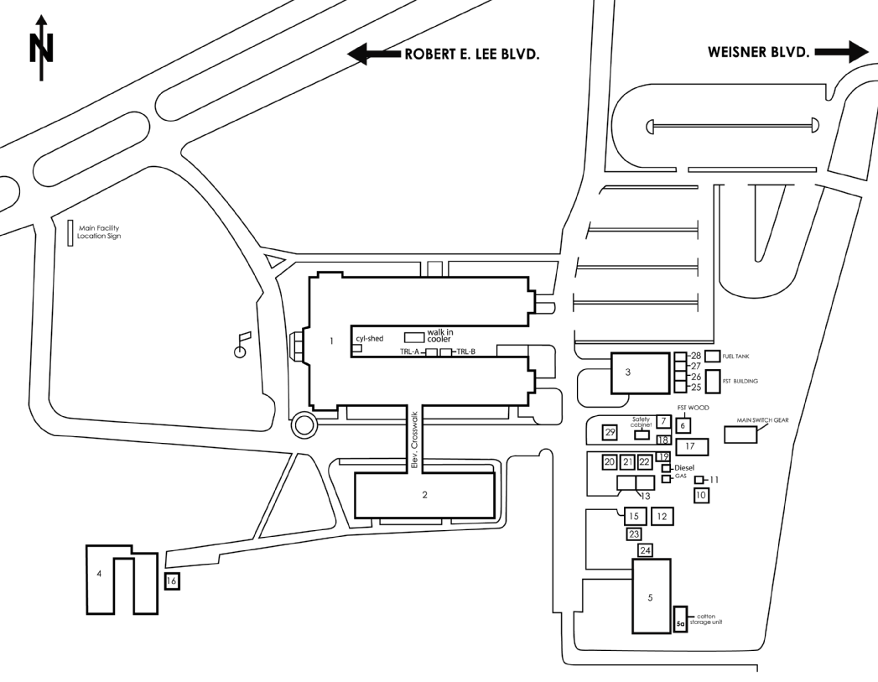

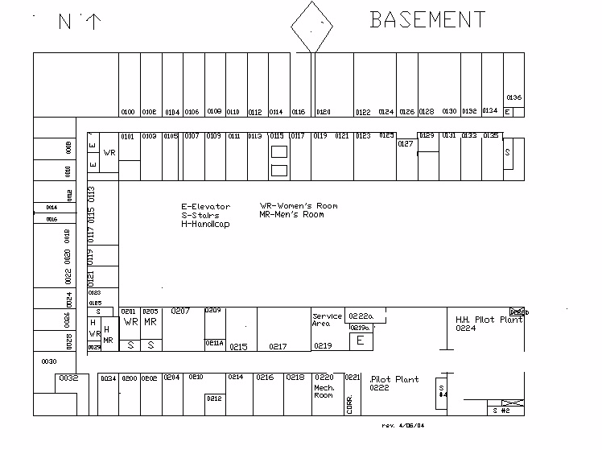

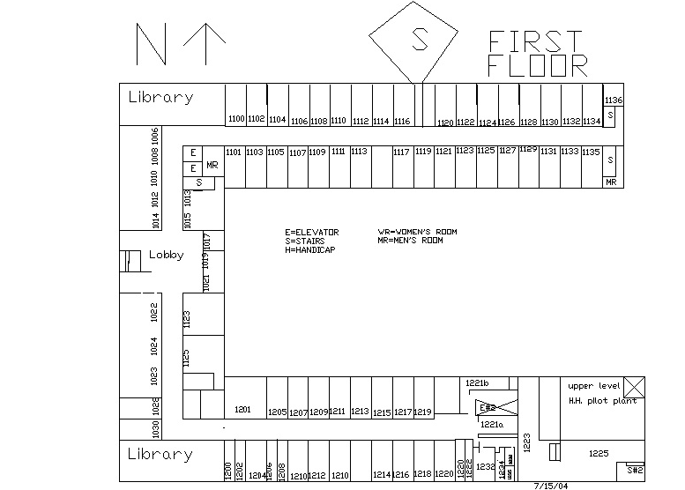

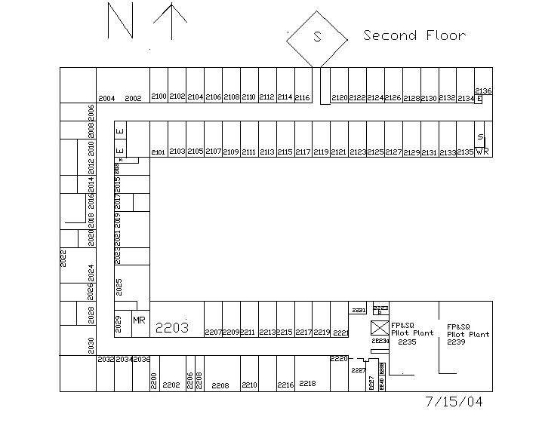

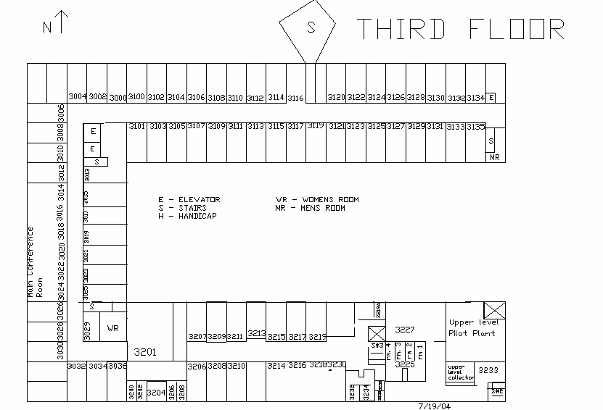

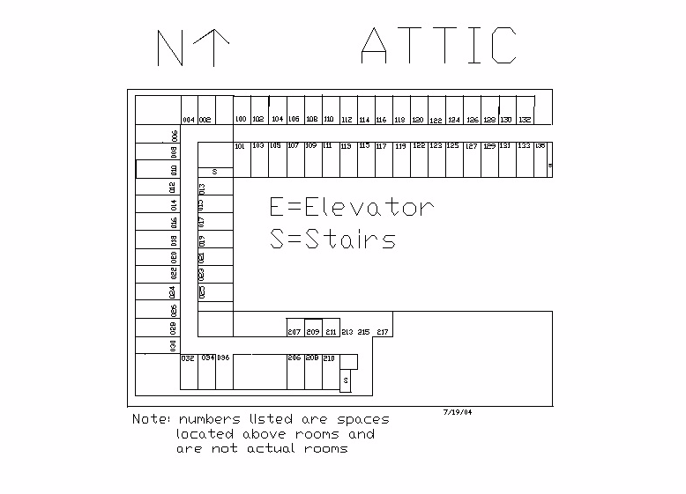

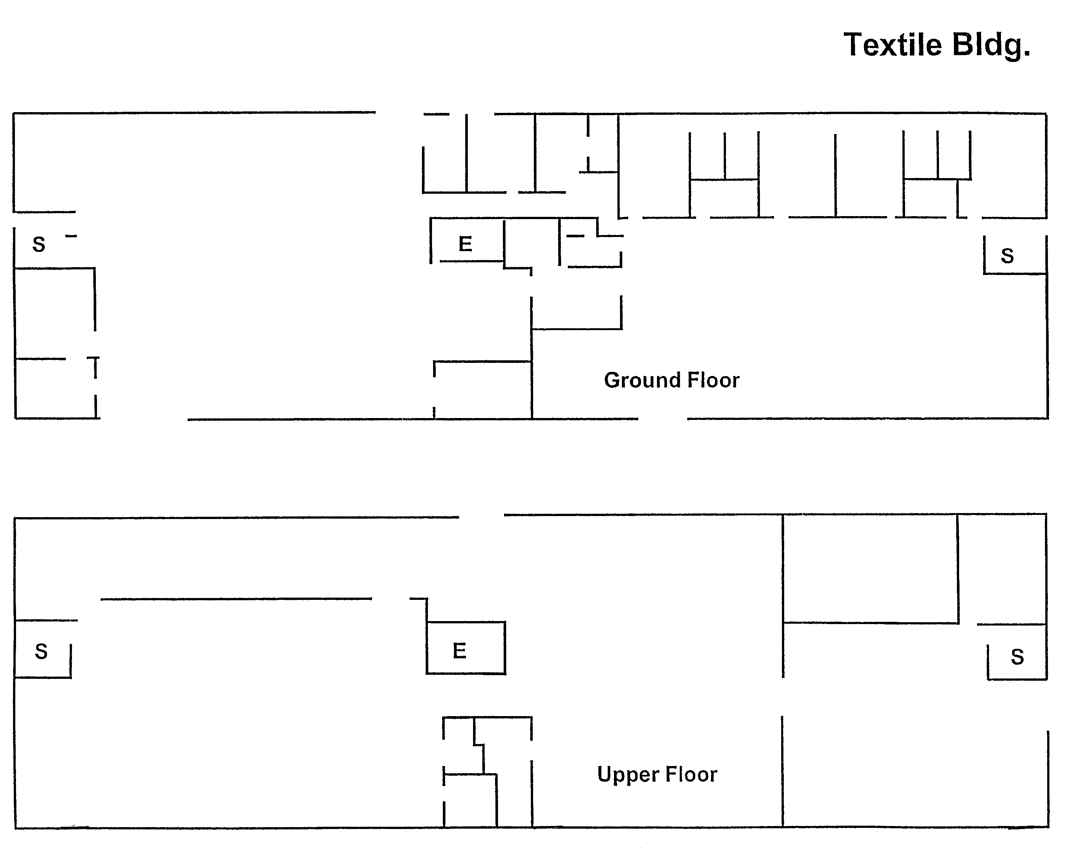

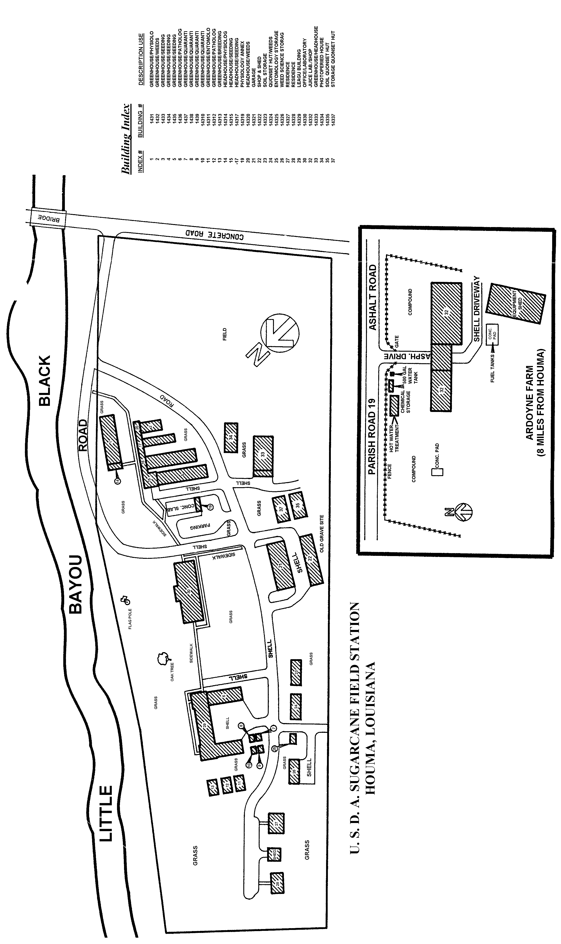

APPENDIX 4

HISTORICAL PRICING DATA

Fiscal Year Routine Work Additional Work Total

2000 $1,047,187 $0 $1,047,187

2001 $2,129,076 $299,729 $2,428,805

2002 $2,205,411 $178,647 $2,384,058

2003 $2,340,826 $478,348 $2,819,174

2004 $2,473,463 $287,870 $2,761,333

2005 $1,215,222 $0 $1,215,222

APPENDIX 5

HISTORICALLY SUBCONTRACTED WORK

FUNCTION CURRENT SUBCONTRACTOR

1. Removal and disposal of waste Tri-Parish Disposal
2. Elevator Maintenance Thyssen Elevators
3. Elevator Inspection Services Thyssen Elevators
4. Inspection of Fire Suppression System Fire Safety & Commodities
5. Maintenance of Card Entry System Sonitrol
6. Maintenance of CCTV Sonitrol
7. Security and Intrusion System Sonitrol
8. Maintenance of Fire/Detection, Alarm System Simplex
9. Central monitoring of Fire and Security Systems Sonitrol
10.Deionized Water Service U.S. Filters
11.Mats and Mop Rentals Cintas
12. Building Automation System (BAS) Siemens
13.Pest and Rodent Control Orkin/Reddman
14.Fire Extinguisher Inspection Fire Safety & Commodities
15.Dry Ice Carbon Dioxide Sales
16. Maintenance of Communication Gear (radio phones) Tomba Communications
17.Funehood Inspections ENV Service and Siemens
18.Cell Phones Cingluar

APPENDIX 6

Facilities Inventory

See Attached Files

APPENDIX 7

List of PM EQUIPMENT

See Attached Files

APPENDIX 8

GOVERNMENT FURNISHED EQUIPMENT LIST

QUANTITY DESCRIPTION SERIAL #

ROOM 1017

1 Gateway Processor, Model # MFATXHRN NM2 E2100 1098377248
1 Gateway Monitor, Model FPD-1530 MUL5022C0015781
1 Hewlett-Packard Laserjet 4L Printer USCC043303
1 Canon P32DH Calculator 038985
1 Boston Electric Stapler 299015

ROOM 1019/1021

1 Motorola Radio Battery Maintenance System WPLN4079AR
1 IBM Selectric III Typewriter 4953932
1 Texas Instruments Calculator TI-5045 II 307688
1 BENQ 17” Monitor, Model FP747
1 Gateway Processor 0019846037
1 GBC Personal Shredder 905 GB02876
1 Hewlett-Packard Laserjet 2100TN Printer USGR043829
1 BENQ 17” Monitor, Model FP747
- Gateway Processor 0023561086

ROOM 1023

1 Viewsonic 17” Monitor AOHO13100025
1 Gateway Athlon Processor 020591060
1 Hewlett-Packard Laserjet 5P Printer AG0002685435
1 Canon P32-DH Calculator 055735

ROOM 1025

1 BENQ 17’ Monitor, Model FP747 99L5372SGA33201086TS3SGA
1 Gateway Series E Processor 098377314
1 Hewlett-Packard Officejet 710 Printer MY99D209F
1 Texas Instruments Calculator TI-532011 121770
1 Nikon 35mm Camera, Model AFN8008 2538755
1 Nikon 35mm Flash Unit (for above camera) 3112924
1 Universal Enterprises Microwave Tester, Model MW1A
1 Alphalab EMF Trifield Meter
1 Zenith Television, Model J2040W 221-64340075
2 Panasonic VCR, Model PV-9401 E95A22931
E95A22928
1 Multi-Vision Pro 16 Multiplexer Robot 100A0130000160
1 Panavision Model 6040 Time-Lapsed Video Recorder I1TC00090

ROOM 1029

RACK 1
1 Dedicated Micros Digital Recorder (Chemical Wing) A2X030501009
1 Dedicated Micros Digital Recorder (Admin Wing) A2X030305009
1 Dedicated Micros Digital Recorder (Industrial Wing) A2X031629005
1 Pelco Inc., Matrix Control Switcher 02289-28-001993
QUANTITY DESCRIPTION SERIAL #

6 EA 2000, Half Duplex Equalizing Amplifier: #9 03132-04-000521
#8 03132-04-001009
#7 03101-04-013341
#2 03125-04-000206
#1 03132-04-000615
#4 03132-04-000311
2 Pelco Inc., Matrix Switcher Connectors 00356-28-0019

RACK 2
1 Dedicated Micros Digital Recorder: (Exterior) A2X030305010
1 Dedicated Micros Digital Recorder: (IWPP) A2X030305001
1 Dedicated Micros Digital Recorder: (Doors) A2X024654001
1 Dedicated Micros Digital Recorder: (SRRC) A2X030305008
1 EA 2000, Half Duplex Equalizing Amplifier: #4-6 02273-04-007825
1 EA 2000, Half Duplex Equalizing Amplifier: #4-5
1 EA 2000, Half Duplex Equalizing Amplifier: #4-7 02274-04-004991
2 Multi-Vision Pro 16, Multiplexer Robot 100A0131000363
145003100410

SECURITY DESK #1
5 Sony 17” Black & White Monitor 1005550
1005533
1025258
1025261
1025237

SECURITY DESK #2
1 Gateway 17” Monitor POO7089972
1 ICT P-III Mini-Tower Processor
1 Keytronic Keyboard Q992012239
1 Hewlett-Packard Photosmart 1115 Printer MX2371F07D

SECURITY CABINET
1 Panasonic VCR AG0002648448
1 Nuvispec Monitor, Model NUVM98W 9606005132
1 Polaroid 600 Camera

RECEPTIONIST AREA

1 Zoll AED Plus X02H003957
1 Merlin Express Elite JL812-09749
1 Merlin Express Elite AG0002392139
1 Hewlett-Packard Laserjet 4L Printer AG0002649735
1 Revere Television Monitor RMON 12B
1 Motorola Maxtrac Base Station 4385ZH0212
1 BENQ 17” Monitor 99L53725SGA3320
1 Keytronic Keyboard Q992012203
1 Gateway Hard Drive 0020664056

QUANTITY DESCRIPTION SERIAL #

SAFETY TECH AREA

1 Radio Shack Weather Alert 12-247B
1 MSA Passport AG0002685492
1 Sony Clearvoice Tape Recorder 157447
1 Simpson Sound Level Meter, Model 884 037306
1 Kurz Anemometer, Series 490 LVE27A81
1 Gateway Monitor, Model FPD1550 MUL5022C0015798
1 Gateway Keyboard E410540
1 ICT Hard Drive 0020566443

CTS WORK STATION

1 Gateway 2000 Monitor 8053069
1 Gateway Hard Drive 007846654
1 Vivitron Keyboard J981459665

EXCESS STOCK EQUIPMENT (LOCATED IN RM. 0012)

7 Panavision VCR, Model AG-6040P H3TA00487
L9TA00181
K9TA00059
L8TA00525
F0TA00195
L9TA00110
E6TA00432
1 ADV 1477 Black & White Quad 145992401582
3 Multi-Vision Multiplexer Robot, Model MV16P-20 145994900835
145994900841
145995102003
3 Multi-Vision Multiplexer Robot, Model MV161 611656-041
804663-032
611656-038
1 AD MicroQuad, Model AD1472 MIC 1677435
1 Pelco Amplifier 8022-8F
1 Nuvispec CCD Camera 95080191
1 Sony Camera 122432
4 HID 5” Card Reader 3201-203059
1702-82877
4701-0812
4701-0339
9 Pelco Cameras None Found
1 Radio Shack Fast Charger None Found
2 Runway Wall Support Kits None Found
4 CCTV SD-450 Cameras None Found
6 Assorted Transformers None Found

DUPLICATING

1 Li-Laminex 12C Laminating Machine ARS 202111
1 Triumph Paper Cutter, Model # 209834 ARS 209834
1 Velobind 323 Binding Machine AG0002238193
1 Rhin-0-Tuff Hole Puncher 108488
1 Gestetner Paper Folder 1222

QUANTITY DESCRIPTION SERIAL #

1 GBC Paper Shredder, Model # 10365 JG05529
1 Ibico Comb Binder, Model # HB-24 021017
- Laminator, Model 7000
1 Panasonic Electric Stapler, Model # AS-300N 282649
1 Texas Instruments Calculator, Model # TI5140 132392
1 Lassco Corner Rounder 056325
1 Rapid 106 Electric Stapler 50891
1 Pentium II Processor
1 Viewsonic Monitor, Model VG150

STOREROOM

1 ICT Mini-Tower Computer AG0002649609
1 Hewlett-Packard Laserjet 2100TN Printer USGR022883
1 Intermec Barcode Printer, Model # 8646 8646-0002374
1 Star Receipt Printer, Model TSP600 120210900106
1 Par Processor w/Keyboard, Scanner, & Bar Code Reader
1 Gateway Processor 0021200439
1 Gateway Monitor, Model EV700
2 WYSE Mono 12” Monitors 01F19601405
01F19601409
1 Minolta Copier, Model EP4050 318269
1 Epson LQ1170 Printer 4161110547
1 Craftsman 6HP Wet/Dry Vacuum 96304V0929
1 Dell Monitor, Model # EP4050 27222AJ083
1 Zebra Label Printer, Model LP2742P5A 47474844
4 Laserwands AG0002649685
AG0002649461
AG0002649460
AG0002649719
2 Chargers (for Laserwands) AG0002649721
AG0002649720

RECEIVING ROOM

- Pentium II Processor
1 CTX Monitor, Model X-50 7A591382952
1 Howe Scale, 1000 lb. Capacity
1 Turnkey Pallet Truck, Model ML-55 23089
1 Michelli Scale, 100 lb. Capacity
1 Zebra Label Printer, Model LP2742P5A 47474844

MAILROOM

1 Neopost Mail Metering Machine, Model SM 78 08016180
1 Neopost Postal Scale, Model SE 95
1 Pelouze Postal Scale, Model 1050 AG0002685438
1 Motorpla Single Unit Charger, Model NTN4633C

ROOM 2013 (IT MANAGERS OFFICE)

QUANTITY DESCRIPTION SERIAL #

1 Gateway P-IV 18” LCD Computer 0028541157
QUANTITY DESCRIPTION SERIAL #

1 Hewlett Packard Laserjet 2100 Copier USDD028085
1 Gateway E-4200 00011124996
1 Gateway Laptop 3 (Loaner) B2500113261

ROOM 2015 (GENERAL USER)

1 Microtek Image Deck Scanner 8C52703437
1 Tektronix Phaser III Color Printer AG0002410840
1 Hewlett Packard Deskjet 682C, Model B4567A SG64N1N03B
1 Polaroid Camera, Model IPC-2 9328050454
1 Polaroid 35mm Power Processor YD84357K
1 Pentium 5/133 Print Server AG0002649654
1 Lasergraphics LFR Mark II Film Recorder
1 ICT Computer AG0002685849
1 Gateway 2000 Computer w/Monitor & HP Laserjet Printer AG000264965
1 MacIntosh IICi External Zip Drive w/Apple Color Monitor AG0002410593
1 MacIntosh G3 External Zip Drive w/Monitor & Laserwriter II AG0002410594
1 ICT Computer AG0002685848
1 Lasergraphics LFR w/UPS & HP Scanjet 3C/ADF AG0002685469
1 ICT Computer AG0002649915
1 Microtek Scanmaster 8700
1 Canoscan FS 2710

ROOM 2017 (WORD PROCESSING)

1 Fridgid Oscillating Fan, Model OSH-131-8 050829
1 Panasonic Electric Pencil Sharpener
1 Hewlett Packard Fax 310 w/Best Fortress UPS AG0002411326
1 ICT Computer w/17” Monitor AG0002685847
1 Hewlett Packard Laserjet 4L Printer USBB138178

ROOM 2019 (ET SHOP)

1 Display Maker Print System & RIP Station (Pentium Computer)
1 Campbell Hausfeld ¾” HP Air Compressor 012093L
1 Canon Digital B/W Still Video Camera, Model RC-250 YD84357K
- Wire Utility Carts
1 Makita 9.6 Cordless Drill 0882862Y572
1 SimmChecker Y550Y548Y5688
1 UNGAR Solder/Desolder, Model 4624 5-15-902B
1 Motorola 6-Station Battery Charger HTN9164B
1 Midwest Micro-Notebook AG0002649574
1 In-focus, Model LP755 3WW93900077
1 Dukane LCD Image 8020 Portable Projector AG0002686023
1 Kodak Digital Zoom Color Camera, Model DC260 EKH90101039
1 Iomega 100MB External Zip Drive W1MU420PC7
1 Iomega IGB External Jazz Drive
1 Test Computer w/15” Monitor
1 Hewlett Packard Laserjet 2200DN Printer USGZ049640
1 Epson Stylus Photo 1200 BJK0020061
1 Gateway P IV 18” LCD Computer (ET Computer) 0028383152
1 Gateway P IV 18” LCD Computer (MCS Computer) 0028444789
1 Gateway P IV 18” LCD Computer (Graphics Artist Computer) 0028417217
1 Laptop 3 (Loaner) 0029690538
2 Lucent Technologies Speaker Telephones
QUANTITY DESCRIPTION SERIAL #

2 Jensen Canvas Tool Kits

UTILITIES OFFICE

1 Gateway E-series Computer
- Stanley Electric Stapler
1 Texas Instruments Calculator TI-5045II
1 Hewlett-Packard Color Printer MY8CAC2082
1 Megatronic Laptop Computer 647992-0001
1 Amprobe DM-II Data Logger 982719
1 Craftsman Cordless Drill 973-274870
1 Johnson Controls Meter Y199AAA-2

MACHINE SHOP

1 Biddle Insulation Tester 212159
1 Oil Tester AG0002241020
1 Current Tester GE65968
1 Hydraulic Pipe Bender
1 Amprobe Current Tracer CT326
1 Angle Iron Bender & Shear 181298
1 Sheet Metal Brake & Bender AG0002241033
1 Steel Brake 56494
1 Metal Punch 65556
1 Band Saw (for metal) AG0002241026
1 Seaming Machine AG0002685391
3 Electric Surface Grinders AG0002241036
1 Milwaukee Rotary Hammer 688B197470070
1 DeWalt Demolition Hammer 0024869822
1 Multi-ton Motorized Pallet Jack 0405740389
1 Ingersoll-Rand Impact Wrench A99B17197
- Robinair Recovery Unit
1 Miller Tack Welder HK232531
1 Fluke Pressure/Vacuum Modulator PV350
- Tassco Phase Finder
1 Portable Electric Welder AG0002241039
1 Hydraulic Press (Plumbing Shop) 33567
1 Drill Press AG0002241031
1 Milwaukee Band Saw 0457285576
1 Little Dickie Lift
3 Pallet Jacks 23347/68840-138/62924
- Freon Recovery System
1 Welding Cutting Torch 719649
1 Pipe Threading Machine 104322
1 Metal Shear AG0002649733
1 Wire-fed Welder 3Z914E
1 20 amp Plasma Cutter 3W772
1 Wire Wheel Brush 49782
1 Pipe Cutter AG0002241032
1 Fluke AMP Clamp M30/SN5025
1 Greenlee Hydraulic Punch 7904SB
1 Fluke Temp Probe TIR M52/SN6942048
1 RRTI Recovery Unit MRR030/SN039044520
1 Fluke Multimeter M16/SN68740154
1 HD Electric Co., 15KV Meter Mark-I/SN1060
QUANTITY DESCRIPTION SERIAL #

1 HD Electric Co., 15KV Ammeter M9361/SNH0296924F
1 Hastings Telescopic Hot Stick M-HV208F
1 Fluke Scopemeter, Model # M105B 944420105003
1 Fluke Power Harmonic Analyzer M-41B
1 Esterline-Angus Miniserve Power Recorder 89385006
1 Fluke Multimeter 617003891
1 Klein Tools Torque Kit M57060
1 Amprobe Spike-Sag-Surge Recorder M-LAS-800
1 Mitchell Instruments Temperature Gun 43779
1 Exte-C Rotation Meter S1251761
- Motorola 6-unit Battery Charger

BOILER PLANT

1 Proto 6-Drawer Tool Box
1 Black & Decker ½” Cordless Hammer Drill 44504
- Slide Hammer
- 2’ Flourescent Droplite
- Refrigerant Leak Detector, Model L790A
- Wavetek 2020 Multimeter w/attachments
- Refrigerant Charging Manifold
1 Bell & Gossett Flowmeter, Model RO2 153709
1 Amprobe, Model ACD-11 20404118
- Streamlight Flashlight
2 Morse Watchman Tour Recorders 70221988/70722720
- Morse Watchman Charger Base
1 Radio Shack Weather Radio 12-247
1 Omega PH Meter 9005
1 Goodway Boiler Tube Cleaner 2717
1 Goodway Ream-a-Matic Chiller Tube Cleaner 1517
1 Dayton 3/8” Impact Wrench 10664H
1 Goodway Vacuum 10086
1 Epson Stylus Color 800 Printer 3HR1271363
- Harris Torch Welder/Cutter
- York Freon Recovery System
1 Lexmark Printer AG0002685586
- Fortress UPS’
- Epson FX-286 Printer

FACILITIES OFFICE

1 Hewlett-Packard 4L Printer AG0002410658
- Gateway E-series Computer
1 Gateway Monitor, Model FPD1530
2 Motorola 6-unit Battery Chargers
1 Sharp EL-2192-G Calculator 4C022119

ROOM 0019

- Battery Powered Floor Polisher
- Electric Floor Polishers
- Electric Floor Scrubbers
- Oreck Vacuum Cleaners (4 Model XL9300 & 1 Model C2720E)
- Kent 26” Hallway Vacuums
QUANTITY DESCRIPTION SERIAL #

- Dayton Wet/Dry Vacuum

PAINT TRAILER

1 Scott Sign-Graver Machine, Model M-SM-500 3417
1 Ideal Stencil Cutter 29035
1 Devilbiss Spray Gun JGHV-530
- Binks Spray Gun, Model M-2001
- Wagner Power-Painter Kit, Model M-220
- Light Fixture Stands
1 Black & Decker Heat Gun 9778
1 Makita Finishing Sander B04550

CARPENTER SHOP

- Hilti DD100 Core Drill w/attachments
1 Ramset Fastening Tool, Model L1600 250322
1 Hilti Fastening Tool, Model DX400B 290419
- Hilti Hammer Drill, Model TE5
1 Black & Decker Screw Gun 2660
1 Skil Scroll Saw, Model DVR 4470
1 Makita Belt Sander 9924B
1 Makita Router 3601B
1 Sears 71/4” Circular Saw A4211
1 Delta 10” Compound Miter Box K9527
1 Sears Dove Tail Joiner Kit 92570
1 Campbell-Hausfeld Compressor WL5043003AJ
1 Central Pneumatic Nail Gun 32870
1 Spot Nail Gun FS4825
2 Rais-n-Roll Dolly, Model RNR10 98955
1 Dust Collecting Machine D49534
1 6” Belt Finishing Machine AG0002241013
1 Band Saw (for wood) AG0002241025
1 DeWalt Radial Arm Saw AG0002241027
1 Delta Table Saw, Model RT40 5121
1 Craftsman Cordless Drill 973274870
- DeWalt Electric Screw Gun, Model DWV251
1 Carpet Knee Kicker 10-412
- Best Key Cutting Machine w/attachments

COMPOUND

1 Electric Portable Welder 3Z563A
2 Redmax Backpack Blowers 074466/072442
1 Bobcat Backhoe Attachment 584100490
1 Melroe Bobcat 753MACH
- Clark Forklift, Model CPG30
1 JLG Manlift 0276710300024515
1 Billy Goat Blower/Vacuum 840193
1 Vicon Seed Spreader 39151
1 Pressure Washer 8801303
1 JCB Forklift 660098
- Redmax Hedge Trimmer, Model HT232
- Shindaiwa Hedge Trimmer, Model HT20-40
1 Bobcat Sweeper Attachment 714401058
1 Duerr Chip Shredder 99-900-5998
1 Stihl Chain Saw, Model 036 225729478
1 Cement Mixer 59020
- Onan Generator, Model 15-OJG-4
2 Dayton Generators 252412/1316135
- Woodchuck Chipper, Model WG11
- Bushhog Rotary Tiller, Model RTN-60
1 60” Utility Bucket (Bobcat attachment) 6704549
2 Sterilizing Soil Carts 2183-95/2184-95
1 E-Z Roll Edger 094875
1 Melroe 60” Grapple (for Bobcat) 659900240
1 Melroe Ditch Trencher (for Bobcat) 420400163
1 Bush Hog, Model TM6 AG00023118259
1 Bush Hog, Model SQ-720 12-21903
1 Bush Hog Finisher, Model # RDTH72 12-07804
1 5-unit Gang Mower 91815/6/7/8/9
2 Honda Self-Propelled Mowers HRC216KL/HRC216-BK
1 JCB Work Platform G1094
1 Troybilt Roto-Tiller 861156
2 Redmax Weedeaters BC34ODL-G3K27/BC34ODL-244360
1 Ford Tractor, Model 3910 B50441602
1 John Deere Backhoe/Front Loader 802200
1 Craftsman Bushwacker Weedeater 99176N200645
2 New Holland Riding Mowers, Model MC28 TE00113/TE00292
1 Stihl Chain Saw, Model 026 247621478
1 Stihl Weedeater, Model FS200 43836534
1 Speedaire Air Compressor 121990L
1 Baldor Grinder K6394
1 Black & Decker 4 ½” Angle Grinder 439692
1 Toro Pro-line 32” Mower 280000211
1 Teel 2” Portable Pump PTR000001
1 Power Trim Edger 275076
1 Vanguard 4”/16hp Portable Pump 3P653
1 EZ-Go Utility Cart 1396658
1 Workhorse 80-gal. Portable Water Pump

AUDIO/VISUAL ROOM

1 Kodak Ektagraph 35mm Slide Projector 5238656
1 Kodak Ektagraph 35mm Slide Projector 3144404
1 Kodak Ektagraph III 35mm Slide Projector A365718
1 Kodak Ektagraph Slide Projector, Model 5600 82266
1 35mm Carousel Slide Projector, Model 4600 172778
1 Kodak Carousel Projector, Model 750H 3390148
1 Kodak Carousel Carrying Case 128875
2 AHJ Overhead Projectors, Model 900 AG0002648353
AG0002648352
1 RCA Television, Model F205363EH (in cabinet) 018791
1 Kodak Ektagraphic III A365686
1 Panavision VCR, Model AG1270P (in cabinet) AG0002648447
1 DP-30 Plus AG0002685412
1 3M LCD Overhead Projector, Model 955 AG0002648354
1 Pioneer Large Screen TV, Model SD-503P JI3600026S
1 RCA DVD/VCR Cassette Recorder DRC6100N
1 Mitsubishi Large Screen TV, Model V5-5061 018791
1 Mitsubishi Video Cassette Recorder 28125067M
1 Kodak Carousel, Model 4600 061623

APPENDIX 9

VEHICLE LISTING

ARS/ GSA Group License No. Vin No. Year Make Model Color
White | FST | A 284234 | 1GNEC16ROXJ438764 | 1999 | Chevy | Suburban
White | FST | A 284235 | 1FTNX21LOXED25508 | 1999 | Ford | F-250 | PU
Blue | FST | G4141168 | 2B4GP45G2XR435221 | 1999 | Dodge | Caravan | Van
White | FST | A 284236 | 1FTYR14X4XTA53590 | 1999 | Ford | Ranger | PU
White | FPSQ | A 284339 | 1GCEK14W722341169 | 2002 | Chevy | Silverado | PU
Blue | ARS | A 230195 | 2B5WB31W3HK279441 | 1987 | Dodge | 12-Pass. | Van
Blue | ARS | A 284273 | 2FAFP73W9YX211781 | 2000 | Ford | Crown V
White | GSA | G4143437 | 2B4GP45G4XR439500 | 1999 | Dodge | Caravan | Van
White | ARS | A 263741 | 1FMCA11U7RZA39044 | 1994 | Ford | Aerostar | Van
Green | GSA | G4164669 | 1FTDA14U0VZB81883 | 2002 | Ford | Windstar | Van
Red | GSA | G4240146 | 1FTPX17LXYNB51751 | 2000 | Ford | F-150 | PU

APPENDIX 9a

MONTHLY VEHCILE INSPECTION SHEET Date__/___/___
VECHILE I.D. #_____________Brand___________Model___________Year________
Owner____________ Inspected by__________

Gen. Condition | Poor | Good | Excellent | Comments
Air conditioner
Heater
Oil levels
Lights
Windows
Tires
Mirrors
Horn
Doors
Jack
Emergency Kit
Engine
Transmission
Brakes
Exhaust Sys

APPENDIX 9b

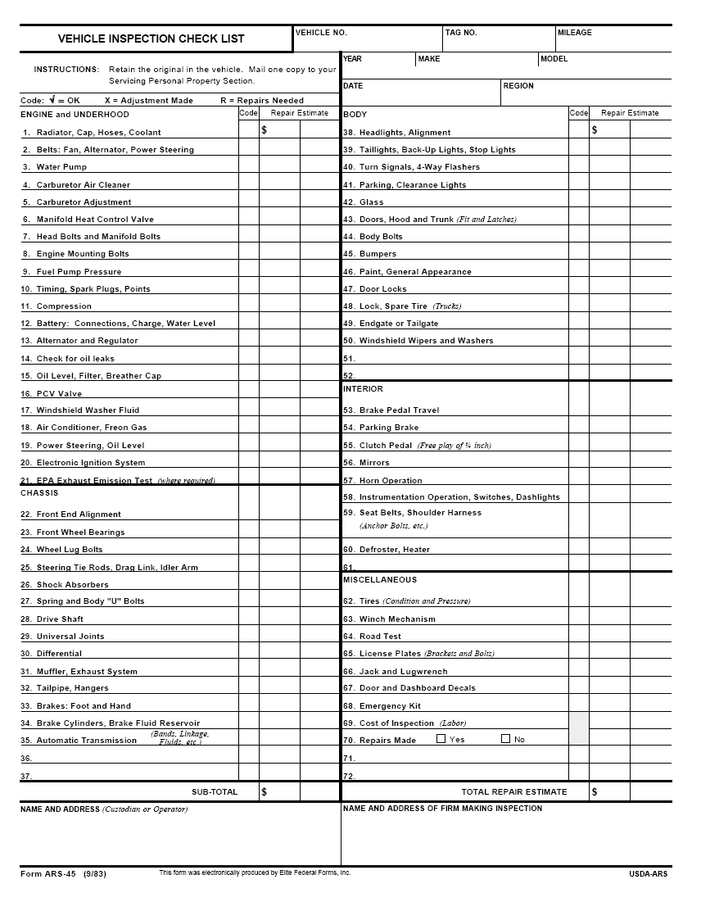

APPENDIX 10
Recommended “No or Low Cost” Energy Conservation Action
The Contractor shall ensure customer and contractor employees awareness of the following ARS Policy recommendations for conservation actions;
- Turn off lights/office equipment when not in use.
- Reduce the use of elevators. Walk down two flights or up one flight instead of using elevators.
- Keep windows/doors shut in areas that are being heated or cooled.
- Close blinds, shades, and drapes at night during the heating seasons to reduce heat loss through the window area. Open them during the day to use the sun for heating the rooms.
- Close blinds, shades, and drapes during the day in summer. These interior shading devices can reduce heat gain in the room as much as 50 percent.
- Minimize overtime work. Consolidate work areas of after-hours workers to minimize the amount of space that must be heated, air conditioned, and lighted.
- If rooms are individually controlled by thermostats, keep temperatures above 76º F in the summer and below 70º F in the winter.
- Avoid the use of fans and space heaters if the building HVAC systems are operating.
- Do not block HVAC air distribution outlets with books, furniture, etc.
- Keep energy conservation awareness a priority by way of staff meetings, newsletters, posters, etc.

APPENDIX 11

VISITORS POLICY

Frequent visitors, vendors and repair personnel. This does not apply to Collaborators and Partners or permanent in-house contractors.

- Center must receive a letter with original signature from the section, division or department manger of the business verifying the name, citizenship, and length of employment of the vendor representative.

- The Vendor representative must attend the Center’s Safety and Security Orientation training course.

- The Vendor representative receives a badge with the individual’s name and the name of the company identifying him/her as a Vendor.

- The Vendor shall visit the center by invitation from the Center personnel only. The invitee must be present at the Center and will be informed of the Vendors arrival to the Center.

- The Vendor shall not visit any lab or a person to solicit or present the products and/or services without invitation from the occupant.

- The Vendor’s badge will be kept at the front desk and the Vendor shall not remove the badge from the facility.

- The business principal shall confirm the employment status of the Vendor representative annually and in the case of national emergency, immediately.

- Upon violation of any of the above rules, the Vendor’s badge and privileges will be removed and will not be reinstated until a written explanation of the breech is received and approved by the office of the ACO at SRRC.

ATTACHMENT 2

SRRC Quality Assurance Plan

- Scope of Contract Requirement:
SRRC and Houma Operations and Maintenance

This requirement is for the full range of operational and maintenance support at the entire complex of the United States Department of Agriculture’s Southern Regional Research Center (SRRC) in New Orleans, Louisiana and Information Technology at the Sugarcane Research Unit (SRU) in Houma, Louisiana. It is essential that the contractor providing this support be knowledgeable in a variety of maintenance and support functions and providing a quality control plan keyed to the government’s performance requirements. These activities are provided in support of the research mission at SRRC and SRU.

  - Scope of operations and maintenance

The Contractor shall provide the work management, preventive maintenance, building maintenance, alteration and repair, ground maintenance, heating, ventilation, air conditioning and refrigeration (HVAC/R), electrical, plumbing, housekeeping, safety, greenhouse support and administrative services to support the research mission of the Centers. These activities include quality control, financial control, and records management. The Contractor’s services and support shall be performed twenty-four hours a day on a seven days per week basis year round. This includes performance at times when the Center may be closed unexpectedly or during non-duty.

- Standards of Performance

The work shall be performed in accordance with all applicable Federal, state, and local laws, as well as Federal, USDA, ARS, and SRRC regulations.

The specific work requirements are found in the following statement of work sections:

- Work Management – see SOW Section 2
- Administrative Services – see SOW Section 3
- Safety – see Section 4
- Information Technology Support – see SOW Section 5
- Utilities Services – see SOW Section 6
- Facilities Services – see SOW Section 7
- Greenhouse and Plot Services – see SOW Section 8

The performance standards are established in that paragraph of the statement of work that covers the specific category of work. Performance are keyed to the relative importance of the task to the overall mission performance at SRRC.

3. Primary Methods of Surveillance

In an effort to minimize the contract administration burden upon the government, simplified methods of surveillance and reliance on simplified techniques shall be used by the Government to evaluate contractor performance. The primary methods of surveillance are random checks, observations, inspections, complaints and review of those records and files that are required to be maintained and delivered under this statement of work. The Government will use appointed representatives, as well as reports and input from Center employees and visitors as sources of comments on the contractor’s performance.

4. Quality Standard

The performance standards are structured to allow the contactor to manage how the work is performed while providing both positive and negative or disincentives for repeated performance shortfalls. The standard for this effort is found in the Performance Work Statement (PWS), included as Attachment (1) to the contract. The standards are found in the following sections of the statement of work:

- Work Management – see SOW Section 2
- Administrative Services – see SOW Section 3
- Safety – see SOW Section 4
- Information Technology Support – see SOW Section 5
- Utilities Services – see SOW Section 6
- Facilities Services – see SOW Section 7
- Greenhouse and Plot Services – see SOW Section 8

- Evaluation Method

The Government shall use the observation methods cited in the statement of work as the basis for determining whether the standards have been met. Dialog with the contractor on the specific discrepancies and complaints shall form the basis for the performance evaluation. The government’s evaluation is then translated into the specific positive and/or negative.

ATTACHMENT 3

Service Contract Act Wage Determination

ATTACHMENT 4

Davis Bacon Act Wage Determination

