u.s. general services administration
integrated acquisition environment

contract award documents Online

ver 3.3

general Services Administration
iNTEGRATED aCQUISITION eNVIRONMENT
2011 Crystal Drive
Arlington, Virginia 22202

DECEMBER 20, 2004

integrated.acquisition@gsa.gov
CONTRACT AWARD DOCUMENTS ONLINE

Executive summary
Historically, citizens and public interest groups have requested greater insight into the processes and decisions of the federal government. Nowhere has this request for transparency had more impact than the processes governing the expenditures of public funds. There is a constant stream of public requests looking for insight into the process of the awarding of Federal Contracts and Grants. In an effort to provide transparency, Federal Agencies developed a resource intensive approach to responding to public document requests from their customers and suppliers. Despite the benefits of computers, database systems, the internet and instant access, agencies still rely extensively on human-decision making and decentralized manual processing in responding to most requests for information. However, faced with increasing budgetary pressures as well as increasing requests for information, several agencies have or are attempting to introduce different forms of electronic or automated posting of requested contract award documents.

The question facing the Federal sector today is whether the best response to this request for increased transparency perceived or actual, is the development of a centralized federal delivery mechanism for contract award documents online.

background
The concept of Contracts Award Documents Online (CADO) is consistent with The President’s Management Agenda (PMA) Expected Results of Expanded Electronic Government, to “make Government more transparent and accountable”. In June 2003 Federal Register Notice 2003-N01 “Integrated Acquisition Environment Pilot; Posting Awarded Contracts on the Worldwide Web” was released. It requested the public to send their comments, suggestions and recommendations on the topic. The Government received 118 comments in August 2003 from a variety of submitters, including individuals, corporations, [Benz Corporation], associations [American Bar Association (ABA)]; and labor unions [American Federation of Government Employees (AFGE)]. Many of the submitters were in favor of more visibility and transparency in the data generated from the contract award process. However, some of submitters were opposed to potentially broadening the release of contract awards and wrote at great length identifying existing policies, regulations, and delivery mechanisms that already provide the public avenues to obtain and collect data on contract awards.

INTRODUCTION
The Integrated Acquisition Environment (IAE) E-Gov initiative, led by the General Services Administration, has spearheaded an evaluation of the data collected and reported on the Government’s current efforts to increase visibility by posting contract award data online.
In January of 2004, IAE formed a working group of subject matter experts with members representing Department of Justice, General Services Administration, Office of Management and Budget, Department of State, Department of Transportation, National Aeronautics and Space Administration, and the Department of Defense. This group focused on evaluating the current availability of contract award data within the acquisition system, existing delivery systems and the intended audiences (civilian or federal). The group also sought to identify the opportunities, barriers, risks, and costs associated with online posting.
This paper focuses on the CADO working group’s investigation and research on the availability and economics regarding releasing contract documents to the public. Through aggregating a handful of disparate facts into a coherent whole, the CADO team derived a simple model that can analyze and detail the current level and methods of managing publicly accessible contracting data. This model emerges from coverage of four basic areas:
- Section One: discusses the various general assumptions and constraints presented to the CADO working group related to federal agency procedures of resolving requests for contract award data.
- Section Two: describes the methodology utilized to evaluate the assumptions and validate the assumed data against actual agency implementation of the described procedures.
- Section Three: details the CADO groups’ findings resulting from the validation process.
- Section Four: presents the CADO group conclusions.
This paper is the final product of this working group. This white paper will help the Government in the decision making processes regarding the visibility and accountability already afforded in the current acquisition system and help identify potential improvements or processes towards enhanced visibility into acquisitions and any additional steps that need be taken to ensure transparency.

Section One

general ASSUMPTIONS / Constraints
Most requests for contract award documentation must be put through the agency’s Freedom of Information Act (FOIA) business process. The CADO Project scope was limited to the validation of implementation of federal agency resolution of requests for contract award data, rather than a review of the entire FOIA business process. The CADO working group utilized the FOIA process solely as the foundation and central reference to compare results against. In addition, the FOIA process was used for agency points of contact, a source of statistical data, assumptions and agency references.

Goal
This working group’s goal is fact finding and modeling of the current FOIA process as it relates to the public release of contract data.

ASSUMPTIONS

Available Contract Award Request Statistics
These assumptions are based on information represented in the Annual FOIA Reports submitted to the U.S. Justice Department by Federal Departments and Agencies. This information included statistics that could be used to readily extrapolate the number(s) and cost(s) of the resolution of requests for contract award data via an electronic (online) process.
        - Federal Agencies are facing a large number of requests for contract data from the general public.
        - Federal Agencies do not have a regulated process for resolving public requests for contract data. However, resolution must be in accordance with the FOIA.
        - Requests for contract award documents via the FOIA procedures are resolved and reported consistently across all Federal agencies.
        - All FOIA requests, regardless of the office of receipt or subject, are forwarded and recorded at the unit’s FOIA office. It should never be the case that a contracting office handles a FOIA request on its own.
        - Although not always the case, agency FOIA offices include the costs of contract personnel and procurement unit resources in the totals reported for the resolution and related reimbursement costs of the award document requests.
        - Agency Legal, Contracting, Administrative and Information Technology costs are recorded and reflected in the annual reports.
        - Agency contracting personnel are trained on the proper procedures for reporting and resolving requests for contract documents via the FOIA process.
        - The majority of FOIA requests assigned exemption “#4” could be related to requests for contract documents
        - The general public desires greater transparency as it relates to contract award documents.
        - The majority of requests for contract award data originated from the general public.
        - The majority of the Federal supplier community supports increased release of contract award documents.
        - Proactive release of contract documentation would reduce requests and related challenges to request resolution.

Section Two

Methodology
The methodology employed by the IAE CADO working group included:
- Modeling the current FOIA process as it relates to the public release of contract documents. (See Appendix A - FOIA Process Model)
- First, the team conducted a survey of responding CFO Act Agency/Bureau FOIA and contracting officials to determine current FOIA required processes, procedures, policies and activities related to the receipt, report and resolution of requests for contract award documents.
- Utilizing the Unified Modeling Methodology (UMM) a series of meetings were conducted with responding FOIA officials to elicit a model representing the application of the FOIA process as applied within their agency/bureau
- This model was then validated in meetings with responding Contracting officials to assure proper representation of the contract personnel activities.
- Survey of responding CFO Act Agency/Bureau CADO members to validate consistent implementation of FOIA process as it relates to the release of contract award documents.
- Survey of Federal Agency Freedom of Information Act (FOIA) and Contracting officials to determine current practices, constraints and policies related to the posting of contract award Data.
- Survey of the responding CFO Act Agencies to identify barriers and constraints to posting contract award data online.

Section Three

Findings
- Current FOIA Process Model
The following is an abbreviated textual description of the modeled FOIA process as it relates to publicly releasing contract award documents:
  - The Federal Government receives a written request to release contract award information that has not been previously released.
  - An Agency’s FOIA officer determines that the request is related to contract documents and forwards the request to the responsible contracting office.
  - The contracting office locates the requested information and notifies the affected party (generally this is the company to whom the contract was awarded) that a FOIA request was received. The responsible contracting officer in coordination with the FOIA office redacts the information that they believe falls into the exception criteria and forwards the redacted version to the affected party and the government agency’s legal department for their review.
  - The affected party reviews the Contracting Officer’s redacted version and either:
    - Agrees with the redacted version and the version is approved for release; or
    - Disagrees with the final redacted version and files an appeal with the agency. If this appeal does not result in a satisfactory conclusion there may be an additional appeal to the Courts for a ruling.
  - Once an agreement is reached, the redacted version is released to the requestor.
  - After multiple (usually 3) requests for the same information, the information may be posted on the Agency’s electronic reading room and made available for pubic consumption to avoid further FOIA
- FOIA Annual Reports - Findings
- The current FOIA annual reporting procedures do not require or facilitate the reporting of unique classification of the exact type of request (i.e. request for personal data vs. contract award data)
- The current FOIA process model does not designate separation or detail accounting of contract document requests from all other FOIA requests so this information is not included in the annual report. In addition, the current FOIA model does not specify a uniform method of handling requests for contract documents, nor is there a process for calculating the additional costs of the inclusion of agency contract/acquisition, CIO staff or other Program Officers, into the FOIA process. These personnel costs are not generally included in the total FOIA staffing and personnel counts.
- The group was unable to determine the number of contract award document requests and their associated costs from the agency annual FOIA Reports.
- FOIA – contract award Document Related Training
- There is no established FOIA training program for contract officers. Federal Agencies rely on organizations' FOIA officers to make sure that their contracting officers are familiar with their duties with respect to the release of contract related information. However, training does take place at the FOIA Officer level.

- Current Agency methods of Posting of contract award documents
- Based on the working group analysis of the current CADO delivery mechanisms three distinct methods standout:
    - Reactive Posting – contract documents are only posted after several FOIA requests for the same documentation. A redacted version of the award documents is posted in the Agency’s Electronic Reading Room.
    - Proactive Posting to Public – As a part of the solicitation process vendors submits a redacted version of their proposal to be posted to the Internet as part of the business process.
    - Proactive Posting to Federal only – all awarded contract documents are posted Online on an intranet restricted to Government users.

Usage of Delivery Methods by Respondent
Delivery Methods | Percentage
Reactive Posting | 86.8
Proactive Posting to Public | 6.6
Proactive Posting Federal only | 6.6
Total | 100
NOTE: Statistics based on 15 responding Agencies of the 24 CFO Act Agencies surveyed.

- Perceived Challenges and Benefits of contract award documents being made publicly available Online
Challenges
- CADO removes the FOIA staff from the process, exposing Agencies to legal challenges by minimizing active FOIA participation in the document release process.
- Proactive posting to the public increases the potential for inadvertently releasing sensitive information.
- Agency Staff limitations – CADO would require drastic increases in administrative and technical staff to maintain and operate proactive systems in both the vendor and government communities.
- Lack of current federal regulation or policy guiding agencies and contractors in the procedures and processes of obtaining contract award documents outside of the current FOIA process.

Benefits
- Increased transparency of contract award documents
- Potential reduction in the number of FOIA requests
- Reduced cost of operations and maintenance of manual response systems in each agency.

- Limited Individual Citizen Interest in CADO
- Responses to the Federal Register Notice 2003-N01, “Integrated Acquisition Environment Pilot; Posting Awarded Contracts on the World Wide Web”, initially indicated a high level of individual citizen interest in CADO.
- Discussions with the respondents to the CADO Workshop, which included FOIA officals, disputed the assumption that the majority of requests for contract award documents were originated by individual citizens. The findings of the group were that the majority of requests for contract award documents originated from the vendor community.
- Agency respondents suggest that the majority of requests for and protests against release of contract award data are initiated from the Federal vendor contract community, not the general public.
- In addition, it was discovered that the majority of requestors were aware of the processes and procedures for obtaining contract award documents via the FOIA process.

Section four

conclusions
The CADO working group concludes that there is insufficient data supporting a Business Case to recommend the design, development and implementation of a centralized federal system to present contract award data online.
Prior to committing to a mandated Federal system to respond to contract award document requests the CADO group suggests at minimum the following be considered:

- The current FOIA Process (as modeled, related to contract award documents), is implemented consistently across the federal government.
- Based upon responses of the 24 CFO Act agencies to the CADO survey there is limited if any demand in the federal sector for a centralized contract award document system.

Appendix A Current FOIA – Contract Award Process Model

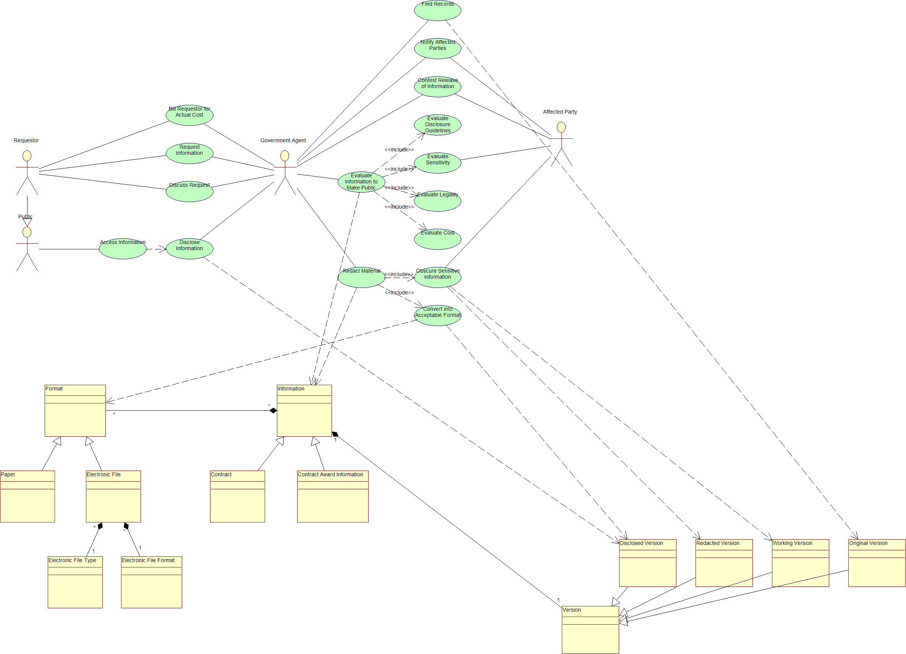

abreviated model details
- The Federal Government receives a written request to release information that has not been previously released.
- An Agency’s FOIA officer determines that the request is related to contract documents and forwards the request to the Contracting Officer.
- The Contracting Officer locates the requested information and will notify the effected party that the information has been requested. The contracting officer in coordination with the FOIA office redact the information that they believe fall into the exception criteria and forwards the redacted version to the submitting party and the legal department for their review.
- The effected party reviews the Contracting Officer’s redacted version and either:
  - Agrees with the redacted version and the version is approved for release
  - Disagrees with the redacted version and the effected party files an appeal with the Courts to not have the information released.
- Once an agreement is reached, the redacted version is released to the requestor.
- After several (usually 3) request for the same information, the information maybe posted on the Agency’s electronic reading room and made available for pubic consumption.

appendix B

Respondent survey Questions / foia officials & Contract representives
- Do you agree with the data/numbers we have documented from your agency’s sites/documents?
- Does your agency place awarded contracts Online?
- If so, how?
- What criteria does your agency use for determining what to post on the reading room site?
- What percentage of total requests are contracts?
- Costs for CADO?
  - Simple
  - Complex
- Are CADO requests processed normally through the FOIA process?
- Are CADO requests costs reported in annual FOIA Report?
- Number of CADO requests annually?
- What percentages of all requests are CADO related?
- What are the current methods used by the 24 CFO Act Federal Agencies to make contract documents publicly available.
- Where does your agency post requests for contract award documents?
- Is this area available to the public?
- Is this area restricted?
- Is your agency experiencing any adverse affects because you do post?
- If your agency doesn’t post, why?
- Does your agency plan to post?
- How do you plan to post?
- How far along are you on that plan?
- Is your agency experiencing any adverse affects because you don’t post?
- If you post, how much does it cost your agency to post awarded contracts Online?
- What is included in your cost numbers?
- How much does it cost your agency to redact documents before posting/release?
- At what point in your agency procedure, do you redact contract documents?

Session Discussion Topics
- If you don’t post on the reading room, why?
- If you have a practice of posting, what is the impact on you?
- Do you have a posting practice already available to leverage?
- Would adding Terms and Conditions information to FPDS-NG resolve the posting issue?
- Does your agency redact Terms and Conditions?
- If so, what criteria do you use for the redaction?
- Why does your agency use the particular redaction practice it does (e.g. all at the front end, only on request for document)?
- Does your agency have any other related practices that might be useful to other agencies?
- If a FOIA request for a contract document came in to a contracting office, would it always need to go through the FOIA office at that location? Or does the contracting office ever handle these requests without FOIA Office involvement?
- Do contracting officers get any training on how to respond to FOIA requests?
- For contract documents, who makes the determination to redact – the contracting officer or the FOIA officer (or both)?
- There is an assumption that Exemption 4 would cover most redactions on a contract document. Is that true?
- How are the annual FOIA reports created? Do the individual offices create them and then roll them up? Is there any sort of electronic process for this?
- Who in the FOIA chain would be able to answer the question "What percent of your FOIA requests are related to contract documents"?
- What other relevant information should we consider? What sources should we use (first line contract officers, etc.)?

Appendix C CADO Responding Agencies / Bureaus
AGENCY/BUREAU | HQ AGENCY | POST ONLINE | AUDIENCE | METHOD
U.S. Dept. of Justice | N/A | Yes | ALL | FOIA Reading Room  (Limited Contract Data)
National Science Foundation | N/A | Yes | ALL | Web Application
Defense Logistics Agency | Department of Defense | Yes | Internal DoD | Web Application  (Limited Contract Data)
U.S. Food & Drug Administration | Department of Health & Human Services | Yes | All | FOIA Reading Room  (Limited Contract Data)
The Bureau of Alcohol, Tobacco and Firearms | Department of Homeland Security | Yes | All | FOIA Reading Room  (Limited Contract Data)
U.S Agency for International Development | N/A. | Yes | All | FOIA Web Site  (contract award documents)
U.S. Department of Education | N/A | Yes | All | FOIA Reading Rooms  (Limited Contract Data)
National Aeronautics and Space Administration | N/A | Yes | All | FOIA Reading Rooms  (Limited Contract Synopsis)
U.S. Dept of Labor | N/A | No | N/A | Bureau Level Reading Rooms  (No Contract Data)
U.S. Department of State | N/A | No | N/A | Reading Room Page Inoperable
U.S. Department of Veterans Affairs | N/A | Yes | All | FOIA Reading Room  (Limited Contract Synopsis)
U.S. General Services Administration | N/A | No | N/A

http://www.usdoj.gov/04foia/04_6.html This site has been created in accordance with the Electronic FOIA Amendments of 1996, which specifies that the Attorney General should make annual FOIA reports from all federal departments and agencies available at "a single electronic access point," beginning with reports for fiscal year 1998
Exemption 4 of the FOIA protects "trade secrets and commercial or financial information obtained from a person [that is] privileged or confidential." This exemption is intended to protect the interests of both the government and submitters of information. Its very existence encourages submitters to voluntarily furnish useful commercial or financial information to the government and it correspondingly provides the government with an assurance that such information will be reliable. The exemption also affords protection to those submitters who are required to furnish commercial or financial information to the government by safeguarding them from the competitive disadvantages that could result from disclosure. The exemption covers two broad categories of information in federal agency records: (1) trade secrets; and (2) information that is (a) commercial or financial, and (b) obtained from a person, and (c) privileged or confidential.
(See Appendix C – Responding Agencies)
(See Appendix B – CADO Survey Questions)
(See Appendix A)
http://www.usdoj.gov/oip/foia_updates/Vol_XVIII_3/page2.html
Under subsection (a) (2) of the FOIA, agencies must make four distinct categories of records affirmatively available for “public inspection and copying.” These so-called “reading room” records consist of: (1) “final opinions [and] . . . orders” rendered in the adjudication of administrative cases; (2) specific agency policy statements; (3) certain administrative staff manuals; and, (4) as of March 31, 1997, records disclosed in response to a FOIA request that “the agency determines have become or are likely to become the subject of subsequent requests for substantially the same records.” For any “reading room” record created by the Department of Justice (DOJ) on or after November 1, 1996, the FOIA now requires that it be made available electronically as well as in paper format.
The National Science Foundation (NSF) is an independent agency of the U.S. Government, established by the National Science Foundation Act of 1950, as amended, and related legislation, 42 U.S.C. 1861 et seq., and was given additional authority by the Science and Engineering Equal Opportunities Act (42 U.S.C. 1885), and Title I of the Education for Economic Security Act (20 U.S.C. 3911 to 3922). The NSF as all agencies contracts for services; however the NSF is basically a Grant providing organization.
NSF Online Document System http://www.nsf.gov/pubsys/ods/
http://www.dla.mil/j-6/dlmso/Default.asp Requires user registration
http://www.fda.gov/foi/electrr.html
http://www.atf.gov/about/foia/err.html
http://www.usaid.gov/about/foia/
http://www.ed.gov/policy/gen/leg/foia/foia_pg3.html#efoia
http://nais.msfc.nasa.gov/cgi-bin/EPS/bizops.cgi?gr=A&pin=04
http://www.dol.gov/dol/foia/main.htm
http://foia.state.gov/SearchRegs/
http://www.va.gov/OIT/CIO/FOIA/errpub.asp

