NOAA Technical Memorandum NWS TPC-5

THE DEADLIEST, COSTLIEST, AND MOST INTENSE UNITED

STATES TROPICAL CYCLONES FROM 1851 TO 2006 (AND

OTHER FREQUENTLY REQUESTED HURRICANE FACTS)

Updated 15 April 2007 for return period information

Eric S. Blake
Edward N. Rappaport
Christopher W. Landsea
NHC Miami

National Weather Service
National Hurricane Center
Miami, Florida

April 2007

PREFACE

This version of the Deadliest, Costliest, and Most Intense United States Tropical Cyclones extends the work of Blake et al. (2005) to include 2005 and 2006. New updates include revised hurricane landfall intensity data from the period 1851-1914, categorized inland hurricane impacts, new major hurricane statistics, an updated assessment of the impact from Helene (1958), and a new estimate of the deaths caused by Audrey in 1957. The technical memorandum also uses a revised methodology (Pielke et al. 2007) to produce an estimate of the monetary loss that historical hurricanes could exact on the current property-at-risk in the same location.

THE DEADLIEST, COSTLIEST, AND MOST INTENSE
UNITED STATES TROPICAL CYCLONES FROM 1851 TO 2006
(AND OTHER FREQUENTLY REQUESTED HURRICANE FACTS)
by
Eric S. Blake, Edward N. Rappaport, and Christopher W. Landsea
NOAA/NWS/NCEP/TPC/National Hurricane Center
Miami, Florida

ABSTRACT

This technical memorandum lists the deadliest tropical cyclones in the United States during 1851-2006 and the costliest tropical cyclones in the United States during 1900-2006. The compilation ranks damage, as expressed by monetary losses, in three ways: 1) contemporary estimates; 2) contemporary estimates adjusted by inflation to 2006 dollars; and 3) contemporary estimates adjusted for inflation and the growth of population and personal wealth (Pielke et al. 2007) to 2006 dollars. In addition, the most intense (i.e., major¹ ) hurricanes to make landfall in the United States during the 156-year period are listed. Some additional statistics on United States hurricanes of this and previous centuries, and tropical cyclones in general, are also presented.

1. INTRODUCTION

The staff of the National Hurricane Center receives numerous requests for statistical information on deaths and damages incurred during tropical cyclones affecting the United States. Information about their intensity is also frequently of interest. Estimates of these measures vary in the literature. Our hope is to present the best compilation of currently available estimates. In some instances, data in our lists represent revised estimates based on more complete information received following earlier publications including previous versions of this technical memorandum.

There are other frequently asked questions about hurricanes, such as: What is the average number of hurricanes per year? Which year(s) had the most and least hurricanes? Which hurricane had the longest life? On what date did the earliest and latest hurricane occur? What was the most intense Atlantic hurricane? What was the largest number of hurricanes in existence on the same day? When was the last time a major hurricane or any hurricane impacted a given community? Answers to these and several other questions are provided in Section 3.

_____________________________________
¹ A major hurricane is a category 3, 4, or 5 hurricane on the Saffir/Simpson Hurricane Scale (see Table 1), and is comparable to a Great Hurricane in some other publications.

2. BACKGROUND AND DEFINITIONS

Many of the statistics in this publication depend directly on the criteria used in preparing another study, “Hurricane Experience Levels of Coastal County Populations-Texas to Maine” [(Jarrell et al. 1992)]. The primary purpose of that study was to demonstrate, county by county, the low hurricane experience level of a large majority of the population. Statistics show that the largest loss of life and property occur in locations experiencing the core of a category 3 or stronger hurricane.

The Saffir/Simpson Hurricane Scale (SSHS, Table 1) provides wind, associated central pressure, and storm surge values. There is not a one-to-one relationship between these elements and it is important to note that the original SSHS category assignment was based on a combination of these elements (Hebert and Taylor 1975). Since about 1990, however, the NHC has assigned the SSHS category by using the maximum one-minute wind speed value only. Thus there is an inconsistency in the HURDAT database (Jarvinen et al. 1984) that will be rectified as the Atlantic best-track reanalysis project is completed (Landsea et al. 2004b). Currently, the SSHS category assignment is based on wind speed from 1851-1914 and 1990-2006 and on a combination of wind, pressure and storm surge from 1915-1989. Heavy rainfall associated with a hurricane is not one of the criteria for categorizing.

Dvorak satellite intensity estimates are often the only estimate of the wind. Available surface wind reports, surface estimates of wind from passive/active microwave satellites, aircraft reconnaissance flight-level winds (from which surface wind speed can be estimated), and dropsonde data occasionally supplement these wind estimates. In post-storm analysis, the central pressure ranges of hurricanes on the SSHS will usually agree fairly well with the wind ranges for each category. On the other hand, the storm surge is strongly dependent on the slope of the continental shelf (shoaling factor). This can change the height of the surge by a factor of two for a given central pressure and/or maximum wind.

The process of assigning a category number to a hurricane in any location is subjective, as is NHC’s estimate of a cyclone’s impact . It is made on a county-by-county basis. In this study, we use criteria for direct hit as described in the work by Jarrell et al. (1992). Note we are discontinuing the use of the term indirect hit because of the lack of local information that is conveyed in that language.

Direct Hit - Using "R" as the radius of maximum winds in a hurricane (the distance in miles from the storm's center to the circle of maximum winds around the center), all or parts of coastal counties falling within approximately 2R to the right and R to the left of a storm's track were considered to have received a direct hit. (This assumes an observer at sea looking toward the shore. If there was no landfall, the closest point of approach was used in place of the landfall point). On average, this direct hit zone extended about 50 miles along the coastline (R≈15 miles). Of course, some hurricanes were smaller than this and some, particularly at higher latitudes, were much larger. Cases were judged individually, and many borderline situations had to be resolved.

In this document, the term strike is designated to mean one of two things:

- During the years 1851-1914 and 1990 to 2006, a hurricane strike is defined as a hurricane that is estimated to have caused sustained hurricane-force winds on the coastline, but does not necessarily make landfall in the area of hurricane-force winds. One example of a hurricane strike is Hurricane Ophelia in 2005, which remained offshore of the North Carolina coast but still brought sustained hurricane-force winds to the coastline.
- During the years 1915 to 1989, a hurricane strike is defined as a hurricane whose center passes within the direct hit definition area provided above. The best-track reanalysis project is working to change the definition to be strictly defined by the winds, but for now the regional effects catalogued by HURDAT are in a transition period that could last several more years.

Statistics on tropical storm and hurricane activity in the North Atlantic Ocean (which includes the Gulf of Mexico and the Caribbean Sea) can be found in Neumann et al. (1999). A stratification of hurricanes by category which have affected coastal counties of the Gulf of Mexico and North Atlantic Ocean can be found in Jarrell et al. (1992) and also at the NOAA Coastal Services Center (http://hurricane.csc.noaa.gov/hurricanes/index.htm). Additional information about the impact of hurricanes can be found in annual hurricane season articles in Monthly Weather Review, Storm Data and Mariner’s Weather Log.

A new feature for this update is including the inland impacts of some hurricanes. These cyclones are indicated with an “I” before the state abbreviation in the HURDAT database and are exclusively used for hurricane impacts that are felt in a state, but not at the coastal areas. One example of this occurrence is Hurricane Dennis (2005). After landfall, Dennis produced category one hurricane winds over inland areas of Alabama, but these effects were not felt along the coast of Alabama. Thus an “I” is added in front of the state designation, to be IAL 1. If a hurricane primarily impacts the coastal areas of a state, inland effects are not listed separately. The goal of this listing is to indicate only the most significant impact of that state. Because of the geography of Florida, any effects in the state are considered coastal.

3. DISCUSSION
Part I

The remainder of this memorandum provides answers to some of the most frequently asked questions about the characteristics and impacts of the tropical cyclones to affect the United States from 1851-2006.

(1) What have been the deadliest tropical cyclones in the United States? Table 2 lists the tropical cyclones that have caused at least 25 deaths on the U.S. mainland 1851-2006. The Galveston Hurricane of 1900 was responsible for at least 8000 deaths and remains #1 on the list. Hurricane Katrina of 2005 killed at least 1500 people and is the third deadliest hurricane to strike the United States. No other landfalling tropical cyclones from 2005 or 2006 made the list. Hurricane Audrey of 1957 has moved up a few places on the list due to an updated list of deaths described in Ross and Goodson (1997). A tropical storm which affected southern California in 1939 and the deadliest Puerto Rico and Virgin Islands hurricanes are listed as addenda to the table.

(2) What have been the costliest tropical cyclones in the United States? Table 3a lists the thirty costliest tropical cyclones to strike the U.S. mainland from 1900-2006. No monetary estimates are available before 1900 and figures are not adjusted for inflation. Hurricane Katrina of 2005 was responsible for at least 81 billion dollars of property damage and is by far the costliest hurricane to ever strike the United States. It is of note that the 2004 and 2005 hurricane seasons produced seven out of the nine costliest systems ever to affect the United States. Table 3b re-orders Table 3a after adjusting to 2006 dollars² and adds several other hurricanes. Even after accounting for inflation, the 2004 and 2005 hurricane seasons produced seven out of the thirteen costliest systems ever to strike the United States. Hawaiian, Puerto Rican and Virgin Island tropical cyclones are listed as addenda to Tables 3a and 3b. Table 3b also lists the thirty costliest hurricanes 1900-2006 assuming that a hurricane having the same track, size and intensity as noted in the historical record would strike the area with today’s population totals and property-at-risk. Note that the methodology (Pielke and Landsea 1998) which was used to update this technical memorandum for the past two issuances has been changed. See Pielke et al. (2007) for more details.

(3) What have been the most intense hurricanes to strike the United States? Table 4 lists the most intense major hurricanes to strike the U.S. mainland 1851-2006. In this study, hurricanes have been ranked by estimating central pressure at time of landfall. We have used central pressure as a proxy for intensity due to the uncertainties in maximum wind speed estimates for many historical hurricanes. Hurricane Katrina had the third lowest pressure ever noted at landfall, behind the 1935 Florida Keys hurricane and Hurricane Camille in 1969. A total of seven hurricanes from the 2004 and 2005 season had low enough pressures at landfall to be included in the list, five of which placed in the top thirty. Hawaiian, Puerto Rican and Virgin Island hurricanes are listed as addenda to Table 4.

² Adjusted to 2006 dollars on the basis of U.S. Department of Commerce Implicit Price Deflator for Construction. Available index numbers are rounded to the nearest tenth. This rounding can result in slight changes in the adjusted damage of one hurricane relative to another.

A look at the lists of deadliest and costliest hurricanes reveals several striking facts: (1) Fourteen out of the fifteen deadliest hurricanes were category 3 or higher. (2) Large death totals were primarily a result of the 10 feet or greater rise of the ocean (storm surge) associated with many of these major hurricanes. Katrina of 2005 typifies this point. (3) A large portion of the damage in
four of the twenty costliest tropical cyclones (Table 3a) resulted from inland floods caused by
torrential rain. (4) One-third of the deadliest hurricanes were category four or higher. (5) Only six of the deadliest hurricanes occurred during the past twenty five years in contrast to three-quarters of the costliest hurricanes (this drops to sixty percent after adjustment for inflation and about one-quarter after adjustment for inflation, population, and personal wealth).

Katrina provided a grim reminder of what can happen in a hurricane landfall. Sociologists estimate, however, that people only remember the worst effects of a hurricane for about seven years (B. Murrow, personal communication). One of the greatest concerns of the National Weather Service's (NWS) hurricane preparedness officials is that people will think that no more large loss of life will occur in a hurricane because of our advanced technology and improved hurricane forecasts. Bill Proenza, spokesman for the NWS hurricane warning service and current Director of NHC, as well as former NHC Directors, have repeatedly emphasized the great danger of a catastrophic loss of life in a future hurricane if proper preparedness plans for vulnerable areas are not formulated, maintained and executed.

The study by Jarrell et al. (1992) used 1990 census data to show that 85% of U.S. coastal residents from Texas to Maine had never experienced a direct hit by a major hurricane. This risk is higher today as an estimated 50 million residents have moved to coastal sections during the past twenty-five years. The experience gained through the landfall of 7 major hurricanes during the past 3 years has not lessened an ever-growing concern brought by the continued increase in coastal populations.

Table 5 summarizes the hurricane strikes on the U. S. mainland since 1851. The data indicate that an average of about 2 major hurricanes every 3 years made landfall somewhere along the U.S. Gulf or Atlantic coast. (All categories combined average about 5 hurricanes every 3 years.) Note that not all areas of the U.S. were settled before 1900 and there could be substantial gaps in landfall data coverage, especially in South Florida. For more details see Landsea et al. (2004b).

Table 6, which lists hurricanes by decades since 1851, shows that during the forty year period 1961-2000 both the number and intensity of landfalling U.S. hurricanes decreased sharply. Based on 1901-1960 statistics, the expected number of hurricanes and major hurricanes during the period 1961-2000 was 75 and 28, respectively. But, in fact, only 55 (or 74%) of the expected number of hurricanes struck the U.S. with only 19 major hurricanes or 68% of that expected number. However, landfall activity during the 2000’s has picked up significantly, and is now near the frequency seen in the very active 1940’s. These increased landfalls are very different than the late 1990’s, which showed average landfall frequencies despite having generally active seasons.
Despite the increase in overall activity, the United States hasn’t seen a significant resurgence of exceptionally strong hurricane landfalls. During the past 35 years, the United States has experienced three Category 4 or stronger hurricanes: Charley in 2004, Andrew of 1992 and Hugo of 1989. However, on the average, a category 4 or stronger hurricane strikes the United States about once every 7 years. This suggests we have seen fewer exceptionally strong hurricanes than an expected 35-year average of about 5. Fewer hurricanes, however, do not necessarily mean a lesser threat of disaster. Records for the most intense U.S. hurricane in 1935, and the second costliest, Andrew in 1992, occurred in years which had much below-average hurricane activity. As occurred in Katrina, a large death toll in a U.S. hurricane is still possible, especially in such vulnerable areas as Houston, New York City, Tampa, and the Florida Keys. The decreased death totals in recent years, outside of 2005, is partly the result of relatively few major hurricanes striking the most vulnerable areas.

Continued coastal growth and inflation will almost certainly result in every future major landfalling hurricane (and even weaker hurricanes and tropical storms) replacing one of the current costliest hurricanes. For example, four out of six hurricane landfalls of 2005 made the top 30 list. If warnings are heeded and preparedness plans developed, the death toll can be minimized. In the absence of a change of attitude, policy, or laws governing building practices (codes and location) near the ocean, however, large property losses are inevitable.

Part II

This section answers some frequently asked questions about tropical storm and hurricane activity.

(1) What is the average number of hurricanes per year? Table 7 gives the average number of tropical cyclones which reached tropical storm, hurricane and major hurricane strength during selected time periods. A total of eleven tropical systems reaching storm strength with six of these becoming hurricanes and two attaining major hurricane status are the best averages to use based on the period of geostationary satellite surveillance.

(2) What year(s) have had the most/least hurricanes and landfalls?
Table 8a shows the years of maximum and minimum tropical storm, hurricane, and major hurricane activity for the Atlantic hurricane basin. Minimum tropical cyclone activity prior to the satellite surveillance era is uncertain and likely to be underrepresented. Activity during 2005 was far above the previous records for the most number of tropical storms and hurricanes, but 1950 is still the record-holder for the maximum number of major hurricanes. The two year period of 2004-2005 was one of the most active ever seen in the Atlantic basin, setting records for most number of tropical storms and hurricanes in a two year period and tying the record (13) for the most number of major hurricanes set in 1950-1951. It is also of note that seven out of the last twelve years have experienced fourteen or more tropical storms.
Table 8b lists the years of maximum U.S. hurricane and major hurricane strikes. 2005 set the record for the most U.S. major hurricane strikes since 1851 and tied for second-most hurricane strikes. 2004-2005 produced twelve U.S. hurricane strikes, eclipsing the previous record of eleven hurricane strikes in consecutive years, set in 1886-1887. 2006 did not have a hurricane strike, and the only times that the United States has gone as long as two years without a hurricane strike are 1862-64, 1930-31, 1981-82 and 2000-01. Note there is considerable uncertainty before 1900 because significant areas of the Gulf and Southeast Atlantic coasts were unpopulated. Three or four hurricanes have struck the United States in one year a total of 37 times. Multiple U.S. major hurricane strikes in one year are somewhat rare, occurring on average about once every decade.
(3) When did the earliest and latest hurricanes occur? The hurricane season is defined as June 1 through November 30. The earliest observed hurricane in a year in the Atlantic was on March 7, 1908, while the latest observed hurricane was on December 31, 1954, the second “Alice” of that year which persisted as a hurricane until January 5, 1955. Zeta of 2005 was the second latest tropical cyclone to form, just six hours ahead of Alice 1954. The earliest hurricane to strike the United States was Alma which struck northwest Florida on June 9, 1966. The latest hurricane to strike the United States was late on November 30, 1925 near Tampa, Florida.

(4) What were the longest-lived and shortest-lived hurricanes? The third system of 1899 holds the record for most days as a tropical storm (28) and major hurricane (11.5), while Ginger in 1971 holds the record for the most days as a hurricane (20). There have been many tropical cyclones which remained at hurricane intensity for 12 hours or less, most recently Ernesto of 2006.

(5) What was the hurricane with the lowest central pressure in the Atlantic basin? Wilma in 2005 had an estimated pressure of 882 millibars in the northwestern Caribbean Sea, breaking the record of 888 millibars, previously held by Gilbert of 1988. The 1935 Labor Day hurricane in the Florida Keys had the lowest central pressure in any hurricane to strike the United States since 1851, with a pressure of 892 millibars.

(6) What were the strongest and weakest hurricanes in terms of maximum sustained winds? The Atlantic re-analysis project is undergoing an extensive overhaul of the best track database at this time. Right now, reliable wind estimates are only available for the years 1851-1914 and from about 1990-2006 using modern techniques. After this project is complete, NHC will publish a list of the strongest hurricanes in terms of winds. Numerous hurricanes have reached only the minimum wind speed near 74 miles per hour and made landfall in the United States, most recently Cindy of 2005.

(7) What was the largest number of hurricanes in the Atlantic Ocean at the same time? Four hurricanes occurred simultaneously on two occasions. The first occasion was August 22, 1893, and one of these eventually killed 1,000-2,000 people in Georgia-South Carolina. The second occurrence was September 25, 1998, when Georges, Ivan, Jeanne and Karl persisted into September 27, 1998 as hurricanes. Georges ended up taking the lives of thousands in Haiti. In 1971 from September 10 to 12, there were five tropical cyclones at the same time; however, while most of these ultimately achieved hurricane intensity, there were never more than two hurricanes at any one time.

(8) How many hurricanes have there been in each month? Table 9a, adapted from Neumann et al. (1999), shows the total and average number of tropical storms, and those which became hurricanes and major hurricanes, by month, for the period 1851-2006. Table 9b displays the same statistics from 1966-2006 corresponding to the geostationary satellite era. Table 9a also adds the monthly total and average number of hurricanes to strike the U. S. since 1851.

(9) How many direct hits by hurricanes of various categories have affected each state? Table 10, updated from Blake et al. (2005), shows the number of hurricanes affecting the United States and individual states, i.e., direct hits. Note that the inland information contained in Table 10 does not reflect all storms to affect inland areas. The inland designation is only used for those hurricanes that exclusively struck inland portions of a state (not at the coast). The table shows that, on the average, close to seven hurricanes every four years (~1.8 per year) strike the United States, while about two major hurricanes cross the U.S. coast every three years. Other noteworthy facts, updated from Blake et al. (2005), are: 1.) Forty percent of all U.S. hurricanes and major hurricanes hit Florida; 2.) Eighty-three percent of category 4 or higher hurricane strikes have hit either Florida or Texas; 3.) Sixty percent of all hurricanes affecting Georgia actually come from the south or southwest across northwestern Florida, though these hurricanes from the Gulf of Mexico are much weaker by the time they reach Georgia than the those that come from the Atlantic Ocean. It should be noted that both Florida and Texas have extensive coastlines, which is reflected in the number of occurrences.

(10) When are the major hurricanes likely to strike given areas? Table 11 shows the incidence of major hurricanes by months for the U.S. mainland and individual states. September has about many major hurricane landfalls as October and August combined. The northern Gulf Coast from Texas to Northwest Florida is the prime target for pre-August major hurricanes. The threat of major hurricanes increases from west to east during August with major hurricanes favoring the U.S. East Coast by late September. Most major October hurricanes occur in southern Florida.

(11) How long has it been since a hurricane or a major hurricane hit a given community? A chronological list of all known hurricanes to strike the United States 1851 through 2006 including month, states affected by category of hurricane, and minimum sea level pressure at landfall can be found in Appendix A, updated from Blake et al. (2005). Table 12 summarizes the occurrence of the last hurricane and major hurricane to directly hit the counties or parishes where most populated coastal communities are located from Brownsville, Texas to Eastport, Maine. An estimated return period of these hurricanes is also listed, which is computed from HURISK (Neumann 1987). In order to obtain the same type of information listed in Table 12 for the remaining coastal communities, the reader is again referred to Jarrell et al. (1992) or the NOAA Coastal Services Center (http://hurricane.csc.noaa.gov/hurricanes/index.htm). There are many illustrative examples of the uncertainty of when a hurricane might strike a given locality. After nearly 70 years without a direct hit, Pensacola, Florida was struck in a period of 11 years by Hurricane Erin and major Hurricane Opal in 1995, major Hurricane Ivan in 2004 and major Hurricane Dennis in 2005. Miami, which expects a major hurricane every nine years, on average, has been struck only once since 1950 (in 1992). Tampa has not experienced a major hurricane for 86 years. Many locations along the Gulf and Atlantic coasts have not experienced a major hurricane during the period 1851-2006 (see Table 12), despite the recent upswing in overall activity.

(12) What is the total United States damage (before and after adjustment for inflation) and death toll for each year since 1900? Table 13a summarizes this information. Table 13b ranks the top 30 years by deaths, unadjusted damage, adjusted damage and normalized damage. In most years the death and damage totals are the result of a single, major hurricane. Gentry (1966) gives damages adjusted to 1957-59 costs as a base for the period 1915-1965. For the most part, death and damage totals for the period 1915-1965 were taken from Gentry's paper, and for the remaining years from Monthly Weather Review. Adjusted damages were converted to 2006 dollars by the factors used in Table 3a.

(13) What are the deadliest and costliest hurricanes to affect Hawaii, Puerto Rico and the U.S. Virgin Islands since 1900? Table 14, provided by Hans Rosendal and Raphael Mojica of the National Weather Service Forecast Offices in Honolulu and San Juan, respectively, summarizes this information. Iniki in 1992 is the deadliest and costliest hurricane to affect Hawaii while Georges of 1998 is the costliest hurricane to affect Puerto Rico. The notorious San Felipe hurricane of 1928 was the deadliest hurricane in Puerto Rico since 1900.

(14) Are there hurricane landfall cycles? Figures 1 through 16 show the landfalling portion of the tracks of major hurricanes that have struck the United States between 1851-2006. The reader might note the tendency for the major hurricane landfalls to cluster in certain areas during certain decades. Another interesting point is the tendency for this clustering to occur in the latter half of individual decades in one area and in the first half of individual decades in another area. During the very active period of the thirties this clustering is not apparent.

A comparison of twenty-year periods beginning in 1851 indicates that the major hurricanes tended to be in Gulf Coast states before 1891, then favored Florida and the western Gulf until 1911, shifting to the eastern Gulf Coast states and Florida during the next twenty years, then to Florida and the Atlantic Coast states during the 1940s-1950s, and back to the western Gulf Coast states in the following twenty-year period. Most major hurricanes have recently favored Florida and the central Gulf Coast states.

CONCLUSIONS

In virtually every coastal city from Texas to Maine, the present National Hurricane Center Director (Bill Proenza) and former directors have stated that the United States is building toward its next hurricane disaster. Hurricane Katrina is a sad reminder of the vulnerability of the United States to hurricanes. The areas along the United States Gulf and Atlantic coasts where most of this country’s hurricane related fatalities have occurred are also experiencing the country’s most significant growth in population. Low hurricane experience levels, as shown by Hebert et al. (1984), Jarrell et al. (1992) and Table 12, are a serious problem and could lead to future disasters. This situation, in combination with continued building along the coast, will lead to dangerous problems for many areas in hurricanes. Because it is likely that people will always be attracted to live along the shoreline, a solution to the problem lies in education and preparedness as well as long-term policy and planning.

The message to coastal residents is this: Become familiar with what hurricanes can do, and when a hurricane threatens your area, increase your chances of survival by moving away from the water until the hurricane has passed! Unless this message is clearly understood by coastal residents through a thorough and continuing preparedness effort, disastrous loss of life is inevitable in the future.

Acknowledgments: Richard Pasch and Colin McAdie made helpful suggestions and Michelle Mainelli assisted with producing some of the tables. Paul Hebert, Glenn Taylor, Bob Case, Max Mayfield and Jerry Jarrell, co-authors of previous versions of this paper, are recognized for their enduring contributions to this work. David Roth provided the source for the Audrey update, and Joan David drafted the decade-by-decade major hurricane figures.

REFERENCES

Blake, E.S., E.N. Rappaport, J.D. Jarrell, and C.W. Landsea, 2005: The Deadliest, Costliest and Most Intense United States Hurricanes from 1851 to 2004 (and Other Frequently Requested Hurricane Facts). NOAA, Technical Memorandum NWS-TPC-4, 48 pp.

Gentry, R.C., 1966: Nature and Scope of Hurricane Damage. American Society for Oceanography, Hurricane Symposium, Publication Number One, 344 pp.

Hebert, P.J. and J.G. Taylor, 1975: Hurricane Experience Levels of Coastal County Populations - Texas to Maine. Special Report, National Weather Serivce Community Preparedness Staff and Southern Region, July, 153 pp.

Hebert, P.J., J.G. Taylor, and R.A. Case, 1984: Hurricane Experience Levels of Coastal County Populations - Texas to Maine. NOAA, Technical Memorandum NWS-NHC-24, 127 pp.

Hebert, P.J., J.D. Jarrell, and B.M. Mayfield, 1997: The Deadliest, Costliest and Most Intense United States Hurricanes of This Century (and Other Frequently Requested Hurricane Facts). NOAA, Technical Memorandum NWS-TPC-1, 30 pp.

Jarrell, J.D., B.M. Mayfield, E.N. Rappaport, and C.W. Landsea, 2001: The Deadliest, Costliest and Most Intense United States Hurricanes from 1900 to 2000 (and Other Frequently Requested Hurricane Facts). NOAA, Technical Memorandum NWS-TPC-3, 30 pp.

Jarrell, J.D., P.J. Hebert, and B.M. Mayfield, 1992: Hurricane Experience Levels of Coastal County Populations - Texas to Maine. NOAA, Technical Memorandum NWS-NHC-46, 152 pp.

Jarvinen, B.R., C.J. Neumann, and A.S. Davis, 1984: A Tropical Cyclone Data Tape for the North Atlantic Basin, 1886-1983: Contents, Limitations, and Uses. NOAA, Technical Memorandum NWS-NHC-22, 21 pp.

Landsea, C.W. et al, 2004b: The Atlantic Hurricane Database Reanalysis Project. Documentation for 1851-1910 alterations and additions to the HURDAT database. Hurricanes and Typhoons: Past, Present and Future, R.J. Murnane and K.B. Liu, Eds., Columbia University Press, 177-221.

Neumann, C. J., 1987: The National Hurricane Center Risk Analysis Program (HURISK). NOAA Technical Memorandum, NWS NHC 38, 56 pp.

Neumann, C.J., B.R. Jarvinen, C.J. McAdie, and G.R. Hammer, 1999: Tropical Cyclones of the North Atlantic Ocean, 1871-1998. NOAA, Historical Climatology Series 6-2, 206 pp.

Pielke, Jr., R.A., and C.W. Landsea, 1998: Normalized U.S. Hurricane Damage. 1925-1995, Weather & Forecasting, 13, 621-631.

Pielke, Jr., R.A., J. Gratz, C.W. Landsea, D. Collins, M. Saunders, and R. Musulin, 2007: Normalized Hurricane Damages in the United States: 1900-2005. Natural Hazards Review, (Submitted).

Ross, N.M.W. and S.M. Goodson: Hurricane Audrey. Sulphur Louisiana, Wise Publications; 1997.

Simpson, R.H., 1974: The hurricane disaster potential scale. Weatherwise, Vol. 27, 169-186.

U.S. Weather Bureau: Climatological Data and Storm Data, various volumes, various periods, National and State Summaries (National Weather Service 1971-1998).

U.S. Weather Bureau: Monthly Weather Review, 1872-1970 (National Weather Service 1971-1973, and American Meteorological Society 1974-2004).

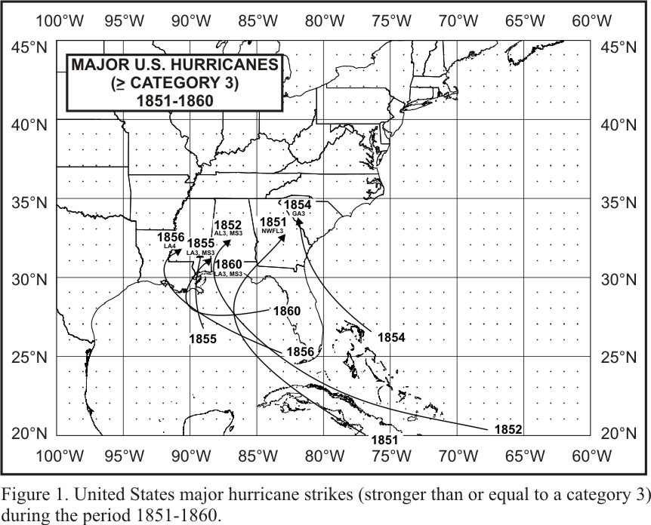

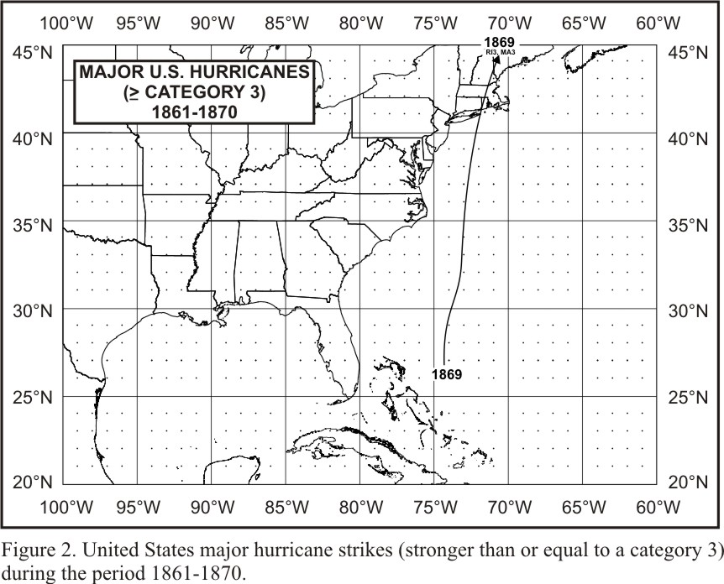
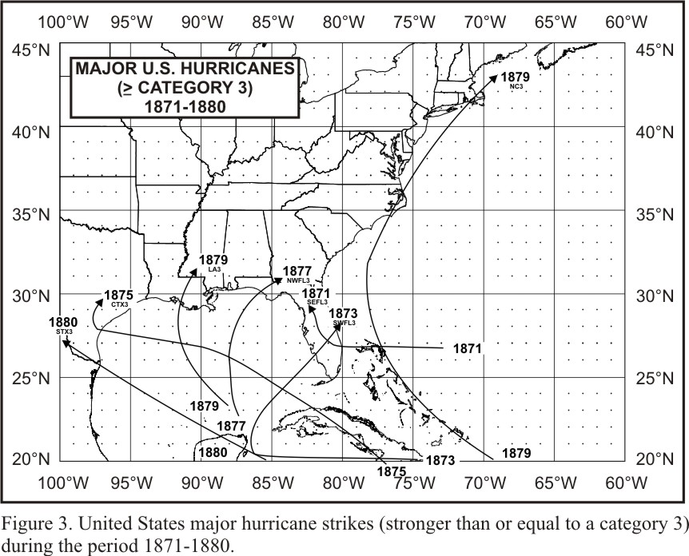

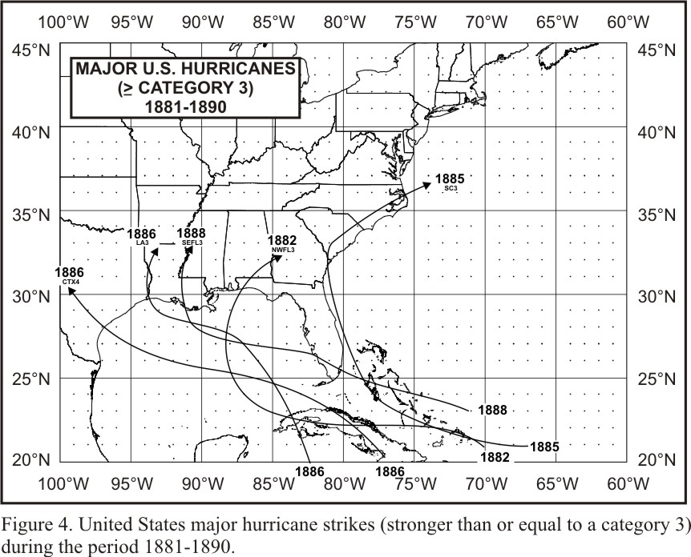
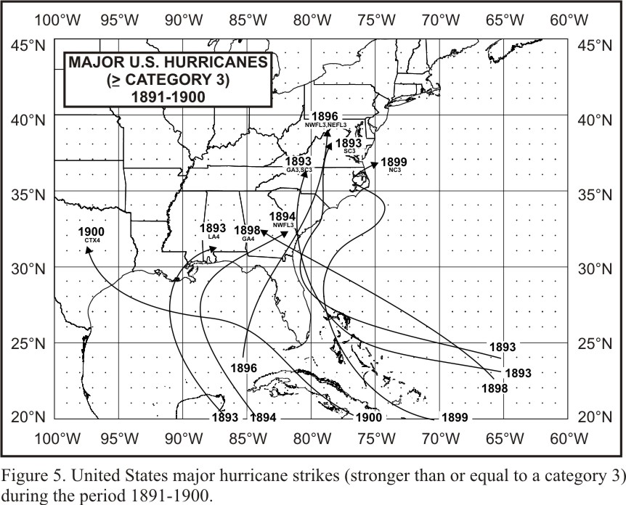

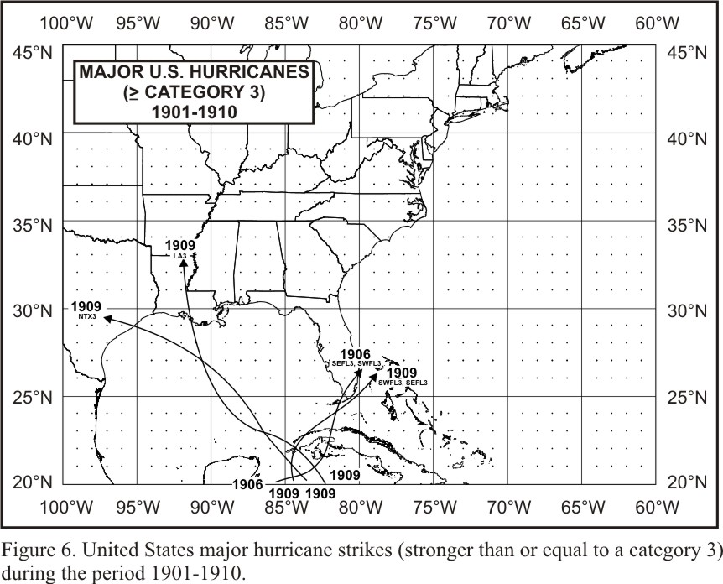
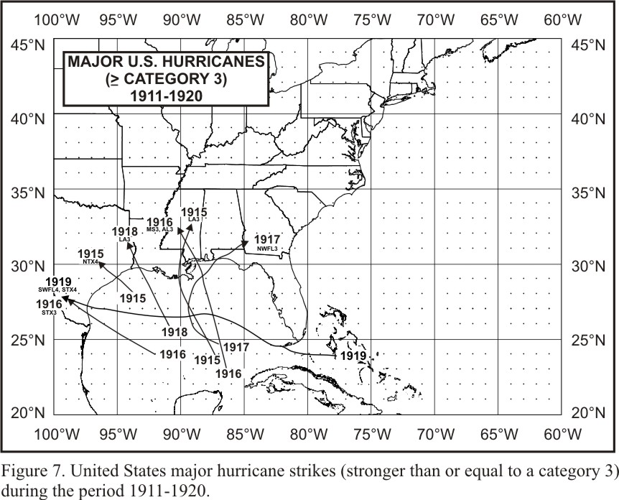

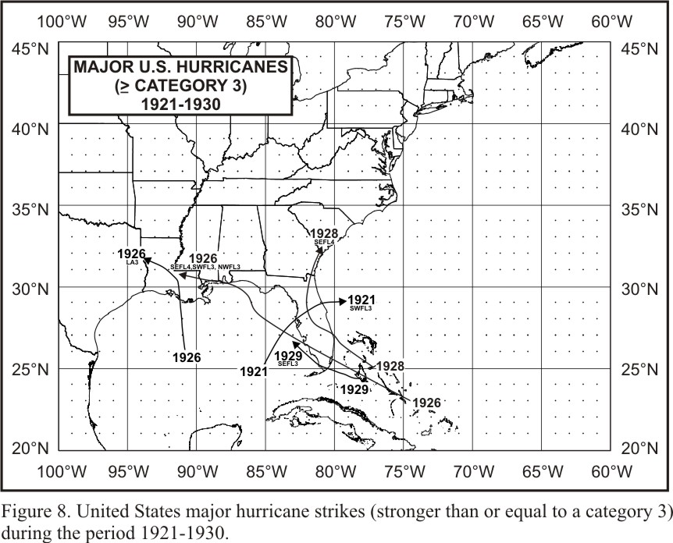
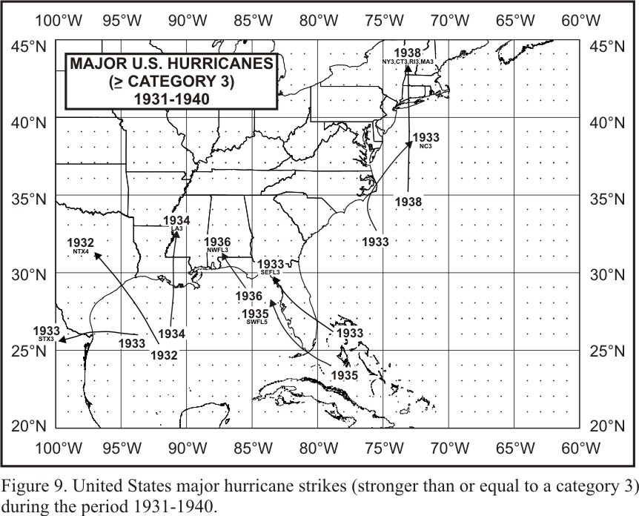

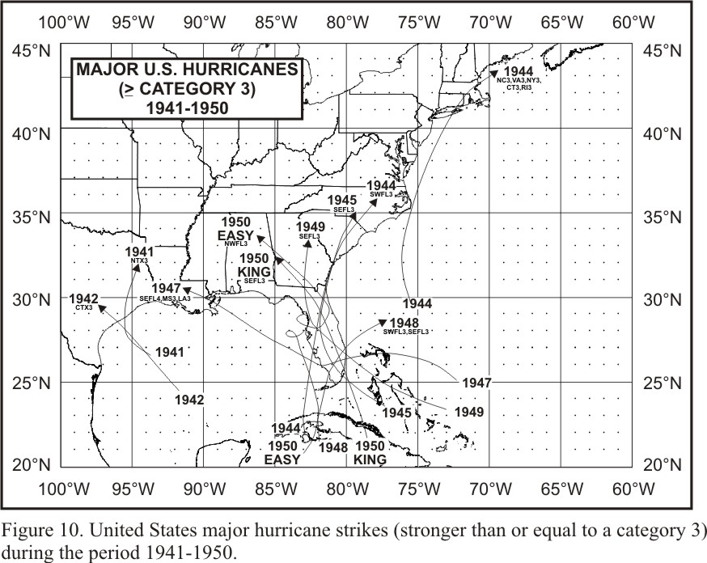
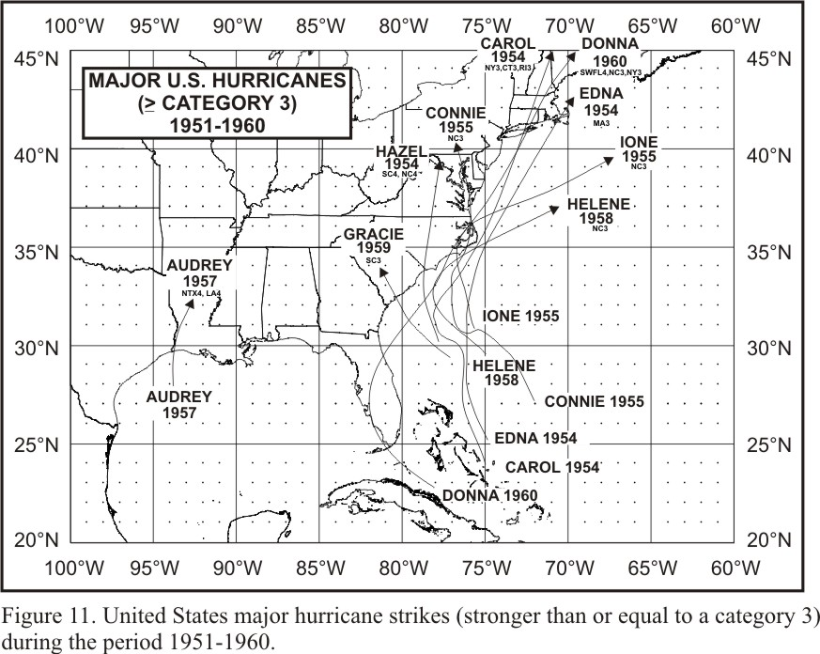

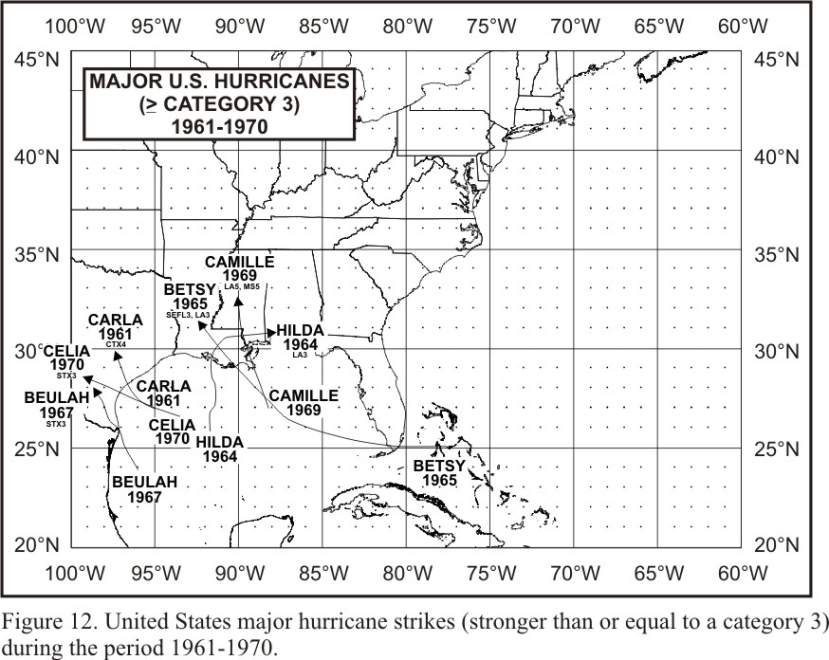
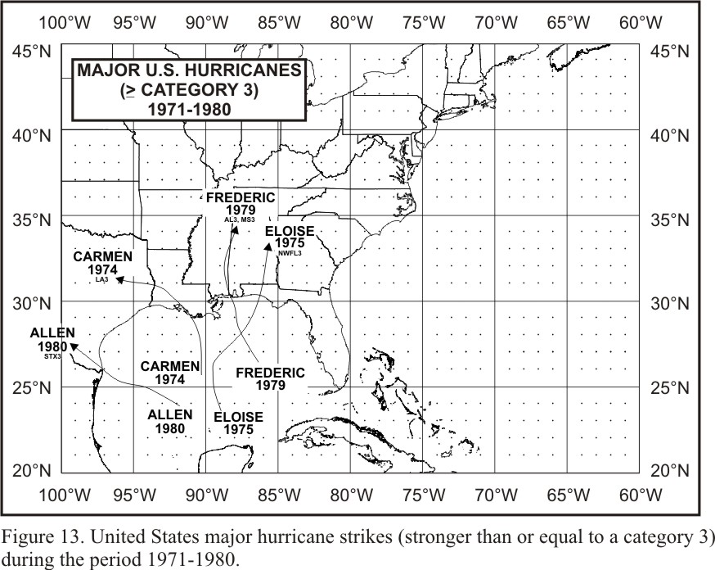

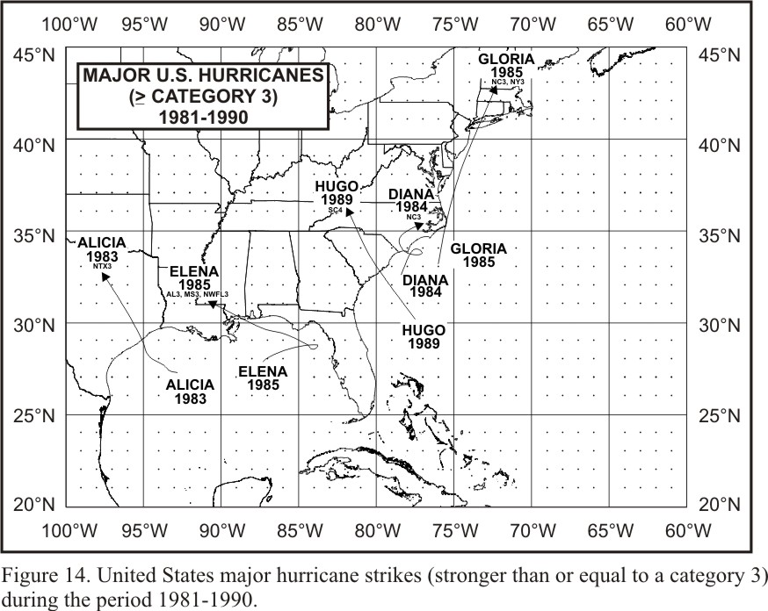
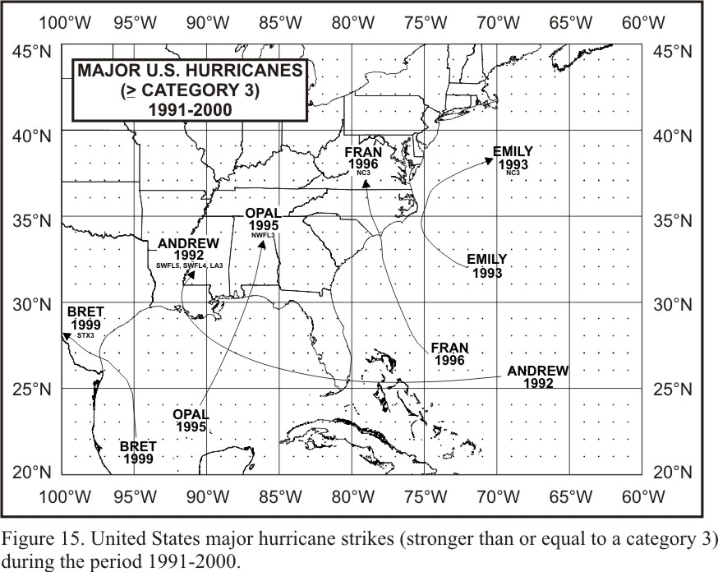

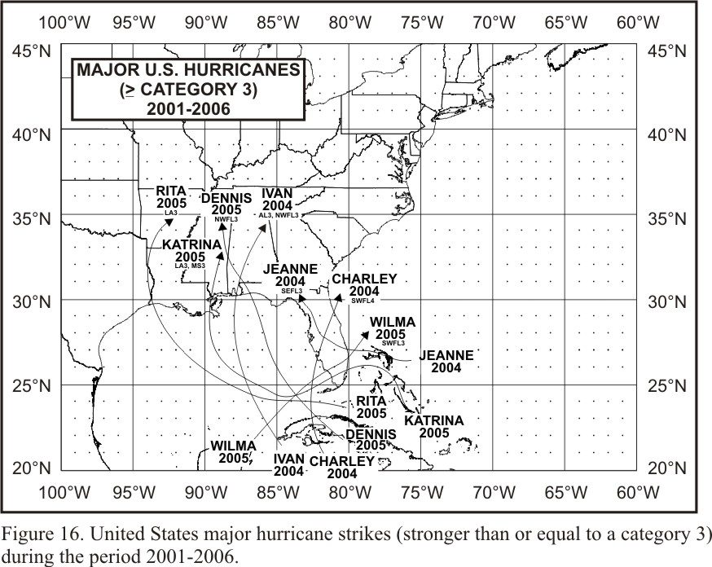
Appendix A: Chronological List of All Hurricanes which Affected the Continental
United States: 1851-2006.(Updated from Jarrell et al. 1992 and reflecting official
HURDAT reanalysis changes through 1914. Note that from 1915 through 1979, no
official wind speed estimates are currently available.)
Year | Month | States Affected | Highest Saffir- | Central | Max. | Name
 |  | and Category by | Simpson U.S. | Pressure | Winds
 |  | States | Category | (mb) | (kt)
1851 | Jun | TX, C1 | 1 | 977 | 80 | -----
1851 | Aug | FL, NW3; I-GA, 1 | 3 | 960 | 100 | “Great Middle Florida”
1852 | Aug | AL, 3; MS, 3; LA, 2; FL, SW2, NW1 | 3 | 961 | 100 | “Great Mobile”
1852 | Sep | FL, SW1 | 1 | 985 | 70 | -----
1852 | Oct | FL, NW2; I-GA, 1 | 2 | 969 | 90 | “Middle Florida”
1853 | Oct * | GA, 1 | 1 | 965 | 70 | -----
1854 | Jun | TX, S1 | 1 | 985 | 70 | -----
1854 | Sep | GA, 3; SC, 2; FL, NE1 | 3 | 950 | 100 | “Great Carolina”
1854 | Sep | TX, C2 | 2 | 969 | 90 | “Matagorda”
1855 | Sep | LA, 3; MS, 3 | 3 | 950 | 110 | “Middle Gulf Shore”
1856 | Aug | LA, 4 | 4 | 934 | 130 | “Last Island”
1856 | Aug | FL, NW2; I-AL, 1; I-GA, 1 | 2 | 969 | 90 | “Southeastern States”
1857 | Sep & | NC, 1 | 1 | 961 | 80 | -----
1858 | Sep | NY, 1; CT, 1; RI, 1; MA, 1 | 1 | 976 | 80 | “New England”
1859 | Sep | AL, 1; FL, NW1 | 1 | 985 | 70 | -----
1860 | Aug | LA, 3; MS, 3; AL, 2 | 3 | 950 | 110 | -----
1860 | Sep | LA, 2; MS, 2; AL, 1 | 2 | 969 | 90 | -----
1860 | Oct | LA, 2 | 2 | 969 | 90 | -----
1861 | Aug * | FL, SW1 | 1 | 970 | 70 | “Key West”
1861 | Sep | NC, 1 | 1 | 985 | 70 | “Equinoctial”
1861 | Nov | NC, 1 | 1 | 985 | 70 | “Expedition”
1865 | Sep | LA, 2; TX, N1 | 2 | 969 | 90 | “Sabine River-Lake Calcasieu”
1865 | Oct | FL, SW2; FL, SE1 | 2 | 969 | 90 | -----
1866 | Jul | TX, C2 | 2 | 969 | 90 | -----
1867 | Jun | SC, 1 | 1 | 985 | 70 | -----
1867 | Oct | LA, 2; TX, S1, N1; FL, NW1 | 2 | 969 | 90 | “Galveston”
1869 | Aug | TX, C2 | 2 | 969 | 90 | “Lower Texas Coast”
1869 | Sep | LA, 1 | 1 | 985 | 70 | -----
1869 | Sep | RI, 3; MA, 3; NY, 1; CT, 1 | 3 | 963 | 100 | “Eastern New England”
1869 | Oct & | ME, 2; MA, 1 | 2 | 965 | 90 | “Saxby’s Gale”
1870 | Jul | AL, 1 | 1 | 985 | 70 | “Mobile”
1870 | Oct * | FL, SW1, SE1 | 1 | 970 | 70 | “Twin Key West (I)”
1870 | Oct | FL, SW1 | 1 | 977 | 80 | “Twin Key West (II)”
1871 | Aug | FL, SE3, NE1, NW1 | 3 | 955 | 100 | -----
1871 | Aug | FL, SE2, NE1 | 2 | 965 | 90 | -----
1871 | Sep | FL, NW1, SW1 | 1 | 985 | 70 | -----
1873 | Sep | FL, NW1 | 1 | 985 | 70 | -----
1873 | Oct | FL, SW3, SE2, NE1 | 3 | 959 | 100 | -----
1874 | Sep | FL, NW1; SC, 1; NC, 1 | 1 | 985 | 70 | -----
1875 | Sep | TX, C3, S2 | 3 | 960 | 100 | -----
1876 | Sep | NC, 1; VA, 1 | 1 | 980 | 80 | -----
1876 | Oct | FL, SW2, SE1 | 2 | 973 | 90 | -----
1877 | Sep | LA, 1; FL, NW1 | 1 | 985 | 70 | -----
1877 | Oct | FL, NW3; I-GA, 1 | 3 | 960 | 100 | -----
1878 | Sep | FL, SW2, NE1; SC, 1; GA, 1 | 2 | 970 | 90 | -----
1878 | Oct | NC, 2; VA, 1; MD, 1; DE, 1; NJ, 1;  I-PA, 1 | 2 | 963 | 90 | -----
1879 | Aug | NC, 3; VA, 2; MA, 1 | 3 | 971 | 100 | -----
1879 | Aug | TX, N2; LA, 2 | 2 | 964 | 90 | -----
1879 | Sep | LA, 3 | 3 | 950 | 110 | -----
1880 | Aug # | TX, S3 | 3 | 931 | 110 | -----
1880 | Aug | FL, SE2, NE1, NW1 | 2 | 972 | 90 | -----
1880 | Sep | NC, 1 | 1 | 987 | 70 | -----
1880 | Oct | FL, NW1 | 1 | 985 | 70 | -----
1881 | Aug | GA, 2; SC, 1 | 2 | 970 | 90 | -----
1881 | Sep | NC, 2 | 2 | 975 | 90 | -----
1882 | Sep | FL, NW3; I-AL, 1 | 3 | 949 | 100 | -----
1882 | Sep | LA, 2; TX, N1 | 2 | 969 | 90 | -----
1882 | Oct | FL, NW1 | 1 | 985 | 70 | -----
1883 | Sep | NC, 2; SC, 1 | 2 | 965 | 90 | -----
1885 | Aug | SC, 3; NC, 2; GA, 1; FL, NE1 | 3 | 953 | 100 | -----
1886 | Jun | TX, N2; LA, 2 | 2 | 973 | 85 | -----
1886 | Jun | FL, NW2; I-GA, 1 | 2 | 973 | 85 | -----
1886 | Jun | FL, NW2; I-GA, 1 | 2 | 973 | 85 | -----
1886 | Jul | FL, NW1 | 1 | 985 | 70 | -----
1886 | Aug | TX, C4 | 4 | 925 | 135 | “Indianola”
1886 | Sep # | TX, S1, C1 | 1 | 973 | 80 | -----
1886 | Oct | LA, 3; TX, N2 | 3 | 955 | 105 | -----
1887 | Jul | FL, NW1; I-AL, 1 | 1 | 981 | 75 | -----
1887 | Aug * | NC, 1 | 1 | 946 | 65 | -----
1887 | Sep | TX, S2 | 2 | 973 | 85 | -----
1887 | Oct | LA, 1 | 1 | 981 | 75 | -----
1888 | Jun | TX, C1 | 1 | 985 | 70 | -----
1888 | Aug | FL, SE3, SW1; LA2 | 3 | 945 | 110 | -----
1888 | Oct | FL, NW2, NE1 | 2 | 970 | 95 | -----
1889 | Sep | LA, 1 | 1 | 985 | 70 | -----
1891 | Jul | TX, C1, N1 | 1 | 977 | 80 | -----
1891 | Aug | FL, SE1 | 1 | 985 | 70 | -----
1893 | Aug | NY, 1; CT, 1 | 1 | 986 | 75 | “Midnight Storm”
1893 | Aug | GA, 3; SC, 3; I-NC, 1; FL, NE1 | 3 | 954 | 100 | “Sea Islands”
1893 | Sep | LA, 2 | 2 | 973 | 85 | -----
1893 | Oct | LA, 4; MS, 2; AL, 2 | 4 | 948 | 115 | “Chenier Caminanda”
1893 | Oct | SC, 3; NC, 2; I-VA, 1 | 3 | 955 | 105 | -----
1894 | Sep | FL, SW2, NE1; SC, 1; VA, 1 | 2 | 975 | 90 | -----
1894 | Oct | FL, NW3; I-GA, 1; NY, 1; RI, 1; CT, 1 | 3 | 955 | 105 | -----
1895 | Aug # | TX, S1 | 1 | 973 | 65 | -----
1896 | Jul | FL, NW2 | 2 | 973 | 85 | -----
1896 | Sep | RI, 1; MA, 1 | 1 | 985 | 70 | -----
1896 | Sep | FL, NW3, NE3; GA, 2; SC, 1; I-NC, 1;  I-VA, 1 | 3 | 960 | 110 | -----
1897 | Sep | LA, 1; TX, N1 | 1 | 981 | 75 | -----
1898 | Aug | FL, NW1 | 1 | 985 | 70 | -----
1898 | Aug | GA, 1; SC, 1 | 1 | 980 | 75 | -----
1898 | Oct | GA, 4; FL, NE2 | 4 | 938 | 115 | -----
1899 | Aug | FL, NW2 | 2 | 979 | 85 | -----
1899 | Aug | NC, 3 | 3 | 945 | 105 | -----
1899 | Oct | NC, 2; SC, 2 | 2 | 955 | 95 | -----
1900 | Sep | TX, N4 | 4 | 936 | 125 | “Galveston”
1901 | Jul | NC, 1 | 1 | 983 | 70 | -----
1901 | Aug | LA, 1; MS, 1; AL, 1 | 1 | 973 | 80 | -----
1903 | Sep | FL, SE1, NW1 | 1 | 976 | 80 | -----
1903 | Sep | NJ, 1; DE, 1 | 1 | 990 | 70 | -----
1904 | Sep | SC, 1 | 1 | 985 | 70 | -----
1904 | Oct | FL, SE1 | 1 | 985 | 70 | -----
1906 | Jun | FL, SW1, SE1 | 1 | 979 | 75 | -----
1906 | Sep | SC, 1; NC, 1 | 1 | 977 | 80 | -----
1906 | Sep | MS, 2; AL, 2; FL, NW2; LA, 1 | 2 | 958 | 95 | -----
1906 | Oct | FL, SW3, SE3 | 3 | 953 | 105 | -----
1908 | Jul | NC, 1 | 1 | 985 | 70 | -----
1909 | Jun | TX, S2 | 2 | 972 | 85 | -----
1909 | Jul | TX, N3 | 3 | 959 | 100 | “Velasco”
1909 | Aug # | TX, S1 | 1 | 955 | 65 | -----
1909 | Sep | LA, 3; MS, 2 | 3 | 952 | 105 | “Grand Isle”
1909 | Oct | FL, SW3, SE3 | 3 | 957 | 100 | -----
1910 | Sep | TX, S2 | 2 | 965 | 95 | -----
1910 | Oct | FL, SW2 | 2 | 955 | 95 | -----
1911 | Aug | FL, NW1; AL,1 | 1 | 985 | 70 | -----
1911 | Aug | SC, 2; GA, 1 | 2 | 972 | 85 | -----
1912 | Sep | AL, 1; FL, NW1 | 1 | 988 | 65 | -----
1912 | Oct | TX, S2 | 2 | 973 | 85 | -----
1913 | Jun | TX, S1 | 1 | 988 | 65 | -----
1913 | Sep | NC, 1 | 1 | 976 | 75 | -----
1913 | Oct | SC, 1 | 1 | 989 | 65 | -----
1915 | Aug | TX, N4 | 4 | 945 | ---- | “Galveston”
1915 | Sep | FL, NW1; I-GA, 1 | 1 | 988 | ---- | -----
1915 | Sep | LA, 4 | 4 | 931 | ---- | “New Orleans”
1916 | Jul | MS, 3; AL, 3 | 3 | 948 | ---- | -----
1916 | Jul | MA, 1 | 1 | ----- | ---- | -----
1916 | Jul | SC, 1 | 1 | 980 | ---- | -----
1916 | Aug | TX, S3 | 3 | 948 | ---- | -----
1916 | Oct | AL, 2; FL, NW2 | 2 | 972 | ---- | -----
1916 | Nov | FL, SW1 | 1 | ----- | ---- | -----
1917 | Sep | FL, NW3 | 3 | 958 | ---- | -----
1918 | Aug | LA, 3 | 3 | 955 | ---- | -----
1919 | Sep | FL, SW4; TX, S4 | 4 | 927 | ---- | -----
1920 | Sep | LA, 2 | 2 | 975 | ---- | -----
1920 | Sep | NC, 1 | 1 | ----- | ---- | -----
1921 | Jun | TX, C2 | 2 | 979 | ---- | -----
1921 | Oct | FL, SW3, NE2 | 3 | 952 | ---- | “Tampa Bay”
1923 | Oct | LA, 1 | 1 | 985 | ---- | -----
1924 | Sep | FL, NW1 | 1 | 985 | ---- | -----
1924 | Oct | FL, SW1 | 1 | 980 | ---- | -----
1925 | No-De | FL, SW1 | 1 | ----- | ---- | -----
1926 | Jul | FL, NE2 | 2 | 967 | ---- | -----
1926 | Aug | LA, 3 | 3 | 955 | ---- | -----
1926 | Sep | FL, SE4, SW3, NW3; AL, 3 | 4 | 935 | ---- | “Great Miami”
1928 | Aug | FL, SE2 | 2 | ----- | ---- | -----
1928 | Sep | FL, SE4, NE2; GA, 1; SC, 1 | 4 | 929 | ---- | “Lake Okeechobee”
1929 | Jun | TX, C1 | 1 | 982 | ---- | -----
1929 | Sep | FL, SE3, NW2 | 3 | 948 | ---- | -----
1932 | Aug | TX, N4 | 4 | 941 | ---- | “Freeport”
1932 | Sep | AL, 1 | 1 | 979 | ---- | -----
1933 | Aug | TX, S2; FL, SE1 | 2 | 975 | ---- | -----
1933 | Aug | NC, 2; VA, 2 | 2 | 971 | ---- | -----
1933 | Sep | TX, S3 | 3 | 949 | ---- | -----
1933 | Sep | FL, SE3 | 3 | 948 | ---- | -----
1933 | Sep | NC, 3 | 3 | 957 | ---- | -----
1934 | Jun | LA, 3 | 3 | 962 | ---- | -----
1934 | Jul | TX, S2 | 2 | 975 | ---- | -----
1935 | Sep | FL, SW5, NW2 | 5 | 892 | ---- | “Labor Day”
1935 | Nov | FL, SE2 | 2 | 973 | ---- | -----
1936 | Jun | TX, S1 | 1 | 987 | ---- | -----
1936 | Jul | FL, NW3 | 3 | 964 | ---- | -----
1936 | Sep | NC, 2 | 2 | ----- | ---- | -----
1938 | Aug | LA, 1 | 1 | 985 | ---- | -----
1938 | Sep | NY, 3; CT, 3; RI, 3; MA, 3 | 3 | 946 | ---- | “New England”
1939 | Aug | FL, SE1, NW1 | 1 | 985 | ---- | -----
1940 | Aug | TX, N2; LA, 2 | 2 | 972 | ---- | -----
1940 | Aug | GA, 2; SC, 2 | 2 | 970 | ---- | -----
1941 | Sep | TX, N3 | 3 | 958 | ---- | -----
1941 | Oct | FL, SE2, SW2, NW2 | 2 | 975 | ---- | -----
1942 | Aug | TX, N1 | 1 | 992 | ---- | -----
1942 | Aug | TX, C3 | 3 | 950 | ---- | -----
1943 | Jul | TX, N2 | 2 | 969 | ---- | -----
1944 | Aug | NC, 1 | 1 | 990 | ---- | -----
1944 | Sep | NC, 3; VA, 3; NY, 3; CT, 3; RI, 3; MA, 2 | 3 | 947 | ---- | -----
1944 | Oct | FL, SW3, NE2 | 3 | 962 | ---- | -----
1945 | Jun | FL, NW1 | 1 | 985 | ---- | -----
1945 | Aug | TX, C2 | 2 | 967 | ---- | -----
1945 | Sep | FL, SE3 | 3 | 951 | ---- | -----
1946 | Oct | FL, SW1 | 1 | 980 | ---- | -----
1947 | Aug | TX, N1 | 1 | 992 | ---- | -----
1947 | Sep | FL, SE4, SW2; MS, 3; LA, 3 | 4 | 940 | ---- | -----
1947 | Oct | GA, 2; SC, 2; FL, SE1 | 2 | 974 | ---- | -----
1948 | Sep | LA, 1 | 1 | 987 | ---- | -----
1948 | Sep | FL, SW3, SE2 | 3 | 963 | ---- | -----
1948 | Oct | FL, SE2 | 2 | 975 | ---- | -----
1949 | Aug * | NC, 1 | 1 | 980 | ---- | -----
1949 | Aug | FL, SE3 | 3 | 954 | ---- | -----
1949 | Oct | TX, N2 | 2 | 972 | ---- | -----
1950 | Aug | AL, 1 | 1 | 980 | ---- | Baker
1950 | Sep | FL, NW3 | 3 | 958 | ---- | Easy
1950 | Oct | FL, SE3 | 3 | 955 | ---- | King
1952 | Aug | SC, 1 | 1 | 985 | ---- | Able
1953 | Aug | NC, 1 | 1 | 987 | ---- | Barbara
1953 | Sep | ME, 1 | 1 | ----- | ---- | Carol
1953 | Sep | FL, NW1 | 1 | 985 | ---- | Florence
1954 | Aug | NY, 3; CT, 3; RI, 3; NC, 2 | 3 | 960 | ---- | Carol
1954 | Sep | MA, 3; ME, 1 | 3 | 954 | ---- | Edna
1954 | Oct | SC, 4; NC, 4; MD, 2 | 4 | 938 | ---- | Hazel
1955 | Aug | NC, 3; VA, 1 | 3 | 962 | ---- | Connie
1955 | Aug | NC, 1 | 1 | 987 | ---- | Diane
1955 | Sep | NC, 3 | 3 | 960 | ---- | Ione
1956 | Sep | LA, 2; FL, NW1 | 2 | 975 | ---- | Flossy
1957 | Jun | TX, N4; LA, 4 | 4 | 945 | ---- | Audrey
1958 | Sep * | NC, 3 | 3 | 946 | ---- | Helene
1959 | Jul | SC, 1 | 1 | 993 | ---- | Cindy
1959 | Jul | TX, N1 | 1 | 984 | ---- | Debra
1959 | Sep | SC, 3 | 3 | 950 | ---- | Gracie
1960 | Sep | FL, SW4; NC, 3; NY, 3; FL, NE2, CT, 2; | 4 | 930 | ---- | Donna
 |  | RI, 2; MA, 1; NH, 1; ME, 1
1960 | Sep | MS, 1 | 1 | 981 | ---- | Ethel
1961 | Sep | TX, C4 | 4 | 931 | ---- | Carla
1963 | Sep | TX, N1 | 1 | 996 | ---- | Cindy
1964 | Aug | FL, SE2 | 2 | 968 | ---- | Cleo
1964 | Sep | FL, NE2 | 2 | 966 | ---- | Dora
1964 | Oct | LA, 3 | 3 | 950 | ---- | Hilda
1964 | Oct | FL, SW2, SE2 | 2 | 974 | ---- | Isbell
1965 | Sep | FL, SE3; LA, 3 | 3 | 948 | ---- | Betsy
1966 | Jun | FL, NW2 | 2 | 982 | ---- | Alma
1966 | Oct | FL, SW1 | 1 | 983 | ---- | Inez
1967 | Sep | TX, S3 | 3 | 950 | ---- | Beulah
1968 | Oct | FL, NW2, NE1 | 2 | 977 | ---- | Gladys
1969 | Aug | LA, 5; MS, 5 | 5 | 909 | ---- | Camille
1969 | Sep | ME, 1 | 1 | 980 | ---- | Gerda
1970 | Aug | TX, S3 | 3 | 945 | ---- | Celia
1971 | Sep | LA, 2 | 2 | 978 | ---- | Edith
1971 | Sep | TX, C1 | 1 | 979 | ---- | Fern
1971 | Sep | NC, 1 | 1 | 995 | ---- | Ginger
1972 | Jun | FL, NW1; NY, 1; CT, 1 | 1 | 980 | ---- | Agnes
1974 | Sep | LA, 3 | 3 | 952 | ---- | Carmen
1975 | Sep | FL, NW3; I-AL, 1 | 3 | 955 | ---- | Eloise
1976 | Aug | NY, 1 | 1 | 980 | ---- | Belle
1977 | Sep | LA, 1 | 1 | 995 | ---- | Babe
1979 | Jul | LA, 1 | 1 | 986 | ---- | Bob
1979 | Sep | FL, SE2, NE2; GA, 2; SC, 2 | 2 | 970 | ---- | David
1979 | Sep | AL, 3; MS, 3 | 3 | 946 | ---- | Frederic
1980 | Aug | TX, S3 | 3 | 945 | 100 | Allen
1983 | Aug | TX, N3 | 3 | 962 | 100 | Alicia
1984 | Sep * | NC, 3 | 3 | 949 | 100 | Diana
1985 | Jul | SC, 1 | 1 | 1002 | 65 | Bob
1985 | Aug | LA, 1 | 1 | 987 | 80 | Danny
1985 | Sep | AL, 3; MS, 3; FL, NW3 | 3 | 959 | 100 | Elena
1985 | Sep | NC, 3; NY,3; CT,2; NH,2; ME,1 | 3 | 942 | 90 | Gloria
1985 | Oct | LA, 1 | 1 | 971 | 75 | Juan
1985 | Nov | FL, NW2; I-GA, 1 | 2 | 967 | 85 | Kate
1986 | Jun | TX, N1 | 1 | 990 | 75 | Bonnie
1986 | Aug | NC, 1 | 1 | 990 | 65 | Charley
1987 | Oct | FL, SW1 | 1 | 993 | 65 | Floyd
1988 | Sep | LA, 1 | 1 | 984 | 70 | Florence
1989 | Aug | TX, N1 | 1 | 986 | 70 | Chantal
1989 | Sep | SC, 4; I-NC, 1 | 4 | 934 | 120 | Hugo
1989 | Oct | TX, N1 | 1 | 983 | 75 | Jerry
1991 | Aug | RI, 2; MA, 2; NY, 2; CT, 2 | 2 | 962 | 90 | Bob
1992 | Aug | FL, SE5, SW4; LA, 3 | 5 | 922 | 145 | Andrew
1993 | Aug * | NC, 3 | 3 | 960 | 100 | Emily
1995 | Aug | FL, NW2, SE1 | 2 | 973 | 85 | Erin
1995 | Oct | FL, NW3; I-AL, 1 | 3 | 942 | 100 | Opal
1996 | Jul | NC, 2 | 2 | 974 | 90 | Bertha
1996 | Sep | NC, 3 | 3 | 954 | 100 | Fran
1997 | Jul | LA, 1; AL, 1 | 1 | 984 | 70 | Danny
1998 | Aug | NC, 2 | 2 | 964 | 95 | Bonnie
1998 | Sep | FL, NW1 | 1 | 987 | 70 | Earl
1998 | Sep | FL, SW2; MS, 2 | 2 | 964 | 90 | Georges
1999 | Aug | TX, S3 | 3 | 951 | 100 | Bret
1999 | Sep | NC, 2 | 2 | 956 | 90 | Floyd
1999 | Oct | FL, SW1 | 1 | 987 | 70 | Irene
2002 | Oct | LA, 1 | 1 | 963 | 80 | Lili
2003 | Jul | TX, C1 | 1 | 979 | 80 | Claudette
2003 | Sep | NC, 2; VA, 1 | 2 | 957 | 90 | Isabel
2004 | Aug * | NC, 1 | 1 | 972 | 70 | Alex
2004 | Aug | FL, SW4, SE1, NE1; SC,1; NC,1 | 4 | 941 | 130 | Charley
2004 | Aug | SC, 1 | 1 | 985 | 65 | Gaston
2004 | Sep | FL, SE2, SW1 | 2 | 960 | 90 | Frances
2004 | Sep | AL, 3; FL, NW3 | 3 | 946 | 105 | Ivan
2004 | Sep | FL, SE3, SW1, NW1 | 3 | 950 | 105 | Jeanne
2005 | Jul | LA, 1 | 1 | 991 | 65 | Cindy
2005 | Jul | FL, NW3; I-AL, 1 | 3 | 946 | 105 | Dennis
2005 | Aug | FL, SE1, SW1; LA, 3; MS, 3; AL, 1 | 3 | 920 | 110 | Katrina
2005 | Sep * | NC, 1 | 1 | 982 | 65 | Ophelia
2005 | Sep | FL, SW1; LA, 3; TX, N2 | 3 | 937 | 100 | Rita
2005 | Oct | FL, SW3, SE2 | 3 | 950 | 105 | Wilma

Notes:

Hurricanes landfalls that do not produce hurricane-force winds along the coast are not included in this list. Two such hurricanes are known: Sep 1888 in MA and May 1908 in NC.

States Affected and Category by States Affected: The impact of the hurricane on individual U.S. states based upon the Saffir-Simpson Hurricane Scale (through the estimate of the maximum sustained surface winds at each state). (TX S-South Texas, TX C-Central Texas, TX N-North Texas, LA-Louisiana, MS-Mississippi, AL-Alabama, FL NW-Northwest Florida, FL SW-Southwest Florida, FL SE-Southeast Florida, FL NE-Northeast Florida, GA-Georgia, SC-South Carolina, NC-North Carolina, VA-Virginia, MD-Maryland, DE-Delaware, NJ-New Jersey, NY-New York, PA-Pennsylvania, CT-Connecticut, RI-Rhode Island, MA-Massachusetts, NH-New Hampshire, ME-Maine. In Texas, south refers to the area from the Mexican border to Corpus Christi; central spans from north of Corpus Christi to Matagorda Bay and north refers to the region from north of Matagorda Bay to the Louisiana border. In Florida, the north-south dividing line is from Cape Canaveral [28.45N] to Tarpon Springs [28.17N]. The dividing line between west-east Florida goes from 82.69W at the north Florida border with Georgia, to Lake Okeechobee and due south along longitude 80.85W.)

Occasionally, a hurricane will cause a hurricane impact (estimated maximum sustained surface winds) in the inland portion of a coastal state but not at the coast of that state. To differentiate these cases versus coastal hurricane impacts, these inland hurricane strikes are denoted with an "I" prefix before the state abbreviation. States that have been so impacted at least once during this time period include Alabama (IAL), Georgia (IGA), North Carolina (INC), Virginia (IVA), and Pennsylvania (IPA). The Florida peninsula, by the nature of its relatively narrow landmass, is all considered as coastal in this database.

Highest U.S. Saffir-Simpson Category: The highest Saffir-Simpson Hurricane Scale impact in the United States based upon estimated maximum sustained surface winds produced at the coast.

Central Pressure: The observed (or analyzed from peripheral pressure measurements) central pressure of the hurricane at landfall.

Maximum Winds: Estimated maximum sustained (1-min) surface (10 m) winds to occur along the U. S. coast. Winds are estimated to the nearest 10 kt for the period of 1851 to 1885 and to the nearest 5 kt for the period of 1886 to date. (1 kt = 1.15 mph.)

* - Indicates that the hurricane center did not make a U.S. landfall (or substantially weakened before making landfall), but did produce the indicated hurricane force winds over land. In this case, central pressure is given for the hurricane's point of closest approach.

& - Indicates that the hurricane center did make a direct landfall, but that the strongest winds likely remained offshore. Thus the winds indicated here are lower than in HURDAT.

# - Indicates that the hurricane made landfall over Mexico, but also caused sustained hurricane force surface winds in Texas. The strongest winds at landfall impacted Mexico, while the weaker maximum sustained winds indicated here were conditions estimated to occur in Texas. Indicated central pressure given is that at Mexican landfall.

Additional Note: Because of the sparseness of towns and cities before 1900 in some coastal locations along the United States, the above list is not complete for all states. Before the Gulf of Mexico and Atlantic coasts became settled, hurricanes may have been underestimated in their intensity or missed completely for small-sized systems (i.e., 2004's Hurricane Charley). The following list provides estimated dates when accurate tropical cyclone records began for
specified regions of the United States based upon U.S Census reports and other historical analyses. Years in parenthesis indicate possible starting dates for reliable records before the 1850s that may be available with additional research: Texas-south > 1880, Texas-central > 1851, Texas-north > 1860, Louisiana > 1880, Mississippi > 1851, Alabama < 1851 (1830), Florida-northwest > 1880, Florida-southwest > 1900, Florida-southeast > 1900, Florida-northeast > 1880,
Georgia < 1851 (1800), South Carolina < 1851 (1760), North Carolina < 1851 (1760), Virginia < 1851 (1700), Maryland < 1851 (1760), Delaware < 1851 (1700), New Jersey < 1851 (1760), New York < 1851 (1700), Connecticut < 1851 (1660), Rhode Island < 1851 (1760), Massachusetts < 1851 (1660), New Hampshire < 1851 (1660), and Maine < 1851 (1790).

