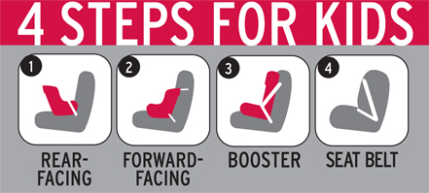
CPS Week Planner

LETTER TO THE EDITOR

[538] WORDS

Dear Editor,
Every year, motor vehicle traffic crashes take the lives of hundreds of young children, leaving behind heartbroken parents, family members, and friends. The lifesaving effects of child safety and booster seats are indisputable. However, they work best when used properly. Often times, parents and caregivers are completely unaware they installed a car seat incorrectly, or they have moved their school-age child from a child restraint to a seat belt prematurely, completely skipping the booster seat stage.
According to research by the National Highway Traffic Safety Administration, three out of four child safety seats are improperly installed in vehicles. That’s why [Local Organization] is urging all parents and caregivers to attend the Second Annual “National Seat Check Saturday,” on Saturday September 20. As part of National Child Passenger Safety Week (September 21-27) [Community name] will have English- and Spanish-speaking certified technicians available to provide free on-site child safety seat inspections from [time] at [location].
Parents and adults who care for children need to make sure they get it right. For starters, they need to carefully read the child safety seat instructions, in addition to the vehicle owner’s manual instructions regarding installing a safety seat. They should also get their child restraint inspected by a certified technician to make sure they installed it correctly. Finally, all parents and caregivers should refer to the following 4 Steps for Kids guidelines to make certain children are secured properly in an appropriate seat:
- For the best possible protection keep infants in the back seat, in rear-facing child safety seats, as long as possible, up to the height or weight limit of the particular seat. At a minimum, keep infants rear-facing until at least age 1 and at least 20 pounds.
- When children outgrow their rear-facing seats (at least age 1 and at least 20 pounds) they should ride in forward-facing child safety seats, in the back seat, until they reach the upper weight or height limit of the particular seat (usually around age 4 and 40 pounds).
- Once children outgrow their forward-facing seats (usually around age 4 and 40 pounds), they should ride in booster seats, in the back seat, until they are old enough that the vehicle seat belts fit properly. Seat belts fit properly when the lap belt lays across the upper thighs and the shoulder belt fits across the chest (usually at age 8 or when they are 4’9” tall).
- When children outgrow their booster seats, (usually at age 8 or when they are 4’9” tall) they can use the adult seat belts in the back seat, if they fit properly (lap belt lays across the upper thighs and the shoulder belt fits across the chest).
When it comes to the safety of a child, there are no excuses. For National Child Passenger Safety Week (September 21-27), [Local Leader/Organization] will have certified child passenger safety technicians available to provide free on-site safety tips and seat inspections from [time] at [location]. Additional information about National Child Passenger Safety Week and proper use of seats can be found at www.nhtsa.gov.
[Name, address and phone number] (The newspaper must have these to verify the identity of the sender, but won’t print the street address or phone number.)

###

