Archived Information

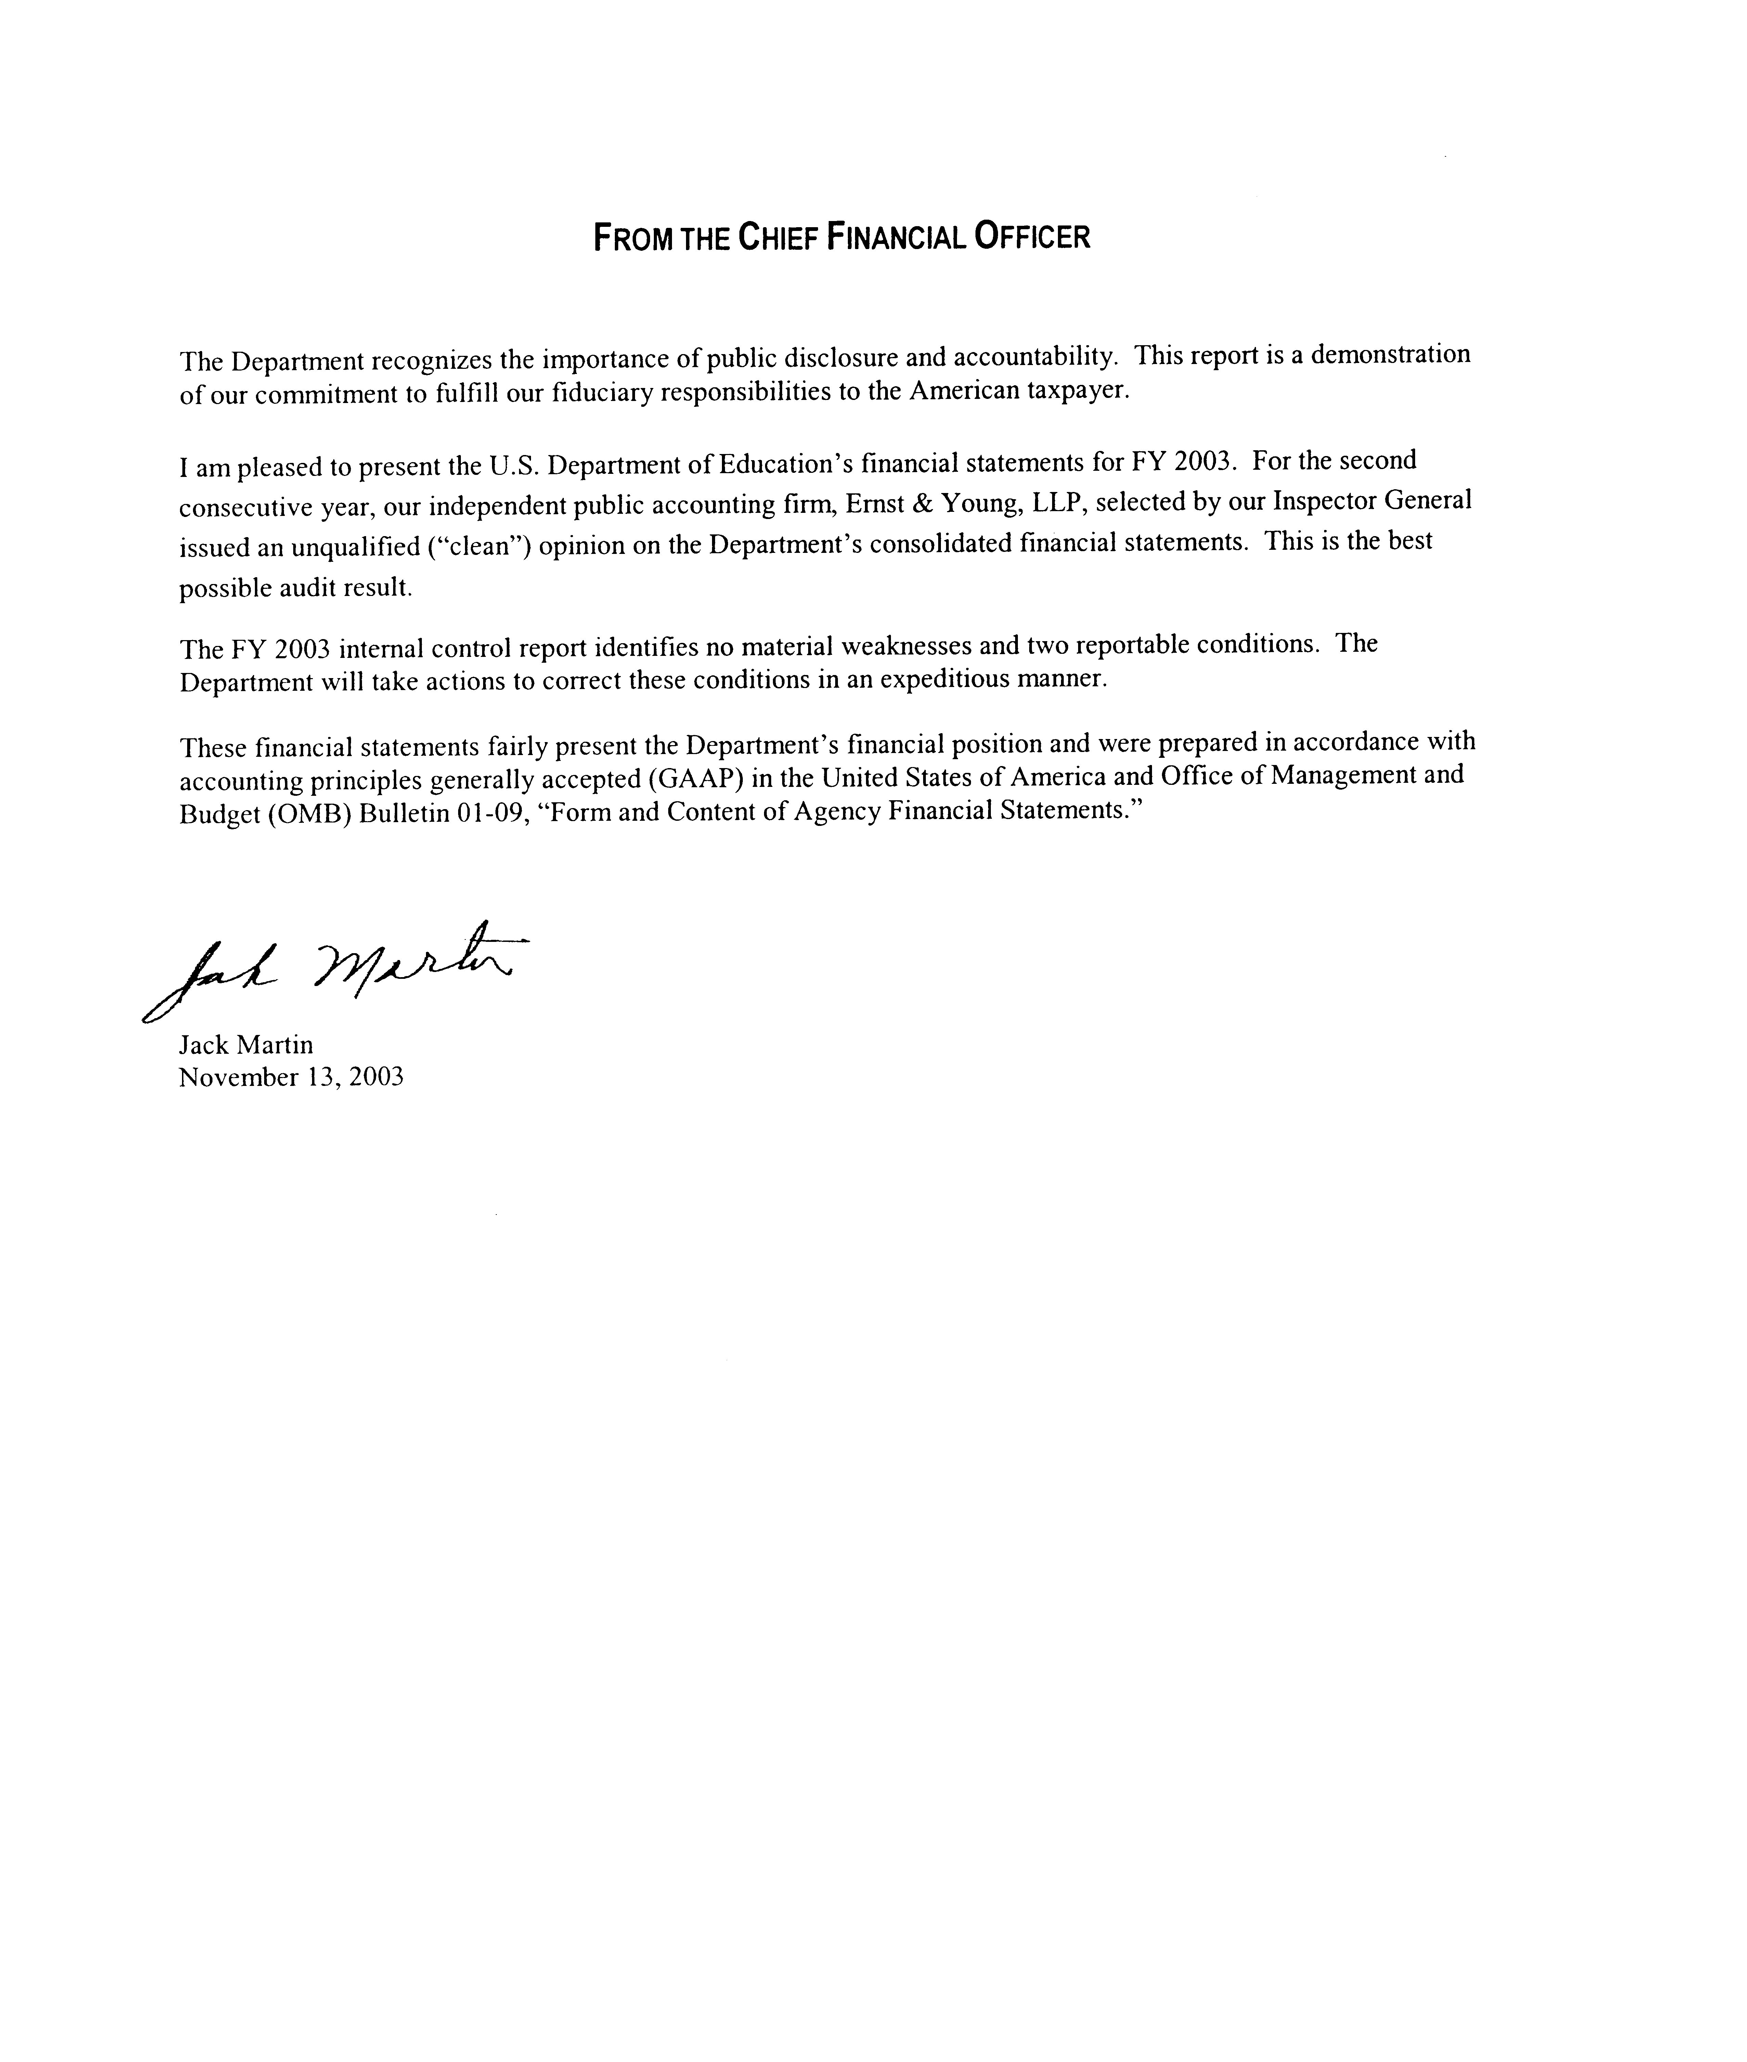

Limitations of Financial Statements

The following limitations apply to the preparation of the fiscal year 2003 Financial Statements:
The principal financial statements have been prepared to report the financial position and results of operations of the entity, pursuant to the requirements of 31 U.S.C. 3515 (b). Although the statements have been prepared from the books and records of the entity in accordance with Generally Accepted Accounting Principles (GAAP) for federal entities and the formats prescribed by OMB, the statements are in addition to the financial reports used to monitor and control budgetary resources that are prepared from the same books and records.
The statements should be read with the realization that they are for a component of the U.S. Government, a sovereign entity. One implication of this is that liabilities cannot be liquidated without legislation that provides resources to do so.

