Framework for Fiscal Year 2007 Work Plan | Mission of OIG | U.S. Department of Education  Office of Inspector General
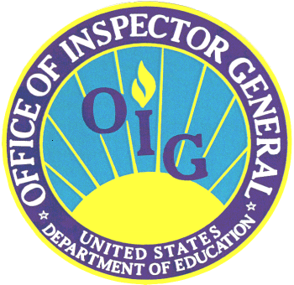 | To promote the efficiency, effectiveness, and integrity of the Department’s programs and operations, we conduct independent and objective audits, investigations, inspections, and other activities | 
This Work Plan provides a framework for how Office of Inspector General resources will be used during Fiscal Year 2007. The plan includes mandatory, requested, and discretionary audits, inspections, and investigations that address the U.S. Department of Education’s top management challenges and emerging issues. The plan is designed to be flexible and may be modified during the year to accommodate higher priority work as determined by the Inspector General or as requested by the U.S. Department of Education, the Congress, or others. | Work Plan  Fiscal Year  2007 | The U.S. Department of Education’s mission is to ensure equal access to education and to promote educational excellence throughout the nation, as well as to improve the management, efficiency and accountability of federal education programs and activities. The Congress has entrusted the Department with approximately $89 billion of taxpayer funds to fulfill its mission. The Office of Inspector General works with the Department to ensure the efficiency, effectiveness, and integrity of these programs and the Department’s operations.
Audits and Inspections of  Student Financial Assistance  Programs | FISCAL YEAR 2007  ANNUAL  WORK PLAN | Audits and Inspections of  State and Local  Programs
▪Selected Institutions  ▪Hurricane Recovery Funds  ▪Special Allowance Payments  ▪Improper Payments  ▪Academic Competitiveness and National Science and Mathematics Access to Retain Talent Grants  ▪Controls for Safeguarding Student Information  ▪Information Technology Contracts  ▪Performance Based Organization performance | Other  Audits and Inspections  ▪Financial Statements and Related Activities  ▪Controls over Hurricane Related Funds by the Department  ▪Implementation of OMB Circular A-123  ▪Quality Control Reviews of Audits  ▪Risk Management Activities  ▪Privacy Act Information Disclosures  ▪Federal Information Security Management Act (FISMA)  ▪IT System Security Controls | ▪Selected Grantees  ▪Hurricane Recovery Funds  ▪Fiscal Controls in Accounting for Federal Funds at Local Education Agencies  ▪Corrective Action and Restructuring Title I Schools in Improvement  ▪Lapsed Funds  ▪Impact of NCLB Waivers  ▪Supplemental Education Service Providers

