
Robert M. Bracker Elementary School
Nogales, Arizona
INTRODUCTION
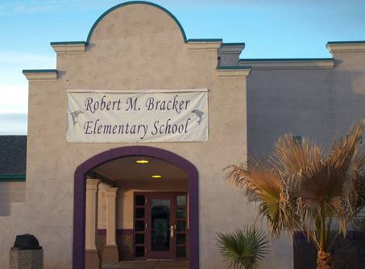
Bracker Elementary School’s design reflects the region’s Spanish heritage
Not far from the border and its sister city, Nogales, Sonora, Mexico, Nogales, Arizona is about 65 miles south of Tucson. The town takes its name from the Spanish word for “walnut,” after the walnut trees that once grew abundantly in the area. Nogales was part of “The Kings Highway” (El Camino Real) traversed by Spanish explorers. Even today, missions built by the Spanish colonials dot the valley’s landscape.
Robert M. Bracker Elementary is one of six elementary schools in the Nogales Unified School District #1, home to a total of 10 schools and about 6,250 students. Bracker, built in 1996, is in a rural but rapidly growing part of Nogales. It is not a neighborhood school; all students are either bused or transported to and from the school by private autos.
Student Demographics
Robert M. Bracker Elementary School
Nogales, Arizona
http://www.nusd.k12.az.us/Schools/Bracker/
260 students, K-5
Hispanic | 99%
White | <1%
Students eligible for free/ reduced price meals | 74%
Students with Limited English Proficiency | 64%
Special Education Students | 6%
Student/Teacher Ratio | 22:1

The school building has graceful arches and the stepped roof entrance reminiscent of early Spanish architecture. The classrooms spread out from the entrance, encircling a large, grassy area used by the students during lunchtime as a supervised recreation area. A covered walkway around the interior perimeter shelters entrances to the classrooms from the weather. Each column supporting the walkway has a different set of arithmetic facts posted on it. Fencing, necessary for security purposes since the school is so close to the border, is attractive, colorful, and unobtrusive. The school grounds and buildings are immaculately clean and a source of pride to everyone in the school.
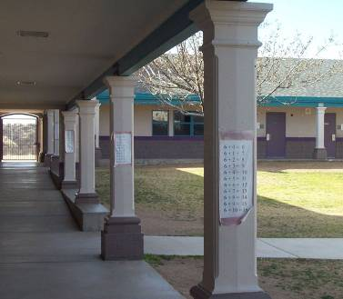
No opportunity to learn is wasted: Columns display
math facts.
In the school’s entrance, school photographs, awards, and trophies are prominently displayed in cases and on the walls. Striking in its seeming incongruity is a display, in various forms and media, of the school mascot, a dolphin. The dolphin represents intelligence, strength and a desire to think differently, to leap free, as it were, of conventional thought.
STUDENT ACHIEVEMENT
Student achievement, as measured by the state criterion-referenced test, the Arizona Instrument to Measure Standards (AIMS), shows steady improvement in all tested grades (3rd through 5th) including disaggregated
groups, from 2002 to the present. For example, the percent passing 3rd grade reading increased from 52% to 72%, while percentages of students at the highest level, “exceeds standards,” rose from 16% to 24%. Math results show even larger increases, with the passing percentage rising from 58% to 90%, and the number of students who
“exceed standards” climbed from 18% to 33%. Significantly, 18% of Hispanic students, 18% of Limited English Proficient (LEP) students, and 26% of the economically disadvantaged students achieved at the highest level, exceeding state standards.
Fifth grade students went from 43% passing reading to 91% from 2002 to 2006. Subgroups mirrored this rise: passing scores for Hispanic students rose from 27% to 94%, and from 27% to 93% for economically disadvantaged students. Scores for LEP students rose from 6% to 72% passing in 2005. Similarly, fifth-grade math scores went from 14% to 94%, and student numbers in the “exceeds standards” category increased from 3% to 25%.
Bracker’s principal, Michelle Olguin, credits the effectiveness of the instructional programs for the decrease in the number of fifth grade students classified as LEP (from 23 in 2003 to fewer than 10 in 2006). During the same period, she noted, numbers of students taking the test in English have increased. But Bracker was no
overnight success.
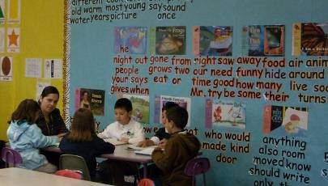
Every Bracker classroom contains Vocabulary Word Walls.
TRIAL BY IMMERSION
The assistant superintendent, of the Nogales school district, Dr. Luciana A. Romero, is the former principal of Bracker Elementary and led the school from its second year of existence. She became assistant superintendent when the Blue Ribbon School application was made just over a year ago.
When Bracker opened in 1997, she said, it featured a dual-language program that was regarded as a magnet for students and their families. Student scores, as measured by the standardized tests then in use, were considered good. However, a majority of students who were assessed on the standardized tests in English were English language learners (ELLs), and were exempted from all aggregate reports. As a result, test scores represented a small number of students at Bracker. Shortly after Bracker opened, the superintendent at the time required all schools in the district to decrease the number of students exempted from aggregate reporting on the English standardized test. With more than 60% of Bracker students identified as ELLs and previously exempted from the aggregate reports, test scores plummeted. Then Arizona voters passed Proposition 203, mandating all-English instruction. The next year, Bracker was labeled underperforming.
Bracker administrators did what many other successful schools and districts have had to do in similar situations. Accepting the challenge, they examined their programs and scoured available student and school data to discover their strengths and challenges. They adopted a strategy of developing strong grade-level leaders, equipping them with intensive professional development in the use of data. These newly trained leaders then served as supports for the entire faculty. “It was all about establishing routines,” Dr. Romero said, although “for some people that was uncomfortable and they left the school.”
The following year brought more challenges: The district mandated the use of Reading First methods in all elementary schools. This created another sense of urgency but also deepened the analysis of student data, especially at the individual student level. “Reading First was our lifeline,” recalled Dr. Romero; students received double and even triple doses of reading intervention instruction. The parents, to their credit, understood and supported this effort and participated through special workshops and assessment meetings.
SEI (structured English immersion) enabled the school to target specific student needs, and the core program provided an opportunity for differentiation. Although by design Reading First involves only grades K through 3, the principal expanded the program to grades 4 and 5 with the use of other funding. This transition was made easier because the Music and Physical Education teachers as well as the counselor and instructional coaches were familiar with the program through training sessions at grade-level meetings and were prepared to support Reading First in their own classes.
Today’s District Reading Coordinator is Bracker’s former Reading First coach. (In her will to find ways to improve student achievement, former Principal Romero created the district’s first reading coach position. Today, all six elementary schools in the district have reading coaches.) After reviewing the data systematically, the Reading Coordinator began shifting the school’s use of assessment from determining grades to informing instruction. The Dynamic Indicators of Early Literacy Skills (DIBELS) test data, used in Reading First, he said, generate a student’s reading grade level as a first step, but do not reveal the assistance necessary to support the student’s progress. By spending a great deal of time observing instruction in the classroom and providing feedback to teachers on their instructional practices, the Coordinator initiated a dialogue through which teachers offered suggestions for improving instruction. Over the years he has seen teachers taking more and more responsibility for student performance.
SHELTERED ENGLISH IMMERSION FOR ALL
All classroom instruction uses the Sheltered English Immersion (SEI) model for all students. SEI instructional techniques include: systematic and explicit instruction, scaffolding, differentiated instruction, a focus on vocabulary, repeated opportunities to practice, thinking time, immediate specific feedback, and student engagement. “Through our own research and experience,” Principal Olguin said, “we have learned that these SEI strategies work for all at-risk students and not just the ELLs.”
According to an Arizona state publication, all SEI models are research-based and include three major components: policy, structure, and classroom practices. In practice, a range of factors including the size, location, and grade levels at the school, as well as the number and percentage of ELLs, results in a variety of SEI structure and classroom practices configurations. The SEI classroom provides four hours of daily ELD (English Language Development) instruction to teach English Language skills to students who are in the process of learning English. ELD instruction focuses on phonology, morphology, syntax, lexicon, and semantics. There are some connections to English language arts instruction, but ELD is considered to be foundational for English language acquisition work. Reading and writing are also considered content in SEI classrooms.
AZELLA, the Arizona English Language Assessment, measures the English Language proficiency of Arizona K-12 students whose primary language is other than English. AZELLA results include a composite proficiency level score and separate subtest scores for listening, speaking, reading, and writing as well as oral language and comprehension scores. SEI classroom entry and exit is determined solely by AZELLA score.
The state currently aims to train all teachers in SEI, and has mandated that all teachers have an endorsement in SEI or at least 60 hours of professional development. An SEI consultant will provide training for Bracker teachers in “Making Content Comprehensible for ELLs: Learning the SIOP model” on seven early release days during the year.
DATA-DRIVEN INTERVENTIONS
The Bracker curriculum is built around the Arizona Articulated Academic standards. Each student receives two hours of reading every day, focused on the five components identified by the National Reading Panel report. The staff supplements a commercial core program aligned with state standards with additional resources. Students also receive an additional hour of language arts instruction and thirty to forty-five minutes of targeted reading instruction to either address skill gaps or accelerate reading skills.
The math program also has a scientifically based program at its center. Frequent assessment indicates what standards students are not mastering, enabling teachers to provide appropriate supplemental materials and re-teach material as needed. Manipulatives and technology allow teachers to enhance the curriculum and differentiate instruction. At the time of the visit, math teachers were receiving off-site training on progress monitoring and
math interventions.
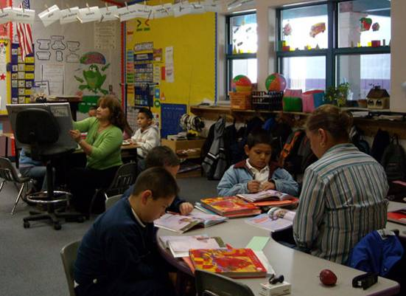
Student reading groups are flexible, changing daily, if necessary.
The targeted reading instruction or interventions are a source of pride to the entire staff and are credited with having a great deal to do with both the improvement in test scores and the improvement in reading skills of all students. The interventions are also credited in part with decreases in the numbers of 5th-grade students classified as LEP and increases in the numbers of students taking the AIMS test in English.
Bracker’s disaggregated student data are carefully examined in order to provide instruction to meet the needs of all students. This occurs in a variety of ways at Bracker and involves most of the school staff at one time or another. A school data team meets four times a year and reviews results from multiple sources of data, including the state achievement test, AIMS, and Galileo, a district benchmark assessment test aligned to performance objectives at each grade level and administered quarterly. Classroom teachers use DIBELS benchmark and progress monitoring assessments in reading.
Grade-level teams meet frequently to analyze assessment data and make any necessary changes in instructional groups. The reading specialist, principal, and reading coach meet with grade-level teams after each round of DIBELS progress monitoring to discuss results, develop short term goals, and plan next steps in instruction. The Literacy Team, which consists of one teacher per grade level, the reading specialist, reading coach, special education resource teacher, and the principal, meet every month for a similar purpose, focused on schoolwide data for schoolwide instructional improvement. Individual teachers use their own formative classroom assessment data to form flexible reading groups during the school day, both in their classrooms and during intervention.
At an appointed time each day, all classes are reorganized based on reading assessment data. Students are told ahead of time each week which intervention group they will be assigned to and its location. The assessment results have already been shared with the students, as have the skills that they need to work on. Similarly, adults in the school have also received their assignments. All intervention personnel have received training in delivering the lessons from both the reading specialist and reading coach. All K-3 teachers, “as part of the Reading First program, received intensive professional development in implementing the reading program and in utilizing assessment data for planning and delivering instruction,” the principal explained. With funding from sources other than Reading First, intervention services are also provided to 4th- and 5th-grade students.
In sample intervention class, two adults work with students at three stations. One group previewed a book with the teacher, who prompted students to examine the book and make predictions about its content. “You have one minute to write,” she said, and students immediately put pencils to paper. A group of students working without a teacher tackled an assignment avidly. “I really like how my independent center is reading the sentences out loud,” the teacher said, from her group. A group with intensive needs met in another room with a specialist. Turning back to her group, the teacher gently corrected student errors as she moved through the lesson on the book. Routines were clear: the teacher asked students to “show me the ready sign” to see if students are on track; she tapped on a student’s book and the student immediately began reading. Activating students’ prior knowledge, the teacher asked, “Remember when we saw a baby goat at the fair?” A vocabulary drill followed the lesson and students were intrigued by how fast they could go. “Quickly, quickly” the teacher reminded them, and students immediately bent their heads to the task. “Really quickly, tell me one thing you learned today.” The teacher clapped her hands to gain the attention of the students in the different centers. The students immediately clapped in response, stopped what they were doing and looked to the teacher.
In addition to intervention, students can also be recommended for after-school tutoring in reading and math, designed to correlate and support classroom instruction.
Two other programs that qualify as interventions are worthy of mention. A Student Intervention team, consisting of the principal, counselor, parents, classroom teacher, reading specialist, and special education resource teacher meets regularly to review data on students who may be struggling and determine if further assistance through special education is needed. And Character Counts, now in its fifth year at the Bracker, emphasizes six desirable character traits for all students: trustworthiness, respect, responsibility, fairness, caring, and citizenship. The same lessons are taught to each grade but the level of sophistication rises with each grade. Every month the intervention specialist focuses on a character trait, screening videos and engaging students in discussions about the trait, drawing on current events at school and in the community for real-life examples. The schoolwide discipline program is based on Character Counts. Students receive color-coded slips based on their behavior: green for appropriate behavior, blue for inappropriate. Random drawings, with prizes, of students’ green slips are frequent. By contrast, too many blue slips results in referral to the principal and parent contact.
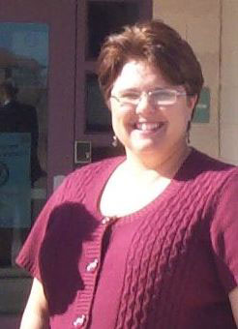
Principal Michelle Olguin is a former reading specialist.

Every classroom in the school that the team observed was neat and immaculately clean. Walls were often entirely covered in student work or information about lessons or ideas for the students. There were math and reading word walls with high-frequency words, compound words, vocabulary words, nouns, verbs, and writing samples. Every class had the day’s assignment and expectations for students clearly posted,
and classrooms were stocked with manipulatives and other teaching aids.
LEADERSHIP
Current principal Michelle Olguin is completing her second year in that position. The former District Reading Coordinator and the former Bracker reading specialist, she brought a wealth of knowledge and experience in instructional practices and ELL education to the school. She is seen by the faculty as a strong instructional leader who spends a great deal of time in classrooms observing students and teachers. “The principal does walk-throughs almost every day,” said one teacher during a classroom visit. On early release Tuesdays, the principal often leads professional development training.
Principal Olguin is committed to sharing responsibility and distributing leadership in the school, as evidenced by the number of committees in the school and opportunities for leadership development. Professional development activities are provided for as many staff as possible to expand the skill set of as many people as possible. “Everyone plays a role in the school including custodians and office staff,” a teacher observed. Perhaps reflecting on school’s small size, others said, “everyone is in charge” and “we’re like a family.”
Asked “what makes your school effective?” one intervention teachers responded that the “Students know the expectations and the routines,” and another added, “The response to their needs is immediate and flexible because of the effective use of the data.” A third remarked that “all interventionists are always included in professional development opportunities.” Part of the personal portfolio that each employee must maintain is a daily log of intervention activity for intervention teachers. This allows intervention teachers to track what they did and with whom they worked and it allows high school helpers to know where to pick up a lesson. It is also helpful in re-grouping the students.
“PARENT POWER”
Parents of the Bracker Dolphins are happy with the many enrichment opportunities the school offers and appreciates that their children are pushed to do their best and are recognized for their achievements. The principal facilitates the school philosophy of responsible parent involvement. By school policy, parents regularly receive school folders of their children’s assessments and work samples and are invited to Parent Power meetings where they learn how they can assist their children at home. Parents too feel a part of the school’s shared responsibility and leadership.
Parents expressed pride in students’ achievement and valued the quarterly “Parent Power” meetings, where they are shown “what we can do at home to help our students.” A parent of four students said that she was “very proud to have my children here” and praised the school’s relationship with parents, strengthened by the fact that “they always communicate everything in both English and Spanish.” Parents said they were happy with the rigor of the classes and proud that “kindergarten students know how to read.” They felt that the school was a safe environment for their children and that discipline was present but positive, in that children were not made examples of when they misbehaved. All the parents were bilingual but when asked about the English-only program in the school they said that they agree with it because they feel that their children “are being prepared for the world.”

CONCLUSION
The Bracker Elementary school faculty and staff were challenged in 1997 to provide a better education for all their students and, in particular, their large number of English language learners. One challenge came from the state of Arizona, when voters passed Proposition 203, requiring all instruction to be given in English. This represented a major shift in instruction from the dual-language model Bracker had been using at the time. Another challenge soon followed, when the Nogales school district mandated the Reading First program to be implemented in all its elementary schools.
These challenges required not only a change in the school’s philosophy of education but also a change in how the school did things. Thankfully, the Bracker had and continues to have an enlightened leadership that realized that these challenges represented opportunities to develop a shared responsibility for the children’s education and to develop the leadership capacities of all the staff. Although it has not been easy, and certainly did not happen overnight, results on the standardized test indicate that the school has been successful in providing a sound education for all its students. And perhaps more important than test scores, the school has created a strong desire on the part of the students to learn and be responsible, along with their parents, for their own education. Few things in life are more gratifying than to hear students, including English language learners, proudly read and perform on grade level.
Robert M. Bracker
Arizona's Instrument to Measure Standards (AIMS)
% proficient and above: 5th grade Reading
 | 2004 | 2005 | 2006 | 2007
All | 56% | 67% | 100% | 92%
Hispanic | 44% | 39% | 61% | 92%
Reduced or Free Lunch | 33% | 48% | 55% | 42%
State Scores |  |  |  | 72%
% proficient and above: 5th grade Math
 | 2004 | 2005 | 2006 | 2007
All | 49% | 83% | 100% | 81%
Hispanic | 65% | 47% | 60% | 81%
Limited English Proficient | 58% |  |  | 25%
State Scores |  |  |  | 71%

