Belle Chasse Primary Belle Chasse, Louisiana

Belle Chasse Primary School (BCP) in Belle Chasse, Louisiana, is 60 miles north of the mouth of the Mississippi River, at the head of the Plaquemines delta formed by the Mississippi on its way to the sea. When Hurricane Katrina made landfall on August 29, 2005, the parish suffered drastic impact from the 150 mph winds and pervasive flooding.
Belle Chasse Primary Belle Chasse, LA
www.ppsb.org 1057 students, preK-4

White 68%
African American 25%
Hispanic 3%
Asian 3%
American Indian 1%
Students eligible for free/ reduced price meals 72%
Students with Limited English Proficiency 3%
Student turnover rate 14%
Student/Teacher Ratio 19:1
Two-thirds of the school community—students, teachers, staff members, and administrators—lost their homes. The Plaquemines Parish school district lost six of its nine schools. When Belle Chasse Primary reopened in October 17, 2005, it was the district’s sole functioning elementary school. The resulting new school community that included a large number of students and teachers from the delta’s destroyed schools.

Given all that students, faculty and staff, and their families had been through, officials at the Louisiana Department of Education offered to waive the fourth grade LEAP21 (Louisiana Education Assessment Program) proficiency targets for the year. School leaders declined, determined to hold all their students to the same high standards they always had. When LEAP scores were released in fall 2006, BCP’s fourth graders scored third highest in the state in mathematics and sixth highest in English language arts. The school had the fewest number of unsatisfactory scores (4%) of any other school in the state.
How does a school get through such an enormous crisis so successfully?

Safe, Respectful, Responsible
When the district created a new school out of an existing K-12 school in 1994, Belle Chasse Primary presented a rare opportunity to design a new school from the ground up. High expectations—for behavior, for learning, for teaching—underlay every aspect of the new school’s plan, but in order to meet them, school leaders first committed to creating an environment of trust.

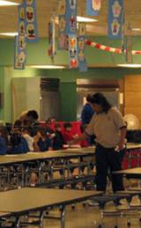
Then-principal Cynthia Hoyle and her colleagues knew they wanted their school to be a strong family, bound both by love and clear rules. The love is expressed in hundreds of ways. It is seen in the principals knowing every child by name, the weekly notes school leaders send teachers, the practice of placing a napkin at every child’s place in the lunchroom and the willingness of the school community to take care of its members through times both happy and harrowing.
At the same time, the school rules are clear. Good discipline is a striking feature of Belle Chasse: blue and green tape stripes the hallways so that students always walk on the right-hand side; they need few reminders to stay quiet in the halls. All students wear blue and green uniforms (a parishwide policy adopted in 1998), keep their voices down in the cafeteria, and unfailingly address adults as “sir” or “ma’am.” Even teachers adhere to a dress and behavior code.
The school rules have, over time, became codified into three simple sentences: “Be safe; be respectful; be responsible,” which even first-graders can recite by heart. Today, these rules are inextricably linked to the school mascot, a brown pelican, “Bella”, named by a former student. Students wear “Bella bands,” colored plastic bracelets, as rewards for good behavior, such as working intently for a period of time, or showing kindness to a teacher or other student. Bella bands qualify students for extra privileges; during the visit, a Bella band opened access to a large basket of chocolate. One student swiftly returned his unopened chocolate when he realized he had forgotten to wear his Bella band that day.
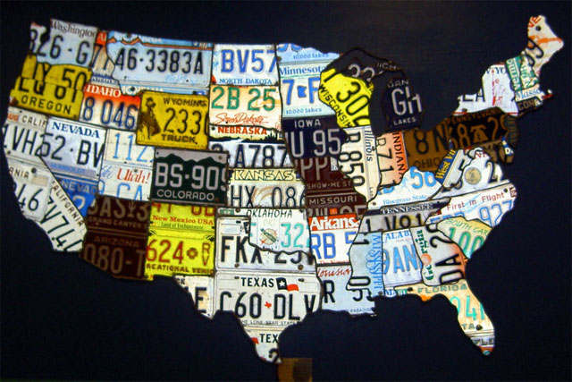
The school devotes a portion of the first few weeks of school to discipline procedures, involving the enrichment (art, music, physical education) teachers in helping students interpret the Bella rules. During the visit, the health teacher led third graders in a discussion of the effects of drugs, tying the discussion to the Bella rules by asking “Is this being safe? Do you think this would be respectful to yourself?”
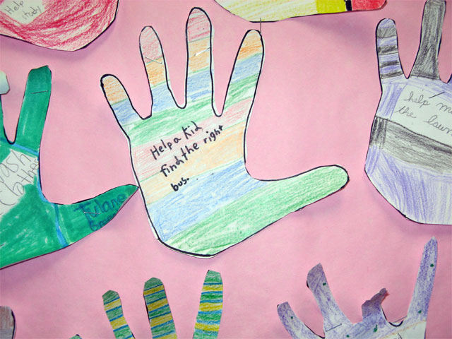


The school’s co-principals, Trish Haydel and Shelley Ritz (Mrs. Hoyle retired from BCP in January to become a district-level coach), explain that their students spend much more time on task because teachers deal with a relatively small number of discipline issues. Most parents support school’s strong discipline measures, seeing them as effectively keeping their children safe, while also teaching them good personal habits, such as keeping track of their belongings and treating others with respect. Classroom observations confirmed that very little teacher time is spent on discipline.
A School Shaped Like a Hand
The Belle Chasse building is shaped rather like a hand, with an administrative core from which radiate four hallways, each dedicated to a grade level, although with the increased population, a series of modular classrooms now stretch out across the grounds to accommodate some third and fourth grade classes. The hallways, including those of the modular units, serve as galleries for student work, from poems and mathematical patterns to portraits of characters from fables.
Every morning students produce and broadcast a television show from the the administrative core. The student anchorpersons report on the weather and school news, celebrate student achievements, and lead the whole school in reciting the pledge of allegiance, the school motto, and the “Star Spangled Banner.” During the visit, students closed one morning session by reciting a rap song they had written about the upcoming state LEAP tests.
In a first grade English language class, students rotated through four stations: one group worked with a teacher, another read independently and worked at computers, a third group read aloud quietly, and a fourth group worked with a paraprofessional staff member. Students in the teacher’s group received her attention in equal measures, and she punctuated the discussion with follow-up questions, pressing students to explain how they knew what they were asserting. The teacher set a timer for a specific interval of time with the promise that if students stayed on task and didn’t “go crazy” the whole class would earn “Bella points,” for good behavior. Students expressed concern for each other in a number of small ways, from reminding one another when it was time to switch stations, to refraining from interrupting while another student was speaking.
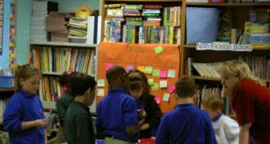
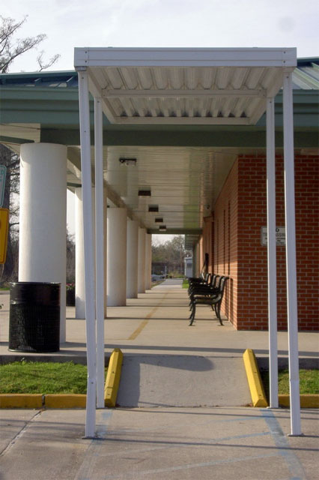
In a third grade English language class, the teacher read aloud to the class, interrupting herself frequently to prompt students to complete the sentence: “A good reader always…” which students answered by calling out “Asks questions!” Students and the teacher completed this call-and-response numerous times. The teacher also stopped to ask specific questions about the text to check for students’ understanding.
Fourth graders studying English worked as a large group to brainstorm an outline for an essay on, “If I were the principal of Belle Chasse Primary for a week,” responding with animation to each student’s suggestion, offering positive feedback and relating suggestions to other things the class had learned. After the teacher led a short discussion on transitions in writing, modeling the use—and non-use—of transitions, students worked on their drafts independently, free to use the class-generated outline in whatever way was most useful to them. Instead of guiding students to write a certain way, the teacher asked them questions about their brainstorming and writing processes. As she circulated the room, having students read her their first two paragraphs, she reminded students to check their work before she read it. When similar problems emerged in several students’ work, she paused to clarify points for the entire class.
Part of the Community
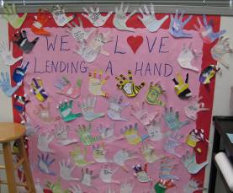
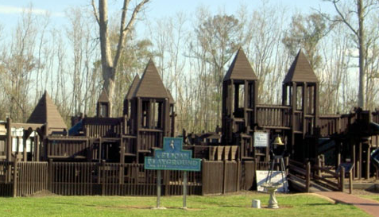
Belle Chasse is fortunate in having extremely strong community support. Chevron, which has a chemical plant in Belle Chasse, has donated thousands of dollars to upgrade the school’s computer equipment. Every classroom has at least three computers and an interactive whiteboard; the school also has a rolling laptop computer lab and three full computer labs, each equipped with 25 computers and a range of instructional software. Over the last ten years, the Belle Chasse PTO has raised more than a quarter of a million dollars for school improvements. Several years ago, some 500 community volunteers built a new school playground, a complex wooden structure with plenty of room for climbing and playing, in five days. In another area of the 35-acre school grounds a new multi-use building, with a full proscenium stage and dressing rooms, is under construction.
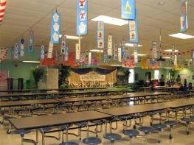
In turn, Belle Chasse extends itself to the community. Babysitting is always available at parent meetings where students regularly receive homework help and, if necessary, dinner, too. When some parents needed guidance on how to help their children study, teachers organized field trips, taking parents around to local libraries and other good study venues. Parents know to expect weekly feedback on their children’s work every Tuesday (parents of younger students receive daily notices), and parents have the telephone numbers and email addresses of their children’s teachers. Several parents concurred when the parent of a child with disabilities observed, “Every kid has a goal, and every child is acknowledged for achieving their highest level.” One parent described Belle Chasse as having an “open parent policy”—they feel welcome at Belle Chasse. The school’s very active PTO solicits “wishlists” from teachers, asking “What can we do for you teachers to help our kids?” and raising the necessary money. Some of that money goes into enrichment activities; it also finances individual tutors for students who need more support and an after-school program that runs until 6 p.m.
The school takes part in community activities, such as the annual Orange Festival, and fund-drives for needy students in developing countries. Teaching students kindness and giving back has always part of the school’s “original DNA”, as it were. “Even a five-year old can give something back to society,” says co-principal Haydel. Every year the school raises money for a charity; earlier this year, students and their families raised $25,000 for the Make-A-Wish foundation for children with terminal illnesses.
A Community Based on Trust
In the early days of making Belle Chasse a family, a “nurturing system,” as Ms. Hoyle describes it, building trust was critical. She and the faculty and staff did “lots of activities”—beginning with scrubbing down the new school, which was not quite finished when school started—to develop strong bonds, she says. What really brought them together, however, was a series of sudden, tragic deaths. “We got so close we really trusted each other,” says an administrator. “We were like a real family.”
Ms. Hoyle, who came to the principalship of Belle Chasse from the position of school librarian at the former K-12 school, put herself through a rapid and rigorous learning experience in order to become the principal she wanted to be. The day after she was named, she arranged to “job shadow” a principal in nearby Jefferson Parish whose work she admired, taking his ideas and practices and making them her own. Although she “used the resources I could get my hands on immediately” rather than go back to school, she created a range of learning opportunities. She read extensively and reached out to peers; in1998 she co-founded the New Orleans School Leadership Center,” modeled on a principals’ academy developed at Harvard University.
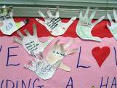
At first, she says, her responsibilities were strongly operational, dedicated to getting the school up and running smoothly. She regularly visited classrooms, she said, checking to see what students were engaged, but an epiphany—prompted by her own continuing professional development efforts—led her to begin asking, “What are they engaged in?”
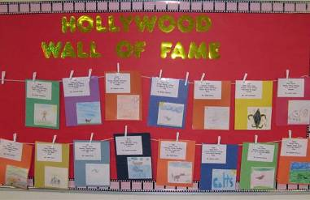

Later, with the strong support of the Plaquemines Parish central office and the BCP school board, she became one of seven Louisiana principals to take part in a School Leadership Center program on principal learning walks. The program, underwritten in large part by the U.S. Department of Education, trained administrators in “what to look for” in classrooms and how to use their findings to drive professional development offerings. For Ms. Hoyle, it was a way to ramp up what she could offer the profession.
Belle Chasse has an extremely supportive central office and a highly engaged school board. Both were receptive to Hoyle’s bringing in coaches and other experts who guided her, then the Belle Chasse Primary faculty, in learning how to identify good teaching, foster it, and leverage it throughout the school. Indeed, the district staff is reachable at all times, including weekends. The superintendent and assistant superintendent conduct regular visits, aiming to be in at least one school every day.
The Learning Walks became tightly focused on three questions: “What is the teacher enabling? How is the teacher enabling it? Will the student be able to transfer that knowledge to another situation?” Observers, whether teachers or administrators, used formal checklists in addition to recording anecdotal impressions; these regular observations served as the basis of discussions, led by the curriculum specialist, at weekly grade-level meetings. Belle Chasse was beginning to use Learning Walks widely when Hurricane Katrina touched down on Plaquemines Parish, and they continue today, even more regularly.
Katrina
Belle Chasse students, teachers, and staff dispersed across the country. When the school reopened seven weeks later, the first order of business was to scrub the school clean again. With schools closed throughout the parish, BCP had to learn how to build a new, much larger community, quickly. Instead of 650, nearly 1200 students returned to attend Belle Chasse Primary; eighty teachers were suddenly added to the staff, and the school’s proportion of students who qualified for free or reduced-price lunch jumped from 54% to 72%.
“We went back to our basic idea,” Mrs. Hoyle says: “trust.” The new students were taught the rules and welcomed with the same warm embrace the teachers, administrators, and staff had always offered. The new teachers, some a little hesitant, soon found themselves “family” as well. With support from the state and district, all of Belle Chasse’s teachers learned how to become co-teachers, adapting their teaching methods to a new model.

Ms. Hoyle started up the Learning Walks again, adding a new step: (voluntary) videotaping teachers. Learning Walks had broken the walls that separate teachers from each other, the videos brought them down. Although teachers laugh nervously about being videotaped, they agree that they find inspiration and new ideas from scrutinizing how their grade-level peers teach—and failures are as instructive as successes. Such exploration is only possible in an atmosphere of trust.
Because both co-principals Haydel and Ritz are former Belle Chasse Primary teachers, levels of trust remained strong when they took the school’s helm in January 2007. Co-principal Haydel looks after pre-K-2 students; co-principal Ritz looks after grades 3-4. Both agree that they complement each other’s skills and find it invaluable to have one another to confer with and rely on. With other school leaders, the curriculum and intervention specialists, Ritz and Haydel examine student data, watching for successful teachers who can model practices for other teachers, and less successful teachers who might benefit from targeted professional development. The district makes a wide range of professional development opportunities available, and BCP also draws on its own in-house expertise.
Real-time Data
Belle Chasse Primary is part of a pilot assessment program offered through the Louisiana Department of Education. The aim, says co-principal Haydel, is to “fine-tune the model to meet the needs of each individual child.” Reading tests at the beginning of the school year screen students for reading difficulties. A triage team examines the data on students identified as at-risk, reviews intervention options, and creates a plan for each student, which is communicated to the student’s parents. At-risk students typically receive additional small group instruction, tutoring, and language- and literacy-based computer programs.
At least once a week, teachers gather formative data about their students—real-time information about what children have learned and where they are struggling. Younger students’ achievement is tracked through DIBELS (Dynamic Indicators of Basic Early Literacy Skills) and other brief assessments; fourth graders get rapid tests known as “blitzes”—quick measures of student knowledge.
At weekly curriculum meetings, very little time goes to “business” or procedural issues. “We handle business through emails,” explained a teacher. They devote their face-to-face time discussing everything from student data to teaching strategies. They watch videos their grade-level peers have offered to show, and share resources, research, ideas, and stories, analyzing both successful lessons and frustrating ones. During the visit, a fourth grade teacher described how she began doing a lesson that day with manipulatives, teaching multiplication by having students physically create arrays, but her students were “in a mood,” unable not to throw the little yellow tiles around. Another fourth grade teacher couldn’t persuade some students to build flat arrays, not towers. Both switched to paper and pencil work, and discussed other alternatives with the rest of the fourth grade teachers. Twice monthly, teachers meet in small learning groups focused on best practices in reading and writing.
Today, with 11 kindergarten classes, 11 first grades, 10 second grades, 10 third grades, and 11 fourth grades, Belle Chasse has re-emerged as a strong family. “The new people belong to us,” a third grade teacher says, “we’ve been through a lot.” Adds another, “We have a sense of what’s important because of what we’ve been through.”
Despite the suffering Katrina put the whole region through, teachers and administrators at Belle Chasse Primary regard Katrina as some kind of professional blessing. Living through the hurricane together strengthened existing relationships and created new ones, making strong colleagues of people who had once been cordial allies. And, noted principals Haydel and Ritz, it was only after integrating the “new” people that Belle Chasse Primary earned its Blue Ribbon.
Belle Chasse Elementary State Criterion-Referenced Tests
% proficient and above: 4th grade Language Arts
 | 2002 | 2003 | 2004 | 2005 | 2006
All | 78 | 90 | 88 | 88 | 78
Low income | 73 | 85 | 88 | 73
Students with Disabilities | 25 | 46 | 61 | 64
State Scores | 57 | 59 | 60 | 64 | 64
% proficient and above: 4th grade Math
 | 2002 | 2003 | 2004 | 2005 | 2006
All | 85 | 92 | 87 | 88 | 80
Low income | 81 | 88 | 82 | 84
Students with Disabilities | 52 | 77 | 67 | 82
State Scores | 50 | 58 | 53 | 61 | 62
