Early Childhood Education: The Journey From Efficacy
Research to Effective, Everyday Practice

Craig T. Ramey and Sharon L. Ramey
Center for Health and Education Research
Georgetown University

Summit on Early Childhood Cognitive Development
Boise, Idaho
June 10, 2002
Early Childhood Education: The Journey From Efficacy Research
To Effective, Everyday Practice

Craig T. Ramey and Sharon L. Ramey
Georgetown University

During the past decade there has been a steady increase in scientific evidence that establishes the undeniable importance of the early years in human development (see Shonkoff, & Phillips, 2000). This evidence is particularly strong with respect to school readiness for children from families of limited education and low income (Ramey & Ramey, 1998). Language and literacy skills and their relation to other aspects of child development have been identified as key areas for further scientific concern and systematic policy formulation (Hart & Risley, 1995; Lyon, 2002).
A series of experimental trials using early childhood education, family support, and pediatric care has demonstrated that high risk children can be prepared for initial success in school. When this increased school readiness is coupled with adequate school programs the initial positive effects persist into adolescence and adulthood. The magnitude of the effects produced by various preschool interventions is systematically related to characteristics of the preschool programs themselves (Ramey & Ramey, 1998). Important program characteristics include having a 1) well specified curriculum, 2) having programs of a half-day or longer, 3) beginning early in the child’s life and developing a strong communication pattern between adults and children and 4) focusing on cognitive development as well as linguistic and social competence.
The purpose of this paper is to highlight specific findings from several of our preschool programs and to advocate for a new type and level of inquiry to make successful programs available to all children who need them. What is needed from the research community is a shift in the central question being asked in contemporary early childhood education research. We need to realize that the old question of whether the development of high-risk children can be positively changed has been answered with a resounding “yes.” We must now move on to more refined questions concerning the relative influence of different types of programs including practical questions concerning age of onset, intensity and duration of treatment as well as the effects of various specific educational curricula. During this transition we need to study and to improve, where needed, the existing early childhood programs.
In my opinion this Summit marks the beginning of a new era in the developing partnerships of scientists and educators to improve preschool educational programs. If significant progress is made in the availability of high-quality preschool programs we believe that these improvements will affect not only children and parents who are disadvantaged, but the taxpayers who support their education. It is our belief that high quality education and rigorous science is a powerful combination that can provide benefits to our whole society.
Now for some specific results which have led us to this point of view.
Each year hundreds of thousands of children enter kindergarten unprepared to meet the intellectual demands of school (Carnegie, 1995). Lack of cognitive readiness bodes ill for future school performance. Poor school readiness predicts increased likelihood of low levels of academic achievement and high levels of retention in grade, special education placement, and ultimately school dropout. In turn, school dropouts are at much elevated risk for unemployment, teen pregnancy, juvenile delinquency, social dependency, and poor parenting practices. Their children all too frequently repeat this pattern. (cf., Carnegie Report, 1995).
Poor school performance is foreshadowed by subaverage performance on cognitive, linguistic and social functioning during the years prior to kindergarten.
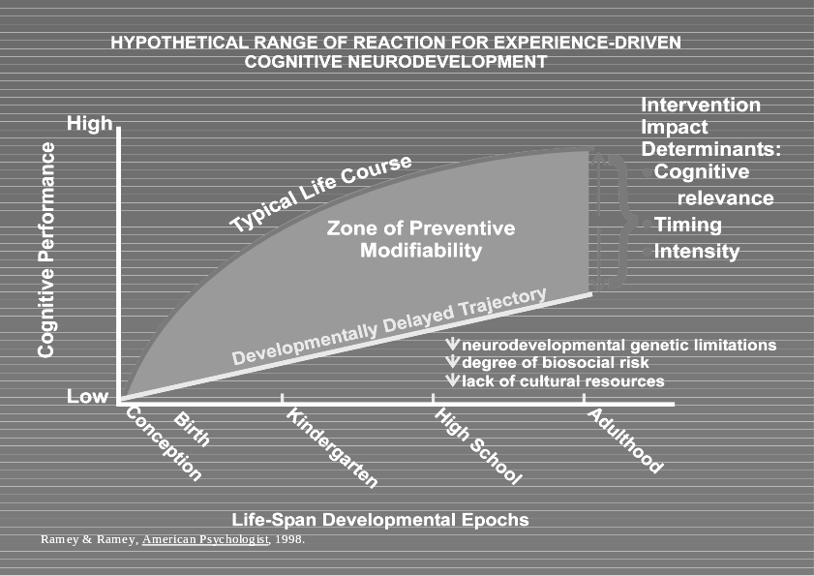
Remedial special education to improve cognitive development and academic achievement that is begun in the elementary school years faces an enormous challenge. In essence for special education to be effective, the base rate of cognitive development must be altered if the progressive gap between normal and subaverage cognitive development is to be arrested and intellectual development is to be established at normative trajectories. If genuine catch-up is to occur, the rate of development during treatment must actually exceed the normative rate. Thus, the shorter the period of remedial intervention the more powerful it must be. This point is illustrated in Figure 1.

Unfortunately, little is known about how to accelerate cognitive development beyond normative or typical rates. Thus, the initial hopes and expectations for remedially oriented special education often go unmet.
A policy alternative to remedial or typical special education is primary prevention. Primary prevention entails the identification of high-risk individuals in the general population and the provision of the hypothesized missing essential experiences for normative development.
A large body of observational research suggests that children who evidence delayed cognitive development have insufficient frequency of exposure to particular adult-child transactional experiences (e.g., Bradley et al, 1989; Huttenlocher, Haijht, Bryk, & Seltzer, 1991; Ramey & Ramey, 2000). These transactional experiences are particularly lacking in low socioeconomic status families and are reliably missing beginning in the second year of life and sometimes earlier. (Yeates et al., 1983). (Huttenlocher et al., 1991). These transactional experiences have been summarized by Ramey & Ramey, 1992 and are presented in Table 1. These so-called Developmental Priming Mechanisms are part of a theoretical framework derived from General
TABLE 1
DEVELOPMENTAL PRIMING MECHANISMS

1. ENCOURAGEMENT OF EXPLORATION:
To be encouraged by adults to explore and to gather information about their environments

2. MENTORING IN BASIC SKILLS:
To be mentored (especially by trusted adults) in basic cognitive skills, such as labelling, sorting, sequencing, comparing, and noting means-ends relationships

3. CELEBRATION OF DEVELOPMENTAL ADVANCES:
To have their developmental accomplishments celebrated and reinforced by others, especially those with whom they spend a lot of time

4. GUIDED REHEARSAL AND EXTENSION OF NEW SKILLS:
To have responsible others help them in rehearsing and then elaborating upon (extending) their newly acquired skills

5. PROTECTION FROM INAPPROPRIATE DISAPPROVAL, TEASING, OR PUNISHMENT:
To avoid negative experiences associated with adults' disapproval, teasing, or punishment for those behaviors that are normative and necessary in children's trial-and-error learning about their environments (e.g., mistakes in trying out a new skill, unintended consequences of curious exploration or information seeking). Note: this does not mean that constructive criticism and negative consequences cannot be used for other child behaviors which children have the ability to understand are socially unacceptable.)

6. A RICH AND RESPONSIVE LANGUAGE ENVIRONMENT:
To have adults provide a predictable and comprehensible communication environment, in which language is used to convey information, provide social rewards, and encourage learning of new materials and skills. Note: although language to the child is the most important early influence, the language environment may be supplemented in valuable ways by the use of written materials.

- GUIDANCE AND LIMITATION:
To have adults keep children safe and to teach what is acceptable, and what is not – the rules of being a cooperative, responsive, and caring person.

Systems Theory and applied to two-generational early intervention programs by Ramey, Ramey, Gaines and Blair (1995). Insufficient exposure to these Developmental Priming Mechanisms is hypothesized to negatively affect developmentally appropriate cortical neuronal connections and synaptic efficiency associated with cognitive, linguistic and social development. In turn these changes are hypothesized to be reflected in summative performance on norm-referenced measures of cognitive, linguistic and social competence.
To test the hypothesis that provision of these theoretically critical experiences can potentially prevent progressive cognitive delay we have conducted two single site randomized trials and one multi-site randomized controlled trial with high-risk children and their families. These projects and their cognitive outcomes are the focus of this presentation.
The Early Intervention Programs
Certain programmatic commonalities run throughout the Abecedarian Project (Ramey & Campbell, 1992), Project CARE (Ramey, Bryant, Sparling, & Wasik, 1985), and the Infant Health and Development Program (Ramey, Bryant, Wasik, Sparling, Fendt, & LaVange, 1992). These early childhood education programs were multidisciplinary, intergenerational, individualized for children and their families, contextually embedded in local service delivery systems, research - oriented and organized around key concepts undergirding randomized controlled trials.
The research design and associated key concepts that have guided our efforts have derived from the evolving literature on randomized controlled trials concerned with efficacy of treatments. That is, can a given program work under nearly idealized research conditions? Guiding concepts for our efficacy trials worthy of special mention include:
1. Recruitment from prespecified populations to enhance generality of findings,
2. Random assignment to treatment and control groups to establish initial group equivalence,
3. Application and documentation of receipt of a replicable compound of services including specific educational curricula,
4. Minimization of attrition to prevent biased estimates of treatment effects,
5. Independent assessment of outcomes by observers masked to treatment conditions of participants,
6. Preplanned statistical analyses of hypothesized outcomes with adequate sample sizes for appropriate statistical power to detect statistically and practically meaningful group differences,
7. Replication of key findings in independent samples of children and families,
8. Publication of findings in peer-reviewed journals,
9. Dissemination of findings to key policy makers and the general public after publication in peer-reviewed journals.
Participants and Programs
The first two projects (The Abecedarian Project (N = 111 children) and Project CARE (N=63 children) were single-site randomized controlled trials which enrolled children at birth who were biologically healthy but who came from very poor and undereducated families. For example the mean maternal education in both projects was approximately 10 years of schooling. Approximately 3/4 of the mothers were unmarried. Control group families (sometimes referred to as Follow-up families) were not a totally untreated group, however. Rather, those children received pediatric follow-up services on a schedule recommended by the American Academy of Pediatrics. In addition the children were provided unlimited iron fortified formula. Families of control group children also received social work services and home visits. These sources were provided due to ethical and research concerns. Their provision, we should note, makes the demonstration of group differences less likely due to their presumed positive influence on the control group children and families.
The Early Intervention groups received the same services just mentioned for the Control groups plus they received an Early Childhood Education Program known as Partners for Learning (Sparling, Lewis & Ramey, 1995) within the context of a specially developed Child Development Center. This Center admitted children after 6 weeks of age and maintained low child/teacher ratios (e.g., 3:1 for children < 1 year; 4:1 for children between 1 and 3 years) and an ongoing inservice curriculum training and technical assistance program for teachers. Parent involvement was facilitated by home visits and parent groups. A fuller description of the preschool program can be found in an article by Ramey & Campbell (1992) and Ramey…. In general, program features in the Abecedarian and CARE projects foreshadowed those that are now recommended by the National Association for the Education of Young Children.
Partners for Learning can be described as an educational curriculum that is concerned with 31 child development areas and consistently oriented toward adult-child transactions involving well-formed and conversational language about topics of every day interest to young children (McGinness & Ramey 1981; Ramey, McGinness, Cross, Collier, & Barrie-Blackley, 1981). Partners for Learning acts both as a child program resource and as a staff development resource and provides a means to individualize the educational program for each child.
The Infant Health and Development Program (N=985) was a slightly modified version of that program used in the Abecedarian and CARE projects. Modifications included: 1) establishing the program as an 8-site randomized controlled trial, 2) limiting enrollment to infants who were born at <2500 grams and <37 weeks gestational age. Thus all child participants were to varying degrees of low birthweight and prematurity, 3) weekly home visits were the main early intervention component until children were 12 months of age (corrected for prematurity). At 12 months of age children began attending Child Development Centers that were replicas of the one used for the Abecedarian and CARE projects. (Fuller descriptions of the Infant Health and Development Program – IHDP - can be found in IHDP (1990) and Ramey, Bryant, Wasik, Sparling, Fendt & LaVange (1992).

Cognitive Results from these Early Education Programs
Figure 2 shows Bayley Mental Development Index scores (MDIs) and Stanford - Binet (S-B)
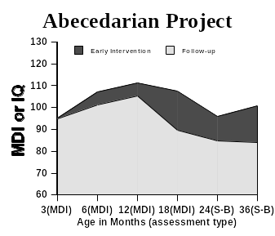
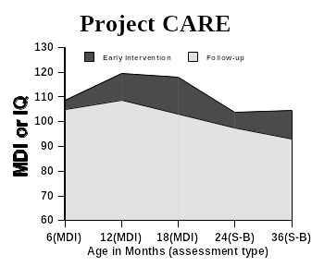

IQ scores by age and treatment conditions during the first 3 years of life for both the Abecedarian project (top panel) and Project CARE (lower panel). The top of the gray area represents the mean performance on the control group’s cognitive assessments at the ages identified on the horizontal axis while the top of the black area represents the mean performance of the early childhood education group. Thus, the amount of black represents the cognitive value added due to the influence of the early childhood education. In both of these graphs there is a divergence of the curves favoring the early intervention groups over the control groups during the first 18 months. Consistent with the random assignment of children to treatment and control conditions, a strong causal inference is justified concerning the preventive power of the early educational curriculum. By 36 months the mean IQ scores in the Abecedarian Project are 101 and 84 for the early education and control group respectively (Ramey & Campbell, 1984). In Project Care the comparable 36-month scores are 105 and 93 (Ramey et al., 1985).
Figure 3 contains plots for the most comparable IHDP children to the Abecedarian and CARE children - those closest to full birthweight (2001 - 2500 grams) at each of the 8 sites. These 8 graphs all show similar divergence to 36 months with an overall mean difference of 13.2 IQ points favoring the early intervention groups at 36 months. Comparable plots (Figure 4) for the lighter low
birthweight groups (<2001 grams) reveals similar trends in 7 of the 8 comparisons (the Harvard site being the exception) but with a somewhat diminished magnitude of difference between the early intervention and control (follow-up) groups (overall mean difference = 6.6 IQ points at 36 months). Thus 17 of the 18 comparisons at 36 months across the Abecedarian, CARE and IHDP projects support the hypothesis that intensive early intervention is associated with higher cognitive performance relative to randomized controls.

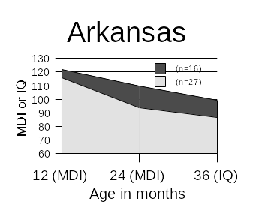
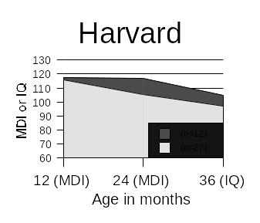
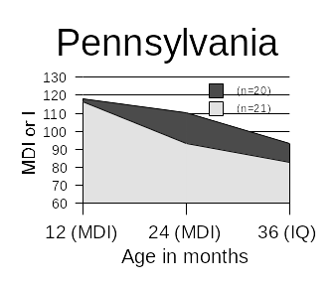
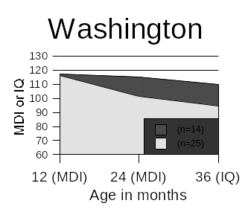
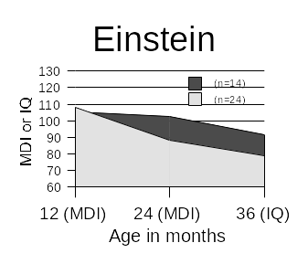
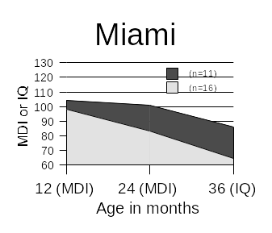
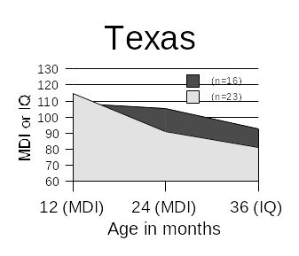
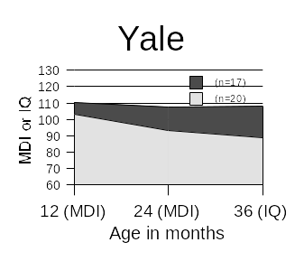

Figure 3. Cognitive scores for infants 2,001-2,500 g at birth

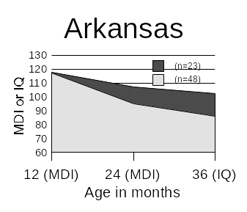
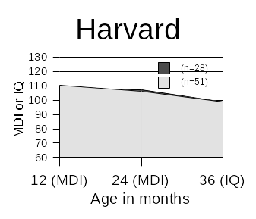
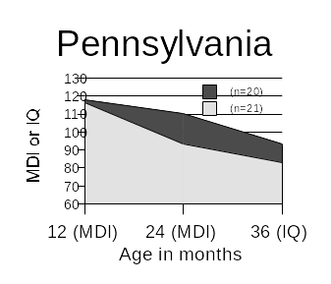
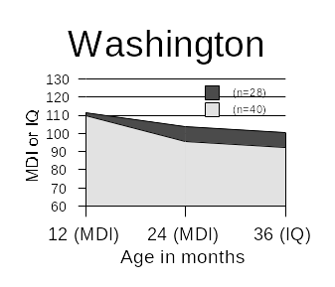
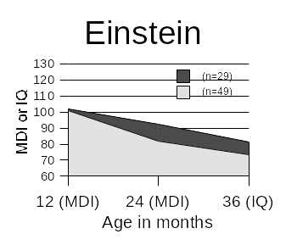
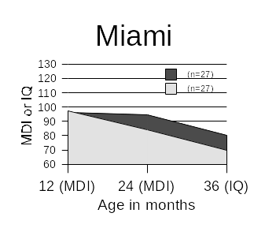
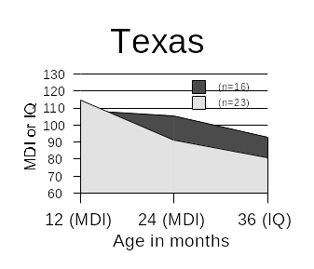
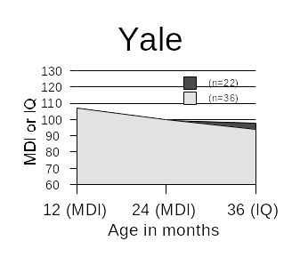

Figure 4. Cognitive scores for infants <2,001 g at birth

Figure 5 illustrates that children’s cognitive performance at 36 months is positively related to
mothers education levels in the IHDP control group and that the positive effects of the early intervention are greater for the children of lesser educated mothers.

(n=232)
(n=162)
(n=166)
(n=104)
(n=134)
(n=63)
(n=76)
(n=48)

IHDP

Mothers’ Educational Levels

Figure 5. Cognitive performance as a function of early intervention and maternal educational level

That is, those children at greatest cognitive risk due to low family educational resources benefited the most.
These were benefits in addition to the cognitive ones. These benefits are summarized in Table 2. In that table the symbol “NS” means that the characteristic described was measured and the two groups were not significantly different by statistical test. The symbol “-”means that the characteristic was not measured at that age. The symbol “*” means that the characteristic was measured and in all instances, without exception, the differences favored the early childhood education group over the

Table 2

Developmental Outcomes Affected Positively

By the Infant Health & Development Project

* = p<,01 - = not measured

NS = not significant
Age in Months
12 24 36
Cognitive Development NS * *
Adaptive and Prosocial Behavior - - *
Behavior Problems - * *
Vocabulary - * *
Receptive Language - * *
Reasoning - - *
Home Environment NS * *
Maternal Interactive Behavior - - *
Maternal Problem Solving - - *
© Ramey 1999, adapted from Gross, Spiker, & Haynes, 1997, Helping Low Birth Weight, Premature Babies

follow-up group. Thus, at 36 months of age the Early Childhood Education group had, on average, higher cognitive development across and showed more adaptive and prosocial behaviors. The educationally treated group also had fewer behavior problems, larger vocabularies, better receptive language, and better reasoning skills. Their home environments were rated as developmentally more supportive, their mothers interacted with them more in developmentally appropriate ways and their mothers were better at solving everyday problems concerning childrearing. Thus, a comprehensive early childhood and family support program produced broad and positive developmental outcomes for both the child and family while it was in operation during the first three years of life at which point it was terminated.
The Abecedarian and Care Projects continued with the Early Childhood Educational Program until the children entered public kindergarten. The cognitive differences between the treated and control groups continued to persist at statistically significant levels (Burchinal, Campbell, Bryant, Wasik, & Ramey, 1997).
Table 3, summarized from a paper by Ramey, MacPhee, and Yeates (1982), presents a summary of results from the Abecedarian Project during the preschool period.

Table 3
Brief Summary of Abecedarian

Results During Preschool Period

Positive Effects on

IQ performance
- Learning & cognitive performance
- Language development
- Resilience to non-optimal biological and behavioral conditions
- Social responsiveness
- Academic locus of control
- Maternal education
- Maternal employment

No Effects on

- Maternal attachment
- Parental child rearing attitudes
- Home environments

Decreased Effects

- Incidence of intellectual subnormality

Summarized from Ramey, MacPhee, & Yeates, 1982

Similarly to the Infant Health and Development Program, the Abecedarian Program produced a broad array of positive effects on both participating children and their parents. It is noteworthy that in these programs and with other high-quality early education projects, so far, there have been no reports of negative side effects on the children, their families, or the attachment between children and families.
Follow-Up Results
The Infant Health and Development Program was terminated at age 3 and produced a disappointing pattern of cognitive results thereafter. Longitudinal analyses of these children’s development showed that by 5 and 8 years of age, the overall IQ differences between the treatment and comparison groups decreased to such an extent that it was no longer educationally significant (Brooks-Gunn et al., 1994; McCarton et al., 1997). However, it is noteworthy that the heavier low birth weight children continued to have significantly higher IQ scores at age 5 and by age 8 the early intervention group scored 4.4 points higher than the comparison. The follow-up researchers involved in this study concluded that early cessation of services at age three was likely to have contributed to the loss of early benefits and that additional interventions are indicated for low birth weight infants to sustain earlier gains. In short, stopping intervention at age three for these highly vulnerable infants is not a good idea.
In the Abecedarian Project we decided to examine the effects of an additional educational treatment that we began at kindergarten entry and continued for the first three years of school. To address this issue we randomly divided each of the two preschool groups. One-half of each group received an enriched educational program from kindergarten entry through second grade. This allowed a practical test of three major educational policy alternatives with respect to timing and duration of early intervention services. That is…
Table 4 provides a brief summary of the services delivered during the school-age phase of the intervention. A fuller description of this aspect of the Abecedarian Project can be found in Ramey and Campbell (1992). In essence, the K-2 program was intensive, focused on home and school continuity, and emphasized reading, math and writing and was conducted year around. Parents, teachers and children participated enthusiastically.

Table 4
Summary of Abecedarian K-2 Transition Program
- Individualized focus on academic and learning activities in school and at home
- Emphasis on reading, mathematics, and writing
- Master Home/School Resource Teachers (12 children and families per teacher)
- Development of an individualized and documented supplemental curriculum for each child
- Explicit attention and action relevant to family circumstances, as needed
- Summer camps with academically relevant experiences

The overall research design on the Abecedarian Project is presented in schematic form in Figure 6.
R
R
R
Figure 6

R = Randomization

At the end of the second grade a stair-step pattern of performance on reading and math was found that indicated a proportional response to the intensity of the treatment. This is illustrated for reading in Figure 7. The majority of the effect was captured, however, by whether the children had participated in the preschool program. The school age program, by itself, was of marginal added value although it seems to have had a slight protective role for those children who had the preschool program.
Abecedarian Project
Woodcock-Johnson
Age-referenced Reading Standard Scores at Age 8

Figure 7

Figure 8
Follow-up assessments of the Abecedarian children have now been completed at 8, 12, 15 and 21 years of age. With respect to standardized measures of intelligence, the differences between the treatment and comparison groups narrowed but continued to be statistically and educationally meaningful at approximately 5 IQ points. Perhaps more germane to education, however, are the results from reading and math achievement assessments. At all ages from 8 to 21, the preschool treatment group had significantly higher academic achievement scores in both reading and mathematics. Figure 8 shows the results for reading performance for Abecedarian children and Figure 9 shows the math performance.
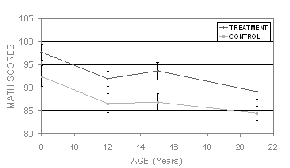
Math Achievement as a Function of Early Treatment Over Time

Figure 9
In the follow-up study at age 21 (Campbell, Ramey, Pungello, Sparling, & Miller-Johnson, 2002) it was found that not only did the children in the preschool treatment group earn significantly higher scores on intellectual and academic measures as young adults but they were also more likely to have attained more years of total education, were three times more likely to attend a four year college (12% vs. 36%), and showed a reduction in teenaged births compared to preschool controls. An earlier follow-up at age 15 had demonstrated that they were 47% less likely to be retained in grade and 75% less likely to be placed in special education (Ramey et al., 2000). Thus, the cognitive benefits that began with a good preschool education better prepared these high-risk children to be ready to develop the reading and math skills that the schools were prepared to teach. In turn the children mastered these two gateway skills and, as a group, did better throughout school and into young adulthood. In short, risk for poor cognitive development was offset to a considerable degree by high-quality preschool education focused on cognitive development, conversational skills and social competence.
These results, although somewhat larger in magnitude of positive effects, are consistent with earlier findings from the Consortium of Longitudinal Studies (Lazar & Darlington, 1982) and from other randomized trials of high-quality early childhood educational programs (see Ramey & Ramey, 1998, for a detailed review). We think it plausible that the greater intensity and duration of our preschool component accounts for their larger effects when compared to lesser intensive preschool interventions. In summary, we believe that the efficacy question of whether early childhood education can have meaningful positive impact on at-risk children has been answered with a clear yes. The obvious question is where do we go from here?
Based on the research evidence in hand we believe that four actions are timely and important:
First, our country should provide appropriate levels and types of early childhood programs to those children in greatest need of additional high-quality preschool education. To do this we need better population-based studies of risk and careful empirical research on the specific benefits of different educational practices and curricula.
Second, existing program standards need to be reviewed and upgraded where guidelines are not consistent with scientific evidence for program effectiveness. We believe that this should be accompanied by high-quality teacher training and technical assistance to improve teacher knowledge and skills.
Third, we should create a nationwide network of model demonstration programs that have been certified as demonstrating exemplary high-standards and practices.
Fourth, we should provide useful and appealing public information that is scientifically-based on the importance of roles and activities of parents and teachers in the development of young children.
These four courses of action are ones that can begin immediately and that can reinforce one another in improving children’s competence. The theoretical systems and technologies are available to facilitate high-quality and practical scientific inquiry. We can readily create the infrastructures to transfer the scientific knowledge to where it will be useful and to monitor its impact on children and families.
As our knowledge about the importance of early childhood cognitive development, literacy, and social competence increases so does our responsibility to act upon this knowledge to improve the conditions that can maximize positive child cognitive outcomes and social competence. We are confident that this can be done effectively and efficiently. We applaud Mrs. Bush, the President, and the Bush administration for their dedication “to leave no child behind.”
References
Bradley, R. H., Caldwell, B. M., Rock, S. L., Ramey, C. T., Barnard, K. E., Gray, A., Hammond, M. A., Gottfried, A., Siegel, L. S., & Johnson, D. L. (1989). Home environment and cognitive development in the first 3 years of life: A collaborative study involving six sites and three ethnic groups in North America. Developmental Psychology, 25, 217-235.
Brooks-Gunn, J., McCarton, C.M., Casey, P.H., McCormick, M.C., Bauer, C.R., Bernbaum, J.C., Tyson, J., Swanson, M., Bennett, F. C., Scott, D. T., Tonascia, J., and Meinert, C. (1994). Early intervention in low-birth-weight premature infants: Results through age 5 years from the Infant Health and Development Program. Journal of the American Medical Association, 272(16): 1257-1262.
Burchinal, M.R., Campbell, F.A., Bryant, D.M., Wasik, B.H., & Ramey, C.T. (1997). Early intervention and mediating processes in cognitive performance of children of low-income African American families. Child Development, 68, 935-954.
Campbell, F.A., Ramey, C.T., Pungello, E., Sparling, J., & Miller-Johnson, S. (2002). Early childhood education: Outcomes as a function of different treatments. Applied Developmental Science, 6, 42-57.
Carnegie Report, 1995. Years of Promise: A Comprehensive Learning Strategy for America=s Children. Carnegie Corporation of New York.
Hart, B., & Risley, T. R. (1995). Meaningful experiences in the everyday experiences of young American children. Baltimore, MD: Paul H. Brookes Publishing Co., Inc.
Horacek, H. J., Ramey, C. T., Campbell, F. A., Hoffman, K. P., & Fletcher, R. H. (1987). Predicting school failure and assessing early interventions with high-risk children. Journal of the American Academy of Child Psychiatry, 26, 758-763.
Huttenlocher, J., Haight, W., Bruk, A., Seltzer, M., & Lyons, T. (1991). Early vocabulary growth: Relation to language input and gender. Developmental Psychology, 27.
The Infant Health and Development Program. (1990). Enhancing the outcomes of low-birth-weight, premature infants. Journal of the American Medical Association, 263, 3035-3042.
Lazar, I., & Darlington, R. (1982). Lasting effects of early education. Monographs of the Society for Research in Child Development (Serial No. 195) 47(2/3):1-151.
Lyon, R.. (2002). Cognition, Reading and School Readiness. Presentation at President’s Summit on Cognitive Development, Georgetown University, Washington, DC.
McCarton, C. M., Brooks-Gunn, J., Wallace, I. F., Bauer, C. R., Bennett, F. C., Bernbaum, J. C., Broyles, R. S., Casey, P. H., McCormick, M. C., Scott, D. T., Tyson, J., Tonascia, J., & Meinert, C. L. (1997). Results at age 8 years of early intervention for low-birth-weight premature infants: The Infant Health and Development Program. JAMA, 277, 126-132.
McGinness, G., & Ramey, C. T. (1981). Developing sociolinguistic competence in children. Canadian Journal of Early Childhood Education, 1, 22-43.
Ramey, C. T., Bryant, D. M., Sparling, J. J., & Wasik, B. H. (1985). Project CARE: A comparison of two early intervention strategies to prevent retarded development. Topics in Early Childhood Special Education, 5, 12-25.
Ramey, C. T., Bryant, D. M., Wasik, B. H., Sparling, J. J., Fendt, K. H., & LaVange, L. M. (1992). Infant Health and Development Program for low birth weight, premature infants: Program elements, family participation, and child intelligence. Pediatrics, 89, 454-465.
Ramey, C. T., & Campbell, F. A. (1984). Preventive education for high-risk children: Cognitive consequences of the Carolina Abecedarian Project. American Journal of Mental Deficiency, 88(5), 515-523.
Ramey, C. T., & Campbell, F. A. (1992). Poverty, early childhood education, and academic competence: The Abecedarian experiment. In A. Huston (Ed.), Children in poverty (pp. 190-221). NY: Cambridge University Press.
Ramey, C. T., Campbell, F. A., Burchinal, M., Skinner, M. L., Gardner, D. M., & Ramey, S. L. (2000). Persistent effects of early childhood education on high-risk children and their mothers. Applied Developmental Science, 4, 2-14.
Ramey, C. T., McGinness, G., Cross, L., Collier, A., & Barrie-Blackley, S. (1981). The Abecedarian approach to social competence: Cognitive and linguistic intervention for disadvantaged preschoolers. In K. Borman (Ed.), The social life of children in a changing society (pp. 145-174). Hillsdale, NJ: Erlbaum Associates.
Ramey, S.L., & Ramey, C.T. (1992). Early educational intervention with disadvantaged children -- To what effect? Applied and Preventive Psychology, 1, 131-140.
Ramey, C. T., & Ramey, S. L. (1998). Early intervention and early experience. American Psychologist, 53, 109-120.
Ramey, C.T., Ramey, S.L., Gaines, R., & Blair, C. (1995). Two-generation early interventions: A child development perspective. In I. Siegel (Series Ed.) and S. Smith (Vol. Ed.), Two-generation programs: A new intervention strategy. Vol.9 Advances in applied developmental psychology (pp.199-228). Norwood, NJ: Ablex Publishing Corporation.
Ramey, S.L., & Ramey, C.T. (2000). Early childhood experiences and developmental competence. In J. Waldfogel & S. Danziger (Eds.), Securing the future: Investing in children from birth to college (pp.122-150). NY: Russell Sage Foundation.
Shonkoff, J. P., & Phillips, D. A. (2000). From neurons to neighborhoods: The science of early childhood development. National Academy Press.
Sparling, J.J., Lewis, I. & Ramey, C.T. (1995). Partners for learning: Birth to 36 months. Lewisville, NC: Kaplan Press.
Yeates, K. O., MacPhee, D., Campbell, F. A., & Ramey, C. T. (1983). Maternal IQ and home environment as determinants of early childhood intellectual competence: Developmental analysis. Developmental Psychology, 19, 731-739.

