IMC 0609
Appendix C

OCCUPATIONAL RADIATION SAFETY
SIGNIFICANCE DETERMINATION PROCESS

I. APPLICABILITY

The significance determination process (SDP) in this Appendix is designed to provide a means by which NRC inspectors and management can assess the significance of inspection findings related to worker health and safety from exposure to radiation from licensed or unlicensed radioactive materials during routine operations of civilian nuclear reactors.

Background and basis information related to this SDP can be found in Inspection Manual Chapter 0308, “Reactor Oversight Process (ROP) Basis Document,” Appendix C, Section 6, “Occupational Radiation Safety SDP.”

II. ENTRY CONDITIONS

Each issue entering the SDP process must first be screened using IMC 0612, Appendix B, “Issue Screening.”

III. DEFINITIONS

Within this SDP, the following definitions apply:

A. ALARA. Maintaining radiation dose as low as is reasonably achievable.

B. Compromised ability to assess dose. Deficient program requirements (i.e., inadequate procedures that resulted in program failures), or failures to implement adequate program requirements, that resulted in chronic failure to account for exposures that exceed, or could have exceeded;

1. an acute intake of radionuclides greater than 0.02 annual level of intake (ALI), per individual, or
2. 100 mrem whole body from external exposure, per individual.

A compromised ability to assess dose can result from:

1. the licensee's failure to use a National Voluntary Laboratory Accreditation Program (NVLAP) certified dosimeter processor when required by 10 CFR Part 20, or
2. failure of the electronic dosimeters (EDs) to respond to, or record, radiation dose, or
3. the improper calibration of instruments or monitors which are used as a basis for establishing protective controls, or
4. the improper analysis of bioassay data that results in missed intakes of radioisotopes, or,
5. the failure to recognize a radiologic hazard in the work place (i.e., the potential for exposure to alpha emitting, radionuclides resulting in the failure to appropriately assess intakes of these nuclides).

C. Substantial potential for overexposure. An event presents a substantial potential when it was fortuitous that the resulting exposure did not exceed the limits of 10 CFR 20. The concern is not the significance of the resulting, or potential, exposure, but whether the licensee provided adequate controls over the situation, as required, to ensure the Part 20 dose limits are not exceeded. No credit is given for luck. When assessing whether a finding constitutes a substantial potential for overexposure, consider if it is possible to construct a reasonable scenario in which a minor alteration of circumstances (as they actually happened) would have resulted in a violation of the Part 20 limits. The following circumstances should be considered:
1. Timing - Could the exposure period have reasonably been longer?
EXAMPLE: An individual in the proximity of an unknown source of radiation receives an unplanned excessive exposure. Because of the duration of the exposure, no limits were exceeded; however, the individual could have reasonably stayed in the proximity of the source long enough to be overexposed.
2. Source Strength - Could the radiation source have reasonably been stronger?
EXAMPLE: While working in the spent fuel transfer canal a worker picked up and handled a piece of activated debris, contrary to the RWP instructions. Although this deficiency did not result in an overexposure, similar (but more highly activated) debris was in the same area of the transfer canal. Had the worker picked up one of the more activated pieces of debris, his actions would have resulted in a dose in excess of the Part 20 limits. Nothing prevented the worker from picking up the more highly activated debris.
3. Distance - Could the person have reasonably been closer to the source?
EXAMPLE: In example (1) above, the individual could have been overexposed by standing closer to the source of the radiation.
4. Shielding - Could some unintended shielding have been reasonably removed?
EXAMPLE: A radioactive source (i.e., activated component) was left in a work area such that the only thing preventing the overexposure of an individual worker was the shielding provided by intervening equipment. This was not part of the work activity. The presence of the equipment was fortuitous and nothing prevented the source from being left in an area that would not have provided shielding.

D. Unplanned, unintended occupational collective dose. The total sum of the occupational radiation doses (collective dose) received by individuals for a work activity in excess of that collective dose planned or intended (i.e., that dose the licensee determined was ALARA) for that work activity.

1. Planned, or intended, collective dose can be the result of a realistic dose estimates (or projection) established during ALARA planning or the dose expected by the licensee (i.e., historically achievable) for the reasonable exposure control measures specified in ALARA procedures/planning. These do not include “stretch goals” set by a licensee to challenge their organization to strive for excellence in ALARA performance.

2. Collective dose associated with reasonably unexpected changes in the scope of work, material conditions, or radiological conditions, during a work activity (and for which measures are implemented to track, and if necessary, to reduce these doses) should also be considered intended dose.

E. Work activity. One or more closely related tasks that the licensee has (or reasonably should have) grouped together as a unit of work for the purpose of ALARA planning and work controls. In determining a reasonable grouping of radiological work, factors such as historical precedence, industry norms, and special circumstances should be considered.

IV. SIGNIFICANCE DETERMINATION PROCESS FOR OCCUPATIONAL RADIATION SAFETY

Step 1. Identify whether the inspection finding is related to ALARA (e.g., does the finding concern unplanned, unintended occupational collective dose resulting from a deficiency in the ALARA planning or work control, or exposure control?).

- If the inspection finding is related to ALARA, then go to Step 2.

- If the inspection finding is not related to ALARA, then go to Step 5.

Step 2. Consider the licensee’s overall ALARA performance. The three-year rolling average collective dose is a high level indication of the radiological challenges the program faces. This SDP decision is intended to direct NRC inspection resources to those programs with the largest challenges.

a. If the licensee’s current 3-year rolling average collective dose is MORE than 135 person-rem/unit for a PWR or more than 240 person-rem/unit for a BWR, then go to Step 3.

- If the licensee’s current 3-year rolling average collective dose is LESS than, or equal to, 135 person-rem/unit for a PWR or LESS than, or equal to, 240 person-rem/unit for a BWR, then the significance of the inspection finding is GREEN.

Step 3. Consider the magnitude of the actual collective dose associated with a work activity. The criterion in this step represents a level of actual dose at which it is reasonably expected that there will be licensee management review and oversight to confirm the adequacy of ALARA measures.

a. If the actual dose is GREATER than 25 person-rem, then the significance of the finding is WHITE.

b. If the actual does is LESS than, or equal to, 25 person-rem, then go to step 4.

Step 4. Consider the overall ALARA program performance and the aggregate impact of the licensee’s collective dose.

a. If the licensee has MORE than 4 occurrences, then the significance of the inspection finding is WHITE.

b. If the licensee has LESS than, or equal to, 4 occurrences, then the significance of the inspection finding is GREEN.

Step 5. Identify if the inspection finding involved an overexposure.

a. If the finding involves an overexposure, then go to Step 6.

b. If the finding DOES NOT involve an overexposure, then go to Step11.

Step 6. Identify if the exposure was a shallow dose equivalent from a discrete radioactive particle (SDE/DRP).

  - If the overexposure was an SDE/DRP exposure, then go to Step 7.

  - If the overexposure WAS NOT an SDE/DRP exposure, then go to Step 8.

Step 7. Consider the magnitude of the SDE.

a. If the SDE was MORE than 5 times the limit, then the significance of the inspection finding is YELLOW.

b. If the SDE was LESS than, or equal to, 5 times the limit, then the significance of the inspection finding is WHITE.

Step 8. Consider the dose when the overexposure is NOT an SDE/DRP exposure.

    - If the dose was LESS than, or equal to, 2 times the limit go to step 9.

b. If the dose was MORE than 2 times the limit, go to step 10.

Step 9. Consider the risk of an overexposure in a Very High Radiation Area

        - If the dose limit was exceeded from external exposures while IN a Very High Radiation Area, then the significance is YELLOW.

b. If dose limit was exceeded from external exposures while NOT IN a Very High Radiation Area, then the significance is WHITE.

Step 10. Consider the magnitude of the dose received.

a. If the dose was MORE than 5 times the limit, then the significance of the inspection finding is RED.

b. If the dose was LESS than, or equal to, 5 times the limit, then the significance of the inspection finding is YELLOW.

Step 11. Consider if the performance deficiency constituted a substantial potential for overexposure.

a. If there was a substantial potential for overexposure, then go to Step 12.

b. If there was no substantial potential for overexposure, then go to Step 14.

Step 12. Consider the substantial potential associated with a SDE/DRP exposure.

          - If the exposure WAS a SDE/DRP exposure, then the significance of the inspection finding is GREEN.

          - If the exposure WAS NOT a SDE/DRP exposure, then go to Step 13.

Step 13. Consider the risk of an external exposure in a Very High Radiation Area that resulted in substantial potential for overexposure.

a. If the substantial potential WAS an external exposure in a Very High Radiation Area, then the significance of the inspection finding is YELLOW.

b. If the substantial potential WAS NOT an external exposure in a Very High Radiation Area, then the significance of the inspection finding is WHITE.

Step 14. Does the finding involve a situation where the licensee’s ability to assess dose was compromised?

a. If the licensee’s ability to assess dose WAS compromised, then the significance of the inspection finding is WHITE.

b. If the licensee’s ability to assess dose WAS NOT compromised, then the significance of the inspection finding is GREEN.

Note: An individual or isolated failure to survey, or monitor, does not constitute a compromised ability to assess dose. However, each should be considered as a failure of a radiation safety barrier and should have been evaluated for its potential for an overexposure in steps 5 and 11 above.

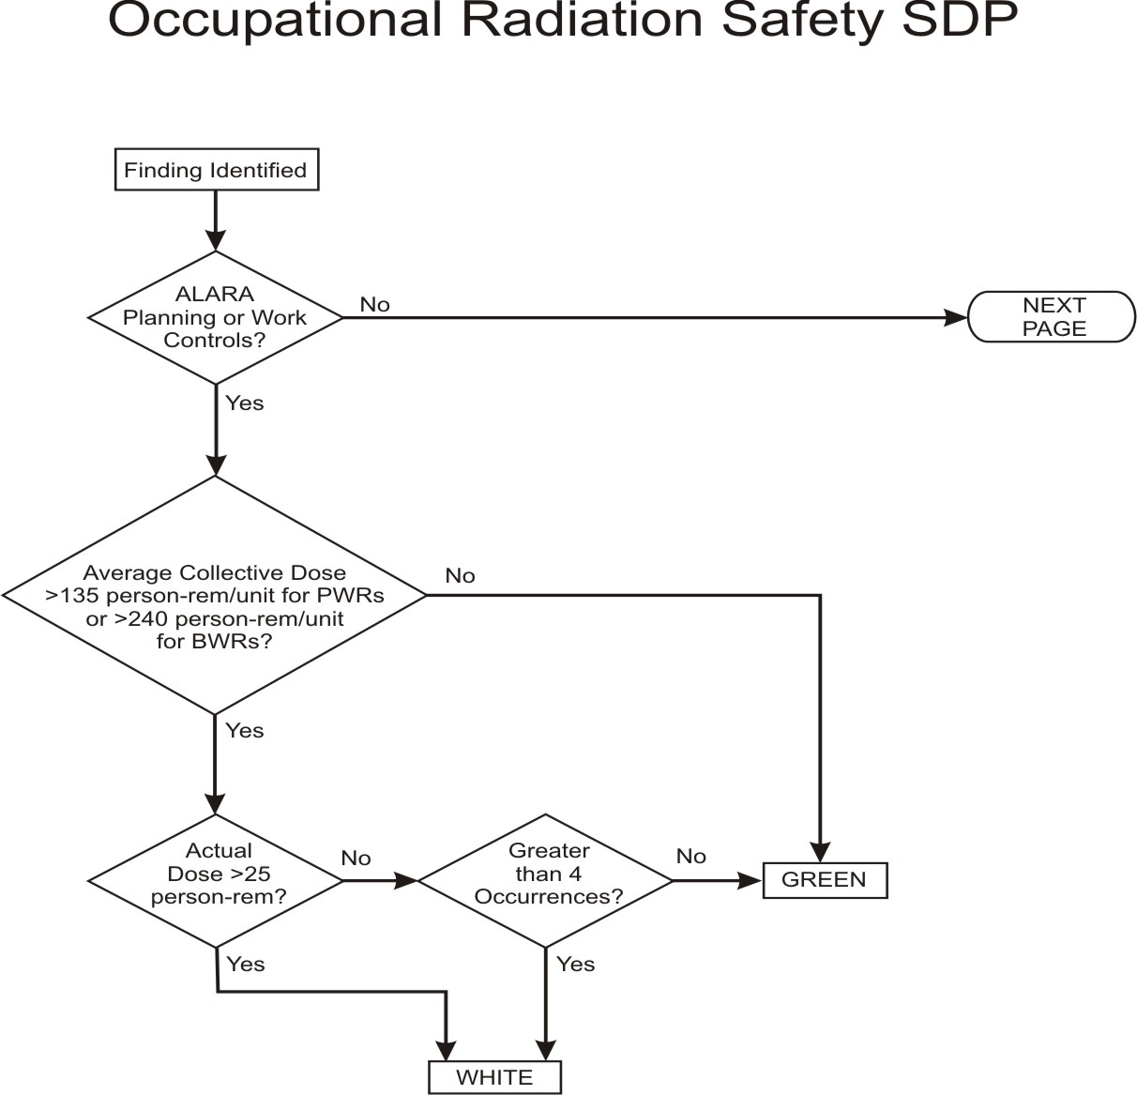

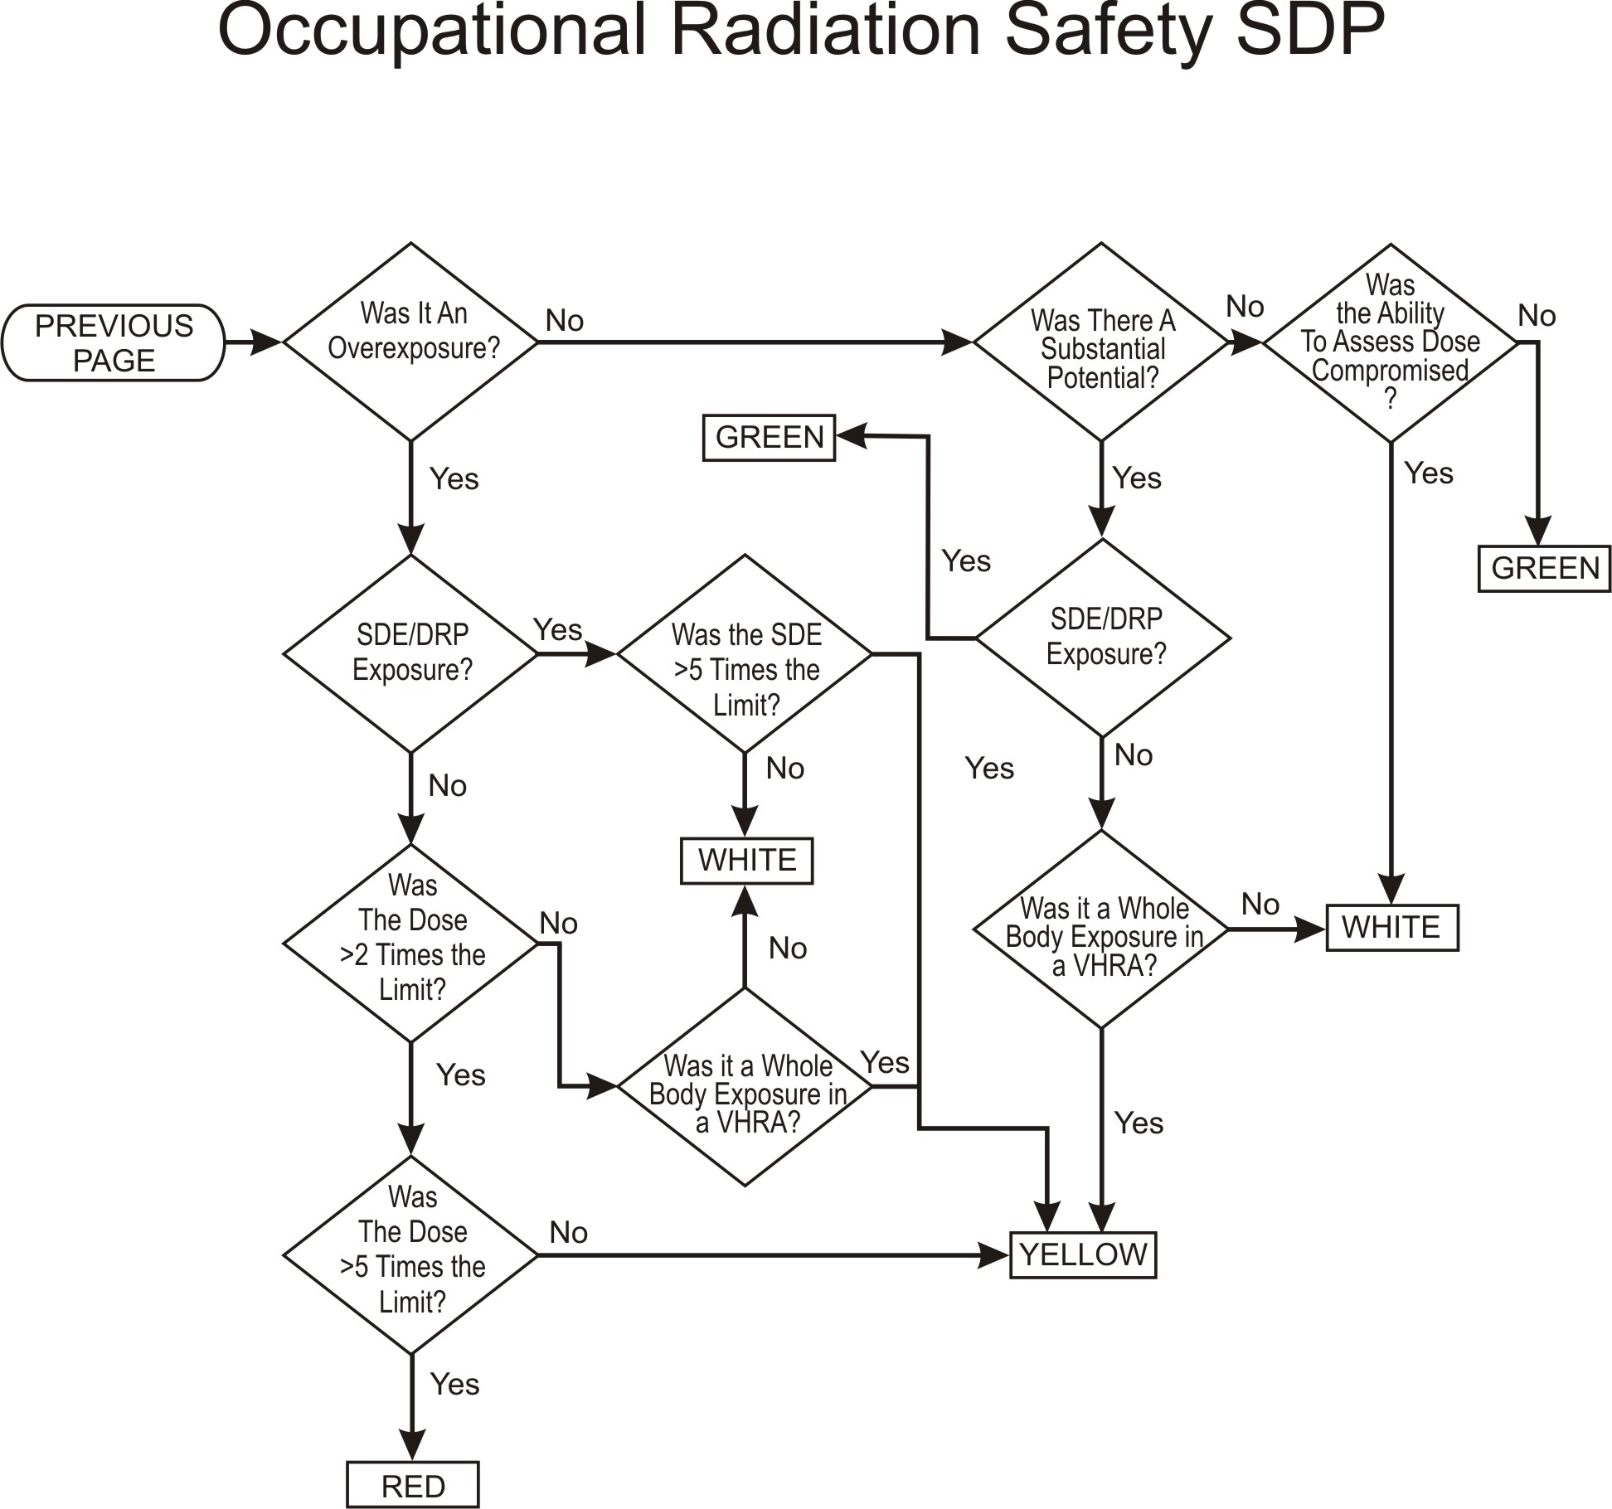
Revision History Page

Commitment  Tracking  Number | Issue  Date | Description of Change | Training Needed | Training  Completion  Date | Comment Resolution  Accession Number
n/a | 12/16/2003 | Added definition and criteria for determining when a licensee has a compromised ability to assess dose | none | n/a | n/a
0609C-1192  0609C-1064 | 08/19/08  CN 08-024 | Revised definition of a substantial potential for overexposure; revised text to match flow diagram; revised text and flow diagram to bring SDP outcomes more in line with Enforcement Policy Supplements | none | n/a | ML081930830

