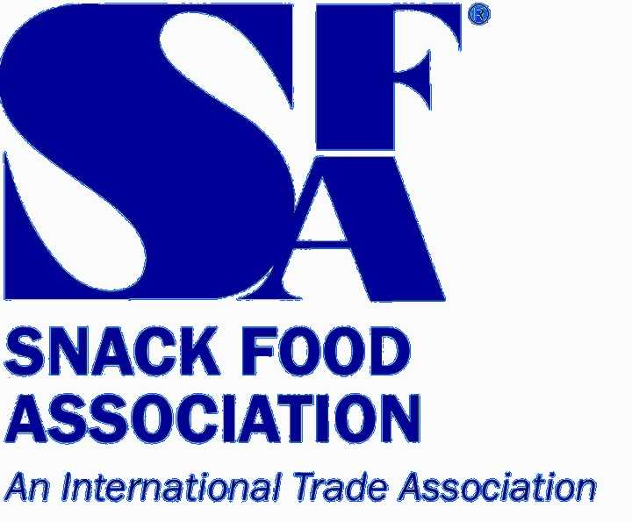
February 11, 2003

VIA EMAIL (www.fda.gov/dockets/ecomments)

Dockets Management Branch
HFA-305
Food and Drug Administration
5630 Fishers Lane, Room 1061
Rockville, MD 20852

RE: Docket No. 02D-0324. Guidance for Industry: Drugs, Biologics, and Medical Devices Derived from Bioengineered Plants for Use in Humans and Animals 67 Federal Register 57828, September 12, 2002

Dear Sir or Madam:

The Snack Food Association (SFA) is an international trade association representing snack food manufacturers and suppliers. SFA business membership includes, but is not limited to, manufacturers of potato chips, tortilla chips, crackers, corn chips, pretzels, popcorn, extruded snacks, meat snacks, pork rinds, snack nuts, party mix, fruit snacks, cereal snacks, snack bars, and various other snacks. Retail sales of snack foods in the U.S. total more than $30 billion annually.

SFA appreciates the opportunity to respond to the request for comments on the “Guidance for Industry: Drugs, Biologics, and Medical Devices Derived From Bioengineered Plants for Use in Humans and Animals” drafted by the U.S. Food and Drug Administration (FDA) in collaboration with the U.S. Department of Agriculture (USDA). The snack food industry is highly concerned with the adulteration risks to the food supply associated with production of plant made pharmaceuticals. For the purpose of these comments, the term “plant made pharmaceuticals (PMPs)” is used to represent PMPs themselves, as well as industrial chemicals and other products not intended to be included in the general food supply or food products.

SFA recognizes that modern biotechnology holds great promise and potential value for American consumers. Under the right circumstances, the use of modern biotechnology to produce pharmaceutical and other materials in plants and animals may benefit public health and be economically desirable. SFA is of the opinion, however, that PMPs should not be produced in

FDA Docket No. 02D-0324
Page 2

food crops because the risk of adulteration through cross-contamination is too great under the current regulatory system.

The StarLink™ episode is instructive. In September 2000, StarLink™ corn, a genetically engineered corn approved only for animal feed, not human food use, was inadvertently introduced into a limited number of food distribution channels. A number of food products with corn or corn-derived ingredients were subject to nation-wide recalls because a tolerance had not been set for StarLink™ in human food. A class-action lawsuit against numerous manufacturers on behalf of consumers was filed and subsequently settled in March 2002.

Although the central concern of StarLink™ was the potential introduction of an unapproved ingredient, PMP contamination presents a much greater potential risk to food ingredients because it involves pharmacologically active materials. Inadvertent (or intentional) PMP adulteration could lead to the presence of an actual drug substance in the food ingredient. SFA members believe that PMP contamination poses a far greater potential risk to consumers and manufacturers alike than the StarLink™ episode.

Use of corn for PMPs is especially problematic. Corn is well understood genetically and biologically, which enhances its desirability for many PMP products. However, corn, a major ingredient in snack products, is one of the largest crops in the U.S. This alone multiplies the risk of using it for production of PMPs. Further, corn is a crop that outcrosses significantly. Corn pollen can flow from one plant to another and one field to the next.

The very real risk of PMP cross-contamination exposes the food industry to regulatory and civil liability that no industry segment is in a position to prevent. The food industry plays no role in the production of PMPs, does not stand to benefit from the PMP technology, and is in no position to prevent the entry of PMPs into the food supply. Any incidents of cross-contamination, however, inevitably will result in legal actions brought against multiple food industry segments, exposing the industry to claims of consumer injury and economic losses. Such claims may be wholly without merit, but even baseless claims or claims for which indemnity may be sought cause industry to incur substantial costs.

For these reasons, SFA believes a prohibition on the use of food crops to produce PMPs deserves serious consideration. In the absence of a prohibition, FDA and USDA must establish regulatory controls that are designed to assure appropriate, thorough protection from PMP contamination of the food supply. These controls must be part of a comprehensive and mandatory system that addresses all aspects of PMP production, including permitting, production, distribution, and use of PMP materials. Anything less will jeopardize consumer confidence in the integrity of the food supply and may threaten trade in food products.

In light of the serious risks posed by the use of food crops to produce PMPs, the agencies are also encouraged to pursue with Congress additional liability provisions or measures to protect food producers experiencing loss from contamination of the food supply by PMP materials.

FDA Docket No. 02D-0324
Page 3

Without such provisions, food manufacturers may suffer unnecessary and unjust exposure to liability and regulatory risks. Even if Congress were to approve generous liability protections, no amount of restitution will compensate the injured party for loss of future sales, especially for the $10 billion segment of the snack market that is corn-based.

We understand that the guidance document is not intended to address all issues associated with PMPs. The document, however, presents an opportunity to provide guidance and policy direction, especially in terms of potential adulteration of the U.S. food supply. We appreciate the opportunity to comment and are committed to working with all government agencies to protect the food supply from adulteration.

If you have any questions, please do not hesitate to contact us.

Regards,

James A. McCarthy
President & CEO

