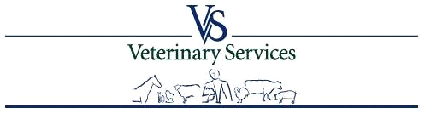

Veterinary Services Process Streamlining (VSPS)
Privacy Impact Assessment

Final

November 2, 2005

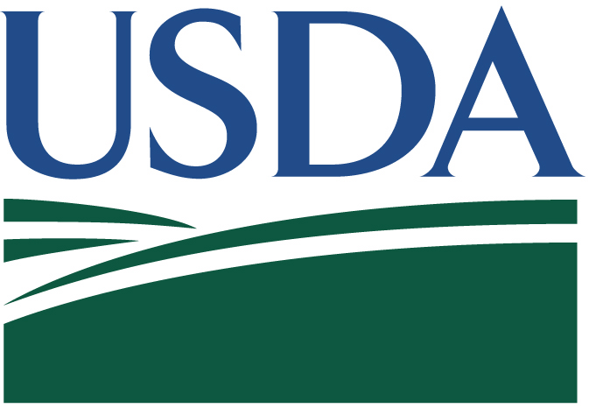

Change Control Log
Version | Date | Section | Description of Change | Responsible Individual(s)
4.0 | 11/02/2005 |  | Updates based on ST&E report. | Butch Lorton/Gabrielle Gaither/Violeta Zorrilla

Table of Contents
1. Overview 1
2. System Information 2
2.1 System Name/Title 2
2.2 Responsible Organization 2
2.3 Information Contact(s) 2
2.4 Security Contact(s) 2
2.5 System Operational Status 3
2.6 General Description/Purpose 3
2.7 Applicable Laws and Regulations 4
3. PRIVACY IMPACT ASSESSMENT 6
3.1 Data in the System 6
3.2 Access to the Data 7
3.3 Attributes of the Data 15
3.4 Maintenance of Administrative Controls 17

- Overview
Among the most basic of customer and employee rights is an expectation that the confidentiality of personal, financial, and employment information will be protected. The collection, maintenance, use, and dissemination of identifiable personal information and data about a customer or employee will be limited as authorized by law and as necessary to carry out agency responsibilities. Customer and employee information is protected by the following:
- Privacy Act of 1974, as Amended (5 USC 552a), which affords individuals the right to privacy in records that are maintained and used by Federal agencies. Note that 5 USC 552a includes the Computer Matching and Privacy Act of 1988 (Public Law 100-503).
- Computer Security Act of 1987 (Public Law 100-235), which establishes minimum security practices for Federal computer systems.
- OMB Circular A-130, management of Federal Information Resources, which provides instructions to Federal agencies on how to comply with the fair information, practices and security requirements for operating automated information systems.
- Freedom of Information Act, as Amended (5 USC 552), which provides for the disclosure of information maintained by Federal agencies to the public while allowing limited protections for privacy.
Per guidance from the Office of the Chief Information Officer, a Privacy Impact Assessment (PIA) is required on all systems developed by USDA to ensure the privacy, confidentiality, integrity, and availability of customer and employee information. The following issues are addressed, with respect to privacy, to protect customer and employee data:
- The use of information must be controlled.
- Information may be used only for a necessary and lawful purpose.
- Individuals must be informed in writing of the principal purpose and routine uses of the information being collected from them.
- Information collected for a particular purpose should not be used for another purpose without the data subject’s consent unless such other uses are specifically authorized or mandated by law.
- Any information used must be sufficiently accurate, relevant, timely, and complete to assure fair treatment of the individual.

- System Information
The following provides general information to support the Privacy Impact Assessment. Refer to the Veterinary Services Process Streamlining (VSPS) System Requirements Specification (SRS), dated March 30, 2005 for detailed information about the system purpose, capabilities, data processing, and data flow. Refer to the Veterinary Services Process Streamlining (VSPS) High-Level System Architecture Design, dated March 30, 2005 for detailed information about the system design and system architecture.
  - System Name/Title
OMB Identifier: 005-32-01-61-01-9011-00-110-132
System Name: Veterinary Services Process Streamlining (VSPS) System
  - Responsible Organization
Animal and Plant Health Inspection Services (APHIS)
Veterinary Services (VS)
Centers for Epidemiology and Animal Health (CEAH)
  - Information Contact(s)
Name: Timothy G. O'Neill
Title: Animal Industry Program Analyst, USDA
Address: Animal & Plant Health Inspection Service
Centers for Epidemiology & Animal Health
2150 Centre Ave, Bldg B, MS 2W4
Fort Collins, CO 80526-8117
Phone: voice: 970-494-7290; fax: 970-494-7294
E-mail: tim.g.oneill@aphis.usda.gov
Name: John M. Damare
Title: Data Manager
Address: USDA:APHIS:Veterinary Services
Plant Health Programs
4700 River Rd, Unit 144
Riverdale, MD 20737
Phone: (301) 734-3579
E-mail: john.m.damare@aphis.usda.gov
  - Security Contact(s)
Name: Timothy G. O'Neill
Title: Animal Industry Program Analyst, USDA
Address: Animal & Plant Health Inspection Service
Centers for Epidemiology & Animal Health
2150 Centre Ave, Bldg B, MS 2W4
Fort Collins, CO 80526-8117
Phone: voice: 970-494-7290; fax: 970-494-7294
E-Mail: tim.g.oneill@aphis.usda.gov
  - System Operational Status
The VSPS system is being developed using a Rapid Application Development (RAD) approach with phased releases of modules and functionality. Modules are rolled-out for user testing and acceptance as they are completed. Refer to the Veterinary Services Process Streamlining (VSPS) Major Application Security Plan, dated March 30, 2005 for detailed information about the current system operational status.
  - General Description/Purpose
VSPS currently consists of six major subsystems, as illustrated in Figure 1-1. The Core component provides user maintenance and system administration functions. The other five components represent the mission areas that contain the primary functions required to capture the information needed to track animal movement into, out of, and within the United States. Each mission area component includes forms that must be automated into a cohesive system so that information can be captured in a timely and accurate manner.

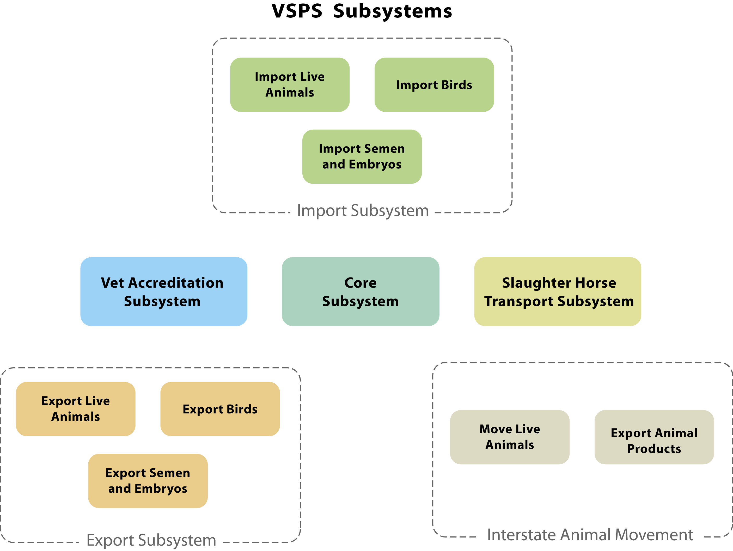
Figure 1-1 Subsystems in the VSPS Application
The mission areas of the application are described in detail in the following paragraphs. These are the modules that will be included in the Certification and Accreditation activities in April 2005.
Veterinary Accreditation: VS relies upon accredited veterinarians to attest to the health of animals being exported to foreign countries or being moved between states, to prevent the introduction of new diseases in other countries or states. A veterinarian must be accredited in each state in which he or she performs federal work. The Veterinary Accreditation module will automate submission of the accreditation application; streamline the approval process through the electronic distribution of information, and record actions taken against accredited veterinarians.
Animal Import: All animals entering the United States must go through an Import Process. There are several routes of entry depending on the purpose of entry (i.e. direct consumption, grazing, pet ownership, temporary admission). The Animal Import module will automate the collection of information and submission of requests by importers for numerous permit forms. This module also supports on-line VS approval of requested permits and processing the arrival and release of animals associated with a permit.
Animal Export: All animals leaving the U.S. are required to go through an Export Process. Each animal must be inspected by an accredited veterinarian and will be subject to the import regulations of the target country of entry. The Animal Export module will automate the way accredited veterinarians gather animal health information, including laboratory test results and VS processing of the final health certificates and final inspection.
Interstate Animal Movement: All animals being moved from state to state are required to go through an Interstate Movement Certification Process. Each animal must be inspected by an accredited veterinarian and will be subject to the target state’s entry regulations. The Interstate Animal Movement module will automate the way accredited veterinarians gather animal health information, including laboratory test results and processing of the final health certificate required for entry into the target state. This module also provides a mechanism for the on-line issuance of permits by the state for requested interstate movements.
Slaughter Horse Transport: Horses that are intended for slaughter (due to behavior problems, old age, blindness, lameness, etc.) are generally sold at auction to private shipping companies that transport the horses, often over long distances, to one of a few slaughter plants licensed to slaughter horses. The Slaughter Horse Transport Program regulates the commercial transport of horses from auction sites to slaughter facilities to ensure the safe and humane treatment of the horses throughout this transfer process. The USDA was directed to establish this regulatory program as a provision of the Federal Agriculture Improvement and Reform Act of 1996, which was included on the 1996 Farm Bill. The Slaughter Horse Transport module provides the means for the data entry of completed VS Form 10-13 forms. These forms are filled out by hand by the Shipper/Owner during the shipment process and are passed to the slaughter facility upon delivery of the horses. The slaughter facilities send the completed paper forms to VS, where the information is entered into the system. The other function provided is to provide a variety of reports for analyzing the inputted data.
  - Applicable Laws and Regulations
- Freedom of Information Act, as Amended, 5 U.S.C. 552
- Privacy Act, as Amended, 5 U.S.C. 552a
- Children’s Online Privacy Protection Act of 1998
- Paperwork Reduction Act of 1995 (P.L. 104-13)
- Computer Fraud and Abuse Act of 1984
- Title VII of the Civil Rights Act of 1964
- Office of Management and Budget Memoranda M-99-18 dated June 2, 1998
- Office of Management and Budget Memoranda M-00-13 dated June 22, 2000
- Office of Management and Budget Circular A-130, Appendix III
- OCIO memorandum, Use of Cookies on Web Pages
- DR 3410-1, Information Collection Activities
- DR 3080-1, Records Disposition
- PRIVACY IMPACT ASSESSMENT
The Privacy Impact Assessment is used to evaluate privacy in the VSPS system. The process is designed to guide system owners and developers in assessing privacy through the early stages of development. The process consists of privacy training, gathering data from a project on privacy issues, identifying and resolving the privacy risks, and approval by the Privacy Policy Analyst in the Office of the Chief Information Officer.
  - Data in the System
1. Generally describe the information to be used in the system in each of the following categories: Customer, Employee, and Other.
The VSPS system collects information from veterinarians that apply on-line to become federally accredited, from importer that are requesting a permit to import animals, and from accredited veterinarians that are submitting health certificates for the export and interstate movement of animals. VS personnel processes and approve applications for federal accreditation, document actions taken against accredited veterinarians, process permit requests and issue import permits, maintain the animal import rules, process export health certificates, and maintain the export protocols. State personnel issue permits for interstate movement requests and maintain the state protocols. The table in Appendix B identifies twenty aggregate data types for the VSPS system.
2a. What are the sources of the information in the system?
The primary sources of information collected and stored in the VSPS system are data entered by importers for import permit requests and accredited veterinarians for accreditation applications, export health certificates, and interstate movement health certificates. The table in Appendix B identifies the twenty aggregate data types for the VSPS system.
2b. What USDA files and databases are used? What is the source agency?
The USDA Premises Allocator database is accessed by the VSPS system via published APIs to obtain the Premises ID for Origin and Destination locations. For import permit requests, the Premises ID is obtained for the final destination location. For export health certificates, the Premises ID is obtained for the origin location. For interstate movement health certificates, the Premises ID is obtained for both the origin and destination location.
The USDA eAuthentication system is accessed when users log on to the VSPS system to verify the user is authorized to access the system. The relationship between the user’s eAuthentication account and the VSPS user account are maintained in the VSPS database.
2c. What Federal Agencies are providing data for use in the system?
The VSPS system has established an interface with the Department of Treasury’s pay.Gov system to facilitate the collection of user fees via on-line credit card payments. Currently, the VSPS system supports the collection of user fees for import permits and export health certificates. All information required to process the credit card transaction are managed by the pay.Gov application. The only pay.Gov information retained in the VSPS database is the pay.Gov transaction identifier, which is associated with a VSPS identifier to allow tracking of payments to specific import or export requests.
2d. What State and Local Agencies are providing data for use in the system?
The State Agencies supported by the VSPS system consist of State Animal Health Officials (SAHO) in each state, who participate in the Veterinary Accreditation process and manage the interstate movements of animals. The interstate movement protocols, which define the requirements that must be satisfied prior to animals entering the state, are managed and maintained in the VSPS system by the SAHO for their respective state. These protocols are applied when Accredited Veterinarians create interstate movement requests.
2e. From what other third party sources will data be collected?

There are no third party sources providing data to the VSPS system.
2f. What information will be collected from the customer/employee?
The Accredited Veterinarians provide personal and professional information to apply on-line to become federally accredited. Importers provide address and contact information for the consignee, consigner, shipper, and destination for permits to import animals along with detailed animal information. The Accredited Veterinarians provide address and contact information for the consignee, consigner, shipper, and origin for health certificates to export animals along with detailed animal information. The Accredited Veterinarians provide address and contact information for the consignee, consigner, shipper, destination, and origin for interstate movement health certificates along with detailed animal information. VS personnel provide information needed to complete the processing and approval of applications for federal accreditation. In addition, VS personnel provide information on actions taken against accredited veterinarians.
3a. How will data collected from sources other than the USDA records and the customer be verified for accuracy?
All data collected and stored in the VSPS system is provided by either a customer (importer, SAHO, and Accredited Veterinarian) or VS personnel.
3b. How will data be checked for completeness?
Extensive edits are employed in the VSPS system when data is entered by importers, SAHO, VS personnel, and accredited veterinarians to ensure completeness and accuracy of data.
  - Access to the Data
1. Who will have access to the data in the system (Users, Managers, System Administrators, Developers, Other)?
The VSPS system supports 13 different types of users, in two user categories. The categories are
- VS users, who are Federal Government employees working within Veterinary Services
- Non-VS users, which include non-Government employees, such as veterinarians, importers, and laboratory technicians.
The user roles defined to the application, the category into which the role falls, and the permissions granted to each, are shown in the following table:

Role Name | Permissions Available
Public (Non-VS User) | Anonymous access to look up Accredited Veterinarians in their area either by zip code or state. Does not involve logging on to the VSPS system.
National – View Only (VS User)  (this role is for VS staff using the application for data analysis) | - Create and update on-line notices for distributing information to VSPS users.  - View all Veterinary Accreditation data at a national level (all states).  - View all Import data at a national level (all states).  - View all Export data at a national level (all states).  - View the state protocols (regulations and policies) at a national level (all states).  - View all interstate movements at a national level (all states).  - View all slaughter horse transport certificates at a national level (all states).
National – Full Access (VS User)  (this role is used by staff members in VS Headquarters in Riverdale, MD) | - Create and update on-line notices for distributing information to VSPS users.  - View all Veterinary Accreditation data at a national level (all states).  - View and process all Import data at a national level (all states).  - View and process all Export data at a national level (all states).  - Manage and maintain the export regulation and policies.  - View the state protocols (regulations and policies) at a national level (all states).  - View all interstate movements at a national level (all states).  - View all slaughter horse transport certificates at a national level (all states).
AVIC Office (VS User)  (this role is available to personnel in the state AVIC offices) | - Create and update on-line notices for distributing information to VSPS users.  - View and edit the Veterinary Accreditation data for veterinarians within their state.  - Update the accreditation status of any Accredited Veterinarian within their state.  - Add an Accredited Veterinarian.  - Maintain the AVIC office information for their state.  - View Veterinary Accreditation data for veterinarians outside their state.  - View all import information where the destination address is within their state.  - View and process export requests where the origin address is within their state.  - View all interstate movements where the destination or origin address is within their state.  - View the state protocols (regulations and policies) for animal entry into their state.  - View all slaughter horse transport certificates where the destination or origin address is within their state.
Port Officer (VS User)  (this role is used by officers at the port locations where animals are imported or exported) | - Create and update on-line notices for distributing information to VSPS users.  - View all Veterinary Accreditation data for veterinarians within and outside their state.  - View and process import requests where the final processing port is their assigned port.  - View and process export requests where the origin address is within their state.  - View all interstate movements where the destination or origin address is within their state.  - View the state protocols (regulations and policies) for animal entry into their state.  - View all slaughter horse transport certificates where the destination or origin address is within their state.
Importer (Non-VS User)  (this role is available to importers and their agents or brokers) | - Maintain a personal address book of frequently used addresses.  - Enter animal information and submit requests for import permits.  - Update permit information and request an amended permit.  - View the data and status of permit requests that were submitted by the user.
Accredited Laboratory (Non-VS User)  (this role is available to technicians working in an accredited laboratory) | - View the status of testing requests that were sent to their laboratory.  - Enter test result for testing requests that were sent to their laboratory.
National – Slaughter Horse (VS User)  (this role is used by VS staff members who process certificates associated with the Humane Horse Transfer Program) | - Create and update on-line notices for distributing information to VSPS users.  - Create and update Owner/Shipper Certificates information.  - View all slaughter horse transport certificates at a national level (all states).
Accredited Veterinarian (Non-VS User)  (this role is used for veterinarians who apply for accredited status and also for currently accredited veterinarians) | - Maintain a personal address book of frequently used addresses.  - Apply online for Federal Accreditation in an initial or additional state.  - View the status of their application in the accreditation approval process.  - View their accreditation information (with the exception of Actions) and edit selected accreditation profile information.  - View the export protocols (regulations and policies) for animal being sent to a foreign country.  - Initiate Export Health Certificates and submit them for VS processing.  - View the state protocols (regulations and policies) for animal being sent to another state.  - Initiate and produce Interstate Movement Health Certificates.  - Import animal information from a 3rd party Veterinary Practice product into a health certificate.  - Import addresses into their personal address book.
Accredited Veterinary Assistant (Non-VS User) | - Maintain a personal address book of frequently used addresses.  - View the export protocols (regulations and policies) for animal being sent to a foreign country.  - Initiate Export Health Certificates and submit them for approval by the Accredited Veterinarian.  - View the state protocols (regulations and policies) for animal being sent to another state.  - Initiate Interstate Movement Health Certificates and submit them for approval by the Accredited Veterinarian.  - Import animal information from a 3rd party Veterinary Practice product into a health certificate.  - Import addresses into their personal address book.
Veterinary Accreditation (VS User)  (this role is for staff members at VS Headquarters in Riverdale, MD, who process applications from veterinarians for accreditation in the VS program) | - Create and update on-line notices for distributing information to VSPS users.  - View all Veterinary Accreditation data at a national level (all states).  - Update the accreditation status of any Accredited Veterinarian.  - Add an Accredited Veterinarian.  - View all Import data at a national level (all states).  - View all Export data at a national level (all states).  - View the state protocols (regulations and policies) at a national level (all states).  - View all interstate movements at a national level (all states).  - View all slaughter horse transport certificates at a national level (all states).
State Veterinarian (Non-VS User)  (this role is used by individuals in the various states who monitor interstate animal movements and who track the accredited veterinarians within the state) | - View the status of veterinarians applying for federal accreditation within their state.  - View Veterinary Accreditation data for veterinarians within and outside their state.  - View all import information where the destination address is within their state.  - View all interstate movements where the destination or origin address is within their state.  - Maintain the state protocols (regulations and policies) for animal entry into their state.  - Manage the issuance of permits for the interstate movement of animals into their state.  - View all slaughter horse transport certificates where the destination or origin address is within their state.
System Administrator (VS User) | - Has access to everything that is available to any of the VS user roles.  - Maintains the user account information.  - Reviews and approves roles for new user accounts.  - Maintains all reference data and system configuration settings.
When a new user applies for a logon ID and password on the VSPS system, the request is forwarded to the USDA eAuthentication system. The USDA eAuthentication system provides two levels of user access: Level 1 provides limited access to USDA applications and can be requested online; Level 2 provides access to all USDA portals and requires the potential user to apply in person, bringing proof of identity. The decision was made to grant only Level 1 access rights to anyone applying for an ID on the VSPS system. Details of the eAuthentication process are available at http://www.eauth.egov.usda.gov/ .
The eAuthentication system will respond to an online request with an ID and password, but the new user must also request a specific role within the application. VSPS will collect user profile information along with the role, practice state, port, etc. Roles are assigned by the VSPS system administrator, commensurate with the tasks that the new user needs to perform.
Once a user has obtained access to the VSPS system via the USDA eAuthentication system, the transactions associated with the user’s role and permissions are made available.
2. How is access to the data by a user determined? Are criteria, procedures, controls, and responsibilities regarding access documented?
Access to the data within the VSPS system is controlled through the use of role based access permissions and internal business logic. Appendix D identifies the system functions (use cases) that will be available for each role. Appendix E identifies the aggregate data types that are associated with each use case with the associated CRUD permissions.

In addition, users logged in with a role Importer and Accredited Veterinarian will only be able to access data that was created under their user ID and will not be able to access data created by other users. User logged in with a role of State Veterinarian will have minimal update capabilities for data that is associated with their state and read only access for all other states. The AVIC Office role will be able to update data associated with their assigned state and will have read only access to data associated with other states. The Port Officer role will have access to only the data that is associated with the port to which they are assigned. The Vet Accreditation HQ role will have full access to the data for all states that is associated with veterinary accreditation. The National – Full Access role will have full access to the data for all states and ports that is associated with imports and exports. The National – View Only role will have read only access to the data for all states and ports that is associated with imports and exports. The System Administrator will have full access to all data contained in the system.
3. Will users have access to all data on the system or will the user’s access be restricted? Explain.
See response to question #2 above.
4. What controls are in place to prevent the misuse (e.g. browsing, unauthorized use) of data by those having access?
See response to question #2 above.
5a. Do other systems share data or have access to data in this system? If yes, explain.
As shown in Appendix B, there are currently 9 interfaces with the VSPS system. The following provides a brief description of each interface:
- Import Tracking System: This interface will provide ITS with permit, arrival, and release data for live animals, birds, semen, and embryos that is captured by the VSPS system during the processing of import requests. A staging area database will be used to manage the exchange of data between the systems.
- Export Health Certificate System: This interface will provide EHCS with animal, testing, and departure data for live animals, birds, semen, and embryos that is captured by the VSPS system during the processing of export health certificates. A staging area will be used to manage the exchange of data between systems.
- User Fee 2000 System: This interface will provide UFS 2000 with payment data that is captured by the VSPS system when payments are made on-line for import permits and export health certificates. A staging area will be used to manage the exchange of data between systems.
- Pay.Gov: This interface will provide real-time processing of credit card transactions using the existing pay.Gov site. When the user reaches the point in the processing of import requests or export requests that payments can be collected, pay.Gov web pages collect the credit card, name, and address information. All interaction with banks and clearing houses to process the payment is managed by pay.Gov and the VSPS system waits for the processes to be completed. When pay.Gov completes the processing of the credit card payment (either approved or declined), the results and tracking number are returned to the VSPS system.
- Premises Allocator: This interface provides a real-time exchange of information to obtain the unique premises identifier assigned to a location that is involved in animal agriculture from the Premises Allocator, which is part of the National Animal Identification System (NAIS). For origin and destination addresses that are used in imports, interstate movements, and exports, a premises identifier is obtained to support animal tracking.
- eAuthentication: This interface provides a real-time exchange of information to support authentication via the eAuthentication service. When the user chooses to log in from the VSPS home page, eAuthentication web pages collect the user name and password information. The user’s eAuthentication account is accessed to verify access rights for the VSPS system. When eAuthentication completes the processing and the user is authenticated, control is returned back to VSPS and the can select a desired role from the VSPS page.
- Movement Activity File: This interface provides animal movement activity files for animals that are imported, exported, or moved between states using the standard format defined in the USAIP Working Plan. Movement activity for imports is reported when the animals associated with the permit are released. Movement activity for exports is reported when the animals associated with the export health certificate are shipped. Movement activity for interstate movements is reported when the animals associated with the interstate health certificate is issued. The file will be sent to an NAIS designated FTP site.
- Vet Practice Product: This interface provides a mechanism for importing animal information into an interstate health certificate from a XML file. The 3rd party products will export data into either a delimited or XML file that will be accessible to the workstation running the VSPS web application. The format of the data contained in the file will be in accordance with a standardize format defined by VSPS.
- Personal Address Book: This interface provides a mechanism for importing personal address book information into a user VSPS address book using a delimited or XML file. The 3rd party address book products will export data into either a XML file that will be accessible to the workstation running the VSPS web application. The format of the data contained in the file will be in accordance with a standardize format defined by VSPS.
5b. Who will be responsible for protecting the privacy rights of the customers and employees affected by the interface.
The Security Contact listed in paragraph 2.4 above.
6a. Will other agencies share data or have access to data in this system (International, Federal, State, Local, Other)?
The State Animal Health Officials in each state will have user accounts that allow then to view the data contained in the VSPS system. Access to the data will be limited to information that pertains to their assigned state. At this point, no other Federal or International agencies have been identified as requiring access to the data contained in VSPS.
6b. How will the data be used by the agency?
The data will be used to support Veterinary Accreditation, Import of Animals, Export of Animals, Interstate Movement of Animals, and Slaughter Horse Transport, all of which are cover under the Code of Federal Regulations (CFR) 9 Animals and Animal Products. The data collected within VSPS will also be used for research, investigative and litigation support, comparative and risk analysis.
6c. Who is responsible for assuring proper use of the data?
The Security Contact listed in paragraph 2.4 above.
  - Attributes of the Data
1. Is the use of the data both relevant and necessary to the purpose for which the system is being designed?
Yes – all data collected is directly related and used in the generation of permits, health certificates, and VS applications.
2a. Will the system derive new data or create previously unavailable data about an individual through aggregation from the information collected?
No – VSPS does not aggregate or derive data based on information collected. All data that is collected within VSPS is used in the originally entered form.
2b. Will the new data be placed in the individual’s record (customer or employee)?
Not applicable – VSPS does not derive any new data.
2c. Can the system make determinations about customers or employees that would not be possible without the new data?
Not applicable – VSPS does not derive any new data.
2d. How will the new data be verified for relevance and accuracy?
Not applicable – VSPS does not derive any new data.
3a. If data is being consolidated, what controls are in place to protect the data from unauthorized access or use?
The VSPS application will be host in the USDA Fort Collins data center which is a secure environment protected by the appropriate firewalls and IT infrastructure, application controls, and internal controls.
3b. If processes are being consolidated, are the proper controls remaining in place to protect the data and prevent unauthorized access? Explain.
The VSPS application will automate and streamline the processes associated with the import of live animals, export of live animals, veterinary accreditation, interstate movement, and slaughter horse transport. Two levels of access protections are being provided in the VSPS design. The first level will control access to the VSPS system through the use of eAuthentication so only user with valid eAuthentication accounts will be able to access the system. The second level of access control will be provided by the VSPS system through the use of role based access permissions. The users will be granted access to the system functions and data directly related to a role that must be approve by a system administrator when the VSPS user account is created.
4a. How will the data be retrieved? Can it be retrieved by personal identifier? If yes, explain.
Access to the data within the VSPS system is controlled through the use of role based access permissions and internal business logic. Appendix D identifies the system functions (use cases) that will be available for each role. Appendix E identifies the aggregate data types that are associated with each use case with the associated CRUD permissions.
In addition, users logged in with a role Importer and Accredited Veterinarian will only be able to access data that was created under their user ID and will not be able to access data created by other users. User logged in with a role of State Veterinarian will have minimal update capabilities for data that is associated with their state and read only access for all other states. The AVIC Office role will be able to update data associated with their assigned state and will have read only access to data associated with other states. The Port Officer role will have access to only the data that is associated with the port to which they are assigned. The Vet Accreditation HQ role will have full access to the data for all states that is associated with veterinary accreditation. The National – Full Access role will have full access to the data for all states and ports that is associated with imports and exports. The National – View Only role will have read only access to the data for all states and ports that is associated with imports and exports. The System Administrator will have full access to all data contained in the system.
4b. What are the potential effects on the due process rights of customers and employees of:
- Consolidation and linkage of files and systems
- Derivation of data
- Accelerated information processing and decision making
- Use of new technologies
The due process rights of the users will not be impacted by the system. The system automates current manual paper processes to accelerating the processing of applications, certificates, and permit requests but the same due process rules still apply. The system will prevent the submittal of unauthorized and/or incomplete application, certificate, and permit requests.
4c. How are the effects to be mitigated?
No impact so there is nothing to mitigate.
  - Maintenance of Administrative Controls
1a. Explain how the system and its use will ensure equitable treatment of customers and employees.
The system will be available via the internet on a 24X7 basis for authorized users to submit Accreditation Applications, export health certificates, and import permit requests. All users have equal access to the system and are only limited by their connection to the internet. VS personnel will be trained to process requests in the order they are received to prevent any appearance of preferential treatment.
2a. If the system is operated in more than one site, how will consistent use of the system and data be maintained in all sites?
The data collected and maintained by VSPS will be kept in a single database, which all users will access. This ensures that a single view of the data is provided to all system users.
2b. Explain any possibility of disparate treatment of individuals or groups.
VS personnel process Accreditation Applications, export health certificates, and import permits that are submitted by veterinarians and importers. These individuals could be treated unfairly if VS personnel show preferential treatment to some individuals and/or delay the processing their requests. VS personnel should process requests in the order they are received to prevent any special or preferential treatment.
2c. What are the retention periods of data in this system?
The retention period for data associated with accredited veterinarians will be forever. The retention period for data associated with the import of animals, export of animals, interstate movement, and slaughter horse transport is planned to be 7 years.
2d. What are the procedures for eliminating the data at the end of the retention period? Where are the procedures documented?
The VSPS system is still under development. The procedures for archiving and eliminating data after the retention period has expired have not been developed. These procedures will be included in the VSPS Operations and Maintenance Guide when the system goes into production.
2e. While the data is retained in the system, what are the requirements for determining if the data is still sufficiently accurate, relevant, timely, and complete to ensure fairness in making determinations?
The data associated with an accredited veterinarian is maintained by the customer (user) that provided the original information. These users have fully access to the data that pertains to them, so the accuracy of the data is controlled by the customer and owner of the data. In addition, these users will be prompted by the VSPS system to verify and update their data every 6 months to ensure the data remains current and accurate.
The data associated with imports, exports, interstate movement, and slaughter horse transport are transactional in nature. Once a request is processed to completion, which should take no longer than 90 days, the data is retained as read only and will not be changed. The timeliness, accuracy, and completeness of this data will not be an issue.
3a. Is the system using technologies in ways that the USDA has not previously employed (e.g. Caller-ID)?
All the technologies used in the VSPS system are currently being used by USDA and exist within the USDA IT infrastructure.
3b. How does the use of this technology affect customer/employee privacy?
Not Applicable
4a. Will this system provide the capability to identify, locate, and monitor individuals? If yes, explain.
The VSPS system will collect and retain address and contact information that is used on veterinary accreditation applications, import permit requests, export health certificates, interstate movement certificates, and slaughter horse transport certificates. This information is required to facilitate the processing the respective request and not used to locate and/or monitor an individual.
4b. Will this system provide the capability to identify, locate, and monitor groups of people? If yes, explain.
The VSPS System collects address and contact information for individuals and businesses. The system does not collect information on groups of people.
4c. What controls will be used to prevent unauthorized monitoring?
Access to the VSPS application via the internet will be through SSL and provide 128-bit encryption for the exchange of data between the VSPS server and user workstation. Only users with a valid e-Authentication account and approved VSPS role will be able to access the system. Access to the data in the system is controlled at the used ID so only the originator of the data is able to view and edit the data.
5a. Under which Systems of Record notice (SOR) does the system operate? Provide number and name.
- USDA/APHIS-1, Investigative and Enforcement Records Regarding Regulatory Activities,
- USDA/APHIS-2, Veterinary Services – Records of Accredited Veterinarians,
- USDA/APHIS-8, Veterinary Services – Animal Welfare,
5b. If the system is being modified, will the SOR require amendment or revision? Explain.
All existing SORs will need to be reviewed and updated to reflect changes based on VSPS processes. In addition, new SORs will be required to cover the import, export, interstate movement, and slaughter horse transport capabilities and data that captured and retained in the VSPS System.

