United States
Department of
Agriculture
Natural
Resources
Conservation
Service
Syracuse, New York
Portland, Oregon
June 2008
A Guide to the Use of the
NRCS - Oregon Rapid Watershed Assessment Tool in
New York State





A Guide to the Use of the Oregon Rapid Watershed Assessment Matrix Tool in New York State

Introduction
Rapid watershed assessments (RWA) provide initial estimates of where conservation investments would best address the concerns of landowners, conservation districts, and other community organizations and stakeholders within a watershed. These assessments help landowners and local leaders set priorities and determine the best actions to achieve their goals.
Information Included in RWAs
RWAs contain summaries of resource concerns and opportunities that are useful for a number of activities - conservation district annual and long range plans; provide a foundation for watershed, area-wide, or site-specific planning. The diagram below shows RWAs in the context of the entire NRCS planning continuum.
Figure 1
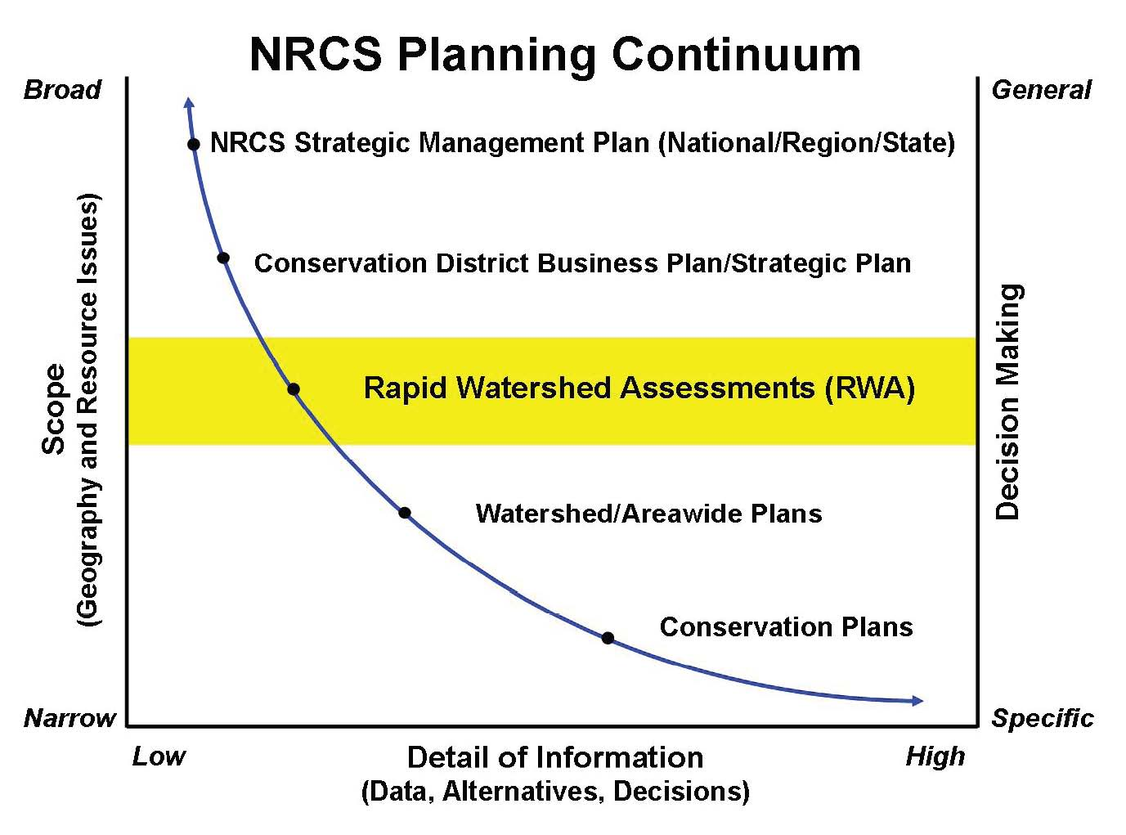
An RWA is composed of a watershed profile and an assessment composed of a series of matrices organized by land use with attendant summaries and reports.
Profile
The watershed profile compiles the best readily-available data, including:
• A general description of the location, size, and political units associated with the watershed.
• Physical description including land use/land cover, precipitation/climate, common resource areas, land capability class, etc.
• Known resource concerns.
• Census and social data.
- Status and history of resource conservation in the watershed.
- References and data sources.
Assessment
The Assessment is a series of matrices based upon land use that summarizes the current resource natural resource (soil, water, air, plant, animals and certain human\social aspects) conditions and related maintenance costs. It also encapsulates desired resource conditions, conservation opportunities and related installation and maintenance costs, qualitative effects on primary resource concerns, and potential funding sources for conservation implementation.
The Assessment contains:
• Current Conditions Table—detailing the current level of conservation in the watershed.
• Future Conditions Table—identifying appropriate suites of conservation practices needed to deal with the primary resource concerns for each major land use.
- Summary Table—summarizing the various costs associated with the Resource Management Systems developed in the previous step.
Benefits
RWAs provide sufficient information to help facilitate the making of some key decisions. RWAs can:
• Provide a quick and inexpensive source of information on which to discuss conservation priorities, allocation of resources, funding for implementation, and how to report outcomes/results.
• Provide enough detail to identify conservation activities that can be taken without waiting on further watershed-level studies or analyses.
• Provide a preliminary source of information for standard environmental evaluations.
• Determine if there is a need for further detailed analysis or watershed studies.
• Identify if there are infrastructure needs.
• Address multiple concerns and objectives of landowners and communities.
• Enhance established local and state partnerships.
• Enable landowners and communities to decide on the best mix of NRCS programs and other funding sources to meet their resource concerns.
• Evaluate availability of conservation program tools (cost share, easements, technical assistance).

Building on RWAs
RWAs address the first six steps of the NRCS planning process on a broad scale. The information is general in nature and is not sufficiently detailed to be used in lieu of an area-wide or watershed plan.

However, the information will proved a solid starting point for local stakeholders to use should they decide to proceed with a more detailed watershed assessment, area-wide or watershed planning effort.

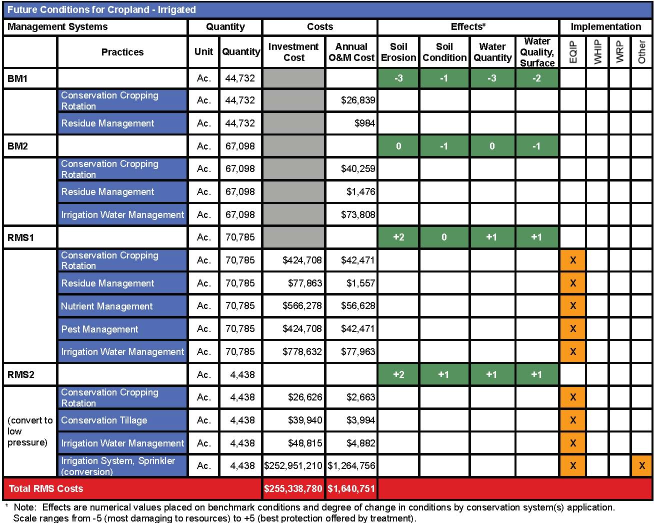
Figure 2: Example Assessment Matrix

Rapid Watershed Assessment Tab Definitions and Data Entry
Data Entry Notes for the RWA Matrix Tool
This RWA Matrix Tool was developed by Natural Resources Conservation Service (NRCS) staff in Oregon. It is a Microsoft Excel based tool that allows for the entry of numerous watershed data elements while performing mathematical, data mining, and populating operations in the background. The purpose of the tool is to provide estimates of where conservation investments would best address the natural resource and social concerns within a watershed. The NRCS Oregon Assessment Tool has been adopted for use in New York. Appropriate tables and information have been edited to reflect conditions in the State. There are 15 TABS or worksheets in the tool as follows:
- Instructions
- Variables
- Select Concerns-Practices
- Practice Effects
- Treatment Levels
- Practice Factor
- Template
- Funding Sources and Report Printing
- Computations
- Rapid Assessment
- CPPE
- Cost List
- Problem Definitions
- Practice Descriptions
- Lookup
DATA ENTRY NOTE: It is extremely important that the NEXT button is clicked after data entry is completed on a given screen\worksheet. This enables the spreadsheet to run MACRO and programming processes (math, data mining, etc.) in the background. Moving from one tab to another by clicking on a tab name will not allow those processes to run.
ALSO: You must click outside of cell that has just had data entered before the NEXT or SORT buttons will function.
Use the backspace key to clear an erroneous error. DO NOT use the space bar.
- Tab 1 - Watershed Variables
The "Variables" screen is used to enter basic information from the watershed profile, other constants and to distribute future conservation participation into treatment levels. People familiar with landowner attitudes about conservation in the watershed should be consulted for estimating future participation. While the example uses 6%, the default interest rate in New York is 5%.
  - The entries in this tab are composed of basic watershed characteristics from the watershed profile including the acreage of the landuse being analyzed and estimates of current conditions and projected changes over the planning time frame. There are three conditions that are addressed:
  - Baseline
    - Baseline is the existing condition which, in most cases, indicates that there are resource concerns and opportunities that should be addressed through conservation planning and application. For the most part the baseline group is composed of farmers and other landowners who are not participating in conservation programs or implementing practices on their own. There may be a few practices that have been commonly adopted by this group in a watershed. For example, a "conservation cropping system" may be followed that generally meets the NRCS conservation practice standard and specification. The baseline level then is that from which a landowner will move to either the progressive or RMS level of participation.
  - Progressive
    - The progressive level is defined as that level of conservation adoption which may lead to a full Resource Management System (RMS) level of treatment. Landowners are commonly actively participating in some conservation programs and have adopted several practices as stand-alone treatment or coordinated systems. These groups of landowners commonly have their technology adoption or implementation at a level that requires time to make decisions, increase capital, learn about new technologies, or other factors. They will often include contact (communication system exists) with their friends and neighbors (peer-to-peer communication) as an activity to help them make a decision.
  - Resource Management System – (RMS)
    - The RMS level consists of landowners who have provided at least a level of protection to meet the quality criteria (QC) for the concern(s) (e.g. soil erosion - sheet and rill or irrigation induced erosion) for all of the SWAPA + Human resource concerns typically seen for a given land use in the watershed. The quality criteria are provided in Section III of the NRCS - Field Office Technical Guide (FOTG). Meeting the QC level of protection helps to prevent resource degradation and permit sustainable use. The user should include practices that address the four major resource concerns selected for display in this matrix. Other practices that help address other resource concerns identified in the resource profile may also be included.
- Tab 2 - Select Concerns-Practices
  - This screen is a two-step process. It involves:
    - The selection of up to four MAJOR resource concerns (e.g. water quality - excessive nutrients and organics in surface water) for the land use in the watershed. These resource concerns will be displayed in the assessment matrix and represent the highest priority concerns that typically must be addressed for this particular land use in this watershed. There may be other resource concerns identified in the profile that should be considered in formulating a conservation management system. However, those will not be displayed in this matrix. Keep in mind that single conservation practices but, more so, conservation management systems (CMS) often provide benefits to other resources and resource concerns.
    - The selection of no more than 30 conservation practices commonly used to address the four major resource concerns selected (above) for the land use. In the “Treatment Levels” tab that occurs later in the application the conservation management systems will be defined. Choices may be made at that point to choose not to use all the practices selected in this step.
      - It is advisable to limit your practice selections to 17 as this is the maximum number allowed in the treatment levels tab.
- Tab 3 - Practice Effects
  - The "Practice Effects" screen automatically displays the default ratings from the statewide Conservation Practice Physical Effects (CPPE) for both the selected resource concerns and conservation practices.
    - The user should carefully consider these ratings to determine if they are applicable. CPPE ratings typically are generalized for all land uses statewide and are based on effects within the "area of influence" of the specific practice considered.
  - For the purposes of a watershed assessment, the user should think about the effects of a practice or CMS on a treatment unit or watershed basis. Sometimes these are different; for example; the CPPE rating for grassed waterways may be "5" for sheet and rill erosion because little erosion would occur within the waterway itself. However, at the treatment unit level the rating might best be "1" or "less" because grassed waterways do very little to control sheet and rill erosion occurring on all cropland in the watershed. Conversely, grassed waterways would have a significant effect on reducing ephemeral and classic gully erosion and the attendant sediment delivery on a watershed basis.
  - This section should be used as a check to determine if the correct conservation practices have been chosen to address the four resource concerns identified\selected under Tab 2. For example, normally every practice should be rated at least a 3 for at least one of the stated resource concerns. Also, every resource concern should have at lest one practice chosen that is at least at the 3 level.
- Tab 4 - Treatment Levels
  - The "Treatment Levels" screen is where the conservation practices typically used for the land use of concern are selected and used at different levels of treatment (baseline, progressive, and RMS described above) in the watershed.
    - Be certain that the conservation practice codes are correct and appear where necessary. If not or if there is an error (e.g. #NA) manually enter the correct code.
- Tab 5 – Practice Factor
  - The "Practice Factor" screen computes the correct practice unit quantities.
    - The factors are intended to be used to calculate practice units in feet, number, or acres, as appropriate. For example, the number of feet of subsurface drainage needed to address excess water concerns needed for a typical cropland unit. The factors can also be used to proportion practice acres if two or more practices are used and substitute for each other - therefore being mutually exclusive. For example:
      - Based upon an average rotation, at a given time only a percentage of the total cropland in the watershed is actually planted to row crops with the balance in close seeded hay or other annual\perennial cover.
      - Of that percentage, perhaps 25% of the cropland in the watershed may be planted using residue management-zone tillage while the remaining 25% is established using residue management-mulch till.
      - Continuing with the conservation tillage (residue management) example, it may be that no baseline farmers are using tillage technology, progressive level farmers characteristically use only mulch till, but the RMS level operators use no-till\strip till.
      - Likewise, landforms in the watershed usually affect what conservation practices are viable in some areas as opposed to others. Contour farming is best suited to landforms that have simple, uniform slopes and shapes (e.g. convex drumlins versus complex slopes on certain valley sides). As such, based upon the landform types, contour farming will only be feasible on a percentage of the cropland in the watershed.
  - This sheet promotes to the top of the list all of the practices selected in Tab 2 and checks the level of treatment where they occur. Factors only have to be determined for those conservation practices checked. The “Short Note” provides a suggested format for calculating appropriate practice factors. Users should not change the factors however they may want to document their rationale.
  - Practice factors should be entered for each level of treatment. For example, at the progressive level perhaps 5% of the treatment unit needs to be in grassed waterways but at the RMS level only 2% needs that treatment because of other practices that tend to minimize the potential for classic gully erosion.
  - Tab 5 must be filled out using the knowledge provided by the stakeholders during the completion of the assessment. The data entered in Tab 5 will have a profound cascading effect on the results found in the Template portion (Tab 6) of the assessment workbook.
- Tab 6 – Template
  - The "Template" provides a two-part summary of the assessment.
    - Part 1 summarizes the practices at each treatment level, the quantities of practices for current benchmark conditions and projected future conditions. It also displays the four major resource concerns, the individual practice effects, and a "systems rating" indicating the overall effectiveness of the conservation system used at each treatment level.
    - Part 2 summarizes the installation, management, and the operation & maintenance costs by practice and treatment level for the projected future conditions by Federal and private share of the costs. It also displays the current benchmark and projected future conditions conservation status bars. The user may want to "hide" blank rows in matrix for printing purposes.
- Tab 7 – Funding Sources
  - "Funding Sources" is an additional part of the summary assessment matrix that displays any USDA programs that may be applicable to conservation practices and systems selected for implementation. There are also columns for indicating if other federal, state or local programs are applicable.
  - The green “Print Analysis” button prints data from all of the following tabs: 1 (Variables), 4 (Treatment Levels), 5 (Practice Factors), 6 (Template), 7 (Funding Sources), and Rapid Assessment. Individual tabs can be printed as needed.
Data Entry Notes
- Light blue cells – direct data entry
- Gray cells with numerical values – value calculated or copied from other cells by\in the spreadsheet after a direct data entry is made
- Yellow cells – Percentage value for projected future condition calculated by the spreadsheet after the percentage value representing the amount of acres expected to remain at a given treatment (baseline, progressive, RMS) is entered.
- As stated above, it is extremely important that the “NEXT” button within a worksheet (tab) is clicked after data entry is completed. This enables the spreadsheet to run processes (math, data mining, etc.) in the background. Moving from one tab to another by clicking on a tab name will not allow those processes to run.
- An effective way to check the data input on Tab 1 into the Projected Future Conditions is to examine the number of acres changing from baseline to progressive/RMS and progressive acres to RMS.
- Click the “SORT” button to bring the selected practices to the top of a list as a group. See Figure 3A for grouping example.
Variables Tab
- Example
  - “Current Conditions” (Baseline)
    - 35,000 acres of cropland (landuse) in the watershed
    - 50% (17,500 acres) of the acres in cropland is estimated to be at the baseline level of treatment.
  - “Projected Change” (Baseline)
    - 30% (5,250 acres) of the 17,500 acres at the current baseline level are expected to remain at that level as the projected future condition.
    - 50% (8,750 acres) of the 17,500 acres at the current baseline level are projected to be treated to the progressive level.
    - 20% (3,500 acres) of the 17,500 acres at the current baseline level are projected to be treated to the RMS level.
  - % Total = 100
  - Baseline Acreage Total = 17,500
  - Projected Future Condition (Baseline)
    - 15% or 5,250 acres of the landuse in the watershed will remain at the baseline level of treatment
(5,250/35,000)
  - Projected Future Condition (Progressive)
    - 40% or 14,000 acres of the landuse in the watershed will be treated or remain at the progressive level of treatment. This value reflects land moving from the baseline to progressive and acres that will remain static at the progressive level.
  - Projected Future Condition (RMS)
    - 45% or 15,750 acres of the landuse in the watershed will be treated to or remain at the progressive level of treatment. This value reflects land moving from the baseline and progressive levels to RMS to and acres that will remain static at the RMS level.
  - Thus, 50% (17,500) of the acres in the watershed will remain at a static treatment level and 50% (17,500) will are projected to be treated.
Figure 1 – Tab 1: Watershed Variables Data Entry Screen

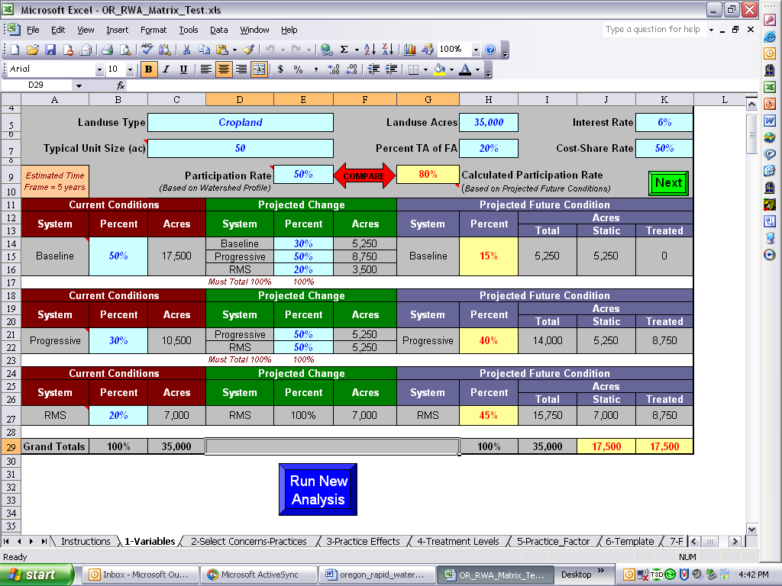

Figure 2 – Tab 1: Variables with Example Data from Table 1 (next page)
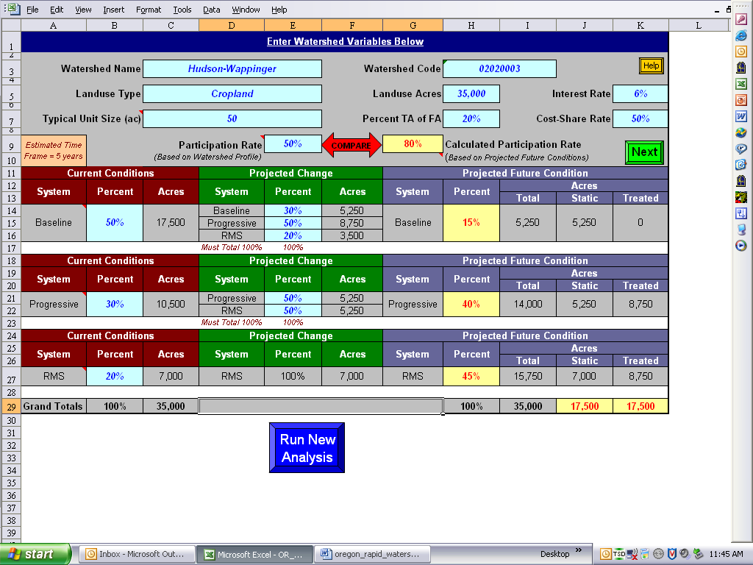
Table 1 – Variables Tab Example Data Information (Note: ¹ The EXCEL application calls for the rate based on the watershed profile. The tool to determine the Participation Rate is
Data Element Name | Entry Information
Watershed Name | Approved name of the 8 digit hydrologic unit
Watershed Code (8 Digit HUC) | 8 digit hydrologic unit code (HUC)
Landuse Type | NRCS landuse
Landuse Acres | Total acres of landuse in the 8 digit watershed
Typical Unit Size | Total acres of a typical management unit (e.g. field). Do not enter the acres of an average sized farm.
Percent TA of FA | Use 20%
Interest Rate | Example is 6%. Use 5% in New York State.
Cost-Share Rate | Use 50%
Participation Rate ¹ | Calculated Participation Rate = Future Treated Acres/(Current Base Acres + Current Progressive Acres)  See: ENTSC. 2004. Guide for estimating participation in conservation programs and projects. East National Technical Support Center, Greensboro, NC. 21 pages. Social Sciences Technical Note 1801  ( http://ssiapps.sc.egov.usda.gov/SocialSciences/Default.aspx )¹
Current Conditions  Baseline, Progressive, and RMS in rows | Percent of the total acreage in the landuse that is considered to be at a baseline condition.  Output: Acres in baseline condition is calculated: (% at condition) (landuse acres)  Acres to progressive condition is calculated and entered automatically in the projected future  condition in the Progressive row  Acres to the RMS condition is calculated and entered automatically in the projected future  condition in the RMS row
Projected Conditions  Baseline, Progressive, and RMS in rows | % remaining at baseline; % moving to progressive; % moving to RMS  Of the x-percent of the total acres at a baseline condition, what percentage is expected to remain at baseline; move to the progressive, and move to the RMS levels of treatment? The total of these must be 100%.  Output: Acres remaining at baseline is calculated; the percentage and total acres of the baseline acres that remain at the baseline level is calculated.  This same scenario cascades down to the progressive and RMS levels.
Note: The following watershed information data is copied automatically to the Template worksheet:
Watershed Name, Watershed Code, Landuse Type, Landuse Acres, Typical Unit Size (ac), Calculated Participation Rate
Current Condition-Baseline acres, Projected Condition baseline acres that will remain in the baseline category;
Current Condition-Progressive acres, acres that will remain at Progressive and move to RMS based upon percentages entered on Progressive row on the Watershed Variables worksheet
Current Condition-RMS acres will be treated in the same manner on the Template worksheet. See Figures and 1 and 2 below
¹ The EXCEL application calls for the rate based on the watershed profile
Figure 3 – Tab 1: Watershed Variables Worksheet Example
Note 1
Note 2
Note 3
Note 5
Note 4
Note 6
Note 7
Note 8
Note 9
Note 10
Note 11
Note 12
Note 16
Note 13
Note 14
Note 15
Note 17
DATA ENTRY NOTE: It is extremely important that the NEXT button is clicked after data entry is completed on a screen. This enables the spreadsheet to run processes (math, data mining, etc.) in the background. Moving from one tab to another by clicking on a tab name will not allow those processes to run.
Table 2 - Explanatory Notes for Figure 1 - Watershed Variables Worksheet Example
Note # | Value Title |  | Value | Calculation Details | Calculation
Baseline
1 | Baseline – Current Conditions |  | 17,500 ac. | 0.50 (50%):  Estimated % of total watershed acres currently at baseline conditions | 0.50 X 35,000 ac.
2 | Baseline – Projected Change (baseline system acres remaining as baseline - static) |  | 5,250 ac. | 0.30 (30%):  Estimated % of watershed acres at the baseline condition that will remain at that same condition | 0.30 (projected % baseline) X 17,500
3 | Baseline – Projected Future Condition - Percent |  | 15% | Percentage of projected static (untreated) baseline acres for the landuse in the watershed | 5,250 ac./35,000 ac.
4 | Baseline - Projected Future Condition – Total / Static Acres |  | 5,250 ac. | Value taken from the “Projected Change” baseline acres | Copied value
Progressive
5 |  | Progressive – Current Conditions | 10,500 ac | 0.30 (30%):  Estimated % of total watershed acres currently at progressive conditions | 0.30 X 35,000 ac.
6 |  | Progressive – Projected Change (progressive system acres remaining as progressive) | 5,250 ac. | 0.50 (50%):  Estimated % of watershed acres at the baseline condition that will remain at that same condition | 0.50 (projected % baseline) X 10,500
7 |  | Progressive – Projected Future Condition – Total Acres | 14,000 | Baseline acres treated to progressive plus progressive static acres | 8,750 + 5,250
8 |  | Progressive – Projected Future Condition - Percent | 40% | Baseline acres treated to progressive plus progressive static acres divided by total landuse acres | 14,000/35,000
9 |  | Progressive- Projected Future Condition – Static Acres | 5,250 ac. | Value copied from “Projected Change” progressive acres remaining at the progressive level | Copied value
10 |  | Progressive – Projected Future Condition – Treated Acres | 8,750 ac. | Difference between total projected future condition acres – progressive and static acres - progressive | 14,000 – 5,250
Resource Management System (RMS)
11 |  | RMS – Current Conditions | 7,000 | 0.20 (20%):  Estimated % of total watershed acres currently at RMS conditions | 0.20 X 35,000 ac.
12 |  | RMS – Projected Change – Percent | 100 | RMS acres are those remaining acres that do not fall within the baseline or progressive categories.
13 |  | RMS – Projected Change (RMS system acres remaining as RMS) | 7,000 ac. | 50% (17,500 ac) @ baseline +  30% (10,500 ac.)@ Progressive  = 80% (28,000 ac.) of landuse in the watershed.  100% - 80% = 20% @RMS remaining  0.20 (20%) X 35,000 ac. =  7,000 ac. | 1.00 X 7,000 ac.
14 |  | RMS – Projected Future Condition - Percent | 15,750 ac. | From “Projected Change –Acres”  Baseline directly to RMS plus Progressive to RMS plus  Acres already at RMS | 3,500 ac. + 5,250 ac. + 7,000 ac
15 |  | RMS – Projected Future Condition – Total Acres | 45% | Baseline acres treated to RMS plus progressive treated to RMS plus existing RMS acres divided by total landuse acres | 15,750/35,000
16 |  | RMS- Projected Future Condition – Static Acres | 7,000 ac. | Value copied from “Projected Change” RMS acres remaining at the RMS level | Copied value
17 |  | RMS – Projected Future Condition – Treated Acres | 8,750 ac. | Difference between total projected future condition acres – progressive and static acres - progressive | 15,750 – 7,000

Rapid Watershed Assessment Matrix
Tab 2 - Select Concerns - Practices - Entry Fields
Figure 4 – Tab 2: Resource Concerns and Practice Selection – Identify Resource Concerns
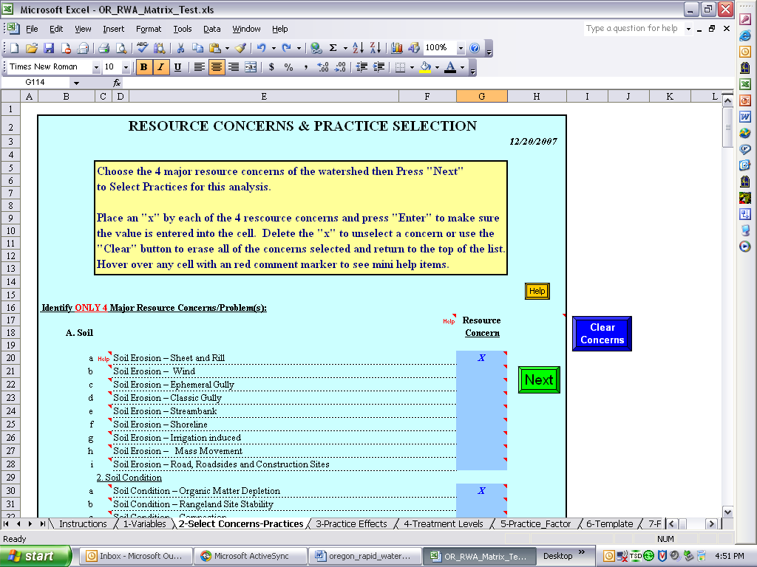
data entry Note: Only 4 major resource concerns may be chosen for the landuse in the watershed on the select concerns-practices worksheets.
The following resources concerns were selected for this example (they do not all show up in Figure 2):
- sheet and rill erosion,
- organic matter depletion,
- excessive nutrients and organics in surface water,
- forage quality and palatability
Figure 5A – Tab 2: Resource Concerns and Practice Selection – Identify Conservation Practices
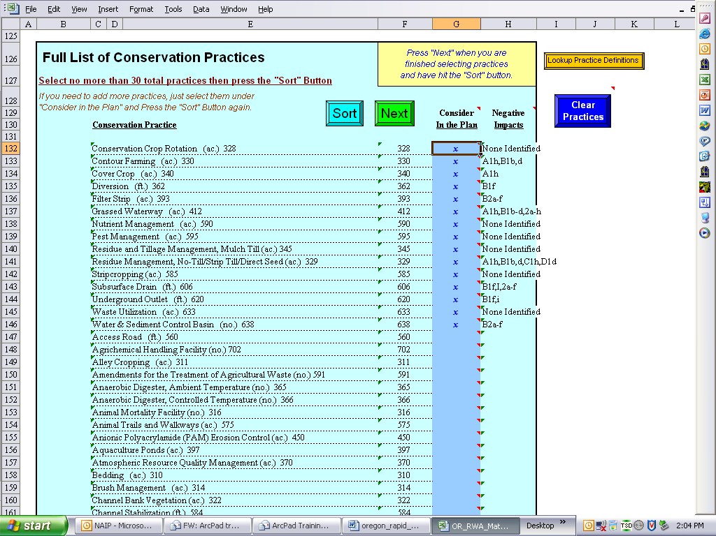
Provided from the Lookup Table
DO NOT edit the Lookup Table
DATA ENTRY NOTE: Be certain to enter only a lower case x into the “consider in the plan” cell.
Figure 5B – Tab 2: Resource Concerns and Practice Selection – Identify Conservation Practices
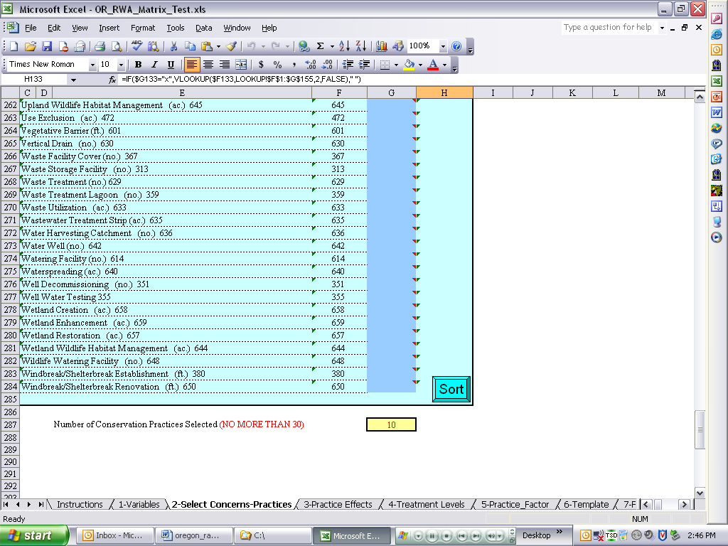
DATA ENTRY NOTE: Click on the SORT button to bring the selected practices to the top of a list as a group. See Figure 3A for grouping example.
Completion of this tab populates the practices into the following tabs:
- Tab 3 – Practice Effects
- Tab 4 – Treatment Levels.
The results for the Practice Effects table are shown below in Figure 6. The values from the Conservation Practice Physical Effects (CPPE) are incorporated into the table from the CPPE tab. DO NOT change the CPPE values in the CPPE lookup table. These are values that have been established by NRCS-NY and are in place in the national SmarTech application. However, the values may be changed in Tab 3 for the specific watershed without affecting the lookup table. This should be done with a member of the SRC staff with RWA responsibilities.
Figure 6 – Tab 3: Practice Effects CPPE Values
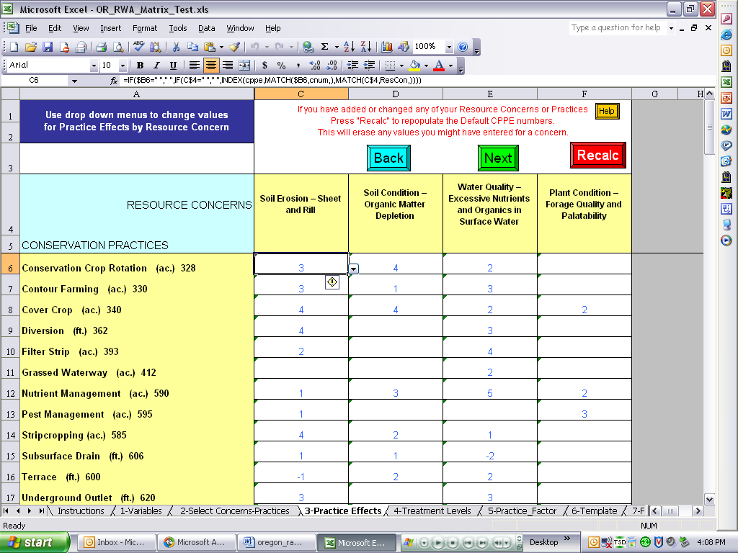

DATA ENTRY NOTES: The CPPE values for the selected practices and resource concerns are populated automatically from the lookup table(s). They may be overwritten ON THIS PAGE if local conditions require. DO NOT edit the look table(s). Blank cells are interpreted as zero (0).
IMPORTANT: You will lose data if you change values here and then go back to earlier tabs and make changes (e.g. add practices). If you need to change data in prior tabs after having made adjustments to the values on this tab, print the page first before making your edits elsewhere. This can save you time by documenting the changes to the effects you already discussed/made for the various practices, thereby allowing you to quickly re-input those values.

Figure 7A – Tab 4 – Treatment Levels Table Populated from Entries into Tab 2
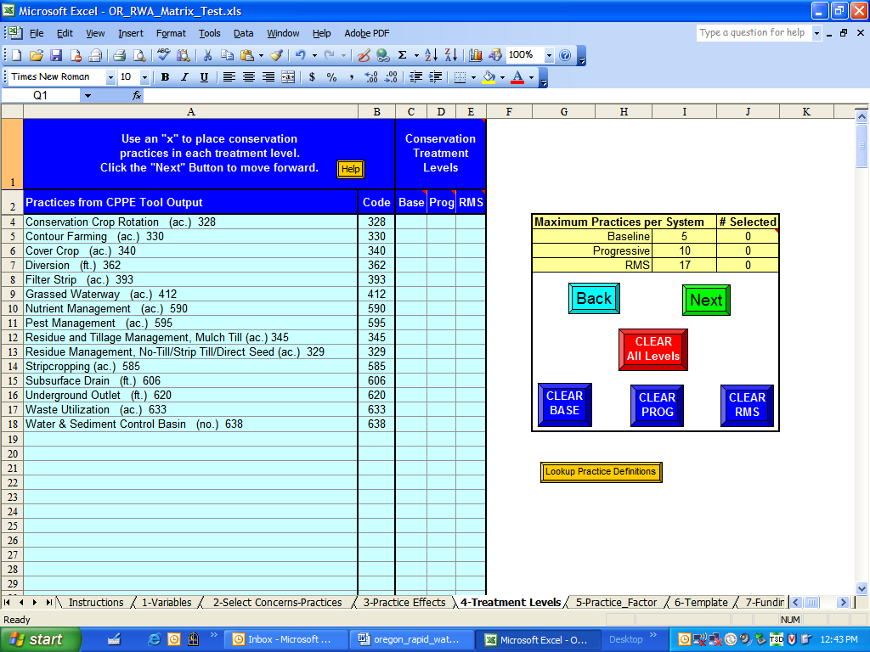
Note: The example’s practices are not distributed by treatment level
DATA ENTRY NOTE: Note the maximum practices per system window. Subordinate tables for practices used at the baseline, progressive, and RMS levels are populated in the background.
Figure 7B - Tab 4 – Treatment Levels Table Populated from Entries into Tab 2
Note: Example practices distributed by treatment level
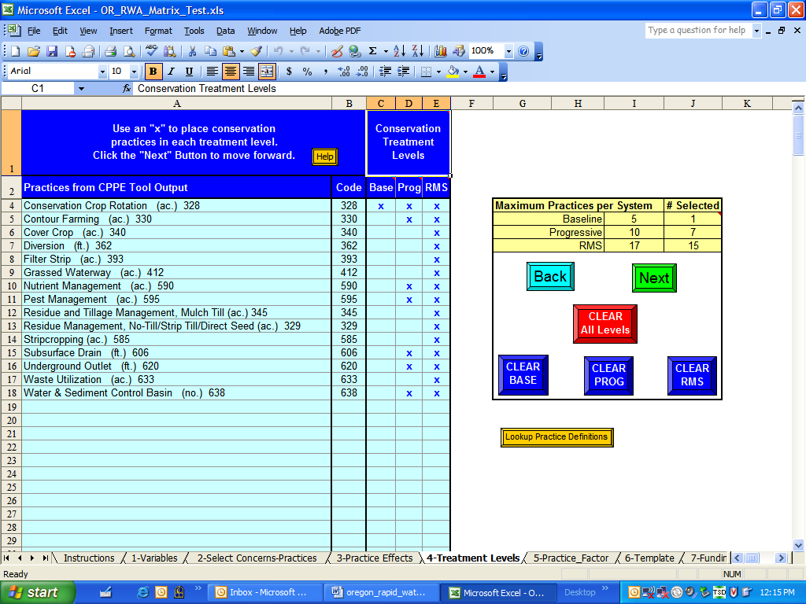
DATA ENTRY NOTE: Practices are checked as being used at each of the treatment levels (baseline, progressive, RMS). Practices included at the baseline level must be checked for the progressive and RMS levels. Likewise, practices checked for the progressive level must also be checked for the RMS level. The extent of the practice needs at the progressive and RMS level can be adjusted later on in the spreadsheet application.

In addition to Tabs 3 and 4, the Practice Factor (Tab 5) table is also populated. This section is used to compute the correct practice unit quantities in feet, number, or acres, as appropriate. This sheet should promote to the top of the list all of the practices selected and checks the level of treatment where they occur. Scroll down through the list to be certain that other practices do not occur outside of the selected. Factors only have to be determined for those conservation practices checked. The “Short Note” provides a suggested format for calculating appropriate practice factors.
If desired, different practice factors can be entered for each level of treatment. For example, at the progressive level perhaps 5% of the cropland treatment unit needs to be established for corn silage using strip tillage but at the RMS level only 2% requires this treatment. This may be so because erosion control is adequately addresses and/or the practice is more commonly adopted at the RMS level of treatment than any other.
If desired, custom calculations can also be run in the columns to the right of the application spreadsheet. As such, if a calculation showing the conversion of square feet to acres, or linear feet to miles is required it can be set-up with the appropriate formula in an open cell [e.g. (cell address sq. ft. /43,560)]. See Figure 8B
Be very wary of changing practice units as they may not be carried forward correctly to other locations in the spreadsheet. This can or most probably will result in erroneous results.
Figure 8A – Tab 5 - Practice Factor Worksheet
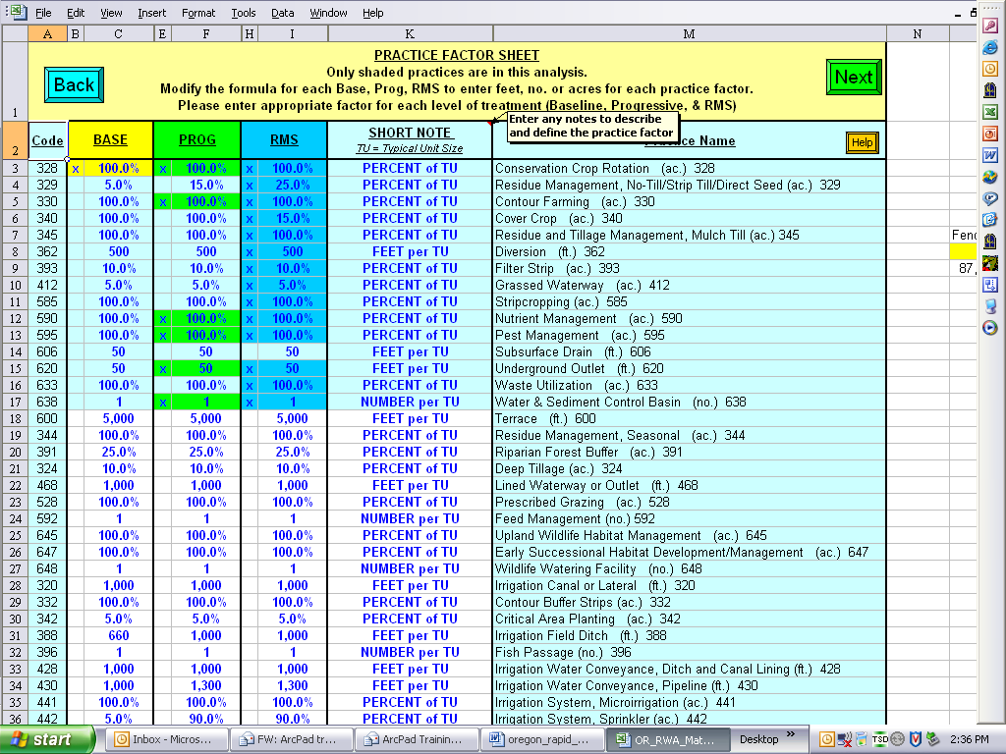
DATA ENTRY NOTE: Data need only be entered in the yellow (baseline), green (progressive), and/or darker blue (RMS) cells. Light blue and white cells will not be used in calculations in other parts of the worksheet/workbook.
Be certain to click on the NEXT button to allow the spreadsheet application to run calculations and carry values, where necessary, to other tabs or worksheets. Do not click on the tab name at the bottom of the worksheets screen to move through the tabs during actual data input.
Figure 8B - Tab 5 - Example of Calculations Outside of the Formal Application Spreadsheet
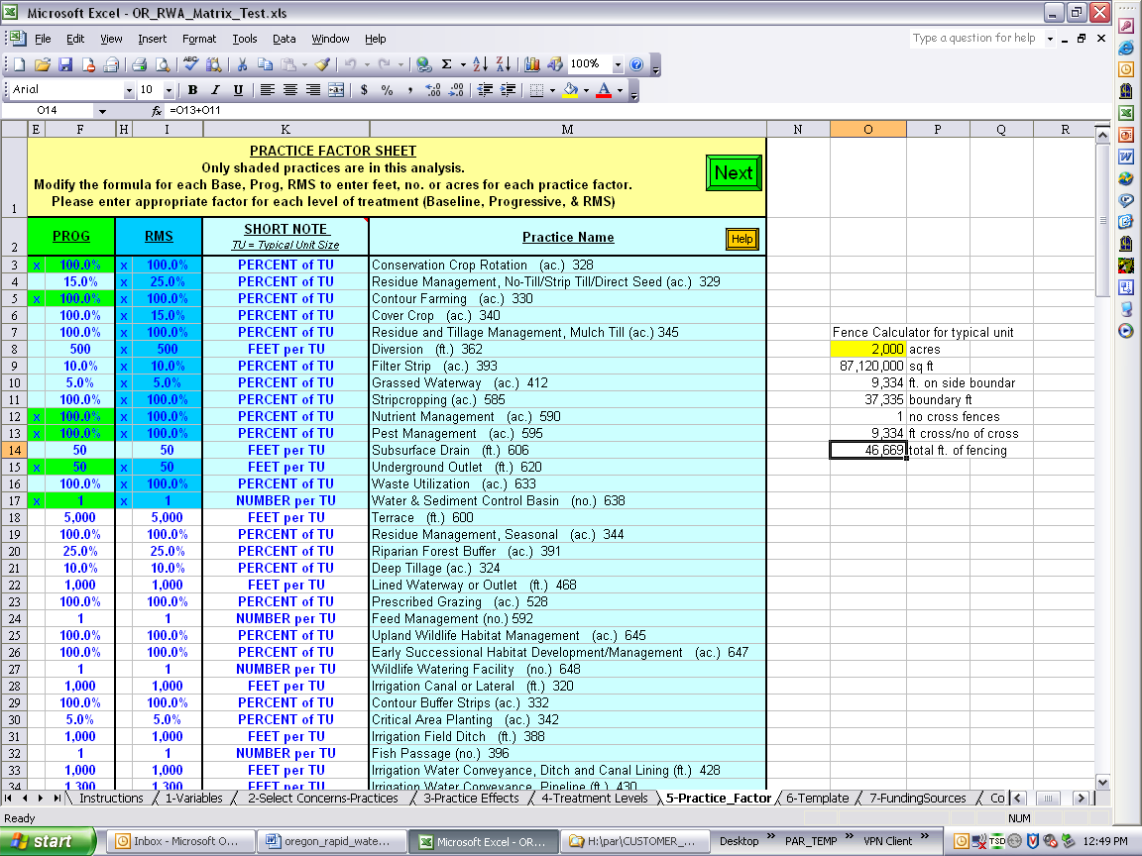
Side calculation example.

Figure 9A – Tab 6: Template Worksheet
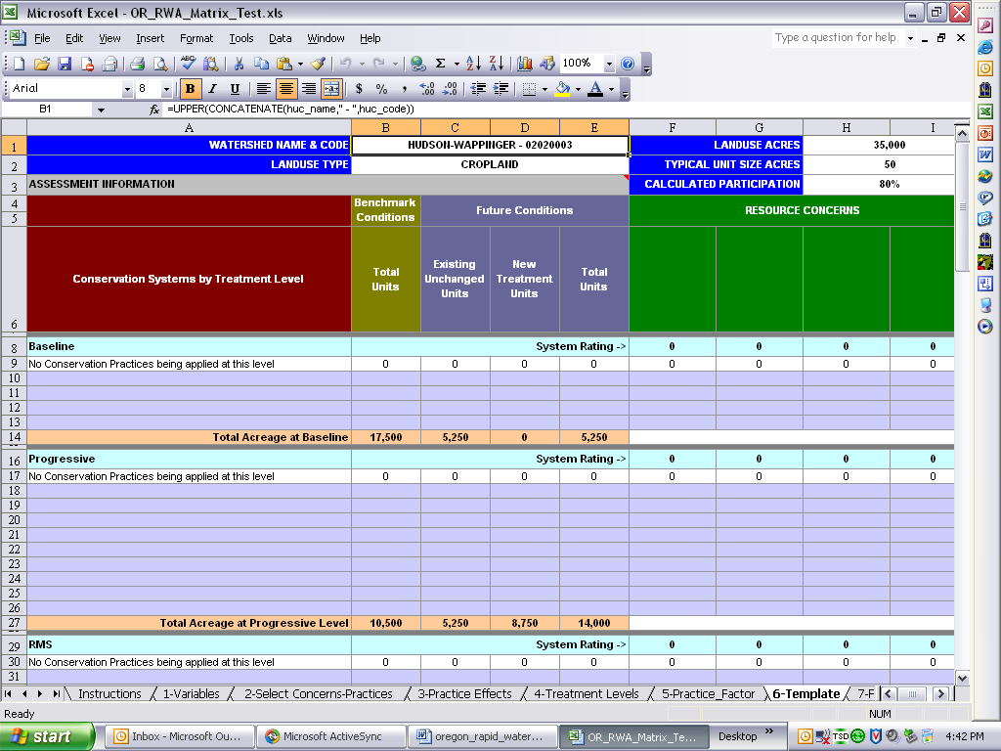
Figure 9B – Tab 6: Completed Sample Template Worksheet
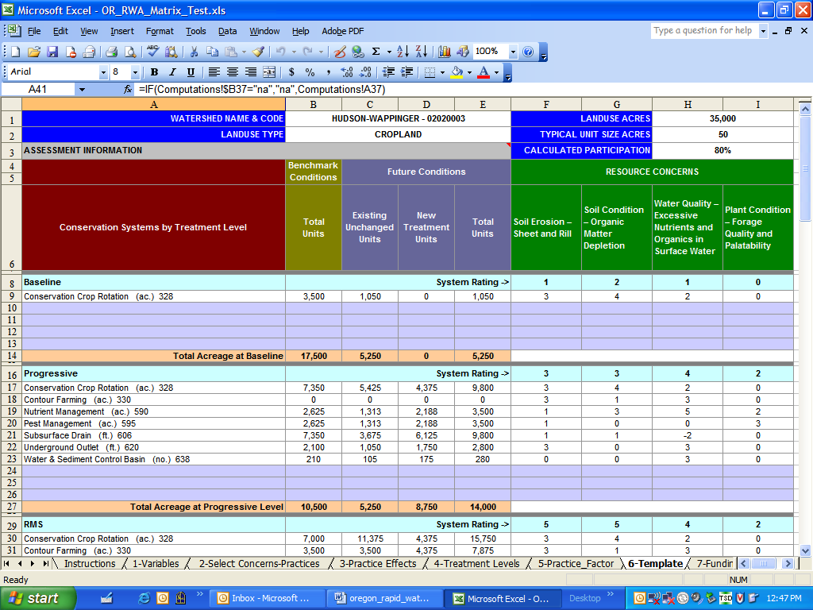
Figure 10 – Lookup Table
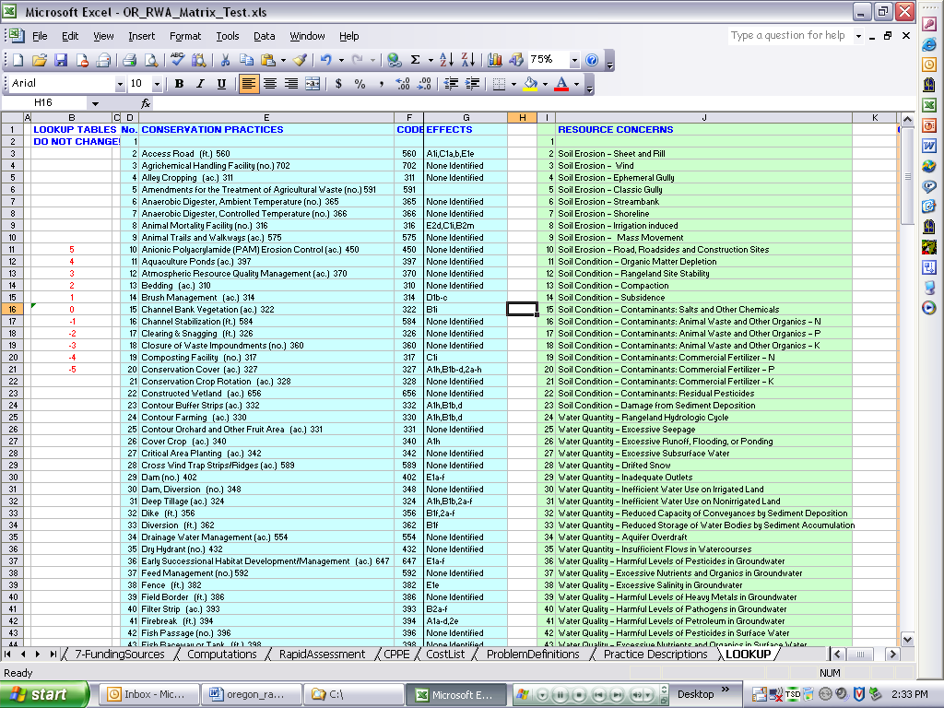

Lisa Greber (no longer with NRCS) and Terry Nelson (retired) of the NRCS Oregon Water Resources Planning Team.

