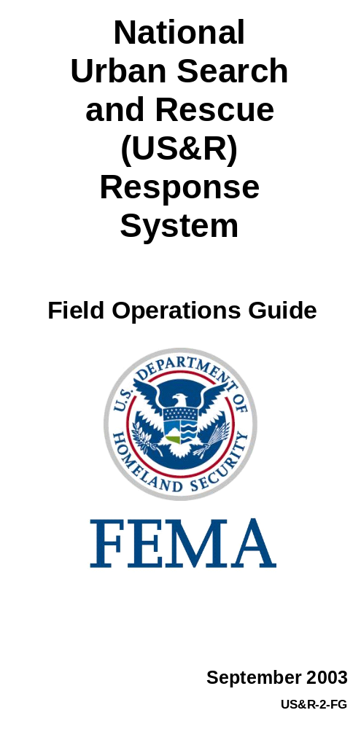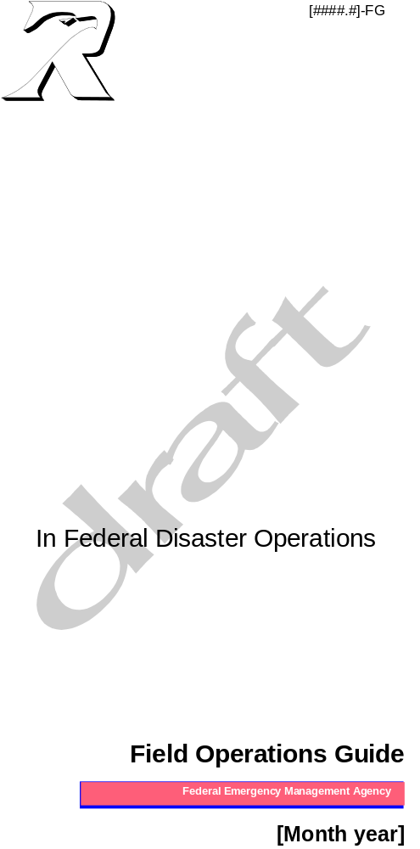

The Federal Emergency Management Agency (FEMA) developed four levels of operational guidance for use by emergency teams and other personnel involved in conducting or supporting disaster operations. This document corresponds to the level highlighted in bold italics.
Level 1 | Overview | A brief concept summary of a disaster-related function, team,  or capability.
Level 2 | SOP or Operations Manual | A complete reference document, detailing the procedures for performing a single function (Standard Operating Procedure),  or a number of interdependent functions (Ops Manual).
Level 3 | Field Operations Guide (FOG) or Handbook | A durable pocket or desk guide, containing essential nuts-and-bolts information needed to perform specific assignments  or functions.
Level 4 | Job Aid | A checklist or other aid for job performance or job training.
This document is consistent with and supports the Federal Response Plan for implementation of the Robert T. Stafford Disaster Relief and Emergency Assistance Act, 42 U.S.C. § 5121, et seq.

The most current copy of this document, including any change pages, is available through the FEMA Intranet in the National Emergency Management Information System (NEMIS) Reference Library (http://nemis.fema.net), under Response and Recovery/Policies and Guidance, Disaster Operations Guidance.

RECORD OF CHANGES

Change No. | Copy No. | Date Entered | Posted  By

THIS PAGE IS INTENTIONALLY LEFT BLANK
FOREWORD
This Field Operations Guide (FOG) has been prepared to guide Department of Homeland Security (DHS)/Federal Emergency Management Agency (FEMA) personnel to perform Federal disaster response operations during major disasters or emergencies.
The National Urban Search and Rescue (US&R) Response System provides for the coordination, development, and maintenance of the Federal effort with resources to locate, extricate, and provide immediate medical treatment to victims trapped in collapsed structures; and to conduct other life saving operations.
The US&R Response System methods of operation, organization, capabilities, and procedures in mobilization, on-site operations, and demobilization are described in this document.
Questions, comments, and suggested improvements related to this document are encouraged. Inquiries, information, and requests for additional copies should be directed in writing to the Department of Homeland Security, Emergency Preparedness and Response Directorate, Response Division, Operations Branch, 500 C Street SW, Washington, DC 20472.

THIS PAGE IS INTENTIONALLY LEFT BLANK

TABLE OF CONTENTS

Record of Changes i
Foreword iii
I. Introduction I-1
A. Document Purpose I-1
B. Concept of Operations I-1
II. National US&R Response system organization II-1
III. pOSITION cHECKLISTS III-1
A. General Operational Checklist III-1
B. Task Force Leader III-2
C. Task Force Safety Officer III-5
D. Task Force Planning Team Manager III-7
E. Technical Information Specialist III-8
F. Structures Specialist III-9
G. Search Team Manager III-10
H. Canine Search Specialist III-11
I. Technical Search Specialist III-12
J. Rescue Team Manager III-13
K. Rescue Squad Officer III-14
L. Rescue Specialist III-15
M. Heavy Equipment and Rigging Specialist III-16
N. Medical Team Manager III-17
O. Medical Specialist III-19
P. Hazardous Materials Team Manager III-20
Q. Hazardous Materials Specialist III-21
R. Logistics Manager III-23
S. Logistics Specialist III-24
T. Communications Specialist III-25
U. Support Specialist III-26
IV. Practices and Procedures IV-1
A. Load Limitations IV-1
B. Cache Packaging/Shipping Requirements IV-1
C. Structure Triage, Assessment, and Marking System IV-2
D. Search Strategy and Tactics IV-12
E. Rescue Operations IV-15
F. Communications Procedures IV-19
G. Medical Procedures IV-20
H. Hand Signals IV-24
I. Military Aircraft Specifications IV-26
J. Task Force Media Procedures IV-27

APPENDICES

appendix a: acronyms and abbreviations a-1
appendix b: GLOSSARY OF COMMON TERMS b-1
appendix c: UNITS OF MEASURE, SYMBOLS, AND CONVERSION FACTORS c-1
appendix D: Sample forms, letters, and Plans D-1
appendix e: NOTES e-1

LIST OF FIGURES

FIGURE ii-1: Ert organization ii-1
FIGURE ii-2: Incident Support Team – Advance ii-1
FIGURE ii-3: ist – expanded organization ii-2
FIGURE ii-4: Type I Task Force Organization ii-3
FIGURE ii-5: Type III Task Force Organization ii-4
THIS PAGE IS INTENTIONALLY LEFT BLANK

Introduction
The Federal Emergency Management Agency (FEMA), Department of Homeland Security (DHS), developed the National Urban Search & Rescue (US&R) Response System to support the Emergency Support Function (ESF) #9 (Urban Search and Rescue) of the Federal Response Plan. Within this framework, resources are mobilized to respond to structural collapse and other incidents nationwide.

Document Purpose
The DHS/FEMA US&R Field Operations Guide (FOG) has been developed to support response resources during training and on missions. The FOG is a compilation and summary of important strategic and tactical information, developed procedures, and reference material.

The FOG is an operational guide for ESF #9 resources, that reflects standardized activities and procedures and promotes safe and effective search and rescue operations.

Concept of Operations

Incident Support Team (IST)
The DHS/FEMA US&R IST provides Federal, State, and local officials with technical assistance for command, control, and logistical support of assigned US&R resources.

Mobilization

IST members will not normally assemble prior to travel to the assigned location. When the IST assembles, the following issues shall be addressed:

[ ] Assemble for an initial briefing by the IST Leader or immediate supervisor.

[ ] Assist with the movement and loading of the IST Administrative/Support Kit.

[ ] Receive appropriate supplies and equipment (portable radio, cellular phone, etc.).

In Transit

[ ] Review latest disaster related information as it becomes available.

[ ] Review the information pertinent to position, including position description, operational checklist, and operational and safety procedures.

[ ] Discuss and coordinate anticipated logistical requirements (i.e., transportation, lodging, etc.) prior to arrival at the assigned location.

[ ] Take full advantage of available travel time for rest prior to arrival.

Arrival and Check-In

[ ] Notify Emergency Support Team (EST) upon arrival.

[ ] Check-in with IST Planning Section.

[ ] Obtain a medical screening and complete a medical information sheet.

[ ] Report to supervisor and obtain a briefing.

On-site Operations

[ ] Coordinate operational objectives with local incident command and Federal response organization.

[ ] Identify and coordinate operational mission objectives and expectations.

[ ] Identify and coordinate logistical support requirements for US&R resources.

[ ] Ensure reliable communications between assigned resources, local authorities, and appropriate Federal agencies.

Task Force (TF)

Arrival at the Assigned Locality/Jurisdiction

- Task Force Leaders (TFLs) shall obtain an initial briefing from the IST or local authorities (if the IST is not in place), including:
- The current local incident management organization and reporting requirements.
- Physical location of the Incident Command Post (ICP)
- Chain of command and coordination contacts
- Planning/briefing meeting schedule and location
- Current situation
- Operational issues
- Local medical system issues
- Communications issues
- Transportation issues
- Logistical support issues
- Safety, health, and security issues
- Media issues.

US&R capabilities and limitations should be conveyed to local authorities supported by the US&R Fact Sheets. The initial briefing should result in a clear understanding of expectations between local authorities and US&R resources.

Establishing the Base of Operations (BoO)

- Upon arrival, a team should identify an appropriate location for a BoO (coordinate with IST and local authorities). Recommended team members include:
- One TFL
- One Planning Team Manager
- One Logistics Manager
- One Communications Specialist.
- Considerations for the BoO include:
- Travel distance to and from the operational worksite
- Transportation and access routes
- Terrain and elevation
- Facilities for personnel and cache sheltering
- Communications
- Safety/security
- Adequate space and available infrastructure including:
- Equipment cache set-up and maintenance
- Task Force Command Post
- Medical treatment area
- Food preparation and feeding area
- Toilet and sanitation area
- Helicopter landing zones (optional).

Operational Period Scheduling and Rotations

Incident scenario will determine initial commitment of resources and length of operational periods. The following three options could apply:
- It may be necessary to commit all TF personnel to the initial life-saving requirements (blitz).
- It may be necessary to commit some percentage of resources to life-saving activities, while the remaining personnel could be used to establish the BoO.
- For sustained operations, an alternating work-cycle may be employed. Some percentage of resources will be assigned work while others are resting.

THIS PAGE IS INTENTIONALLY LEFT BLANK

National US&R Response System Organization

This chapter identifies the US&R response organization and the relationships with other Federal response entities.
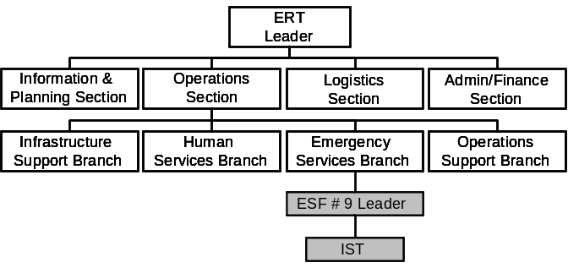

Figure II-1: ERT Organization

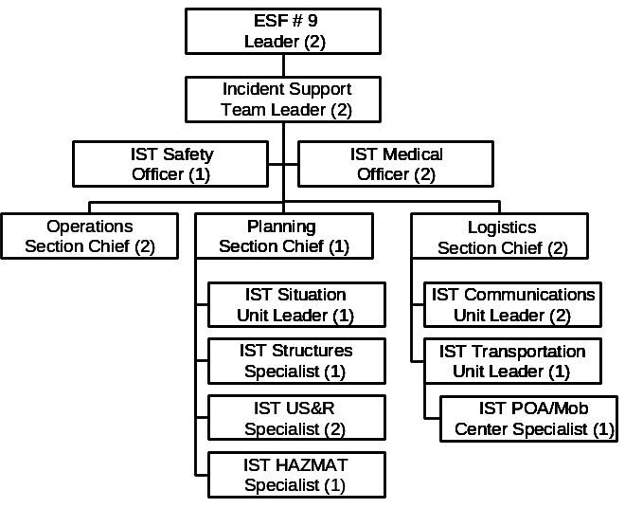
Figure II-2: Incident Support Team – Advance

Figure II-3 reflects an example of an IST organization expanded to meet the incident needs. The actual configuration will be determined by each incident’s requirements.

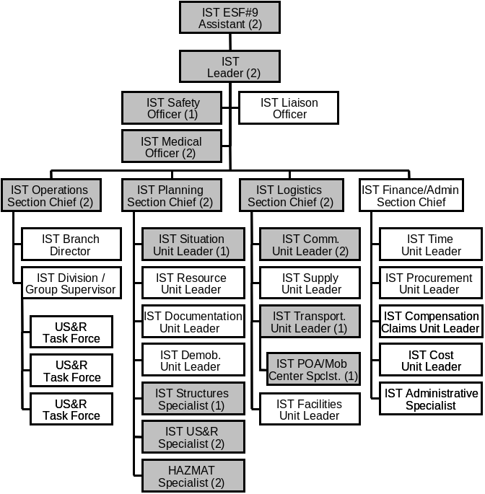

Figure II-3: Incident Support Team Expanded
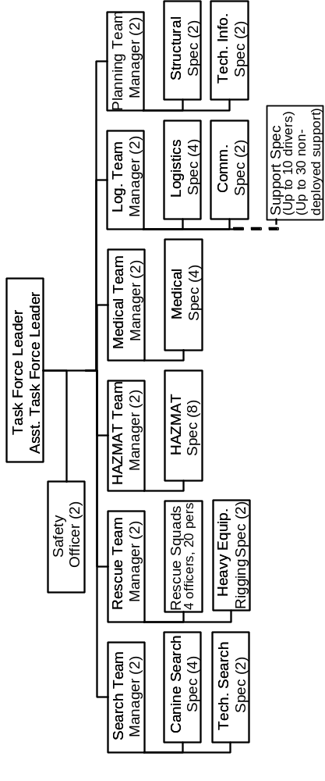

Figure II-4: Type I Task Force Organization

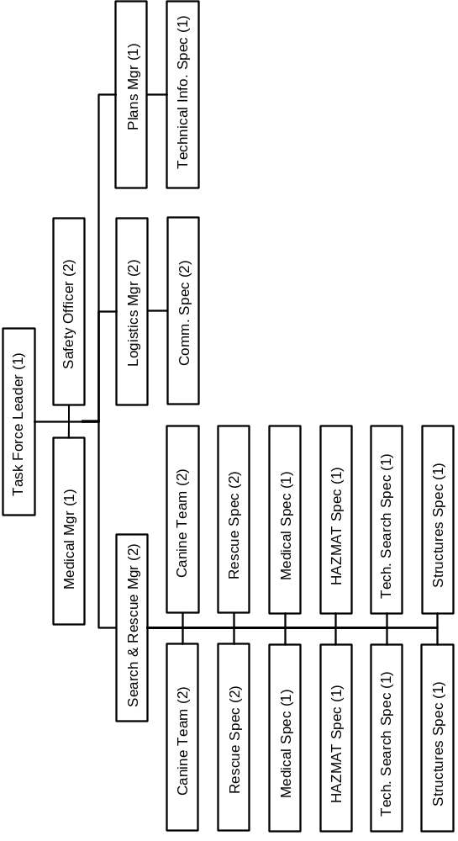

Figure II-5: Type III Task Force Organization

pOSITION cHECKLISTS
The purpose of operational checklists is to define the duties and responsibilities of the respective National US&R Response System positions during a mission assignment. These lists are intended to be a general summary of actions from the “In Transit” phase through the “Reassignment/Demobilization” phase.

General Operational Checklist
IN TRANSIT

[ ] Review this document for information pertinent to operational checklists and procedures.

[ ] Monitor mission-related information from local sources such as radio and television when they are available.

[ ] Review disaster related information, as it becomes available.

[ ] Maintain unit integrity and accountability.

ARRIVAL AT MOBILIZATION CENTER (Mob Center)

[ ] Participate in TF briefings and meetings as directed.

[ ] Maintain unit integrity and accountability.

ON-SITE OPERATIONS

[ ] Participate in the TF daily briefings and meetings as directed.

[ ] Ensure safety practices and procedures are followed.

[ ] Ensure equipment is operational prior to each work period.

[ ] Carry out assignments as directed.

[ ] Brief shift replacement fully on all ongoing operations when relieved at work cycle rotations.

[ ] Prepare appropriate reports.

REASSIGNMENT/DEMOBILIZATION

[ ] Participate in the TF daily briefings and meetings as directed.

[ ] Prepare personal belongings for demobilization.

[ ] Upon return, participate in the TF mission after action and incident stress management activities.

Task Force Leader

IN TRANSIT

[ ] Discuss and coordinate anticipated logistical requirements (i.e., transportation, etc.) with the team managers prior to arrival at the mobilization center.

[ ] Maintain contact with the EST/IST as required.

ARRIVAL AT MOBILIZATION CENTER

[ ] Meet with the IST Point of Arrival (POA)/Mob Center Specialist, or the appropriate officials at the mobilization center, and receive a briefing and TF assignment.

[ ] Brief team managers and introduce the IST or facility’s representative and local authority.

[ ] Ensure priority movement of personnel and equipment is identified.

[ ] Ensure that an assessment of available resources to support the TF operations is conducted.

[ ] If necessary, deploy an advance team with the IST to assess an appropriate site for locating the BoO.

[ ] Assemble all personnel for a mission briefing with the assigned IST POA/Mob Center Specialist and/or appropriate officials to include: assignment, situation report, medical center support, team issues, equipment off-loading, and maps.

[ ] Ensure security provision for personnel and equipment are arranged.

ON-SITE OPERATIONS

[ ] Contact local authority/IST and receive a briefing to include:
- Incident situation report and objectives;
- Tactical assignments;
- TF support layout and requirements (BoO);
- Communications plan, frequencies, and radio designations;
- Emergency signaling and evacuation procedures;
- Medical treatment and evacuation procedures;
- Process for ordering supplies and equipment; and
- Local and site hazards and personal safety precautions.

[ ] Brief the TF on the findings of this action before beginning work.

[ ] In the absence of an IST, provide a US&R Task Force Fact Sheet and organization structure to local officials.

[ ] Identify TF support requirements and request process with the IST:
- Provisions (food, water, etc.)
- Heavy equipment (cranes, bulldozers, etc.)
- Support personnel.

[ ] Assess initial TF strategic considerations:
- Structural triage
- Building marking
- Search and reconnaissance activities
- Equipment cache set-up
- Rescue operations.

[ ] Deploy one or two Reconnaissance Teams as soon as possible, if required.

[ ] Ensure a TF BoO is established in an appropriate location.

[ ] Ensure team managers develop a process to determine an overall operational assessment process that includes:
- Functional requirements and immediate needs
- Work schedules for extended operations
- Rest and rotation periods for personnel
- Adequacy of support facilities.

[ ] Participate in planning meetings and operational briefings with the IST.

[ ] Evaluate the capacity of assigned resources to complete the assignment. Order additional resources if needed.

[ ] Ensure that the Medical Team Manager, in conjunction with the IST Medical Unit Leader, obtains a general health and medical situation assessment and locates available resources. Convey medical capabilities and limitations to local official(s) (use the Task Force Medical Team Fact Sheet), indicating the need for additional resources or specialized medical capabilities. Pertinent incident medical planning information should be passed on, through the chain of command, to State, Federal, and National Disaster Medical System (NDMS) officials.

[ ] Ensure that the Medical Team Manager provides guidance to TF members on health maintenance matters.

[ ] Ensure that all TF supervisors are identified by vests.

[ ] Evaluate TF operations performance in meeting established objectives to include:
- Effectiveness of overall strategy and tactics;
- Assessment of equipment shortages and needs;
- Ensure the health and welfare needs of personnel;
- Assessment of fatigue in personnel;
- Assessment of signs of and extended incident stress in personnel; and
- Ensure adherence to established procedures.

[ ] Conduct regular TF meetings and daily briefings.

[ ] Brief replacement fully on all ongoing operations when relieved at work cycle rotations. Ensure off-going TF managers are debriefed at each operational cycle.

[ ] Prior to the receipt of the demobilization order, provide an estimate to the IST of the hours necessary for personnel and cache rehabilitation.

REASSIGNMENT/DEMOBILIZATION

[ ] Assess the suitability of TF for reassignment and advise the IST if required.

[ ] Brief personnel on mission status, reassignment, and demobilization determinations.

[ ] Ensure the return of BoO site to at least its original condition.

[ ] Inform the home jurisdiction of the TF’s status.

[ ] Ensure that all tools and equipment are inventoried, returned to the cache, and prepared for movement.

[ ] Maintain contact with the IST and provide a status report on reassignment or demobilization.

[ ] Ensure that all operational losses and maintenance requirements of tools and equipment are documented.

[ ] Ensure that all TF members have input in the TF mission critique.

[ ] Conduct a TF post-incident team meeting (possibly at the mobilization center on return).

[ ] Ensure stress management activities are conducted.

Task Force Safety Officer

IN TRANSIT

[ ] Ensure accountability is maintained.

[ ] Ensure that appropriate Personal Protective Equipment (PPE) is used .

[ ] Provide adequate time for rest and rehabilitation.

[ ] Review safety considerations with the TF members.

[ ] Monitor safety requirements while in transit.

ARRIVAL AT MOBILIZATION CENTER

[ ] Ensure accountability is maintained.

[ ] Review emergency signaling and evacuation procedures.

[ ] Ensure that appropriate PPE is used.

[ ] Observe personnel and equipment off-loading to identify safety hazards.

[ ] Observe conditions at the mobilization center for safety issues (i.e., staging, sleeping areas, hygiene, traffic patterns).

ON-SITE OPERATIONS

[ ] Ensure accountability is maintained.

[ ] Develop and implement daily health and safety plans which address:
- Sanitation
- Hygiene
- Evacuation and Assembly Points
- Proper level of PPE
- Decontamination procedure
- Operations to determine safe practices
- Work/rest cycles
- Climatic condition monitoring
- Fire protection monitoring at all locations.

[ ] Provide input to the planning process regarding safety messages.

[ ] Investigate each injury and illness and ensure appropriate documentation is completed.

[ ] Interview off-going shifts to assess developing hazards, safety problems, and injuries.

REASSIGNMENT/DEMOBILIZATION

[ ] Ensure accountability is maintained.

[ ] Notify the Logistics Manager of the loss or potential maintenance requirements.

[ ] Ensure that necessary follow-up care for TF members has been arranged.

Task Force Planning Team Manager

IN TRANSIT

[ ] Discuss and coordinate anticipated planning requirements with the TFL prior to arrival at the mobilization center.

ARRIVAL AT MOBILIZATION CENTER

[ ] Attend initial briefing with local authority and IST.

ON-SITE OPERATIONS

[ ] Establish TF reporting requirements and planning cycle.

[ ] Oversee development of TF Tactical Plan.

[ ] Ensure that Planning Team gathers site-specific incident information (building plans, Hazardous Material (HAZMAT) information, local construction, etc.).

[ ] Re-assign technical experts.

[ ] Compile all daily records and reports.

REASSIGNMENT/DEMOBILIZATION

[ ] Notify the Logistics Manager of any operational equipment loss and potential maintenance requirements of the Planning Team.

[ ] Prepare the Planning Team input for a TF post-incident team meeting.

[ ] Compile all documentation necessary for TF after-action meeting.

Technical Information Specialist

IN TRANSIT

(See general operational checklist.)

ARRIVAL AT MOBILIZATION CENTER

[ ] Coordinate cache supplies and equipment that should receive priority for initial movement to the assigned area.

ON-SITE OPERATIONS

[ ] Establish a work area and organize TF files. Maintain a documentation log.

[ ] Maintain a TF operations log throughout the mission.

[ ] Document TF operations and significant incidents by all appropriate audio and visual mediums.

[ ] Keep the Planning Team Manager apprised of any accomplishments or conflicts, supplies deficiencies, or equipment malfunctions.

REASSIGNMENT/DEMOBILIZATION

[ ] Notify the assigned supervisor of any operational equipment loss or potential maintenance requirements.

[ ] Compile all documentation necessary for TF after-action meeting.

Structures Specialist

IN TRANSIT

(See general operational checklist.)

ARRIVAL AT MOBILIZATION CENTER

[ ] Brief Rescue Manager, Search Manager, Safety Officer, and Heavy Rigging Specialists on relevant structural concerns.

[ ] Determine coordination and communication protocol with the IST Structural Unit Leader.

ON-SITE OPERATIONS

[ ] Perform structural triage and brief Reconnaissance Team on structural considerations.

[ ] Mark building in accordance with the Structure/Hazards Evaluation and Search Assessment procedures.

[ ] Gather appropriate building plans, etc., as available, and coordinate with building representative, if available.

[ ] Contact local structural engineers, contractors, and/or building department officials to determine construction data.

[ ] Provide assessment to TF team managers, Safety Officer, and Heavy Rigging Specialists, including:
- Recommendation for areas requiring hazard mitigation with respect to shoring and bracing (using available materials) and/or the removal of structural components, hazards, and debris; and
- Discussing the most productive method of access relative to probable location of victims.

[ ] Work with search and rescue personnel to determine the most appropriate course of action to gain access to victims. This would include:
- Most appropriate routes to conduct searches;
- Determine what structural materials are likely to be found while gaining access;
- Effects of rescue operations on other building elements;
- Special precautions required during breaching operations;
- Special considerations of buildings with basements; and
- Advice on the placement of shoring and bracing material.

[ ] Make recommendations for monitoring the assigned structures for changing conditions.

[ ] Keep the Planning Team Manager apprised of any tactical accomplishments or conflicts, supplies deficiencies, or equipment malfunctions.

REASSIGNMENT/DEMOBILIZATION

[ ] Notify the assigned supervisor of any operational equipment loss or potential maintenance requirements.

Search Team Manager

IN TRANSIT

[ ] Participate in TF briefings and planning meetings as needed.

ARRIVAL AT MOBILIZATION CENTER

[ ] Request availability of veterinarian services.

[ ] Identify an area for canine relief and exercise.

[ ] Work with Logistics personnel to identify equipment that should receive priority for initial movement to the assigned area.

[ ] Supervise assigned personnel in departure to the assigned jurisdiction or the incident site.

ON-SITE OPERATIONS

[ ] Coordinate with the TFL and other team managers to determine if one or multiple Reconnaissance Teams should be deployed, based on the results of the structural triage.

[ ] Brief Reconnaissance Team on search strategy including canine, technical, physical search requirements, and maintain a map of alerts and areas searched.

[ ] Evaluate ongoing team operations for effectiveness and modify as appropriate.

[ ] Provide periodic progress reports to the TFL of accomplishments or problems.

REASSIGNMENT/DEMOBILIZATION

[ ] Ensure that all assigned tools and equipment are inventoried, returned to the cache, and prepared for movement.

[ ] Record any operational losses and potential maintenance requirements.

[ ] Submit personal notes and documentation to the Technical Information Specialist for After-Action Reports. This should include reviewing pertinent position descriptions and operational checklists and procedures for recommended changes.

[ ] Upon return, participate in the TF mission critique and Critical Incident Stress Debriefing (CISD).

Canine Search Specialist

IN TRANSIT

[ ] Monitor the canine for adequate rest, injuries, stress, or fatigue. Report any deficiencies to the Search Team Manager.

ARRIVAL AT MOBILIZATION CENTER

[ ] Monitor the canine for adequate rest, injuries, stress, or fatigue.

ON-SITE OPERATIONS

[ ] Keep the Search Team Manager apprised of any tactical accomplishments.

[ ] Monitor the canine for adequate rest, injuries, stress, or fatigue.

REASSIGNMENT/DEMOBILIZATION

[ ] Prepare the canine for transportation.

[ ] Monitor the canine for adequate rest, injuries, stress, or fatigue.

Technical Search Specialist

IN TRANSIT

(See general operational checklist.)

ARRIVAL AT MOBILIZATION CENTER

(See general operational checklist.)

ON-SITE OPERATIONS

[ ] Prepare technical search equipment for operation.

[ ] Assist with the Reconnaissance Team evaluation of search areas. Provide technical assistance during rescue operations.

[ ] Keep the Search Team Manager apprised of any tactical accomplishments.

REASSIGNMENT/DEMOBILIZATION

[ ] Notify the Logistics Section of any operational equipment loss or potential maintenance requirements.

Rescue Team Manager

IN TRANSIT

[ ] Attend TF management meetings and planning sessions as they are conducted.

ARRIVAL AT MOBILIZATION CENTER

[ ] Supervise assigned personnel.

ON-SITE OPERATIONS

[ ] Assign Rescue Team personnel to assist in reconnaissance operations as required.

[ ] Attend planning meetings to develop of the TF Tactical Plan.

[ ] Ensure proper rescue work site control and safety.

[ ] Evaluate ongoing team operations for effectiveness and modify as appropriate.

[ ] Ensure the integration of medical personnel in rescue operations.

[ ] Provide periodic progress reports to the TFL of accomplishments or conflicts.

[ ] Submit all daily records and reports to the Planning Team Manager.

REASSIGNMENT/DEMOBILIZATION

[ ] Review the status of the current team assignment and advise the TFL.

[ ] Notify the Logistics Manager of any operational equipment losses and potential maintenance requirements.

[ ] Prepare Rescue Team input for a TF post-incident team meeting.

Rescue Squad Officer

IN TRANSIT

[ ] Discuss and coordinate anticipated logistical requirements with the Rescue Team Manager.

ARRIVAL AT MOBILIZATION CENTER

[ ] Determine the availability of resources.

[ ] Supervise assigned personnel.

ON-SITE OPERATIONS

[ ] Implement TF Tactical Plan.

[ ] Ensure proper safety practices and procedures.

[ ] Supervise assigned personnel.

[ ] Make periodic progress reports to the Rescue Team Manager of accomplishments or conflicts.

[ ] Submit all daily records and reports to the Planning Team Manager.

REASSIGNMENT/DEMOBILIZATION

[ ] Assess the rescue squad for reassignment and advise the Rescue Team Manager.

[ ] Notify the assigned supervisor of the loss of any operational equipment or potential maintenance requirements.

Rescue Specialist

IN TRANSIT

(See general operational checklist.)

ARRIVAL AT MOBILIZATION CENTER

(See general operational checklist’)

ON-SITE OPERATIONS

[ ] Implement tactical component of TF Tactical Plan.

REASSIGNMENT/DEMOBILIZATION

[ ] Notify the assigned supervisor of the loss of any operational equipment or potential maintenance requirements.

Heavy Equipment and Rigging Specialist

IN TRANSIT

(See general operational checklist.)

ARRIVAL AT MOBILIZATION CENTER

(See general operational checklist.)

ON-SITE OPERATIONS

[ ] Conduct an on site assessment of the need for cranes and heavy equipment.

[ ] Brief heavy equipment operators and construction officials regarding the TF capabilities, limitations, operational procedures, and objectives.

[ ] Ensure that heavy equipment operators are briefed on TF safety considerations and emergency signaling procedures.

[ ] Provide technical support and advice during rescue operations.

[ ] Keep the Rescue Team Manager apprised of any tactical accomplishments.

REASSIGNMENT/DEMOBILIZATION

[ ] Notify the assigned supervisor of the loss of any operational equipment or potential maintenance requirements.

Medical Team Manager

IN TRANSIT

[ ] Ensure that all controlled substances are accounted for and secured during all mission phases.

[ ] Ensure appropriate medical coverage for the TF is maintained during all mission phases.

[ ] Discuss and coordinate anticipated medical and personnel logistical requirements.

[ ] Attend TF management meetings and planning sessions as they are conducted.

[ ] Monitor the TF for injury and/or illness during this phase of the activation.

ARRIVAL AT MOBILIZATION CENTER

[ ] Establish contact with IST Medical Unit Leader and receive briefing.

[ ] Conduct the medical portion of the general TF briefing.

[ ] Supervise assigned personnel at all mission phases.

ON-SITE OPERATIONS

[ ] Attend TF management meetings and planning sessions for development of TF Tactical Plan.

[ ] Evaluate ongoing team operations for effectiveness and modify as appropriate.

[ ] Provide medical control and perform medical care as appropriate.

[ ] Provide input to the TF planning process regarding health care issues affecting the TF.

[ ] Coordinate with Safety Officer to ensure that effective safety protocols are issued.

[ ] Provide the TFL with periodic progress reports.

[ ] In the event of serious injury or death of a TF member, verify the identity of the victim and follow TF personnel death procedures.

REASSIGNMENT/DEMOBILIZATION

[ ] Review the current status of the TF's operational readiness and provide a medical opinion to the TFL as to whether personnel are physically and/or psychologically fit to accept another operational assignment.

[ ] Coordinate incident stress defusing as indicated during the demobilization.

[ ] Coordinate appropriate follow up care for any TF member treated by the Medical Team.

[ ] Notify the Logistics Specialist of any operational equipment loss and potential maintenance requirements.

[ ] Prepare a Medical Team report for TF after-action meeting.

Medical Specialist

IN TRANSIT

[ ] Evaluate and monitor TF environmental, hydration, health, stress, and safety issues.

ARRIVAL AT MOBILIZATION CENTER

[ ] Monitor TF personnel for signs of fatigue, dehydration, stress, or other health problems.

[ ] Initiate appropriate medical care to any team member or victim and document same.

ON-SITE OPERATIONS

[ ] Under the direction of the Medical Team Manager, assist in the treatment, extrication, and transfer of injured members and victims to local emergency medical services or available support networks.

REASSIGNMENT/DEMOBILIZATION

[ ] Monitor health and well-being of TF personnel.

[ ] Notify the assigned supervisor of the losses of any operational equipment or potential maintenance requirements.

[ ] Initiate appropriate medical care to any team member or victim, and document same.

Hazardous Materials Team Manager

IN TRANSIT

[ ] Attend TF management meetings and planning sessions as they are conducted.

ARRIVAL AT MOBILIZATION CENTER

[ ] Supervise assigned personnel.

ON-SITE OPERATIONS

[ ] Participate in the development of the TF Tactical Plan.

[ ] Ensure proper HAZMAT work site control and safety.

[ ] Evaluate ongoing team operations for effectiveness.

REASSIGNMENT/DEMOBILIZATION

[ ] Review the status of the current team assignment.

[ ] Notify the Logistics Manager of any operational equipment losses and potential maintenance requirements.

[ ] Prepare HAZMAT Team input for a TF post-incident team meeting.

Hazardous Materials Specialist

IN TRANSIT

(See general operational checklist.)

ARRIVAL AT MOBILIZATION CENTER

(See general operational checklist.)

ON-SITE OPERATIONS

[ ] Gather appropriate hazardous material information from local sources.

[ ] Conduct a local site survey (and if possible, an aerial reconnaissance) for the general area (approximately a five mile radius). Sketch the general area and note the following:
- Location and status of major fixed facilities and transportation lines (i.e., nuclear power facilities, hazardous waste sites, refineries, etc.);
- Topography;
- Prevailing weather conditions (i.e., present, 6-hour, 24-hour, and 72-hour forecasts);
- Evidence of smoke, flame, vapor cloud, etc.; and
- Visible structural damage to critical facilities.

[ ] Check on the local capacity to treat possible hazardous material exposure victims.

[ ] Ensure availability of decontamination, in the event of contact, as appropriate for any TF personnel or victim. This will consist of a rapid emergency decontamination to be followed by a more thorough technical decontamination if indicated.

[ ] Assess the availability of local response capabilities to mitigate possible hazardous material situations.

[ ] Identify issues that could require the determination of 1) conditional entry, or 2) the cessation of TF operations, such as damage to nuclear facilities or installations causing the migration of hazardous products toward the specific rescue area.

[ ] Conduct a survey at specific rescue sites or other confined space areas to include:
- Flammable atmospheres (10% of the Lower Explosive Limit);
- Oxygen deficiencies;
- Radiation levels;
- Biological agents or contaminants;
- Asbestos contamination; and
- Other specific products, as indicated.

[ ] Deny entry, unless appropriate protective action is taken, if the following conditions exist:
- Any positive flammable gas indicator readings;
- Oxygen levels below 19.5% or above 22.0%;
- Any toxic material readings within 10% of its Immediate Danger to Life and Health (IDLH);
- Obvious or perceptible fumes, odors, smoke, or vapor from a confined space, or where vision is obscured within five foot levels; and
- Asbestos hazards.

[ ] Document all events and forward to the Technical Information Specialist. The following, as a minimum, are required:
- Site survey;
- Site safety plan in conjunction with the Safety Officer;
- Perimeter and entry readings;
- Personal exposure forms; and
- Medical surveillance records.

[ ] Verify meter readings with a second meter and different operator, if possible. All readings will be documented according to operator and meter unit number, and will denote the findings, time, and location.

[ ] Monitor ongoing working rescue sites as necessary. Provide technical assistance to the appropriate supervisory position.

[ ] Keep the HAZMAT Team Manager apprised of any tactical accomplishments or conflicts, supplies deficiencies, or equipment malfunctions.

REASSIGNMENT/DEMOBILIZATION

[ ] Notify the assigned supervisor of the loss of any operational equipment or potential maintenance requirements.

Logistics Manager

IN TRANSIT

[ ] Discuss and coordinate anticipated logistical requirements with the TFL and Logistics Specialist.

ARRIVAL AT MOBILIZATION CENTER

[ ] Supervise the movement and off-loading of equipment.

[ ] Prepare priority cache supplies and equipment for movement to the assigned area.

[ ] Assist the TFL in the selection of BoO.

[ ] Supervise assigned personnel during all mission phases.

ON-SITE OPERATIONS

[ ] Implement a property accountability system.

[ ] Supervise the unloading, sorting, and set-up of the equipment cache.

[ ] Coordinate with the IST the transportation method to and from the BoO and operational site(s).

[ ] Establish the equipment cache area within the BoO.

[ ] Participate in development of TF Tactical Plan.

[ ] Evaluate ongoing team operations for effectiveness and modify as appropriate.

[ ] Submit all daily records and reports to the Planning Team Manager.

REASSIGNMENT/DEMOBILIZATION

[ ] Coordinate on-site re-supply with IST Logistics Section Chief.

[ ] Provide input to demobilization process.

[ ] Ensure that all cache tools and equipment are inventoried and returned to the cache and prepared for movement.

[ ] Track and maintain a listing of the losses of any operational equipment or potential maintenance requirements.

[ ] Prepare the Logistics report for the TF after-action meeting.

Logistics Specialist

IN TRANSIT

(See general operational checklist.)

ARRIVAL AT MOBILIZATION CENTER

[ ] Coordinate the off-loading and security of personal gear and TF equipment.

[ ] Coordinate the movement and transportation of the cache to the assigned jurisdiction or incident site.

ON-SITE OPERATIONS

[ ] Track location and availability of special tools and equipment.

[ ] Coordinate the unloading, sorting, and set-up of the equipment cache.

[ ] Establish the equipment cache area within the BoO.

[ ] Provide regular updates to the Logistics Manager.

REASSIGNMENT/DEMOBILIZATION

[ ] Ensure that all cache tools and equipment are inventoried and returned to the cache and prepared for movement.

[ ] Report losses of any operational equipment or potential maintenance requirements.

[ ] Identify cache rehabilitation requirements to the Logistics Manager.

Communications Specialist

IN TRANSIT

[ ] Maintain communications with the EST.

[ ] During ground transportation, maintain intra-TF communications.

ARRIVAL AT MOBILIZATION CENTER

[ ] Coordinate with the IST Communications Unit Leader.

[ ] Acquire tactical, command, and coordination communications frequencies from the IST, if not already known and programmed.

ON-SITE OPERATIONS

[ ] Assess the local communication infrastructure.

[ ] In the absence of an IST, establish communication link with the local jurisdiction.

[ ] Brief TF personnel on the TF communications plan.

[ ] Monitor electrical and battery supply status and reorder as needed.

[ ] Monitor TF communications for compliance with established procedures.

[ ] Tag and list defective equipment for follow-up repair.

REASSIGNMENT/DEMOBILIZATION

[ ] Maintain TF communications during return travel.

[ ] Ensure that all communications equipment is properly cleaned, calibrated, and repackaged for transport. Report any re-supply needs to the Logistics Manager.

[ ] Ensure the communication cache is returned to an operational state of readiness as soon as possible.

[ ] Review the effectiveness of TF communication system and provide input for TF after-action meeting.

Support Specialist

IN TRANSIT

[ ] Provide support activities to maintain vehicles in running condition.

[ ] Assist TFL and Logistics Manager in any administrative and vehicle support needs.

ARRIVAL AT MOBILIZATION CENTER

[ ] Assist in the off-loading and security of personal gear and TF equipment.

[ ] Assist in maintaining and organizing resources for identified logistical requirements in conjunction with the Logistics Manager and the appropriate officials at the mobilization center.

[ ] Assist and coordinate the movement and transportation of the cache to the assigned jurisdiction or incident site.

ON-SITE OPERATIONS

[ ] Assist in the establishment of a staging area and/or BoO.

[ ] Assist in the unloading, sorting, and set-up of the equipment cache.

[ ] Receive transportation plan from Logistics Manager.

[ ] With direction from the Logistics Manager, assist in providing security for BoO and all mobile TF vehicles.

[ ] Provide support as necessary for TF, as determined by the Logistics Manager.

REASSIGNMENT/DEMOBILIZATION

[ ] Assist in the breakdown of the TF BoO.

[ ] Assist in inventory of tools and equipment and prepare for movement.

[ ] Assist in the packaging, movement, and loading of the equipment cache.

Practices and Procedures

Load Limitations
The following requirements are in effect to control the total weight to be transported and to calculate the total TF weight estimations:
- Team member 185 lbs. (average for estimation)
- Personal gear 65 lbs. for red and yellow gear
(strict limit)
- Canine (and support) 100 lbs. (average for estimation).

Cache Packaging/Shipping Requirements

Cache Packaging Standards
- The following general standards are required for DHS/FEMA National US&R Response System caches:
- The cache is divided into seven separate elements. Color-coding will expedite the sorting of containers during mobilization and on-site activities. The following colors will be used to denote the various elements:
− RESCUE Red
− MEDICAL Blue
− TECHNICAL Yellow
− COMMUNICATIONS Green
− LOGISTICS White
− WMD/HAZMAT Orange
− PLANS Purple

Ground Movement

Refer to TF Mobilization Plan, Logistics Manager, and General Checklists.

Air Movement

Refer to TF Mobilization Plan, TF Planning Manager, Logistics Manager, and General Checklists.

Aircraft Loading

Refer to TF Mobilization Plan, Logistics Manager, and General Checklists.

The following requirements should be addressed when assembling the cache for aircraft loading:

[ ] Store all compressed cylinders together, standing upright with valves padded.

[ ] Load and document Lithium/titanium batteries with other hazardous materials.

[ ] Disconnect and tape equipment battery terminal leads, securely mount batteries, and ensure there are no fluid leaks or cracks in the case.

[ ] Drain and purge generators and gasoline-powered equipment fuel tanks.
[ ] Store spare fuel for equipment in Department of Transportation (DOT)-approved containers or in military jerry-cans, with a five-gallon maximum capacity per can.

[ ] Ensure each spare fuel can is filled to the top seam, or one inch below the filler neck, and have a serviceable cap and seal

[ ] Ensure the total load of spare fuel does not exceed 40 gallons.

[ ] Group equipment on pallets in the event that some containers or an entire pallet must be jettisoned out the rear of the aircraft due to an in-flight emergency.

[ ] Load HAZMAT last on a single pallet to ensure it is easily identifiable and accessible to military flight personnel and can be easily jettisoned during flight.

Structure Triage, Assessment, and Marking System

Introduction
- The Structure Triage, Assessment, and Marking System is designed to help identify, select, and prioritize the building(s) with the highest probability of success with respect to finding and rescuing live victims.
- As such, this may not be the building(s) with the largest number of potential victims or the building in the best structural condition.
- It is important that information related to building identification, conditions and hazards, and victim status be posted in a standardized fashion.

Initial Size-Up

Many factors must be dealt with when a TF arrives at an incident and attempts to size-up the situation and begin operations. In general, it is anticipated that a TF may need to perform the following activities prior to beginning US&R operations:
- Identify buildings individually (i.e., by address, physical location, unique design, etc.);
- General area triage (i.e., to identify separate buildings, from many in a given area, that offer the highest potential for viable rescue opportunities);
- Hazard assessment and marking of any building prior to search and rescue operations; and

- At least two possibilities exist when TFs arrive at their assigned location within an affected jurisdiction.
- First, local emergency response personnel may have identified viable search/rescue opportunities for the TF:
  - The location and/or identification of separate buildings may be clearly identified.
  - This information greatly reduces the number of considerations that the TFL must address.
  - Essentially, many of the general size-up issues may have been conducted (by the local personnel) and the TF managers would base their action plan and assignment of resources on this information.
  - Information provided by local sources must be reviewed for validity.
- Second, there may be little or no reconnaissance information when the TF arrives:
  - The TF may be faced with a geographic area (several buildings/part of a block/several block area) with no tangible info as to where to concentrate their efforts.
  - In this case, the decision-making process and sizing-up of the situation becomes much more complex.

The following rationale may be used by a TFL during the first hours of arrival at an assigned location, if faced with the second situation of little or no information:

Structure Triage
- One or two TF Structure Triage Teams may be deployed into the area in question. A team should include:
- One Structures Specialist
- One Hazardous Materials Specialist.
- Each team will conduct a short triage (approximately one hour or less in duration) of the buildings in the area. The identification of structure location should be established during the triage process.
- This assignment could be conducted simultaneously at the inception of the mission, while the TFL deploys personnel to assess possible sites for locating the BoO.

Reconnaissance
- At the conclusion of the rapid structural triage, one or two TF Reconnaissance Team(s) should be deployed to evaluate each building deemed viable as a result of the rapid triage for continued search and/or rescue operations.
- A Reconnaissance Team is composed of nine TF personnel.
- Structure and search markings should be performed during this phase and prior to the initiation of rescue operations.

Structure Triage Assumptions

The following assumptions relate to the structure triage performed at the TF level:
- If a large area or many buildings are involved, triage would probably be performed by two Structure Triage Teams:
- It would be imperative that the teams compare assessment criteria before and after triage.
- This ensures that uniform evaluations are obtained.
- There will be some buildings that will have significant hazards so that operations cannot proceed until the hazards are mitigated:
- These would be given "NO GO" assessments (i.e., structure on fire/collapse hazard/HAZMAT spill).
- Follow-up marking of the structure must occur during the reconnaissance phase.
- Triage assessments will be made based on value judgments that are based on rapidly obtained information:
- These should always be subject to a common sense review.
- Adjustments may need to be made by the TF management personnel.
- Triage criteria should be re-evaluated after the initial search, in light of live victim locations.
- It is not anticipated that structure marking would occur during the initial triage phase.

Structure Identification within a Geographic Area
- An important duty of a Structure Triage Team is to clearly differentiate buildings in groupings such as by block(s) or jurisdictional areas/sectors.
- This geographic (area/sector) identification of buildings would be consolidated at the Command Post and used to:
- Deploy search and rescue personnel; and
- Track the structure and hazard evaluation and search assessment information.
- It is imperative that each structure within a geographic area is clearly identified. This identification will assist both in the specific ongoing search and rescue effort and, in the long term, post-disaster identification of the site.
- This identification is important from a technical documentation perspective regarding specific events at a given site.
- The system builds upon the normal pre-disaster street name, hundred block and building number. As TF personnel establish a need to identify a structure within a given block, they will identify each structure by existing street name and building number:
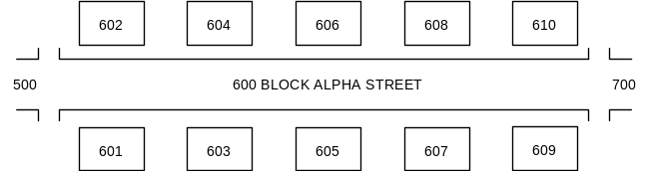
- If some previously existing numbers have been obliterated, an attempt should be made to reestablish the numbering system based upon one or more structures that still display an existing number.

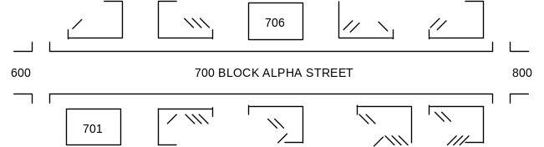
- The damaged building(s) would be assigned numbers to separately identify them as indicated. The front of the structure(s) in question should be clearly marked using International Orange spray paint with the new number being assigned.
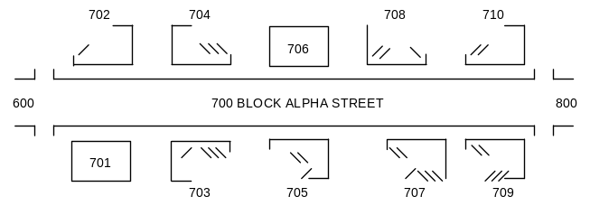
- If no number is identifiable in a given block then TF personnel will identify the street name and the hundred block for the area in question based on other structures in proximity to the site in question.


- In this case, structures will be assigned the appropriate numbers to designate and differentiate them. The front of the structure(s) in question should be clearly marked using International Orange spray paint with the new number being assigned.

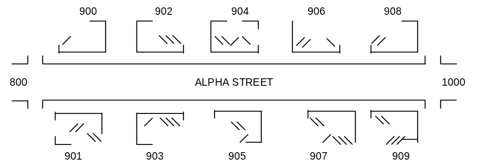
- It is important to identify locations within a single structure.
- The address side of the structure shall be defined as SIDE A. Other sides of the structure shall be defined in a clockwise manner from SIDE A.
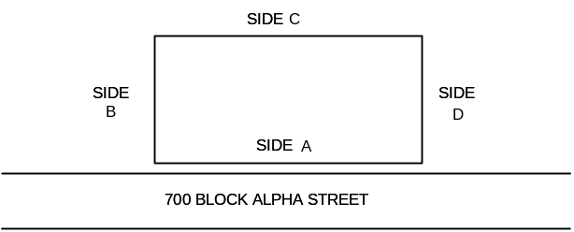

- The interior of the structure will be divided into QUADRANTS. They are identified ALPHABETICALLY, clockwise, starting where the SIDE A/SIDE B perimeters meet.
- The center core, where all four quadrants meet will be identified as Quadrant E (i.e., central core lobby, etc.).

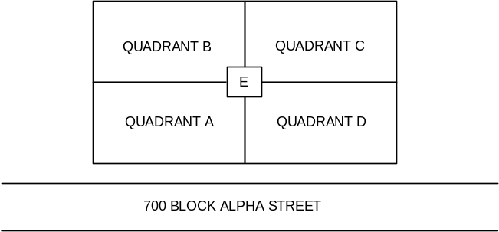
- Multi-story building floors should be numbered as referenced from the exterior, if necessary.
- The grade-level floor is designated floor #1 and, moving upward, the 2nd floor would be floor #2, etc.
- Conversely, the first floor below grade level would be b-1, the second b-2, etc.

Structure Triage
- When a TF arrives at their assigned location, it may be necessary to deploy a Structure Triage Team to assess the affected area. A TF Structures Specialist and Hazardous Materials Specialist should be assigned to this team.
- The triage consists of a three-step process:
- The concise identification and location of buildings for reference;
- A rapid assessment of the affected area; and
- The identification of potential building(s) that require a more detailed assessment.
- When evaluating an area encompassing several to many buildings, it is necessary to perform a rapid visual assessment of each building. This assessment should determine:
- General structural condition;
- Probable occupancy (i.e., office, commercial, retail, residential, etc.); and
- Whether or not obvious access to the interior exists for each building.
- During this assessment the Structure Triage Team will prepare a rough sketch of the general area and identify each building.
- Once a general sweep and rapid assessment of the assigned area has been completed, the team should consult with the TF management personnel to identify a priority scheme for a more detailed analysis of opportune buildings.
- The following factors should be considered in the determination of the priorities for search and rescue operations:
- Occupancy − refers to building use, not the number of occupants.
- Collapse Mechanism − how the building failed will provide an indication of the potential for voids wherein a victim(s) could survive.
- Time of Day − refers to the time of the event which caused the collapse:
  - This is a critical factor when combined with the occupancy type.
  - For example, if an earthquake occurs at 2100 hours and collapses an office building and an apartment building, the apartment building would normally represent the higher potential for a successful rescue than would the office building.
  - If the event occurred at 1000 hours, the opposite would be true.
- Prior Intelligence − information from the general public relating to known trapped victims.
- Search and Rescue Resources Available − does the particular building require resources beyond what is readily available to the TF (is heavy equipment required to gain access).
- Structural Condition of the Building − in general, can search and rescue operations proceed with a minimum of stabilization effort?

Triage Scoring
- The triage scoring process assesses various factors to obtain a numerical score for each structure assessed. The intent of the score is to calculate a figure, where a higher number represents a better risk/benefit ratio.
- A Structure Triage Evaluation Form has been developed for use during the triage phase. (See Appendix D).
- The following categories will be scored:
- Total number of potentially trapped victims
- Condition of voids
- Time required to access victims
- Chance of additional collapse
- Special occupancy information
- "No Go" conditions.

Triage Analysis
- The triage information must be consolidated, summarized, and presented to the TF management personnel for planning and tasking purposes.
- The TFL and appropriate specialists will then analyze the information and begin to:
- Develop an action plan for strategy and tactics;
- Prioritize the work sites;
- Assign resources (Reconnaissance Teams);
- Commence rescue operations, if appropriate; and
- Make a final determination on the location of the TF BoO.

Reconnaissance
- At the conclusion of the rapid structure triage, TF Reconnaissance Teams should be deployed to evaluate each building deemed viable (as a result of the rapid triage) for continued search and/or rescue operations.
- Structure and search marking should be performed during this phase and prior to the initiation of rescue operations.

Task Force Marking Systems
- Information derived from a coordinated building triage and/or search and reconnaissance activities must be consolidated by the TF supervisory personnel.
- This is used to identify operational priorities and also must be forwarded to the local ICP (or other officials in charge) to assist with their overall assessment of the event.
- Information gathered by TF personnel must be represented in a standardized fashion to ensure uniformity and clarity. The TF Marking System is identified and divided into two sections:
- Structure/Hazards Evaluation Marking
- Search Assessment Marking.
- The marking procedures are designed to identify specific information pertinent to each affected building.
- Each component can be completed independent of the other, although normally the Structure and Hazards Evaluation would be completed first.
- It is expected that the TF Structures and HAZMAT Specialists on the Reconnaissance Team would address the Structure and Hazards Evaluation marking while the balance of the team would address the Search Assessment marking.

Structure/Hazards Evaluation Marking
- A 2' X 2' square box is outlined at any entrance accessible for entry into any compromised structure.
- Aerosol cans of spray paint (International Orange color only) will be used for this marking system.
- It is important that an effort is made to mark all normal entry points to a building under evaluation to ensure that TF personnel approaching the building can identify that it has been evaluated and discern its condition.
- Specific markings will be clearly made inside the box to indicate the condition of the structure and any hazards at the time of the assessment.
- Normally the square box marking would be made immediately adjacent to the entry point identified as safe. An arrow will be placed next to the box indicating the direction of the safe entrance if the Structure and Hazards Evaluation marking must be made somewhat remote from the safe entrance.
- The TIME, DATE, and SPECIALIST Identification (ID), will also be noted outside the box at the upper right-hand side. This information will be made with pieces of carpenter's chalk or lumber crayon (as noted in the Structure Specialist's Equipment List).
- All TF personnel must be aware of the possibility of, and look for other Structure and Hazards Evaluation markings made on the interior of the building.
- As each subsequent assessment is performed throughout the course of the mission, a new TIME, DATE, and SPECIALIST ID entry will be made (with carpenter's chalk) below the previous entry, or a completely new marking box made if the original information is now incorrect.

The depiction of the various markings is as follows:

 |  |  | Structure is accessible and safe for search and rescue operations. Damage is minor with little danger of further collapse.
 | Structure is significantly damaged. Some areas are relatively safe, but other areas may need shoring, bracing, or removal of falling and collapse hazards. The structure may be completely pancaked.
 | Structure is not safe for search and rescue operations and may be subject to sudden additional collapse. Remote search operations may proceed at significant risk. If rescue operations are undertaken, safe haven areas and rapid evacuation routes should be created.
 | Arrow located next to a marking box indicates the direction to the safe entrance to the structure, should the marking box need to be made remote from the indicated entrance.
 |  | Indicates that a HAZMAT condition exists in or adjacent to the structure. Personnel may be in jeopardy. Consideration for operations should be made in conjunction with the Hazardous Materials Specialist. Type of hazard may also be noted.

- The TIME, DATE, and TF ID, are noted outside the box at the upper right-hand side. This info is made with carpenter's chalk or lumber crayon. An optional method is to apply duct tape on the exterior of the structure and write the information with a grease pencil or black marker.

7/15/91 1310 hrs.
HM - natural gas
CA-TF1

The example indicates that a safe point of entry exists above the marking (possibly a window, upper floor, etc.). The single slash means the structure may require some shoring and bracing. The assessment was made on July 15, 1991, at 1:10 PM. There is an apparent indication of natural gas in the structure. The evaluation was made by TF #1 out of the State of California.
- All TF personnel must be aware of the possibility of, and look for other Structure and Hazards Evaluation markings made on the interior of the building.
- As each subsequent assessment is performed throughout the course of the mission:
- A new TIME, DATE, and TF ID entry will be made below the previous entry; and/or
- A completely new marking box made if the original information is now incorrect.
- Marking boxes are also placed in each of the specific areas within the structure (i.e., rooms, hallways, stairwells, etc.) to denote conditions in separate parts of the building.

Search Assessment Marking
- A separate and distinct marking system is necessary to conspicuously denote information relating the victim location determinations in the areas searched.
- The Search Assessment marking system is designed to be used in conjunction with the Structure and Hazards Evaluation marking system.
- An "X" that is 2' X 2' in size will be made with International Orange color spray paint. This X will be constructed in two operations:

1400 hr  CA-TF1 | Single slash drawn upon entry to a structure or area indicates search operations are currently in progress. The time and TF identifier are posted as indicated.
 | Crossing slash drawn upon personnel exit from the structure or area.

- Distinct markings will be made inside the four quadrants of the X to clearly denote the search status and findings at the time of this assessment.
- The marks will be made with carpenter chalk, lumber crayon, or duct tape and black magic marker.

 | LEFT QUADRANT - US&R TF identifier
 | TOP QUADRANT - Time and date that the TF personnel left the structure.
 | RIGHT QUADRANT - Personal hazards.
 | BOTTOM QUADRANT - Number of live and dead victims still inside the structure. ["0" = no victims]

- It is important that markings are made specific to each area of entry or separate part of the building.
- If no victims are found, it is noted with a "0" below.
- Situation updates are noted as they are available:
- Previous search markings are crossed out; and
- New markings are placed below (or next to) their previous markings with the most recent information.

Search Strategy and Tactics

TACTICAL SEARCH OPERATIONS

Canine Search
- A Canine Search Team is usually comprised of two search canines and handlers and one Search Team Manager. The staffing of the TF search element allows for two separate canine teams to be deployed early in the mission.
- The Search Team Manager will sketch the general features of the structure or area being searched noting any significant information on the sketch and forward it to the Planning Section.
- Should either of the canine teams indicate a find, the Search Team Manager will pull that team away from the find location. The handler involved in the find should mentally note the exact location but not mark it at this time. The Search Team Manager will then direct the second canine team into the same general area. If the second team provides an indication of a find at the same location, this position is marked. The Search Team Manager will then pass this information on to the TFL and Rescue Team Manager for subsequent action. The search team then continues with its assignment.

Electronic Search
- Technical search personnel use electronic acoustic/seismic listening devices as their primary tool. These personnel may also use fiber-optic equipment, thermal imaging (if available on site), or other sophisticated equipment as necessary.
- A sketch of the general features of the structure or area being searched is made noting any significant information. This information is then forwarded to the Planning Section.
- The general application of the acoustic/seismic device involves the deployment of an array of two or more pick-up probes around the perimeter of a building or void area.
- A bull horn or other hailing device should be used to attempt to give direction to any conscious victim trapped within the structure.
- The victim is directed to make a repetitive sound (i.e., "keep knocking five times").
- The area should be made as quiet as possible.
- In the same manner as the redundant canine find determination, the second Technical Search Specialist (or other TF member skilled in acoustic/seismic devices) should be used to confirm the initial find. If second operator provides an indication at the same location, it should be marked. This information would then be passed on to the TFL, and Search and Rescue Team Managers for action.
- Fiber-optic viewing equipment, especially when used in conjunction with concrete hammer/drills, is effective for pinpointing the location of victims, although it may also be used for general void searches within collapsed buildings.
- Personnel may drill an array or series of holes (in a floor space for example). Operators follow along with the fiber-optic device(s) making quick assessments.
- Due to its actual visual indication of a victim, no redundant check is usually required. If the operator is required to move on for subsequent operations, the site should be marked with red tape to indicate a live victim. This information would then be passed on to the TFL, and Search and Rescue Team Managers for action.
- The specialists should sketch the general features of the structure and area being searched noting any significant information on the sketch for future reference.

Physical Search
- Physical search operations include deploying personnel over and around a collapse site. These personnel can make separate visual assessments in voids and confined space areas for any indication of victims. They may also be used in a coordinated fashion as an array of listeners.
- A bull horn or hailing device would be used to provide direction to trapped victims. The area is then quieted and the personnel listen and attempt to pinpoint the location of the noise.
- This operation is more exacting than the others and poses a significant risk to the personnel involved in the operation.

SEARCH STRATEGY

Large Scale Search Prioritization
- Two general strategies may be used to decide how to deploy TF search resources:
- The first would be to sector the area in question. Depending upon the size of the damaged area and the search resources available, an area may be sectored by city block or other easily definable criteria. The available search resources would be divided and apportioned to each sector for search operations. The sector strategy may work well for smaller areas but would most likely prove impractical for larger areas (such as part or all of a city or jurisdiction) in relation to the limited search resources available.
- The second method would be to determine the search priorities in terms of the type of occupancies affected. Those that present the highest likelihood of survivability (in terms of type of construction) and the number of potential victims (in terms of the type of occupancy of the building) would receive attention first. Occupancies such as schools, hospitals, nursing homes, high rise and multi-residential buildings, office buildings, etc., would be searched first.

Reconnaissance Team
- TF staffing allows for two Reconnaissance Teams. Both can be deployed initially and subsequently alternate operational periods for sustained operations.
- A Reconnaissance Team includes:
- Search Team Manager − is the team supervisor, sketches, records info, communicates details and recommendations to the TFL.
- Canine Search Specialist − conducts canine search operations and redundant verifications of alerts.
- Technical Search Specialist − conducts electronic search operations.
- Medical Specialist − provides treatment for located victims and/or TF members.
- Structures Specialist − provides analysis and advice regarding building stability, shoring, and stabilization.
- HAZMAT Specialist − monitors atmospheres in and around voids and confined spaces. Assesses, identifies, and marks HAZMAT dangers.
- Rescue Specialist − provides assistance to the Reconnaissance Team, including drilling and breaching for electronic viewing equipment and/or deployment of listening arrays.

The following operations may be conducted by a Reconnaissance Team:
- General area or building reconnaissance and evaluations. This will be addressed in the structure triage, assessment, and marking system presentation.
- Victim location identification. This would include canine, electronic, and physical search operations. The location of viable victims would be denoted by marking the location.
- Hazard identification and flagging. Any type of personal hazard should be assessed and identified, such as overhanging building components, structural instability or secondary collapse zones, hazardous materials, live utilities, etc. Hazard zones should be conspicuously cordoned off with surveyors tape or Fire Line tape.
- Assess general atmospheric conditions in and around confined spaces or voids.
- Sketch the general search area and note all significant issues. Communicate findings and recommend priorities to the TFL and the Planning Section.
- The following equipment and supplies, as a minimum, are required:
- Electric hammer-drills
- Electronic viewing equipment
- Electronic listening devices
- Atmospheric monitoring equipment
- Marking materials
- Alerting devices
- Medical pack
- Personal gear – per person.

Rescue Operations

Rescue Site Management and Coordination
- Each rescue work site must have one person designated in charge to maintain unity of command, usually designated as the Rescue Squad Officer. He/she has authority over all TF personnel, including those from other disciplines, involved in the operation at that rescue site.
- Larger or more complex rescue operations may require the commitment of two or more rescue squads to a single operation. When two or more rescue squads are assigned to operate together, the Rescue Team Manager may assume command or assign one of the Rescue Squad Officers to be in charge of the site (this must be clearly communicated to all personnel involved). A Safety Officer should be assigned to larger or more complex operations.

Non-Task Force Resource Requests/Liaison
- It may sometimes be necessary to request assistance from personnel or organizations outside the TF. This could include assistance from military personnel, utility contractors, heavy equipment operators, etc. The Rescue Team Managers should relay these requests through the TFL.
- Management and supervision of non-TF resources is of critical importance to the overall safety and effectiveness of the rescue operations.
- Personnel used in this fashion should be somehow identified (i.e., Fire Line tape or surveyor's tape used as an arm band).
- Basic safety gear (goggles/hard hat) should be provided.
- Close supervision is required for personnel with little or no rescue training.
- Basic safety and hazards assessment briefing should be provided for them.

Rescue Site Engagement/Disengagement
- A standardized method of engaging and exiting (disengaging) a rescue site should be followed.
- Rescue personnel must adhere to a consistent, formalized site management procedure to ensure the safe, effective operation of the rescue squad(s).
- At the same time, the Rescue Specialists should begin to take firm control of the immediate site, including:
- Hazard assessment and mitigation;
- Shut down of all utilities;
- Collapse hazard zone (hot zone) established;
- Rescue work zone should be clearly defined;
- All bystanders removed; and
- Equipment assembly area/cutting work station organized
- Once the size-up is completed and the plan of action developed, a short team briefing should be conducted. The TF Operations Report has been developed and can be used for this purpose.

Evaluating Rescue Opportunities
- There are generally five phases of rescue operations at collapse incidents:
- Phase One: Assessment of the collapse area.
  - Area searched for possible victims (surface/buried);
  - Evaluation of the structure's stability; and
  - Utilities evaluated and shut down for safety.
- Phase Two: Remove surface victims as quickly and safely as possible.
- Phase Three: All voids and accessible spaces searched and explored for viable victims.
  - An audible call out system can be used during this phase.
  - Only trained canine or specially-trained personnel should be used in voids/accessible space searches.
- Phase Four: Selected debris removal (using special tools/techniques) may be necessary after locating a victim.
- Phase Five: General debris removal is usually conducted after all known victims have been removed.
- The most perplexing strategic decisions will probably involve choices between multiple rescue opportunities that surpass the rescue resources of a TF. In this situation, TF management personnel must prioritize rescue opportunities. Factors include:
- Victim(s)’ viability and longevity;
- Degree of difficulty and duration of each rescue;
- Possible end results of rescue efforts (i.e., a single rescue operation yielding the extrication of two or more victims, etc.); and
- Safety considerations for rescue personnel.

Operations Site Set-up
- Control of the area immediately surrounding the selected work site must be established before rescue operations commence.
- An Operational Work Area is established to control access to the rescue work site except for assigned TF members and other local rescue personnel involved in an operation, and to provide safe and secure work areas for the personnel supporting the rescue operations.
- The Operational Work Area is identified by a single, horizontal cordon of flagging or rope as depicted below:
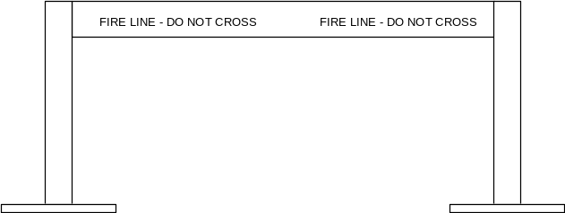

- A Collapse/Hazard Zone is established to control access to the immediate area that could be affected or impacted by further building collapse, falling debris, or other hazardous situations (i.e., aftershocks). The only individuals that will be allowed within this area are the primary TF personnel directly involved in search for or extrication of victims. All other TF personnel must be located outside the hot zone until assigned or rotated.
- The Collapse/Hazard Zone will be identified by an X-type cordon of flagging as depicted below:
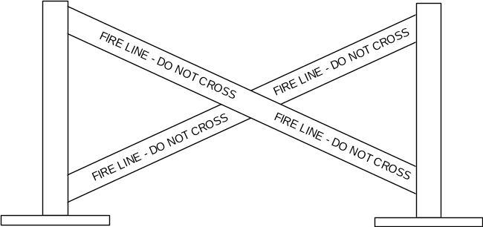

Operations Site Set-up
- When establishing the perimeter of the operational work area, the needs of the following support activities must be provided for and properly identified:
- Access/Entry Routes (Personnel Accountability Location) – a clearly defined avenue(s) should be planned and identified for access to and from the rescue work site. Personnel, tools, equipment, and other logistics needs would be safely channeled through this route. In addition, controlled egress would be required to quickly evacuate a victim or injured TF member.
- Emergency Assembly Area – location(s) where TF personnel assemble following an emergency evacuation.
- Medical Treatment Area – location where the TF medical team can set-up operations and provide treatment to TF members and extricated victims.
- Personnel Staging Area – where unassigned TF members can rest, eat, and be immediately available in case the assigned rescue workers become trapped.
- Equipment Staging Area – where assigned tools and equipment can be safely stored, maintained, and issued as needed to support the operation.
- Cut Station – where building materials/lumber can be stored and processed as needed to support the on site search and rescue operations.

Inter-Discipline Coordination
- Structures Specialists must be involved in ongoing rescue extrication operations.
- Hazardous Materials Specialists should assist with initial site analysis prior to US&R operations. This includes identification of any hazardous products, evaluation of the general atmosphere around/within the structure, and periodic reviews.
- Medical Specialists provide medical assessment, intervention, and stabilization which are essential to the eventual survival of the entrapped victim. Rescue personnel should ensure that Medical Team personnel have access to the victim as soon as possible. This may require temporary cessation of rescue operations.
- Heavy Equipment and Rigging Specialists may provide recommendations during rescue operations requiring the integration of cranes, large scale lifting operations, heavy equipment movement, etc. In addition, they must act as liaison between the rescue squad(s) conducting the rescue and non-TF equipment operators who may not fully understand the tactics and subtleties involved.
- Technical Information Specialists will document significant aspects of a rescue.
- Rescue Squad Officers may have to integrate other non-TF personnel into ongoing operations, including utilities, law enforcement, military, and volunteer personnel.

Site/Personnel Safety

Emergency signaling and evacuation procedures must be understood and immediately recognized. Alerting devices shall be used to sound the appropriate signals as follows:
- Cease Operation/All Quiet 1 long signal (3 seconds)
- Evacuate the Area 3 short signals (1 second each), followed by pause, repeated until all members are accounted for
- Resume Operations 1 long and 1 short signal.

Communications Procedures
It is extremely important for clear, concise communications between the separate entities, or between personnel within those entities, that will be involved in response to an urban disaster.

Task Force Designations

Each TF will be identified by a unique radio call sign. The call sign includes the state of origin of the TF and a distinguishing number to differentiate each TF from that State.

The following TF designation will identify the currently accepted TFs sponsored by the listed sponsoring organizations:

Arizona AZ-1 Phoenix Fire Dept.
California CA-1 Los Angeles City Fire Dept.
CA-2 Los Angeles County Fire Dept.
CA-3 Menlo Park Fire Dept.
CA-4 Oakland Fire Dept.
CA-5 Orange County Fire Dept.
CA-6 Riverside City Fire Dept.
CA-7 Sacramento Fire Dept.
CA-8 San Diego Fire Dept.
Colorado CO-1 State of Colorado
Florida FL-1 Miami-Dade County
Florida FL-2 City of Miami
Indiana IN-1 City of Indianapolis
Maryland MD-1 Montgomery County Fire Dept.
Massachusetts MA-1 City of Beverly
Missouri MO-1 Boone County Fire Protection District
Nebraska NE-1 City of Lincoln
Nevada NV-1 Clark County
New Mexico NM-1 State of New Mexico
New York NY-1 New York City Fire and Police Depts.
Ohio OH-1 Miami Valley, Ohio
Pennsylvania PA-1 State of Pennsylvania
Tennessee TN-1 Memphis/Shelby County E.M.A.
Texas TX-1 State of Texas
Utah UT-1 State of Utah
Virginia VA-1 Fairfax County Fire Dept.
VA-2 Virginia Beach Fire Dept.
Washington WA-1 Pierce/King Counties

VOICE COMMUNICATIONS PROCEDURES

Phonetic Alphabet

A - alpha (AL fah) N - november (no VEM ber)
B - bravo (BRAH voh) O - oscar (OSS car)
C - charlie (CHAR lee) P - papa (pah PAH)
D - delta (DELL tah) Q - quebec (keh BECK)
E - echo (ECK oh) R - romeo (ROW me oh)
F - foxtrot (FOKS trot) S - sierra (SEE air rah)
G - golf (GOLF) T - tango (TANG go)
H - hotel (HOH tell) U - uniform (YOU nee form)
I - india (IN dee ah) V - victor (VIK tah)
J - juliet (JEW lee ett) W - whiskey (WISS key)
K - kilo (KEY low) X - x-ray (ECKS ray)
L - lima (LEE mah) Y - yankee (YANG key)
M - mike (MIKE) Z - zulu (ZOO loo)

Medical Procedures
TREATMENT PRIORITIES

The treatment priorities for the TF Medical Team are:
- First TF personnel, TF search canine and support staff
- Second victims directly encountered by the TF
- Third other injured as practical.

The TF Medical Team, being medically sophisticated, may be handing off a potentially unstable patient to a less sophisticated, interim level of medical provider for transport to definitive care. This is considered to be standard practice under the circumstances of disaster operations.

MISSION CONSIDERATIONS

- Upon activation, the Medical Team of each TF operates under the authority of the NDMS. Prior to any deployment a Task Force Medical Team member must have an Application for Federal Employment (OF-612), Employment Eligibility Verification (I-9), NDMS Member Information form, Declaration of Federal Employment (OF-306), Appointment Affidavit (SF-61) and NDMS Volunteer Agreement on file with USPHS. These forms are available at: www.opm.gov/forms/index.htm.
- Upon activation, the Appointment Affidavits (SF-61), Declaration of Federal Employment (OF-306) and NDMS Volunteer Agreement can be sent via Federal Express to NDMS. A roster of Medical Team personnel being deployed must be faxed to NDMS at: 800-450-3595 or 800-USA-KWIK (800-872-5945).

The TF Medical Team Manager and IST Medical Unit Leader will need to consider the following medical infrastructure factors from point of departure staging, travel, point of arrival staging, base of operations activity, field operations, and through demobilization:
- Local in-patient medical facilities
- Location, points of contact, staffing, contact numbers, hours of operations, capabilities, biohazardous waste disposal resource, and transportation mode.
- Capabilities include: clinic or basic or comprehensive emergency department, radiology (plain films and computed tomography), pharmacy, trauma (including replantation), burn, pediatrics and percutaneous coronary interventions.
- Local EMS
- Structure (fire, private, third service), access, capabilities, medical oversight, closest first response units, closest ALS units, HAZMAT, air medical evacuations (public or private), air rescue, communications, familiarity with US&R BoO, contact information and points of contact.
- Federal resources associated with US&R mission
- DMATs, MMRS, NMRT, DMORT, VMATs, EPA, CDC, NPS, and FBI
- Locations, capabilities, mission assignments, contacts/communication, points of contact.
- Local public health
- Location, points of contact, contact information, capabilities, laboratory resources.
- Local out-patient medical facilities
- Clinics, physician offices: locations, points of contact, contact information, capabilities, hours of operations
- Dental clinics and dentists: location, hours of operation.
- Veterinary medical facilities
- Veterinary hospitals with emergency services: location, points of contact, contact information, hours of operations
- Veterinarians: access for telephone consultations, office locations, availability, familiarity with working dogs, contact information, hours of operation.
- Medical/pharmaceutical resupply (other than DHS/FEMA and NDMS)
- Local pharmacies, locations, hours of operations, fax copy of US&R physicians medical license and DEA certificate, methods of payment.
- US&R IST contact information
- Medical examiner/coroner contact information
- Poison Information Center contact information
- ESF-8 and ESF-9 contact information
- Biohazardous waste disposal options
- Forms ICS 215 and US&R 15 are used to track and organize this information.

Patient Transfer Considerations

Medical Team members and essential non-replaceable equipment should not be transported away from the work site for continued patient care. The only exceptions may be for the transport of injured or ill TF personnel or seriously ill victims who need to be accompanied by a TF Medical Team member. This may occur at the Medical Team Manager's discretion if it does not compromise the capability to care for TF members and additional victims.

Patient Documentation
- The NDMS Patient Care Report creates written documentation of each patient's assessment and any medical intervention performed by the TF Medical Team.
- These forms will be used to record all care, including that provided to TF personnel, and will:
- Provide documentation of the transfer of a patient from the TF's control to other medical resources; and
- Assist tracking follow-up care for patient outcome studies.
- Prior to transport, the NDMS Patient Care Report will be completed documenting the complete patient care performed by the TF Medical Team (per instructions) and will be attached to the victim. A copy of each completed Patient Care Report must be maintained by the Medical Team.
- For minor medical care given to Task Force members, documentation of injuries or illnesses is made in the Task Force Injury/Illness Log. This log is submitted to the IST Medical Unit Leader at the end of each operational period and is used to track trends in injuries or illnesses and design appropriate interventions.

Controlled Drug Accountability

The Controlled Drugs Accountability Form will be used for tracking and documenting the disposition of controlled-substance medications. The Medical Team Managers are responsible for maintaining all medical-related forms throughout the course of the mission.

Medical Care For Injured Task Force Members
- Any TF member requiring medical attention shall have documentation completed, including but not limited to:
- The Patient Care Report;
- Their sponsoring agency's internal reports and forms; and
- U.S. Department of Labor form CA-1 (refer to the Federal Injury Compensation Guidelines in the National Disaster Medical System (NDMS) Disaster Medical Assistance Team (DMAT) manual for copies and explanation).
- The Medical Team should assist with all other documentation to support follow-up investigation (Worker’s Compensation, etc.).

EVACUATION PROCESS FOR TASK FORCE MEMBERS
- The IST Medical Unit Leader shall recommend the optimal medical destination and method of transport to that destination.
- TF personnel may be assigned to escort the injured member to assure optimal care for the injured member.
- The TFL will communicate all pertinent details through the local ICP, and DHS/FEMA communications channels back to the injured member's sponsoring organization.
- The TFL or Medical Team Manager will brief all personnel on the occurrence, the member's condition, destination, and the care provided. Periodic updates of TF members' injuries and condition will be conducted as warranted.
- The TF/IST must identify, in advance, the medical evacuation system for any seriously injured or ill TF member (or canine). The evacuation system should include plans for continued management of the TF member's illness or injury until delivery to an appropriate definitive care center.

Death of a Task Force Member
- In the event of death of a TF member, the Medical Team Manager shall verify the identity and confirm the death of the individual. The probable cause of death should be specified, if possible. This information must be provided to the TFL as soon as possible.
- Security should be ensured for the deceased member's personal items, such as wedding rings and watches, etc.
- The TFL should assign a TF member to accompany the remains to original Point of Departure. Transfer of the remains must be coordinated with:
- Local Incident Command staff
- DHS/FEMA officials
- Local Medical Examiner/Coroner
- ESF #8 Disaster Mortuary Operations Team (DMORT) representative
- Department of Defense (DoD) officials.
- The Medical Team Manager must initiate all appropriate documentation to record the details regarding the cause of death and support the Safety Officer’s investigation.

Reassignment And Demobilization
- The Medical Team Manager must assist in evaluating the capabilities of the TF medical personnel, equipment, and supplies to accept a new assignment, if necessary.
- The evaluation of the TF personnel's physical and mental capabilities, as well as the operations and stressors already sustained, will weigh greatly on this determination.
- Any operational losses and potential maintenance requirements of supplies, medicines, and equipment must be documented.
- The Medical Team Manager must ensure that appropriate medical supplies and equipment are maintained by Medical Team members throughout the course of a reassignment or demobilization.

Post-Mission Activities
- The Medical Team Manager should submit documentation to the TF Technical Information Specialist for After-Action Reports. This should include reviewing pertinent position descriptions, operational checklists, and protocols for recommended changes.

Hand Signals

Helicopter Hand Signals

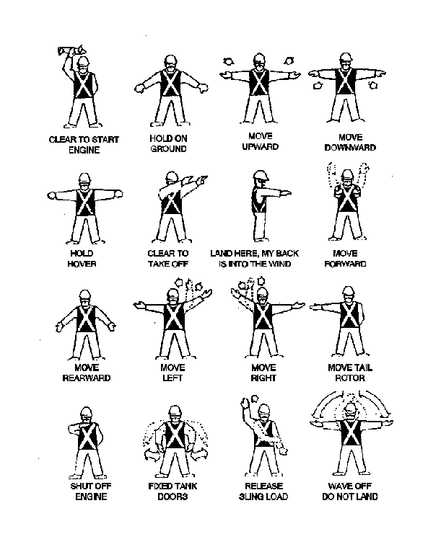

Crane Hand Signals
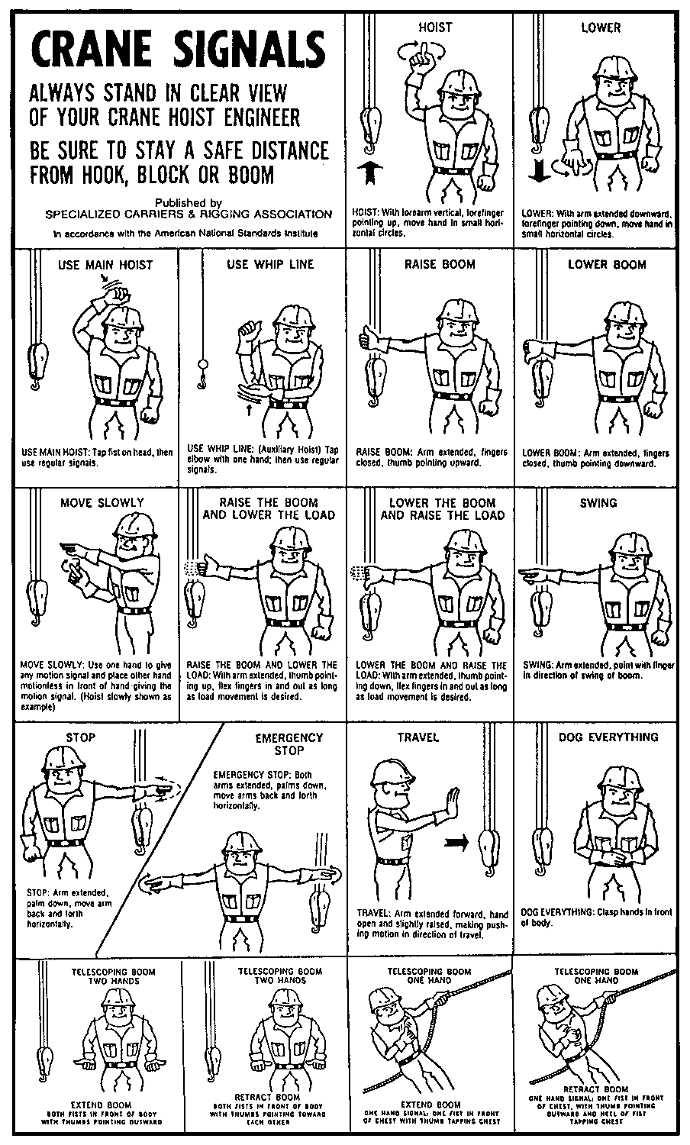

Military Aircraft Specifications

Military Aircraft Capabilities

Aircraft  Type | Cargo Capability (Tons) | Passenger Capability | Airspeed (MPH)
C-130 | 11.6 | 90 | 260
C-141 | 27.3 | 200 | 390
C-17 | 35.7 | 100 | 390
KC-10 | 37.8 | N/A | 425
C-5 | 73.5 | 73 | 415

Allowable Cabin Loads (ACL)

Type Aircraft | Passenger Seats (ACL) | Cargo Tons (ACL)
Wide-body Aircraft:
B-747 | 400-479 | 90
DC-10 | 280-330 | 75
L-1011 | 280-300 | 60
MD-11 | 360-402 | 82-86
Narrow-body Aircraft:
A-310 | 210 | 0
DC 8-61 | 0 | 45
DC 8-62 | 0 | 39.2
DC 8-62/61 | 0 | 39.2
DC 8-63/73 | 0 | 45
B 707-320 B/C | 180 | 36.5
B 727, B 737 | 94-160 | 22
B 757-200 | 190 | 0
B 767 | 200-240 | 0
DC 9-30 | 0 | 17
L-100 | 0 | 23

Task Force Media Procedures

Information flow related to disaster response activities will be managed and coordinated by the DHS/FEMA Headquarters Office of Public Affairs.
- On-site Media procedures will be established by the local authorities. The IST will liaison with the TFs regarding all media activities.
- Interviewing “Do's":
- Ask the reporter’s name. Then use it in response;
- Use full name. Nicknames are not appropriate;
- Choose the site (if possible). Make sure you are comfortable with the location of the interview. Consider what is in the background;
- Choose the time (if possible). If you would be more comfortable waiting another five minutes, ask the reporter if that's okay;
- Be calm. Demeanor and apparent control of the situation are very important in establishing the tempo of evolving events;
- Tell the truth;
- Be cooperative. There is an answer to most questions, and if you don’t know it now, let them know you will work diligently to determine the facts needed;
- Be professional. Don’t let personal feelings about the media in general, or this reporter specifically, affect response;
- Be patient. Expect dumb questions. If the same question is asked again, repeat answer without irritation;
- Take time. If you make a mistake during a taped or non-broadcast interview, indicate that you would like to start over with response, if appearing live, just start over; and
- Use wrap-around sentences. This means repeating the question with answer for a complete sound byte.
- Interviewing “Don'ts”:
- Say "no comment";
- Give personal opinion. Stick to the facts;
- Go off the record. Anything you say can and will be used against you;
- Lie. To tell a lie unintentionally is a mistake. To intentionally tell a lie is stupid;
- Bluff. The truth will come out;
- Be defensive. The media and their audience recognize a defensive attitude and tend to believe you're hiding something;
- Be afraid. Fear is debilitating and is not a characteristic you want to portray;
- Be evasive. Be up front on what you know about the situation, and what you plan to do to mitigate the incident;
- Use jargon. The public is not familiar with much of the language used in the US&R field;
- Confront. This is not the time to tell a reporter how much you dislike the media;
- Try to talk and command an incident at the same time. You won’ do either well.
- Wear sunglasses;
- Smoke;
- Promise results or speculate; and
- Repeat leading questions.
APPENDIX A

ACRONYMS AND ABBREVIATIONS

ACL | Allowable Cabin Loads
AP | Assembly Point
BoO | Base of Operations
CISD | Critical Incident Stress Debriefing
cm | Centimeters
Dept. | Department
DFO | Disaster Field Office
DHS | Department of Homeland Security
DMAT | Disaster Medical Assistance Team
DMORT | Disaster Mortuary Team
DoD | Department of Defense
DOT | Department of Transportation
EMA | Emergency Management Agency
EP&R | Emergency Preparedness and Response
ERT | Emergency Response Team
ESF | Emergency Support Function
EST | Emergency Support Team
FCO | Federal Coordinating Officer
FEMA | Federal Emergency Management Agency
FIRESCOPE | Firefighting Resources of California Organized for Potential Emergencies
FOG | Field Operations Guide
FRP | Federal Response Plan
HAZMAT | Hazardous Material(s)
i.e. | Example
IAP | Incident Action Plan
IC | Incident Commander
ICP | Incident Command Post
ICS | Incident Command System
ID | Identification
IDLH | Immediate Danger to Life or Health
IST | Incident Support Team
JIC | Joint Information Center
km | Kilometers
kph | Knots per Hour
ml | Milliliters
mm | Millimeters
mph | Miles per Hour
MOA | Memorandum of Agreement
Mob Center | Mobilization Center
MOU | Memorandum of Understanding
NDMS | National Disaster Medical System
NEMIS | National Emergency Management Information System
NIIMS | National Interagency Information Management System
Ops | Operations
PCF | Patient Care Form
POA | Point of Arrival
POC | Point of Contact
POD | Point of Departure
PPE | Personal Protective Equipment
RST | Regional Support Team
SOP | Standard Operating Procedure
TF | Task Force
TFCP | Task Force Command Post
TFL | Task Force Leader
US&R | Urban Search and Rescue

APPENDIX B

GLOSSARY OF COMMON TERMS

------------- A -------------

Activation − Formal request from DHS/FEMA to a TF via the Point of Contact, that an event has occurred or is projected to occur, that requires mobilization and response for a mission.

Advisory − Formal notification by DHS/FEMA to all TFs that an event is imminent or has occurred but does not require action at this time.

After-Action Debriefing Form − Used by the TF managers at the conclusion of a mission to collect and categorize appropriate information.

After-Action Meeting − A formal meeting of the TF personnel assigned to a mission after return from the field.

After-Action Report − Documentation of TF actions and other pertinent information.

Alert − Formal notification by DHS/FEMA to identified TFs that a disaster is imminent or has occurred that may result in activation.

Assembly Point (AP) − Location or facility where TF members initially report after receiving activation orders from the sponsoring organization.

------------- B -------------

Base of Operations − TF base camp used to facilitate mission activities.

------------- C -------------

Cache − A DHS/FEMA-approved complement of tools, equipment, and supplies stored in a designated location, available for emergency use.

Collapse hazard zone − The area established by the TF for the purpose of controlling all access to the immediate area of the collapse.

------------- D -------------

Demobilization − The process used to plan for and implement the return of TFs to their original Point of Departure.

Department of Homeland Security (DHS) − The executive department of the United States [whose] primary responsibility is to: (a) prevent terrorism; (b) reduce the vulnerability of the United States to terrorism; (c) minimize the damage, and assist in the recovery, from terrorist attacks that do occur within the United States; (d) carry out all functions of entities transferred to the Department, including by acting as a focal point regarding natural and manmade crises and emergency planning; (e) ensure that the functions of the agencies and subdivisions within the Department that are not related directly to securing the homeland are not diminished or neglected except by a specific explicit Act of Congress; (f) ensure that the overall economic security of the United States is not diminished by efforts, activities, and programs aimed at securing the homeland; and (g) monitor connections between illegal drug trafficking and terrorism, coordinate efforts to sever such connections, and otherwise contribute to efforts to interdict illegal drug trafficking.

Disaster Field Office (DFO) − The temporary office established in or near the designated disaster area from which the Federal Coordinating Officer and staff, the Emergency Response Team, the State Coordinating Officer and staff (when possible), and regional response organizations coordinate response activities.

Disaster Medical Assistance Team (DMAT) − The basic medical unit of the National Disaster Medical System (NDMS). All TF Medical Teams will be registered as a "specialized" DMAT with the NDMS.

------------- E -------------

Emergency signaling − Signals produced by warning devices on the US&R work site to address evacuation of the area, cease operations or quiet the area, and resume operations.

Engagement/disengagement − Procedures followed by a TF when beginning or ending operations at a specific work site or assigned area.

Emergency Response Team (ERT) − The interagency group assembled to assist the assigned FCO in carrying out his/her disaster response coordination responsibilities. The ERT coordinates the overall Federal disaster response reporting on the conduct of specific operations, exchanging information, and resolving issues related to ESFs and other response requirements. ERT members respond and meet as requested by the FCO.

ERT ESF #9 Leader − The position on the ERT that assumes management and coordination of ESF #9 resources when the RST transfers all US&R responsibilities to the ERT and when the IST is operational in the field. The ERT ESF #9 Leader coordinates all US&R activities with the State, the Emergency Services Branch Chief, the IST ESF #9 Assistant, and the EST ESF #9 Leader.

Emergency Support Function (ESF) – A functional area of response activity established to facilitate the delivery of Federal assistance required during the immediate response phase of a disaster to save lives, protect property and public health, and to maintain public safety. ESFs represent those types of Federal assistance which the State will most likely need because of the overwhelming impact of a catastrophic or significant disaster on its own resources and response capabilities, or because of the specialized or unique nature of the assistance required. ESF missions are designed to supplement State and local response efforts.

ESF #9 − National US&R Response System

ESF #9 Assistant − The position located with the IST that provides management oversight to the IST. The ESF #9 Assistant coordinates with the EST and ERT ESF #9 cells, the IST Leader, Task Force Leaders, local and State incident management personnel, and supporting ESFs.

ESF #9 cell (at the DFO) − DHS/FEMA representatives at the DFO who coordinate State requests for US&R resources.

EST ESF #9 Leader − The individual at working at the EST responsible for assessing requests for US&R Task Forces, alerting, activating and deploying ESF #9 resources when approved and overseeing ESF #9 mission assignments, staffing, information and planning, and demobilization activities.

ESF #9 Leader − The individual at DHS/FEMA Headquarters responsible for assessing requests for US&R TFs.

Emergency Support Team (EST) − The Emergency Support Team (EST) is organized, using Incident Command System (ICS) functional groupings of management, operations, logistics, information and planning, and administration/finance, for the activation of the EST, of Federal resources, and mission assignments. The EST coordinates requests for additional resources and receives situation reports.

------------- F -------------

Federal Emergency Management Agency (FEMA) − Agency with primary responsibility for ESF #9 (Urban Search and Rescue.)

Federal Coordinating Officer (FCO) − The senior official in charge at the DFO who manages all Federal response activities.

Federal Response Plan (FRP) − The Federal Government's plan of action to assist affected States and local jurisdictions after a major disaster or emergency.

------------- I -------------

Incident Action Plan (IAP) − A document developed by the ICS management team that identifies all incident objectives, strategies and tactics, and assigns responsibilities.

Incident Command Post (ICP) − The location where the local jurisdiction's primary command functions are executed.

Incident Commander (IC) − The local jurisdiction's person responsible for the management of all incident operations.

Incident Daily Briefing Form − A form for conducting planning sessions and briefings during the course of a mission.

Incident Support Team (IST) − The IST provides a group of highly qualified specialists readily available for rapid assembly and deployment to a disaster area. The IST furnishes Federal, State, and local officials with technical assistance in acquiring and using US&R resources. It provides advice, Incident Command assistance, management, and coordination of US&R Task Forces, and US&R logistics support.

Initial TF Briefing Form − A form developed for use during the activation phase of the response.

------------- J -------------

Joint Information Center (JIC) − The physical location where Public Information Officers collocate and form the core of the Joint Information System.

------------- L -------------

Load master − Individual responsible for all matters associated with preparing the TF equipment, supplies, and personnel during the palletizing, loading, in-flight logistics, and down-loading of the aircraft.

Local Emergency Operations Center (EOC) − Each local jurisdiction will usually have an EOC to coordinate response to and support of moderate to large-scale incidents. Initial damage and needs assessment information is consolidated at this point to determine response needs and State and Federal asset requirements. Authority for the management of a disaster rests with the local officials and/or Incident Leader of the affected jurisdictions. State and Federal response is in support of local requests once local resources and capabilities are overwhelmed.

Local jurisdiction − The affected locality/government that has the mandated responsibility for managing the disaster within its borders or boundaries.

------------- M -------------

Medical Team Fact Sheet − An informational sheet outlining the capabilities and requirements of the TF Medical Team.

Memorandum of Agreement (MOA) − The document between an organization sponsoring a TF and DHS/FEMA outlining all agreements and responsibilities.

Memorandum of Understanding (MOU) − Written agreements developed on site between the IST and jurisdictional incident management personnel to ensure a complete understanding of the scope, nature and requirements of the ESF #9 assignment.

Mobilization Center − A temporary facility used to receive process and support resources/TFs during the mobilization and demobilization phases of a mission.

------------- N -------------

National Disaster Medical System (NDMS). − A system under the auspices of NDMS used during natural disasters or emergencies.

------------- O -------------

Operational checklist − A chronological listing of considerations and/or tasks that the identified user should address when carrying out mission assignments.

Operational period − The time interval scheduled for execution of a given set of US&R actions.

Operational procedures − Documents developed to address strategies and tactics that a TF may be required to address and execute during a mission response.

Operational work area − The area established by the TF for controlling all activities in the immediate area of the work site.

Operations Chief − The position in the Incident Command System that is responsible for managing the overall incident tactical operations and to whom the US&R TFs directly or indirectly report.

------------- P -------------

Point of Arrival (POA) − The location where responding resources arrive, prior to being transported to a mobilization center or assigned to an affected local jurisdiction.

Point of Departure (POD) − Designated location where a TF reports for transport to an incident.

------------- R -------------

Responder Information Sheet − A form developed to collect and list all necessary information on TF personnel.

Regional Support Team (RST) − Entity that serves as the initial point of contact for the affected State(s), other Federal agencies, and the Emergency Support Team. The RST ceases to be a coordinating center once the DFO is established.

------------- S -------------

Safety Officer − an individual assigned the primary responsibility of safety compliance.

Sponsoring Organization − the entity responsible for developing and managing all aspects of a TF.

Staging Area − A designated area or facility where incoming resources report to and receive their tactical assignments and situation briefings by the local jurisdiction.

------------- T -------------

TF Base of Operations Location Checklist − A form developed to assist TF personnel select a location for the BoO.

TF Command Post (TFCP) − Central control point within the TF BoO.

TF Operations Report − A form for documenting events during the execution of rescue operations.

TF Fact Sheet − summarizes the composition, capabilities and limitations, and support requirements of a US&R TF.
APPENDIX C

UNITS OF MEASURE, SYMBOLS, AND CONVERSION FACTORS

TEMPERATURE CONVERSION FACTORS

Centigrade to Fahrenheit:

(Centigrade Temperature X 1.8) + 32 = Fahrenheit

(Fahrenheit Temperature - 32) X 0.555 = Centigrade

WATER BY VOLUME/WEIGHT

(at 16.7 º Centigrade or 62 º Fahrenheit)

1 US gallon = | 8.33 lbs.
1 US gallon = | 0.833 UK gallons
1 US gallon = | 3.79 liters
1 UK gallon = | 10 lbs.
1 UK gallon = | 1.2 US gallons
1 UK gallon = | 4.54 liters
1 liter = | 1 kilogram (2.2 lbs.)
1 liter = | 0.26 US gallons
1 liter = | 0.22 UK gallons
1 feet³ = | 62.3 lbs.

DISTANCE

1 Nautical Mile (6082 ft) = | 1.152 Statute Miles
1 Nautical Mile (6082 ft) = | 1.852 Kilometers
1 Kilometer (1000 meters) = | 0.54 Nautical Miles
1 Kilometer (1000 meters) = | 0.62 Statute Miles
1 Statute Mile (5280 ft) = | 1.6 Kilometers
1 Statute Mile (5280 ft) = | 0.87 Nautical Miles

AREA

1 acre = | 43,560 ft²
1 square mile = | 640 acres
METRIC TO ENGLISH

To convert | into | multiply by
LENGTHS
millimeters (mm) | inches | 0.03937
centimeters (cm) | inches | 0.3937
meters | inches | 39.37
meters | feet 3.281 | feet 3.281
meters | yards | 1.0936
kilometers (km) | yards | 1093.6
kilometers (km) | miles | 0.6214
SURFACES
centimeter² | square inches | 0.155
meter² | square feet | 10.764
meter² | square yards | 1.196
kilometer² | square miles | 0.3861
hectares | acres | 2.471
VOLUMES
centimeter³ (cm) | cubic inches | 0.06102
centimeter³ (cm) | liquid ounces | 0.03381
meter³ | cubic feet | 35.314
meter³ | cubic yards | 1.308
meter³ | US gallons | 264.2
liters | cubic inches | 61.023
liters | cubic feet | 0.03531
liters | US gallons | 0.2642
liters | cups | 4.166
liters | pints | 2.128
liters | quarts | 1.053
milliliters (ml) | teaspoon | 0.2
milliliters (ml) | tablespoon | 0.666
milliliters (ml) | fluid ounces | 0.333
WEIGHTS
grams | grains | 15.432
grams | ounces | 0.03527
kilograms (kg) | ounces | 35.27
kilograms (kg) | pounds | 2.2046
Kilograms (kg) | US tons | 0.001102
metric ton | pounds | 2204.6
metric ton | US tons | 1.1023
ENGLISH TO METRIC

To convert | into | multiply by
LENGTHS
inches | millimeters (mm) | 25.4
inches | centimeters (cm) | 2.54
inches | meters | 0.0254
feet | meters | 0.3048
yards | meters | 0.9144
yards | kilometers (km) | 914.4
miles | kilometers (km) | 1.609
SURFACES
square inches | centimeter² | 6.452
square feet | m^{eter2} | 0.092
square yards | meter² | 0.8361
acres | hectares | 0.4047
square miles | kilometer² | 2.59
VOLUMES
cubic inches | centimeter³ | 16.387
cubic inches | liters | 0.0164
cubic feet | meter³ | 0.0283
cubic feet | liters | 28.317
cubic yards | meter³ | 0.7646
fluid ounces | milliliters (ml) | 30.0
liquid ounces | centimeter³ | 29.57
teaspoon | milliliters (ml) | 5.0
tablespoon | milliliters (ml) | 15.0
cups | liters | 0.24
pints | liters | 0.47
quarts | liters | 0.95
US gallons | meter³ | 0.00378
US gallons | liters | 3.785
WEIGHTS
grains | grams | 0.0648
ounces | grams | 28.35
ounces | kilograms (kg) | 0.02835
pounds | kilograms (kg) | 0.4536
pounds | metric ton | 0.000454
US tons | kilograms (kg) | 907.2
US tons | metric ton | 0.9072

SAFFIR/SIMPSON HURRICANE SCALE

(Source: Department of Commerce,
National Oceanic and Atmospheric Administration,
National Weather Service, National Hurricane Center)

Category 1 hurricane -- The lowest of five levels of relative hurricane intensity on the Saffir/Simpson hurricane scale. A Category 1 hurricane is defined by winds of 74 to 95 MPH, or a storm surge of 4 to 5 feet above normal. This category normally does not cause real damage to permanent structures, although damage to unanchored mobile homes, shrubbery, and trees can be expected. Also some coastal road flooding and minor pier damage.

Category 2 hurricane -- The second of five levels of relative hurricane intensity on the Saffir/Simpson hurricane scale. A Category 2 hurricane is defined by winds of 96 to 110 MPH, or a storm surge of 6 to 8 feet above normal. This category normally causes some roofing material, door, and window damage to buildings. Considerable damage to vegetation, mobile homes, and piers can be expected. Coastal and low-lying escape routes can be expected to flood 2-4 hours before arrival of storm center. Small craft in unprotected anchorages will break moorings.

Category 3 hurricane -- The third of five levels of relative hurricane intensity on the Saffir/Simpson hurricane scale. A Category 3 hurricane is defined by winds of 111 to 130 MPH, or a storm surge of 9 to 12 feet above normal. This category normally does some structural damage to small residences and utility buildings, with a minor amount of curtain wall failures. Mobile homes are destroyed. Flooding near the coast can be expected to destroy smaller structures, with larger structures damaged by floating debris. Terrain continuously lower than 5 feet above sea level may be flooded inland as far as 6 miles.

Category 4 hurricane -- The fourth of five levels of relative hurricane intensity on the Saffir/Simpson hurricane scale. A Category 4 hurricane is defined by winds of 131 to 155 MPH, or a storm surge of 13 to 18 feet above normal. This category normally causes more extensive curtain wall failures, with some complete roof structure failure on small residences. Major erosion will occur at beach areas. Major damage to lower floors of structures near the shore can be expected. Terrain continuously lower than 10 feet above sea level may be flooded, requiring massive evacuation of residential areas inland as far as 6 miles.

Category 5 hurricane -- The severest of five levels of relative hurricane intensity on the Saffir/Simpson hurricane scale. A Category 5 hurricane is defined by winds greater than 155 MPH, or a storm surge greater than 18 feet above normal. This category normally causes complete roof failure on many residential and industrial buildings; some are blown over or away. Major damage to lower floors of all structures located less than 15 feet above sea level and within 500 yards of the shoreline can be expected. Massive evacuation of residential areas on low ground within 5-10 miles of the shoreline may be required.

Wind Factors

The following chart classifies wind speeds by both miles per hour (mph) and knots per hour (kph).

1 knot per hour equals 1.15 miles per hour
Tropical Storm | 34-64 kph | 40-74 mph
Category 1 Hurricane | 65-83 kph | 75-95 mph
Category 2 Hurricane | 84-96 kph | 96-110 mph
Category 3 Hurricane | 97-115 kph | 111-132 mph
Category 4 Hurricane | 116-135 kph | 133-155 mph
Category 5 Hurricane | 136-200 kph | 156-230 mph

THIS PAGE IS INTENTIONALLY LEFT BLANK

APPENDIX D

SAMPLE Forms, Letters,

plans, and Procedures

The following are samples of commonly-used US&R forms, letters, plans, and procedures.

Form Name | Page No.
US&R Task Force Fact Sheet | D-2
US&R Task Force Mission Capabilities Fact Sheet | D-3
US&R Task Force Medical Team Fact Sheet | D-4
US&R Task Force Support Requirements | D-5
DOD Canine Transport Release Letter | D-6
Passenger Manifest (DD 2131 or AMC 96) | D-7
ICS 201: Incident Briefing | D-10
ICS 202: Incident Objectives | D-14
ICS 203: Organization Chart | D-15
ICS 204: Assignment List | D-16
ICS 205: Incident Radio Communications Plan | D-17
ICS 205-T: Telephone Plan | D-18
ICS 206: Medical Plan | D-19
ICS Safety: Safety Plan | D-20
ICS 209: Situation Report | D-21
ICS 213: General Message | D-22
ICS 214: Unit Log | D-23
Structure Triage Form | D-24
Structures Hazards Evaluation | D-26
US&R Task Force Patient Care Form | D-27
FEMA Form 60-1: Requisition for Supplies, Equipment, and/or Services. | D-29
After-Action Debriefing Form | D-30
Note the CA-1 (Report of Accident) and the CA-2 (Report of Illness) are not included in this Appendix

URBAN SEARCH & RESCUE TASK FORCE FACT SHEET

TASK FORCE NAME: ________________________________________________
COMPOSITION
- Tactical unit for search and rescue operations;
- Multi-disciplinary organization:
- Search element
- Medical element
- Rescue element
- Technical support element
- Command element;
- Totally self-sufficient for the first 72 hours of operation;
- Full equipment cache to support the Task Force's operations; and
- Supported by DHS/FEMA sponsored Incident Support Team.
CAPABILITIES
- Capable of round-the-clock search and rescue operations (two 12-hour shifts).
- Search operations:
- Physical
- Canine
- Electronic.
- Rescue operations in various types of structures:
- Wood frame
- Steel frame
- Unreinforced masonry
- Reinforced concrete.

- Sophisticated medical treatment capabilities limited to:
- Injured Task Force members; and
- Initial treatment of victims encountered during operations.
- Technical support capabilities for Task Force operations:
- Structural integrity assessments;
- Liaison with heavy equipment/crane operators;
- On and off site communication capabilities within Task Force, IST, and local jurisdiction; and
- Hazardous materials assessments.
URBAN SEARCH & RESCUE TASK FORCE MISSION CAPABILITIEs fact sheet
DHS/FEMA US&R Task Forces are capable of providing the following additional actions when dispatched to hurricane or typhoon, tornado, or flood emergencies:
US&R Operations
- Conduct physical search and rescue operations in damaged and collapsed structures;
- Provide emergency medical care to disaster response personnel;
- Provide emergency medical care to the injured;
- Reconnaissance duties - assess damage and needs and provide feedback to local, State, and Federal officials;
- Assess and shut off utilities to houses or buildings;
- Assess hazardous materials surveys and evaluations of affected areas;
- Conduct structural and hazard evaluations of government and municipal buildings needed for immediate occupancy to support disaster relief operations; and
- Assist in stabilizing damaged structures, including shoring and cribbing operations, on damaged buildings as required.
Citizen Assistance/Outreach
- Direct citizens to available response and recovery services such as medical, food, water, shelter, etc., once established;
- Distribute tarps, sheeting, and furring strips to occupants of damaged dwellings; and
- Assist homeowners and occupants in securing their property from the effects of weather, looters, etc.
Assistance to Local Emergency Response Personnel
- Assist local emergency response personnel in coordination of their response efforts;
- Assist in the establishment of emergency communications links;
- Clear streets, highways, airports, and government support facilities of trees and debris;
- Mark and identify streets and buildings;
- Manage, direct, and train local volunteers and first responders in basic US&R operations; and
- Provide medical treatment information to local physicians on disaster-related injuries such as crush syndrome.

URBAN SEARCH & RESCUE TASK FORCE MEDICAL TEAM FACT SHEET

TASK FORCE NAME: ________________________________________________

COMPOSITION
- Organization:
- Medical Manager(s) (emergency physicians); and
- Medical Specialists (Paramedic/RN-qualified);
- Totally self-sufficient for the first 72 hours of operation; and
- Full medical equipment cache to support the Medical Team's operations.
CAPABILITIES/LIMITATIONS
- Designed to provide sophisticated (and possibly prolonged) pre-hospital and emergency medical care;
- Medical Team treatment priorities:
- First – Treatment of Task Force members, including canine (and support personnel);
- Second – Entrapped victims directly encountered by the Task Force; and
- Third – Others as practical;
- It is not the intent of the Medical Team to be a freestanding medical resource at the disaster site;
- Capable of round-the-clock operations (two 12-hour shifts);
- Comprehensive medical equipment cache designed to support:
- 10 critical cases
- 15 moderate cases
- 25 minor cases; and
- It is expected that Task Force "fixed asset" medical equipment (i.e., defibrillators, monitors, ventilators, etc.) will not leave the rescue site with any patients but will be maintained for the continued protection of the Task Force members.
MEDICAL TEAM SUPPORT REQUIREMENTS
- Transportation
- Medical transport required for extricated victims; and
- Evacuation required for any injured Task Force member;
- Communications
- Reporting requirements to the Incident Command Post; and
- Secure communications with the transport systems listed above;
- Medical hand-off procedures for victims
- Type of triage tags being used;
- Exchange of assets (backboards, splints, etc.); and
- If necessary; procedures for handling deceased victims;
- Designated local medical liaison for special medical needs (Emergency Medical System (EMS) medical director or equivalent).

URBAN SEARCH & RESCUE TASK FORCE SUPPORT REQUIREMENTS
- Transportation
- Vehicles/aircraft needed for the movement of the Task Force and cache;
- Medical transport required for extricated victims; and
- Evacuation required for any injured Task Force member.
- Communications
- The Task Force's radios are set to frequency;
- It would be advantageous to provide the Task Force with a radio from the host jurisdiction;
- Reporting requirements need to be identified (how/when); and
- Secure communications with the medical transport and to member evacuation systems.
- Initial strategic/tactical briefing
- If available, copies of past, current, and future Incident Action Plans should be provided; and
- Strategic/tactical assignment clearly identified for the Task Force.
- Media considerations
- The local jurisdiction's Public Information Officer (PIO) should be identified; and
- The local jurisdiction's media procedures (info release, interviews, etc.) should be identified.
- Appropriate area maps, building plans, or other information should be provided.

DEPARTMENT OF THE AIR FORCE
HEADQUARTERS AIR MOBILITY COMMAND

February 19, 2003
MEMORANDUM FOR FEMA
ATTN: MLSO, Room 586
500 C Street SW
Washington DC 20472-5000

FROM: HQ AMC/LGT
402 Scott Drive, Unit 2A2
Scott AFB IL 62225-5308

SUBJECT: Urban Search and Rescue (US&R) Canines

1. Search and rescue canines may be transported uncaged on AMC-controlled military aircraft using the same criteria applied to seeing-eye dogs when properly restrained, muzzled, and under the control of a handler. The handler will be responsible for cleanliness of the animal and the surrounding area. This approval applies to AMC missions in direct support of FEMA US&R Operations conducted both within the continental United States and overseas. We will make necessary changes to AMC instructions to accommodate movement of uncaged US&R canines. A copy of this memorandum should be in the possession of the US&R canine handler.

2. POC is Ms. Rothenbach, HQ AMC/LGTP, DSN 779-2409 or Mr. Hamilton, HQ AMC/LGTC, DSN 779-4260. This is a coordinated HQ AMC/LGT/DOO/DOV memorandum.

Jane E. Clark, Lt Col, USAF
Deputy Ch, Aerial Port Operations, Trans Div
Directorate of Logistics

Cc:
HQ AMC/DOO/DOV

1. MISSION NUMBER |  |  |  | 2. AIRCRAFT VEHICLE VESSEL NO |  |  |  | 3. POINT POE |  | 4. DESTINATION POD
5. LINE  No.  a. | Grade  b. | NAME AND SSN  c. |  |  | d. CHECKED BAGGAGE |  |  |  | PAX  WEIGHT  e. | REMARKS  f.
5. LINE  No.  a. | Grade  b. |  |  |  | PIECES | WEIGHT |  |  | PAX  WEIGHT  e. | REMARKS  f.
1 |  |  |  |  |  |  |  |  |  | Troop Commander
2 |  |  |  |  |  |  |  |  |  | Troop Commander
3 |  |  |  |  |  |  |  |  |  | Log Chief (Loadmaster)
4 |  |  |  |  |  |  |  |  |  | Log Chief
5 |  |  |  |  |  |  |  |  |  | Logistics
6 |  |  |  |  |  |  |  |  |  | Logistics
7 |  |  |  |  |  |  |  |  |  | Logistics
8 |  |  |  |  |  |  |  |  |  | Logistics
9 |  |  |  |  |  |  |  |  |  | K9 Handler
10 |  |  |  |  |  |  |  |  |  | K9 Handler
11 |  |  |  |  |  |  |  |  |  | K9 Handler
12 |  |  |  |  |  |  |  |  |  | K9 Handler
13
14
15
16
17
18
19
20
21
22
23
24
25
26
27
28
29
30
I CERTIFY THAT NO UNAUTHORIZED WEAPONS / AMMUNITION / EXPLOSIVE DEVICES, OR OTHER PROHIBITED ITEMS ARE IN THE POSSESSION OF THOSE PERSONNEL FOR WHOM I AM THE DESIGNATED MANIFESTING REPRESENTATIVE OR TROOP COMMANDER, AND THAT THEIR AUTHORIZED WEAPONS HAVE BEEN CLEARED.
a. DATE |  |  | b. PRINTED NAME AND GRADE |  |  |  | c. SIGNATURE
DD Form 2131, NOV 86 PREVIOUS EDITION IS OBSOLETE PASSENGER MANIFEST
Page 1 of 3

1. MISSION NUMBER |  |  |  | 2. AIRCRAFT VEHICLE VESSEL NO |  |  |  | 3. POINT POE |  | 4. DESTINATION POD
5. LINE  No.  a. | Grade  b. | NAME AND SSN  c. |  |  | d. CHECKED BAGGAGE |  |  |  | PAX  WEIGHT  e. | REMARKS  f.
5. LINE  No.  a. | Grade  b. |  |  |  | PIECES | WEIGHT |  |  | PAX  WEIGHT  e. | REMARKS  f.
31
32
33
34
35
36
37
38
39
40
41
42
43
44
45
46
47
48
49
50
51
52
53
54
55
56
57
58
59
60
I CERTIFY THAT NO UNAUTHORIZED WEAPONS / AMMUNITION / EXPLOSIVE DEVICES, OR OTHER PROHIBITED ITEMS ARE IN THE POSSESSION OF THOSE PERSONNEL FOR WHOM I AM THE DESIGNATED MANIFESTING REPRESENTATIVE OR TROOP COMMANDER, AND THAT THEIR AUTHORIZED WEAPONS HAVE BEEN CLEARED.
a. DATE |  |  | b. PRINTED NAME AND GRADE |  |  |  | c. SIGNATURE
DD Form 2131, NOV 86 PREVIOUS EDITION IS OBSOLETE PASSENGER MANIFEST
Page 2 of 3

1. MISSION NUMBER |  |  | 2. AIRCRAFT VEHICLE VESSEL NO |  |  |  |  | 3. POINT POE |  |  | 4. DESTINATION POD
5. LINE  No.  a. | GRADE  b. | NAME AND SSN  c. |  |  | d. CHECKED BAGGAGE |  |  |  |  | PAX  WEIGHT  e. | REMARKS  f.
5. LINE  No.  a. | GRADE  b. |  |  |  | PIECES | WEIGHT |  |  |  | PAX  WEIGHT  e.
61
62
63
64
65
66
67
68
69
70
71
72
73
74
75
76
77
78
79
80
81
82
TOTAL THIS PAGE
TOTAL FROM PAGE 2
TOTAL FROM PAGE 1
TOTALS |  |  |  |  |  |  |  |  |  |  | TOTAL LBS PSNGRS, & BAGGAGE
I CERTIFY THAT NO UNAUTHORIZED WEAPONS / AMMUNITION / EXPLOSIVE DEVICES, OR OTHER PROHIBITED ITEMS ARE IN THE POSSESSION OF THOSE PERSONNEL FOR WHOM I AM THE DESIGNATED MANIFESTING REPRESENTATIVE OR TROOP COMMANDER, AND THAT THEIR AUTHORIZED WEAPONS HAVE BEEN CLEARED.
a. DATE |  |  |  | b. PRINTED NAME AND GRADE |  |  |  |  | c. SIGNATURE
DD Form 2131, NOV 86 PREVIOUS EDITION IS OBSOLETE PASSENGER MANIFEST
Page 3 of 3

INCIDENT BRIEFING |  | 1. INCIDENT NAME |  | 2. DATE  PREPARED | 3. TIME  PREPARED
4. MAP SKETCH
ICS 201 (12/93)  NFES 1325 | PAGE 1 |  | 5. PREPARED BY (NAME AND POSITION)

6. SUMMARY OF CURRENT ACTIONS
ICS 201 (12/93)  NFES 1325 | PAGE 2

7. CURRENT ORGANIZATION
ICS 201 (12/93)  NFES 1325 | PAGE 3

8. RESOURCES SUMMARY
RESOURCES  ORDERED | RESOURCES  IDENTIFICATION |  | ETA | ON  SCENE  * | LOCATION / ASSIGNMENT
ICS 201 (12/93)  NFES 1325 |  | PAGE 4

INCIDENT OBJECTIVES |  | 1. INCIDENT NAME |  | 2. DATE  PREPARED | 3. TIME  PREPARED
4. OPERATIONAL PERIOD (DATE/TIME)
5. GENERAL CONTROL OBJECTIVES FOR THE INCIDENT (INCLUDE ALTERNATIVES)
6. WEATHER FORECAST FOR OPERATIONAL PERIOD:
7. GENERAL SAFETY MESSAGE:
8. ATTACHMENTS (X IF ATTACHED)
ORGANIZATION LIST (ICS 203) _____________________

ASSIGNMENT LIST (ICS 204) _____________________

COMMUNICATION PLAN (ICS 205) _____________________

MEDICAL PLAN (ICS 206) _____________________

INCIDENT MAP _____________________
ICS 202 3-80 | 9. PREPARED BY (PLANNING SECTION CHIEF) |  | 10. APPROVED BY (INCIDENT COMMANDER)

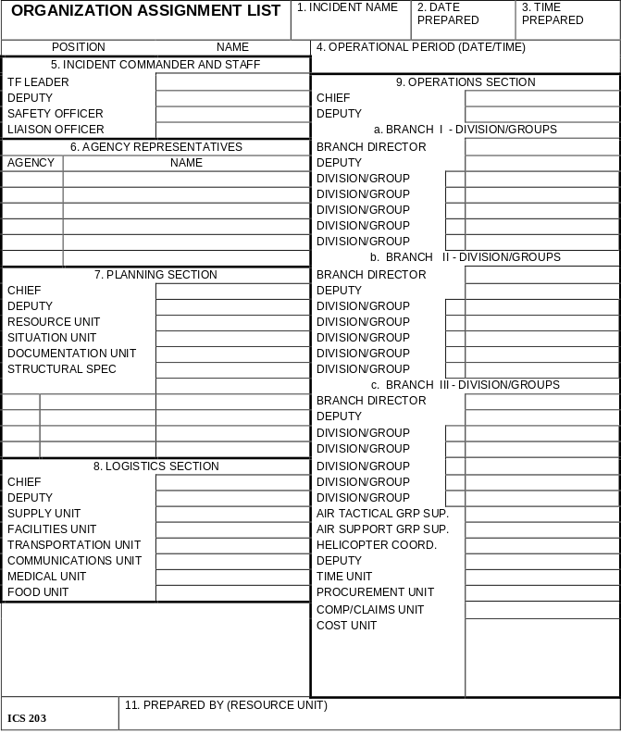

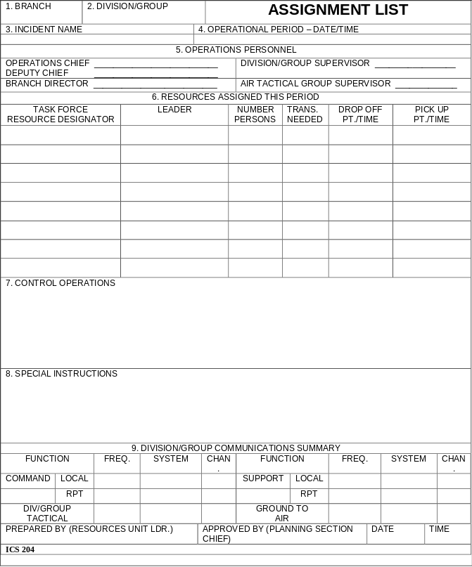

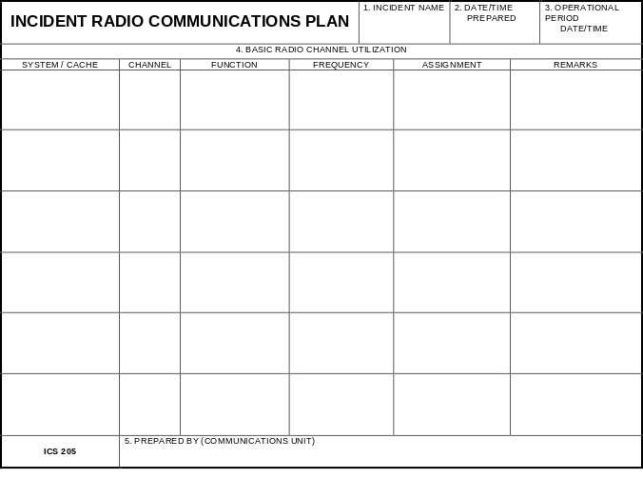

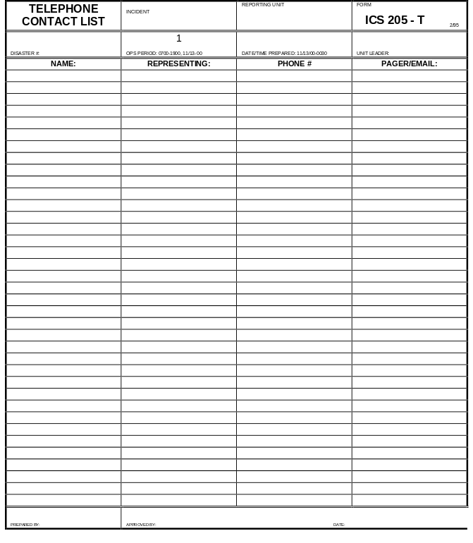

MEDICAL PLAN |  | 1. INCIDENT  NAME |  |  | 2. DATE  PREPARED |  |  |  | 3. TIME  PREPARED |  |  | 4. OPERATIONAL PERIOD
5. INCIDENT MEDICAL AID STATIONS
MEDICAL AID STATIONS |  |  |  | LOCATION |  |  |  |  |  |  |  |  | PARAMEDICS
 |  |  |  |  |  |  |  |  |  |  |  |  | YES |  | NO
6. TRANSPORTATION
A. AMBULANCE SERVICES
NAME |  |  | ADDRESS |  |  |  |  |  |  | PHONE |  |  | PARAMEDICS
 |  |  |  |  |  |  |  |  |  |  |  |  | YES |  | NO
B. INCIDENT AMBULANCES
NAME |  |  |  | LOCATION |  |  |  |  |  |  |  |  | PARAMEDICS
 |  |  |  |  |  |  |  |  |  |  |  |  | YES |  | NO
7. HOSPITALS
NAME | ADDRESS |  |  | TRAVEL TIME |  |  | PHONE |  |  | HELIPAD |  |  |  | BURN CENTER
NAME |  |  |  | AIR |  | GRND |  |  |  | YES | NO |  |  | YES |  | NO
8. MEDICAL EMERGENCY PROCEDURES
9. PREPARED BY (MEDICAL. UNIT LEADER) |  |  |  |  |  |  |  | 10. REVIEWED BY (SAFETY OFFICER)
ICS 206 8-78

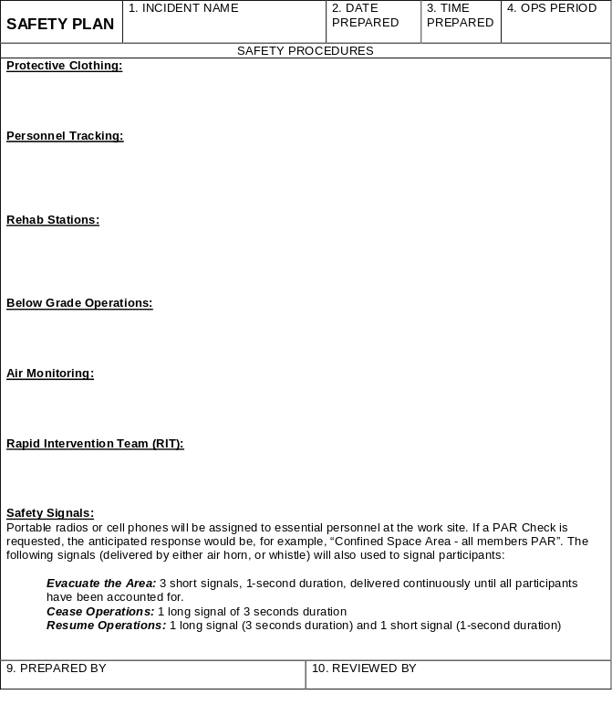
ICS - Safety

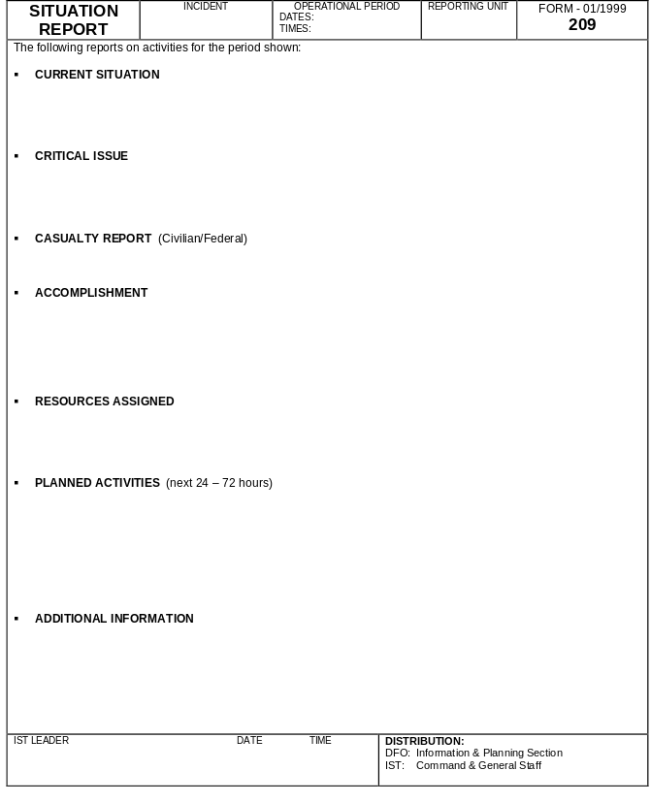

GENERAL MESSAGE

TO: |  |  | POSITION
FROM: |  |  | POSITION
SUBJECT |  |  |  | DATE | TIME
MESSAGE
REPLY
DATE | TIME | SIGNATURE/POSITION
ICS Form 213, 1/79 NFES 1336

UNIT LOG |  | 1. INCIDENT NAME |  |  | 2. DATE  PREPARED | 3. TIME  PREPARED
4. UNIT NAME/ DESIGNATORS |  |  | 5. UNIT LEADER (NAME AND POS.) |  |  | 6. OPERATIONAL  PERIOD
7. PERSONNEL ROSTER ASSIGNED
NAME |  |  |  | ICS POSITION |  |  | HOME BASE
8. ACTIVITY LOG (CONTINUE ON REVERSE)
TIME | MAJOR EVENTS
ICS 214

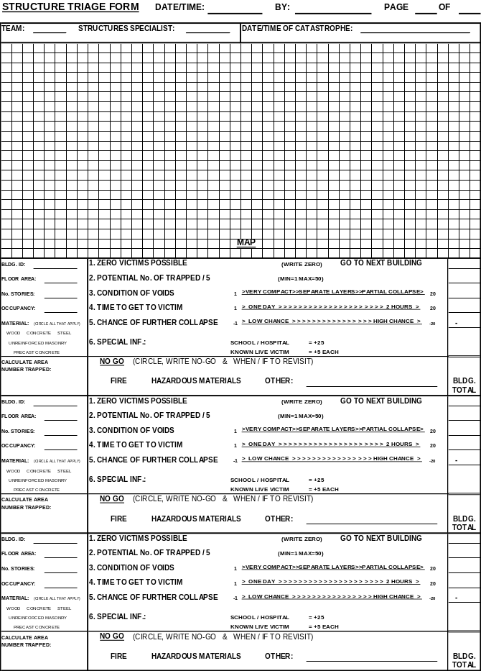

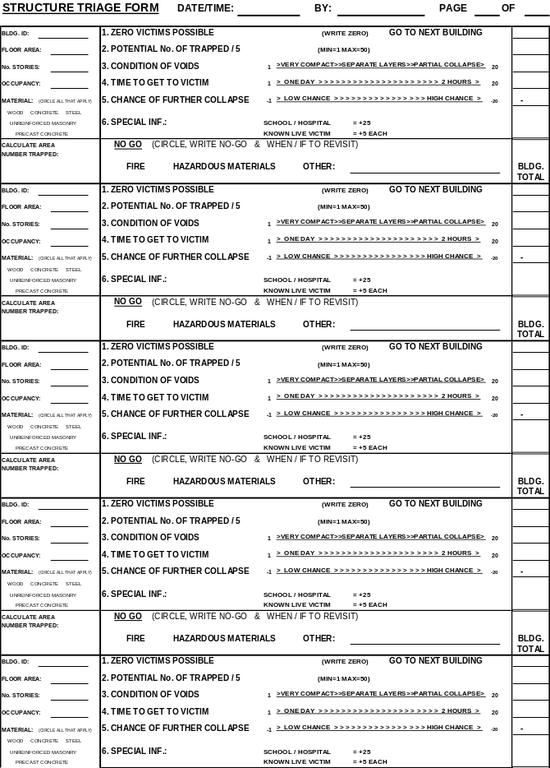

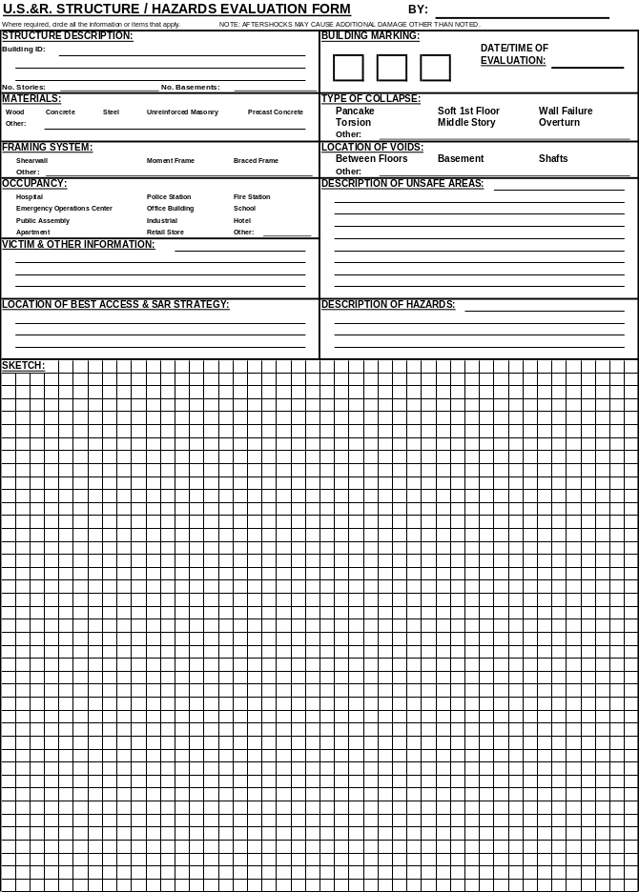

US&R TASK FORCE PATIENT CARE FORM
DATE: |  |  |  |  |  | TIME:
PT. NAME: |  |  |  |  |  | AGE: SEX:
LOCATION: |  |  |  |  |  | SS #: - -
MISSION NAME: |  |  |  |  |  | TASK FORCE:
MEDICAL HISTORY |  |  |  |  |  | MEDICATIONS/ALLERGIES
________________________________________  ________________________________________  ________________________________________  ________________________________________  ________________________________________  ________________________________________ |  |  |  |  |  | _____________________________  _____________________________  _____________________________  _____________________________  _____________________________  _____________________________
PHYSICAL EXAM

__________________________________________________________________________
__________________________________________________________________________
__________________________________________________________________________
__________________________________________________________________________
__________________________________________________________________________
__________________________________________________________________________
MEDICATIONS |  |  |  |  | VITAL SIGNS
TYPE | DOSE | ROUTE | TIME | INITIALS | TIME |  | B.P. | PULSE | RESP. | TEMP.

US&R TASK FORCE PATIENT CARE FORM (CONTINUED)
INTERVENTIONS AND PATIENT COURSE
______________________________________________________________________________________________________________________________________________________________________________________________________________________________________________________________________________________________________________________________________________________________________________________________________________________________________________________________________________________________________________________________________
ENTRAPMENT TIME: | CONDITION:
DIAGNOSIS: ______________________________________________________________________________________________________________________________________________________________________________________________________________________________
ACCEPTING MEDICAL RESOURCE:
OFFICIAL

MAIL

PERMIT

DESTINATION: | POSITION:
SIGNATURE: | POSITION:
PRINT NAME: | MED TM MNGR SIGN:
TO: Definitive-Care Center Physician: This patient was treated by a special medical team. Please complete and return the attached card so that a follow-up evaluation may occur. If possible, please detail patient's course, outcome and any comments on the reverse side of the card.

REQUISITION FOR SUPPLIES, EQUIPMENT, AND/OR SERVICES
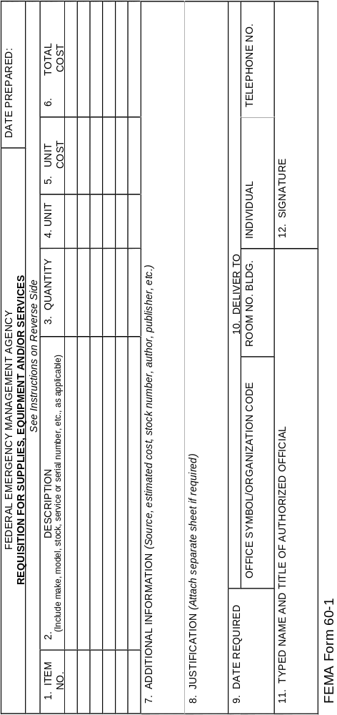
AFTER-ACTION DEBRIEFING | INCIDENT | OPERATIONAL PERIOD  DATE TIMES |  | REPORTING  UNIT ESF #9 | FORM 2/95  US&R—006
■ MANAGEMENT COORDINATION
[ ] Intra-task force cooperations
[ ] integration of local jurisdiction's system

■ COMMUNICATIONS
[ ] intra-task force
[ ] inter-task force
[ ] with DFO, EOC, POA and other facilities

■ PLANNING/BRIEFING ACTIVITIES
[ ] planning sessions
[ ] task force briefings
[ ] shift scheduling/rotation/change over
[ ] resource utilization

■ BASE OF OPERATIONS LAYOUT/SET-UP
[ ] physical layout/site safety
[ ] cache set-up/organization
[ ] adequacy of sleeping/feeding/sanitation arrangements, etc.

■ MEDICAL ISSUES
[ ] care/treatment of task force personnel
[ ] canine issues
[ ] victim treatment/hand-off
[ ] management of controlled drugs/medicines/supplies and adequacy of the cache
[ ] victim summary

■ SUPPLY/LOGISTICS ISSUES
[ ] property accountability
[ ] resource tracking (between work sites, etc.
[ ] tool care/maintenance
[ ] resupply requests

■ PERSONAL SAFETY ISSUES
[ ] use of personal protective gear
[ ] rest/feeding/rehabilitation of personnel
[ ] emergency signaling procedures
[ ] CISD monitoring/intervention

■ INTERPERSONAL SKILLS/PERSONAL PERFORMANCE
[ ] task force management personnel
[ ] task force personnel

IST LEADER DATE TIME |  |  | DISTRIBUTION:

GENERAL MESSAGE

TO: |  |  | POSITION
FROM: |  |  | POSITION
SUBJECT |  |  |  | DATE | TIME
MESSAGE
REPLY
DATE | TIME | SIGNATURE/POSITION
ICS Form 213, 1/79 NFES 1336

APPENDIX E

NOTES & COMMENTS



NOTES & COMMENTS

NOTES & COMMENTS

NOTES & COMMENTS

