MADDEN-JULIAN OSCILLATION (MJO)
DIAGNOSTIC DISCUSSION

issued by

CLIMATE PREDICTION CENTER/NCEP
October 31, 2005

Synopsis: The MJO is expected to remain weak during the next 1-2 weeks.
The MJO remained weak during most of October with a signature closer to that typical of the northern hemisphere summer MJO. During the past month, one clear MJO event is evident as a couplet of enhanced/suppressed convection, mainly north of the equator, shifted northeastward from the Indian Ocean to the western Pacific Ocean (Fig. 1). Regions of upper-level divergence (convergence) also show signs of a weak-moderate eastward propagating signal during October (Fig. 2). This eastward shift in convection can also be seen in low-level wind anomalies during the third week in October as westerly wind anomalies extend across Indonesia (Fig. 3).
Most recently, the area of enhanced convection is repositioned mainly across the eastern Indian Ocean, western Indonesia, and Southeast Asia regions. There remains a large degree of uncertainty for the future evolution of the MJO and based on the latest observational evidence and model forecasts we expect the MJO to remain weak during the upcoming 1-2 week period. As always, close monitoring of the MJO is necessary to identify signatures of a more coherent MJO signal.
Despite the weak MJO signal, there exists a few potential benefits/hazards in the global tropics associated with the current MJO activity. During week 1, we expect an increased chance of above average rainfall stretching from the eastern Indian Ocean into the western Pacific Ocean and an increased chance of tropical cyclone development in the Bay of Bengal due to the weak enhanced phase of the MJO and above average SSTs. During week 2, we expect a slight shift eastward in the above average rainfall region and an increased chance of tropical cyclone development across the western Pacific Ocean. There exists an elevated risk of tropical cyclone activity in the Caribbean Sea during week 1 due to continued warm SSTs and the likelihood of a few disturbances entering this region. Also, Typhoon Kai-Tak will impact Indochina, especially Vietnam, with high winds and heavy rains early during week 1.
This discussion is a consolidated effort of NOAA and its funded institutions. Weekly updates for SST, 850-hPa wind, OLR and features of the equatorial subsurface thermal structure are available on the Climate Prediction Center web page at http://www.cpc.ncep.noaa.gov. The next MJO Diagnostics Discussion is scheduled for 5 December 2005.

Climate Prediction Center
National Centers for Environmental Prediction
NOAA/National Weather Service
Camp Springs, MD 20746-4304

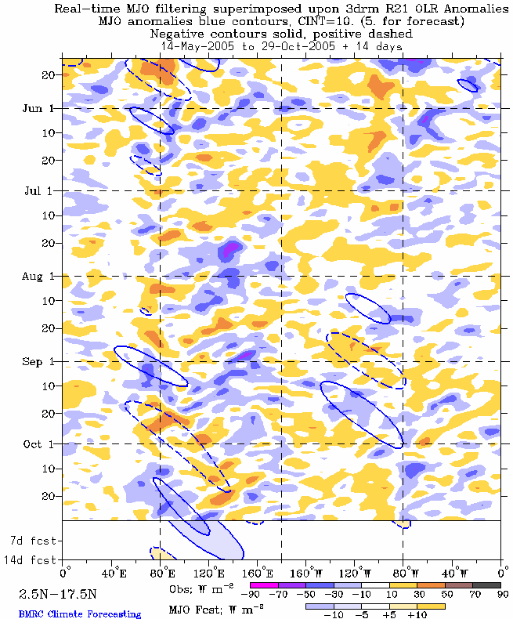

Figure 1: Time-longitude section (2.5°N-17.5°S) of anomalous Outgoing Longwave Radiation (OLR) (W m⁻²). Negative OLR anomalies (wetter-than-normal conditions) are indicated by blue shading while positive OLR anomalies (drier-than-normal conditions) are indicated by orange/red shading.

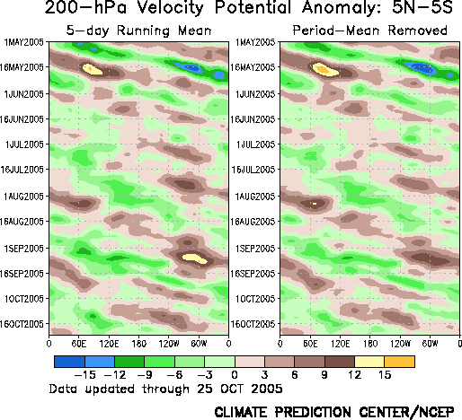

Figure 2: Five day running mean time longitude sections of the 200-hPa velocity potential anomalies averaged from 5°N to 5°S from the realtime version of the NCEP/NCAR Reanalysis. Contour interval is 3 x 10⁶ m² s⁻¹ with the brown (green) shading indicating areas of upper-level convergence (divergence) respectively.

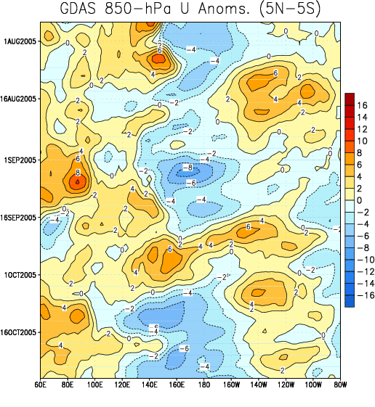

Figure 3: Time-longitude section (5°N-5°S) of anomalous 850-hPa zonal wind (m s⁻¹) (GDAS).
Contour interval is 2 m s⁻¹. Dashed contours indicate negative anomalies. The base period for computing anomalies is 1979-1995. Stronger-than-average easterlies are indicated by blue shading and weaker-than-average easterlies or westerlies by orange/red shading.

