

BSO Tutorial for Tax Year 2007

Submit a Wage File

Contains the following lessons:

- Submit a W-2 Wage File
- Submit a W-2c Wage File
- Submit a Resubmission File
- Submit a Reconciliation File

Lesson 1: Submit a W-2 Wage File

Follow the instructions below to submit a W-2 wage file to the Social Security Administration. For information on preparing formatted Electronically Filing Wage W-2 data files (EFW2, formerly MMREF-1), select the link for Specifications for Filing Forms W-2 Electronically (EFW2) at www.socialsecurity.gov/employer/pub.htm.

Step 1: Point your browser to the Business Services Online Welcome page: www.socialsecurity.gov/bso/bsowelcome.htm.
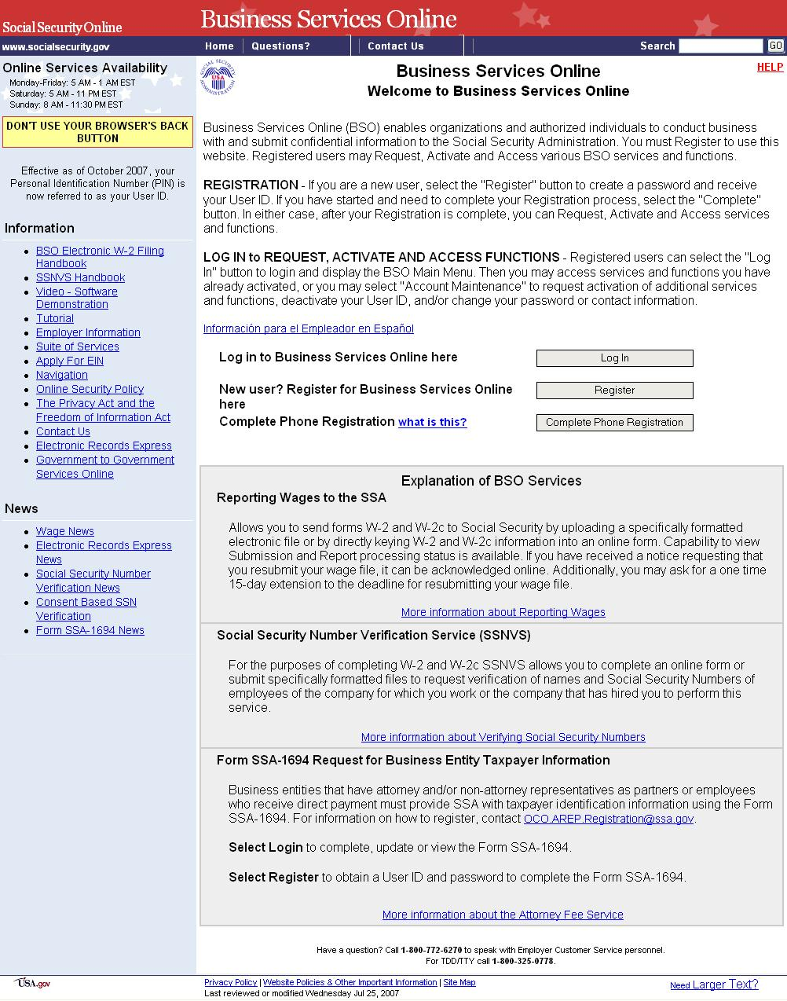
Step 2: Select the Log In button on the Business Services Online Welcome page. The system displays the General Login Attestation page.

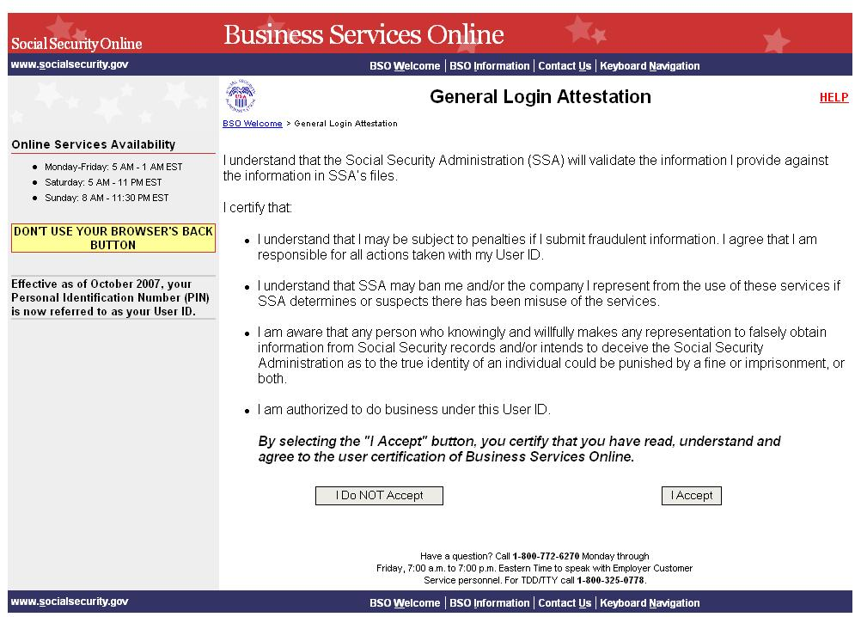

Step 3: Select the I Accept button after reading the conditions defined on the General Login Attestation page. The system displays the Log In to BSO page.
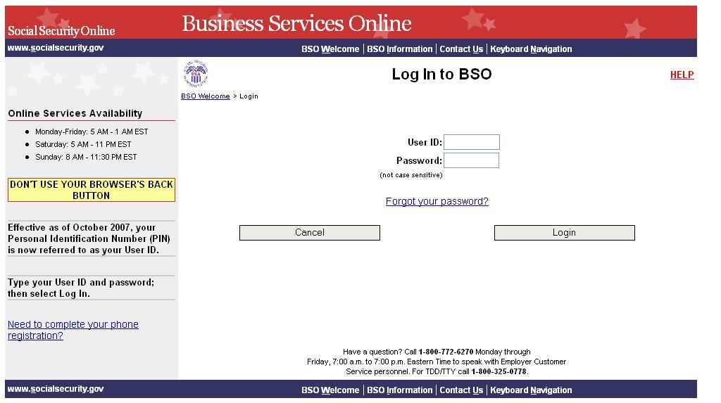

Step 4: Enter your User ID and password.

Step 5: Select the Login button to display the BSO Main Menu page. (To return to the BSO Welcome page, select the Cancel button.)

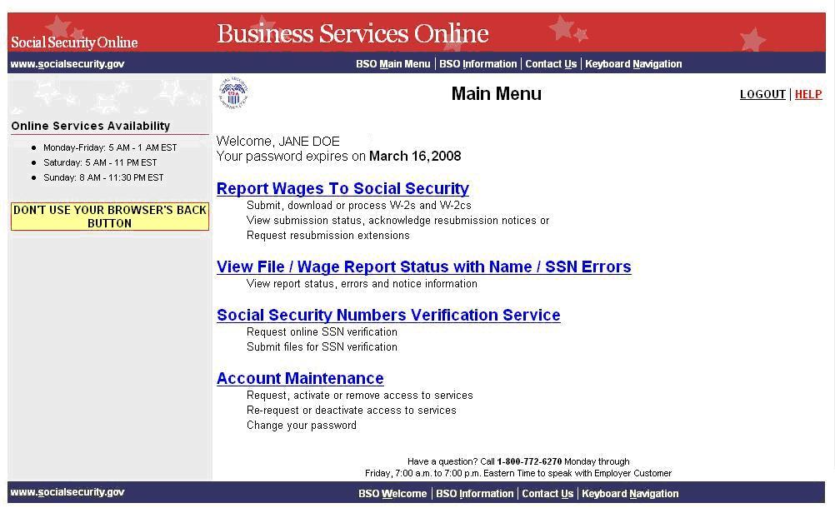

Step 6: Select the Report Wages to Social Security link on the BSO Main Menu page.

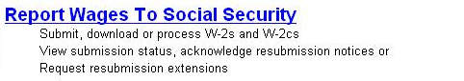

The system displays the Report Wages to Social Security page.

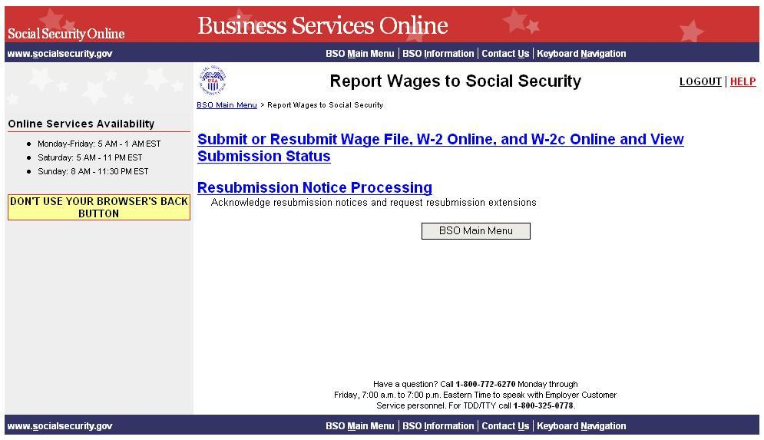

Step 7: Select Submit or Resubmit Wage File, W-2 Online, and W-2c Online and View Submission Status link on the Report Wages to Social Security page.

The system displays the Submit or Resubmit Wage File, W-2 Online, and W-2c Online and View Submission Status page.

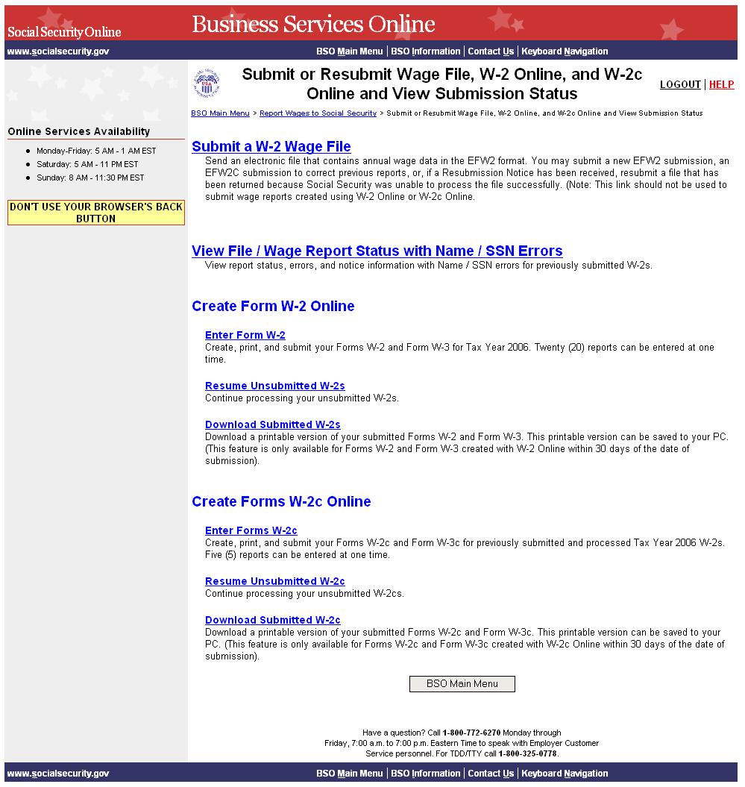

Step 8: Select Submit a W-2 Wage File link on the Submit or Resubmit Wage File, W-2 Online, and W-2c Online and View Submission Status page.

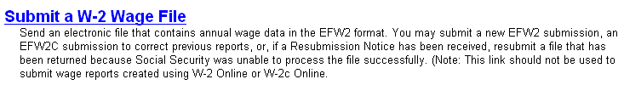

The system displays the Wage Reporting Attestation page.
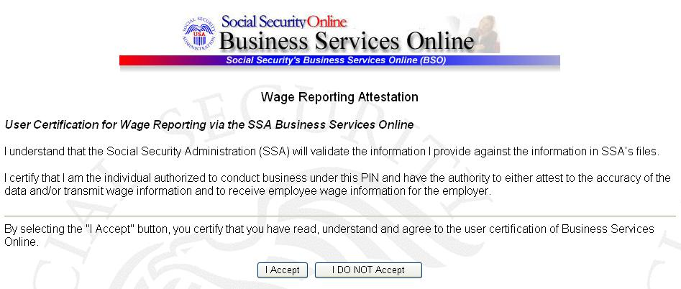

Step 9: Select the I Accept button after reading the conditions defined on the Wage Reporting Attestation page. The system displays the Before You Start page.

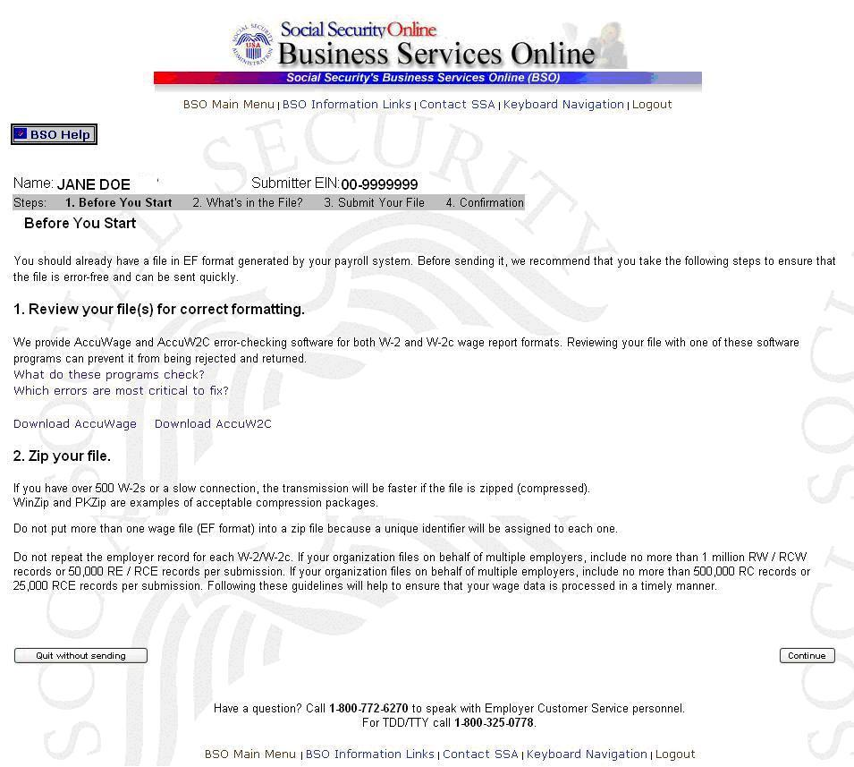

Step 10: Select the Continue button after verifying that you have ensured the quality of your submission and properly compressed your file(s). The system displays the What’s in the File? page.

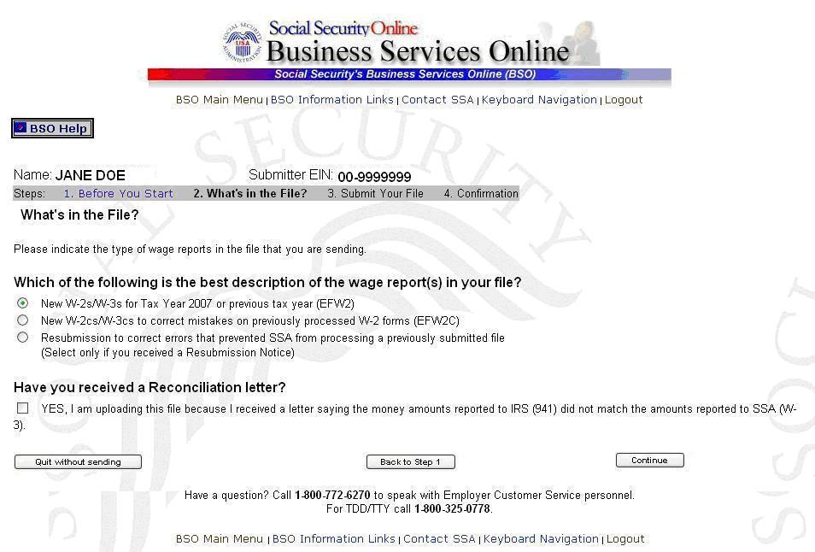

Step 11: Select the New W-2s/W-3s for Tax Year 2007 or previous tax year (EFW2) radio button and select the Continue button to access the Submit Your File page. (The Back to Step 1 button displays the Before You Start page and the Quit without sending button displays the BSO Main Menu page.)

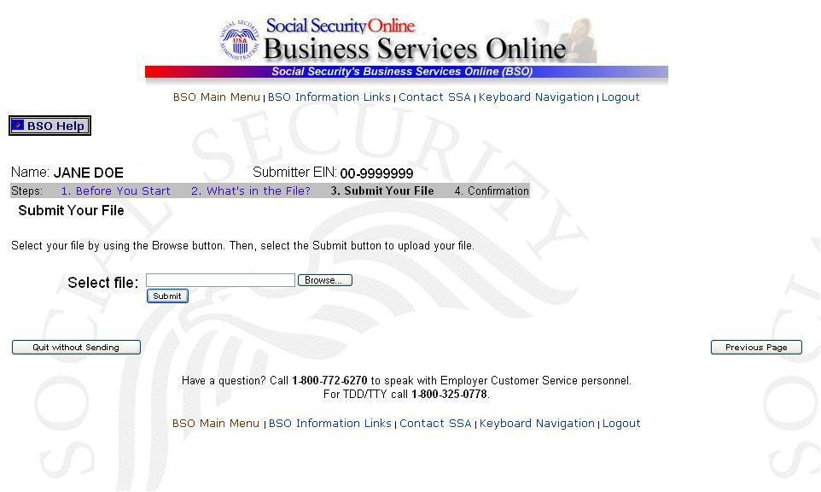

Step 12: Type the name of the file in the Select file field or select the Browse button to the right of the field to select the file.

Step 13: Select the Submit button to submit the file to SSA. (The Previous Page button displays the What’s in the File? page and the Quit without sending button displays the BSO Main Menu page.) After displaying the Submission in Progress window (for large files), the system displays the Confirmation – Your File Was Received page with a pop-up window for the option to request print of the confirmation.

Step 14: Select the OK button in the pop-up window to print the Confirmation – Your File Was Received page. Otherwise, select the Cancel button to close the pop-up window.

At this time, print this page and check the size of your file.

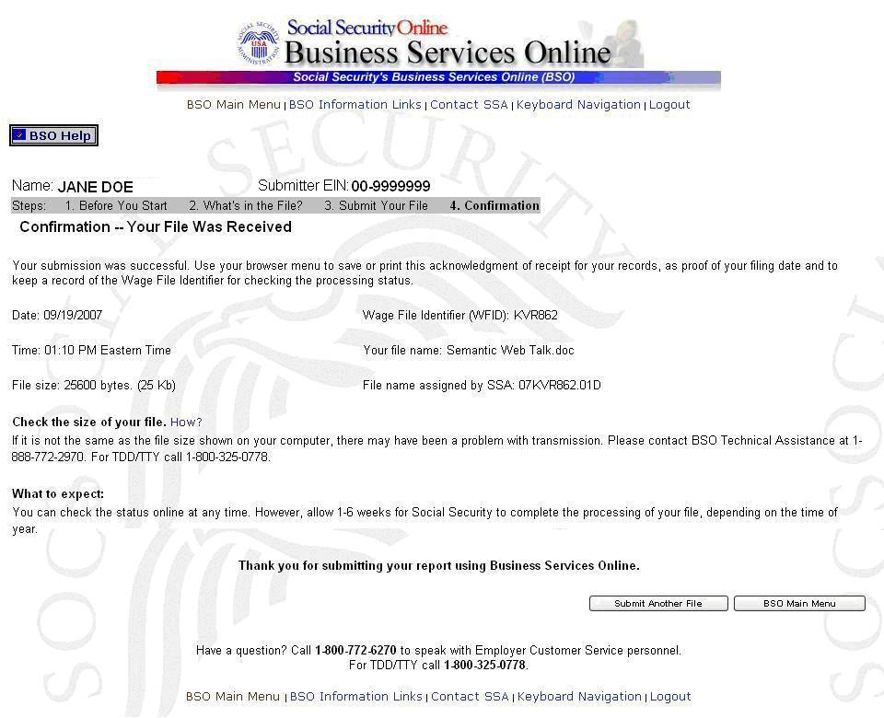

Step 15: To submit another file, select the Submit Another File button to return to the What’s in the File? page. To return to the BSO Main Menu page, select the BSO Main Menu button.

If a communications disruption occurs while you are submitting a wage file, log in again and select the View File / Wage Report Status [with or without] Name / SSN Errors link from the BSO Main Menu page to determine whether the file transfer was successful. If the submission is not displayed, you will have to submit it again. Select the same submission type that you initially selected.

Lesson 2: Submit a W-2c Wage File

Follow the instructions below to submit a corrected W-2 wage file to the Social Security Administration. For information on preparing formatted Electronically Filing Wage W-2c data files (EFW2C, formerly MMREF-2), select the link for Specifications for Filing Forms W-2c Electronically (EFW2C) at www.socialsecurity.gov/employer/pub.htm.

Step 1: Point your browser to the Business Services Online Welcome page: www.socialsecurity.gov/bso/bsowelcome.htm.
Step 2: Select the Log In button on the Business Services Online Welcome page. The system displays the General Login Attestation page.
Step 3: Select the I Accept button after reading the conditions defined on the General Login Attestation page. The system displays the Log In to BSO page.
Step 4: Enter your User ID and password.

Step 5: Select the Login button to display the BSO Main Menu page. (To return to the BSO Welcome page, select the Cancel button.)

Step 6: Select the Report Wages to Social Security link on the BSO Main Menu page.
The system displays the Report Wages to Social Security page.
Step 7: Select Submit or Resubmit Wage File, W-2 Online, and W-2c Online and View Submission Status link on the Report Wages to Social Security page.
The system displays the Submit or Resubmit Wage File, W-2 Online, and W-2c Online and View Submission Status page.

Step 8: Select Submit a W-2 Wage File link on the Submit or Resubmit Wage File, W-2 Online, and W-2c Online and View Submission Status page.
The system displays the Wage Reporting Attestation page.
Step 9: Select the I Accept button after reading the conditions defined on the Wage Reporting Attestation page. The system displays the Before You Start page.
Step 10: Select the Continue button after verifying that you have ensured the quality of your submission and properly compressed your file(s). The system displays the What’s in the File? page.

Step 11: Select the New W-2cs/W-3cs to correct mistakes on previously processed W-2 forms (EFW2C) radio button and select the Continue button to access the Submit Your File page. (The Back to Step 1 button displays the Before You Start page and the Quit without sending button displays the BSO Main Menu page.)
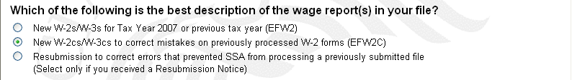

Step 12: Type the name of the file in the Select file field or select the Browse button to the right of the field to select the file.

Step 13: Select the Submit button to submit the file to SSA. (The Previous Page button displays the What’s in the File? page and the Quit without sending button displays the BSO Main Menu page.) After displaying the Submission in Progress window (for large files), the system displays the Confirmation – Your File Was Received page with a pop-up window for the option to request print of the confirmation.

Step 14: Select the OK button in the pop-up window to print the Confirmation – Your File Was Received page. Otherwise, select the Cancel button to close the pop-up window.
At this time, print this page and check the size of your file.

Step 15: To submit another file, select the Submit Another File button to return to the What’s in the File? page. To return to the BSO Main Menu page, select the BSO Main Menu button.

If a communications disruption occurs while you are submitting a wage file, log in again and select the View File / Wage Report Status [with or without] Name / SSN Errors link from the BSO Main Menu page to determine whether the file transfer was successful. If the submission is not displayed, you will have to submit it again. Select the same submission type that you initially selected.

Lesson 3: Submit a Resubmission File

Follow the instructions below to submit a resubmission file to the Social Security Administration (SSA). This option should be used only if you have received a notice from the SSA asking you to correct and resubmit your data. The EIN of the person resubmitting wage data to SSA must match the EIN of the person who originally submitted the file.

Step 1: Point your browser to the Business Services Online Welcome page: www.socialsecurity.gov/bso/bsowelcome.htm.
Step 2: Select the Log In button on the Business Services Online Welcome page. The system displays the General Login Attestation page.
Step 3: Select the I Accept button after reading the conditions defined on the General Login Attestation page. The system displays the Log In to BSO page.
Step 4: Enter your User ID and password.
Step 5: Select the Login button to display the BSO Main Menu page. (To return to the BSO Welcome page, select the Cancel button.)
Step 6: Select the Report Wages to Social Security link on the BSO Main Menu page.
The system displays the Report Wages to Social Security page.
Step 7: Select Submit or Resubmit Wage File, W-2 Online, and W-2c Online and View Submission Status link on the Report Wages to Social Security page.
The system displays the Submit or Resubmit Wage File, W-2 Online, and W-2c Online and View Submission Status page.
Step 8: Select Submit a W-2 Wage File link on the Submit or Resubmit Wage File, W-2 Online, and W-2c Online and View Submission Status page.
The system displays the Wage Reporting Attestation page.

Step 9: Select the I Accept button after reading the conditions defined on the Wage Reporting Attestation page. The system displays the Before You Start page.

Step 10: Select the Continue button after verifying that you have ensured the quality of your submission and properly compressed your file(s). The system displays the What’s in the File? page.

Step 11: Select the Resubmission to correct errors that prevented SSA from processing a previously submitted file radio button (select only if you received a Resubmission Notice). The system will activate the fields below the Resubmission radio button.
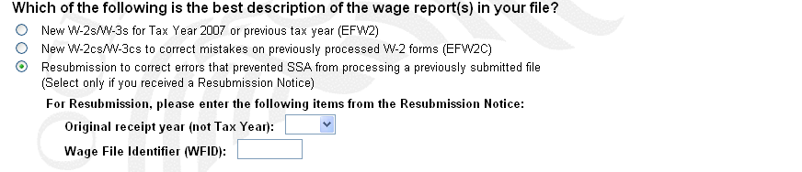

Step 12: Select the original receipt year in the Original Receipt Year (not Tax Year) from the drop-down menu. This should match the Receipt Year given on the Resubmission Notice.

Step 13: Enter the WFID in the Wage File Identifier (WFID) field.
Step 14: Select the Continue button to access the Submit Your File page. (The Back to Step 1 button displays the Before You Start page and the Quit without sending button displays the BSO Main Menu page.)

Step 15: Type the name of the file in the Select file field or select the Browse button to the right of the field to select the file.
Step 16: Select the Submit button to submit the file to SSA. (The Previous Page button displays the What’s in the File? page and the Quit without sending button displays the BSO Main Menu page.) After displaying the Submission in Progress window (for large files), the system displays the Confirmation – Your File Was Received page with a pop-up window for the option to request print of the confirmation.
Step 17: Select the OK button in the pop-up window to print the Confirmation – Your File Was Received page. Otherwise, select the Cancel button to close the pop-up window.

At this time, print this page and check the size of your file.

Step 18: To submit another file, select the Submit Another File button to return to the What’s in the File? page. (To return to the BSO Main Menu page, select the BSO Main Menu button.)

If a communications disruption occurs while you are submitting a wage file, log in again and select the View File / Wage Report Status [with or without] Name / SSN Errors link from the BSO Main Menu page to determine whether the file transfer was successful. If the submission is not displayed, you will have to submit it again. Select the same submission type that you initially selected.

Lesson 4: Submit a Reconciliation File

Follow the instructions below to submit a reconciliation file to the Social Security Administration. This option should only be used if you have received a letter from the Social Security Administration notifying you of a discrepancy between money amounts shown on a Form W-3 sent to the Social Security Administration and a Form 941 sent to the IRS.

Step 1: Point your browser to the Business Services Online Welcome page: www.socialsecurity.gov/bso/bsowelcome.htm.
Step 2: Select the Log In button on the Business Services Online Welcome page. The system displays the General Login Attestation page.
Step 3: Select the I Accept button after reading the conditions defined on the General Login Attestation page. The system displays the Log In to BSO page.
Step 4: Enter your User ID and password.

Step 5: Select the Login button to display the BSO Main Menu page. (To return to the BSO Welcome page, select the Cancel button.)

Step 6: Select the Report Wages to Social Security link on the BSO Main Menu page.
The system displays the Report Wages to Social Security page.
Step 7: Select Submit or Resubmit Wage File, W-2 Online, and W-2c Online and View Submission Status link on the Report Wages to Social Security page.
The system displays the Submit or Resubmit Wage File, W-2 Online, and W-2c Online and View Submission Status page.
Step 8: Select Submit a W-2 Wage File link on the Submit or Resubmit Wage File, W-2 Online, and W-2c Online and View Submission Status page.
The system displays the Wage Reporting Attestation page.
Step 9: Select the I Accept button after reading the conditions defined on the Wage Reporting Attestation page. The system displays the Before You Start page.
Step 10: Select the Continue button after verifying that you have ensured the quality of your submission and properly compressed your file(s). The system displays the What’s in the File? page.

Step 11: Select the appropriate type of file (New W-2, New W-2c, or Resubmission).

Step 12: Select the YES, I am uploading this file because SSA sent a letter saying the money amounts reported to IRS (941) did not match the amounts reported to SSA (W-3). checkbox.

Step 13: Select the Continue button to access the Submit Your File page. (The Back to Step 1 button displays the Before You Start page and the Quit without sending button displays the BSO Main Menu page.)

Step 14: Type the name of the file in the Select file field or select the Browse button to the right of the field to select the file.
Step 15: Select the Submit button to submit the file to SSA. (The Previous Page button displays the What’s in the File? page and the Quit without sending button displays the BSO Main Menu page.) After displaying the Submission in Progress window (for large files), the system displays the Confirmation – Your File Was Received page with a pop-up window for the option to request print of the confirmation.
Step 16: Select the OK button in the pop-up window to print the Confirmation – Your File Was Received page. Otherwise, select the Cancel button to close the pop-up window.
At this time, print this page and check the size of your file.

Step 17: To submit another file, select the Submit Another File button to return to the What’s in the File? page. To return to the BSO Main Menu page, select the BSO Main Menu button.

If a communications disruption occurs while you are submitting a wage file, log in again and select the View File / Wage Report Status [with or without] Name / SSN Errors link from the BSO Main Menu page to determine whether the file transfer was successful. If the submission is not displayed, you will have to submit it again. Select the same submission type that you initially selected.

