

BSO Tutorial for Tax Year 2007

Social Security Number Verification Service (SSNVS)

Contains the following lessons:

- Request Online SSN Verification
- Submit an Electronic File for SSN Verification
- View Status and Retrieval Information
- View the SSNVS Handbook

Lesson 1: Request an Online SSN Verification

Registered users (employers and certain third-party submitters) can verify up to 10 names and Social Security Numbers (SSNs) online and receive immediate results.

In order access the Social Security Number Verification Service (SSNVS) users must first register with the Integrated Registration Services (IRES) and receive a User Identification Number (User ID) and password.

To request access to SSNVS, after you have registered, complete the following steps:

Step 1: Point your browser to the Business Services Online Welcome page: www.socialsecurity.gov/bso/bsowelcome.htm.

Step 2: Select the Log In button on the Business Services Online Welcome page. The system displays the General Login Attestation page.

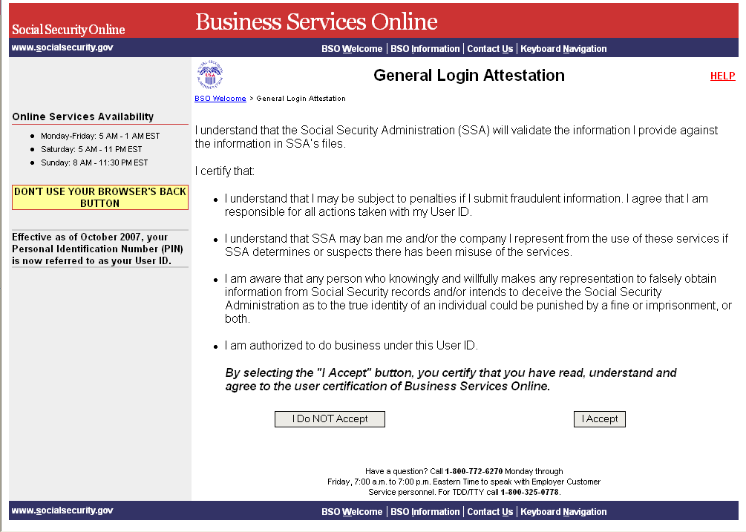

Step 3: Select the I Accept button to indicate you have read the user certification statement and agree to its contents. This will open the Log In to BSO web page.

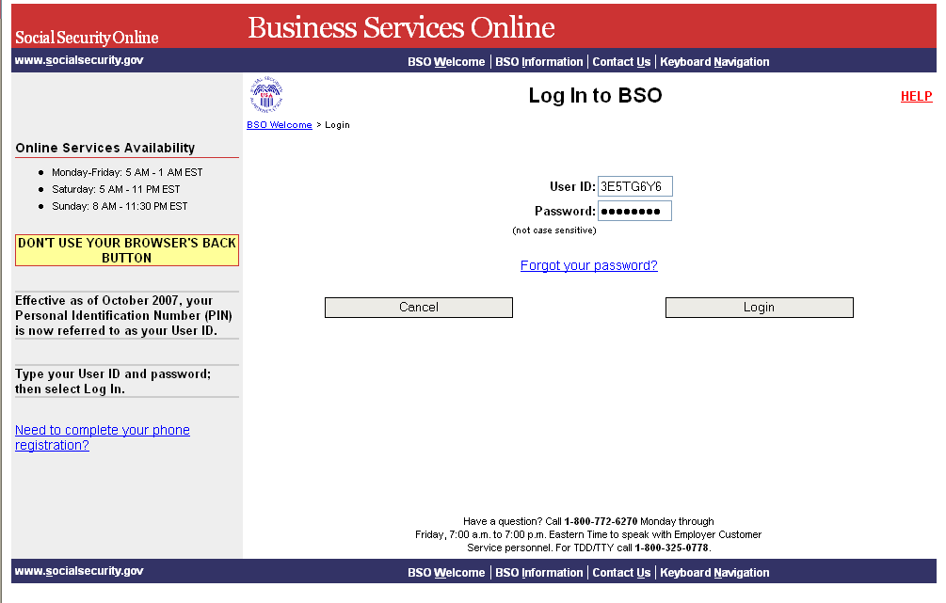

Step 4: Enter your User ID and password.

Step 5: Select the Login button from the Business Services Online Login web page. This will open the BSO Main Menu web page.
To return to the Business Services Online Welcome page, select the Cancel button.

Step 6: Select the Social Security Numbers Verification Service link.

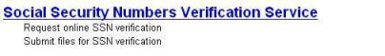

The system displays the Verify Social Security Numbers menu page.

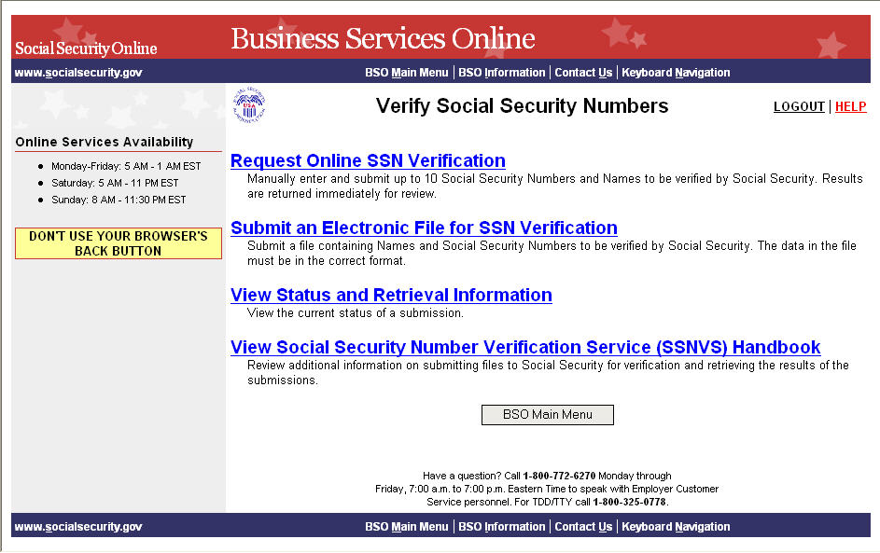

Step 7: Select the Request Online SSN Verification link.

The system displays the SSNVS Attestation page.

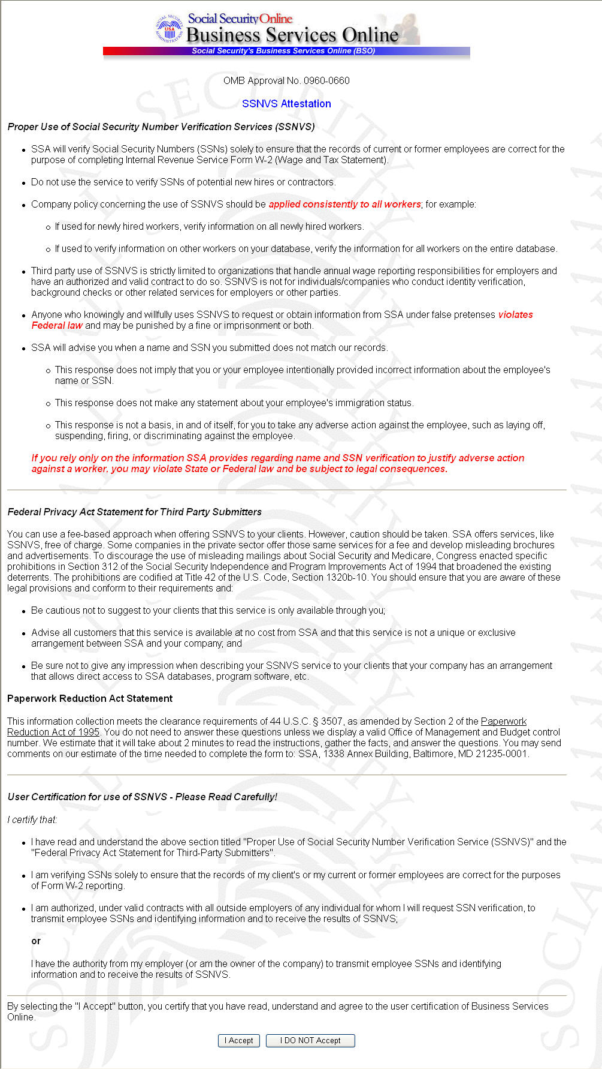

Step 8: Select the I Accept button to indicate you have read the SSNVS user certification statement and agree to its contents. The system will then display the SSN Verification page.

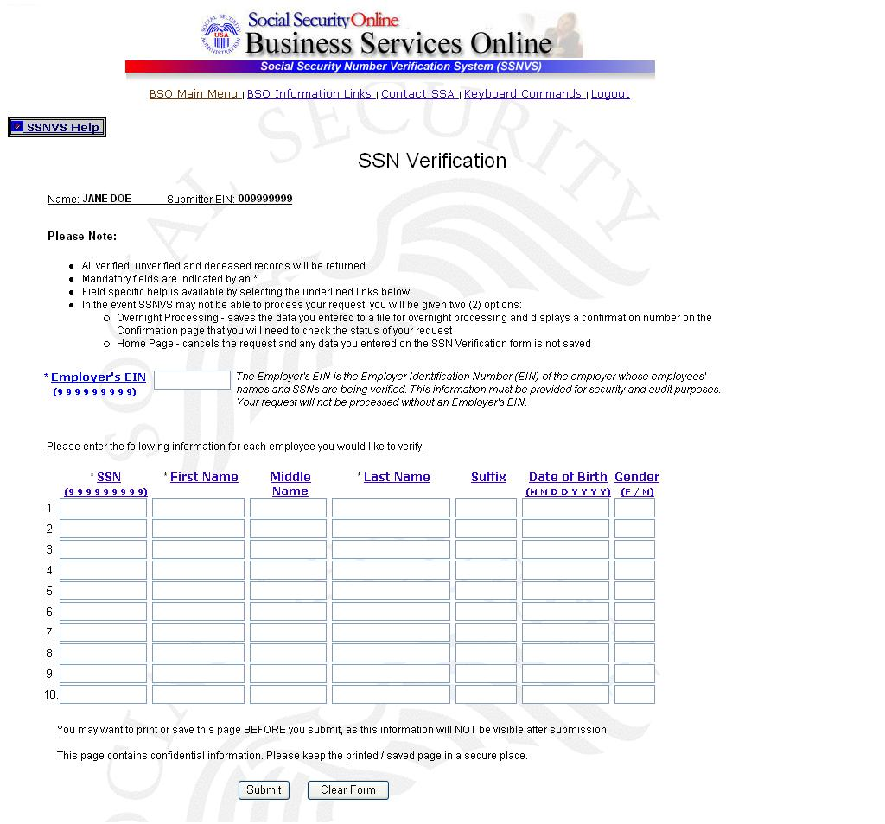

Step 9: In the Employer’s EIN field place the EIN of the employer under which wages are to be reported for the names and SSNs being verified. Complete one (1) row for each name and SSN you would like to verify. You must complete all mandatory fields in at least one (1) row before selecting the Submit button.

- The Submitter's EIN field at the top of the page is the EIN of the employer of the user submitting the verification request.
- The Employer's EIN, SSN, First Name and Last Name fields are mandatory.
- The Middle Name, Suffix, Date of Birth (DOB) and Gender fields are optional.

Step 10: Select the Submit button to process the data. (Otherwise, select the Clear Form button to delete the data.) The system displays the SSN Verification Results page.

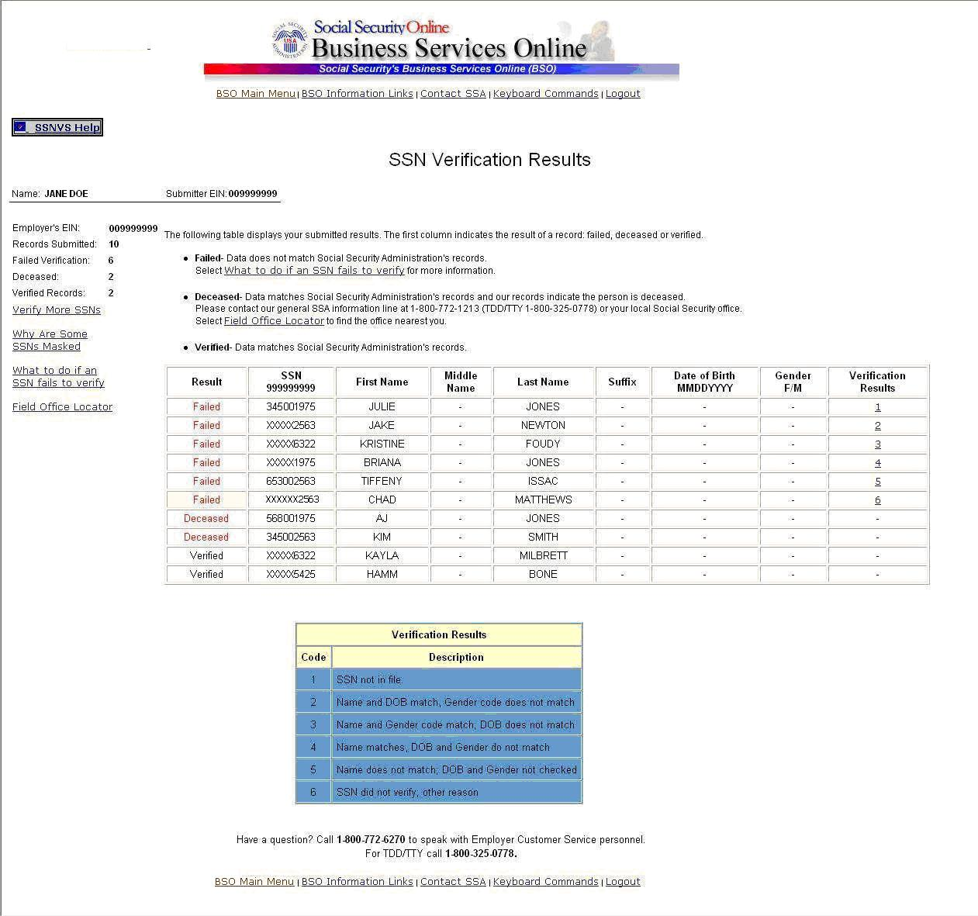

This page will display:
- Left-Hand Menu – the Employer’s EIN, total number of records submitted, total number of failed verifications, total number of deceased records and total number of verified records.
- Body – All of the information submitted by the user plus the verification results code.
If any problems occur with the submission the system will display the Convert to Batch page. Select the Overnight button and SSA will process your request and send you the results within 2 business days. Follow the instructions in Lesson 2: Submit an Electronic File for SSN Verification for more information.

Step 11: The SSN submitted for verification matches SSA's records.

The user will see a “-“in the Verification Results field.

For security reasons, if the record has a “-” Verification Result, the first five (5) positions of the SSN will be masked with an "X".

Step 12: The SSN submitted for verification matches SSA's records but our records indicate the individual is deceased.
The user will see the word “Deceased” in the Results column and a “-“in the Verification Results field.

Step 13: If there are failed verifications, the number in the Verification Results column displays the reason for the failed verification.

The following are failed verification result code descriptions:
1 SSN is not in Social Security Administration’s records
2 Name and DOB match; Gender Code does not
3 Name and Gender Code match; DOB does not
4 Name matches: DOB and Gender Code do not
5 Name does not match; DOB and Gender Code not checked
6 SSN did not verify; other reason.

For security reasons, if the record has a verification results code of 2, 3, 4 or 6, the first five (5) positions of the SSN will be masked with an "X".
If the data does not match SSA’s records, select the What to do if Names/SSNs don’t match? link to view important information.

Step 14: Select the Verify More SSNs link to verify additional SSNs. (To return to the BSO Main Menu page, select the BSO Main Menu link.)

Lesson 2: Submit an Electronic File for SSN Verification

Follow the instructions below to upload a file containing names and Social Security Numbers (SSNs) to be verified by the Social Security Administration. The results are usually available the next government business day.

Step 1: Point your browser to the Business Services Online Welcome page: www.socialsecurity.gov/bso/bsowelcome.htm.

Step 2: Select the Log In button on the Business Services Online Welcome page. The system displays the General Login Attestation page.

Step 3: Select the I Accept button after reading the conditions defined on the General Login Attestation page. The system displays the Log In to BSO page.

Step 4: Enter your User ID and password.

Step 5: Select the Login button. The system displays the BSO Main Menu page. (To return to the Business Services Online Welcome page, select the Cancel button.)

Step 6: Select the Social Security Numbers Verification Service link.

The system displays the Verify Social Security Numbers menu page.

Step 7: Select the Submit an Electronic File for SSN Verification link.

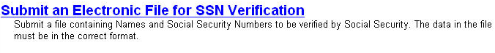

The system displays the SSNVS Attestation page.

Step 8: Select the I Accept button after reading the conditions defined on the SSNVS Attestation page. The system displays the Submit a File for SSN Verification – Before You Start page.

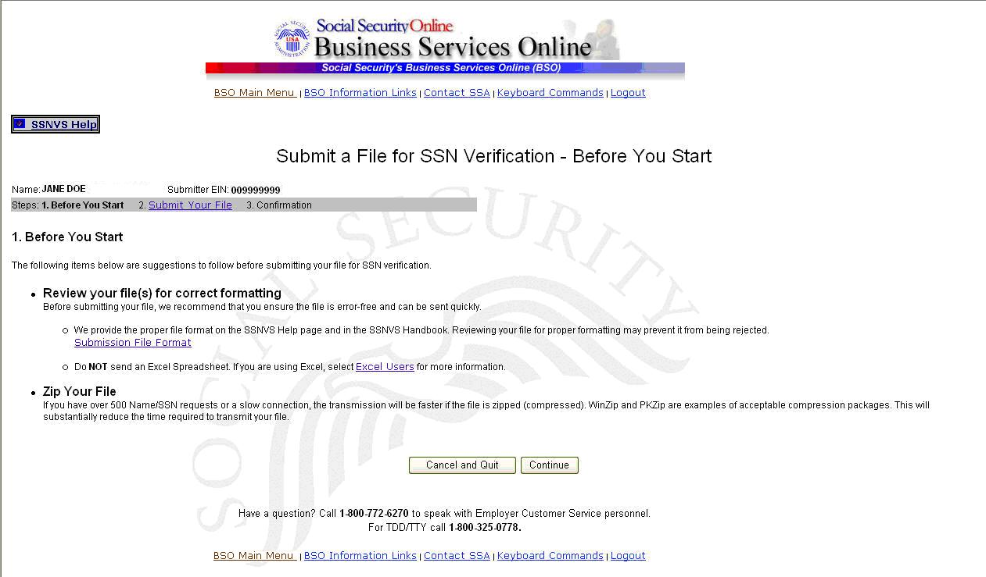

Step 9: Select Continue after reading the information on the Submit a File for SSN Verification – Before You Start page. The system displays the Submit a File for SSN Verification – Submit Your File page.

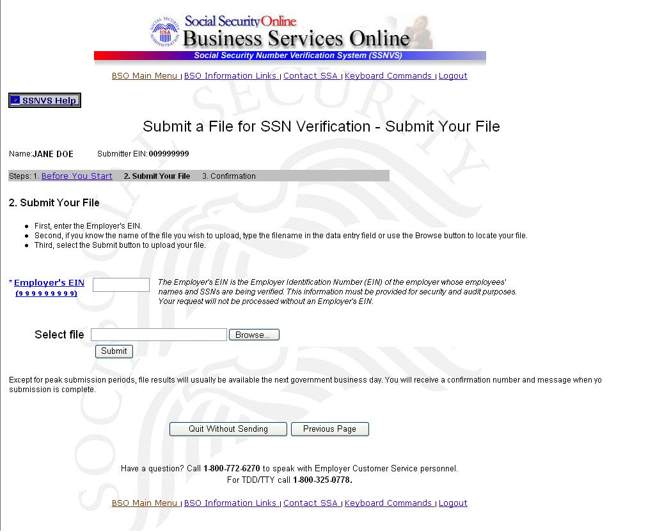

Step 10: Enter the Employer's EIN of the employer under which wages are to be reported for the names and SSNs being verified. If you know the name of the file you wish to upload, type the file name in the Select File field or select a file from your local or network directory by selecting the Browse button.

- The file should contain no more than 250,000 SSN verification requests.
- If you have over 500 SSN verification requests or you have a slow connection it is recommended that you zip your file using WinZip, PKZIP, or another zip-compatible program.

Step 11: Select the Submit button. The system displays a file upload in process pop-up window.
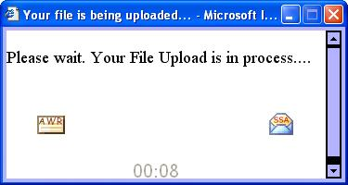

Once the file has been transferred, the system displays the Submit a File for SSN Verification – Confirmation page.

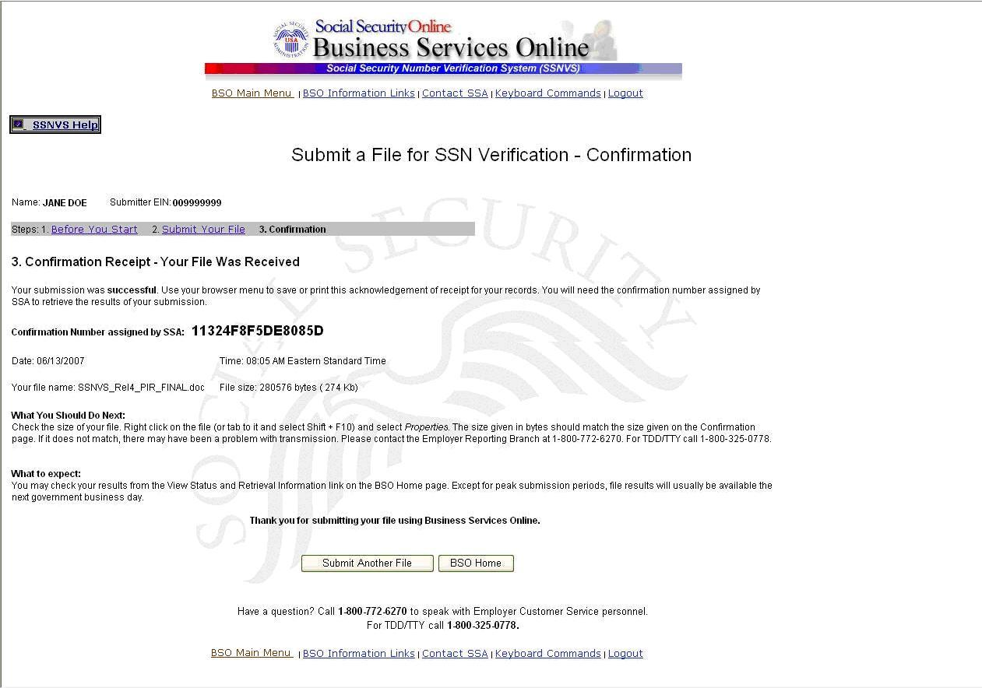
Be sure to keep a record of your confirmation number. You will need it to track the status of your submitted file.

Step 12: Select the OK button in the pop-up window to print the Submit a File for SSN Verification - Confirmation page.

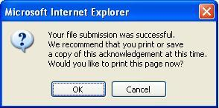

Otherwise select the Cancel button to close the pop-up window

Step 13: Select the Submit Another File button to submit another file or select the BSO Home button to return to the BSO Main Menu page.

Lesson 3: View Status and Retrieval Information

Follow the instructions below to view the status of electronic files submitted for overnight processing.
Step 1: Point your browser to the Business Services Online Welcome page: www.socialsecurity.gov/bso/bsowelcome.htm.

Step 2: Select the Log In button on the Business Services Online Welcome page. The system displays the General Login Attestation page.

Step 3: Select the I Accept button after reading the conditions defined on the General Login Attestation page. The system displays the Log In to BSO page.

Step 4: Enter your User ID and password.

Step 5: Select the Login button. The system displays the BSO Main Menu page. (To return to the Business Services Online Welcome page, select the Cancel button.)

Step 6: Select the Social Security Numbers Verification Service link.

The system displays the Verify Social Security Numbers menu page.

Step 7: Select the View Status and Retrieval Information link.


The system displays the SSNVS Attestation page.

Step 8: Select the I Accept button after reading the conditions defined on the SSNVS Attestation page. The system displays the Status and Retrieval page.

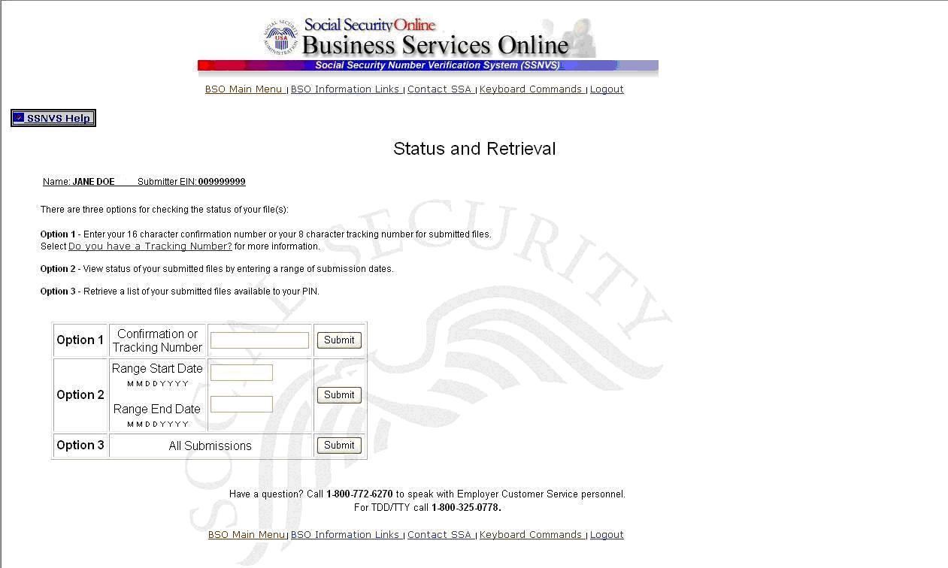

Step 9: Select one of the following options to view the status of your submitted file.

Option 1: Enter the specific tracking or confirmation number to view the status of an individual file.
Option 2: Enter a start and end date to view the status of files submitted within a date range.
Option 3: View the 100 most recent SSNVS file submissions associated with your User ID.
If the file you are searching for is not displayed, focus your search by using Option 1 or 2.

Step 10: Select the corresponding e Submit button. The system displays the Status and Retrieval Results page.

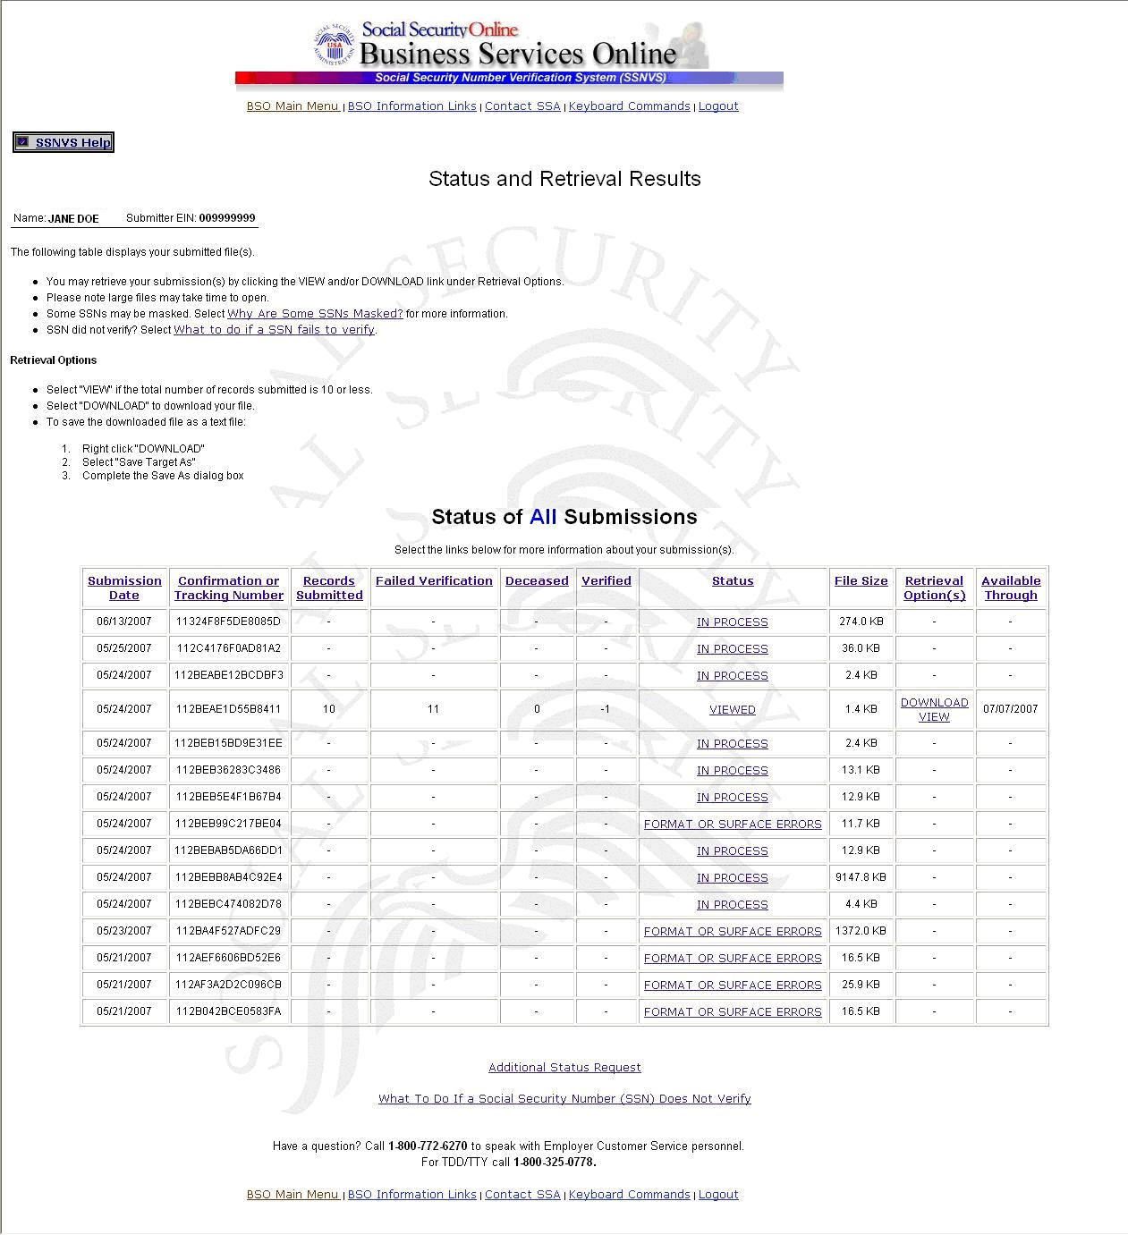

Step 11: The status and retrieval options are displayed in a table; for a full explanation of each column, click on the column header. This opens a new browser to the SSNVS Help web page which is only accessible when logged into SSNVS.
Select the Download/View link in the Retrieval Option(s) column to view your results.
- For 10 or less SSNs submitted, the results may be downloaded or viewed online.
- For more than 10 SSNs submitted, the results may be downloaded only.

Step 12: Select the link in the Status column for more information about the status of your submission, if applicable.
The Available Through column displays the date the Status and/or Results are available to the user.
- Users are able to view or download the results for 30 days from the day they become available.
- After 30 days and up to two (2) years, the user can only view the status of their files.
- During the period files are available, you can download or view them an unlimited number of times.

Lesson 4: View the SSNVS Handbook

The SSNVS Handbook can either be viewed by logging-in to the SSNVS application or by selecting the SSNVS Handbook links below.
- BSO Welcome page – http://www.ssa.gov/bso/
- SSNVS News page – http://www.ssa.gov/employer/ssnvsNews.htm
- SSNVS Information and Instructions page – http://www.ssa.gov/employer/ssnv.htm#overview

To access the SSNVS handbook from the SSNVS application, follow the instructions below.
Step 1: Point your browser to the Business Services Online Welcome page: www.socialsecurity.gov/bso/bsowelcome.htm.

Step 2: Select the Log In button on the Business Services Online Welcome page. The system displays the General Login Attestation page.

Step 3: Select the I Accept button after reading the conditions defined on the General Login Attestation page. The system displays the Log In to BSO page.

Step 4: Enter your User ID and password.

Step 5: Select the Login button. The system displays the BSO Main Menu page. (To return to the Business Services Online Welcome page, select the Cancel button.)

Step 6: Select the Social Security Numbers Verification Service link.

The system displays the Verify Social Security Numbers menu page.

Step 7: Select the View Social Security Number Verification Service (SSNVS) Handbook link.

The system displays the SSNVS Handbook.
