Plan: Request an Executive Sponsor Brief

Audience
Leaders of new and existing PHIN Communities of Practice (CoPs) that are in need of an executive sponsor

Purpose
As a new CoP it is important to retain a sponsor who can legitimize and support the community. This Template provides a mechanism for demonstrating the value of sponsoring a community of practice.

To Use this Resource
This document is in Microsoft Word format to allow you to add, edit, or remove information to suit your needs. You may also change the header to include the name of your Community.

After modifying the template, you can:
- Print this document and write on a hard copy
- Complete and e-mail the document to recipients
- Use the points as a discussion guide

You can also use the Request an Executive Sponsor PowerPoint to help present the information captured in this template.

Have an Idea for How this Resource Can be Improved?
We’d love to hear it! Use the feedback form or send an email to phin@cdc.gov to let us know how this resource can be improved or to suggest other resources you would find useful.

Overview
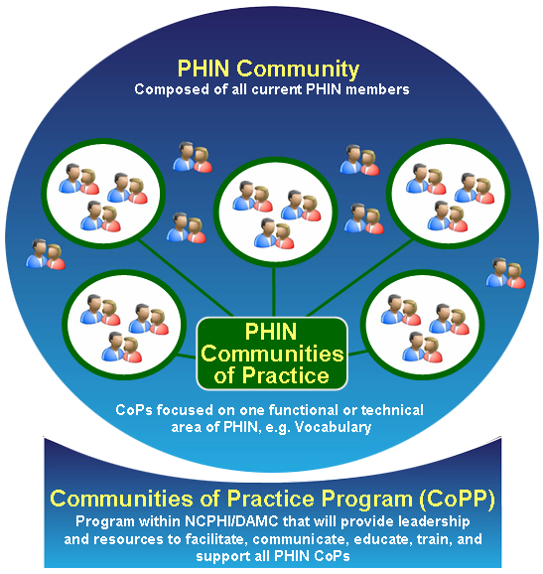
PHIN strives to improve public health use and exchange of information by promoting the use of standards and technical requirements. It is comprised of individuals with the interest and passion to work toward the application and implementation of PHIN requirements and related issues.

In addition to individuals, the PHIN Community includes a collection of Communities of Practice (CoPs) that focus on specific functional and technical areas related to PHIN.

A CoP is a group of individuals who come together to learn about a shared topic. Members meet and interact regularly in order to:
  - Collaborate
  - Solve problems
  - Build knowledge

Organizations benefit when their representatives participate in a CoP. When an organization allows its personnel to join, it is potentially increasing:
  - Employee efficiency, in terms of time and cost, in retrieving information
  - Industry benchmarking capacity
  - Involvement in key industry and national initiatives
  - Organizational reputation as a contributor in building new capabilities

Strategic Alignment with PHIN
[I am / We are] interested in forming a Community of Practice that would be aligned with PHIN (see Aligning with PHIN) to address:

- [Enter Focus of CoP]
  - [Enter objective]
  - [Enter objective]
  - [Enter objective]

The [Enter Proposed CoP] will benefit [Enter name of organization/center/unit, etc] by enhancing our efforts to:
  - [Enter org/unit/center business outcomes related to the PHIN CoP]
  - [Enter org/unit/center business outcomes related to the PHIN CoP]
  - [Enter org/unit/center business outcomes related to the PHIN CoP]

The [Enter Proposed CoP] will benefit from aligning with PHIN because we will:
  - Reduce duplication efforts
  - Have access to best practices and lessons learned from the PHIN Community
  - Have contact with Subject Matter Experts
  - Reduce our time/cost to retrieve information
  - Reduce the learning curves of new employees
  - Gain or enhance our reputation as a leader and contributor in the field

Sponsorship
[Enter Proposed CoP] needs a sponsor in order to:
  - Gain legitimacy
  - Encourage participation
  - Collaborate with other CoPs and business leaders
  - Provide input into the CoP priorities and PHIN strategic direction

Responsibilities
As a Sponsor, your roles and responsibilities will include:
  - Championing the [Enter proposed CoP] internally and externally
  - Providing support in developing initial membership – alerting others to the opportunity to join and the importance of participating
  - Providing perspective on particular initiatives or issues of concern
  - Periodically reviewing progress
  - Providing support where needed for gaining resources (personnel, infrastructure)

Benefits
As a Sponsor of the [Enter proposed CoP] Community, you will:
  - Have access to a cadre of motivated individuals focused on a topic relevant to you
  - Become known as a proponent of cutting-edge strategies and technologies
  - Gain insight into the issues and successes surrounding the world of [Enter proposed CoP]
  - Meet peers and thought leaders with interest in [Enter proposed CoP]

Required Resources - Now
The [Enter proposed CoP] believes that the following resources will be required initially:
  - [Insert initial resources required from the sponsoring org/unit/center such as leadership, space, logistical resources or funding – include the time commitment that is anticipated from CoP leadership]
  - [Insert initial resources required from the sponsoring org/unit/center such as leadership, space, logistical resources or funding – include the time commitment that is anticipated from CoP leadership]
  - [Insert initial resources required from the sponsoring org/unit/center such as leadership, space, logistical resources or funding – include the time commitment that is anticipated from CoP leadership]

Required Resources - Later
In the future, [Insert timeframe], the [Enter proposed CoP] believes that the following resources will be required:

  - [Insert anticipated resources required from the sponsoring org/unit/center such as leadership, space, logistical resources or funding – include the time commitment that is anticipated from CoP leadership]
  - [Insert anticipated resources required from the sponsoring org/unit/center such as leadership, space, logistical resources or funding – include the time commitment that is anticipated from CoP leadership]
  - [Insert anticipated resources required from the sponsoring org/unit/center such as leadership, space, logistical resources or funding – include the time commitment that is anticipated from CoP leadership]

Proposed Performance Goals
In order to document progress and demonstrate value over time, the [Enter proposed CoP] will provide:

  - A [Insert timeframe] briefing on the CoP and how our work is related to the team/organization with recommendations on how the sponsor can share this with others
  - Written updates appropriate for forwarding or distribution
    - [Insert proposed communication type – e-mail, newsletter article, web feature, etc]
    - [Insert proposed communication type – e-mail, newsletter article, web feature, etc]
  - Evaluation results, planned for [Insert target timeframe] which will include:
    - [Insert evaluation type]
    - [Insert evaluation type]

