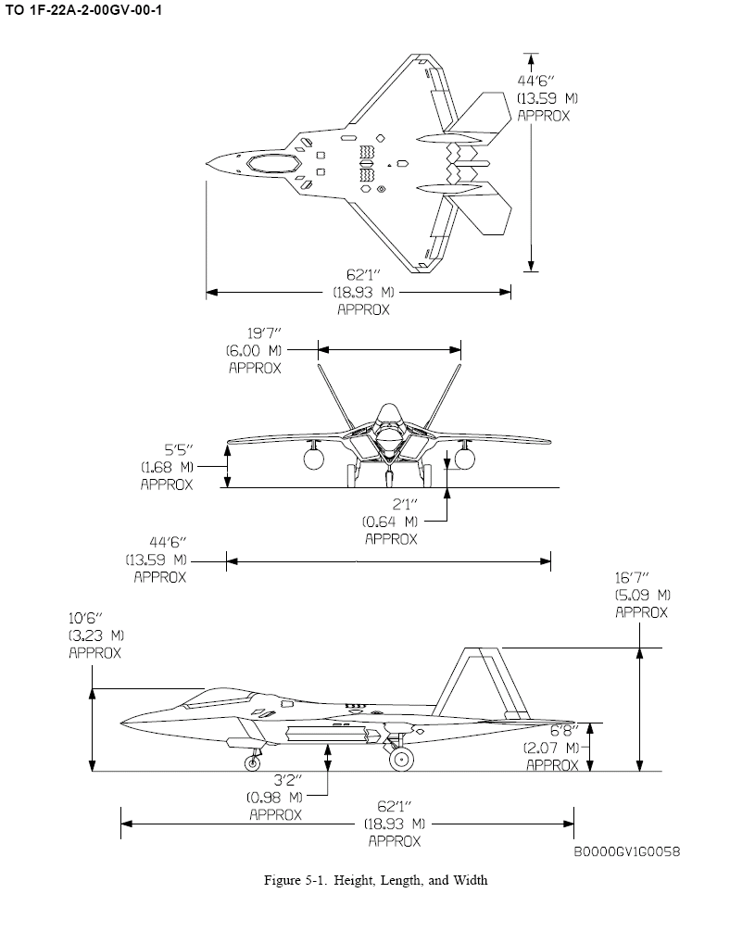
Length of wings leading edge is 19’ and trailing edge is 8’2”
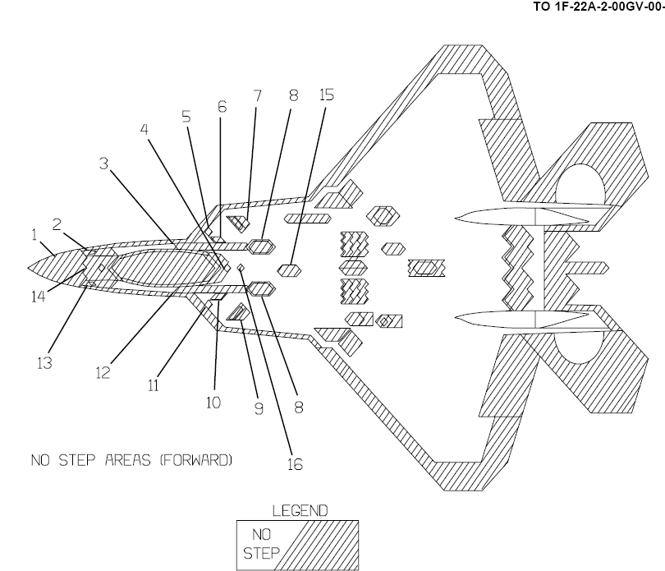
Purpose of the stairs is for maintainers to work along the perimeter of the top of the aircraft shown in this diagram.

