The Persistence of a Liquid Puddle when the Air Temperature is Below Freezing

Peggy LeMone
Jefferson Junior High School
Columbia, Missouri

Teacher: Mrs. Spragg
23 April 2008

ABSTRACT

Photographic evidence and data from sites with similar weather situations are examined to explain how a puddle in the street could remain liquid for several days, in spite of temperature remaining below freezing (highest temperatures, -5°C). We suggest that the puddle had been at least supplemented by subsurface water flowing through cracks in the curb and road. We further suggest that the puddle remained liquid because of high salt content.
1. Research Question and Hypothesis
This study was prompted by the surprising discovery of a liquid puddle on a residential road, after several days of subfreezing temperatures (-7 C and below, see Figure 1) and no precipitation. Where did the water come from? Why wasn’t it frozen?

Understanding the conditions under which such a puddle would form has important implications both for safety (National Research Council 2004) and for representing how the earth heats and moistens the atmosphere in weather and climate models (Ek et al. 2003). While it is not immediately obvious that a liquid puddle would be dangerous, we found that the water splashed onto the windshield and froze instantly, reducing visibility for the driver. Also, puddles affect the exchanges of both energy and water vapor between the atmosphere and the surface. Yet many land-surface models do not account for puddles, assuming that the “extra” water either runs off into streams or is soaked into the soil (e.g., Ek et al. 2003).

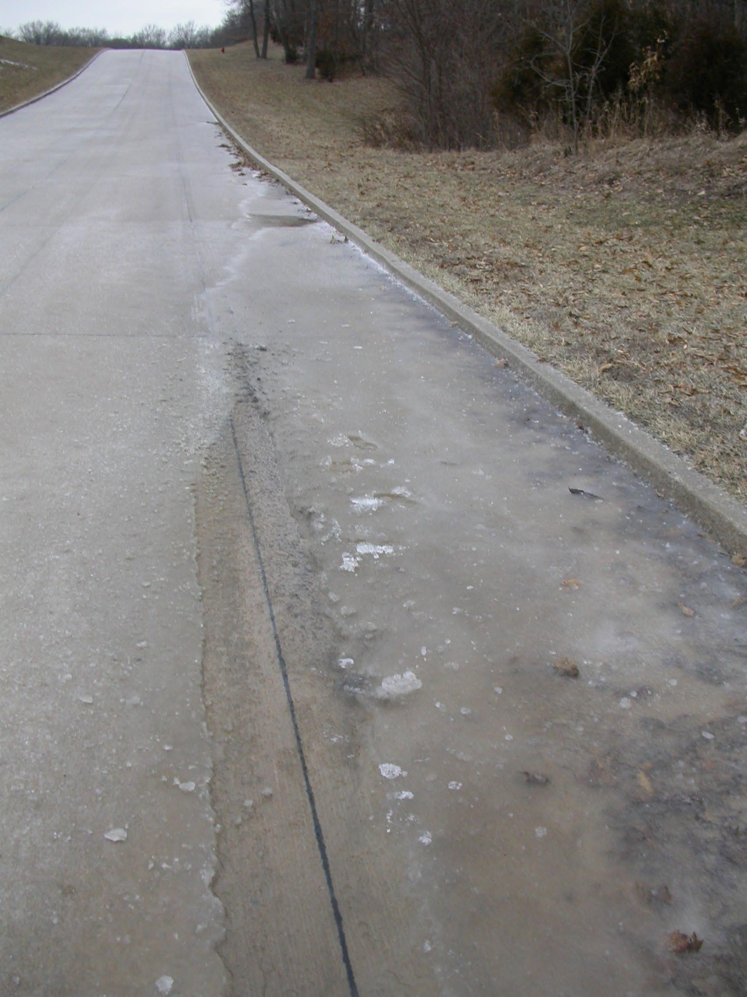
Figure 1. Picture of puddle on road in Columbia, Missouri, USA, on 21 February 2008.

After careful study of the puddle and its vicinity, two possible explanations emerged for its persistence. First, the water could have come from a leaky pipe: there was a pipe connecting fire hydrants on the north side of the road, where the puddle was. And secondly, it is possible that water from below the surface could have come through openings in the curb or road surface to supply the puddle.

For subsurface water to flow into the road, the temperatures underground would have to be above freezing, in spite of the air temperature being below freezing (-7 C and below) for several days. It is well-known that the temperatures below ground tend to be less extreme than air temperature; indeed, the farther one goes down, the less the temperature tends to change with time (e.g., Marshall et al., 1999). In fact, the air temperature in caves a few tens of meters below the surface is close to the annual average temperature of the air above ground (though there can be some variation, see e.g., https://mwrcms.nps.gov/wica/naturescience/cave-meterology.htm).

It is likely that the puddle remained liquid because of salt put on the road. In the United States, roads are frequently treated with sodium chloride (ordinary table salt) or magnesium chloride. These compounds lower the freezing point of water, thus keeping roads from becoming slippery (National Research Council 2004).

In this paper, we will demonstrate that the puddle was caused by underground water seeping through cracks in the curb and road surface. We will also present evidence that there was salt in the puddle, making it likely that the salt kept the water from freezing.

2. Materials and Methods

Observations were made strictly using a camera, to collect evidence of possible origins of the water, and to document the appearance of the puddle and the road. Temperature readings were obtained from the U.S. Weather Service, which is around 10 km from the puddle and a car thermometer. Since we are concerned with why the puddle remained liquid, we focused on daytime maximum temperatures, which do not vary much horizontally on days with no precipitation (e.g., LeMone et al. 2003). We also used the weather reports to find when the most recent precipitation occurred.

We took observations during two five-day periods, 18-22 February, and 19-23 March. We were particularly interested in watching for how the puddle changed size, recent precipitation patterns, and signs that the road had been salted.

Since we had no equipment for measuring air or soil temperature, we searched the Web and contacted scientists for data showing how soil temperature varies with depth. We were particularly interested in short bursts of cold, subfreezing temperatures like the period around 21 February. We successfully obtained data from Smileyberg, Kansas, U.S.A., and Bondville, Illinois, U.S.A., which are at about the same latitude as Columbia, Missouri, and bracketed Columbia in longitude.

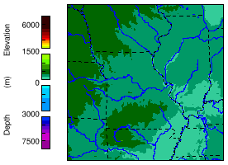
Smileyberg
Columbia
Bondville
x
x
x
Figure 2. Map showing approximate locations of Smileyberg, Columbia, and Bondville. They are all located in the Midwestern United States.

3. Data Summary and Analysis

- The water source

Figures 3 and 4 show examples of temperature changes with depth during periods in the winter when the air temperature reaches its lowest values. These are periods similar to when the the puddle was first observed.

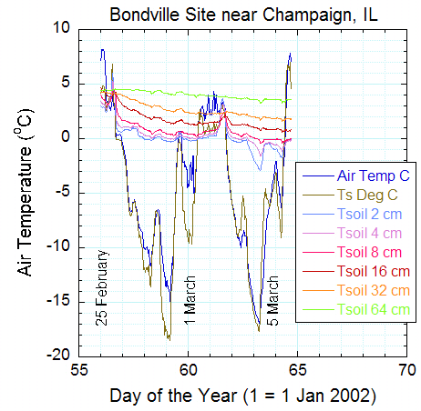
Figure 3. Air temperature at Bondville, Illinois during two cold-air events. Note that the soil temperature stays warmer than the air temperature, particularly at lower depths. Day 60 – 1 March, Day 70 – 11 March). Data available on the Web at http://cdiac.ornl.gov/ftp/ameriflux/data/Level1/Sites_ByName/Bondville/FLUX-2002/.

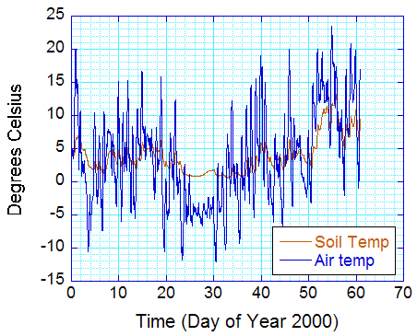
Figure 4. For grassland site near Smileyberg, Kansas, the air temperature (at about 2 meters) and soil temperature (average 0-5 cm). Data from Argonne National Laboratory, courtesy R.E. Coulter.

In both cases, the soil temperature stayed warmer than the air temperature. Further, we see from Figure 3 that the soil temperature is warmer with greater depth, as expected. Thus it is likely that there could be unfrozen water below the surface.
To see whether there were places groundwater that were leaking onto the road, we visited the puddle site and photographed the street (Figure 5). From the figure, we see a gap in the curb (15-20 centimets high), and water is clearly seeping up through a gap in the road. Most of the gap is sealed with tar, but there are clearly openings for the water to seep through.
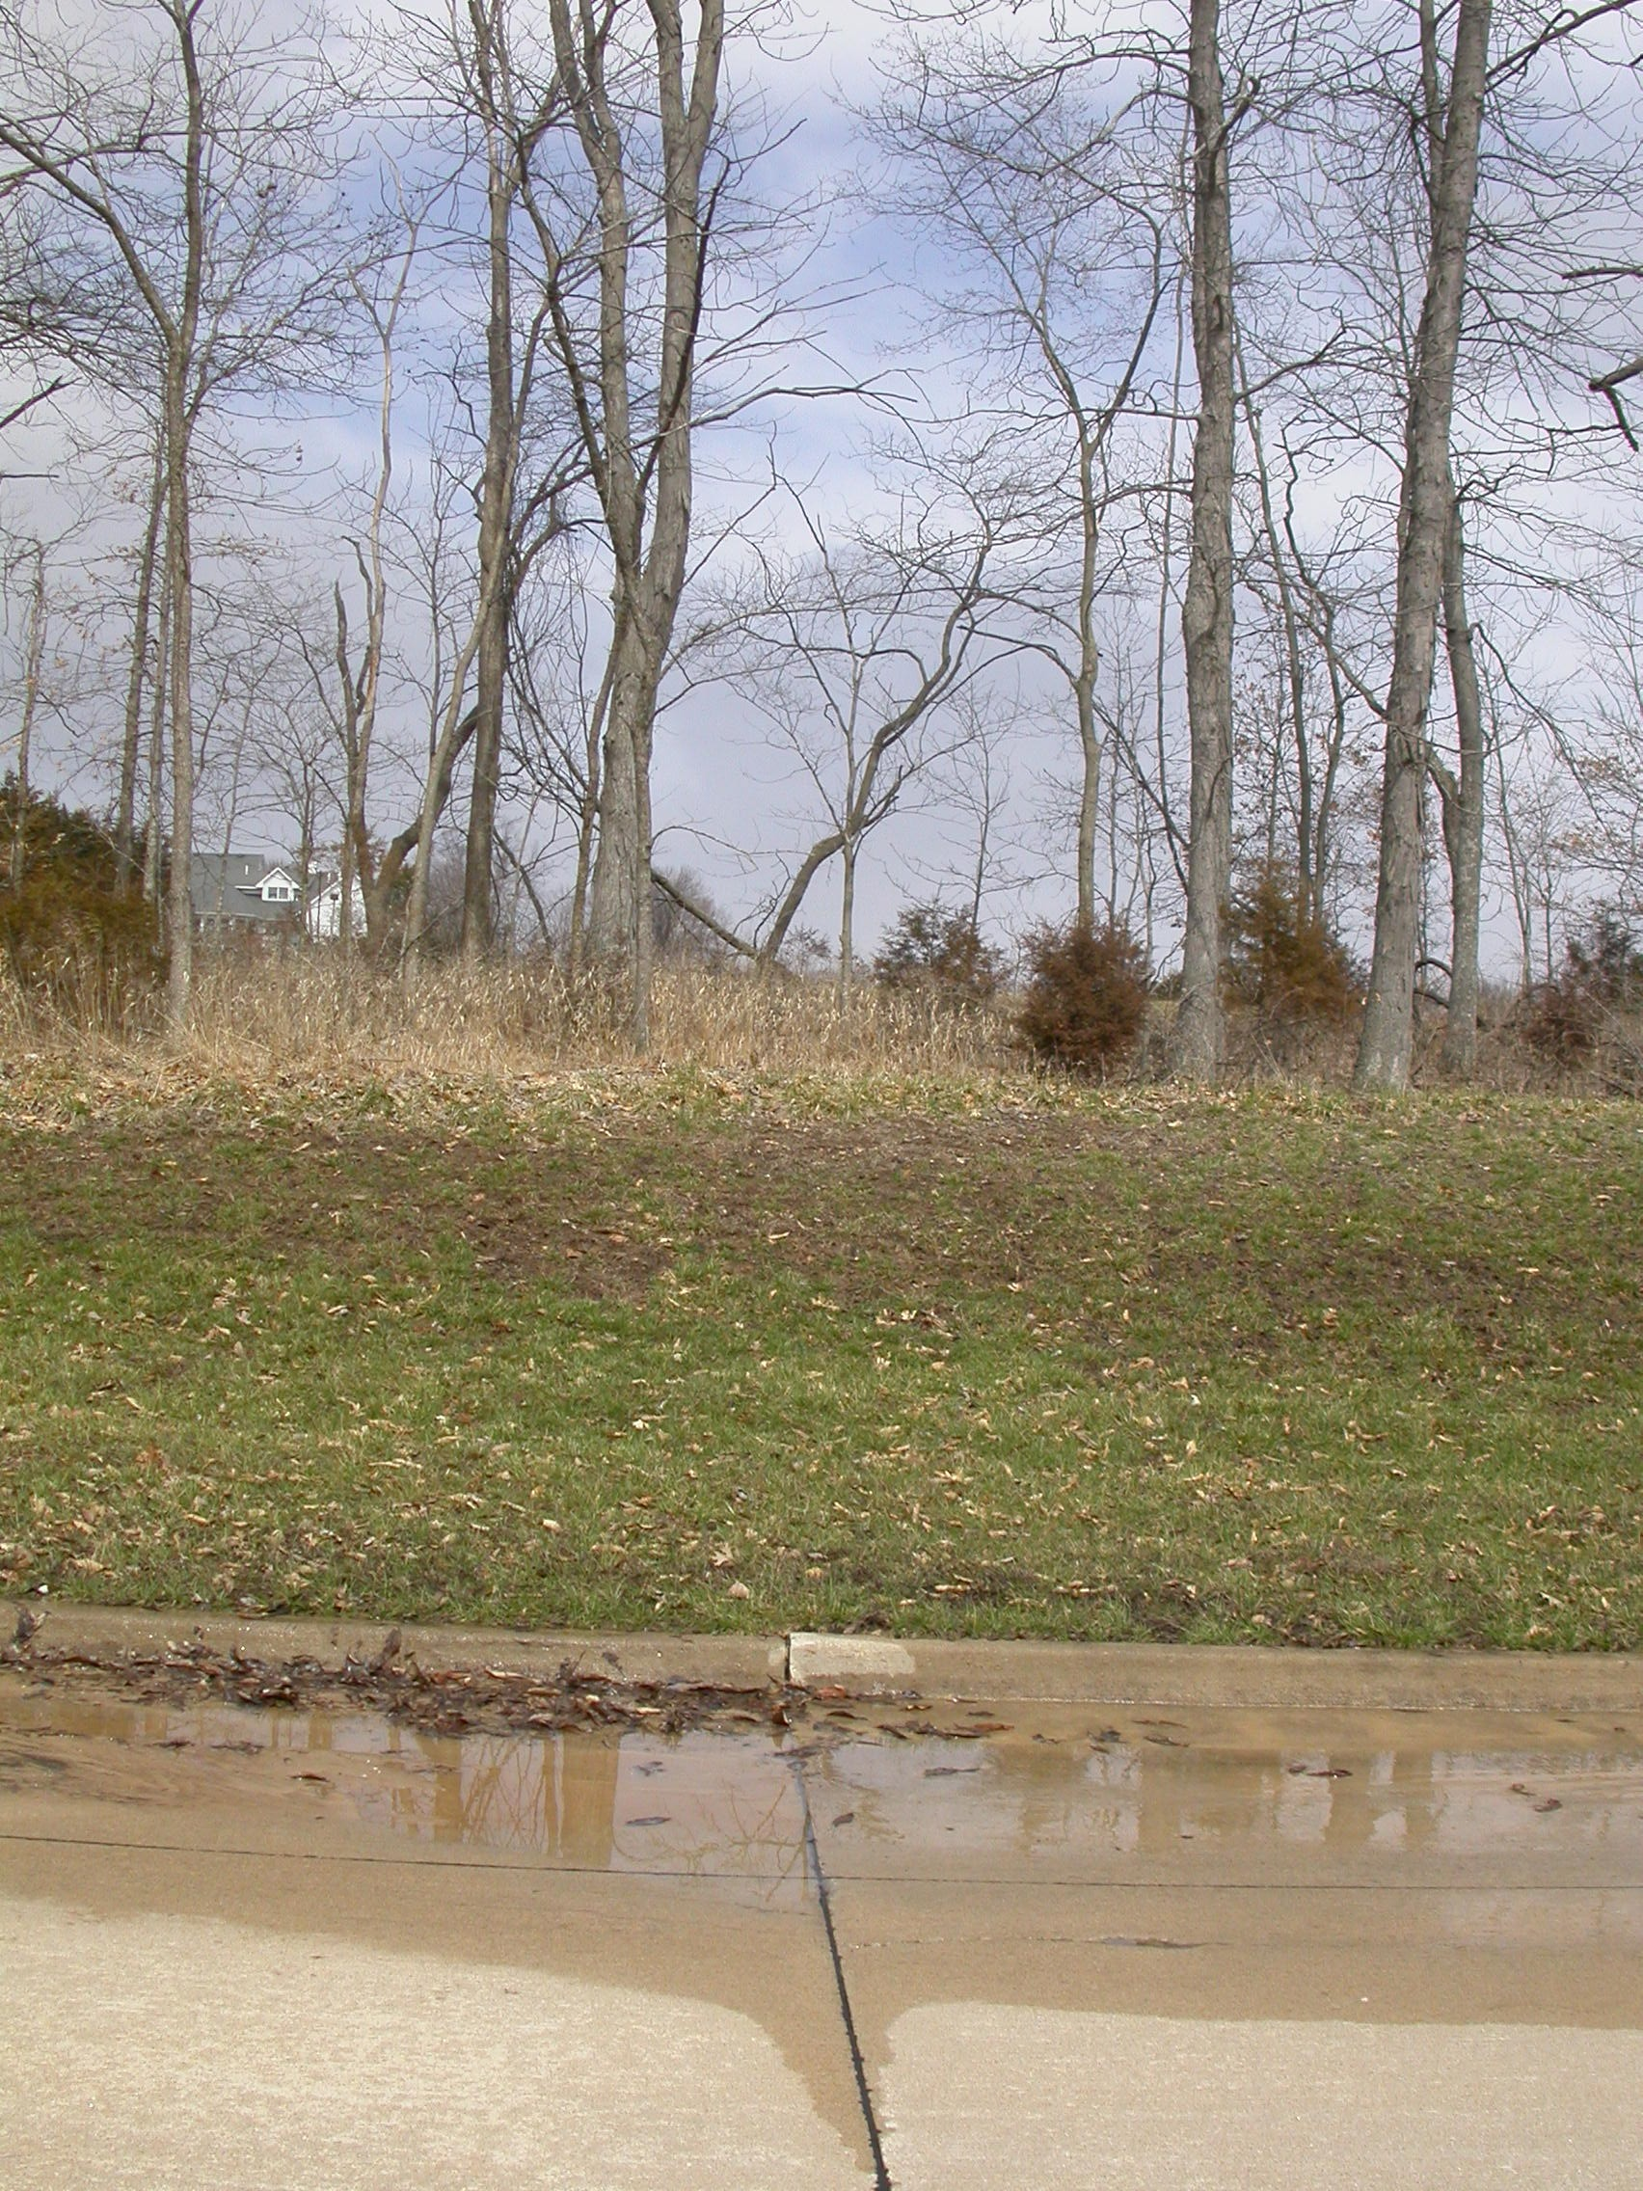
Figure 5. Puddle site, photographed in March, showing a gap in the curb and water seeping up through a crack in the road.

A look at the weather records the previous week indicated heavy precipitation. Thus the ground was quite wet. The size of the puddle when we were watching it in February did not change significantly.
None of these observations eliminate the possibility that the water could have come from a broken pipe. From interviews, we know that the pipe was fairly new (order 10 years old) and that the contractor has a good reputation. More importantly, a second visit to the puddle site a month later and after several dry days showed no puddle, suggesting that the pipe was not leaking. The ground wasn’t disturbed, so the pipe had not been repaired.
b. Evidence of salt on the road
Shortly after the picture in Figure 1 was taken, it started to snow. A few hours later, I noticed crystals on the road, each surrounded by melting snow (Figure 6), and I saw the truck spreading the crystals. I picked up a crystal and carefully tasted it, verifying that it was in fact sodium chloride (table salt). When I visited the dried-out puddle site in March, I noticed white stains. This suggested that the salty water had flowed to the puddle site, and much of the water had evaporated there.
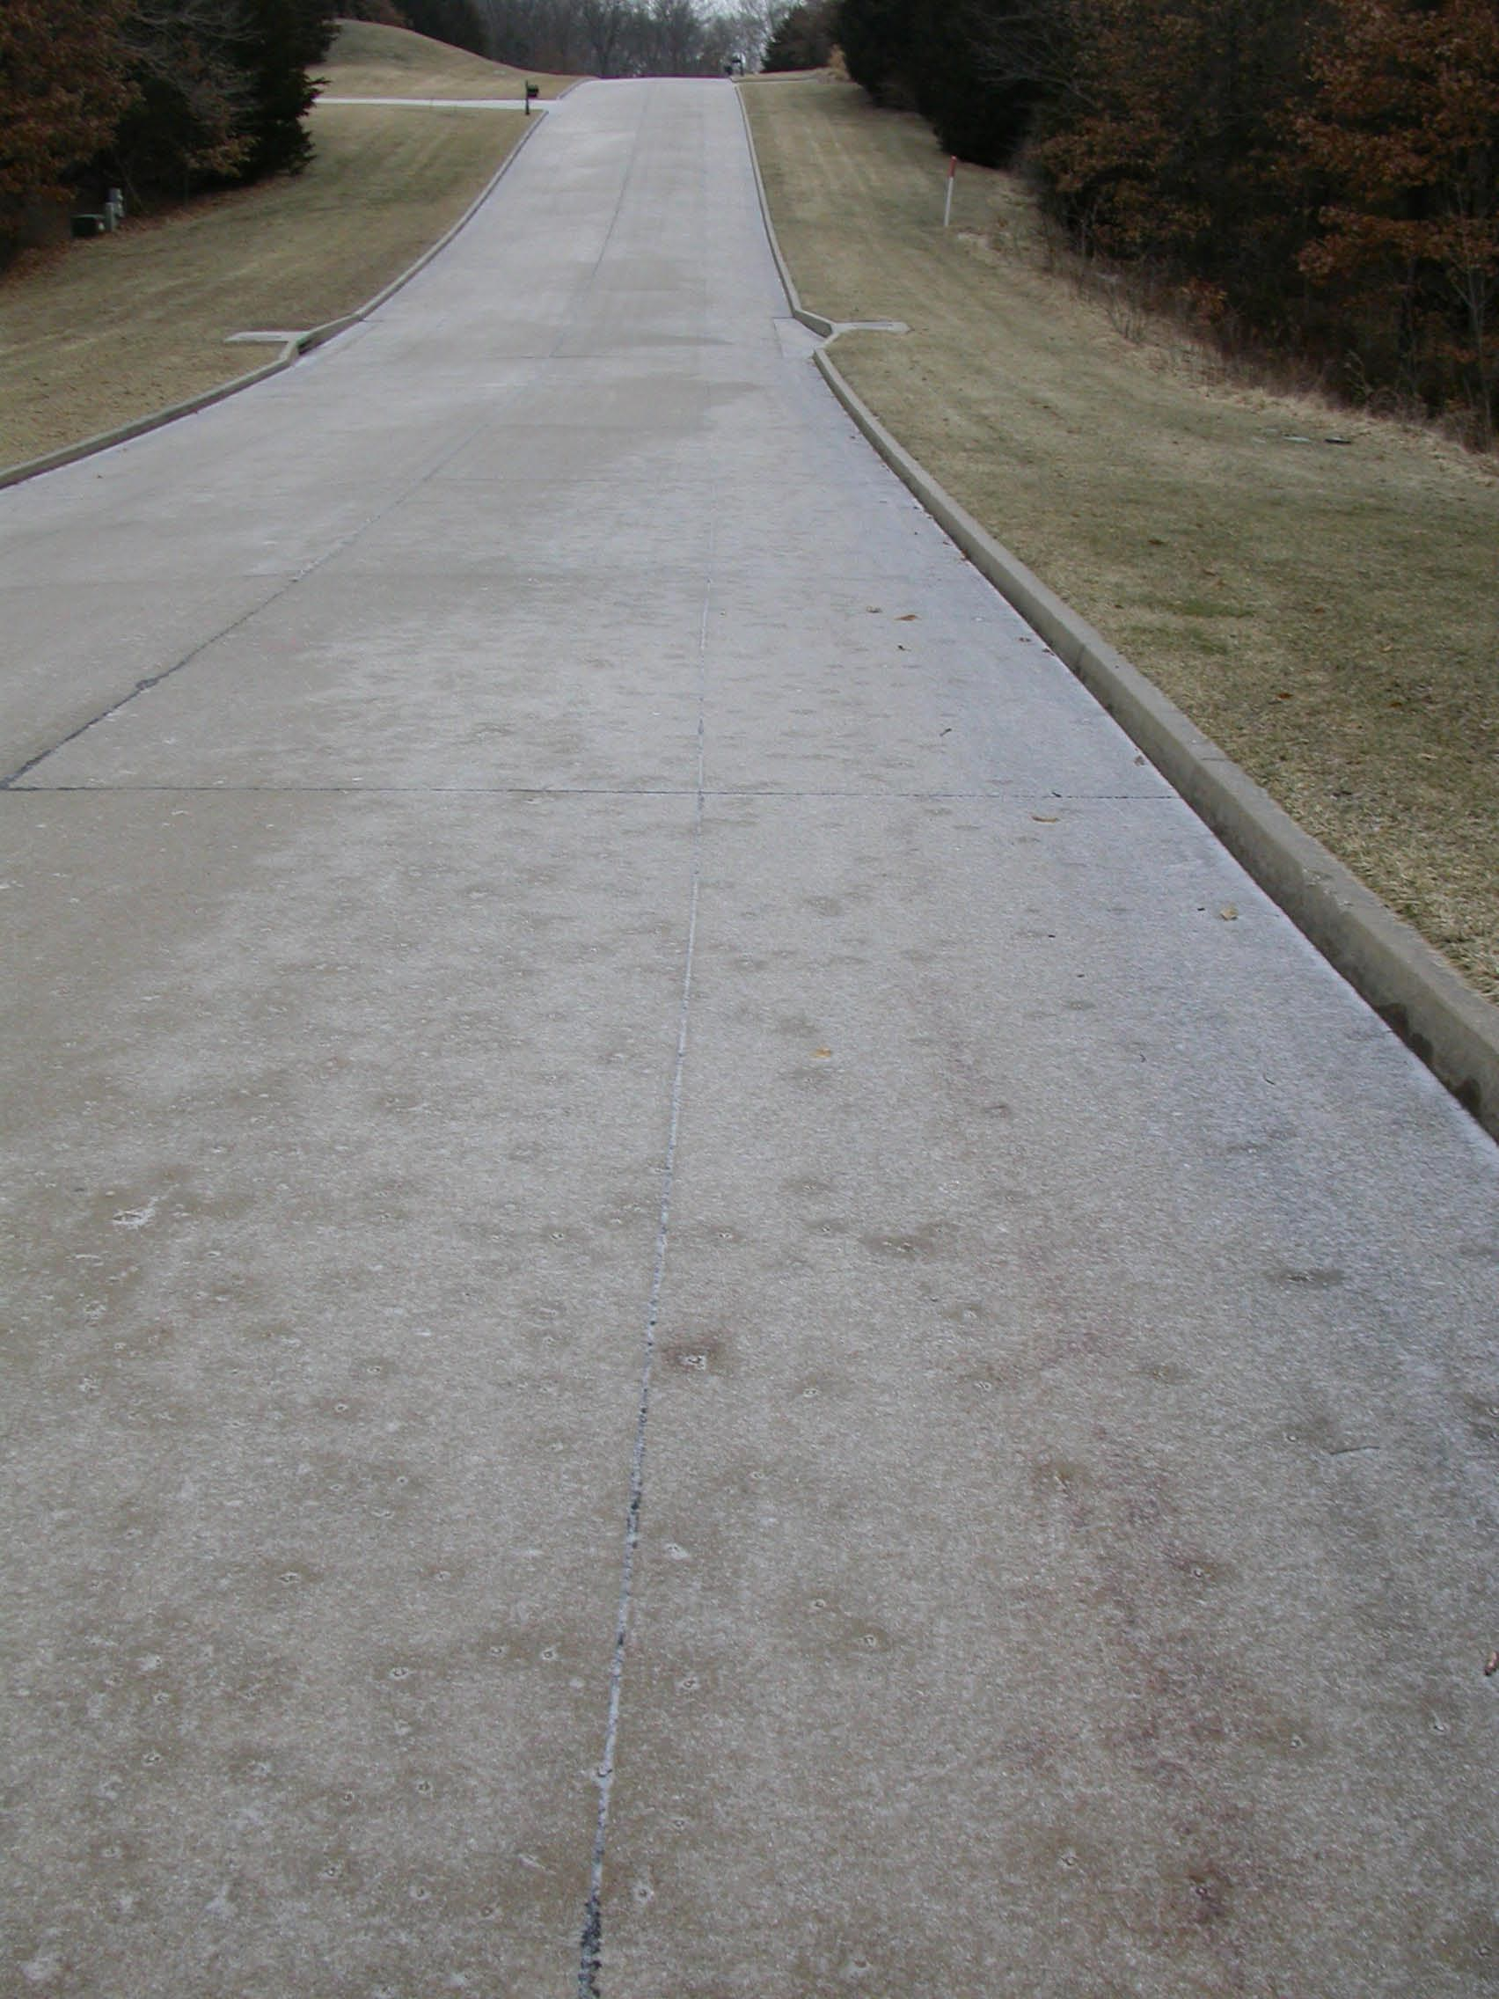
Figure 6. Snow melting around salt crystals

4. Results, Conclusions, and Discussion
Evidence is strong that the water supplying the puddle was from flow through saturated ground through cracks in the road and curb. Recent heavy precipitation caused the soil to saturate, and the cracks in the road enabled the water to continue to flow onto the road after the precipitation was over. There is no evidence supporting the alternative hypothesis that the water came from a leak in the pipe connecting the fire hydrants. The water remained above freezing because the changes in air temperature do not immediately penetrate into the ground. This was confirmed by observations of similar weather from two other sites. It is likely that at least some of the water in the puddle could have been left over from earlier precipitation.
The water probably remained liquid because the road was treated with salt (sodium chloride) when it snowed. White stains at the puddle site suggested that dissolved salt from other parts of the roads had been carried to the puddle site – that is, the salt was concentrated in the puddle area. This would lower the freezing point of the water.
Were we to want stronger evidence for our conclusions, data at the site showing both the saturated soils and their temperatures would have been ideal. Since we did not have that information, we looked for data in similar situations.
We suggest that cars constantly running over the puddle may have also prevented it from freezing. This would be a useful question to investigate. Further factors to look at would be the temperature of the road and the soil underneath.
Acknowledgments. I wish to acknowledge Bob, Mac, and Sara LeMone, who provided information about the road, pipes, and the times they were built. Richard Coulter supplied the data from Argonne National Laboratory’s Smileyberg site. This paper is dedicated to Bob LeMone, who died while this was being written.

REFERENCES

Ek, M. B., K. E. Mitchell, Y. Lin, E. Rogers, P. Grummann, V. Koren, G. Gayno, and J. D. Tarplay, 2003: Implementation of the Noah land-use model advances in the NCAP operational mesoscale Eta model. J. Geophys. Res., 108 (D22), No. 8851 NOV 29.
LeMone, M.A., R.L. Grossman, R.T. McMillen, K.-N. Liou, S.C. Ou, S. McKeen, W. Angevine, K. Ikeda, and F. Chen (2002): CASES-97: Late-morning warming and moistening of the convective boundary layer over the Walnut River Watershed. Boundary-Layer Meteorology, 104, 1-52.
National Park Service, Wind Cave National Park (https://mwrcms.nps.gov/wica/naturescience/cave-meterology.htm:) Cave Meteorology.
National Research Council, 2004: Where the Weather Meets the Road: A research Agenda for Improving Road Weather Services. National Academies Press, Washington, D.C., USA. 174 pp.
Marshall, T.J., J. W. Holmes, and C.W. Rose, 1999: Soil Physics (Third Edition). Cambridge University Press, 453 pp.

