Reducing the Health Impact from Former Methamphetamine labs in Kentucky

2005 - 2006:

Environmental Public Health Leadership Institute Fellow(s):

Connie S. Mendel; B.S.,R.S.
Environmental Health Manager
Louisville Metro Health Department
Environmental Health and Protection
400 E. Gray St.
Louisville, KY 40202

David E. Jones; M.P.H.,B.S.,R.S.
Epidemiologist
Kentucky Department of Public Health
275 East Main, HS2E-B
Frankfort, KY 40601

Mentors

Craig A. Shepherd; R.S., M.P.H., D.A.A.S.
CAPT U. S. Public Health Service
Chief Environmental Health Officer
Senior Environmental Health Officer
Environmental Health Services Branch
Division of Emergency and Environmental Health Services National Center for Environmental Health Centers for Disease Control and Prevention
4770 Buford Highway, NE (F28)
Atlanta, GA 30341-3724

Michael Goodman; M.S.M.E.,M.S.
Innovation Associates Organizational Learning
14 Church Street
Hopkinton, MA 01748

(Acknowledgements):

Clyde, Bolton
Kentucky Department of Public Health, Division of Public Health Protection and Safety

Tim, Hubbard
Kentucky Department of Environmental Protection

Fazi, Sherkat
Kentucky Department of Environmental Protection

Sgt. James Hill
Louisville Metro Police Department

Capt. David Wood
Louisville Metro Police Department

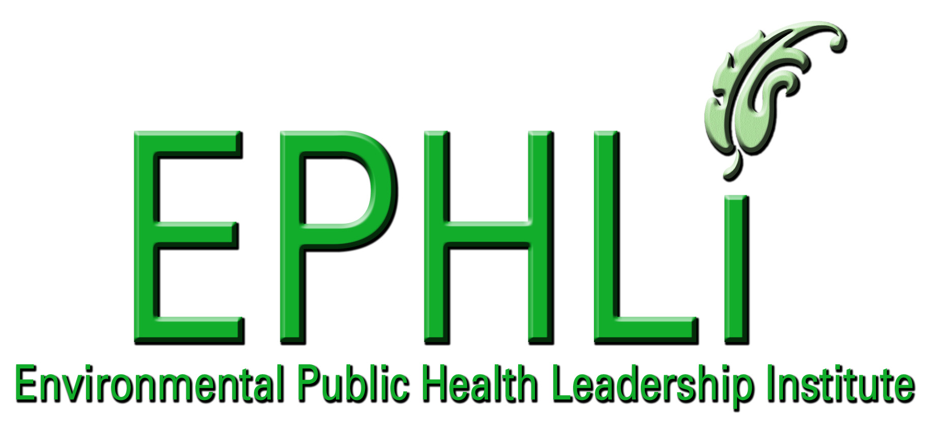

EXECUTIVE SUMMARY:

“Meth," "speed”, “crank," "chalk,"- "go-fast," "zip," "cristy," "ice," "crystal," 64glass," or "quartz. Methamphetamine usage has been prominent in the United States for the past 8 years. This trend has been spreading west to east impacting urban and rural settings. Methamphetamine may be more disruptive than other drugs because in addition to problems related to its use, methamphetamine creates a host of problems related to its local production. (1) It has health impact as well as economical impacts. The health impacts effect all ages, races, gender and social classes. Further, this drug possesses a unique problem with its production, because of the inherit dangers of the drug recipes and the waste left behind by the meth cookers.
In Kentucky, after a lab is busted a gross cleanup is initiated by the KY State Police. This cleanup is thorough but it leaves residual waste in the residence; “Though found in small amounts, meth lab contaminants may pose health threats to persons exposed to them.” (2)
An increase in meth production has caused an increase in the number of homes, apartments, hotels, motels, etc that are contaminated sites. Many of these sites are not being cleaned up in Kentucky; these sites are creating a health hazard to Kentuckians with unknown chronic outcomes.
Through convening a multi agency workgroup, Kentucky will strive to provide educational materials to all stakeholders in Kentucky, outreach to LHD’s staff impacted by former meth labs, provide guidance documents for legislative approach, and interim-guidance for citizens and public health workers. Our overarching approach will be to provide guidance to LHD’s and citizens and ultimately providing recommendations via a guidance document on cleanup to Kentucky’s General Assembly for promulgation.
Our workgroup implemented and distributed interim cleanup guidance to all the local health departments in Kentucky. We have also been able to create a rough draft of the guidance document that will be submitted to the General Assembly in the 2006 session. The workgroup has been an overarching collaboration reaching across agencies structural and political lines.
At a local level we worked towards defining ours roles and responsibilities during a meth lab response, through work groups, tabletop exercises, emergency drills and creation of meth lab response guidelines for Louisville Metro. This created a more organized emergency response by Police, Fire, EMS, Health and other agencies, resulting in less time on scene, working together better, and a greater awareness of hazards, injuries and health effects occurring during meth lab responses. This also ensures fewer responders being exposed to contaminants and proper notification of meth lab sites to the local Health Department for follow-up to reduce environmental contamination and exposure to the future residents.
The state has much work to do to protect the citizens from meth contaminated sites; work is being done to improve this environment. We will work to submit this guidance to General Assembly and will work on educating the legislature on the dangerous environment placed upon our children, elderly and communities.

INTRODUCTION/BACKGROUND:

Methamphetamine usage has been prominent in the United States for the past 8 years. This trend has been spreading west to east and impacting urban and rural settings. Much effort has been put into place across the nation into law enforcement action and education about methamphetamine but a lack of response has been placed in the cleanup of locations housing meth production/labs.
Specifically in Kentucky, methamphetamine has been a logarithmic problem for the past 6 years. In 1999 Kentucky had 67 methamphetamine busts and by 2004 increased too 562 meth busts. Once the police have busted a location and conducted a gross cleanup the process leaves an insidious threat to the people moving into the location. These hazards presented in these homes, apartments, hotels, motels, etc, directly and indirectly impact the health to the new residence. The residence may have such symptoms as: respiratory complications, skin/eye irritation, headaches, nausea and dizziness. At higher exposures may have lung, liver, kidney damage and burns may result. Presently, the complete risks of chronic conditions associated with former meth locations are unknown but we do know that many of the components associated have a risk of cancer, neurological, and other systemic effects. Other than the health risks this issue impacts property values, economic burden, loss of revenue to farmers and cleanup costs.
To date a number of states have developed standards and methodologies for the cleanup of methamphetamine labs. These standards vary from state to state and many states have similar standards. Kentucky has not formalized any standards and will use the existing standards from states such as Colorado and Washington.
The mission of the Department of Public Health is to ensure the Health and Welfare of the citizens of Kentucky. To meet this mission, our group has devised the following actions:
- Develop Educational Tools: Website, Booklets, Brochures
- Submit Cleanup Guidelines
- Create a Certified Meth Cleanup Program
- Develop a Training program
- Regulations/ legislature implementation
- Protection of Staff at MLHD and State
In summary through our efforts with the meth work groups at the state and local level we have developed sustainable partnerships, increased awareness and provided educational tools via website, brochures and public meetings on methamphetamine and its health risks from a former lab sites. Other objectives will be to promulgate regulations and statutes to protect the citizens of the commonwealth. We will be presenting a cleanup guidance document to legislature in January with hope of increasing the inertia for these pending deliverables.
This will directly impact EH by guidance put into place, which will protect the EH staff throughout the state and will give direct roles and responsibilities for the local health departments with contaminated sites. Ideally, this will establish a paradigm shift in the public health culture and meet our mission and attaining our vision for the protection of our citizens.

Problem Statement:

Adults, Children, and Infants (Kentuckians) are exposed to post gross cleanup contaminants from clandestine methamphetamine labs causing potential adverse health outcomes.

Behavior Over Time Graph (BOT):

BOT: Meth Labs Issue
Time
Contamination Log
Health Impact
Public Pressure
Resources
Variables

“Fixes That Backfire” 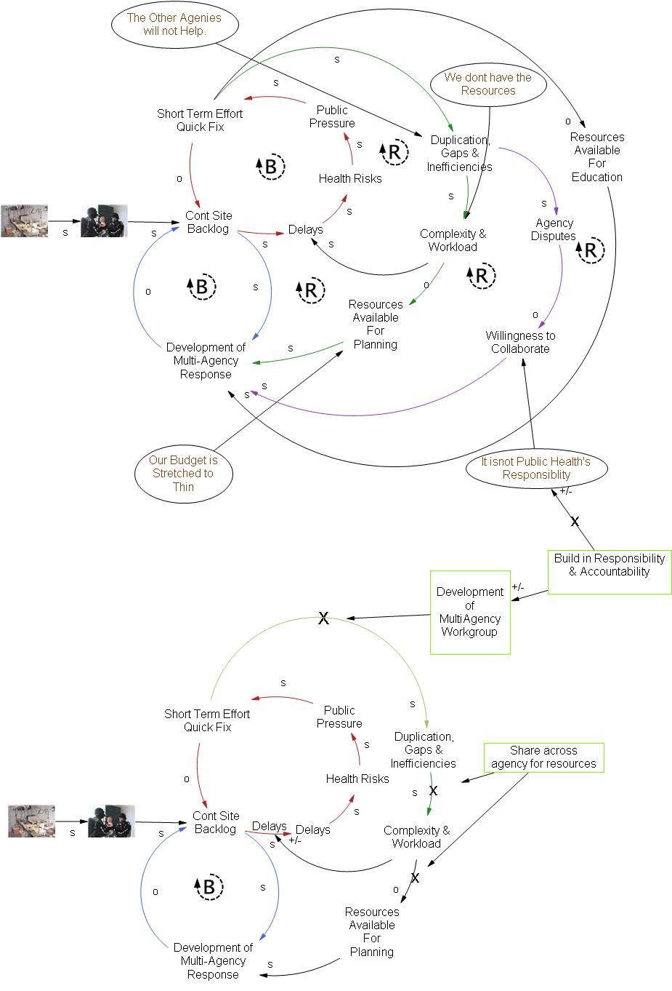
We can coordinate our resources!
We can work together!
Intervention Loop

10 Essential Environmental Health Services:
Describe how your project seeks to enhance or fulfill one or more of the 10 Essential Environmental Health Services and/or the three (3) functions described in the IOM report: assessment, policy development and assurance.

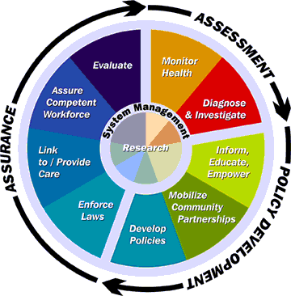

Policy Development

Inform, Educate, and Empower: The development of the interim guidance document for state and local public health directly educates. Further, the creation of the guidance document to the General Assembly further, impacts this EEHS.
Mobilize Community Partnerships: The cabinet level collaboration work group and the department level work group have both mobilized and brought various agencies together. This removed existing barriers/walls and allowed the development of concerted effort towards the methamphetamine issue.
Develop Policy: The work that has been done is focused to provide guidance to the General Assembly which will ultimately promulgate laws/regulations.

National Goals Supported

Environmental Health Competency Project
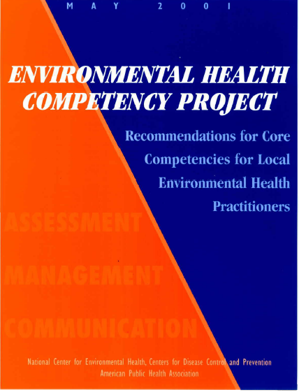 |  |  | Assessment |  |  |  |  | Management |  |  |  |  | Communication
Information Gathering |  |  | Analysis | Evaluation | Economic and Political | Problem Solving | Org Know/Behavior | Project Management | Computer/IT Support | Reporting/Documentation/Record Keeping | Collaboration | Educate | Communicate | Conflict Resolution | Marketing
√ | √ |  | √ | √ | √ |  |  | √ | √ | √ | √ | √ | √ | √

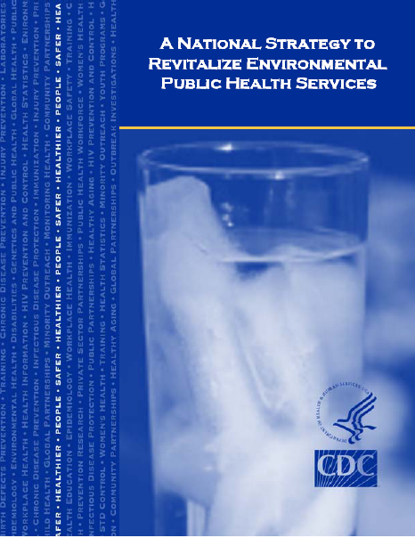

A National Strategy to Revitalize Environmental
Public Health Services
Build Capacity |  | Support Research |  |  |  | Foster Leadership | Communicate & Market |  | Develop Workforce | Create Strategic Partnerships
Objective IA | Objective IB | Objective IC | Objective IIA | Objective IIB | Objective IIC | Objective I | Objective IV-A | Objective IV-B | Objective V | Objective IV
 |  |  |  |  |  |  |  | √ | √ | √

Error! Not a valid link.

Methamphetamine Cleanup
Logic Model
(Local Level)

Activities
Draft “Coordinated Meth Lab Response Guidelines”
Draft clean-up standards for meth lab sites
A greater awareness of hazards, injuries and health effects occurring during meth lab responses
Outputs
Intermediate
Outcomes
Louisville Metro Health Department

Louisville Metro Police

Louisville Fire & Rescue

Jefferson Co. Fire Depts.

Louisville Emergency Medical Services

Louisville Emergency Management Agency

Louisville Metro Council

Louisville/ Jefferson Co. Board of Health

KY Drug Enforcement Agency

Metropolitan Sewer District

Short-term
Long-term
Adopt Coordinated Meth Lab Response Guidelines
Present “Environmental clean-up standards at Meth Lab Sites” to Louisville Metro Council / Board of Health

Enforcement of Environmental clean-up standards at Meth Lab Sites
Multi-Agency Meth Lab response table top exercise
Research potential Health Hazards of meth lab sites
Track Louisville Metro Health Dept. responses to Meth Labs
Multi-Agency Meth Lab emergency drill/ exercise
Adopt clean-up meth lab clean-up standards
Improved/ Organized Response
Reduce Environmental Contamination in Former lab sites.

Methamphetamine Cleanup
Logic Model
(State Level)

Activities
Processes
Impacts

Division of Public Health Protection and Safety

Division of Epidemiology & Health Planning

Division of Adult and Child Health

Department for Environmental Protection

Department of labor

Kentucky State Police

Realtor Association

Local Health Departments

KPHLI

MHMR

DCBS

Local Law Enforcement

DEA

Business Owners

Cleanup Contractors

To reduce the number of homes, apartments, and inhabitable residence contaminated from a former meth lab by 5%by end of 2006.
Reduce the potential morbidity from residual meth exposure remaining from former meth labs.
Goal
Creation of Booklet, cleanup guidance.
Inputs
Distribute of Booklet to Citizens
Distribution of Booklet to Stakeholders
Appoint Annex Manager for Meth Cleanup S.T.A.T. Document
Form steering committee of all stakeholders
Create Finalized S.T.A.T by December, 2005
By September 30th 2005, an interim cleanup guidance document will be approved and provided to 75% of stakeholders and 25% of citizens.
Creation of an Annex in the S.T.A.T. document for the Meth statewide program by December 20, 2005
Outcome
By March 2006, 20% of meth lab cleanups in KY will follow the Interim Cleanup Guidance Document.

PROJECT OBJECTIVES/DESCRIPTION/DELIVERABLES:

Local Level
Program Goal: Reduce the rate of acute and chronic health effects to emergency responders and residents from exposure to environmental contaminants.

Health Problem: The increase of methamphetamine production in Metro Louisville has increased the exposure of emergency responders and citizens to post methamphetamine lab site contamination, which may cause acute and/or chronic health effects.

Outcome:
To reduce exposure to methamphetamine lab site contaminates by 10% in 2006.

Determinant: the number of Meth labs investigated by the Louisville Metro emergency response agencies in 2006.

Impact Objective: Improve the multi-agency meth lab emergency responses by December 31, 2005 with local fire, police, EMS, emergency management and health agencies.

By January 2006 the Louisville Metro Health Department will assure proper environmental clean-up of 50% of the former methamphetamine lab sites.

Contributing Factors:

- Lack of regulatory enforcement for cleanup of former methamphetamine labs.
- Lack of awareness of the dangers from residual contamination of inhabitable residence.
- Lack of cleanup guidance for general public, local health departments, etc.
- Lack of defined roles and responsibilities among stakeholders; police, fire, EMS, EMA and health agencies.
- Lack of funding structure provided for cleanup of residence homes, etc.

Process Objectives:

Implement a multi-agency meth lab emergency response plan by December 31, 2005 with local fire, police, EMS, emergency management and health agencies.

Event: By November 30, 2005 create a multi-agency meth lab emergency response incorporating local fire, police, EMS, emergency management and health agencies
.

Activities:
  - Meet with stakeholders to outline roles and responsibilities by July 31, 2005.
  - 75% participation of stakeholders in meth lab tabletop exercise by August 31, 2005
  - Draft a written multi-agency meth lab response plan by July 31 2005
  - 75% participation of stakeholders in meth lab emergency drill/exercise by September 30, 2005.
  - Review/evaluation of draft plan and exercise by 75% of stakeholders by October 31, 2005
  - Revision and distribution of multi-agency meth lab emergency response plan by November 30, 2005.

By January 31, 2006 all former meth lab sites in Metro Louisville will meet environmental clean-up standards.

Event: Adoption of environmental clean-up standards by the Louisville Jefferson County Board of Health (or other policy making group) by April 01, 2006.

Activities:
  - Determine Environmental Health Hazards of a meth lab site November 30, 2005
  - Draft clean-up Standards for responsible party and/or property owner by January 31, 2006
  - Review/Evaluation by all stakeholders by February 15, 2006
  - Revision and distribution of standards by March 01, 2006
  - Present standards to Louisville–Jefferson County Board of Health (or other policy making group) by March 15, 2006.

State Level
Program Goal: Reduce the potential morbidity from residual methamphetamine exposure remaining in former methamphetamine lab residence.

Health Problem: The increase of methamphetamine labs has increased the exposure of Kentucky’s citizens to post meth lab cleanup contamination which may cause acute and/or chronic exposure/outcomes.

Outcome Objective: To reduce the number of homes, apartments, and/or inhabitable residence contaminated from a former methamphetamine by 1% in 2006.

Determinant The number of methamphetamine labs reported by the E.P.I.C. system of KSP for 2006.

Impact Objective: March 2006 20% of methamphetamine lab cleanups in Kentucky will follow the Interim Cleanup Guidance Document

- Contributing Factors Lack of regulatory enforcement for cleanup of former methamphetamine labs.
- Lack of awareness of the dangers from residual contamination of inhabitable residence.
- Lack of cleanup guidance for general public, local health departments, etc.
- Lack of defined roles and responsibilities among stakeholders, i.e. EPPC, KYOSHA, DPH, AGR, etc.
- Lack of funding structure provided for cleanup of residence homes, etc.

Process Objectives By September 30, 2005 an Interim Cleanup Guidance Document will be approved and provided to 75% stakeholders and 25% of the citizens.
Event: Creation and Distribution of Interim Cleanup Guidance Document.

Activities:
  - Creation of booklet by July 1st, 2005
  - Reviewed/Commented by all stakeholders by July 15, 2005
  - Booklet finalized by July 30th, 2005
  - Distribution plan created by August 15th, 2005
  - Distribution plan finalized by all stakeholders by August 30th, 2005
  - Phase 1 of distribution of booklet to stakeholders and 10% of citizens by September 10th, 2005
  - Phase 2 distribution of booklet to 25% of citizens by September 20th, 2005
  - Phase 3 distribution of booklet to 15% of citizens by September 30th, 2005
- Creation of an Annex in the STAT document For Methamphetamine statewide program.

Event: Creation of S.T.A.T. annex D for cleanup by December 20, 2005.

Activities:
  - By September 16 deadline for annex managers to provide completed annex draft to steering committee for review and comment.
  - By October 7 completed draft plan submitted to steering committee for review and comment.
  - By December 20 finalize plan and sent to steering committee for publication to stakeholders.

EVENTS AND ACTIVITIES:
Local Level

- May 17, 2005
Meeting with Louisville Metro emergency response agency representatives to draft guideline document for emergency response to clandestine drug labs.
- May 26, 2005
Meeting with Louisville Metro Councilperson, attorneys and emergency response agency representatives to discuss creating new legislation to ensure proper clean up of clandestine drug lab sites.
- May 27, 2005
Recognizing methamphetamine use and production workshop provided to Louisville Metro government department representatives
- June 13, 2005
Meeting with Louisville Metro emergency response agencies’ representatives to finalize guideline document for emergency response to clandestine drug labs
- July 12, 2005
Emergency response table top exercise with Louisville Metro emergency response agency representatives.
- July 13, 2005
Louisville Metro Health Department Environmental Staff provided training by Louisville Metro Police, Narcotics Division on recognizing methamphetamine use and production.
- September 1, 2005
Training provided to Louisville Metro emergency responders by Kentucky State Police on proper care and removal of children found at clandestine drug laboratories.
- September 26, 2005
Meeting with Louisville Metro Councilperson, attorneys to discuss creating clandestine laboratory clean-up legislation.
- October 10, 2005
Meeting with Louisville Metro Councilperson, attorneys and emergency response agency Directors to discuss roles and responsibilities.
- October 13, 2005
Louisville Metro Council Resolution encouraging the Louisville Metro Health Department through the promulgation of regulations to develop procedures, standards and guidelines for the clean up, closure, reopening and restoration of structures where clandestine drug manufacturing sites are or have been located.

State Level

- July 9th, 2003 first Meth Cleanup Work Group Meeting. Pulled together various agencies and developed agenda and roles and responsibilities and built new relationships across groups.
- June 15, 2003 2nd work group meeting. Education of all stakeholders on present meth status and impact from the perspective of Kentucky State Police. Defined strategic initiative.
- October 22, 2003, third work group meeting. Refined roles and responsibilities and work on short term fixes such as website.
- January 2004, abolishment of group due to new political structure in state government. Perception of not being a Public Health issue.
- May 26, 2005Reestablishment of the Meth Cleanup Work Group. Development of White Paper for Department of Public Health. Develop priorities and set goals for initiatives. Meet to create interim guidelines and steps towards the guidance document for General Assembly via Cabinet Work Group.
- July 18th, 2005 – Creation of cabinet Level (Health Services) work group. This group was initiated by the Secretary of Cabinet for Health and Human Services.
- August 1st, 2005 Cabinet level meeting. Development of the S.T.A.T. concept and formed subcommittees for addressed specific meth issues. During this time the Cleanup meth work group was adopted as one of the subcommittees.
- August, 15th development of rough draft of guidance document by Meth Cleanup subcommittee.
- September 15th, distribution of interim guidance document to all local health departments via electronic document.
- November, 21st finalization of guidance document to be submitted to the Undersecretary of Health and Human Services.
- January 6th, 2006 cabinet level meeting and submittal of guidance document to undersecretary.

DELIVERABLES:
Local Level

- Multi Agency Meth Lab Response Guidelines
- Coordinated emergency meth lab response
- EH staff meth lab awareness training
- Notification to LMHD of meth labs
- LMHD staff issue and follow-up orders to clean up meth lab sites

State Level

- Educational Tools: Website, Booklets, Brochure
  - Interim Cleanup Guidelines
  - Awareness
  - Partnerships
  - Training
  - Protection of Staff at MLHD and State

FUTURE INITIATIVES/ACTIONS:

- Draft procedures, standards and guidelines for the clean up, closure, reopening and restoration of structures where clandestine drug manufacturing sites are or have been located.
- Louisville Metro Health Department to adopt drafted procedures, standards and guidelines as Board of Health regulations.
- Submit guidance recommendation document to Governor and General Assembly for creation of laws/regulations impacting the current structure of cleanup response. (Development of standards, Contractor Program, etc)

LEADERSHIP DEVELOPMENT OPPORTUNITIES:

Connie Mendel
Reflections

Participating in the Environmental Public Health Leadership Institute has been a very worthwhile experience for me. After having such a great experience in the Kentucky Public Health Leadership Institute, I knew I wanted to be part of a national program devoted toward improving Environmental Health, a branch of Public Health that is usually unnoticed and under funded until a disaster occurs. EPHLI exceeded my expectations in areas I did not anticipate, particularly in personal growth. I had anticipated valuable and meaningful networking with other dedicated Environmental Health professionals and I was certainly not disappointed, these Fellows and Mentors are the best in their fields and I am inspired by their dedication to their craft. I had also anticipated the support I needed to develop and continue my project, Thanks to my Mentor, Craig Shepherd and Mentor Team; Jessica Shelly and David Jones, especially David, who has helped me immensely throughout the development of the project. What I had not anticipated was the meaningful personal growth and valuable skills gained in communication, and developing leadership.

David Jones
Reflections

The institute has been very rewarding and insightful. It has helped to further my leadership abilities and expand my perceptions. The tools made available were invaluable, i.e. the systems thinking, CSI and MBTI and the institute gave a unique oportunity to communicate/build releationships with other states and the CDC. Through all of my education and work experience this opportunity has been very unique and has bridged the gap from practioner to leadership. This program is highly recommened for building capacity and the future leadership of EH. The progarm will definitely strengthen EH and I look forward to the impact the next group of fellows will have on this country. As Connie stated above, thanks to all who have provided a greater insight to our project and allowed us to tackle critical aspects of meth impact on Kentucky.

ABOUT THE EPHLI FELLOW(s)

Connie Mendel is a 1991 graduate of the University of South Carolina with a Bachelor of Science degree in Marine Science. She spent 6+ years with food and flavoring manufacturers in Louisville KY, supervising their chemistry and microbiology laboratories. In 1997, she joined the Jefferson County, now Louisville Metro Health Department as an Environmental Health Specialist in the Food Hygiene, Mosquito Control and Hazardous Materials Programs. From Supervisor of the Mosquito Control and Hazardous Material Programs to currently Environmental Health Manager, she is continually striving, along with coworkers, to improve the quality of their services, effectiveness of their programs and assuring a competent environmental health staff. Connie is married to Walter Scott Mendel and has two wonderful stepchildren; Maggie and Charlie.

David Jones is a 1997 graduate of Eastern Kentucky University with a Bachelor of Science in Environmental Resources and a minor in Environmental Health. He spent 1 year as a lead inspector and than attended University of Alabama, Birmingham where he received a Master of Public Health with a core of Environmental Health. After graduation, he worked as a consultant out of Louisville, Kentucky. At this position he wore a variety of hats from industrial hygiene, occupational health and safety and environmental management. He then began his public health work as an epidemiologist in maternal and child health. After his contract ended, he came on full time as a state employee working in the Division of Public Health Protection and Safety as an epidemiologist. At this position he worked on many environmental health issues, from bioterrorism to mercury spills to disease outbreaks. Presently, he works as an epidemiologist with the Division of Epidemiology and Health Planning with zoonotic disease and other reportable diseases. David is married to Kate Jones and lives in Frankfort, Kentucky.

REFERENCES
1. Weisheit, Ralph A. “The Impact of Methamphetamine on Illinois Communities:
An Ethnography.” A Report to the Illinois Criminal Justice Information Authority., 2004. PDF: http://www.icjia.state.il.us/public/pdf/ResearchReports/methethnography.pdf.

2. Wrightson, Rick. “Methamphetamine Frequently Asked Questions.” KCI: The Anti-Meth Site. http://www.kci.org/meth_info/faq_meth.htm

